⛰️ Mountain Day Worksheet
Japan's Newest Holiday: A Day for Mountains
Read the story. 英文を読もう。
Class ______ No. ____ Name ______________________________

🔊 音声を聞こう（スマホで読みとってね）
1 Japan has a holiday just for mountains. It is called Yama no Hi, or Mountain Day, and it comes every year on August 11. It is also the newest national holiday in Japan. The first Mountain Day was in 2016.
2 Why mountains? About two thirds of Japan is covered by forest, and most of it grows on mountains. Rain and snow fall on the mountains and slowly become rivers. Mountains give people clean water, wood, and fresh air. The law says the day is for getting close to mountains and thanking them for their gifts.
3 The date has a sad story behind it. At first, many lawmakers wanted August 12. But on August 12, 1985, a Japan Airlines plane crashed into a mountain in Gunma. In that accident, 520 people died. So the lawmakers chose the day before, August 11.
4 Mountain Day comes in the middle of summer, so it is a great time to go hiking. The trails on Mount Fuji are open only in summer. Many climbers walk up at night and wait at the top for the sunrise. People call this sunrise goraiko. But mountains can be dangerous, and every year thousands of hikers need help. Many of them get lost.
5 Mountain Day is also the start of summer vacation for many workers. Trains and highways get very busy as families go back to their hometowns for Obon. In 2020 and 2021, the holiday moved for the Tokyo Olympics. Now it is back on August 11, waiting for you and your hiking boots.
Words 単語
national holiday（国民の祝日） / newest（いちばん新しい） / forest（森、森林） / gift（贈り物、恵み） / lawmaker（国会議員、立法者） / crash（墜落する、衝突する／墜落事故） / hiking（山歩き、ハイキング） / trail（登山道、山道） / sunrise（日の出） / dangerous（危険な） / hometown（ふるさと、生まれ育った町） / get lost（道に迷う）

⛰️ Mountain Day Worksheet
Reading Check
Choose the best answer. 正しいものを選ぼう。
Class ______ No. ____ Name ______________________________
1. What is the main idea of the reading?
(A) Mount Fuji is the tallest mountain in Japan. (B) Mountain Day is a new holiday to enjoy and thank mountains. (C) Japan Airlines started a new holiday in 2016. (D) Obon is the most important summer holiday in Japan.
2. When was the first Mountain Day?
(A) In 1985. (B) In 2014. (C) In 2020. (D) In 2016.
3. Why didn't the lawmakers choose August 12?
(A) Because a plane crashed into a mountain on that day in 1985. (B) Because August 12 is already Marine Day. (C) Because schools are open on August 12. (D) Because Mount Fuji closes on August 12.
4. How much of Japan is covered by forest?
(A) About one tenth. (B) About two thirds. (C) About one half. (D) Almost all of it.
5. In paragraph 4, what does "goraiko" mean?
(A) A mountain hut. (B) A summer vacation. (C) The sunrise seen from a mountain top. (D) A trail on Mount Fuji.
6. Which sentence matches the reading?
(A) Mountain Day is always on a Monday. (B) Mount Fuji is open all year. (C) The holiday did not move for the Olympics. (D) Many people travel to their hometowns around Mountain Day.
7. Why might trains be very crowded on August 10?
(A) Because many people start traveling for their summer vacation. (B) Because everyone must climb Mount Fuji on August 10. (C) Because the trains stop running on Mountain Day. (D) Because August 10 is the newest holiday.
8. In the dialogue, where is Haruto going tomorrow?
(A) To Mount Fuji with Emily's family. (B) To his hometown for Obon. (C) To Mount Takao with his brother. (D) To a shoe store to buy boots.
True or False? T か F に○
1. Mountain Day is on August 11. T / F
2. Mountain Day started more than 100 years ago. T / F
3. At first, many lawmakers wanted August 12. T / F
4. The trails on Mount Fuji are open all year. T / F
5. Many people start their Obon vacation around Mountain Day. T / F
6. Mountain Day is always on a Monday. T / F

⛰️ Mountain Day Worksheet
Word Work
単語のれんしゅう
Class ______ No. ____ Name ______________________________
① Match the pictures and the words. 絵と単語を線でむすぼう。
⛰️ | ● | ● | mountain
🌲 | ● | ● | rice ball
🥾 | ● | ● | tent
🎒 | ● | ● | tree
🧭 | ● | ● | boots
🌄 | ● | ● | compass
🍙 | ● | ● | sunrise
⛺ | ● | ● | backpack
② Unscramble the words. 並べかえて単語にしよう。
1. F O S R E T (森) → ____________________
2. I U M S T M (頂上) → ____________________
3. T R I A L (登山道) → ____________________
4. I L B M C (登る) → ____________________
5. S N R S I U E (日の出) → ____________________
6. I O Y L H A D (祝日) → ____________________
③ Fill in the blanks. 語群から選んで入れよう。
[ walk / holiday / slowly / winter / water / snow / balls / lost / forest / morning / Mountain / ocean / map ]
On August 11, Mika and her dad got up at four in the (1) __________ . It was (2) __________ Day, a national (3) __________ in Japan. They took a train to the mountain and started to (4) __________ up the trail. The air was cool, and the (5) __________ was full of birds. Dad checked the (6) __________ at every corner, so they did not get (7) __________ . At the top, they ate rice (8) __________ and drank cold (9) __________ . "Thank you, mountain," Mika said. Then they walked down (10) __________ and safely.

⛰️ Mountain Day Worksheet
Crossword Puzzle
ヒントを読んでクロスワードを完成させよう。
Class ______ No. ____ Name ______________________________
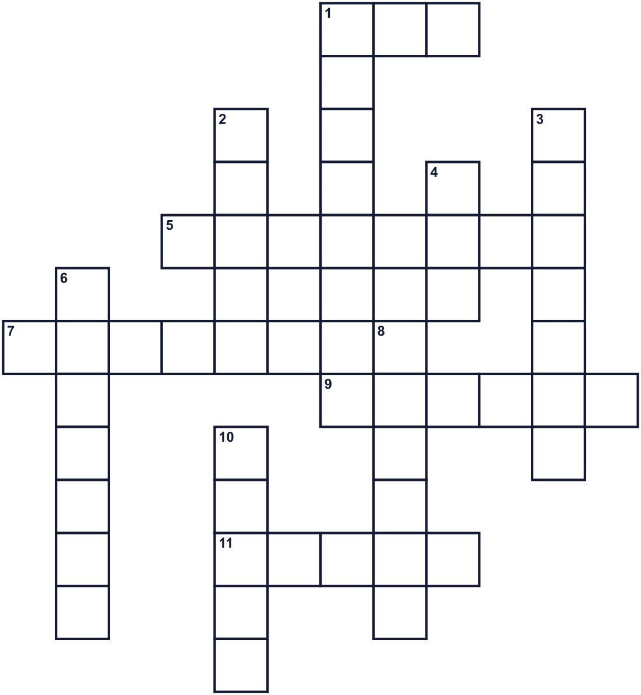
Across →
1. A small house where climbers sleep at night. (3)
5. A very high hill. Fuji is one. (8)
7. A big place with many trees. (6)
9. The eighth month of the year. (6)
11. A small path in the mountains. (5)
Down ↓
1. Walking for fun in nature. (6)
2. Strong shoes for walking on rocks. (5)
3. The time in the morning when the sun comes up. (7)
4. A paper that shows roads and places. (3)
6. A day when people do not go to work. (7)
8. The highest point of a mountain. (6)
10. You drink this when you are thirsty. (5)

⛰️ Mountain Day Worksheet
Word Search
かくれた単語をさがそう（→ ↓ ↘ ↗）
Class ______ No. ____ Name ______________________________
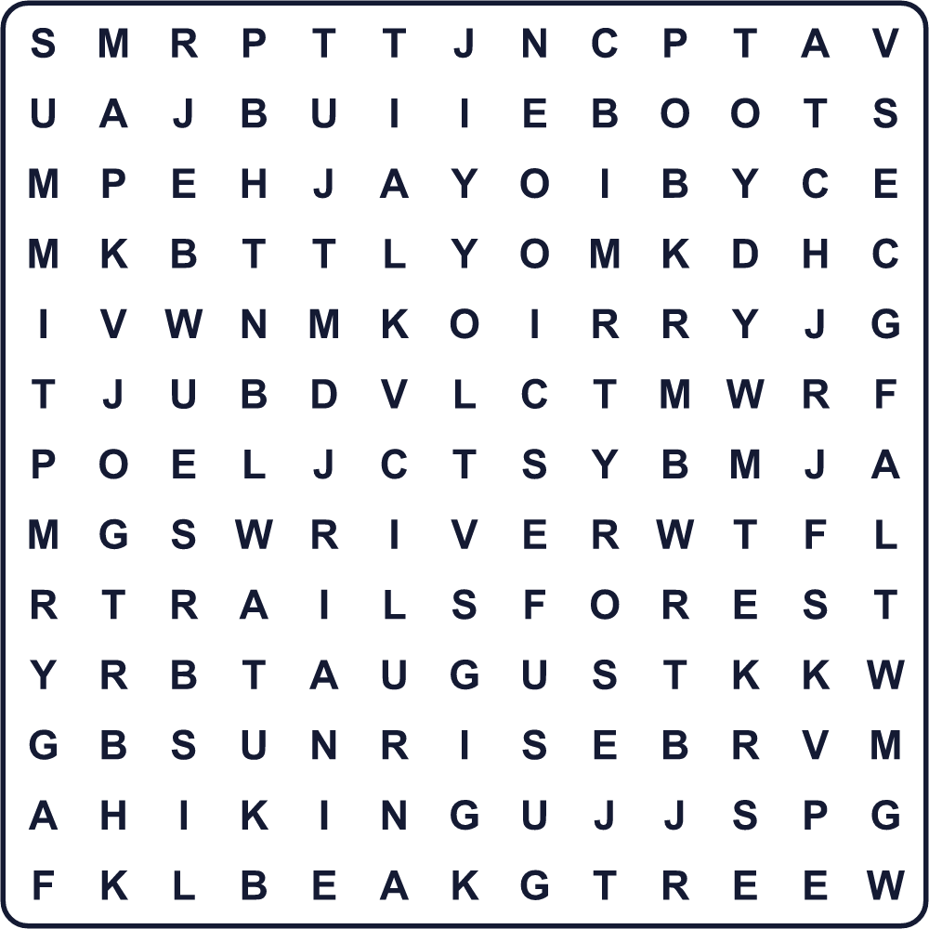
AUGUST BOOTS CLIMB FOREST HIKING HUT MAP MOUNTAIN RIVER SUMMIT SUNRISE TRAIL TREE
Secret Code 暗号を解こう
✂=A ☺=H ♠=I ⚓=K ☾=M ✚=N ✉=O ★=S ☀=T ♪=U ♣=Y
☀ ☺ ✂ ✚ ⚓ ♣ ✉ ♪ ☾ ✉ ♪ ✚ ☀ ✂ ♠ ✚ ★
______________________________________________________________

⛰️ Mountain Day Worksheet
Maze & Sentences
Class ______ No. ____ Name ______________________________
Help Ken reach the summit! ケンを山の頂上まで連れていこう！
正しい道の文字を集めると、ひみつの言葉になるよ。 START 🧒 → GOAL 🗻
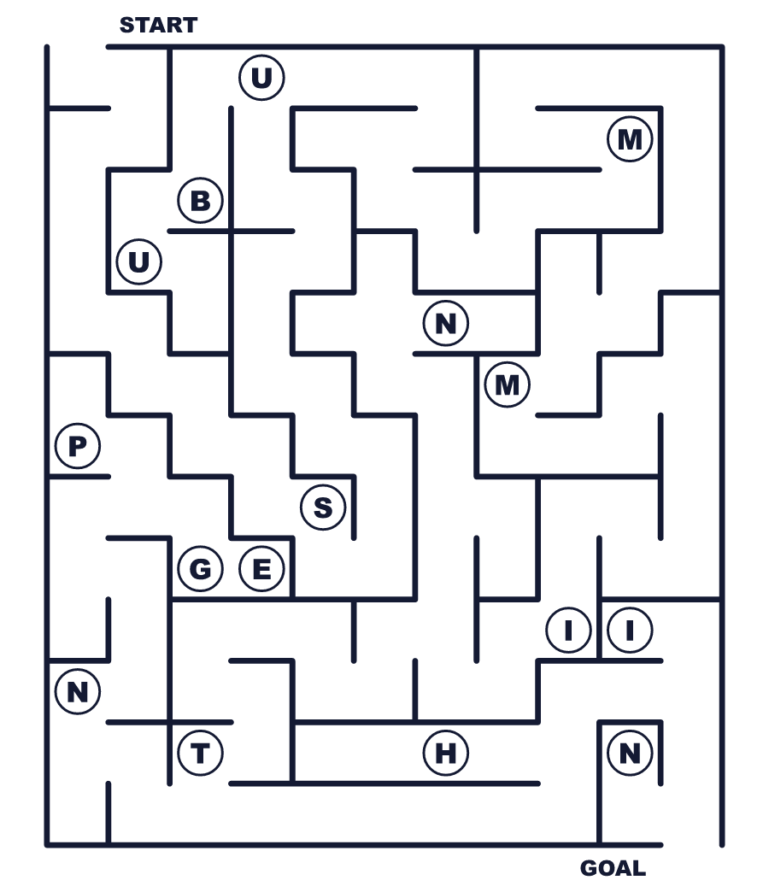
Secret word: ＿ ＿ ＿ ＿ ＿ ＿
Put the words in order. 並べかえよう。
1. 11 / Day / is / Mountain / on / August . (山の日は8月11日です。)
______________________________________________________________
2. the / in / holiday / It / Japan / is / newest . (それは日本でいちばん新しい祝日です。)
______________________________________________________________
3. clean / water / for / thank / We / mountains . (私たちはきれいな水を山に感謝します。)
______________________________________________________________
4. summer / people / Fuji / Many / Mount / in / climb . (夏には多くの人が富士山に登ります。)
______________________________________________________________
5. a / lost / you / Take / so / do / map / get / not . (道に迷わないように地図を持って行きなさい。)
______________________________________________________________

⛰️ Mountain Day Worksheet
Class Activity & Writing
Class ______ No. ____ Name ______________________________
Find Someone Who… クラスで聞いて回ろう！
Find someone who … | Name
… has climbed Mount Fuji 富士山に登ったことがある
… has seen a sunrise from a mountain 山の上から日の出を見たことがある
… likes mountains better than the sea 海より山が好き
… has stayed in a mountain hut 山小屋に泊まったことがある
… knows the date of Mountain Day 山の日の日付を知っている
… can name three mountains in Japan 日本の山を3つ言える
… has eaten a rice ball on a mountain 山の上でおにぎりを食べたことがある
… knows the English word for 頂上 「頂上」の英語を知っている
Let's Write! 英語で書いてみよう。
On Mountain Day, I want to go to ______ because ______.
山の日に、私は＿＿へ行きたいです。なぜなら＿＿だからです。
______________________________________________________________
______________________________________________________________
Mountains give us ______. I want to say thank you for ______.
山は私たちに＿＿をくれます。私は＿＿に感謝したいです。
______________________________________________________________
______________________________________________________________
If I made a new holiday in June, I would call it ______ Day because ______.
もし6月に新しい祝日を作るなら、＿＿の日と名づけます。なぜなら＿＿だからです。
______________________________________________________________
______________________________________________________________

⛰️ Mountain Day Worksheet
Trace & Color
なぞって書こう。絵に色をぬろう。
Class ______ No. ____ Name ______________________________
⛰️ 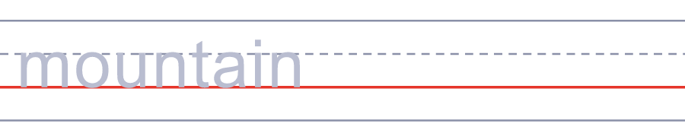

🌲 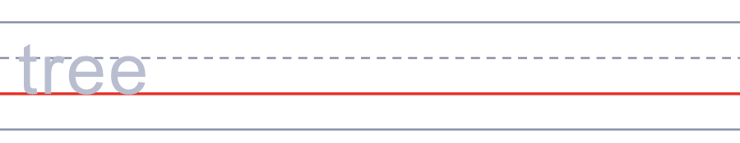
🥾 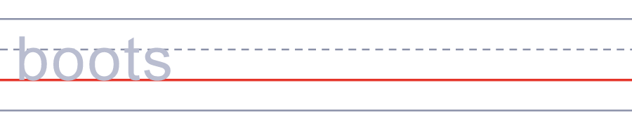
🎒 
🧭 
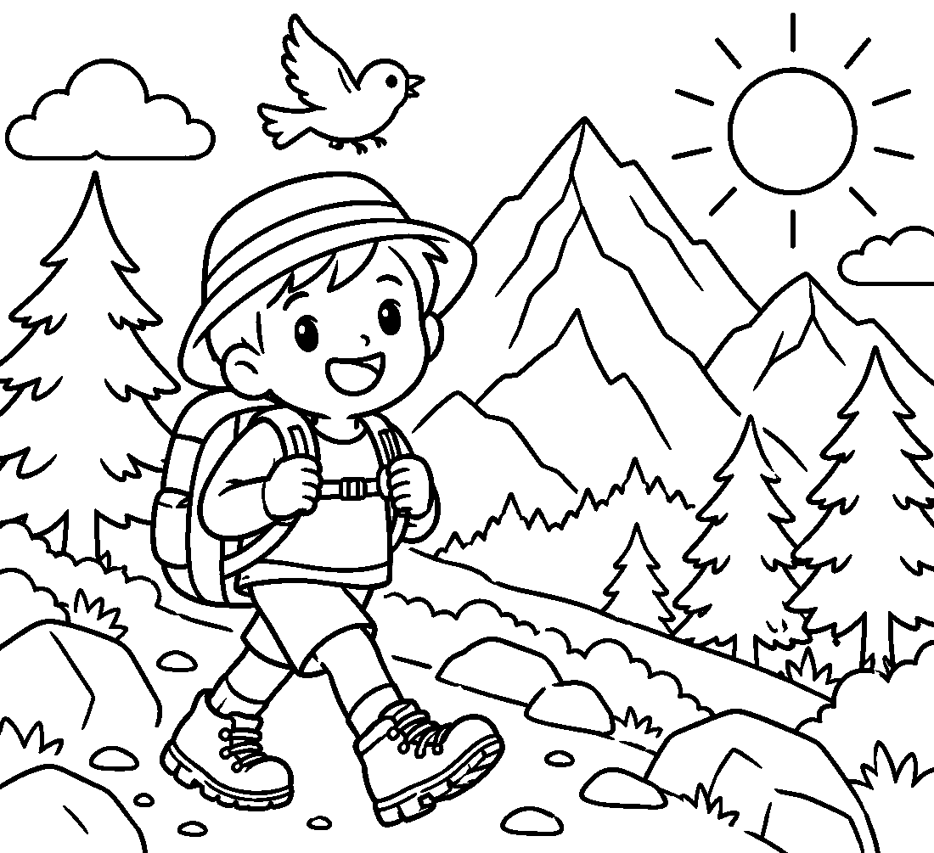

⛰️ Mountain Day Worksheet
Answer Key 解答
Reading Check: 1.B 2.D 3.A 4.B 5.C 6.D 7.A 8.C
True or False: 1.T 2.F 3.T 4.F 5.T 6.F
Match: ⛰️=mountain 🌲=tree 🥾=boots 🎒=backpack 🧭=compass 🌄=sunrise 🍙=rice ball ⛺=tent
Unscramble: 1.FOREST 2.SUMMIT 3.TRAIL 4.CLIMB 5.SUNRISE 6.HOLIDAY
Fill in the blanks: (1)morning (2)Mountain (3)holiday (4)walk (5)forest (6)map (7)lost (8)balls (9)water (10)slowly
Sentence order: 1. Mountain Day is on August 11. 2. It is the newest holiday in Japan. 3. We thank mountains for clean water. 4. Many people climb Mount Fuji in summer. 5. Take a map so you do not get lost.
Secret Code: THANK YOU MOUNTAINS
Maze: SUMMIT
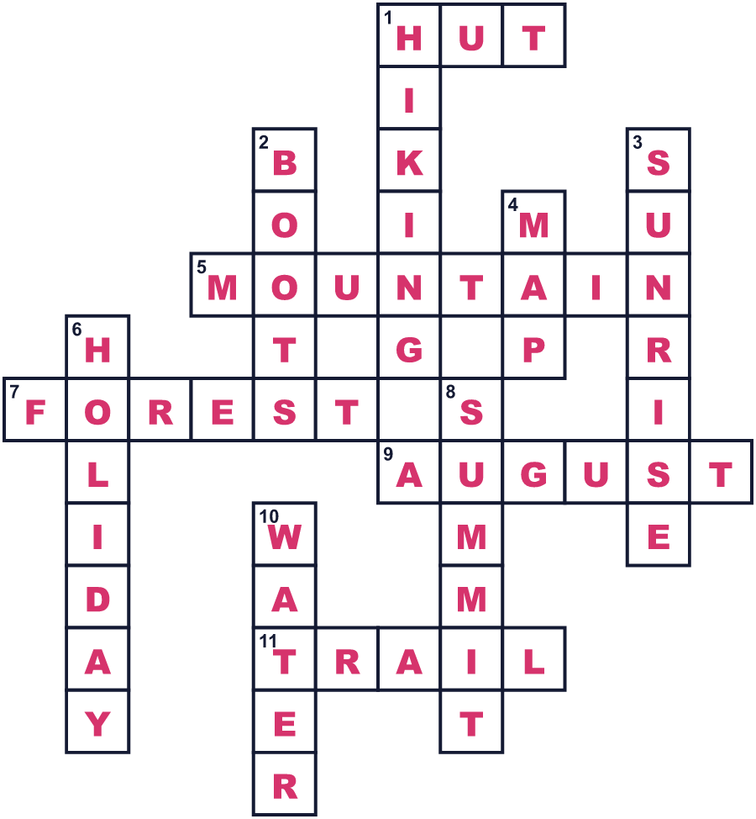
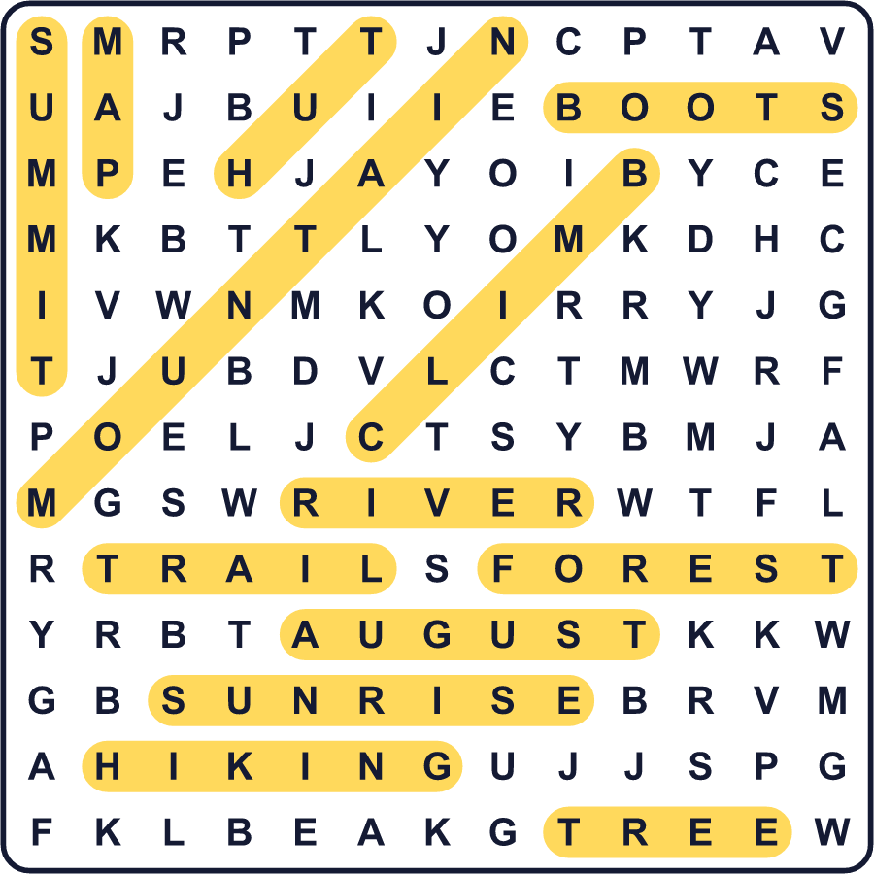
全訳
1 日本には、山のためだけの祝日があります。「山の日」、英語で Mountain Day と呼ばれ、毎年8月11日にやってきます。日本でいちばん新しい国民の祝日でもあります。最初の山の日は2016年でした。
2 なぜ山なのでしょう。日本の約3分の2は森におおわれていて、その多くは山に広がっています。山に降った雨や雪は、ゆっくりと川になります。山は人々にきれいな水や木、新鮮な空気をくれます。法律では、この日は山に親しみ、山の恵みに感謝するための日だとされています。
3 この日付には、悲しいいきさつがあります。最初、多くの国会議員は8月12日を望んでいました。しかし1985年8月12日、日本航空の飛行機が群馬県の山に墜落しました。その事故で520人が亡くなりました。そこで議員たちは、その前日の8月11日を選びました。
4 山の日は夏のまん中にあるので、山歩きにぴったりの時期です。富士山の登山道が開いているのは夏の間だけです。多くの登山者は夜に登り、頂上で日の出を待ちます。この日の出は「ご来光」と呼ばれます。でも山は危険なこともあり、毎年何千人もの登山者が助けを必要とします。その多くは道に迷った人です。
5 山の日は、多くの働く人にとって夏休みの始まりでもあります。家族がお盆でふるさとへ帰るので、電車や高速道路はとても混みます。2020年と2021年には、東京オリンピックのためにこの祝日が移動しました。今は8月11日に戻り、あなたと登山靴を待っています。

