💧 World Water Day Worksheet
Every Drop Has a Story
Read the story. 英文を読もう。
Class ______ No. ____ Name ______________________________

🔊 音声を聞こう（スマホで読みとってね）
1 Turn on the tap, and clean water comes out. For many of us, this is a normal part of the day. But in 2022, about 2.2 billion people did not have safe drinking water. More than 100 million people still drank water from lakes and rivers.
2 World Water Day is on March 22. The idea came from a big meeting in Rio de Janeiro, Brazil, in 1992. Leaders from many countries talked about the future of the Earth there. In December of that year, the United Nations chose March 22 as a special day for water. The first World Water Day was in 1993.
3 Every year, the day has a new theme. In 2024, the theme was water and peace. In 2025, it was glaciers, the big rivers of ice in the mountains. In 2026, the theme is equality between women and men. In many homes without water, women and girls carry it every day. In 53 countries, they spend 250 million hours a day on this work. That is time they cannot use for school or jobs.
4 Only about 2.5 percent of the water on Earth is fresh water. And most of it is frozen in ice, so every drop is important. On World Water Day, students clean rivers, make posters, and learn where their water comes from. You can start at home. Next time you turn on the tap, think about the long trip your water took to get to you.
Words 単語
tap（蛇口） / safe（安全な） / theme（テーマ、主題） / glacier（氷河） / equality（平等） / carry（運ぶ、持っていく） / fresh water（淡水、真水） / drop（しずく、一滴）

💧 World Water Day Worksheet
Reading Check
Choose the best answer. 正しいものを選ぼう。
Class ______ No. ____ Name ______________________________
1. What is the main idea of the reading?
(A) Safe water is not normal for everyone, so World Water Day asks us to think about it. (B) World Water Day is a day when everyone must stop using water at home. (C) World Water Day started in Japan and later spread to Brazil. (D) Most of the water on Earth is fresh water that people can drink.
2. Where did the idea for World Water Day come from?
(A) A school club in Kenya (B) A meeting in Tokyo in 2026 (C) A water company in New York (D) A big meeting in Rio de Janeiro
3. In the reading, what does "glaciers" mean?
(A) Big lakes in the desert (B) Big rivers of ice in the mountains (C) Small drops of rain (D) Long pipes for water
4. Which is true about the theme in 2026?
(A) It is about water and peace. (B) It is about rivers in Brazil. (C) It is about equality between women and men. (D) It is about saving water at school.
5. In the dialogue, why does Amara know about carrying water?
(A) Her grandmother carried water when she was young. (B) She saw it in a movie at school. (C) Kenta told her about it. (D) She carries water to school every day.
True or False? T か F に○
1. World Water Day is on March 22. T / F
2. The first World Water Day was in 2026. T / F
3. Most of the water on Earth is fresh water. T / F
4. In many homes, women and girls carry water every day. T / F

💧 World Water Day Worksheet
Word Work
単語のれんしゅう
Class ______ No. ____ Name ______________________________
① Match the pictures and the words. 絵と単語を線でむすぼう。
💧 | ● | ● | bucket
🚰 | ● | ● | drop
🪣 | ● | ● | ocean
🌧️ | ● | ● | mountain
🌊 | ● | ● | tap
🏔️ | ● | ● | rain
③ Fill in the blanks. 語群から選んで入れよう。
[ carry / candy / river / hour / study / night / school / snow / morning / well / clean ]
Asha is twelve. Every (1) __________ , she walks to the (2) __________ with her mother. They (3) __________ big yellow buckets. The walk takes one (4) __________ . Then Asha goes to (5) __________ , but she is often late. Last year, her village got a new (6) __________ . Now the water is (7) __________ and close to home. Asha has more time to (8) __________ .

💧 World Water Day Worksheet
Crossword Puzzle
ヒントを読んでクロスワードを完成させよう。
Class ______ No. ____ Name ______________________________
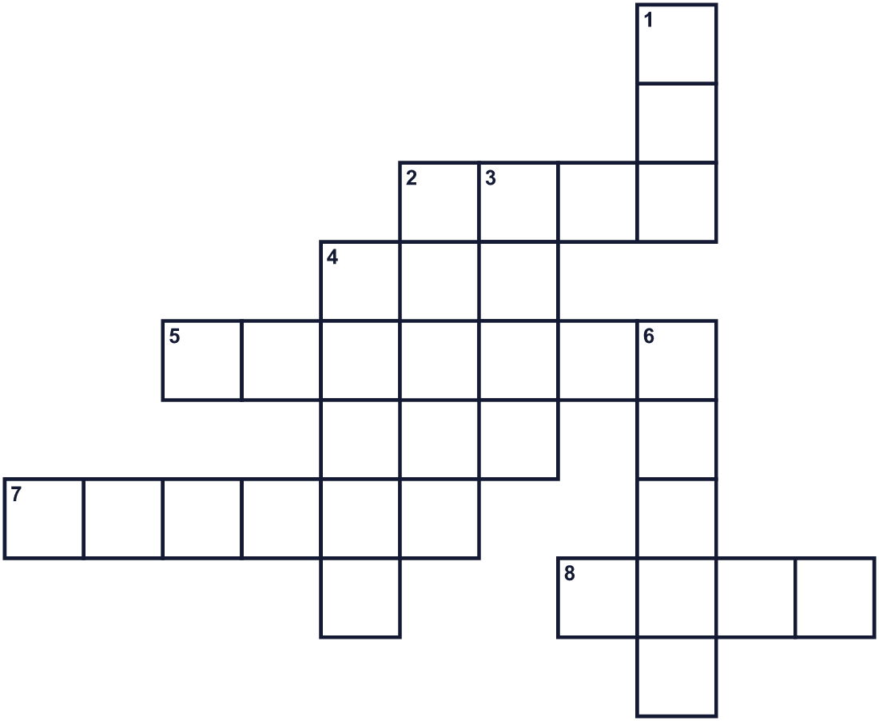
Across →
2. One very small bit of water, like a tear. (4)
5. A very big river of ice in the mountains. (7)
7. You carry water in this. It has a handle. (6)
8. A deep hole in the ground. People get water from it. (4)
Down ↓
1. Turn it on, and water comes out in the kitchen. (3)
3. Water that falls from clouds. (4)
4. We drink it. Fish live in it. (5)
6. A long line of water that goes to the sea. (5)

💧 World Water Day Worksheet
Word Search
かくれた単語をさがそう（→ ↓ ↘ ↗）
Class ______ No. ____ Name ______________________________
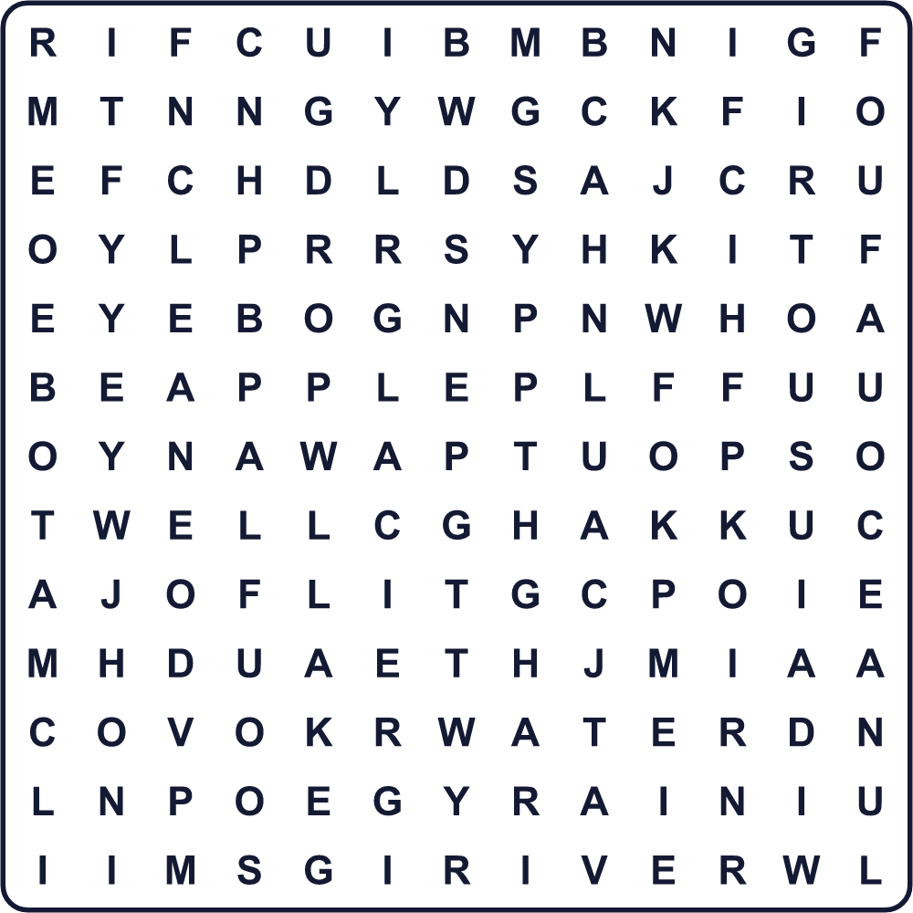
CLEAN DROP GLACIER LAKE OCEAN RAIN RIVER TAP WATER WELL

💧 World Water Day Worksheet
Maze & Sentences
Class ______ No. ____ Name ______________________________
Help Asha find clean water! アシャをきれいな水のところまで連れていこう！
正しい道の文字を集めると、ひみつの言葉になるよ。 START 👧 → GOAL 🚰
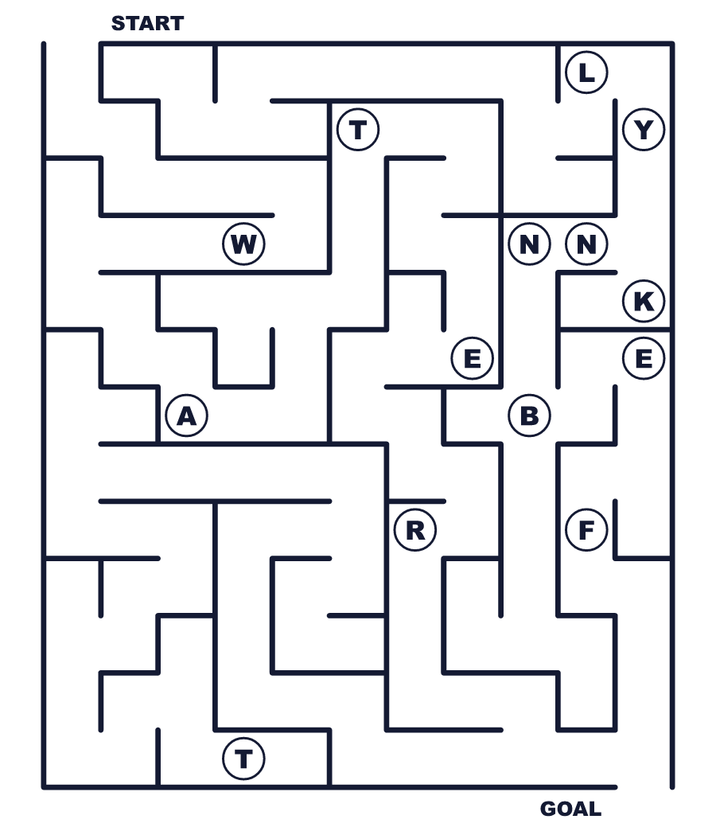
Secret word: ＿ ＿ ＿ ＿ ＿

💧 World Water Day Worksheet
Class Activity & Writing
Class ______ No. ____ Name ______________________________
Let's Write! 英語で書いてみよう。
I use water for ______. I can save water by ______.
私は______に水を使います。______することで水を節約できます。
______________________________________________________________
______________________________________________________________
If I had to carry water every day, I would feel ______ because ______.
もし毎日水を運ばなければならないとしたら、______と感じるだろう。なぜなら______だから。
______________________________________________________________
______________________________________________________________

💧 World Water Day Worksheet
Trace & Color
なぞって書こう。絵に色をぬろう。
Class ______ No. ____ Name ______________________________
💧 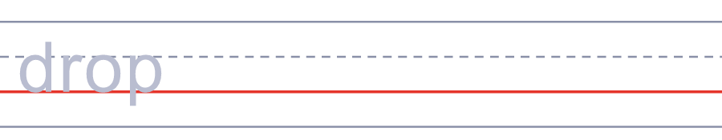

🚰 
🪣 
🌧️ 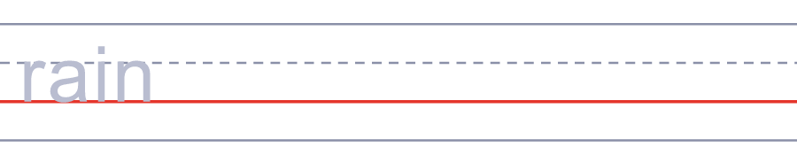
🌊 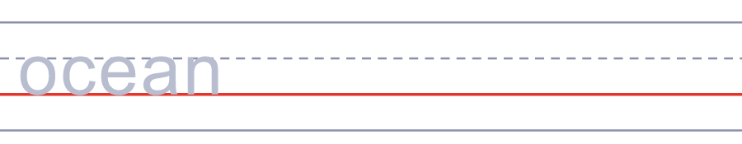

💧 World Water Day Worksheet
Answer Key 解答
Reading Check: 1.A 2.D 3.B 4.C 5.A
True or False: 1.T 2.F 3.F 4.T
Match: 💧=drop 🚰=tap 🪣=bucket 🌧️=rain 🌊=ocean 🏔️=mountain
Fill in the blanks: (1)morning (2)river (3)carry (4)hour (5)school (6)well (7)clean (8)study
Maze: WATER
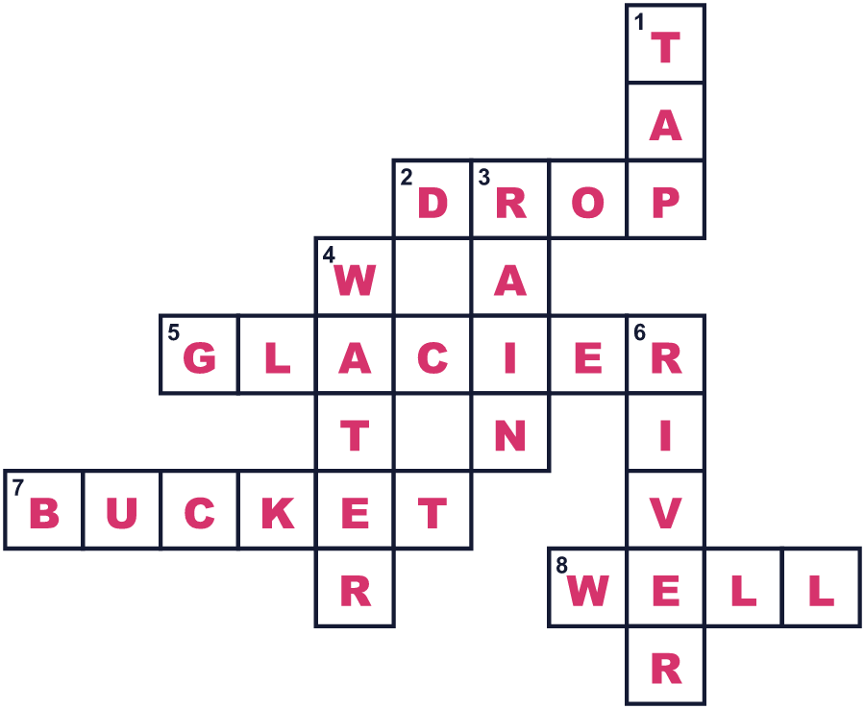
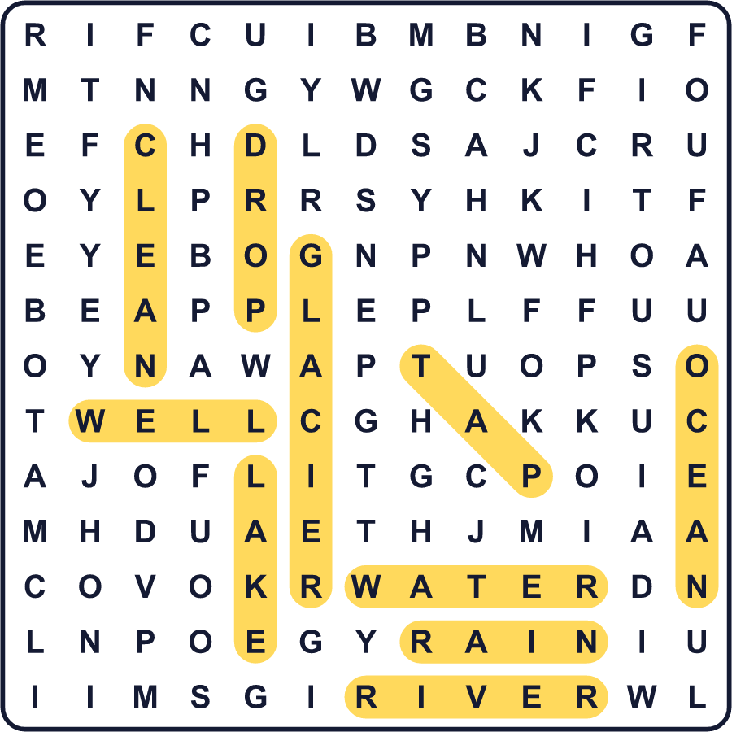
全訳
1 蛇口をひねれば、きれいな水が出てきます。多くの人にとって、それはふつうの毎日の一部です。でも2022年、約22億人が安全な飲み水を使えませんでした。1億人以上が、今も湖や川の水を飲んでいました。
2 世界水の日は3月22日です。このアイデアは、1992年にブラジルのリオデジャネイロで開かれた大きな会議から生まれました。そこでは多くの国のリーダーが、地球の未来について話し合いました。その年の12月、国連は3月22日を水のための特別な日に選びました。最初の世界水の日は1993年でした。
3 この日には、毎年新しいテーマがあります。2024年のテーマは、水と平和でした。2025年は、山にある大きな氷の川、氷河でした。2026年のテーマは、男女の平等です。水のない多くの家では、女性と女の子が毎日水を運びます。53か国で、彼女たちはこの仕事に1日2億5,000万時間を使っています。それは、学校や仕事に使えない時間です。
4 地球の水のうち、淡水は約2.5%しかありません。しかもその多くは凍っています。だから一滴一滴が大切なのです。世界水の日には、生徒たちが川を掃除し、ポスターを作り、自分たちの水がどこから来るのかを学びます。家から始めることもできます。次に蛇口をひねるとき、その水があなたのもとに届くまでの長い旅を思い浮かべてみてください。

