🍎 World Teachers' Day Worksheet
A Promise Made in Paris
Read the story. 英文を読もう。
Class ______ No. ____ Name ______________________________

🔊 音声を聞こう（スマホで読みとってね）
1 Think of your favorite teacher. What made that teacher special? On October 5, people in more than 100 countries say thank you to teachers like that. This is World Teachers' Day.
2 The date comes from a meeting in Paris on October 5, 1966. Leaders from many countries agreed on a long list of ideas for teachers. It had 146 parts. It talked about pay, training, and the number of students in a class. It also said that teaching is a profession, a job that needs special skills. In 1994, UNESCO chose October 5 as World Teachers' Day.
3 But there is a big problem. The world does not have enough teachers. UNESCO says we need 44 million more teachers by 2030. Africa south of the Sahara needs 15 million of them. Also, more and more teachers are leaving their jobs. So this day is a party, and it is also a call for help.
4 Many countries also have their own teachers' day. In South Korea, it is May 15, the birthday of King Sejong, who created the Korean alphabet. Students often give their teachers carnations. In Thailand, students bring flowers and grass to their teachers. Each plant has a meaning, like a sharp mind or never giving up. Japan does not have its own teachers' day. But at graduation, Japanese students often sing a thank-you song to their teachers, and that song first came from America.
Words 単語
favorite（いちばん好きな） / agree（同意する、合意する） / training（研修、訓練） / profession（専門職） / enough（十分な） / leave（（仕事などを）やめる、去る） / alphabet（文字（の体系）、アルファベット） / graduation（卒業、卒業式）

🍎 World Teachers' Day Worksheet
Reading Check
Choose the best answer. 正しいものを選ぼう。
Class ______ No. ____ Name ______________________________
1. What is the reading mainly about?
(A) How to become a teacher in Paris (B) The history of the Korean alphabet (C) World Teachers' Day, the need for teachers, and teachers' days around the world (D) Why students sing at graduation
2. How many parts did the 1966 list have?
(A) 100 (B) 146 (C) 1994 (D) 44
3. Why does the writer call this day "a call for help"?
(A) Because many teachers are sick (B) Because Paris needs more schools (C) Because Korea has no teachers' day (D) Because the world does not have enough teachers
4. In paragraph 2, a "profession" is:
(A) a job that needs special skills (B) a kind of school holiday (C) a long meeting (D) a gift for a teacher
5. In the dialogue, what does Haruki write on the card?
(A) Happy birthday! (B) You made me love English. (C) Please give us less homework. (D) See you in Korea.
True or False? T か F に○
1. World Teachers' Day is on October 5. T / F
2. The 1966 meeting was in Tokyo. T / F
3. In South Korea, students give teachers carnations. T / F
4. The world has more teachers than it needs. T / F

🍎 World Teachers' Day Worksheet
Word Work
単語のれんしゅう
Class ______ No. ____ Name ______________________________
① Match the pictures and the words. 絵と単語を線でむすぼう。
🍎 | ● | ● | card
📚 | ● | ● | flowers
✏️ | ● | ● | school
🏫 | ● | ● | books
💐 | ● | ● | apple
✉️ | ● | ● | pencil
③ Fill in the blanks. 語群から選んで入れよう。
[ apple / cries / Teachers' / lessons / flowers / classmates / gift / message / smiles / umbrella ]
Today is October 5, World (1) __________ Day. Kai and his (2) __________ make a big card for Ms. Sato. Everyone writes a short (3) __________ . Kai writes, "Thank you for your fun (4) __________ ." Mina draws an (5) __________ and some (6) __________ . When Ms. Sato opens the card, she (7) __________ . "This is the best (8) __________ ever," she says.

🍎 World Teachers' Day Worksheet
Crossword Puzzle
ヒントを読んでクロスワードを完成させよう。
Class ______ No. ____ Name ______________________________
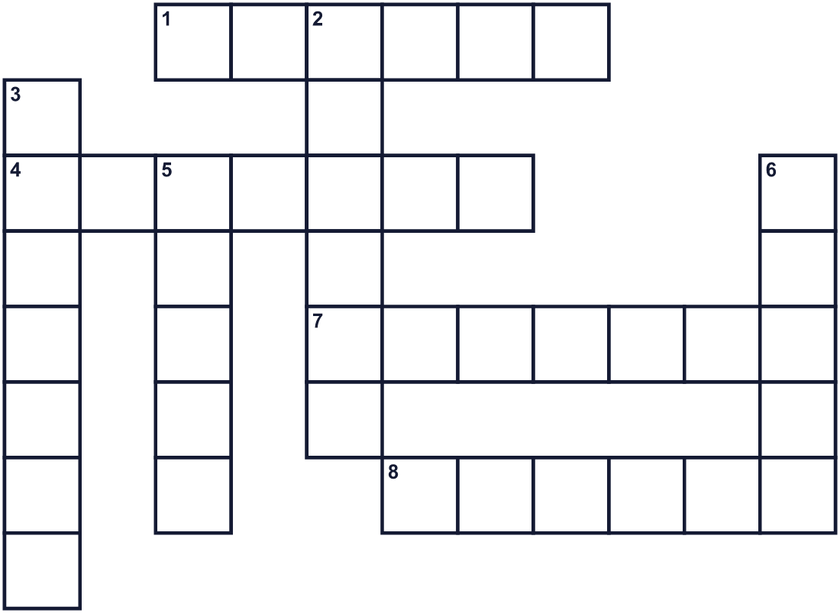
Across →
1. A time when a class learns one thing. (6)
4. A person who helps students learn at school. (7)
7. The tenth month of the year. (7)
8. A word you say when someone helps you. (6)
Down ↓
2. A place where children go to learn. (6)
3. A person who learns at school. (7)
5. A red fruit. Some children give one to their teacher. (5)
6. The capital city of France. (5)

🍎 World Teachers' Day Worksheet
Word Search
かくれた単語をさがそう（→ ↓ ↘ ↗）
Class ______ No. ____ Name ______________________________
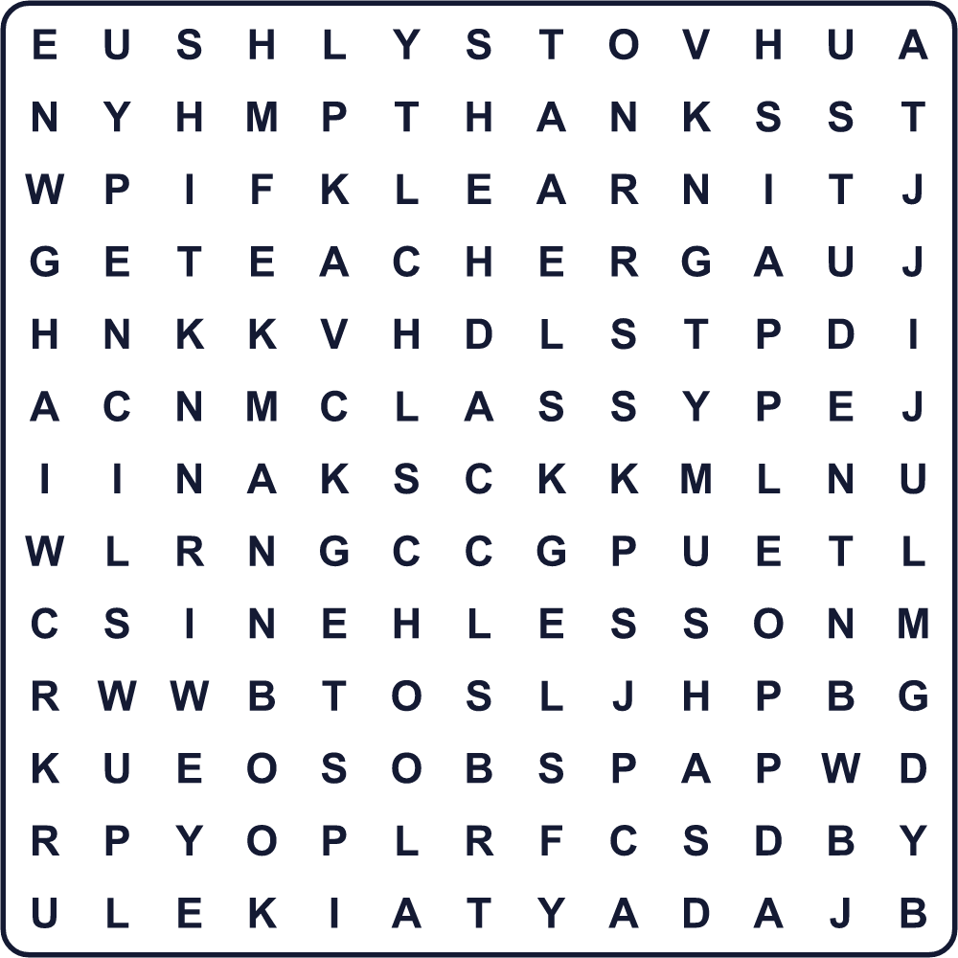
APPLE BOOK CLASS LEARN LESSON PENCIL SCHOOL STUDENT TEACHER THANKS

🍎 World Teachers' Day Worksheet
Maze & Sentences
Class ______ No. ____ Name ______________________________
Help the student bring the card to the teacher! 生徒がカードを先生に届けられるようにしよう！
正しい道の文字を集めると、ひみつの言葉になるよ。 START 🧒 → GOAL 🏫
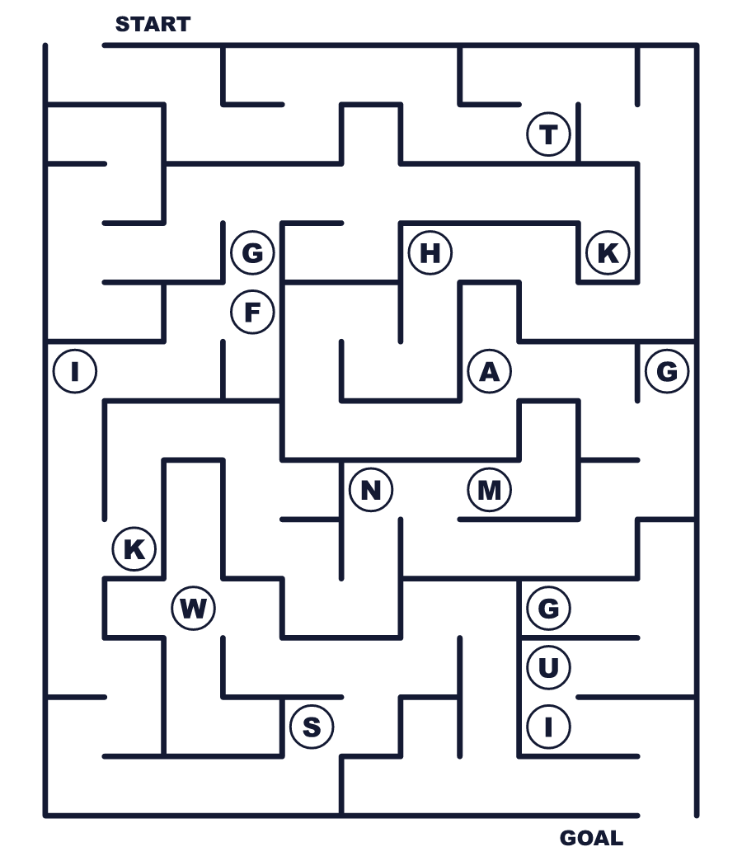
Secret word: ＿ ＿ ＿ ＿ ＿ ＿

🍎 World Teachers' Day Worksheet
Class Activity & Writing
Class ______ No. ____ Name ______________________________
Let's Write! 英語で書いてみよう。
My favorite teacher is ______ because ______.
私のいちばん好きな先生は______です。なぜなら______だからです。
______________________________________________________________
______________________________________________________________
If I were a teacher, I would teach ______ because ______.
もし私が先生なら、______を教えます。なぜなら______だからです。
______________________________________________________________
______________________________________________________________

🍎 World Teachers' Day Worksheet
Trace & Color
なぞって書こう。絵に色をぬろう。
Class ______ No. ____ Name ______________________________
🍎 

📚 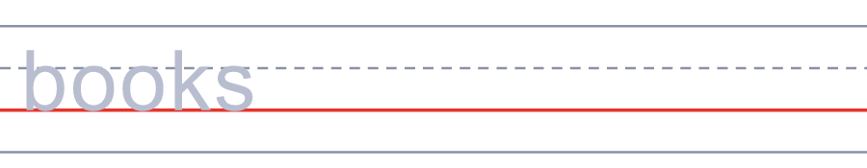
✏️ 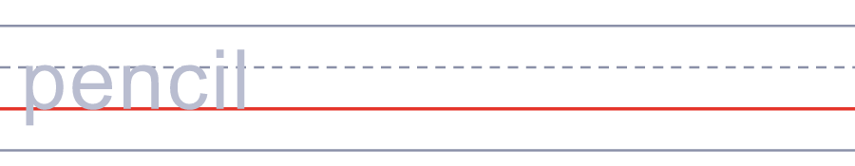
🏫 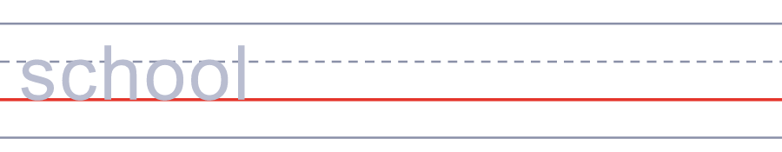
💐 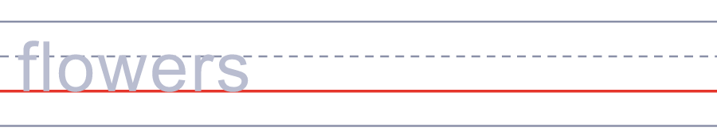

🍎 World Teachers' Day Worksheet
Answer Key 解答
Reading Check: 1.C 2.B 3.D 4.A 5.B
True or False: 1.T 2.F 3.T 4.F
Match: 🍎=apple 📚=books ✏️=pencil 🏫=school 💐=flowers ✉️=card
Fill in the blanks: (1)Teachers' (2)classmates (3)message (4)lessons (5)apple (6)flowers (7)smiles (8)gift
Maze: THANKS
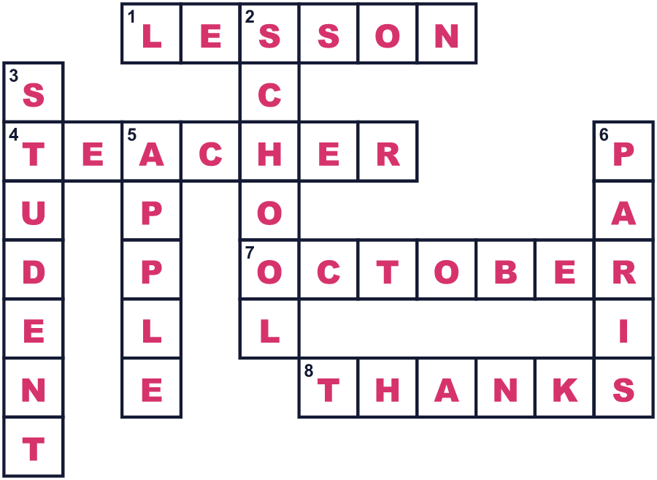
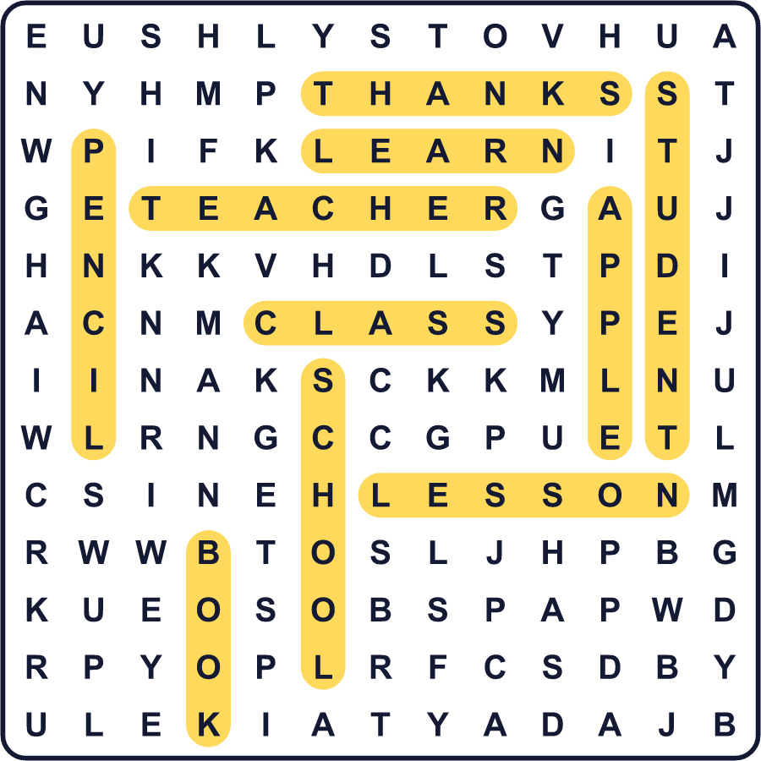
全訳
1 あなたの好きな先生を思い浮かべてください。その先生のどこが特別でしたか。10月5日には、100を超える国の人々が、そんな先生たちに「ありがとう」を伝えます。これが世界教師デーです。
2 この日付は、1966年10月5日にパリで開かれた会議から来ています。多くの国の代表が、先生についての長い項目のリストに合意しました。それは146項目ありました。給料や研修、1クラスの生徒の数について書かれていました。また、教えることは専門職、つまり特別な技術がいる仕事だとも述べていました。1994年、ユネスコは10月5日を世界教師デーに選びました。
3 でも、大きな問題があります。世界には先生が足りないのです。ユネスコによると、2030年までにあと4400万人の先生が必要です。サハラ砂漠より南のアフリカだけで、そのうち1500万人が必要です。さらに、仕事をやめる先生がどんどん増えています。だからこの日は、お祝いであると同時に、助けを求める声でもあるのです。
4 自分たちの先生の日をもつ国もたくさんあります。韓国では5月15日で、韓国の文字を作った世宗大王の誕生日です。生徒はよく先生にカーネーションを贈ります。タイでは、生徒が先生に花や草を届けます。それぞれの植物には、頭の鋭さやあきらめない心といった意味があります。日本には自分の国の先生の日はありません。でも卒業式で、日本の生徒はよく先生への感謝の歌を歌います。そしてその歌は、もとはアメリカから来たものなのです。

