🐧 World Penguin Day Worksheet
The Penguins Who Come Back Every Year
Read the story. 英文を読もう。
Class ______ No. ____ Name ______________________________

🔊 音声を聞こう（スマホで読みとってね）
1 Every year in late April, something special happens in Antarctica. Near McMurdo Station, a research base, groups of Adélie penguins appear. They are walking to the sea after raising their chicks. Some of them walk and swim more than 13,000 kilometers in a year. People say the scientists there started to celebrate this day. That is how World Penguin Day began.
2 There are about 18 kinds of penguins. The biggest is the emperor penguin. It is about 1.1 meters tall and can dive about 550 meters into the sea. The smallest is the little penguin. It weighs only about 1.2 kilograms, less than a big bottle of water.
3 Many people think all penguins live on the ice. But that is not true. Some live on warm beaches in Africa, Australia, and South America. The Galápagos penguin lives near the equator, where it is hot. And no penguins live at the North Pole. Their black backs and white fronts help them hide in the water.
4 Today, many penguins are in danger. Eleven of the 18 kinds may disappear in the future. Some cannot find enough fish to eat. On World Penguin Day, zoos and aquariums teach visitors about these problems. Japan has many penguins, too. People say one in four penguins in zoos and aquariums lives in Japan. So next time you see a penguin, remember its long trip and its hard life.
Words 単語
appear（現れる） / chick（ひな） / scientist（科学者） / dive（もぐる、飛びこむ） / weigh（重さが～ある） / equator（赤道） / in danger（危険にさらされて） / aquarium（水族館）

🐧 World Penguin Day Worksheet
Reading Check
Choose the best answer. 正しいものを選ぼう。
Class ______ No. ____ Name ______________________________
1. What is the main idea of the reading?
(A) Penguins are all the same size and live on the ice. (B) World Penguin Day began in Japan at an aquarium. (C) Penguins are very different from each other, and many need our help. (D) Penguins live at the North Pole and the South Pole.
2. Why do Adélie penguins appear near McMurdo Station?
(A) They are walking to the sea after raising their chicks. (B) The scientists give them food every April. (C) They want to see the people at the base. (D) They are looking for a warm place to sleep.
3. How much does the little penguin weigh?
(A) About 35 kilograms (B) About 18 kilograms (C) About 11 kilograms (D) About 1.2 kilograms
4. In paragraph 3, what is "the equator"?
(A) A very cold island near Antarctica (B) A hot line around the middle of the Earth (C) A kind of fish that penguins eat (D) A big aquarium in South America
5. In the dialogue, what does Leo learn?
(A) Penguins cannot swim fast. (B) Not all penguins live in Antarctica. (C) Feeding time is at four. (D) Humboldt penguins come from Japan.
True or False? T か F に○
1. World Penguin Day is on April 25. T / F
2. Some penguins live at the North Pole. T / F
3. The emperor penguin is the biggest penguin. T / F
4. All penguins live in cold places. T / F

🐧 World Penguin Day Worksheet
Word Work
単語のれんしゅう
Class ______ No. ____ Name ______________________________
① Match the pictures and the words. 絵と単語を線でむすぼう。
🐧 | ● | ● | penguin
🐟 | ● | ● | egg
🥚 | ● | ● | chick
🧊 | ● | ● | fish
🌊 | ● | ● | ice
🐣 | ● | ● | wave
③ Fill in the blanks. 語群から選んで入れよう。
[ fish / snow / beach / bread / down / day / tree / chicks / nest / sleeps ]
In New Zealand, a little penguin swims all (1) __________ in the sea. It catches small (2) __________ . When the sun goes (3) __________ , it comes back to the (4) __________ . It walks up the sand to its (5) __________ . Its two hungry (6) __________ are waiting. The penguin gives them food. Then the family (7) __________ together under the stars.

🐧 World Penguin Day Worksheet
Crossword Puzzle
ヒントを読んでクロスワードを完成させよう。
Class ______ No. ____ Name ______________________________
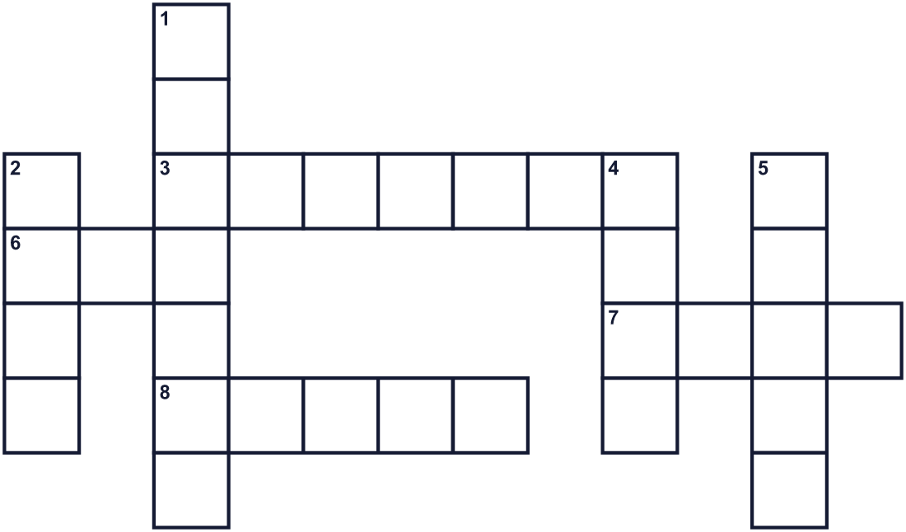
Across →
3. A black and white bird. It swims but cannot fly. (7)
6. Frozen water. (3)
7. To move in water with your arms and legs. (4)
8. A very big sea. (5)
Down ↓
1. The name of the biggest penguin. It also means a king of an empire. (7)
2. Animals that live in water. Penguins eat them. (4)
4. A home that a bird makes for its eggs. (4)
5. A baby bird. (5)

🐧 World Penguin Day Worksheet
Word Search
かくれた単語をさがそう（→ ↓ ↘ ↗）
Class ______ No. ____ Name ______________________________
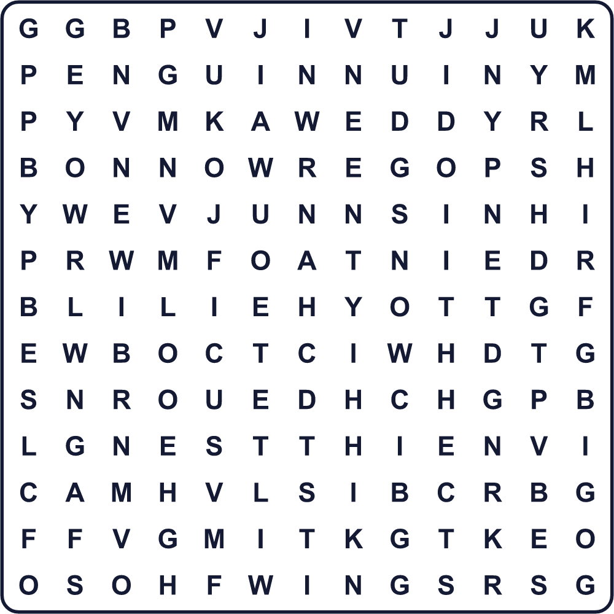
CHICK EGG FISH ICE NEST OCEAN PENGUIN SNOW SWIM WINGS

🐧 World Penguin Day Worksheet
Maze & Sentences
Class ______ No. ____ Name ______________________________
Help the penguin get to the sea! ペンギンを海まで連れていこう！
正しい道の文字を集めると、ひみつの言葉になるよ。 START 🐧 → GOAL 🌊
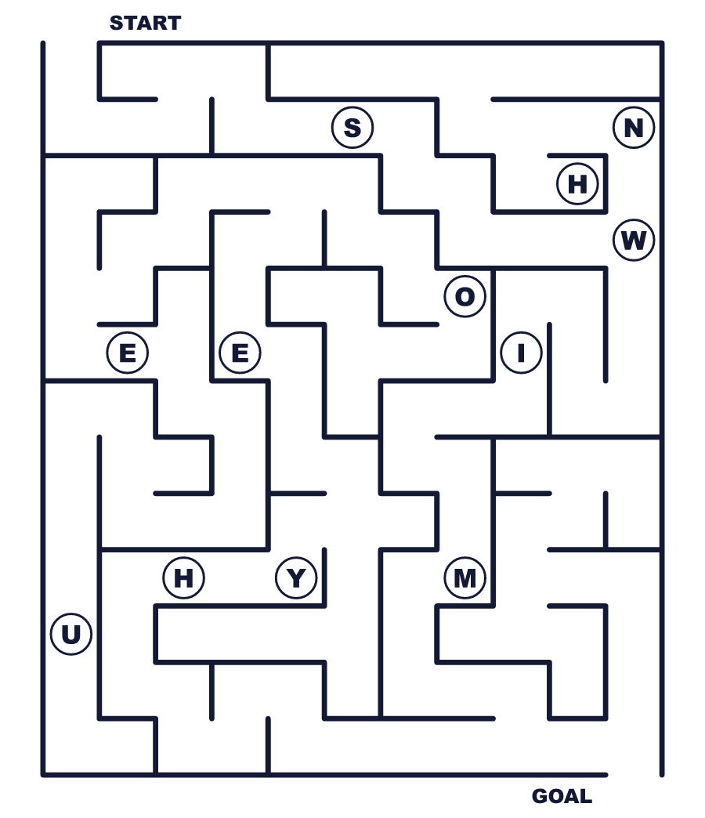
Secret word: ＿ ＿ ＿ ＿

🐧 World Penguin Day Worksheet
Class Activity & Writing
Class ______ No. ____ Name ______________________________
Let's Write! 英語で書いてみよう。
If I were a penguin, I would live in ______ because ______.
もし私がペンギンなら、______に住みたい。なぜなら______だから。
______________________________________________________________
______________________________________________________________
One thing I can do to help penguins is ______.
ペンギンを助けるために私にできることの1つは______です。
______________________________________________________________
______________________________________________________________

🐧 World Penguin Day Worksheet
Trace & Color
なぞって書こう。絵に色をぬろう。
Class ______ No. ____ Name ______________________________
🐧 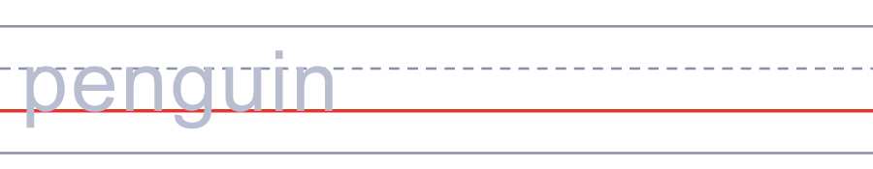

🐟 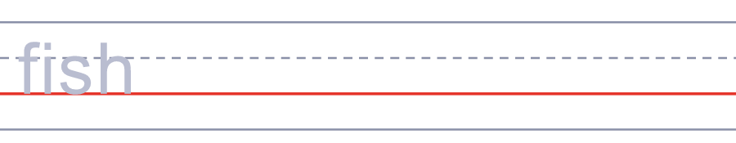
🥚 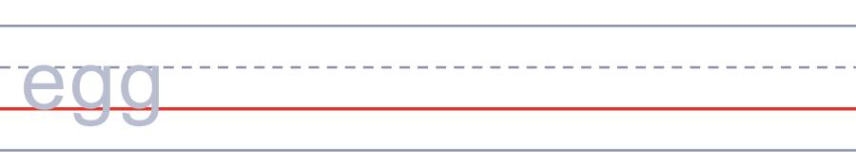
🧊 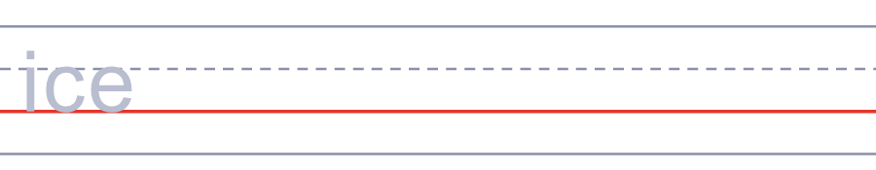
🌊 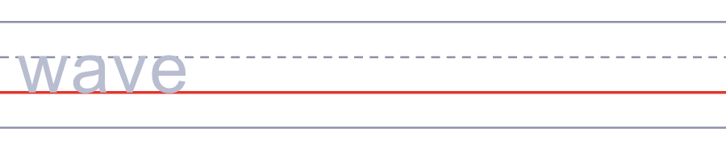

🐧 World Penguin Day Worksheet
Answer Key 解答
Reading Check: 1.C 2.A 3.D 4.B 5.B
True or False: 1.T 2.F 3.T 4.F
Match: 🐧=penguin 🐟=fish 🥚=egg 🧊=ice 🌊=wave 🐣=chick
Fill in the blanks: (1)day (2)fish (3)down (4)beach (5)nest (6)chicks (7)sleeps
Maze: SWIM
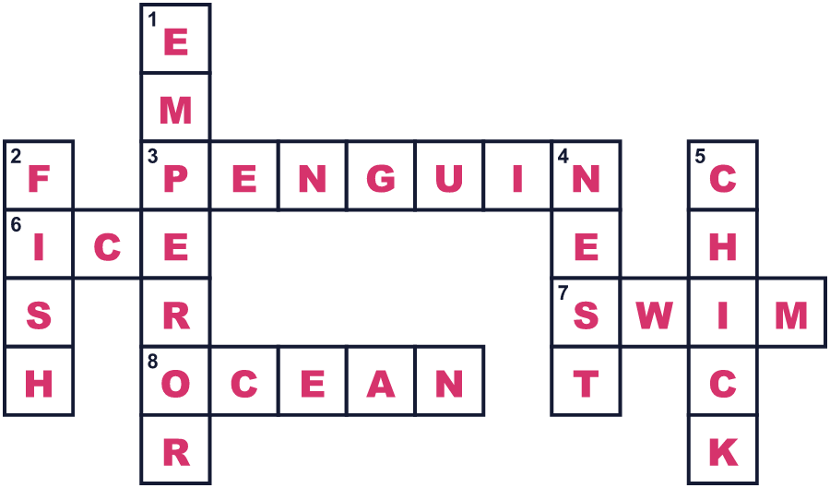
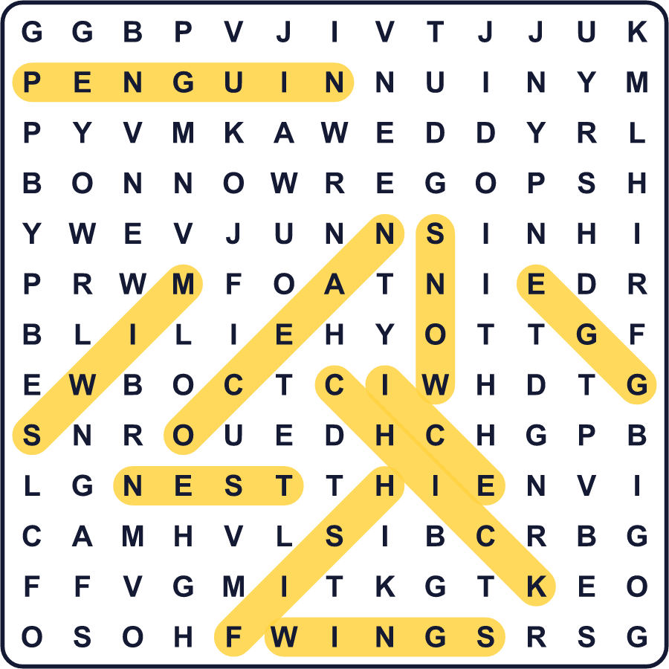
全訳
1 毎年4月の終わり、南極で特別なことが起こります。研究基地のマクマード基地の近くに、アデリーペンギンの群れが現れるのです。ひなを育て終えて、海へ向かって歩いているところです。その中には、1年で1万3,000km以上も歩いたり泳いだりするものもいます。そこの科学者たちがこの日を祝い始めたと言われています。こうして世界ペンギンの日が始まりました。
2 ペンギンは約18種類います。いちばん大きいのはコウテイペンギンです。身長は約1.1mで、海の中へ約550mももぐれます。いちばん小さいのはコガタペンギンです。体重はわずか約1.2kgで、大きなペットボトル1本より軽いのです。
3 多くの人は、ペンギンはみんな氷の上に住んでいると思っています。でも、それはちがいます。アフリカやオーストラリア、南アメリカの暖かい海岸に住む種もいます。ガラパゴスペンギンは、暑い赤道の近くに住んでいます。そして、北極にはペンギンは1羽もいません。黒い背中と白いおなかは、水の中で身をかくすのに役立ちます。
4 今、多くのペンギンが危機にあります。18種のうち11種が、将来いなくなるおそれがあります。食べる魚を十分に見つけられない種もいます。世界ペンギンの日には、動物園や水族館が来た人にこうした問題を伝えます。日本にもたくさんのペンギンがいます。動物園や水族館にいるペンギンの4羽に1羽は、日本にいると言われています。だから次にペンギンを見たら、その長い旅ときびしい暮らしを思い出してください。

