🌊 World Oceans Day Worksheet
Half of Every Breath
Read the story. 英文を読もう。
Class ______ No. ____ Name ______________________________

🔊 音声を聞こう（スマホで読みとってね）
1 Take a deep breath. At least half of the oxygen in that breath came from the ocean. Very small plants and other tiny living things in the sea make it. We cannot see them, but we need them every day.
2 The ocean covers more than 70 percent of our planet. It holds about 97 percent of all the water on Earth. It also gives food to more than one billion people. But the ocean is in trouble. There are fewer big fish, and many coral reefs are dying. Plastic trash floats on the water and hurts sea animals.
3 In 1992, world leaders met in Rio de Janeiro, Brazil. There, Canada asked for a special day for the ocean. Many groups started to celebrate on June 8. In 2008, the United Nations made it official, and the first UN World Oceans Day was in 2009. The first theme was Our Oceans, Our Responsibility.
4 Today, people around the world clean beaches on this day. Aquariums hold events for families. Students learn that the deepest part of the sea is almost 11,000 meters deep. Japan has its own Marine Day in July, and it is a national holiday. Japan may be the only country with a holiday like this. So on June 8 and in July, think about the sea. It gives us every second breath.
Words 単語
ocean（海、海洋） / oxygen（酸素） / breath（呼吸、ひと息） / tiny（とても小さい） / planet（惑星） / coral reef（サンゴ礁） / trash（ごみ） / official（公式の）

🌊 World Oceans Day Worksheet
Reading Check
Choose the best answer. 正しいものを選ぼう。
Class ______ No. ____ Name ______________________________
1. What is the main idea of the reading?
(A) The ocean is important to us, so the world has a day to think about it. (B) The ocean is too big and too deep for people to study. (C) Japan started World Oceans Day in July. (D) Plastic is good for sea animals.
2. How much of the oxygen in our breath comes from the ocean?
(A) About 10 percent (B) At least half (C) More than 70 percent (D) One billion percent
3. Which country asked for a special day for the ocean in 1992?
(A) Brazil (B) Japan (C) Canada (D) The United States
4. Which is true about Marine Day in Japan?
(A) It is on June 8. (B) It is a UN day. (C) It started in 2009. (D) It is a national holiday in July.
5. In the dialogue, why does Sota decide to pick up ten bottles?
(A) Because he wants to swim (B) Because he learns the ocean makes half of our oxygen (C) Because Marine Day is in July (D) Because he wants to win a prize
True or False? T か F に○
1. World Oceans Day is on June 8. T / F
2. The ocean covers less than half of the Earth. T / F
3. Canada first had the idea for World Oceans Day. T / F
4. Japan's Marine Day is on June 8. T / F

🌊 World Oceans Day Worksheet
Word Work
単語のれんしゅう
Class ______ No. ____ Name ______________________________
① Match the pictures and the words. 絵と単語を線でむすぼう。
🐋 | ● | ● | octopus
🐢 | ● | ● | crab
🐙 | ● | ● | turtle
🦀 | ● | ● | fish
🐚 | ● | ● | whale
🐠 | ● | ● | shell
③ Fill in the blanks. 語群から選んで入れよう。
[ snow / forest / beach / bags / water / crab / plastic / trash / clean ]
On June 8, Nana and her class go to the (1) __________ . The (2) __________ is blue and calm. But there is (3) __________ on the sand. The students pick up (4) __________ bottles and bags. Then they see a small (5) __________ . "Let's keep its home (6) __________ ," says Nana. At the end, they have ten big (7) __________ of trash.

🌊 World Oceans Day Worksheet
Crossword Puzzle
ヒントを読んでクロスワードを完成させよう。
Class ______ No. ____ Name ______________________________
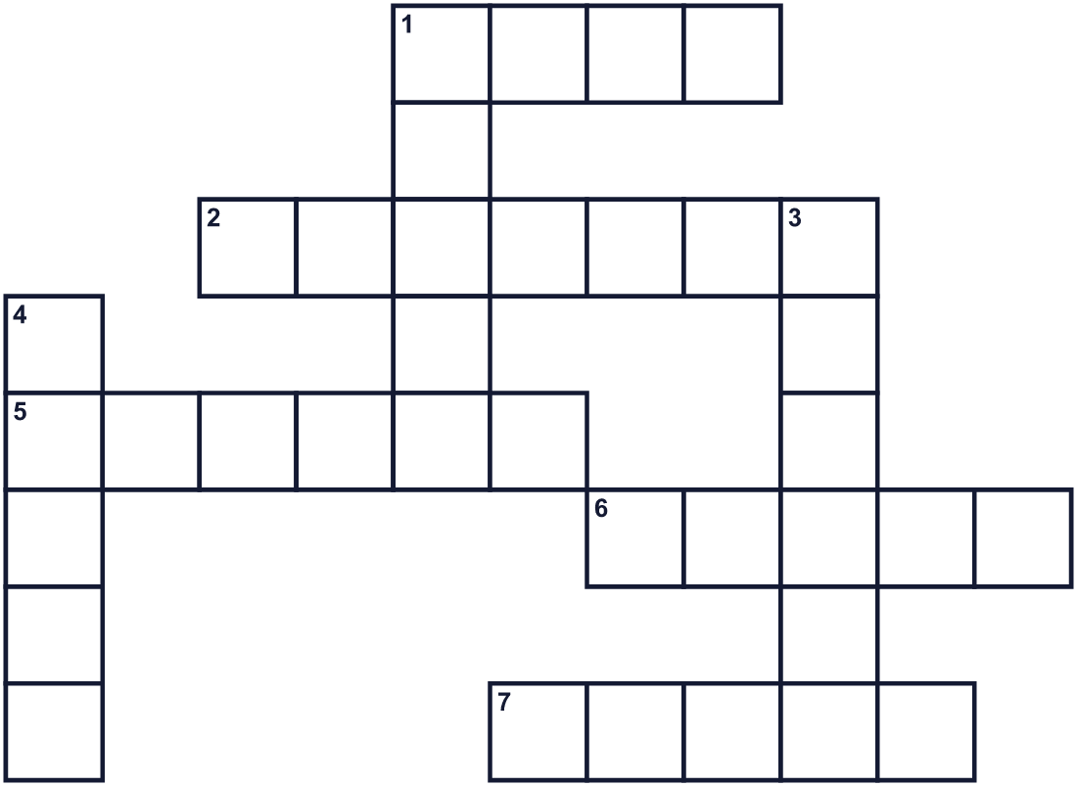
Across →
1. Water that moves up and down near the shore. (4)
2. Bottles and bags are often made of this. (7)
5. We need it to breathe. (6)
6. A sandy place by the sea. (5)
7. A very big area of salt water. (5)
Down ↓
1. The biggest animal in the sea. (5)
3. The country that first asked for this day. (6)
4. Many fish live near this colorful sea animal. (5)

🌊 World Oceans Day Worksheet
Word Search
かくれた単語をさがそう（→ ↓ ↘ ↗）
Class ______ No. ____ Name ______________________________
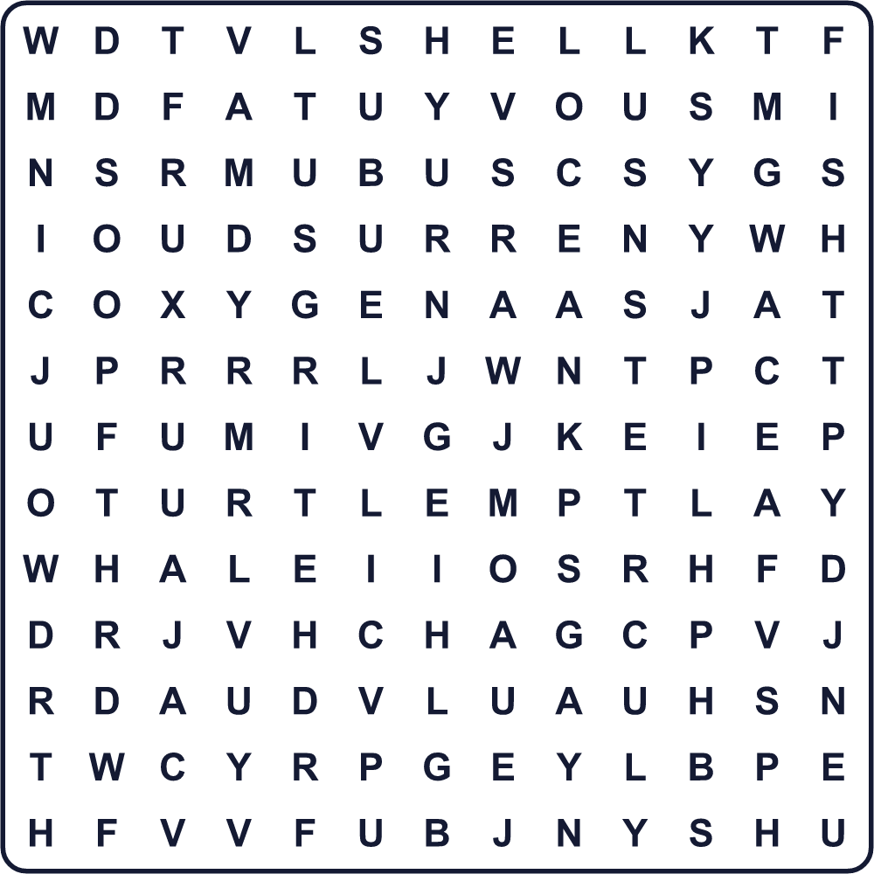
BEACH CORAL FISH OCEAN OXYGEN PLASTIC SHELL TURTLE WAVE WHALE

🌊 World Oceans Day Worksheet
Maze & Sentences
Class ______ No. ____ Name ______________________________
Help the turtle swim back to the sea! カメを海まで泳がせてあげよう！
正しい道の文字を集めると、ひみつの言葉になるよ。 START 🐢 → GOAL 🌊
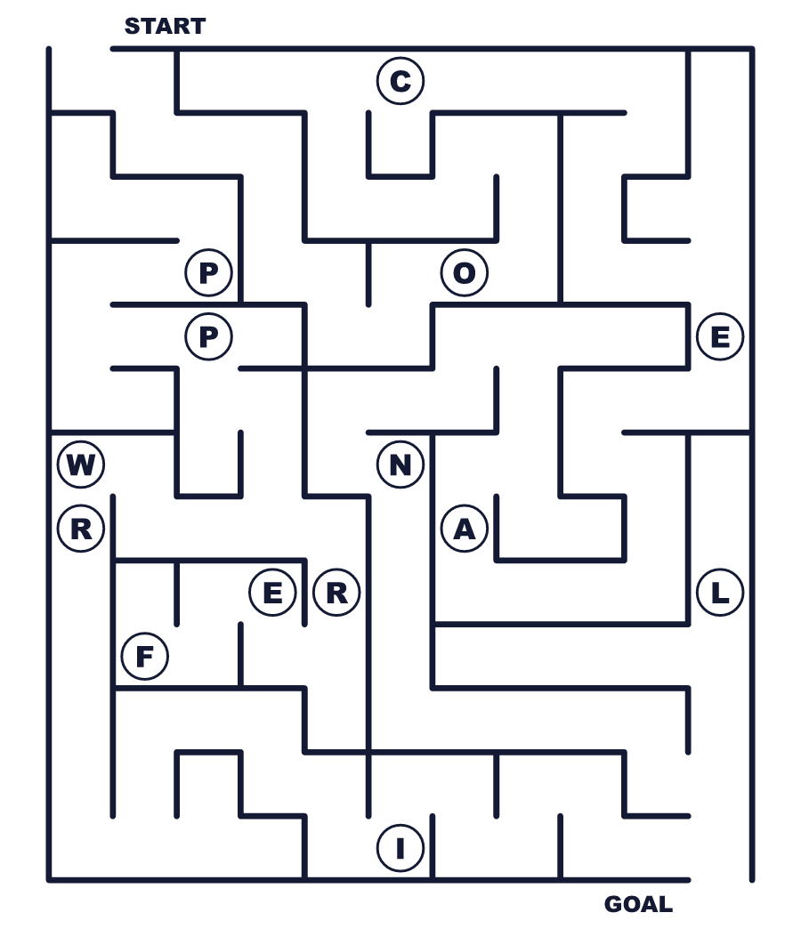
Secret word: ＿ ＿ ＿ ＿ ＿

🌊 World Oceans Day Worksheet
Class Activity & Writing
Class ______ No. ____ Name ______________________________
Let's Write! 英語で書いてみよう。
If I were a sea animal, I would be a ______ because ______.
海の生きものになれるなら、______になりたい。なぜなら______だから。
______________________________________________________________
______________________________________________________________
To protect the ocean, I will stop using ______.
海を守るために、私は______を使うのをやめます。
______________________________________________________________
______________________________________________________________

🌊 World Oceans Day Worksheet
Trace & Color
なぞって書こう。絵に色をぬろう。
Class ______ No. ____ Name ______________________________
🐋 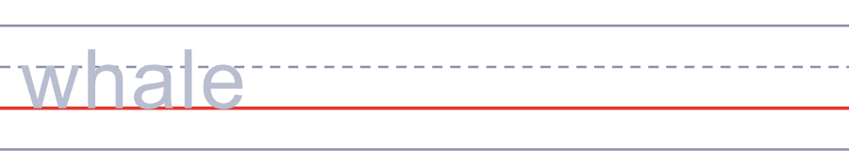

🐢 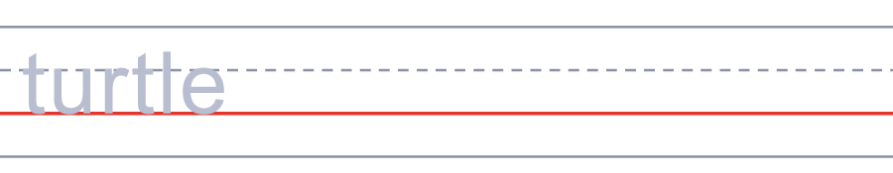
🐙 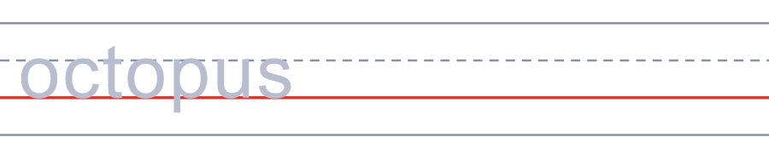
🦀 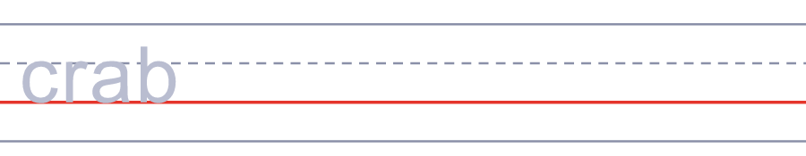
🐚 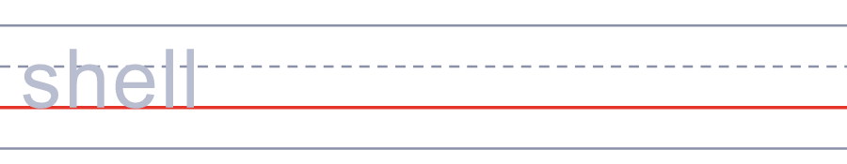

🌊 World Oceans Day Worksheet
Answer Key 解答
Reading Check: 1.A 2.B 3.C 4.D 5.B
True or False: 1.T 2.F 3.T 4.F
Match: 🐋=whale 🐢=turtle 🐙=octopus 🦀=crab 🐚=shell 🐠=fish
Fill in the blanks: (1)beach (2)water (3)trash (4)plastic (5)crab (6)clean (7)bags
Maze: OCEAN
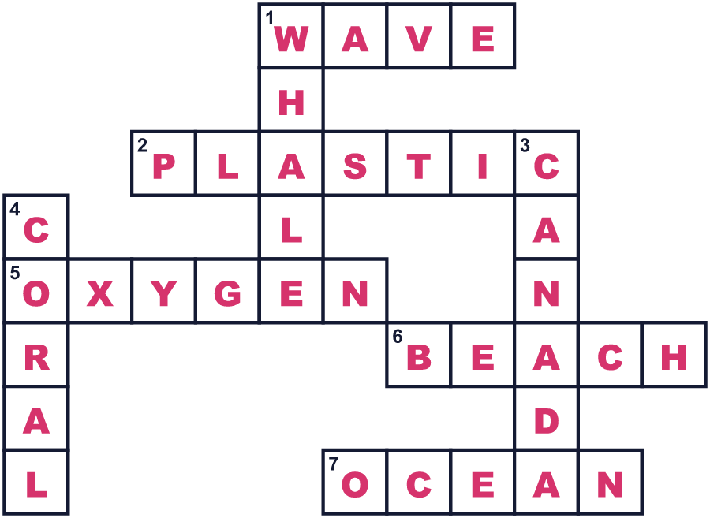
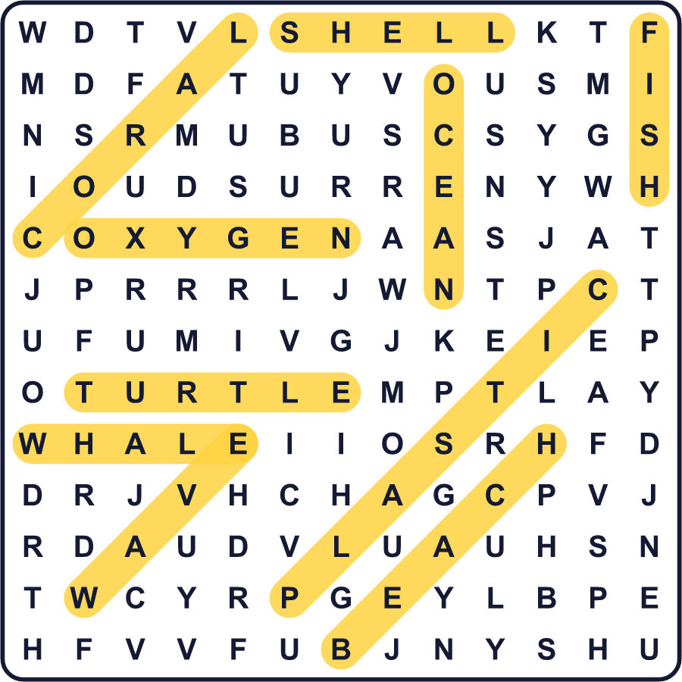
全訳
1 深く息を吸ってみてください。その息の酸素の少なくとも半分は、海から来たものです。海のとても小さな植物や、ほかの小さな生きものが作っているのです。私たちには見えませんが、毎日必要としています。
2 海は地球の70％以上をおおっています。地球のすべての水の約97％をためています。10億人以上の人に食べ物も与えています。でも、海は困った状態にあります。大きな魚は減り、多くのサンゴ礁が死にかけています。プラスチックのごみが水に浮かび、海の動物を傷つけています。
3 1992年、世界のリーダーたちがブラジルのリオデジャネイロに集まりました。そこでカナダが、海のための特別な日を作ろうと呼びかけました。多くの団体が6月8日に祝うようになりました。2008年に国連が正式に決め、国連の最初の世界海洋デーは2009年でした。最初のテーマは「私たちの海、私たちの責任」でした。
4 今、世界中の人がこの日に海岸をそうじします。水族館は家族向けのイベントを開きます。生徒たちは、海のいちばん深い場所が深さ1万1000メートル近くもあることを学びます。日本には7月に独自の「海の日」があり、国民の祝日です。このような祝日があるのは、日本だけかもしれません。だから6月8日にも7月にも、海のことを考えてみましょう。海は、私たちの2回に1回の呼吸をくれているのですから。

