🍫 World Chocolate Day Worksheet
Money You Could Drink
Read the story. 英文を読もう。
Class ______ No. ____ Name ______________________________

🔊 音声を聞こう（スマホで読みとってね）
1 Long ago in Mexico, you could buy a turkey with chocolate. The money was not a candy bar. It was cacao beans. A record from 1545 says 100 beans could buy a turkey, and 30 beans could buy a small rabbit. Today, July 7 is World Chocolate Day, a day to enjoy this very old food.
2 Cacao grows on trees in hot, wet places. Its flowers grow right on the trunk, and tiny flies help them make fruit. One tree can have about 6,000 flowers in a year, but only about 20 pods. Each pod has 20 to 60 beans inside. The tree's scientific name means "food of the gods."
3 For thousands of years, chocolate was a drink, and it was bitter, not sweet. In 1544, Maya visitors brought chocolate to the royal court of Spain. Europeans added sugar, and the drink became popular with rich people. Then, in 1847, a British company started to sell chocolate for eating. In 1875, a Swiss man made milk chocolate.
4 But why July 7? Some people say chocolate came to Europe on that day in 1550. But nobody has found an old record of that date. The holiday itself is quite new, and the oldest record of it is from 2009. Shops love it, of course. In Japan, people eat a lot of chocolate in February, so July 7 can be a chocolate day just for you.
Words 単語
bean（豆） / trunk（（木の）幹） / pod（さや、実） / bitter（苦い） / royal court（宮廷） / popular（人気のある） / record（記録） / scientific name（学名）

🍫 World Chocolate Day Worksheet
Reading Check
Choose the best answer. 正しいものを選ぼう。
Class ______ No. ____ Name ______________________________
1. What is the main idea of the reading?
(A) Chocolate is a very old food with a surprising history. (B) Chocolate was first made in Japan in February. (C) Cacao trees grow best in cold places. (D) World Chocolate Day is a national holiday.
2. What could 100 cacao beans buy, according to the 1545 record?
(A) A small rabbit (B) A chocolate bar (C) A turkey (D) A house
3. How many pods can one cacao tree make in a year?
(A) About 6,000 (B) About 60 (C) About 2,000 (D) About 20
4. In paragraph 3, the word "bitter" means:
(A) very sweet (B) not sweet, with a strong taste (C) very cold (D) made with milk
5. Why does the writer say "nobody has found an old record of that date"?
(A) To show that chocolate never came to Europe (B) To say that the 1550 story may not be true (C) To say that July 7 is a Japanese holiday (D) To show that shops do not like the day
True or False? T か F に○
1. Long ago, cacao beans were used as money. T / F
2. Chocolate was always a sweet candy bar. T / F
3. Cacao flowers grow on the trunk of the tree. T / F
4. World Chocolate Day is a national holiday in Japan. T / F

🍫 World Chocolate Day Worksheet
Word Work
単語のれんしゅう
Class ______ No. ____ Name ______________________________
① Match the pictures and the words. 絵と単語を線でむすぼう。
🍫 | ● | ● | bean
🫘 | ● | ● | turkey
🌳 | ● | ● | tree
🥛 | ● | ● | milk
🦃 | ● | ● | rabbit
🐇 | ● | ● | chocolate
③ Fill in the blanks. 語群から選んで入れよう。
[ rich / half / snow / chocolate / Day / beans / drink / pumpkin ]
On July 7, Mia gives her dad a (1) __________ bar. "Why?" he asks. "It is World Chocolate (2) __________ ," she says. Dad smiles and breaks the bar in (3) __________ . "Did you know chocolate was a (4) __________ long ago?" he says. "And people used cacao (5) __________ as money." Mia laughs. "Then you are very (6) __________ now, Dad!"

🍫 World Chocolate Day Worksheet
Crossword Puzzle
ヒントを読んでクロスワードを完成させよう。
Class ______ No. ____ Name ______________________________
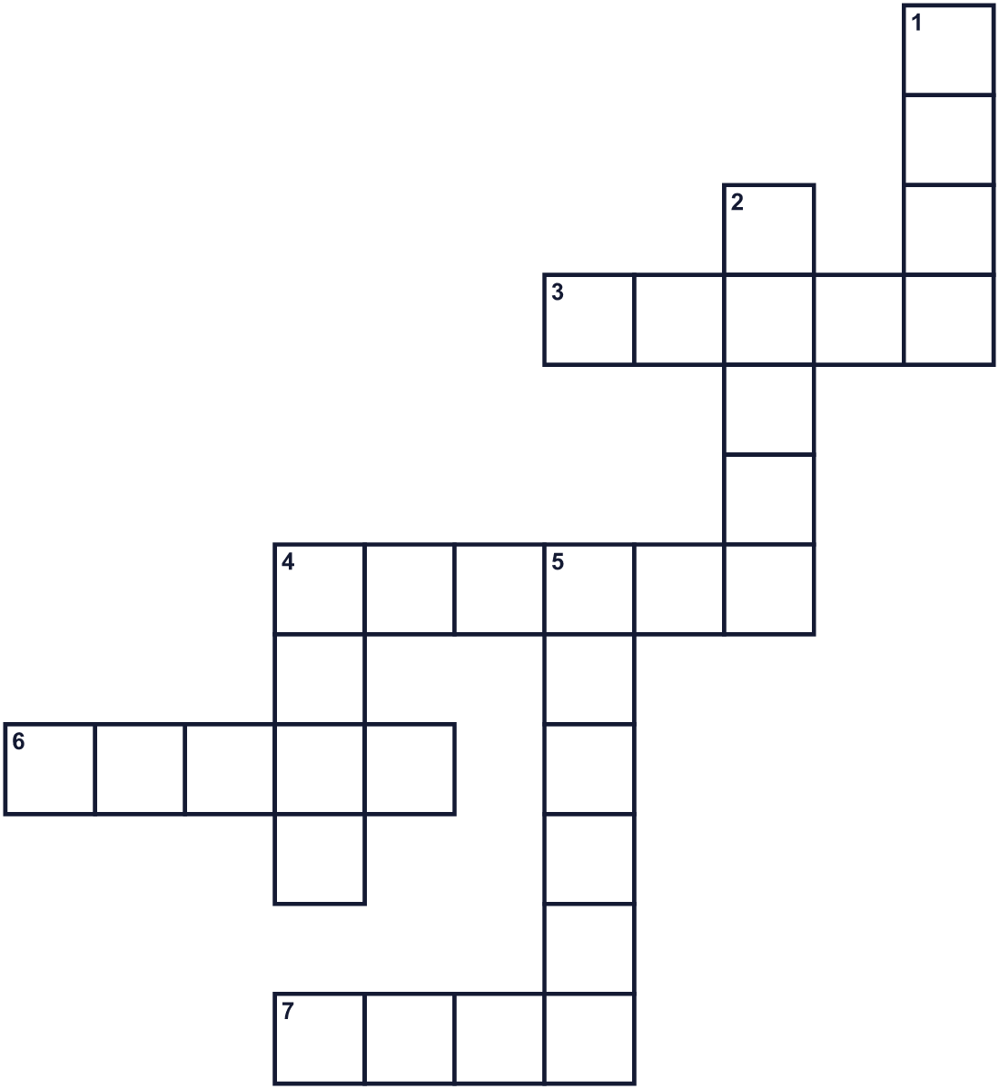
Across →
3. The main part of a tree. (5)
4. Not sweet. Coffee without sugar tastes like this. (6)
6. The tree that gives us chocolate. (5)
7. The seventh month of the year. (4)
Down ↓
1. A white drink from cows. (4)
2. Europeans put this in chocolate to make it sweet. (5)
4. A small seed. Chocolate is made from it. (4)
5. A big bird. 100 cacao beans could buy one. (6)

🍫 World Chocolate Day Worksheet
Word Search
かくれた単語をさがそう（→ ↓ ↘ ↗）
Class ______ No. ____ Name ______________________________
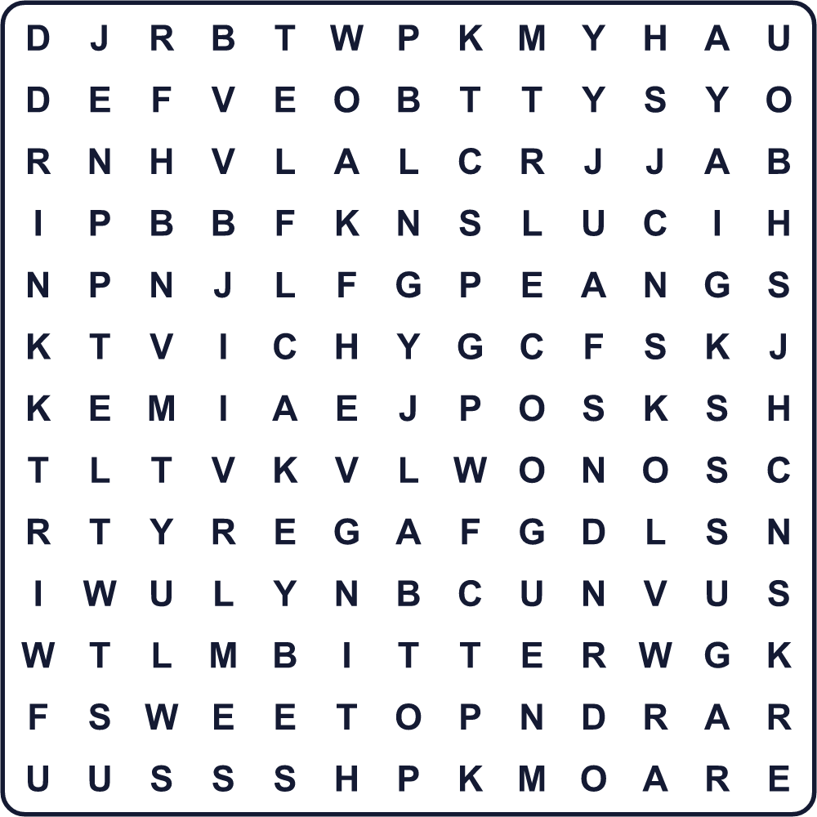
BEAN BITTER CACAO DRINK MILK POD SUGAR SWEET TRUNK TURKEY

🍫 World Chocolate Day Worksheet
Maze & Sentences
Class ______ No. ____ Name ______________________________
Help the girl find the chocolate! 女の子をチョコのところまで連れていこう！
正しい道の文字を集めると、ひみつの言葉になるよ。 START 👧 → GOAL 🍫
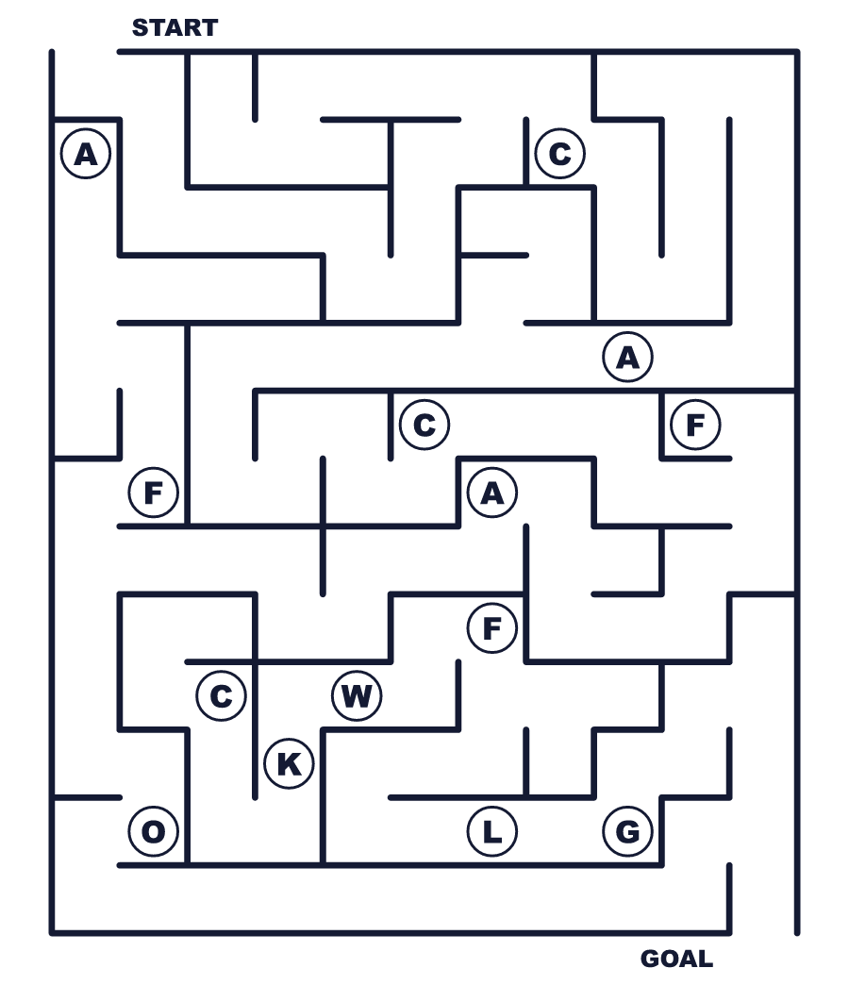
Secret word: ＿ ＿ ＿ ＿ ＿

🍫 World Chocolate Day Worksheet
Class Activity & Writing
Class ______ No. ____ Name ______________________________
Let's Write! 英語で書いてみよう。
My favorite chocolate is ______ because ______.
私の好きなチョコは______です。なぜなら______だからです。
______________________________________________________________
______________________________________________________________
If I had 100 cacao beans, I would buy ______.
カカオ豆が100粒あったら、______を買います。
______________________________________________________________
______________________________________________________________

🍫 World Chocolate Day Worksheet
Trace & Color
なぞって書こう。絵に色をぬろう。
Class ______ No. ____ Name ______________________________
🍫 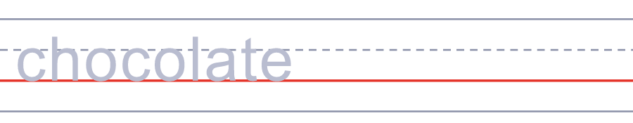

🫘 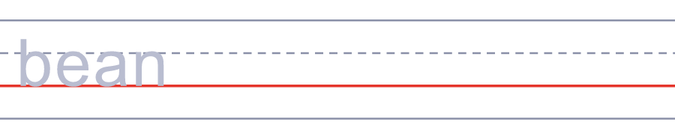
🌳 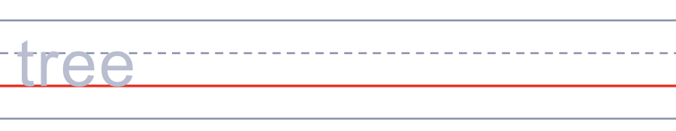
🥛 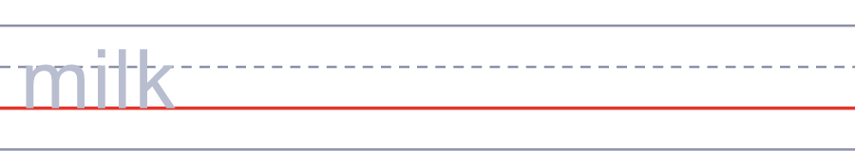
🦃 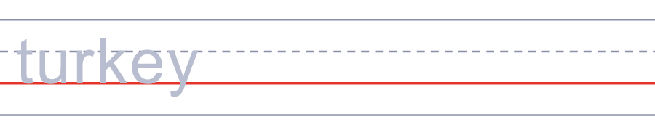

🍫 World Chocolate Day Worksheet
Answer Key 解答
Reading Check: 1.A 2.C 3.D 4.B 5.B
True or False: 1.T 2.F 3.T 4.F
Match: 🍫=chocolate 🫘=bean 🌳=tree 🥛=milk 🦃=turkey 🐇=rabbit
Fill in the blanks: (1)chocolate (2)Day (3)half (4)drink (5)beans (6)rich
Maze: CACAO
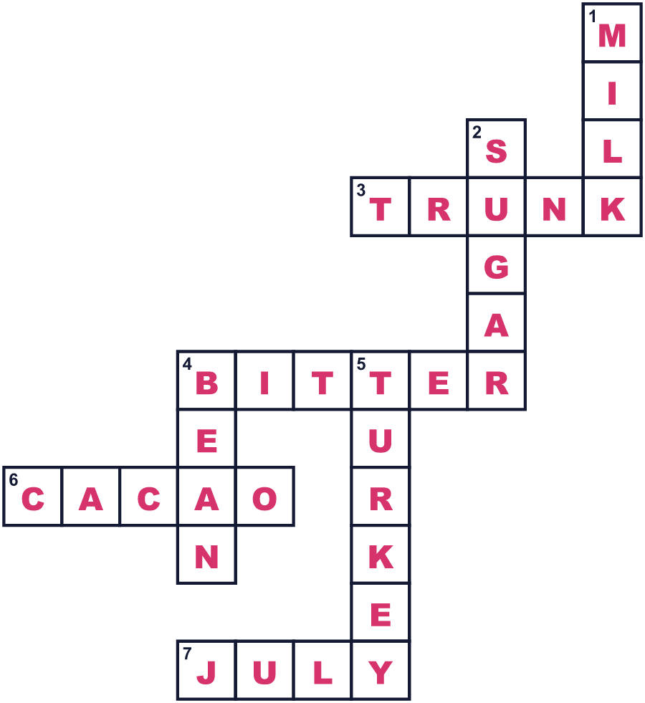
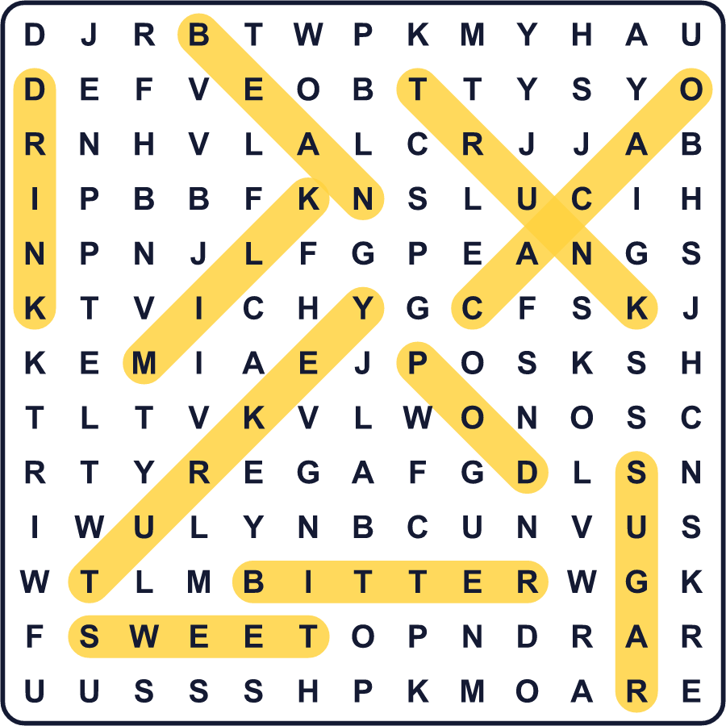
全訳
1 昔のメキシコでは、チョコレートで七面鳥が買えました。お金は板チョコではありません。カカオ豆でした。1545年の記録には、豆100粒で七面鳥、30粒で小さなウサギが買えたとあります。今、7月7日は世界チョコレートデー。このとても古い食べ物を楽しむ日です。
2 カカオは、暑くて雨の多い場所で木になります。花は幹から直接咲き、小さなハエが実をつける手伝いをします。1本の木に1年で約6000の花が咲きますが、実はたった20個ほどです。1つの実には、20〜60粒の豆が入っています。この木の学名は「神々の食べ物」という意味です。
3 何千年もの間、チョコは飲み物で、甘くはなく苦いものでした。1544年、マヤの人々がスペインの宮廷にチョコレートを持ってきました。ヨーロッパの人々は砂糖を入れ、この飲み物はお金持ちの間で人気になりました。そして1847年、イギリスの会社が食べるチョコレートを売り始めました。1875年には、スイスの男性がミルクチョコレートを作りました。
4 でも、なぜ7月7日なのでしょう。1550年のこの日にチョコがヨーロッパに来た、と言う人もいます。でも、その日付の古い記録はだれも見つけていません。この記念日そのものはかなり新しく、いちばん古い記録は2009年のものです。もちろん、お店はこの日が大好きです。日本では2月にたくさんチョコを食べるので、7月7日は自分のためのチョコの日にしてもいいかもしれません。

