📚 World Book Day Worksheet
Books, Roses, and Costumes
Read the story. 英文を読もう。
Class ______ No. ____ Name ______________________________
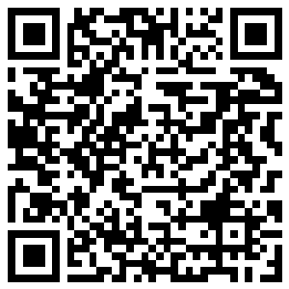
🔊 音声を聞こう（スマホで読みとってね）
1 On April 23, the streets of Barcelona turn red. There are tables of books and buckets of roses everywhere. Writers sit at small desks and sign their books. People give books and roses to the people they love. In the past, men gave roses and women gave books, but now everyone gives both. This is Sant Jordi Day, and it is also World Book Day.
2 The idea started in Spain. In the 1920s, a book publisher in Barcelona wanted to sell more books. So he started a special day for books. In 1995, UNESCO, a part of the United Nations, made April 23 a day for books all over the world.
3 Why April 23? William Shakespeare died on April 23, 1616. People also say he was born on April 23, so he may have died on his birthday! Many people say that Miguel de Cervantes, the writer of Don Quixote, died on the same day. But this is not quite true. Spain and England used different calendars at that time. In fact, Shakespeare died 11 days after Cervantes.
4 In the UK and Ireland, World Book Day is not in April. It is on the first Thursday in March. On that day, children go to school dressed as characters from books. You may see wizards, detectives, and talking animals in the classroom! Each child also gets a book token, so every child can get a new book.
Words 単語
publisher（出版社、出版する人） / sign（サインする、署名する） / calendar（暦、カレンダー） / character（登場人物、キャラクター） / dress up（仮装する、着飾る） / detective（探偵、刑事） / token（引換券、商品券） / quite（完全に、まったく（not quite で「完全には～ない」））

📚 World Book Day Worksheet
Reading Check
Choose the best answer. 正しいものを選ぼう。
Class ______ No. ____ Name ______________________________
1. What is the reading mainly about?
(A) How to grow roses (B) The life of William Shakespeare (C) World Book Day and how people celebrate it (D) How to become a writer
2. Who started the idea of a day for books?
(A) A book publisher in Barcelona (B) William Shakespeare (C) A teacher in London (D) The king of England
3. Why did Cervantes and Shakespeare not really die on the same day?
(A) Because they lived in different centuries (B) Because Spain and England used different calendars (C) Because Shakespeare died in Spain (D) Because nobody knows when they died
4. In paragraph 3, what does "not quite true" mean?
(A) Very true (B) A funny joke (C) A new rule (D) Not completely correct
5. What will Sota be on World Book Day?
(A) A witch (B) A wizard (C) A detective (D) A talking animal
True or False? T か F に○
1. UNESCO's World Book Day is on April 23. T / F
2. In the UK, World Book Day is in October. T / F
3. In Barcelona, people give books and roses on April 23. T / F
4. Shakespeare and Cervantes really died on the same day. T / F

📚 World Book Day Worksheet
Word Work
単語のれんしゅう
Class ______ No. ____ Name ______________________________
① Match the pictures and the words. 絵と単語を線でむすぼう。
📚 | ● | ● | books
🌹 | ● | ● | rose
🐉 | ● | ● | detective
🧙 | ● | ● | pencil
🕵️ | ● | ● | wizard
✏️ | ● | ● | dragon
③ Fill in the blanks. 語群から選んで入れよう。
[ token / pizza / swim / hat / map / stories / dress / adventure / teacher / book ]
Tomorrow is World Book Day. Leo wants to (1) __________ up as a pirate from his favorite (2) __________ . His mom makes a black (3) __________ with paper. Leo draws a (4) __________ for his costume. At school, his (5) __________ is a witch! In the afternoon, the class reads (6) __________ together. Leo gets a book (7) __________ . He chooses a new (8) __________ book.

📚 World Book Day Worksheet
Crossword Puzzle
ヒントを読んでクロスワードを完成させよう。
Class ______ No. ____ Name ______________________________
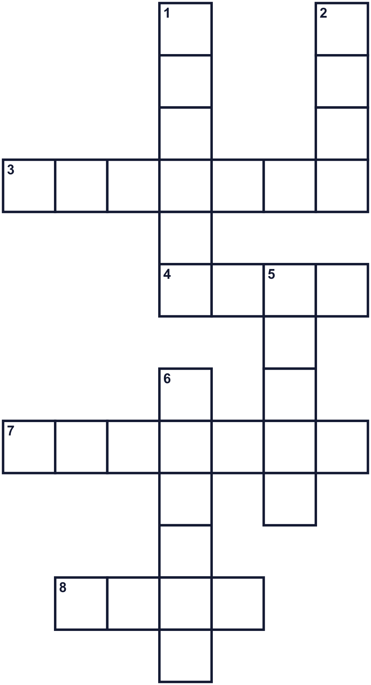
Across →
3. Special clothes. You wear them to look like someone else. (7)
4. A beautiful red flower. People give it in Barcelona. (4)
7. A place where you can borrow things to read. (7)
8. You read it. It has many pages. (4)
Down ↓
1. A person who makes stories. (6)
2. One side of a sheet of paper in a book. (4)
5. It tells what happened, true or not. It can start with "Once upon a time." (5)
6. A big animal in stories. It can breathe fire. (6)

📚 World Book Day Worksheet
Word Search
かくれた単語をさがそう（→ ↓ ↘ ↗）
Class ______ No. ____ Name ______________________________
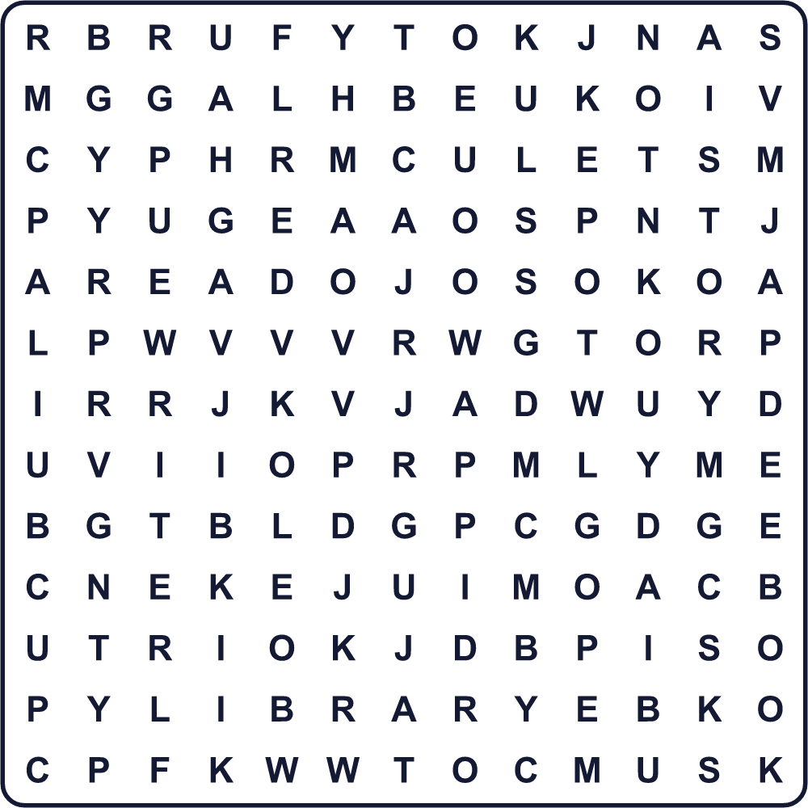
APRIL BOOK COSTUME DRAGON LIBRARY PAGE READ ROSE STORY WRITER

📚 World Book Day Worksheet
Maze & Sentences
Class ______ No. ____ Name ______________________________
Help the knight bring the rose to the library! 騎士がバラを図書館まで届けるのを手伝おう！
正しい道の文字を集めると、ひみつの言葉になるよ。 START 🌹 → GOAL 📚
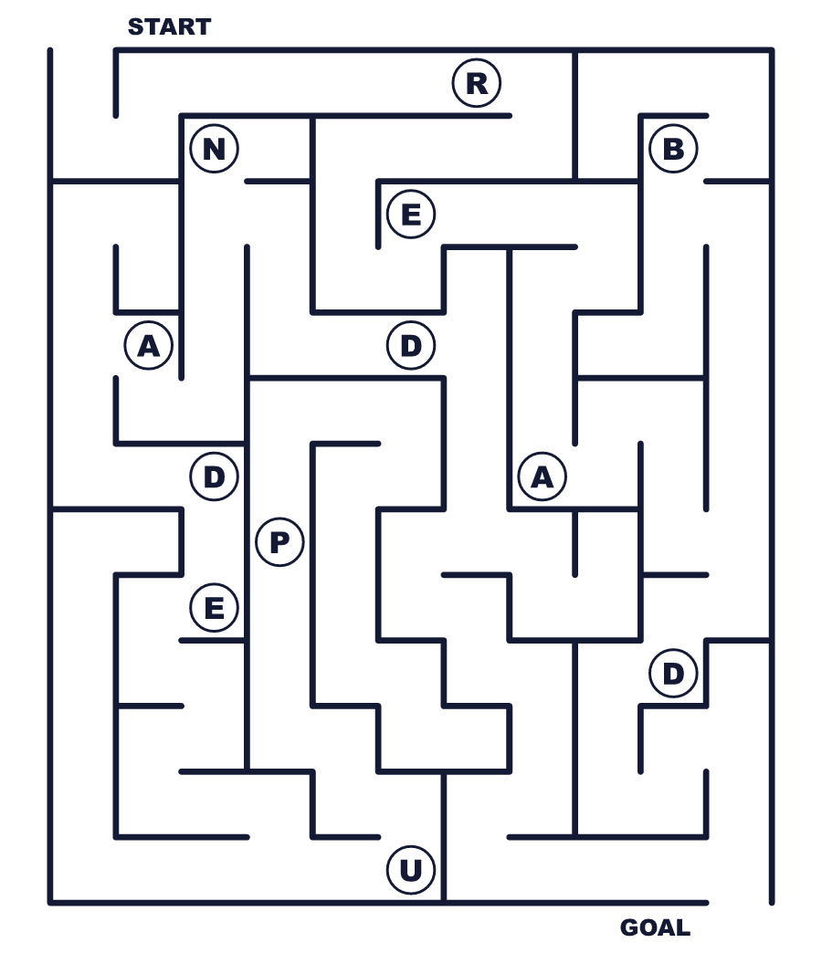
Secret word: ＿ ＿ ＿ ＿

📚 World Book Day Worksheet
Class Activity & Writing
Class ______ No. ____ Name ______________________________
Let's Write! 英語で書いてみよう。
My favorite book is ______. I like it because ______.
私のいちばん好きな本は＿＿＿です。なぜなら＿＿＿だからです。
______________________________________________________________
______________________________________________________________
On World Book Day, I would like to dress up as ______ because ______.
ワールド・ブック・デーには、＿＿＿の仮装をしたいです。なぜなら＿＿＿だからです。
______________________________________________________________
______________________________________________________________

📚 World Book Day Worksheet
Trace & Color
なぞって書こう。絵に色をぬろう。
Class ______ No. ____ Name ______________________________
📚 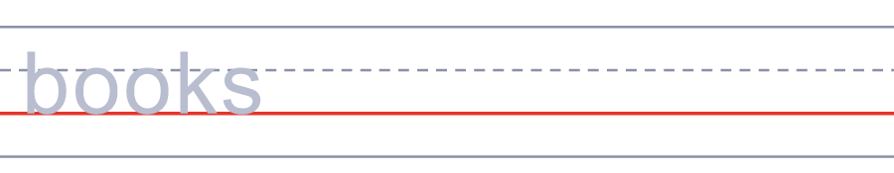

🌹 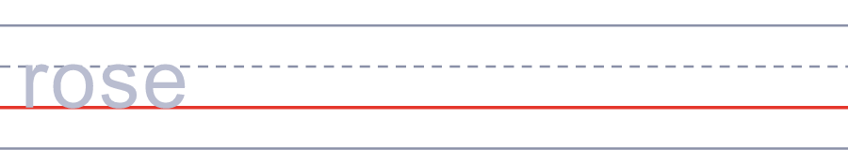
🐉 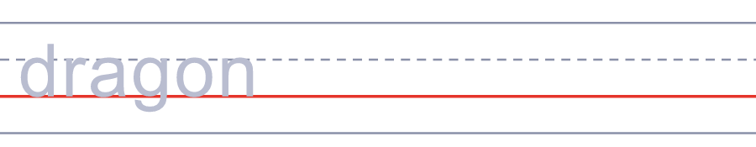
🧙 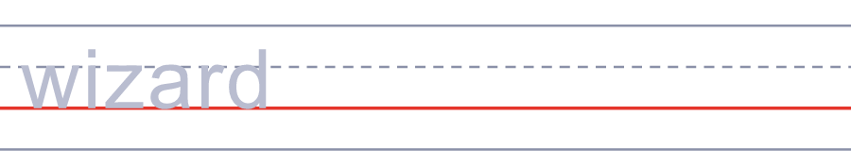
🕵️ 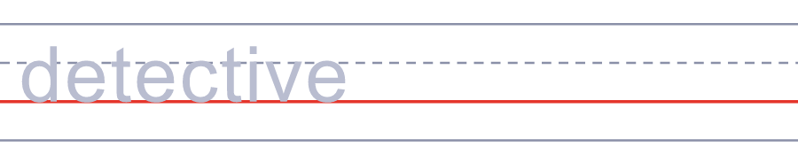

📚 World Book Day Worksheet
Answer Key 解答
Reading Check: 1.C 2.A 3.B 4.D 5.C
True or False: 1.T 2.F 3.T 4.F
Match: 📚=books 🌹=rose 🐉=dragon 🧙=wizard 🕵️=detective ✏️=pencil
Fill in the blanks: (1)dress (2)book (3)hat (4)map (5)teacher (6)stories (7)token (8)adventure
Maze: READ
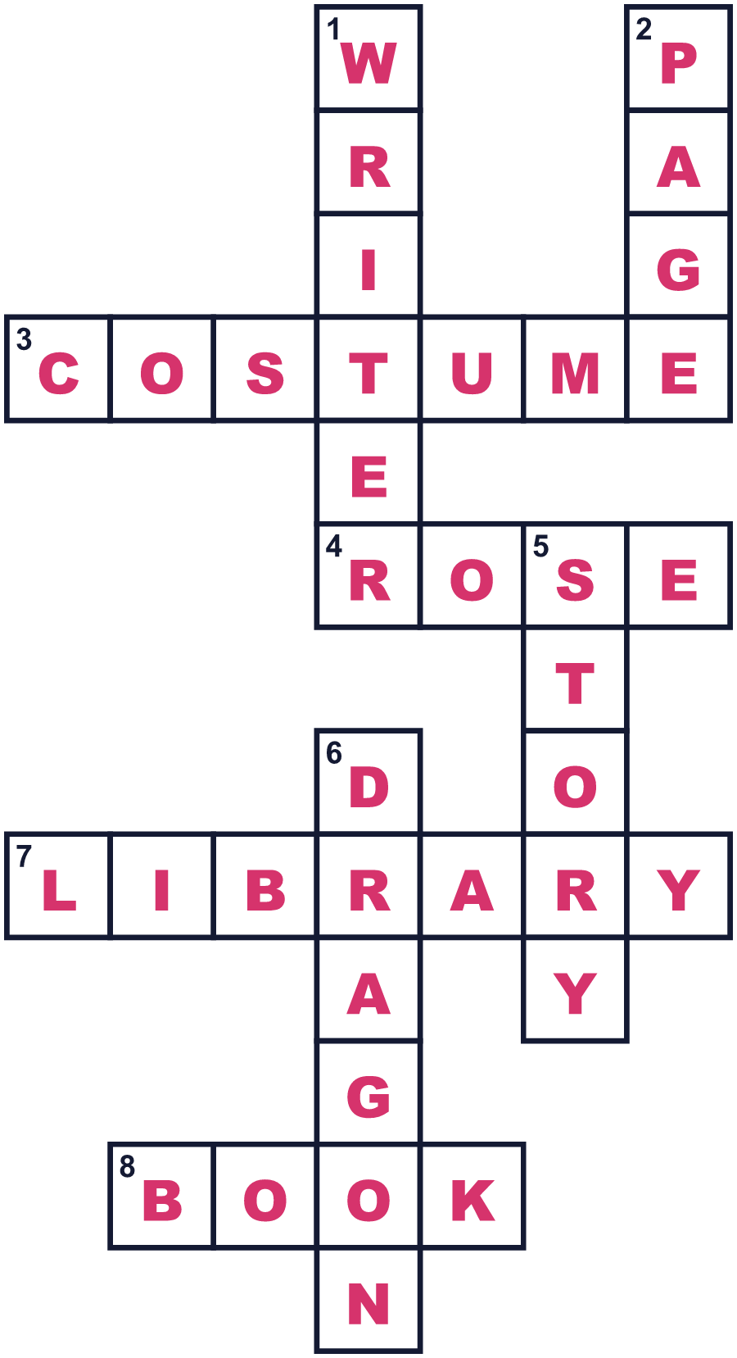
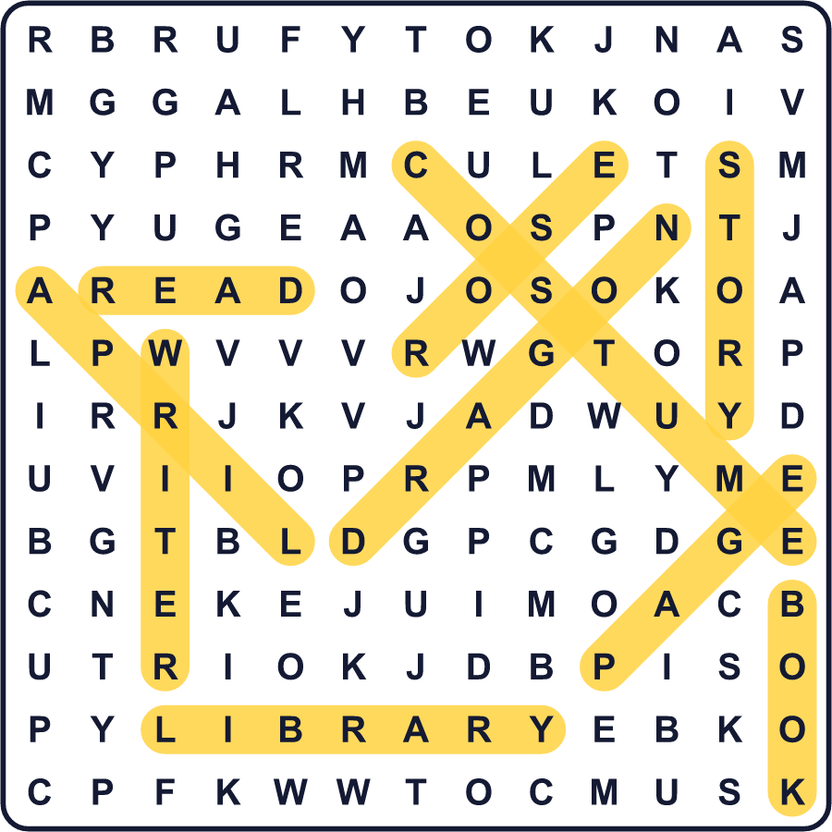
全訳
1 4月23日、バルセロナの通りは赤く染まります。どこもかしこも、本の机とバラのバケツでいっぱいです。作家たちは小さな机にすわり、自分の本にサインをします。人々は、大切な人に本とバラを贈ります。昔は男性がバラを、女性が本を贈りましたが、今はだれもが両方を贈ります。これはサン・ジョルディの日で、世界本の日でもあります。
2 このアイデアはスペインで生まれました。1920年代、バルセロナのある出版社が、本をもっと売りたいと考えました。そこで、本のための特別な日を始めました。1995年、国連の機関であるユネスコが、4月23日を世界中の本の日にしました。
3 なぜ4月23日なのでしょう。ウィリアム・シェイクスピアは1616年4月23日に亡くなりました。彼は4月23日に生まれたとも言われるので、誕生日に亡くなったのかもしれません！『ドン・キホーテ』を書いたミゲル・デ・セルバンテスも同じ日に亡くなった、と多くの人が言います。でも、これは正確ではありません。当時、スペインとイギリスはちがう暦を使っていたのです。実際には、シェイクスピアはセルバンテスの11日後に亡くなりました。
4 イギリスとアイルランドでは、世界本の日は4月ではありません。3月の第1木曜日です。その日、子どもたちは本の登場人物の格好をして学校へ行きます。教室で、魔法使いや探偵や、しゃべる動物に会えるかもしれません！子どもたちはそれぞれ本の引換券ももらうので、だれでも新しい本を手に入れられます。

