🐝 World Bee Day Worksheet
A Small Country and a Small Insect
Read the story. 英文を読もう。
Class ______ No. ____ Name ______________________________

🔊 音声を聞こう（スマホで読みとってね）
1 Take a bite of an apple, and say thank you to a bee. Bees carry pollen from flower to flower. This helps plants make fruit and seeds. About 75 percent of the world's food crops need this help, at least a little. Without bees, our plates would look very different.
2 World Bee Day is on May 20. The idea came from Slovenia, a small country in Europe. Many people there keep bees, and they paint pictures on their beehives. One picture shows a devil and an old woman, and it makes people laugh. In 2017, the United Nations agreed, and the first World Bee Day was in 2018.
3 Why May 20? It is the special day of Anton Jansa. He was born in Slovenia in 1734. At first, he wanted to be a painter. But he loved bees more, and he became a famous bee teacher in Vienna. He made boxes for bees that people could stack like blocks.
4 Today, many bees are in danger. There are more than 20,000 kinds of bees, and most of them do not make honey. Some farm chemicals hurt them, and they are losing their homes. But we can help, even in a big city. In Tokyo, people keep bees on the roof of a tall building in Ginza. You can plant flowers on your balcony, too. A bee may visit them tomorrow.
Words 単語
pollen（花粉） / crop（作物） / beehive（ハチの巣箱、ハチの巣） / painter（画家） / stack（積み重ねる） / danger（危険） / chemical（化学物質、薬品） / roof（屋根、屋上）

🐝 World Bee Day Worksheet
Reading Check
Choose the best answer. 正しいものを選ぼう。
Class ______ No. ____ Name ______________________________
1. What is the main idea of the reading?
(A) Bees are important, and World Bee Day helps people think about them. (B) Bees are dangerous, so people should stay away from flowers. (C) Slovenia is the only country where people eat honey. (D) Anton Jansa was a famous painter who never kept bees.
2. When was the first World Bee Day?
(A) In 1734 (B) In 2017 (C) In 2018 (D) In 2006
3. What did Anton Jansa want to be at first?
(A) A farmer (B) A teacher (C) A doctor (D) A painter
4. In paragraph 4, "in danger" means:
(A) very happy and safe (B) in a bad situation and might be hurt (C) busy making honey (D) living in a big city
5. In the dialogue, why does Lucy say "thank the bees"?
(A) Because bees make strawberry jam (B) Because bees help strawberries grow (C) Because bees live in her school (D) Because bees are good painters
True or False? T か F に○
1. World Bee Day is on May 20. T / F
2. The idea for World Bee Day came from Japan. T / F
3. Bees help plants make fruit. T / F
4. All bees make honey. T / F

🐝 World Bee Day Worksheet
Word Work
単語のれんしゅう
Class ______ No. ____ Name ______________________________
① Match the pictures and the words. 絵と単語を線でむすぼう。
🐝 | ● | ● | sunflower
🍯 | ● | ● | apple
🌻 | ● | ● | bee
🍎 | ● | ● | honey
🍓 | ● | ● | queen
👑 | ● | ● | strawberry
③ Fill in the blanks. 語群から選んで入れよう。
[ fish / bread / honey / flowers / snow / beehives / bees / pollen ]
Mika's school has two (1) __________ on the roof. Every morning, the bees fly out to find (2) __________ . They carry (3) __________ from one flower to another. In June, the students open the boxes. They find sweet (4) __________ inside! Mika puts some on her (5) __________ . "Thank you, little (6) __________ ," she says.

🐝 World Bee Day Worksheet
Crossword Puzzle
ヒントを読んでクロスワードを完成させよう。
Class ______ No. ____ Name ______________________________
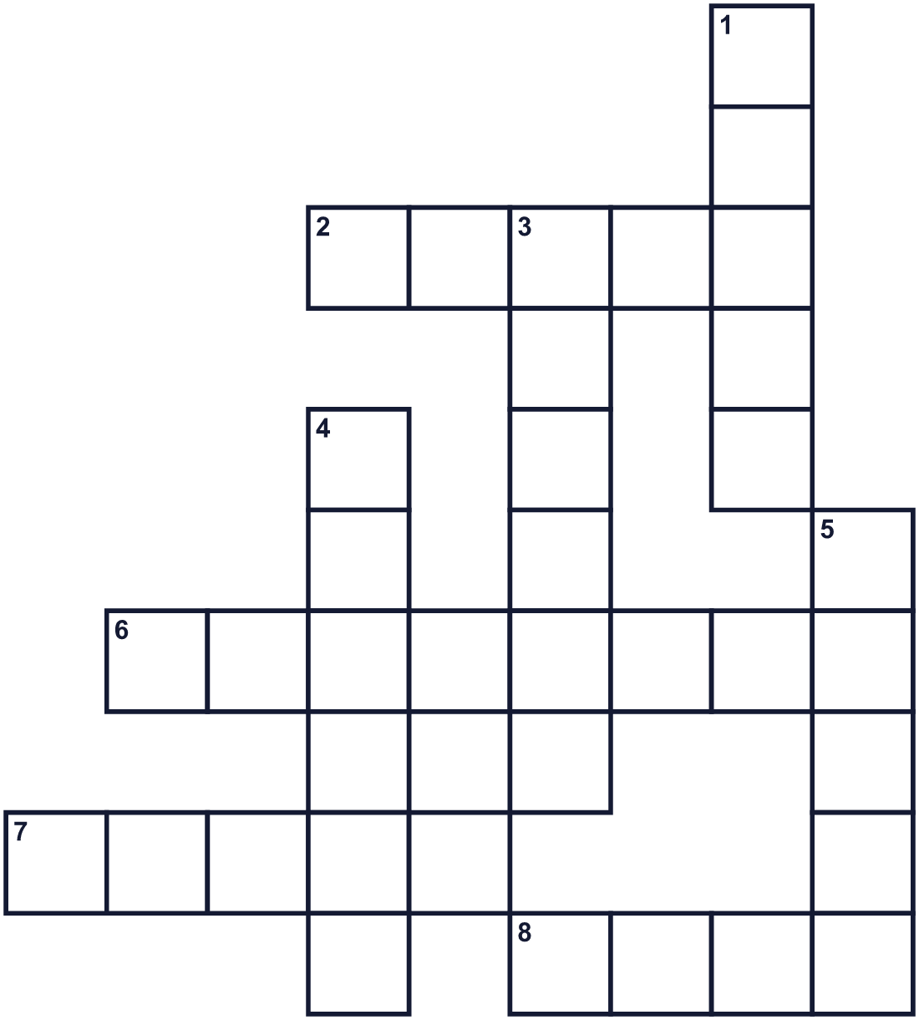
Across →
2. A red or green fruit. Bees help it grow. (5)
6. The small European country that asked for this day. (8)
7. A sweet, golden food that bees make. (5)
8. A home for many bees. (4)
Down ↓
1. The mother bee. She lays the eggs. (5)
3. Yellow powder that bees carry from flower to flower. (6)
4. Bees visit it to get nectar. (6)
5. Bees do this to tell friends where food is. (5)

🐝 World Bee Day Worksheet
Word Search
かくれた単語をさがそう（→ ↓ ↘ ↗）
Class ______ No. ____ Name ______________________________
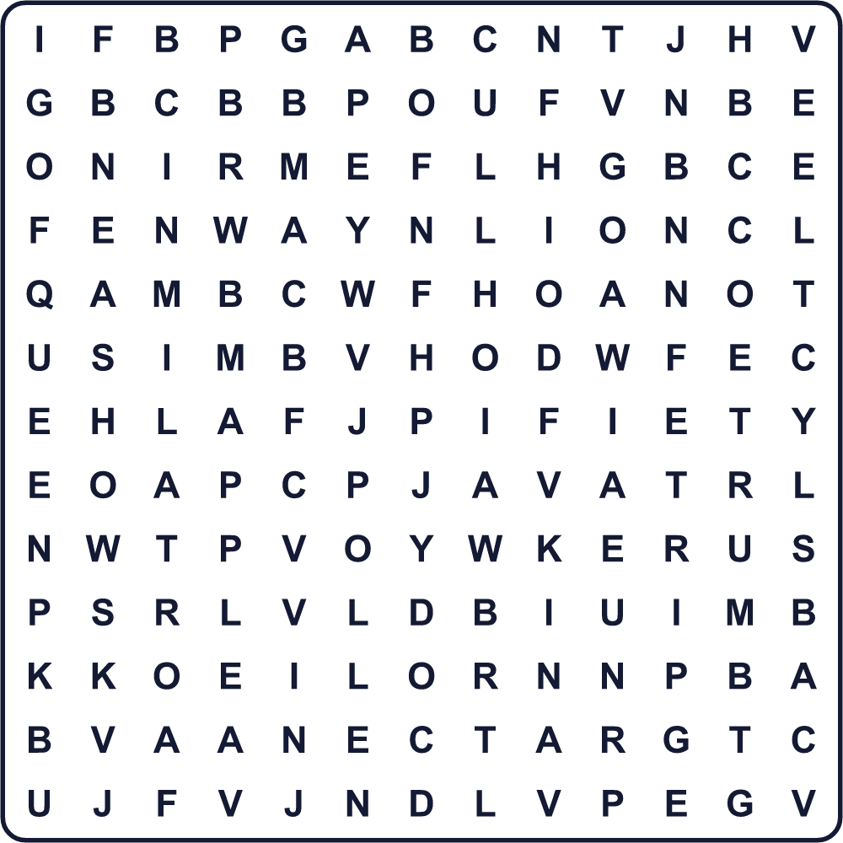
APPLE DANCE FARM FLOWER HIVE HONEY NECTAR POLLEN QUEEN WING

🐝 World Bee Day Worksheet
Maze & Sentences
Class ______ No. ____ Name ______________________________
Help the bee find the flower! ミツバチを花のところまで連れていこう！
正しい道の文字を集めると、ひみつの言葉になるよ。 START 🐝 → GOAL 🌼
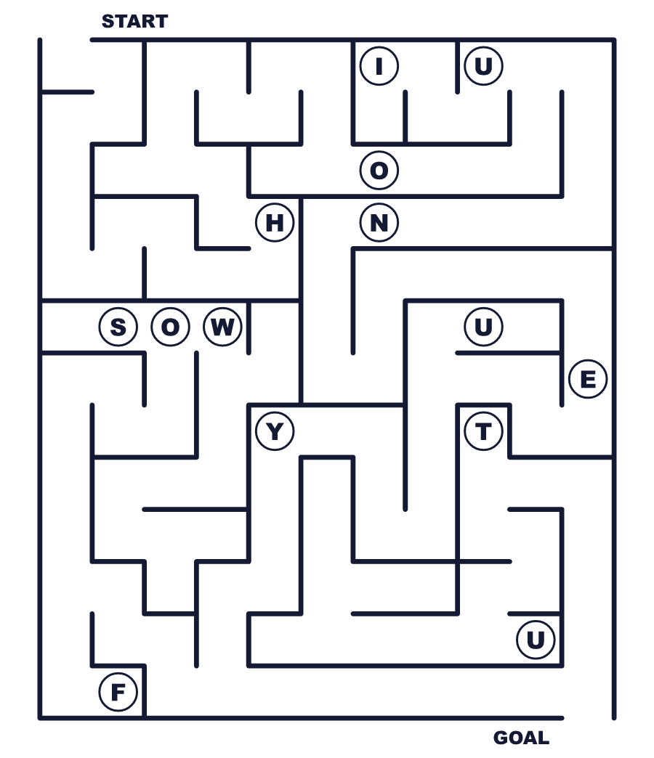
Secret word: ＿ ＿ ＿ ＿ ＿

🐝 World Bee Day Worksheet
Class Activity & Writing
Class ______ No. ____ Name ______________________________
Let's Write! 英語で書いてみよう。
If there were no bees, I could not eat ______. That would be ______.
ハチがいなかったら、私は______を食べられません。それは______です。
______________________________________________________________
______________________________________________________________
To help bees, I will ______.
ハチを助けるために、私は______します。
______________________________________________________________
______________________________________________________________

🐝 World Bee Day Worksheet
Trace & Color
なぞって書こう。絵に色をぬろう。
Class ______ No. ____ Name ______________________________
🐝 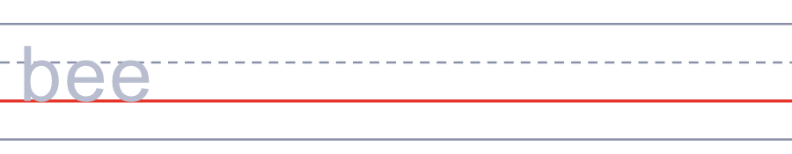

🍯 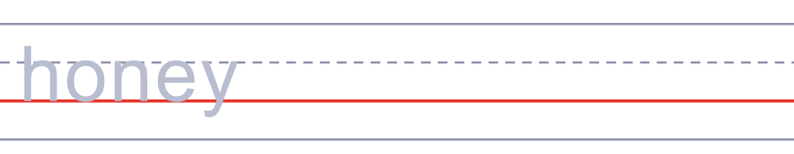
🌻 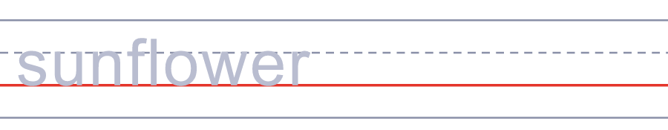
🍎 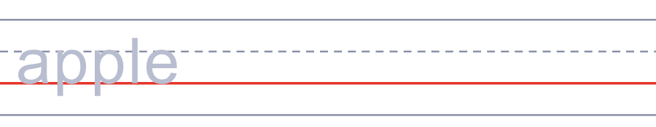
🍓 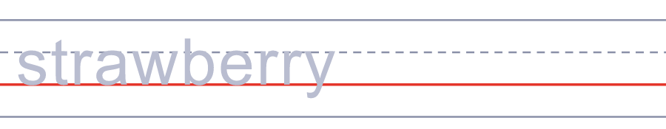

🐝 World Bee Day Worksheet
Answer Key 解答
Reading Check: 1.A 2.C 3.D 4.B 5.B
True or False: 1.T 2.F 3.T 4.F
Match: 🐝=bee 🍯=honey 🌻=sunflower 🍎=apple 🍓=strawberry 👑=queen
Fill in the blanks: (1)beehives (2)flowers (3)pollen (4)honey (5)bread (6)bees
Maze: HONEY
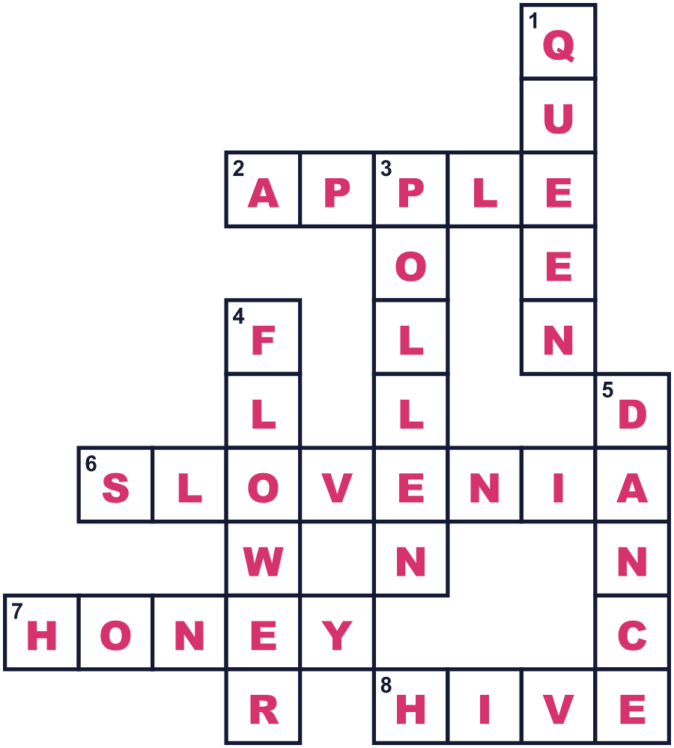
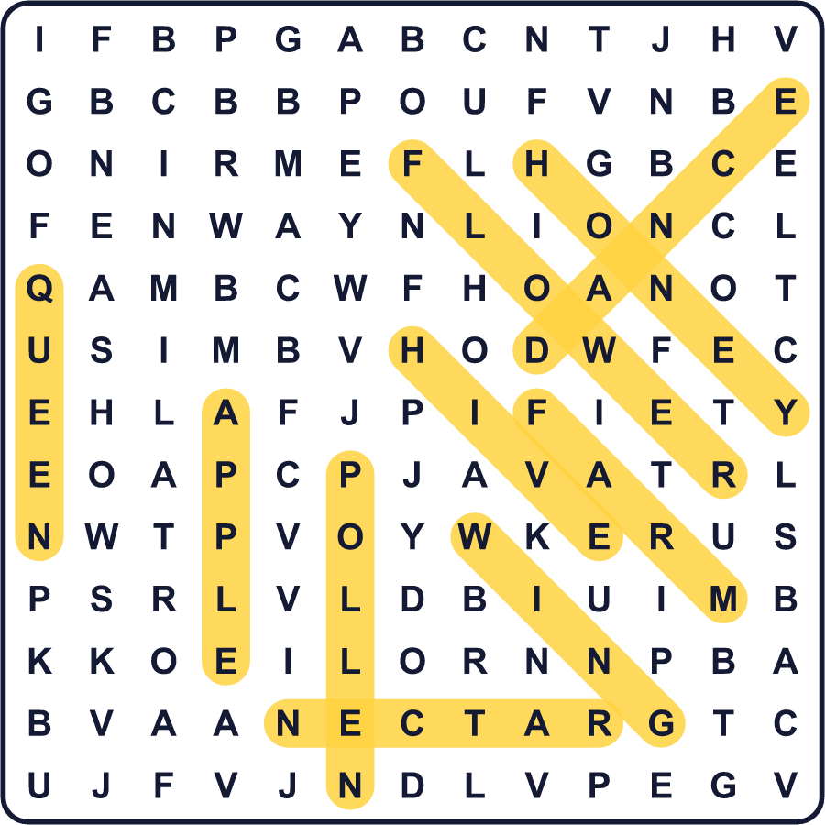
全訳
1 リンゴをひと口かじったら、ハチにありがとうと言いましょう。ハチは花から花へ花粉を運びます。そのおかげで、植物は実や種を作れます。世界の食用作物の約75％は、少なくとも少しはこの助けを必要としています。ハチがいなければ、私たちのお皿はずいぶんちがって見えるでしょう。
2 世界ミツバチの日は5月20日です。このアイデアは、ヨーロッパの小さな国スロベニアから生まれました。そこでは多くの人がハチを飼っていて、巣箱に絵を描きます。悪魔とおばあさんを描いた絵もあり、見る人を笑わせます。2017年に国連が賛成し、最初の世界ミツバチの日は2018年でした。
3 なぜ5月20日なのでしょう。アントン・ヤンシャの特別な日だからです。彼は1734年にスロベニアで生まれました。はじめ、彼は画家になりたいと思っていました。でもハチのほうがもっと好きになり、ウィーンで有名なハチの先生になりました。彼は、積み木のように積み重ねられるハチの箱を作りました。
4 今、多くのハチが危機にあります。ハチは2万種類以上いて、そのほとんどははちみつを作りません。農薬の中にはハチを傷つけるものがあり、ハチはすみかも失いつつあります。でも、大都会でも私たちは助けることができます。東京では、銀座の高いビルの屋上でハチが飼われています。あなたもベランダに花を植えることができます。明日、ハチがその花を訪れるかもしれません。

