📚 Women's History Month Worksheet
From One Week to One Month
Read the story. 英文を読もう。
Class ______ No. ____ Name ______________________________
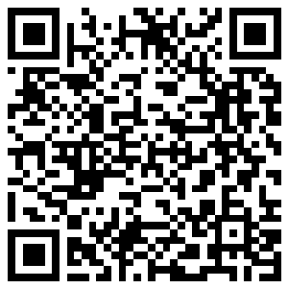
🔊 音声を聞こう（スマホで読みとってね）
1 In 1972, a high school history teacher in California got a simple question from a student. What is the women's movement? The teacher, Molly Murphy MacGregor, could not answer it. After school, she looked through her old college history books. She found only one chapter about women's rights in just one book.
2 So she decided to do something. In 1978, she and other women in Sonoma County, California, planned a Women's History Week for local schools. They chose the week of March 8, International Women's Day. More than 100 women visited classrooms and talked about women in history. Hundreds of students wrote essays, and the week ended with a parade in the city of Santa Rosa.
3 The idea spread quickly. In 1980, President Jimmy Carter asked the whole country to celebrate National Women's History Week. He wrote that too often, the work of women went unnoticed. Then more and more states began to celebrate for the whole month of March. By 1986, there were 14 of them. In 1987, Congress made March Women's History Month for the first time.
4 Today, schools, libraries, and museums share stories of women every March. Students read about scientists, writers, and leaders, and they make posters and reports. Every year, a group called the National Women's History Alliance chooses a theme. The theme for 2026 was about women who lead change and build a future that lasts.
5 Women's History Month is not only an American event. People in Britain also celebrate it in March. But Canada celebrates it in October. On October 18, 1929, a court decided that Canadian women were persons under the law. Because of this, women could join the Senate. And in Japan, Women's Week starts on April 10, the day women first voted in 1946.
Words 単語
history（歴史） / movement（（社会的な）運動） / chapter（（本の）章） / rights（権利） / essay（作文、小論文） / parade（パレード、行進） / celebrate（祝う） / president（大統領） / Congress（（アメリカの）連邦議会） / theme（テーマ、主題） / court（裁判所） / vote（投票する）

📚 Women's History Month Worksheet
Reading Check
Choose the best answer. 正しいものを選ぼう。
Class ______ No. ____ Name ______________________________
1. What is the story mainly about?
(A) How a teacher wrote a new history textbook (B) Why Canada has its own holidays (C) How Women's History Month started and grew (D) How women in Japan won the right to vote
2. When was the first Women's History Week in Sonoma County?
(A) In 1972 (B) In 1978 (C) In 1980 (D) In 1987
3. How many women visited classrooms during the week?
(A) About 14 (B) About 18 (C) About 50 (D) More than 100
4. Why did they choose the week of March 8?
(A) It was International Women's Day. (B) It was the first day of spring. (C) Schools had no classes that week. (D) President Carter asked them to.
5. In paragraph 3, "The idea spread quickly" means the idea ...
(A) was forgotten soon (B) changed into a new idea (C) reached many places fast (D) stayed in one school
6. Which is true according to the story?
(A) Molly Murphy MacGregor answered the question at once. (B) Canada celebrates Women's History Month in October. (C) The theme is the same every year. (D) Congress made March Women's History Month in 1980.
7. Why did MacGregor decide to do something?
(A) She was surprised that her books said so little about women. (B) Her students wanted a parade. (C) The president asked her to help. (D) She wanted to write a famous book.
8. In the dialogue, who will Haruto make a poster about?
(A) Sally Ride (B) Molly Murphy MacGregor (C) Jimmy Carter (D) Tsuda Umeko
True or False? T か F に○
1. Women's History Month started in California. T / F
2. The first celebration in 1978 was one month long. T / F
3. President Jimmy Carter supported National Women's History Week in 1980. T / F
4. Canada celebrates Women's History Month in March. T / F
5. International Women's Day is on March 8. T / F
6. The theme of Women's History Month is the same every year. T / F

📚 Women's History Month Worksheet
Word Work
単語のれんしゅう
Class ______ No. ____ Name ______________________________
① Match the pictures and the words. 絵と単語を線でむすぼう。
📚 | ● | ● | rocket
🚀 | ● | ● | microscope
🔬 | ● | ● | microphone
🍁 | ● | ● | calendar
🥁 | ● | ● | book
🪙 | ● | ● | coin
🎤 | ● | ● | drum
📅 | ● | ● | leaf
② Unscramble the words. 並べかえて単語にしよう。
1. H R T I O S Y (歴史) → ____________________
2. E A R A D P (パレード) → ____________________
3. Y S E A S (作文) → ____________________
4. M E E H T (テーマ) → ____________________
5. U M M U S E (博物館) → ____________________
6. L A R D E E (リーダー、指導者) → ____________________
③ Fill in the blanks. 語群から選んで入れよう。
[ famous / listen / March / history / proud / angry / museum / grandmother / questions / poster / essay / pizza / rainy ]
In (1) __________ , Aiko's class in Ohio studies women in (2) __________ . Each student chooses one woman. Aiko chooses her (3) __________ , a nurse who helped many people. Aiko asks her a lot of (4) __________ and writes an (5) __________ . Then she makes a (6) __________ with old photos. At the end of the month, the class opens a small (7) __________ in the gym. Parents come and (8) __________ to the stories. Aiko feels very (9) __________ . "History is not only about (10) __________ people," she says.

📚 Women's History Month Worksheet
Crossword Puzzle
ヒントを読んでクロスワードを完成させよう。
Class ______ No. ____ Name ______________________________
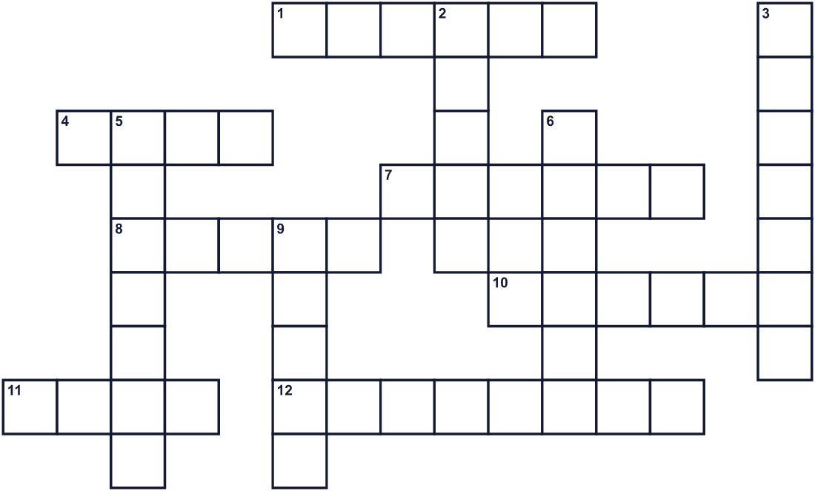
Across →
1. A building where you can see old and important things. (6)
4. To choose a leader in an election. (4)
7. This country celebrates women's history in October. (6)
8. The main idea. It changes every year. (5)
10. The family name of the president who started the national week in 1980. (6)
11. Seven days. (4)
12. The group that makes laws in the United States. (8)
Down ↓
2. A short piece of writing. Hundreds of students wrote one in 1978. (5)
3. The study of the past. (7)
5. The tenth month of the year. (7)
6. People walk down the street with music and flags. (6)
9. The third month of the year. (5)

📚 Women's History Month Worksheet
Word Search
かくれた単語をさがそう（→ ↓ ↘ ↗）
Class ______ No. ____ Name ______________________________
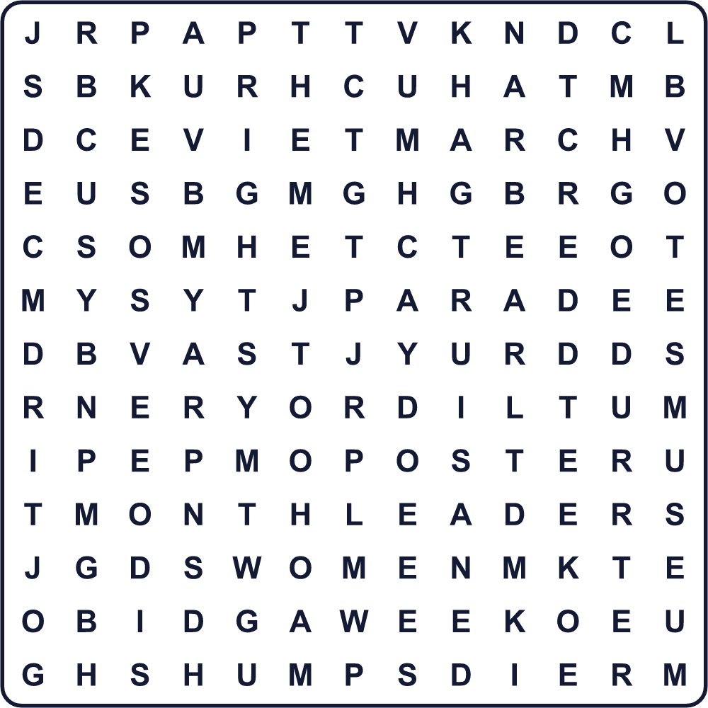
ESSAY HISTORY LEADER MARCH MONTH MUSEUM PARADE POSTER RIGHTS THEME VOTE WEEK WOMEN
Secret Code 暗号を解こう
▲=A ✎=E ☘=H ☎=I ♦=K ✉=M ✂=N ✚=O ⚑=R ☾=S ✿=T ☃=W ★=Y
☃ ✚ ✉ ✎ ✂ ✉ ▲ ♦ ✎ ☘ ☎ ☾ ✿ ✚ ⚑ ★
______________________________________________________________

📚 Women's History Month Worksheet
Maze & Sentences
Class ______ No. ____ Name ______________________________
Help the teacher bring women's history to school! 女性の歴史を学校に届けよう！
正しい道の文字を集めると、ひみつの言葉になるよ。 START 📚 → GOAL 🏫
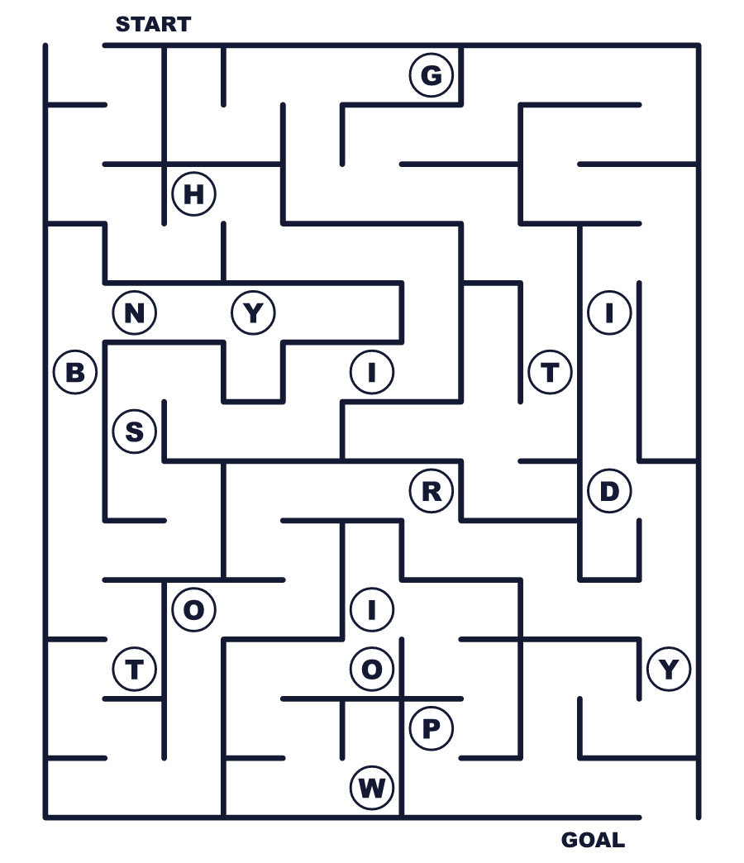
Secret word: ＿ ＿ ＿ ＿ ＿ ＿ ＿
Put the words in order. 並べかえよう。
1. is / History / Month / Women's / in / March . (女性史月間は3月です。)
______________________________________________________________
2. week / started / It / 1978 / as / one / in . (それは1978年に1週間として始まりました。)
______________________________________________________________
3. visited / women / 100 / than / classrooms / More . (100人を超える女性が教室を訪れました。)
______________________________________________________________
4. Canada / October / history / celebrates / women's / in . (カナダは10月に女性の歴史を祝います。)
______________________________________________________________
5. a / theme / is / new / there / year / Every . (毎年、新しいテーマがあります。)
______________________________________________________________

📚 Women's History Month Worksheet
Class Activity & Writing
Class ______ No. ____ Name ______________________________
Find Someone Who… クラスで聞いて回ろう！
Find someone who … | Name
… knows a famous woman scientist 有名な女性科学者を知っている
… has read a book about a woman in history 歴史上の女性についての本を読んだことがある
… can name a woman on a Japanese bill 日本のお札に描かれた女性の名前を言える
… has been to a history museum 歴史博物館に行ったことがある
… knows the date of International Women's Day 国際女性デーの日付を知っている
… has a grandmother with an interesting story おもしろい話を持っているおばあさんがいる
… likes making posters ポスターを作るのが好き
… has watched a parade パレードを見たことがある
Let's Write! 英語で書いてみよう。
A woman in history I want to learn about is ______ because ______.
私が知りたい歴史上の女性は＿＿です。なぜなら＿＿だからです。
______________________________________________________________
______________________________________________________________
A woman in my family or town who I respect is ______. She ______.
私が尊敬する家族や町の女性は＿＿です。彼女は＿＿。
______________________________________________________________
______________________________________________________________
If I made a poster for Women's History Month, I would draw ______.
もし女性史月間のポスターを作るなら、私は＿＿をかくでしょう。
______________________________________________________________
______________________________________________________________

📚 Women's History Month Worksheet
Trace & Color
なぞって書こう。絵に色をぬろう。
Class ______ No. ____ Name ______________________________
📚 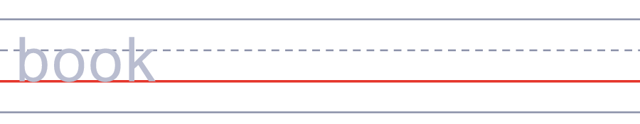

🚀 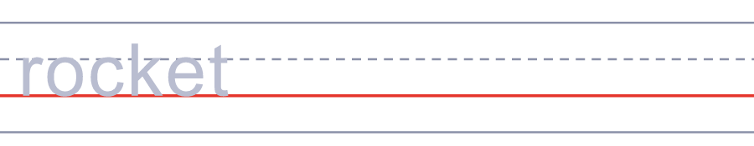
🔬 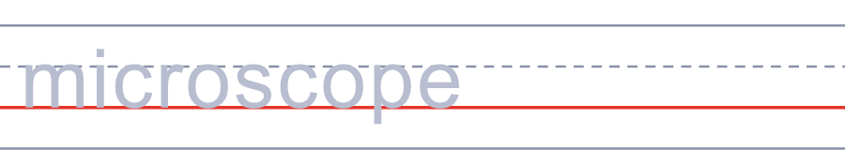
🍁 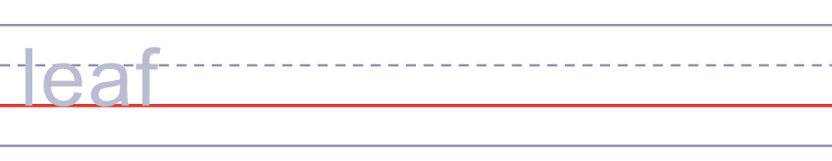
🥁 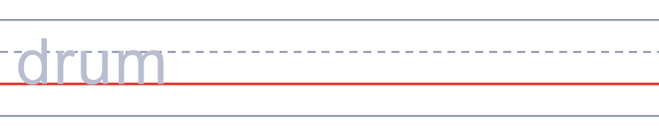
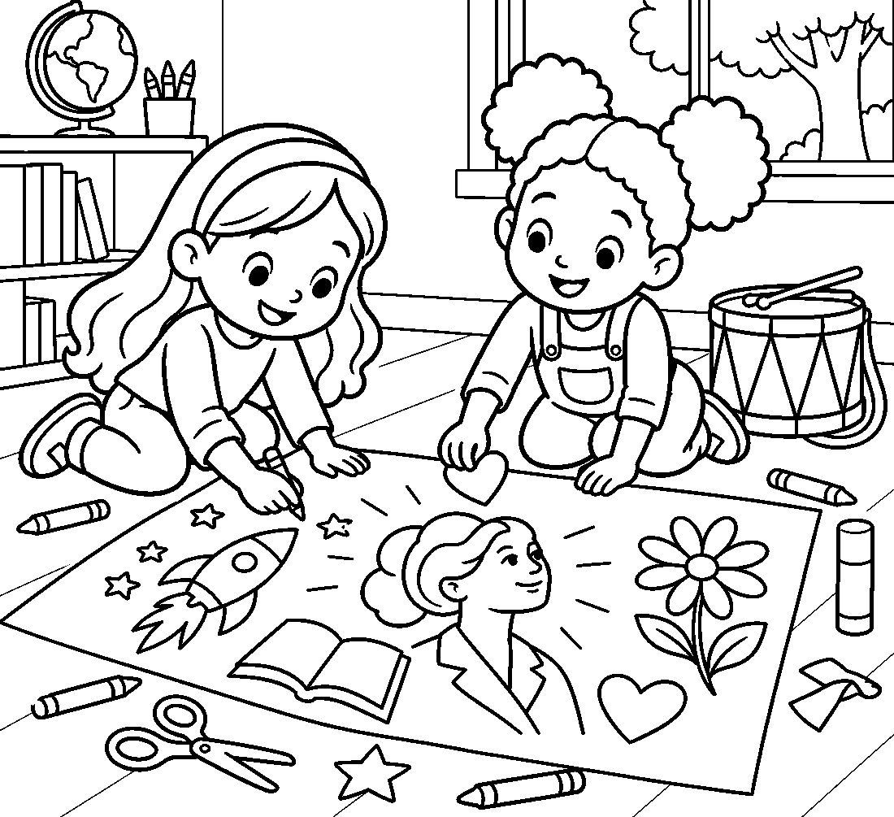

📚 Women's History Month Worksheet
Answer Key 解答
Reading Check: 1.C 2.B 3.D 4.A 5.C 6.B 7.A 8.D
True or False: 1.T 2.F 3.T 4.F 5.T 6.F
Match: 📚=book 🚀=rocket 🔬=microscope 🍁=leaf 🥁=drum 🪙=coin 🎤=microphone 📅=calendar
Unscramble: 1.HISTORY 2.PARADE 3.ESSAY 4.THEME 5.MUSEUM 6.LEADER
Fill in the blanks: (1)March (2)history (3)grandmother (4)questions (5)essay (6)poster (7)museum (8)listen (9)proud (10)famous
Sentence order: 1. Women's History Month is in March. 2. It started as one week in 1978. 3. More than 100 women visited classrooms. 4. Canada celebrates women's history in October. 5. Every year there is a new theme.
Secret Code: WOMEN MAKE HISTORY
Maze: HISTORY
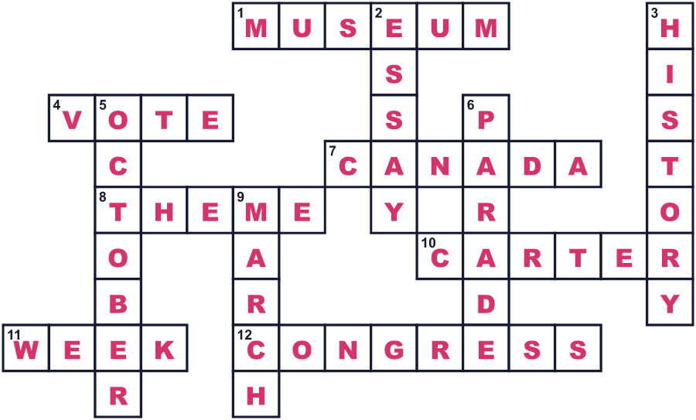
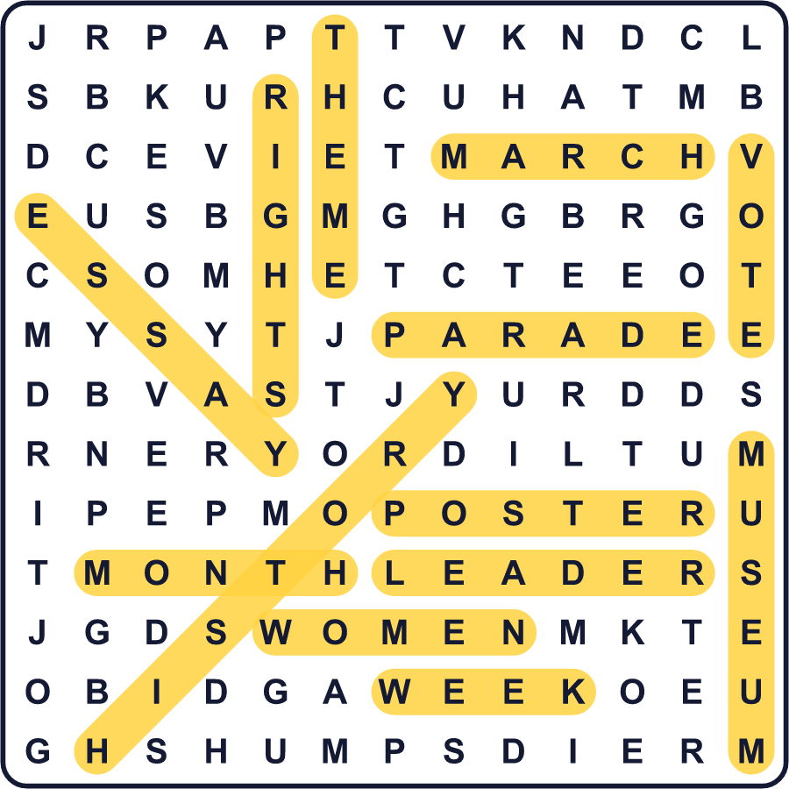
全訳
1 1972年、カリフォルニア州の高校で歴史を教える先生が、生徒からある単純な質問を受けました。「女性運動って何ですか？」その先生、モリー・マーフィー・マグレガーは答えられませんでした。放課後、彼女は大学時代の歴史の本に目を通しました。女性の権利についての章は、たった1冊の本に1章あるだけでした。
2 そこで彼女は、行動を起こすことにしました。1978年、彼女とカリフォルニア州ソノマ郡のほかの女性たちは、地元の学校のために女性史週間を計画しました。選んだのは、国際女性デーである3月8日の週でした。100人を超える女性が教室を訪れ、歴史の中の女性について話しました。何百もの生徒が作文を書き、その週はサンタローザの町のパレードでしめくくられました。
3 このアイデアはすぐに広まりました。1980年、ジミー・カーター大統領は、国じゅうに全国女性史週間を祝うよう呼びかけました。彼は、女性たちの働きはあまりにも多くの場合、気づかれないままだったと書きました。その後、3月をまるごと祝う州がどんどん増えていきました。1986年までに、その数は14州になりました。そして1987年、連邦議会が初めて3月を女性史月間にしました。
4 今では毎年3月に、学校や図書館、博物館が女性たちの物語を紹介しています。生徒たちは科学者や作家、リーダーについて読み、ポスターやレポートを作ります。毎年、全米女性史アライアンスという団体がテーマを選びます。2026年のテーマは、変化を導き、長く続く未来をつくる女性たちについてでした。
5 女性史月間は、アメリカだけの行事ではありません。イギリスの人々も、3月にこの月を祝います。でも、カナダは10月に祝います。1929年10月18日、裁判所が、カナダの女性は法律上の「人」であると判断したのです。このおかげで、女性も上院議員になれるようになりました。そして日本では、1946年に女性が初めて投票した4月10日から、女性週間が始まります。

