🍬 White Day Worksheet
A Sweet Answer from Japan
Read the story. 英文を読もう。
Class ______ No. ____ Name ______________________________
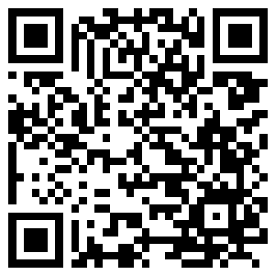
🔊 音声を聞こう（スマホで読みとってね）
1 In many countries, Valentine's Day is one day of love. But in Japan, there are two. On February 14, many women give chocolate to men. Then, one month later on March 14, men give something back. This second day is called White Day.
2 White Day did not come from America or Europe. It was born in Japan in the late 1970s. At that time, Japanese candy makers wanted to sell more sweets in March. A group of candy companies chose March 14 as Candy Day. Their first big event was held in Tokyo in 1980.
3 Other people also say they started it. A sweet shop in Fukuoka sold marshmallows with chocolate inside in 1978. The shop called the day Marshmallow Day. Later, everyone used the same name, White Day. White is the color of sugar and pure love.
4 Today, people give candy, cookies, and marshmallows. Some give flowers, small bags, or jewelry. Many people also give sweets to friends and coworkers to say thank you. Some people say the return gift should cost three times more, but most people do not follow that idea.
5 White Day has also traveled to South Korea, Taiwan, and China. In Korea, men often give big baskets of candy. On April 14, single people there eat black noodles together. But in America and Europe, most people have never heard of White Day. So if a friend from abroad asks, tell them it is a sweet invention from Japan.
Words 単語
return gift（お返し（の贈り物）） / give back（お返しをする、返す） / candy maker（菓子メーカー、菓子職人） / marshmallow（マシュマロ） / coworker（同僚） / custom（習慣、慣習） / invention（発明（品）） / pure（純粋な、けがれのない） / abroad（海外に、海外で） / basket（かご） / jewelry（アクセサリー、宝石類） / cost（（お金が）かかる）

🍬 White Day Worksheet
Reading Check
Choose the best answer. 正しいものを選ぼう。
Class ______ No. ____ Name ______________________________
1. What is the main idea of the passage?
(A) White Day is a Japanese day for giving gifts back. (B) White Day is an old holiday from Europe. (C) White Day is a day for buying white clothes. (D) White Day is a national holiday in Korea.
2. When was the first big Candy Day event held?
(A) In 1970 (B) In 1978 (C) In 1980 (D) In 1988
3. What did the shop in Fukuoka sell?
(A) Cookies with candy on top (B) White chocolate cakes (C) Flowers and cards (D) Marshmallows with chocolate inside
4. Why did candy makers want a new day in March?
(A) They wanted to sell more sweets. (B) They wanted a new national holiday. (C) They wanted to stop Valentine's Day. (D) They wanted to make white clothes popular.
5. In paragraph 5, what does "traveled to" mean?
(A) Took a trip for fun (B) Became popular in (C) Was sold only in (D) Was stopped in
6. Which is true according to the passage?
(A) Only lovers give gifts on White Day. (B) Most people give gifts that cost three times more. (C) Many people give sweets to friends and coworkers. (D) White Day started in America.
7. Why do you think people call White Day "a sweet invention"?
(A) Because it is a very old festival. (B) Because people made it and it is about sweets. (C) Because scientists found it in a lab. (D) Because it is only for children.
8. In the dialogue, why is Daiki buying many cookies?
(A) He wants to eat them on the train. (B) It is Emily's birthday tomorrow. (C) His boss told him to buy them. (D) He wants to give return gifts on White Day.
True or False? T か F に○
1. White Day is on March 14. T / F
2. White Day started in Europe a long time ago. T / F
3. On White Day, people often give candy or cookies. T / F
4. White Day is a national holiday in Japan. T / F
5. White Day is also popular in South Korea. T / F
6. Everyone must give a gift that costs three times more. T / F

🍬 White Day Worksheet
Word Work
単語のれんしゅう
Class ______ No. ____ Name ______________________________
① Match the pictures and the words. 絵と単語を線でむすぼう。
🍬 | ● | ● | ribbon
🍪 | ● | ● | present
🎁 | ● | ● | basket
🎀 | ● | ● | candy
💐 | ● | ● | letter
💌 | ● | ● | flowers
🧺 | ● | ● | chocolate
🍫 | ● | ● | cookie
② Unscramble the words. 並べかえて単語にしよう。
1. N A C Y D (キャンデー、飴) → ____________________
2. I E H W T (白) → ____________________
3. E T U R N R (返す) → ____________________
4. K E O C I O (クッキー) → ____________________
5. I B R N B O (リボン) → ____________________
6. H A S T K N (ありがとう) → ____________________
③ Fill in the blanks. 語群から選んで入れよう。
[ thank / ribbon / smiles / Day / snow / cookies / Christmas / chocolate / card / pumpkin / month / sweet / box ]
Sota is a junior high school student. Last (1) __________ , his classmate Rina gave him some (2) __________ on Valentine's Day. Sota wants to say (3) __________ you. On March 14, which is White (4) __________ , he bakes (5) __________ with his father. They put the cookies in a small (6) __________ with a white (7) __________ . Sota also writes a short (8) __________ . At school, he gives the box to Rina. She (9) __________ and says, "These are so (10) __________ ! You made them yourself?"

🍬 White Day Worksheet
Crossword Puzzle
ヒントを読んでクロスワードを完成させよう。
Class ______ No. ____ Name ______________________________
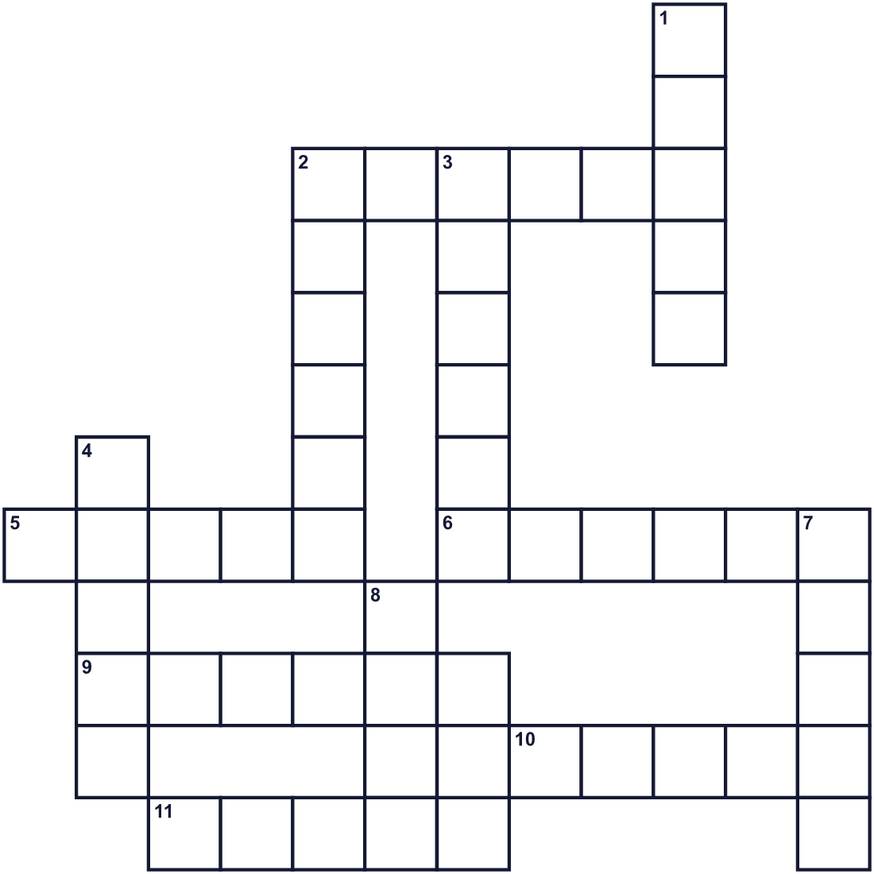
Across →
2. A long, thin piece of cloth for a present. (6)
5. The country where White Day was born. (5)
6. A word you say when someone is kind to you. (6)
9. A small baked sweet. You can make it with flour and butter. (6)
10. A country near Japan. People there give baskets of sweets on March 14. (5)
11. The color of sugar and snow. (5)
Down ↓
1. A small hard sweet. Kids love it. (5)
2. To give or send something back. (6)
3. You can carry fruit or sweets in it. (6)
4. The third month of the year. (5)
7. A sweet white thing. You put it in tea. (5)
8. Another word for a present. (4)

🍬 White Day Worksheet
Word Search
かくれた単語をさがそう（→ ↓ ↘ ↗）
Class ______ No. ____ Name ______________________________
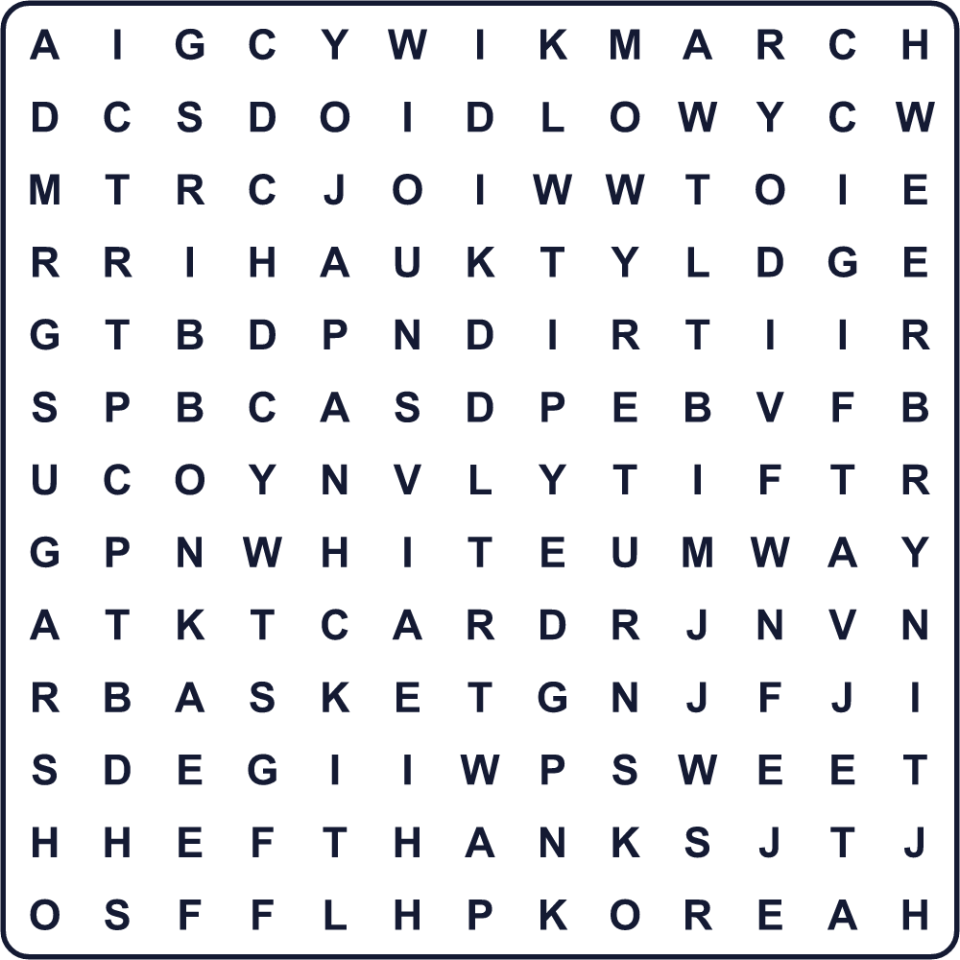
BASKET CANDY CARD COOKIE GIFT JAPAN KOREA MARCH RETURN RIBBON SUGAR SWEET THANKS WHITE
Secret Code 暗号を解こう
♪=A ☺=C ☃=H ⚓=K ✂=M ♦=N ▲=O ⚑=S ★=T ■=U ☂=Y
★ ☃ ♪ ♦ ⚓ ☂ ▲ ■ ⚑ ▲ ✂ ■ ☺ ☃
______________________________________________________________

🍬 White Day Worksheet
Maze & Sentences
Class ______ No. ____ Name ______________________________
Help Ken bring the candy to Aya! ケンがアヤにキャンデーを届けられるように助けよう！
正しい道の文字を集めると、ひみつの言葉になるよ。 START 👦 → GOAL 🍬
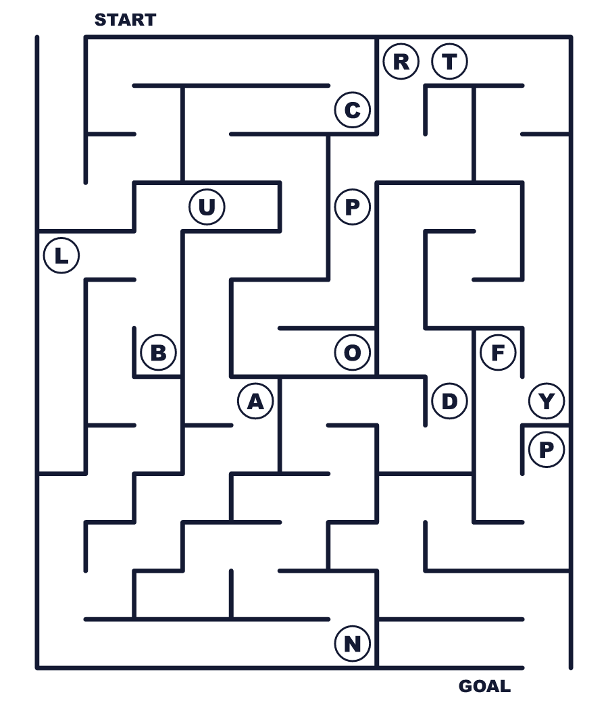
Secret word: ＿ ＿ ＿ ＿ ＿
Put the words in order. 並べかえよう。
1. White / in / Japan / born / Day / was . (ホワイトデーは日本で生まれました。)
______________________________________________________________
2. 14 / give / back / something / March / Men / on . (男性は3月14日にお返しをします。)
______________________________________________________________
3. for / I / my / friends / made / cookies . (私は友だちのためにクッキーを作りました。)
______________________________________________________________
4. chocolate / you / month / for / last / the / Thank . (先月はチョコをありがとう。)
______________________________________________________________
5. give / People / baskets / in / of / Korea / candy . (韓国の人はキャンデーのかごを贈ります。)
______________________________________________________________

🍬 White Day Worksheet
Class Activity & Writing
Class ______ No. ____ Name ______________________________
Find Someone Who… クラスで聞いて回ろう！
Find someone who … | Name
… has given a White Day gift ホワイトデーのお返しをしたことがある
… likes marshmallows マシュマロが好き
… can bake cookies クッキーを焼ける
… knows where White Day was born ホワイトデーがどこで生まれたか知っている
… has written a thank-you card お礼のカードを書いたことがある
… likes white chocolate ホワイトチョコが好き
… knows the date of Pi Day パイ・デーの日付を知っている
… has a friend from South Korea or Taiwan 韓国か台湾の友だちがいる
Let's Write! 英語で書いてみよう。
If I give a White Day gift, I will give ______ to ______ because ______.
ホワイトデーに贈り物をするなら、______に______をあげます。なぜなら______だからです。
______________________________________________________________
______________________________________________________________
I want to say thank you to ______ because ______.
______にありがとうと言いたいです。なぜなら______だからです。
______________________________________________________________
______________________________________________________________
To explain White Day to a friend from abroad, I would say, "______."
海外の友だちにホワイトデーを説明するなら「______」と言います。
______________________________________________________________
______________________________________________________________

🍬 White Day Worksheet
Trace & Color
なぞって書こう。絵に色をぬろう。
Class ______ No. ____ Name ______________________________
🍬 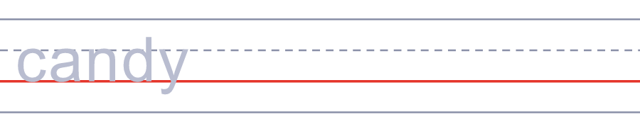

🍪 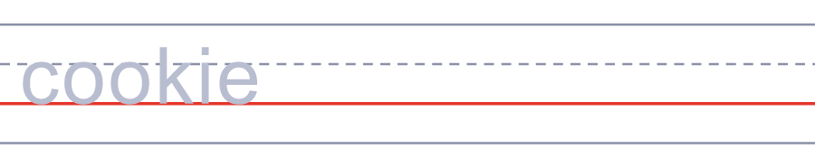
🎁 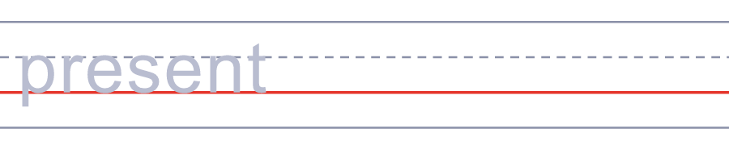
🎀 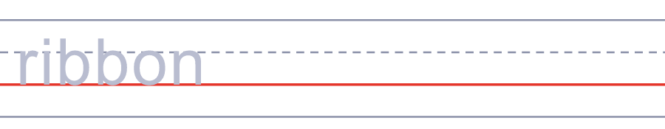
💐 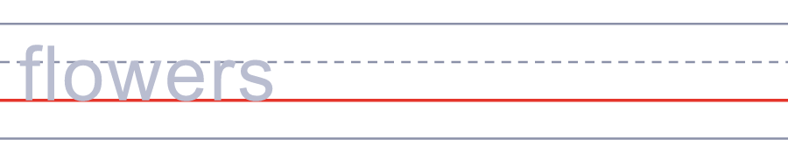
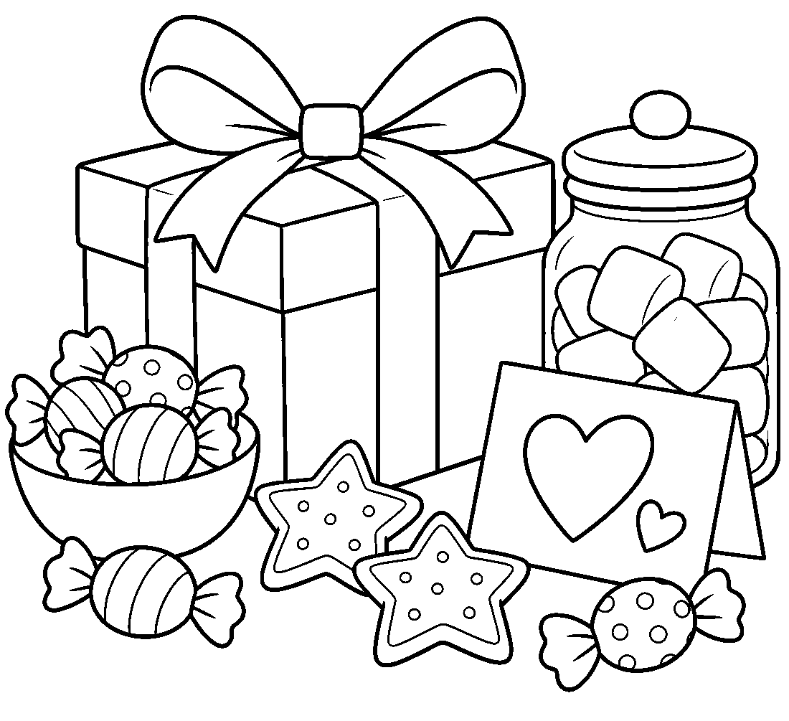

🍬 White Day Worksheet
Answer Key 解答
Reading Check: 1.A 2.C 3.D 4.A 5.B 6.C 7.B 8.D
True or False: 1.T 2.F 3.T 4.F 5.T 6.F
Match: 🍬=candy 🍪=cookie 🎁=present 🎀=ribbon 💐=flowers 💌=letter 🧺=basket 🍫=chocolate
Unscramble: 1.CANDY 2.WHITE 3.RETURN 4.COOKIE 5.RIBBON 6.THANKS
Fill in the blanks: (1)month (2)chocolate (3)thank (4)Day (5)cookies (6)box (7)ribbon (8)card (9)smiles (10)sweet
Sentence order: 1. White Day was born in Japan. 2. Men give something back on March 14. 3. I made cookies for my friends. 4. Thank you for the chocolate last month. 5. People in Korea give baskets of candy.
Secret Code: THANK YOU SO MUCH
Maze: CANDY
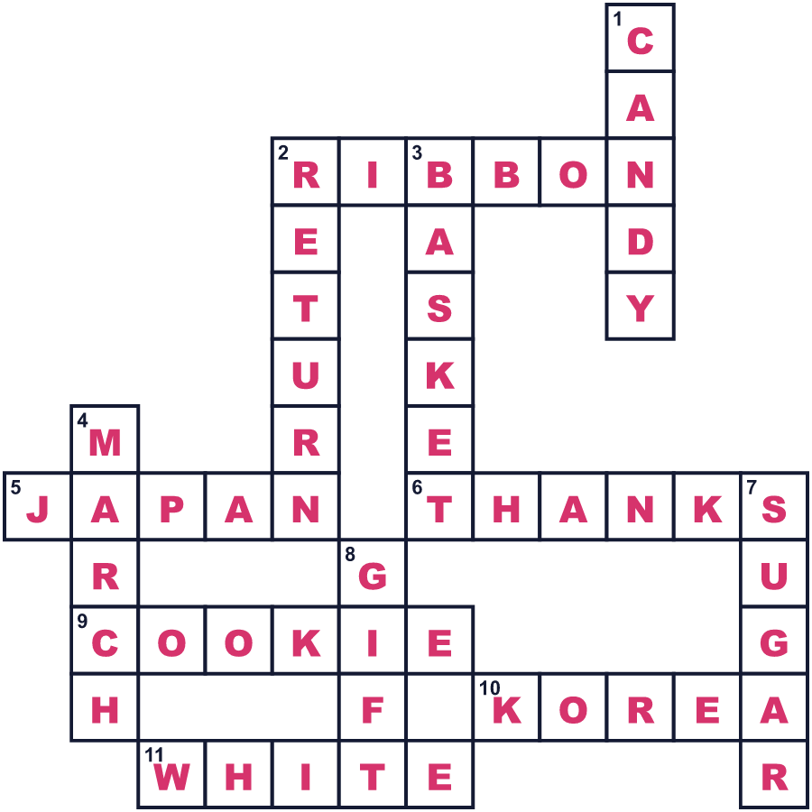
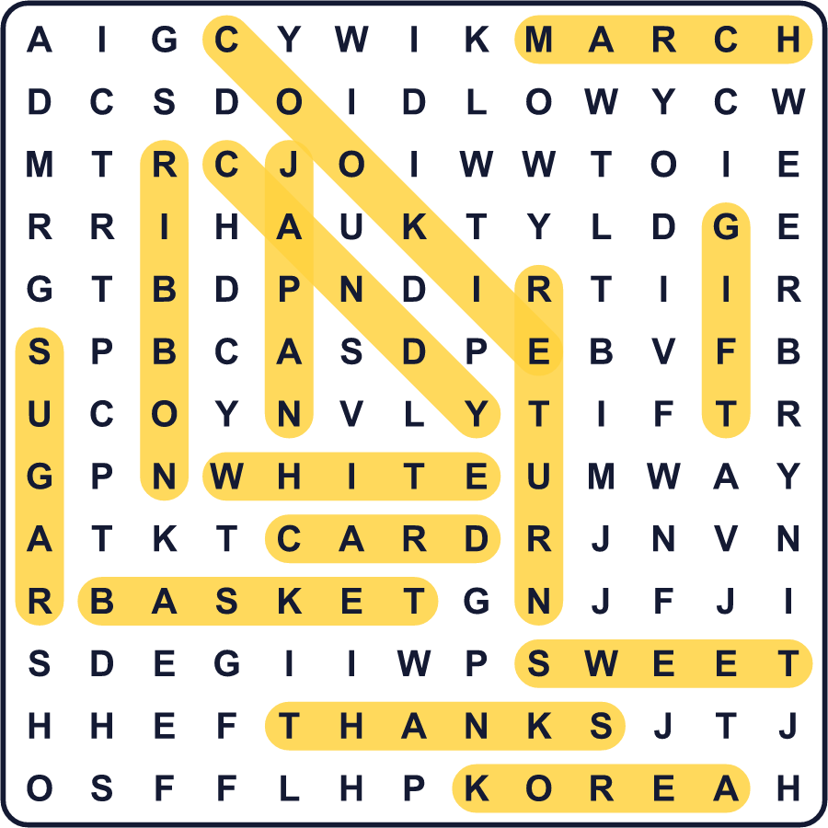
全訳
1 多くの国で、バレンタインデーは愛の日の1日だけです。でも日本には2日あります。2月14日には、多くの女性が男性にチョコレートを贈ります。そして1か月後の3月14日、男性がお返しをします。この2つ目の日をホワイトデーと言います。
2 ホワイトデーはアメリカやヨーロッパから来たのではありません。1970年代後半に日本で生まれました。当時、日本の菓子メーカーは3月にもっとお菓子を売りたいと考えていました。飴メーカーの組合が3月14日を「キャンデーの日」に決めました。1980年には東京で最初の大きなイベントが開かれました。
3 ほかにも「自分たちが始めた」と言う人たちがいます。福岡のお菓子屋さんは、1978年に中にチョコが入ったマシュマロを売り出しました。その店はこの日をマシュマロデーと呼びました。のちに、みんなが同じ名前「ホワイトデー」を使うようになりました。白は砂糖の色であり、純粋な愛の色でもあります。
4 今では、キャンデーやクッキー、マシュマロを贈ります。花や小さなバッグ、アクセサリーを贈る人もいます。友だちや同僚に、ありがとうの気持ちでお菓子を配る人もたくさんいます。お返しは3倍の値段にすべきだと言う人もいますが、ほとんどの人はそうしていません。
5 ホワイトデーは韓国・台湾・中国にも広がりました。韓国では、男性がキャンデーを山もりにした大きなかごを贈ることがよくあります。そして4月14日には、恋人のいない人たちが集まって黒い麺を食べます。でもアメリカやヨーロッパでは、ほとんどの人がホワイトデーを聞いたこともありません。だから海外の友だちに聞かれたら、これは日本生まれの甘い発明だと教えてあげましょう。

