🪷 Vesak Worksheet
Three Big Days Under One Full Moon
Read the story. 英文を読もう。
Class ______ No. ____ Name ______________________________

🔊 音声を聞こう（スマホで読みとってね）
1 On one night in May, the moon is full and round. In many Asian countries, this night is very special. It is Vesak, the most important day for many Buddhists. On this day, they remember the life of the Buddha. Streets glow with lights, and temples are full of flowers and candles.
2 The Buddha was a prince born more than 2,000 years ago in what is now Nepal. He left his rich life to look for an answer to human pain. Later, he sat under a tree and became the Buddha, or the Awakened One. Many Buddhists believe he was born, became awake, and died on the same full moon day.
3 Each country has its own way to celebrate. In Sri Lanka, people hang paper lanterns in front of their homes. Some families give free food to anyone on the street. In Thailand, people walk around the temple three times with candles in their hands. Many people wear white and do not eat meat that day.
4 The date is not the same everywhere, because it follows the moon. In 1999, the United Nations made it an international day. In some years, there are two full moons in May, so countries choose different days. Japan has its own Buddha Day, too, but it is on April 8. It is called Hanamatsuri, the Flower Festival. Children pour sweet tea over a tiny statue of the baby Buddha and smile.
Words 単語
Buddhist（仏教徒） / full moon（満月） / prince（王子） / awake（目が覚めている） / lantern（ちょうちん、ランタン） / temple（寺、寺院） / statue（像） / remember（しのぶ、思い出す）

🪷 Vesak Worksheet
Reading Check
Choose the best answer. 正しいものを選ぼう。
Class ______ No. ____ Name ______________________________
1. What is the main idea of the reading?
(A) Vesak is a Japanese festival for flowers in April. (B) Vesak is a Buddhist day that remembers the Buddha's life. (C) Vesak is a day when people only eat meat and drink tea. (D) Vesak is a new holiday that started in the year 1999.
2. Where was the Buddha born?
(A) In Japan (B) In Thailand (C) In Sri Lanka (D) In what is now Nepal
3. In Thailand, what do people do with candles?
(A) They walk around the temple three times. (B) They hang them in front of their homes. (C) They give them to people on the street. (D) They put them on a statue of the Buddha.
4. Why is the date of Vesak not the same everywhere?
(A) Because the United Nations changes it (B) Because people like different seasons (C) Because it follows the moon (D) Because it moved to April 8
5. In the dialogue, what is a dansala?
(A) A small statue of the baby Buddha (B) A place that gives free food and drinks (C) A paper lantern from Japan (D) A full moon in the month of May
True or False? T か F に○
1. Vesak remembers the birth, awakening, and death of the Buddha. T / F
2. Vesak is always on April 8 in every country. T / F
3. The United Nations made Vesak an international day in 1999. T / F
4. Vesak is a national holiday in Japan. T / F

🪷 Vesak Worksheet
Word Work
単語のれんしゅう
Class ______ No. ____ Name ______________________________
① Match the pictures and the words. 絵と単語を線でむすぼう。
🏮 | ● | ● | lantern
🌕 | ● | ● | tree
🪷 | ● | ● | full moon
🕯 | ● | ● | tea
🌳 | ● | ● | lotus
🍵 | ● | ● | candle
③ Fill in the blanks. 語群から選んで入れよう。
[ temple / lantern / meat / snow / night / white / free / moon / tea / door ]
Tonight is Vesak. Ravi and his sister make a paper (1) __________ at home. They hang it by the (2) __________ . Then the family walks to the (3) __________ . They wear (4) __________ clothes. The (5) __________ is full and bright. On the street, people give (6) __________ food to everyone. Ravi gets a cup of hot (7) __________ . "This is my favorite (8) __________ ," he says.

🪷 Vesak Worksheet
Crossword Puzzle
ヒントを読んでクロスワードを完成させよう。
Class ______ No. ____ Name ______________________________
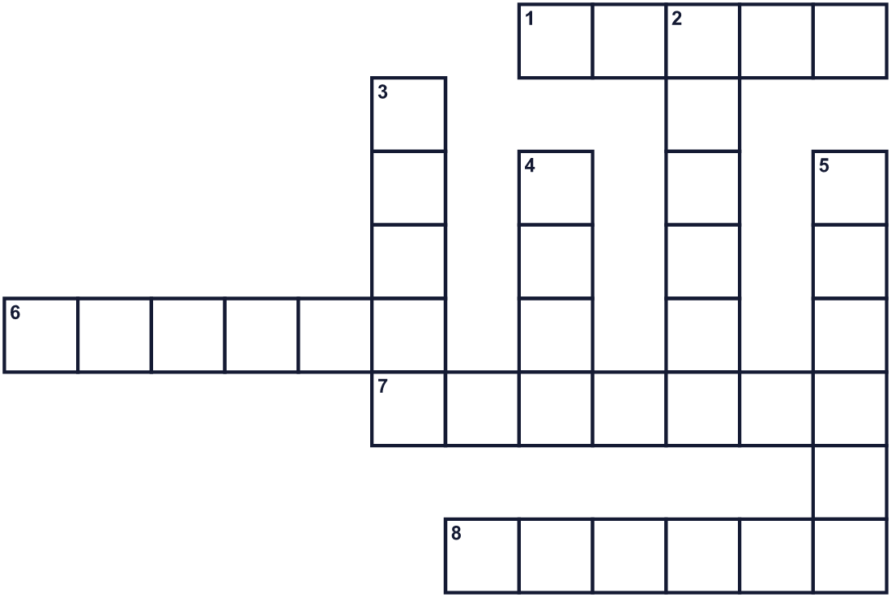
Across →
1. A beautiful flower that grows in muddy water. (5)
6. This word means the Awakened One. (6)
7. A paper light. People hang it by the door. (7)
8. In Japan, people pour sweet tea on a small one. (6)
Down ↓
2. A building where Buddhists pray. (6)
3. The country where the Buddha was born. (5)
4. It is full and round on this special night. (4)
5. The son of a king. (6)

🪷 Vesak Worksheet
Word Search
かくれた単語をさがそう（→ ↓ ↘ ↗）
Class ______ No. ____ Name ______________________________
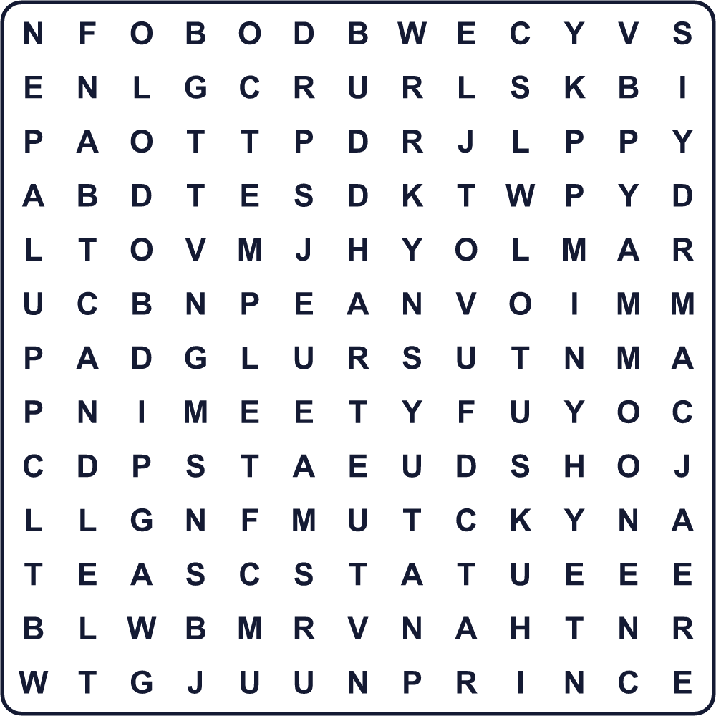
BUDDHA CANDLE LANTERN LOTUS MOON NEPAL PRINCE STATUE TEA TEMPLE

🪷 Vesak Worksheet
Maze & Sentences
Class ______ No. ____ Name ______________________________
Help Ravi bring his lantern to the temple! ラヴィがちょうちんを寺まで運ぶのを手伝おう！
正しい道の文字を集めると、ひみつの言葉になるよ。 START 🧒 → GOAL 🏮
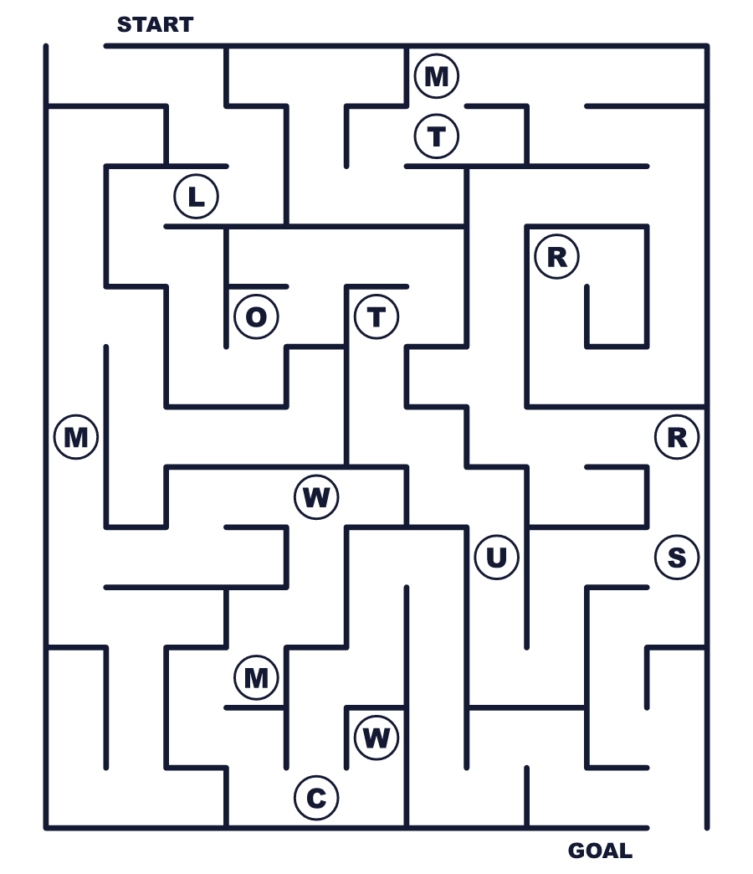
Secret word: ＿ ＿ ＿ ＿ ＿

🪷 Vesak Worksheet
Class Activity & Writing
Class ______ No. ____ Name ______________________________
Let's Write! 英語で書いてみよう。
If I made a Vesak lantern, it would be ______ because ______.
ウェーサーカのちょうちんを作るなら、______なものにしたい。なぜなら______だから。
______________________________________________________________
______________________________________________________________
On a special day, I want to give ______ to ______.
特別な日に、私は______に______をあげたい。
______________________________________________________________
______________________________________________________________

🪷 Vesak Worksheet
Trace & Color
なぞって書こう。絵に色をぬろう。
Class ______ No. ____ Name ______________________________
🏮 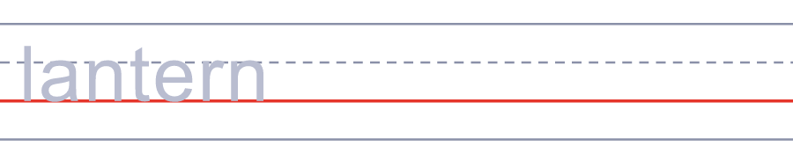

🌕 
🪷 
🕯 
🌳 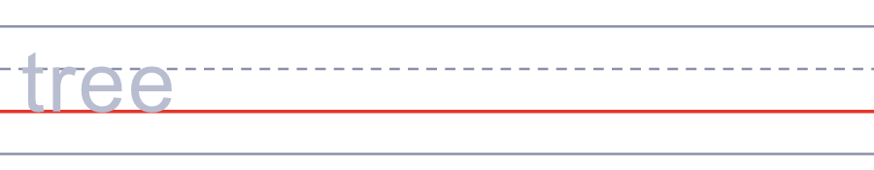

🪷 Vesak Worksheet
Answer Key 解答
Reading Check: 1.B 2.D 3.A 4.C 5.B
True or False: 1.T 2.F 3.T 4.F
Match: 🏮=lantern 🌕=full moon 🪷=lotus 🕯=candle 🌳=tree 🍵=tea
Fill in the blanks: (1)lantern (2)door (3)temple (4)white (5)moon (6)free (7)tea (8)night
Maze: LOTUS
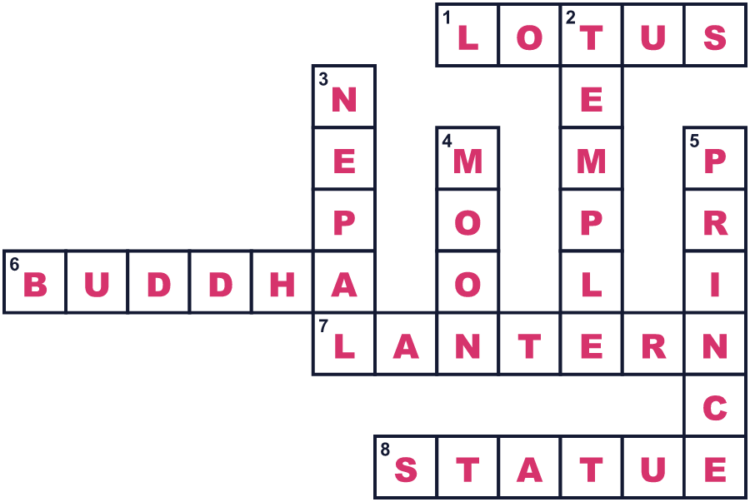
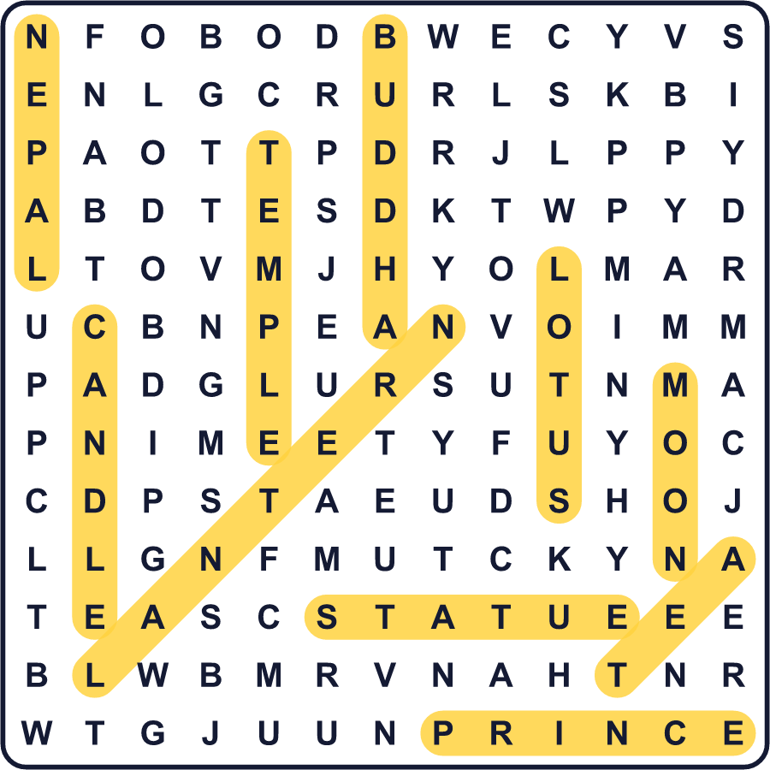
全訳
1 5月のある夜、月がまんまるに満ちます。アジアの多くの国で、この夜はとても特別です。それはウェーサーカ祭。多くの仏教徒にとって、いちばん大切な日です。この日、人々はブッダの生涯をしのびます。通りは明かりで輝き、寺は花とろうそくでいっぱいになります。
2 ブッダは2000年以上前、今のネパールにあたる場所で生まれた王子でした。彼は人間の苦しみへの答えを探すため、豊かな暮らしを捨てました。のちに彼は木の下に座り、ブッダ、つまり「目覚めた人」になりました。多くの仏教徒は、彼が生まれた日、目覚めた日、亡くなった日が、どれも同じ満月の日だったと信じています。
3 国ごとに、それぞれの祝い方があります。スリランカでは、人々が家の前に紙のちょうちんをつるします。通りを行くだれにでも、食べ物を無料でふるまう家族もいます。タイでは、人々がろうそくを手に、寺のまわりを3回歩きます。その日は白い服を着て、肉を食べない人も多くいます。
4 日付はどこでも同じではありません。月の動きに合わせているからです。1999年、国連はこの日を国際的な日にしました。5月に満月が2回ある年もあり、そのときは国によって選ぶ日がちがいます。日本にもブッダの日がありますが、それは4月8日です。花祭り、つまり「花のお祭り」と呼ばれます。子どもたちは赤ちゃんのブッダの小さな像に甘いお茶をかけて、にっこりします。

