💝 Valentine's Day Worksheet
Who Gives Chocolate to Whom?
Read the story. 英文を読もう。
Class ______ No. ____ Name ______________________________
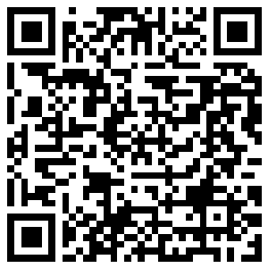
🔊 音声を聞こう（スマホで読みとってね）
1 In February 1958, a chocolate company held a Valentine's sale in a Tokyo department store. In three days, it sold only three chocolate bars and one card. Almost nobody in Japan knew about the day then. Today, stores in Japan are full of chocolate every February.
2 Valentine's Day is on February 14. It takes its name from Saint Valentine, a Christian man in ancient Rome. He was killed for his beliefs, probably in the third century. People tell many love stories about him. But most of them are legends, or old stories that may not be true.
3 The day became a day of love much later. In the 1380s, the English poet Geoffrey Chaucer wrote a poem about birds. In his poem, the birds choose their partners on Saint Valentine's Day. Soon, people in England and France began to send love poems on this day. Some of the oldest ones were written by a French duke in an English prison.
4 In the United States, men and women both give gifts. They send cards, red roses, and chocolate to their partners. Children often give small cards to every classmate. Some people even buy presents for their dogs and cats!
5 Japan is different. Here, women traditionally give chocolate to men. Honmei choco is for the person you really love. Giri choco is for co-workers, and giri means duty. Today, many students give tomo choco to friends, and many adults buy chocolate for themselves. Then on March 14, White Day, people give gifts back.
Words 単語
saint（聖人） / legend（伝説） / belief（信念、信仰） / poet（詩人） / partner（相手、パートナー、恋人） / duke（公爵） / prison（刑務所、牢屋） / classmate（同級生） / traditionally（伝統的に、昔から） / co-worker（同僚、職場の仲間） / duty（義務、務め） / department store（デパート、百貨店）

💝 Valentine's Day Worksheet
Reading Check
Choose the best answer. 正しいものを選ぼう。
Class ______ No. ____ Name ______________________________
1. What is the main idea of the passage?
(A) Valentine's Day is a public holiday in Rome. (B) Valentine's Day has a long history, and countries celebrate it in different ways. (C) Japanese chocolate is the best in the world. (D) Chaucer invented chocolate for Valentine's Day.
2. What did the shop sell at the 1958 sale?
(A) Three chocolate bars and one card (B) Thirty boxes of chocolate (C) One chocolate bar and three cards (D) Nothing at all
3. When did Chaucer write his poem about birds?
(A) In the third century (B) In 1958 (C) In the 1380s (D) In the 1840s
4. Why do the birds matter in Chaucer's poem?
(A) They carry love letters. (B) They eat chocolate. (C) They save Saint Valentine. (D) They choose their partners on Saint Valentine's Day.
5. In paragraph 2, what does "legends" mean?
(A) Famous chocolate shops (B) Old stories that may not be true (C) Letters from prison (D) Christian holidays
6. Which sentence is true about the passage?
(A) In the United States, only women give gifts. (B) Giri choco is for the person you really love. (C) In the United States, children often give cards to all their classmates. (D) White Day is on February 14.
7. What can we guess about Valentine's Day in Japan?
(A) It has changed a lot since 1958. (B) It started in ancient Rome. (C) Men never receive anything. (D) Nobody buys chocolate anymore.
8. In the dialogue, what does Emma plan to do?
(A) Buy flowers for her dad (B) Make chocolate for Haruto too (C) Go back to Canada on White Day (D) Give thirty boxes to her co-workers
True or False? T か F に○
1. Valentine's Day is always on February 14. T / F
2. Valentine's Day is a public holiday in the United States. T / F
3. Geoffrey Chaucer wrote a poem about birds and Saint Valentine's Day. T / F
4. In the United States, only women give Valentine's gifts. T / F
5. In Japan, people give gifts back on March 14. T / F
6. Japan's first Valentine's sale in 1958 sold thousands of chocolates. T / F

💝 Valentine's Day Worksheet
Word Work
単語のれんしゅう
Class ______ No. ____ Name ______________________________
① Match the pictures and the words. 絵と単語を線でむすぼう。
🍫 | ● | ● | arrow
🌹 | ● | ● | bird
💌 | ● | ● | ring
🏹 | ● | ● | strawberry
🎁 | ● | ● | chocolate
💍 | ● | ● | rose
🐦 | ● | ● | gift
🍓 | ● | ● | letter
② Unscramble the words. 並べかえて単語にしよう。
1. U C I P D (愛の神（弓矢を持つ）) → ____________________
2. A R E H T (ハート、心臓) → ____________________
3. S N T I A (聖人) → ____________________
4. P O M E (詩) → ____________________
5. F T G I (贈り物) → ____________________
6. G N D E L E (伝説) → ____________________
③ Fill in the blanks. 語群から選んで入れよう。
[ summer / friends / noodles / February / slowly / Day / card / restaurant / candy / piano / sad / chocolate / smile ]
Sora lives in Seoul, South Korea. On (1) __________ 14, she gave (2) __________ to her friend Minho. A month later, on March 14, Minho gave her (3) __________ . Koreans call this day White (4) __________ . Sora's brother Jun was (5) __________ . Nobody gave him anything on either day. So on April 14, he met his (6) __________ at a small (7) __________ . They all ate black (8) __________ together. "This is Black Day," Jun said with a (9) __________ . "Next year, maybe I will get a (10) __________ !"

💝 Valentine's Day Worksheet
Crossword Puzzle
ヒントを読んでクロスワードを完成させよう。
Class ______ No. ____ Name ______________________________
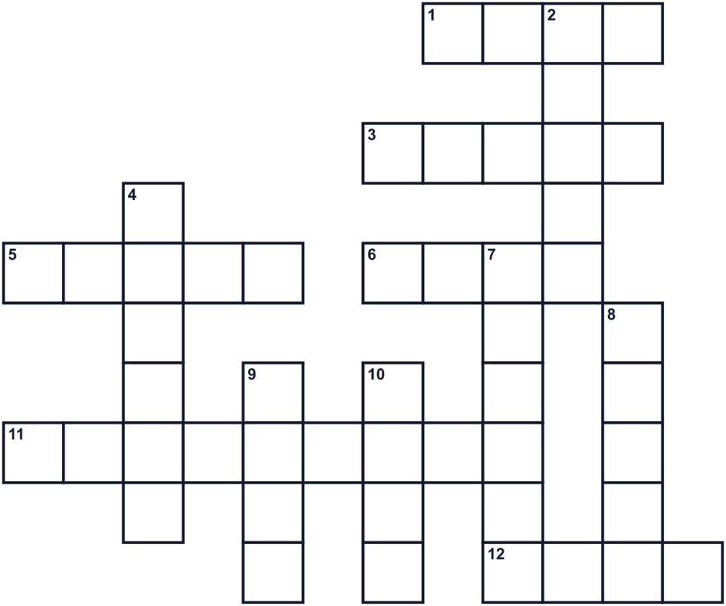
Across →
1. A flower with thorns. Red ones mean love. (4)
3. A little god of love with a bow and arrows. (5)
5. Animals with wings. They choose partners in an old poem. (5)
6. Another word for a present. (4)
11. A sweet brown food made from cocoa. (9)
12. Something you must do. Giri means this. (4)
Down ↓
2. A holy person in the Christian church, like Valentine. (5)
4. A place with locked doors for people who did wrong. (6)
7. A person you like and play with. Tomo choco is for this person. (6)
8. It pumps blood. It is also a symbol of love. (5)
9. Chaucer wrote one about birds. (4)
10. A folded paper with a message for someone. (4)

💝 Valentine's Day Worksheet
Word Search
かくれた単語をさがそう（→ ↓ ↘ ↗）
Class ______ No. ____ Name ______________________________
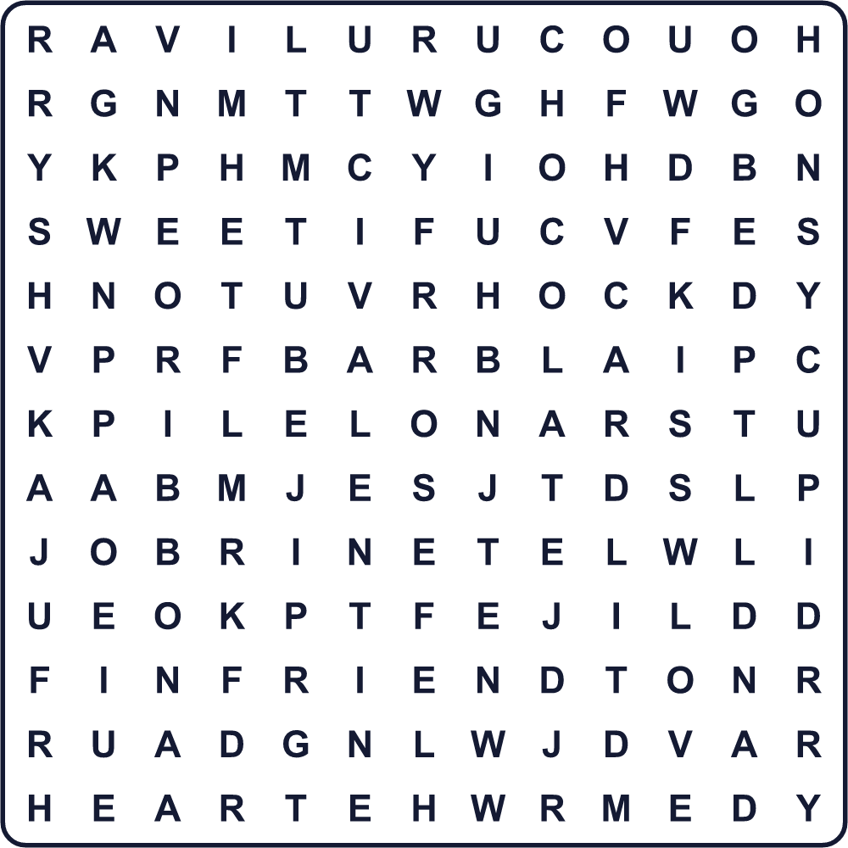
CARD CHOCOLATE CUPID FRIEND GIFT HEART KISS LOVE POEM RIBBON ROSE SWEET VALENTINE
Secret Code 暗号を解こう
⚓=A ☎=B ◎=E ♦=I ◆=L ✿=M ●=N ♪=T ⚑=V ★=Y
☎ ◎ ✿ ★ ⚑ ⚓ ◆ ◎ ● ♪ ♦ ● ◎
______________________________________________________________

💝 Valentine's Day Worksheet
Maze & Sentences
Class ______ No. ____ Name ______________________________
Help Cupid find the heart! キューピッドをハートのところまで連れていこう！
正しい道の文字を集めると、ひみつの言葉になるよ。 START 👼 → GOAL 💝
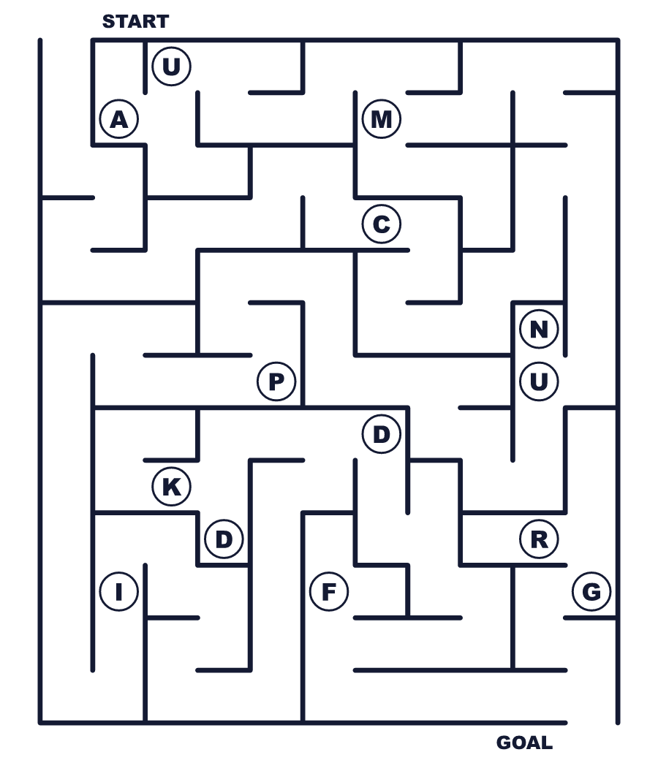
Secret word: ＿ ＿ ＿ ＿ ＿
Put the words in order. 並べかえよう。
1. February / 14 / is / Valentine's / on / Day . (バレンタインデーは2月14日です。)
______________________________________________________________
2. small / give / Children / classmates / to / cards / their . (子どもたちは同級生に小さなカードを配ります。)
______________________________________________________________
3. give / chocolate / traditionally / Women / to / men / in / Japan . (日本では伝統的に女性が男性にチョコを贈ります。)
______________________________________________________________
4. poem / The / birds / the / in / partners / choose / their . (その詩では鳥たちが相手を選びます。)
______________________________________________________________
5. White / People / gifts / back / give / on / Day . (人々はホワイトデーにお返しをします。)
______________________________________________________________

💝 Valentine's Day Worksheet
Class Activity & Writing
Class ______ No. ____ Name ______________________________
Find Someone Who… クラスで聞いて回ろう！
Find someone who … | Name
… has made chocolate at home 家でチョコを作ったことがある
… has given a card to a friend 友だちにカードを渡したことがある
… likes dark chocolate ビターチョコが好き
… knows the date of White Day ホワイトデーの日付を知っている
… can say "I love you" in another language 「愛してる」を英語以外の外国語で言える
… has a pet at home 家でペットを飼っている
… likes strawberries イチゴが好き
… knows who Cupid is キューピッドが誰か知っている
Let's Write! 英語で書いてみよう。
I want to give a Valentine's card to ______ because ______.
私は______にバレンタインカードを贈りたい。なぜなら______だからです。
______________________________________________________________
______________________________________________________________
Roses are red, violets are blue, ______, and so are you.
「バラは赤い、スミレは青い」に続けて、自分だけの詩を作ろう。
______________________________________________________________
______________________________________________________________
I think Japan's giri choco is ______ because ______.
日本の義理チョコは______だと思います。なぜなら______だからです。
______________________________________________________________
______________________________________________________________

💝 Valentine's Day Worksheet
Trace & Color
なぞって書こう。絵に色をぬろう。
Class ______ No. ____ Name ______________________________
🍫 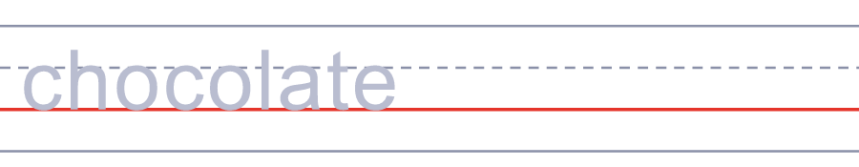

🌹 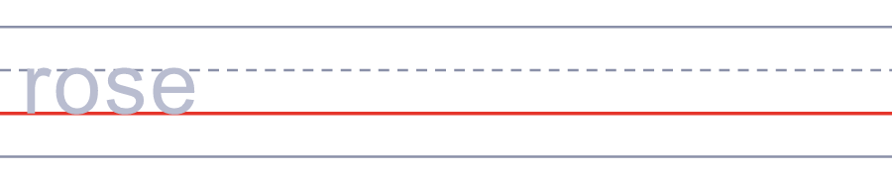
💌 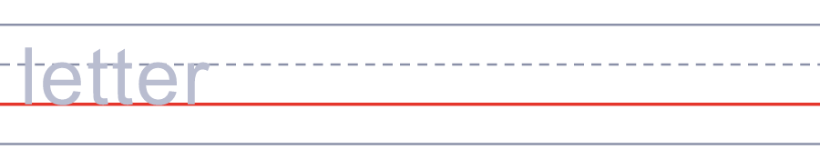
🏹 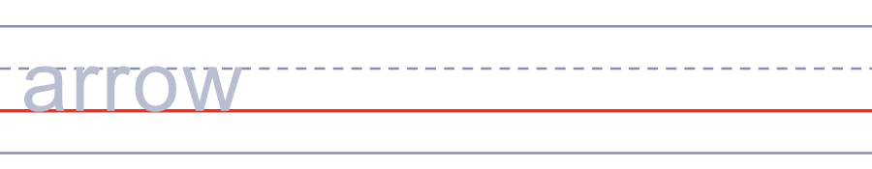
🎁 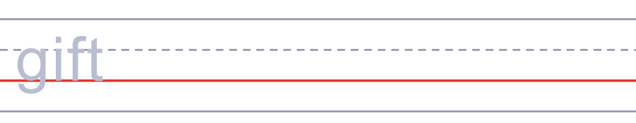
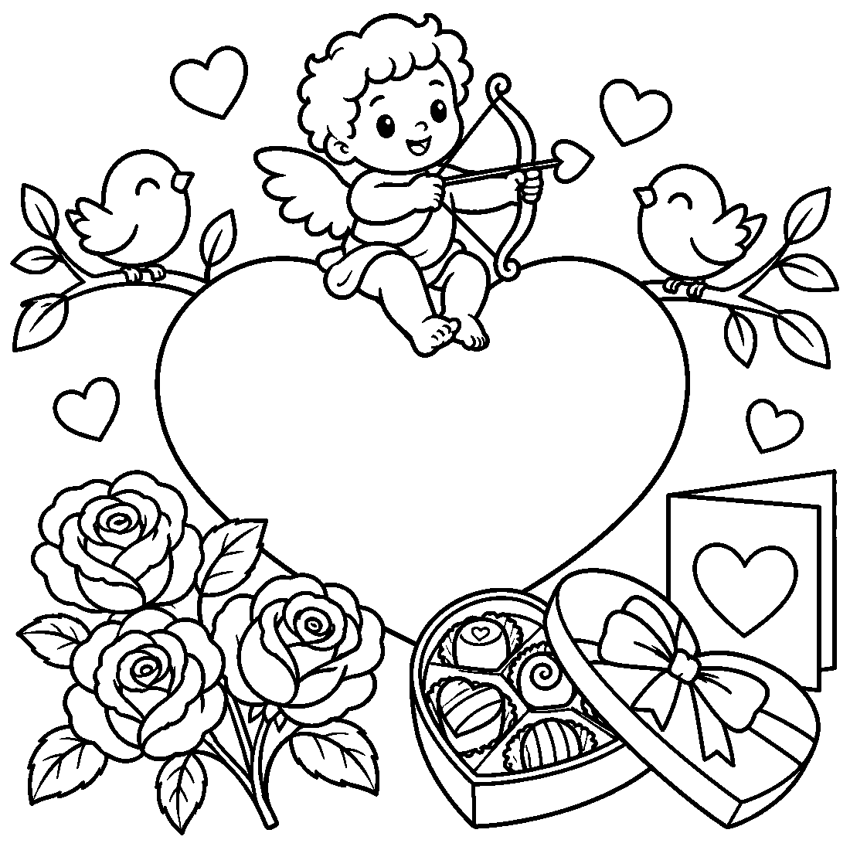

💝 Valentine's Day Worksheet
Answer Key 解答
Reading Check: 1.B 2.A 3.C 4.D 5.B 6.C 7.A 8.B
True or False: 1.T 2.F 3.T 4.F 5.T 6.F
Match: 🍫=chocolate 🌹=rose 💌=letter 🏹=arrow 🎁=gift 💍=ring 🐦=bird 🍓=strawberry
Unscramble: 1.CUPID 2.HEART 3.SAINT 4.POEM 5.GIFT 6.LEGEND
Fill in the blanks: (1)February (2)chocolate (3)candy (4)Day (5)sad (6)friends (7)restaurant (8)noodles (9)smile (10)card
Sentence order: 1. Valentine's Day is on February 14. 2. Children give small cards to their classmates. 3. Women traditionally give chocolate to men in Japan. 4. The birds choose their partners in the poem. 5. People give gifts back on White Day.
Secret Code: BE MY VALENTINE
Maze: CUPID
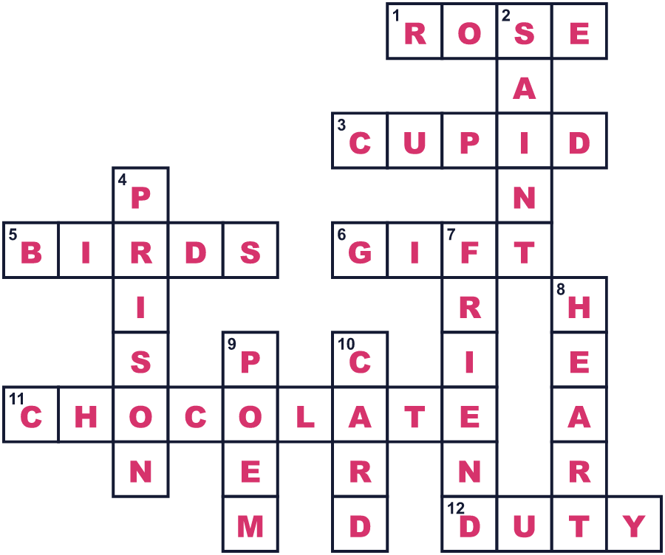
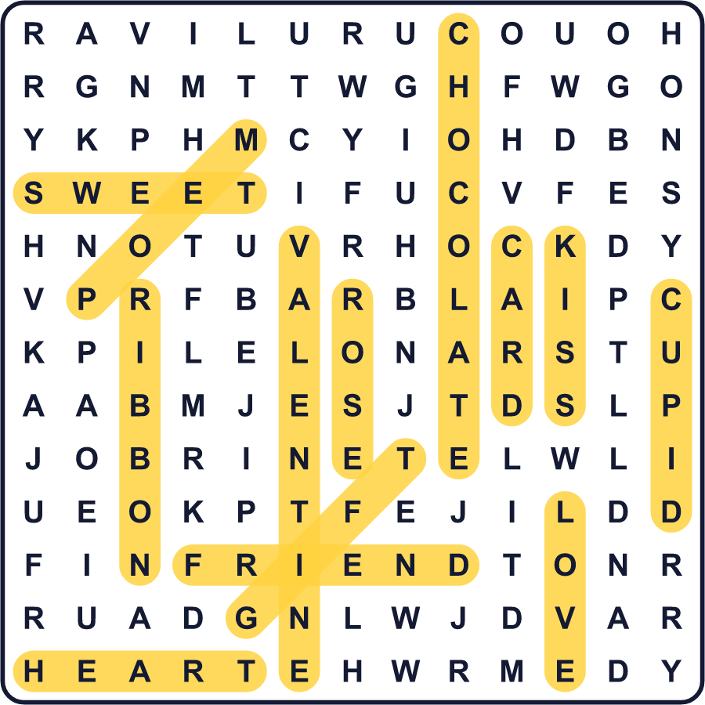
全訳
1 1958年2月、あるチョコレート会社が、東京のデパートでバレンタインセールを開きました。3日間で売れたのは、板チョコ3枚とカード1枚だけでした。当時の日本では、この日を知っている人はほとんどいなかったのです。今では毎年2月、日本の店はチョコレートでいっぱいになります。
2 バレンタインデーは2月14日です。名前は、古代ローマのキリスト教徒、聖バレンタインから来ています。彼は信仰のために殺されました。おそらく3世紀のことです。彼については、恋の話がたくさん語られます。でもそのほとんどは伝説、つまり本当かどうかわからない昔話です。
3 この日が愛の日になったのは、ずっと後のことです。1380年代、イギリスの詩人ジェフリー・チョーサーが鳥の詩を書きました。その詩では、鳥たちが聖バレンタインの日に相手を選ぶのです。やがてイギリスやフランスの人々は、この日に恋の詩を贈るようになりました。現存する最も古いもののいくつかは、イギリスの牢屋にいたフランスの公爵が書いたものです。
4 アメリカでは、男性も女性も贈り物をします。恋人にカードや赤いバラ、チョコレートを贈ります。子どもたちは、よくクラス全員に小さなカードを配ります。犬や猫にプレゼントを買う人までいます！
5 日本はちがいます。日本では伝統的に、女性が男性にチョコレートを贈ります。本命チョコは、本当に好きな人へのチョコです。義理チョコは職場の仲間へのチョコで、「義理」は「おつきあいの務め」という意味です。今では多くの学生が友だちに友チョコを贈り、多くの大人が自分のためにチョコを買います。そして3月14日のホワイトデーに、お返しをします。

