🌊 Marine Day Worksheet
A Holiday That Came by Ship
Read the story. 英文を読もう。
Class ______ No. ____ Name ______________________________

🔊 音声を聞こう（スマホで読みとってね）
1 Japan is a country of islands. It has about 14,000 islands, and the sea is everywhere. So Japan has a national holiday just for the sea. It is called Umi no Hi, or Marine Day, and it comes on the third Monday of July.
2 The story starts with a ship. In the summer of 1876, Emperor Meiji traveled around northern Japan. On the way home, he sailed on the Meiji Maru, a ship that checked lighthouses. The ship sailed from Aomori to Hakodate, and then down the Pacific coast. The ship arrived safely in Yokohama on July 20. Later, people remembered this day as a day for the sea.
3 For many years, it was not a day off. But many people wanted a holiday for the sea, and more than 10 million people signed their names. In 1996, July 20 finally became Marine Day. Since 2003, it has been on a Monday, so people get a three-day weekend.
4 The date moved two more times. Because of the Tokyo Olympics, Marine Day was on July 23 in 2020 and on July 22 in 2021. Both days were Thursdays. Some calendars printed before the change showed the wrong dates.
5 Today, many families go to the beach on Marine Day. Some people visit ships and ports, and others enjoy fresh fish. The Japanese government says no other country has a national holiday for the sea. And the old Meiji Maru still stands in Tokyo, waiting for visitors.
Words 単語
marine（海の） / island（島） / emperor（天皇、皇帝） / sail（航海する、船で行く） / lighthouse（灯台） / arrive（着く） / safely（無事に、安全に） / sign（署名する） / weekend（週末） / port（港） / seafood（魚介類、海の幸） / national holiday（国民の祝日）

🌊 Marine Day Worksheet
Reading Check
Choose the best answer. 正しいものを選ぼう。
Class ______ No. ____ Name ______________________________
1. What is the main idea of the passage?
(A) How to swim in the sea (B) How Marine Day started and how it is celebrated (C) The history of the Tokyo Olympics (D) How to build a lighthouse
2. About how many islands does Japan have?
(A) 140 (B) 14,000 (C) 1,400 (D) 140,000
3. Where did the Meiji Maru arrive on July 20, 1876?
(A) Yokohama (B) Hakodate (C) Aomori (D) Osaka
4. In which year was Marine Day on July 22?
(A) 1996 (B) 2003 (C) 2020 (D) 2021
5. In paragraph 3, what does "signed their names" mean?
(A) sang songs (B) wrote their names to show they agreed (C) changed their names (D) forgot their names
6. Which is true about Marine Day?
(A) It has always been on a Monday. (B) It started in 2020. (C) Since 2003, it has been on a Monday. (D) It is in August.
7. Why did Marine Day move in 2020 and 2021?
(A) Because of the Tokyo Olympics (B) Because of a typhoon (C) Because the Meiji Maru broke (D) Because schools asked for it
8. In the dialogue, when does Sofia want to see the Meiji Maru?
(A) On Saturday (B) On Sunday (C) On Monday (D) On Tuesday
True or False? T か F に○
1. Marine Day is on the third Monday of July. T / F
2. The Meiji Maru arrived in Yokohama on July 20, 1876. T / F
3. Marine Day became a national holiday in 1876. T / F
4. In 2021, Marine Day was on July 22. T / F
5. Many countries have a national holiday for the sea. T / F
6. The Meiji Maru was a ship for checking lighthouses. T / F

🌊 Marine Day Worksheet
Word Work
単語のれんしゅう
Class ______ No. ____ Name ______________________________
① Match the pictures and the words. 絵と単語を線でむすぼう。
🌊 | ● | ● | fish
🚢 | ● | ● | island
🐟 | ● | ● | crab
🐚 | ● | ● | wave
⚓ | ● | ● | shell
🏝️ | ● | ● | dolphin
🦀 | ● | ● | anchor
🐬 | ● | ● | ship
② Unscramble the words. 並べかえて単語にしよう。
1. O E C A N (海、大洋) → ____________________
2. A L N D S I (島) → ____________________
3. H A E B C (浜辺) → ____________________
4. A S L I O R (船乗り) → ____________________
5. A R H O C N (いかり) → ____________________
6. O N Y A D M (月曜日) → ____________________
③ Fill in the blanks. 語群から選んで入れよう。
[ ice / Day / ship / castle / sea / thank / mountain / beach / snow / port / sister / summer / winter ]
It is Marine (1) __________ . Riku and his family drive to the (2) __________ . The sun is hot, and the (3) __________ is blue. Riku swims with his (4) __________ . Then they build a big sand (5) __________ . Dad buys shaved (6) __________ for everyone. In the afternoon, they see a white (7) __________ far away. "Where is it going?" Riku asks. "Maybe to a (8) __________ in another country," says Mom. Before going home, Riku says (9) __________ you to the sea. "See you next (10) __________ !"

🌊 Marine Day Worksheet
Crossword Puzzle
ヒントを読んでクロスワードを完成させよう。
Class ______ No. ____ Name ______________________________
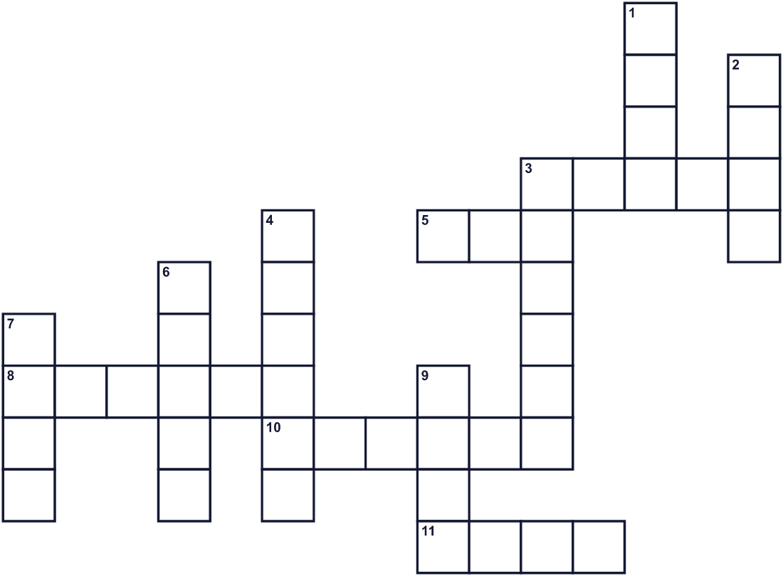
Across →
3. A hard thing on the beach. A small sea animal once lived in it. (5)
5. A very big area of salty water. (3)
8. Land with water all around it. (6)
10. A heavy metal thing that keeps a ship in one place. (6)
11. A place where ships stop. Yokohama is one. (4)
Down ↓
1. Water that moves up and down on the ocean. (4)
2. Marine Day is in this month. (4)
3. A person who works on a ship. (6)
4. Since 2003, Marine Day is usually on this day of the week. (6)
6. A sandy place next to the ocean. (5)
7. It lives in water and swims with fins. (4)
9. A big boat that carries people or things. (4)

🌊 Marine Day Worksheet
Word Search
かくれた単語をさがそう（→ ↓ ↘ ↗）
Class ______ No. ____ Name ______________________________
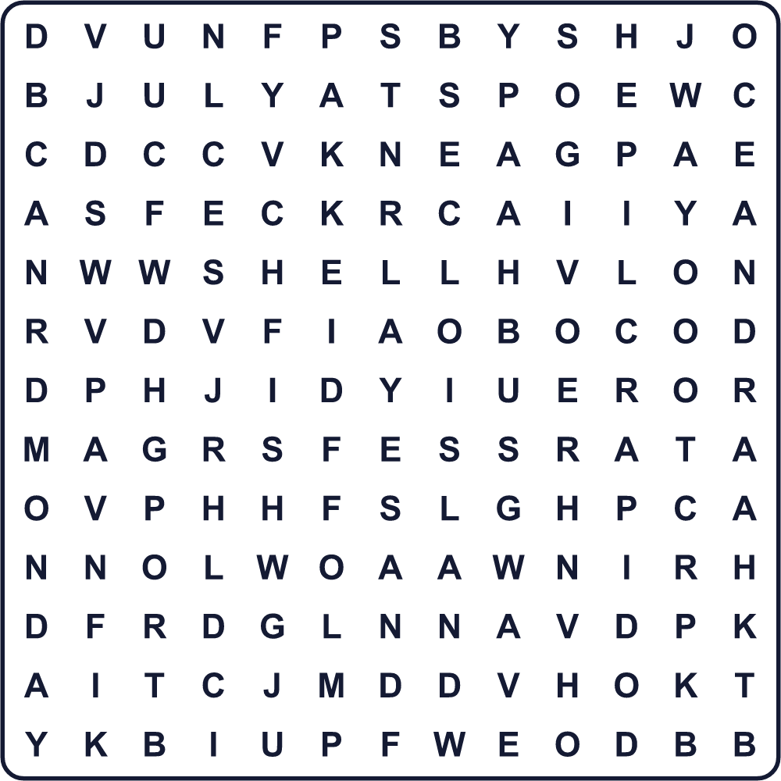
ANCHOR BEACH FISH ISLAND JULY MONDAY OCEAN PORT SAILOR SAND SEA SHELL SHIP WAVE
Secret Code 暗号を解こう
☂=A ✎=E ◎=H ★=K ◆=N ✉=O ✚=S ♦=T ⚑=U ♠=Y
♦ ◎ ☂ ◆ ★ ♠ ✉ ⚑ ✚ ✎ ☂
______________________________________________________________

🌊 Marine Day Worksheet
Maze & Sentences
Class ______ No. ____ Name ______________________________
Help the Meiji Maru sail to Yokohama! 明治丸を横浜まで航海させよう！
正しい道の文字を集めると、ひみつの言葉になるよ。 START 🚢 → GOAL ⚓
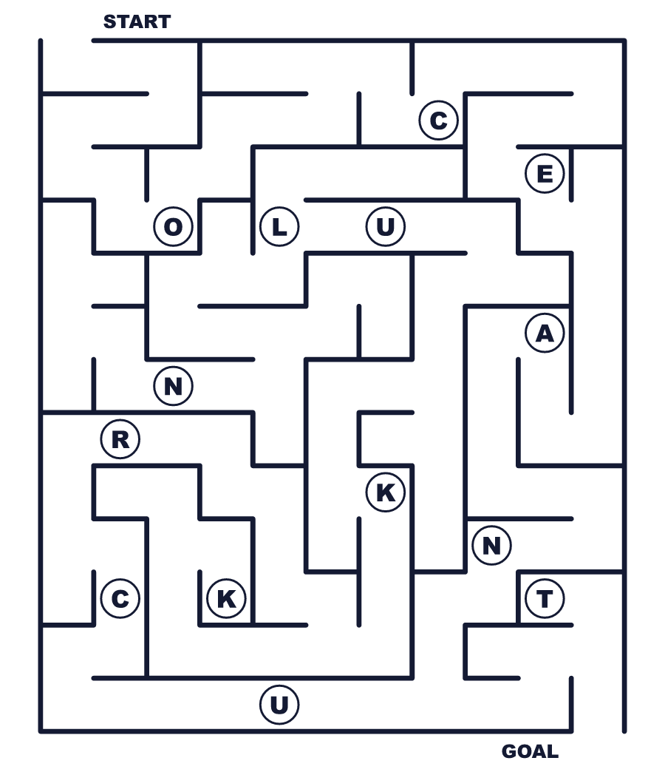
Secret word: ＿ ＿ ＿ ＿ ＿
Put the words in order. 並べかえよう。
1. holiday / a / Marine / is / national / Day . (海の日は国民の祝日です。)
______________________________________________________________
2. ship / in / Yokohama / safely / arrived / The . (その船は無事に横浜に着きました。)
______________________________________________________________
3. Japan / islands / has / thousand / fourteen / about . (日本には約1万4千の島があります。)
______________________________________________________________
4. Monday / the / went / to / beach / We / on . (私たちは月曜日に海へ行きました。)
______________________________________________________________
5. sea / thank / you / say / the / to / Let's . (海にありがとうを言おう。)
______________________________________________________________

🌊 Marine Day Worksheet
Class Activity & Writing
Class ______ No. ____ Name ______________________________
Find Someone Who… クラスで聞いて回ろう！
Find someone who … | Name
… has been on a big ship 大きな船に乗ったことがある
… can swim fifty meters 50メートル泳げる
… likes sushi すしが好き
… has seen a lighthouse 灯台を見たことがある
… knows the date of Marine Day this year 今年の海の日の日付を知っている
… has visited an aquarium 水族館に行ったことがある
… can name three sea animals in English 海の生き物を英語で3つ言える
… has picked up shells on a beach 浜辺で貝がらを拾ったことがある
Let's Write! 英語で書いてみよう。
My favorite thing about the sea is ______ because ______.
海についていちばん好きなことは＿＿です。なぜなら＿＿だからです。
______________________________________________________________
______________________________________________________________
On Marine Day, I want to ______.
海の日に、私は＿＿したいです。
______________________________________________________________
______________________________________________________________
To keep the sea clean, we should ______.
海をきれいに保つために、私たちは＿＿するべきです。
______________________________________________________________
______________________________________________________________

🌊 Marine Day Worksheet
Trace & Color
なぞって書こう。絵に色をぬろう。
Class ______ No. ____ Name ______________________________
🌊 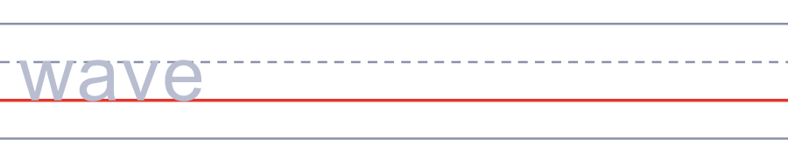

🚢 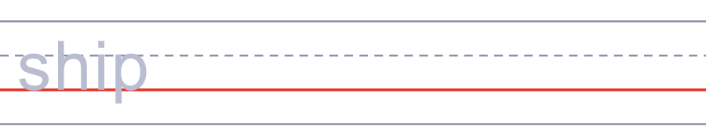
🐟 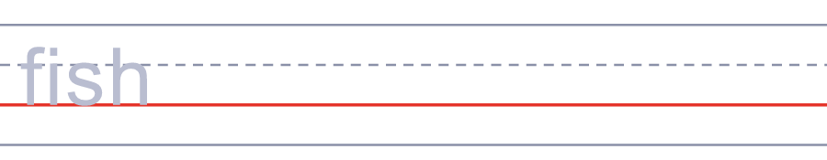
🐚 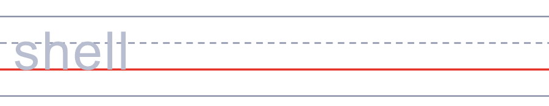
⚓ 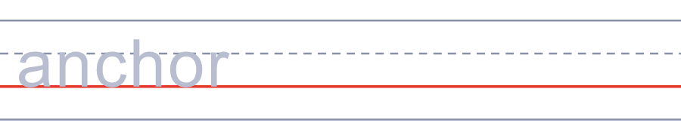
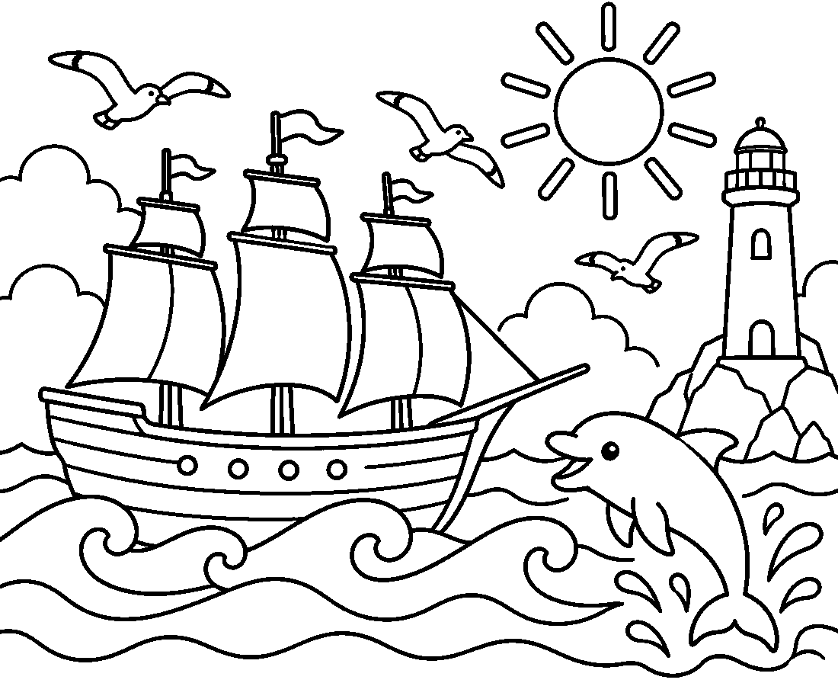

🌊 Marine Day Worksheet
Answer Key 解答
Reading Check: 1.B 2.B 3.A 4.D 5.B 6.C 7.A 8.D
True or False: 1.T 2.T 3.F 4.T 5.F 6.T
Match: 🌊=wave 🚢=ship 🐟=fish 🐚=shell ⚓=anchor 🏝️=island 🦀=crab 🐬=dolphin
Unscramble: 1.OCEAN 2.ISLAND 3.BEACH 4.SAILOR 5.ANCHOR 6.MONDAY
Fill in the blanks: (1)Day (2)beach (3)sea (4)sister (5)castle (6)ice (7)ship (8)port (9)thank (10)summer
Sentence order: 1. Marine Day is a national holiday. 2. The ship arrived in Yokohama safely. 3. Japan has about fourteen thousand islands. 4. We went to the beach on Monday. 5. Let's say thank you to the sea.
Secret Code: THANK YOU SEA
Maze: OCEAN
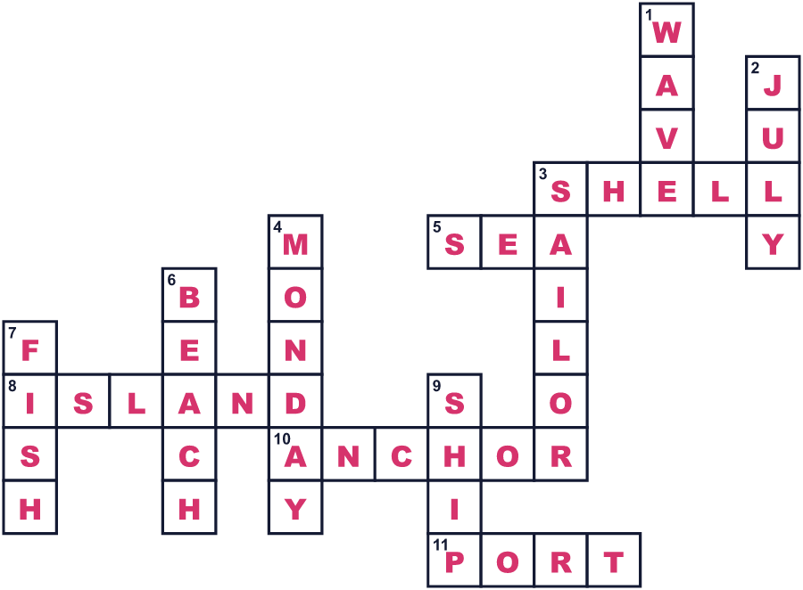
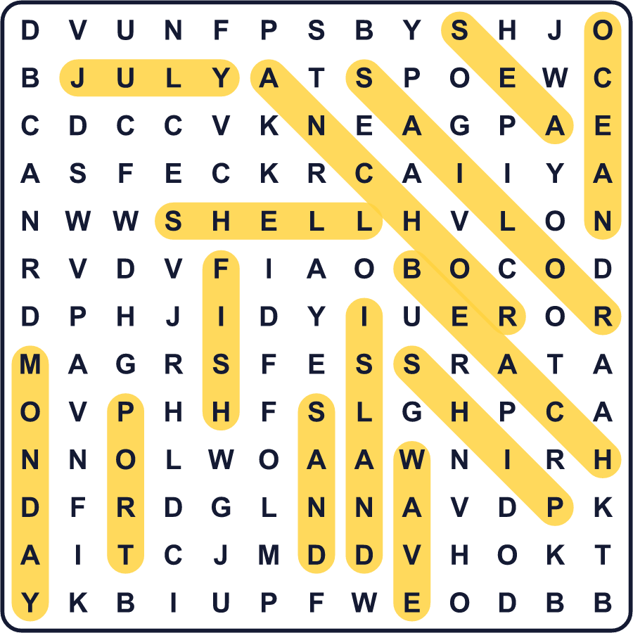
全訳
1 日本は島の国です。約14,000の島があり、海はどこにでもあります。だから日本には、海のためだけの国民の祝日があります。「海の日」、英語で Marine Day と呼ばれ、7月の第3月曜日にやってきます。
2 物語は一隻の船から始まります。1876年の夏、明治天皇は日本の北の地方をめぐる旅をしました。帰り道、天皇は灯台を見回る船、明治丸に乗りました。船は青森から函館へ、そして太平洋の海岸に沿って南へ進みました。船は7月20日に無事に横浜に着きました。のちに人々は、この日を海の記念日として覚えるようになりました。
3 長い間、この日は休みではありませんでした。でも、海の祝日を望む人がたくさんいて、1,000万人をこえる人が署名しました。1996年、7月20日はついに海の日になりました。2003年からは月曜日になったので、人々は3連休を楽しめます。
4 日付はさらに2回動きました。東京オリンピックのため、海の日は2020年は7月23日、2021年は7月22日でした。どちらも木曜日でした。変更の前に印刷されたカレンダーの中には、日付がまちがったままのものもありました。
5 今では、多くの家族が海の日に海へ出かけます。船や港を見に行く人もいれば、新鮮な魚を楽しむ人もいます。日本政府は、海の国民の祝日がある国はほかにないと説明しています。そして古い明治丸は今も東京にあって、訪れる人を待っています。

