☔ Tsuyu (Rainy Season) Worksheet
Plum Rain and a Little White Doll
Read the story. 英文を読もう。
Class ______ No. ____ Name ______________________________

🔊 音声を聞こう（スマホで読みとってね）
1 In June, the sky in much of Japan turns gray. It rains on many days for more than a month. This is the rainy season, called tsuyu. The kanji for tsuyu mean plum and rain. Many people say this is because plums get ripe at this time. Some people say the name first came from another word for mold.
2 Old Japanese calendars have a special day called nyubai. It means entering the rainy season. Today, this day is decided by the position of the sun. It is usually around June 11. Farmers used it as a sign to get ready for planting rice.
3 But the real rain does not read calendars. So the weather office in Japan watches the sky and says when the rainy season has started in each area. In Okinawa, it usually starts in early May. In Hokkaido, there is no official rainy season at all. Every September, the office checks the summer weather again and sometimes changes the dates.
4 Children have their own way to stop the rain. They make a teru teru bozu, a small white doll of paper or cloth. They hang it by the window and wish for a sunny day. The idea may come from China, where a paper girl with a broom sweeps the clouds away. And if you hang the doll upside down, you are asking for rain!
Words 単語
rainy season（雨季、梅雨） / plum（梅、プラム） / ripe（熟した） / mold（カビ） / position（位置） / official（公式の、正式な） / hang（つるす、かける） / upside down（さかさまに）

☔ Tsuyu (Rainy Season) Worksheet
Reading Check
Choose the best answer. 正しいものを選ぼう。
Class ______ No. ____ Name ______________________________
1. What is the passage mainly about?
(A) How to grow plums in Japan (B) The rainy season in Japan and a doll for sunny weather (C) Why Hokkaido has the most rain in Japan (D) How to make a paper ghost for Halloween
2. When is nyubai usually?
(A) around May 10 (B) around June 7 (C) around June 11 (D) around July 19
3. What does the weather office do every September?
(A) It checks the summer weather again. (B) It starts the rainy season in Hokkaido. (C) It makes teru teru bozu for children. (D) It decides the position of the sun.
4. In paragraph 1, what does ripe mean in plums get ripe?
(A) small and hard (B) wet from rain (C) sold in shops (D) ready to eat
5. Why does Haruki tell Mia not to hang the doll upside down?
(A) Because it will fall down. (B) Because it means you want rain. (C) Because it looks like a ghost. (D) Because the window is too small.
True or False? T か F に○
1. Nyubai is usually around June 11. T / F
2. Hokkaido has a long official rainy season. T / F
3. A teru teru bozu is a doll for sunny weather. T / F
4. The weather office never changes the dates. T / F

☔ Tsuyu (Rainy Season) Worksheet
Word Work
単語のれんしゅう
Class ______ No. ____ Name ______________________________
① Match the pictures and the words. 絵と単語を線でむすぼう。
☔ | ● | ● | sun
🐌 | ● | ● | broom
🐸 | ● | ● | frog
☁️ | ● | ● | umbrella
🌞 | ● | ● | snail
🧹 | ● | ● | cloud
③ Fill in the blanks. 語群から選んで入れよう。
[ upside / sun / soccer / face / snow / paper / June / window ]
It is (1) __________ . It rains every day. Sora wants to play (2) __________ on Saturday. So she makes a teru teru bozu with white (3) __________ . She draws a smiling (4) __________ on it. Then she hangs it by the (5) __________ . On Saturday, the sky is blue. "Thank you!" Sora says. The (6) __________ is shining!

☔ Tsuyu (Rainy Season) Worksheet
Crossword Puzzle
ヒントを読んでクロスワードを完成させよう。
Class ______ No. ____ Name ______________________________
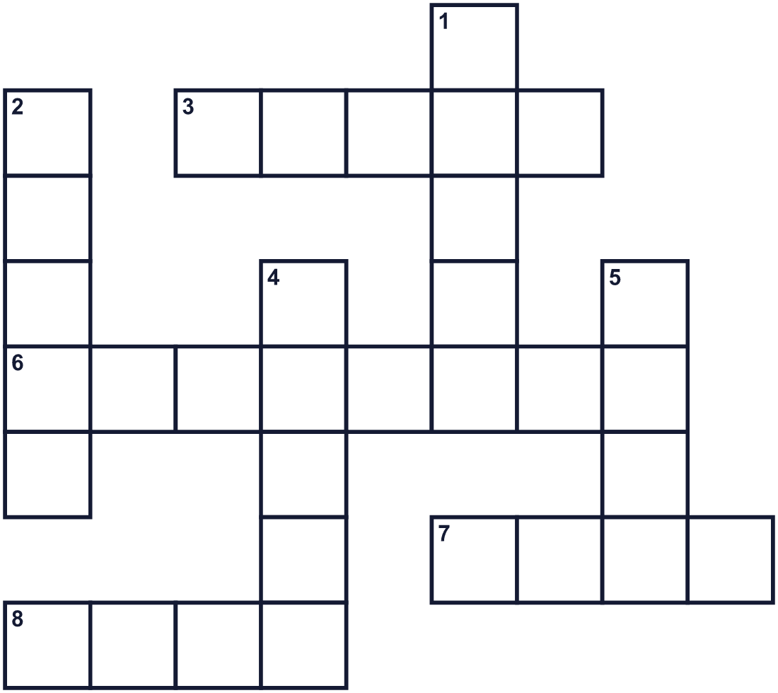
Across →
3. The weather is bright, and there are no clouds. (5)
6. You hold it over your head on wet days. (8)
7. The sixth month of the year. (4)
8. A small round fruit. Its tree has pink or white flowers in early spring. (4)
Down ↓
1. A small slow animal with a shell on its back. (5)
2. It is white or gray and floats in the sky. (5)
4. You use it to sweep the floor. (5)
5. Water that falls from the sky. (4)

☔ Tsuyu (Rainy Season) Worksheet
Word Search
かくれた単語をさがそう（→ ↓ ↘ ↗）
Class ______ No. ____ Name ______________________________
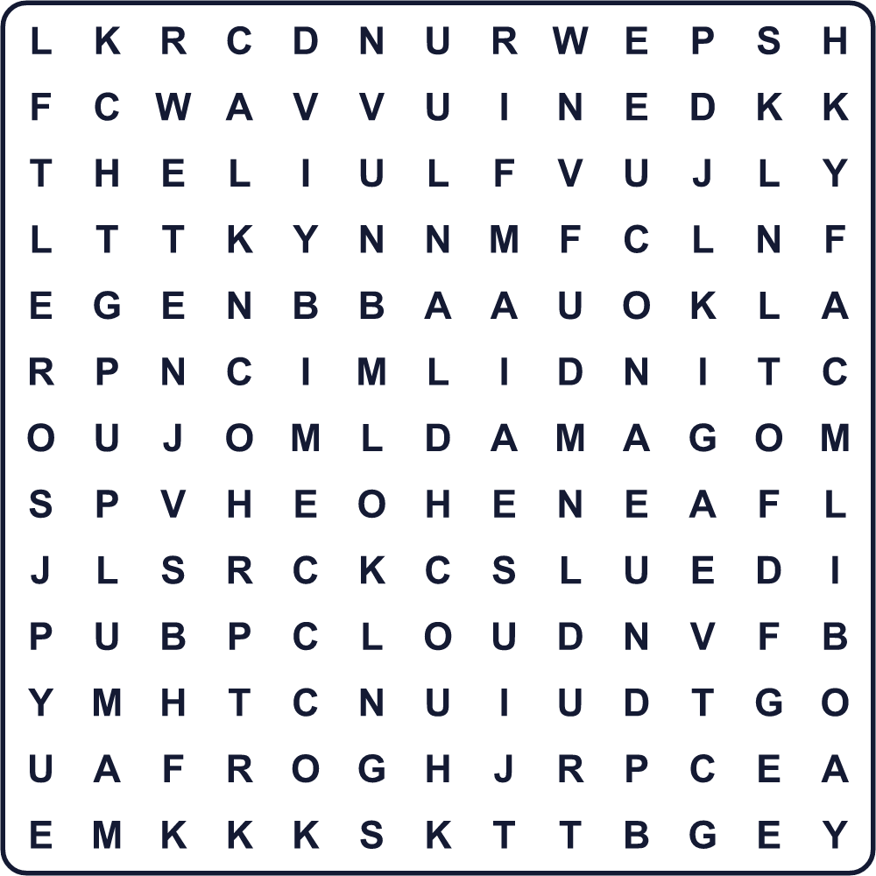
CLOUD DOLL FROG JUNE PLUM RAIN SNAIL SUNNY UMBRELLA WET

☔ Tsuyu (Rainy Season) Worksheet
Maze & Sentences
Class ______ No. ____ Name ______________________________
Help Sora get home before the rain! ソラが雨の前に家に帰れるように助けよう！
正しい道の文字を集めると、ひみつの言葉になるよ。 START 👧 → GOAL 🏠
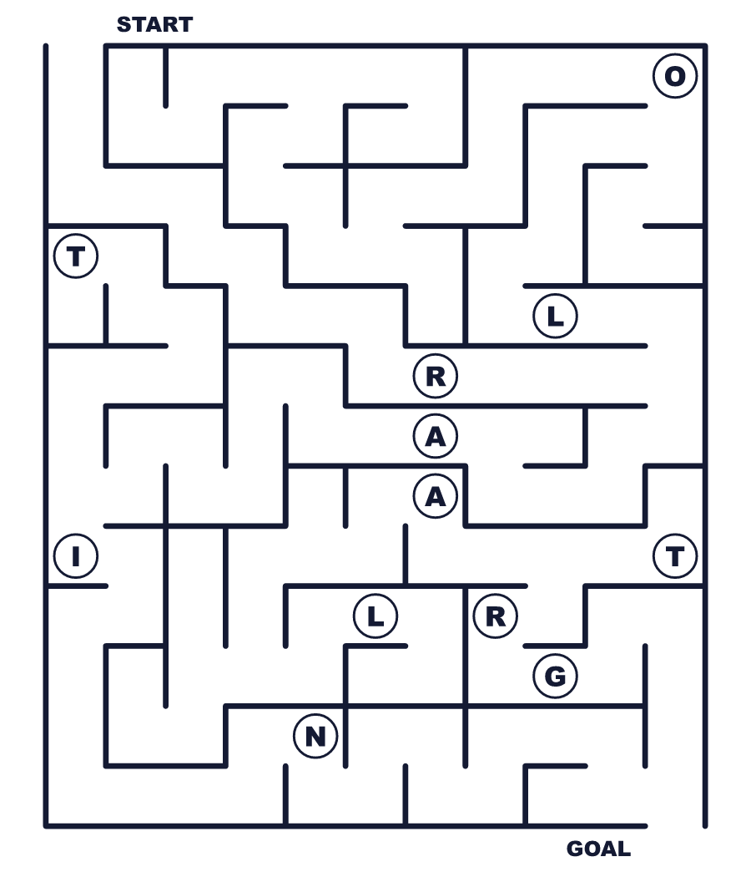
Secret word: ＿ ＿ ＿ ＿

☔ Tsuyu (Rainy Season) Worksheet
Class Activity & Writing
Class ______ No. ____ Name ______________________________
Let's Write! 英語で書いてみよう。
On a rainy day, I like to ______ because ______.
雨の日に、私は______するのが好きです。なぜなら______だからです。
______________________________________________________________
______________________________________________________________
If I made a teru teru bozu, I would wish for a sunny day for ______.
てるてる坊主を作るなら、______のために晴れを願います。
______________________________________________________________
______________________________________________________________

☔ Tsuyu (Rainy Season) Worksheet
Trace & Color
なぞって書こう。絵に色をぬろう。
Class ______ No. ____ Name ______________________________
☔ 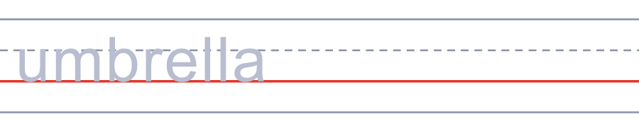

🐌 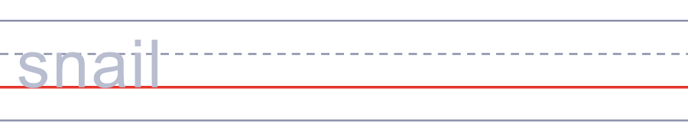
🐸 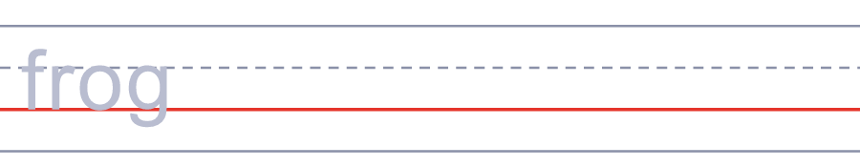
☁️ 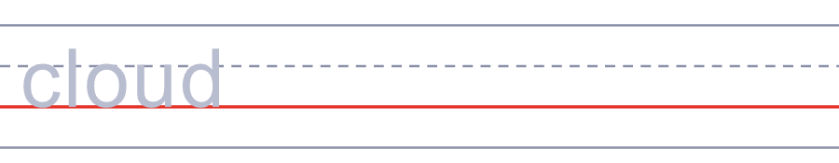
🌞 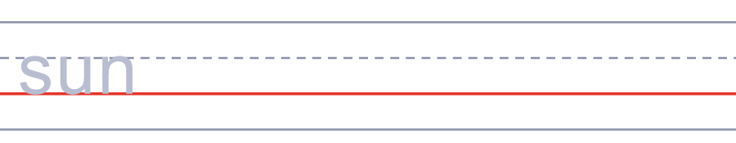

☔ Tsuyu (Rainy Season) Worksheet
Answer Key 解答
Reading Check: 1.B 2.C 3.A 4.D 5.B
True or False: 1.T 2.F 3.T 4.F
Match: ☔=umbrella 🐌=snail 🐸=frog ☁️=cloud 🌞=sun 🧹=broom
Fill in the blanks: (1)June (2)soccer (3)paper (4)face (5)window (6)sun
Maze: RAIN
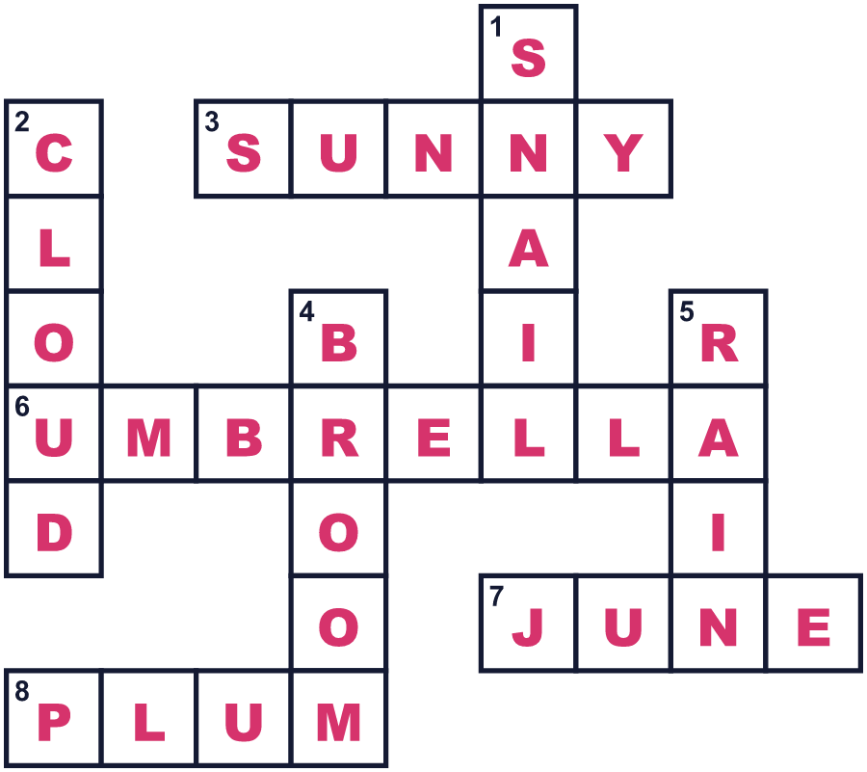
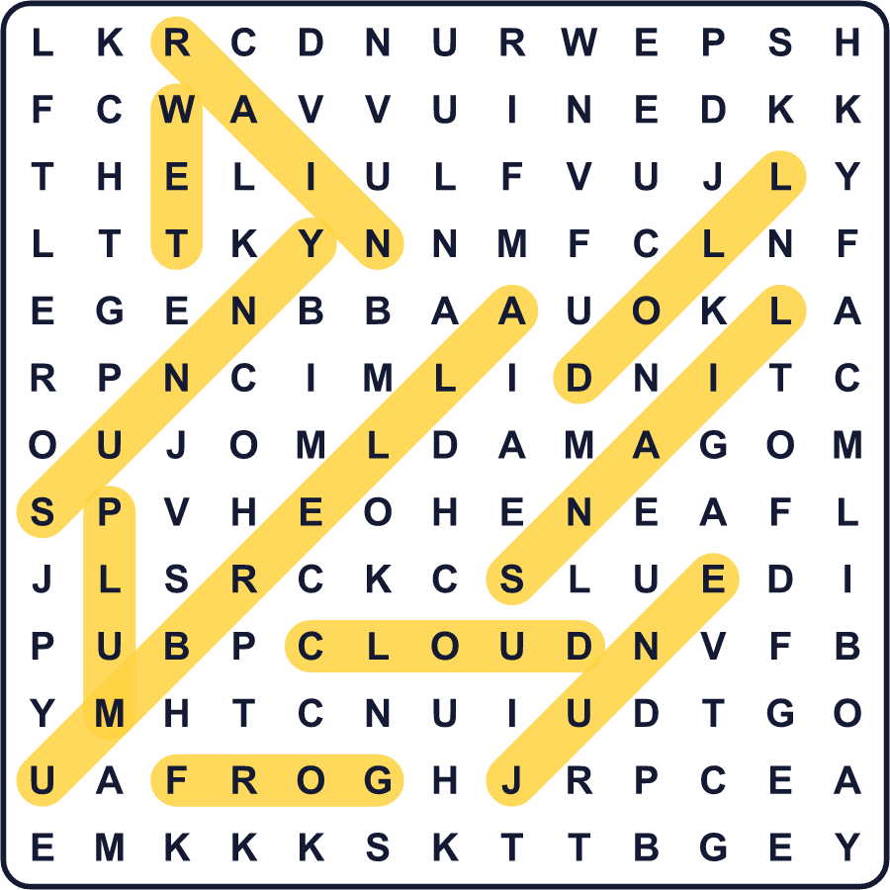
全訳
1 6月、日本の多くの地域で空が灰色になります。1か月以上のあいだ、雨の日が多くなります。これが雨の季節、梅雨です。梅雨の漢字は「梅」と「雨」です。このころに梅の実が熟すからだ、と多くの人が言います。名前はもともとカビを表す別の言葉から来た、と言う人もいます。
2 日本の昔からの暦には、入梅という特別な日があります。梅雨に入る、という意味です。今では、この日は太陽の位置で決まります。たいてい6月11日ごろです。農家はこれを田植えの準備をする目印に使いました。
3 でも、本物の雨は暦を読みません。そこで日本の気象庁は空を見て、それぞれの地域でいつ梅雨に入ったかを発表します。沖縄ではたいてい5月のはじめに始まります。北海道には、正式な梅雨がまったくありません。毎年9月、気象庁は夏の天気をもう一度確かめ、日付を変えることもあります。
4 子どもたちには、雨を止める自分たちの方法があります。てるてる坊主を作るのです。紙や布でできた小さな白い人形です。窓のそばにつるして、晴れの日を願います。この考えは中国から来たのかもしれません。中国では、ほうきを持った紙の女の子が雲をはき出してくれるのです。そして、人形をさかさまにつるすと、雨をお願いしていることになるのです！

