🎑 Tsukimi (Moon Viewing) Worksheet
A Rabbit on the Moon: Tsukimi in Japan
Read the story. 英文を読もう。
Class ______ No. ____ Name ______________________________

🔊 音声を聞こう（スマホで読みとってね）
1 Look up at the moon on a clear autumn night. Can you see a rabbit? In Japan, people say a rabbit lives on the moon and makes rice cakes. Each fall, families put out food for the moon and enjoy its light. This custom is called tsukimi, or moon viewing.
2 Tsukimi came from China a long time ago. The oldest record of a moon party in Japan is from 859. Rich people at the palace wrote poems and played music under the moon. Some of them sat in boats and looked at the moon in the water. In an old story from the same time, Princess Kaguya goes back to the moon on this very night.
3 Today, tsukimi is on the 15th night of the eighth month of the old moon calendar. It is usually in September or early October. Families put round rice dumplings and tall grass called susuki by the window. Some people also offer taro, because it is harvest time.
4 Here is a fun fact. The moon on this night is not always full. In 2026, tsukimi was on September 25, but the full moon came two days later. This happens because the moon often takes more than 14 days to grow full, and the number of days changes every month. So the 15th night and the full moon are often one or two days apart.
5 Many countries in Asia enjoy the same moon. Chinese families eat mooncakes, and Koreans go back to their hometowns for Chuseok. In Vietnam, children walk through the streets with bright lanterns. So next time you see the autumn moon, say hello to the rabbit!
Words 単語
moon viewing（月見） / full moon（満月） / custom（習慣、風習） / rice cake（餅） / dumpling（団子） / offer（供える） / harvest（収穫） / palace（宮殿、宮廷） / poem（詩） / calendar（暦） / lantern（灯籠、ちょうちん） / mooncake（月餅）

🎑 Tsukimi (Moon Viewing) Worksheet
Reading Check
Choose the best answer. 正しいものを選ぼう。
Class ______ No. ____ Name ______________________________
1. What is the main idea of the reading?
(A) Rabbits in Japan eat rice cakes in the fall. (B) Moon viewing is an autumn custom in Japan with a long history. (C) Japanese people go to China to see the moon. (D) The full moon in Japan always comes on September 15.
2. When is the oldest record of a moon party in Japan from?
(A) 2026. (B) 1135. (C) 859. (D) 1991.
3. What did rich people at the palace do under the moon?
(A) They wrote poems and played music. (B) They made mooncakes. (C) They walked with lanterns. (D) They had a barbecue.
4. In 2026, when was the full moon?
(A) On September 23. (B) On September 25. (C) On September 15. (D) Two days after September 25.
5. In paragraph 3, what does "offer" mean?
(A) To sell something. (B) To give something as a gift to a god or the moon. (C) To throw something away. (D) To cook something.
6. Which sentence matches the reading?
(A) Tsukimi started in Brazil. (B) Tsukimi is always in August. (C) Children in Vietnam walk with lanterns. (D) The moon on this night is always full.
7. Why do some people offer taro?
(A) Because taro looks like a rabbit. (B) Because the moon likes potatoes. (C) Because it is the time to harvest taro. (D) Because taro is from China.
8. In the dialogue, what does Lucas say some people in Brazil see on the moon?
(A) Saint George. (B) A rabbit. (C) A crab. (D) A woman's face.
True or False? T か F に○
1. Tsukimi came from China. T / F
2. The moon on Jugoya is always a full moon. T / F
3. Families put dumplings and susuki by the window. T / F
4. In Japan, people say a rabbit makes rice cakes on the moon. T / F
5. Tsukimi is a national holiday in Japan. T / F
6. In 2026, tsukimi was on August 15. T / F

🎑 Tsukimi (Moon Viewing) Worksheet
Word Work
単語のれんしゅう
Class ______ No. ____ Name ______________________________
① Match the pictures and the words. 絵と単語を線でむすぼう。
🌕 | ● | ● | dumpling
🐇 | ● | ● | lantern
🍡 | ● | ● | star
🌾 | ● | ● | grass
🌰 | ● | ● | chestnut
🏮 | ● | ● | mooncake
⭐ | ● | ● | rabbit
🥮 | ● | ● | full moon
② Unscramble the words. 並べかえて単語にしよう。
1. R B A B T I (うさぎ) → ____________________
2. S T V A R E H (収穫) → ____________________
3. N U A M T U (秋) → ____________________
4. N A T R L E N (灯籠) → ____________________
5. E N P S I R C S (お姫さま) → ____________________
6. C S O U M T (習わし) → ____________________
③ Fill in the blanks. 語群から選んで入れよう。
[ year / window / outside / cakes / grass / table / rabbit / beach / dumplings / moon / pencil / snow / quiet ]
On the night of Jugoya, Sota helped his mom make (1) __________ . They made fifteen and put them on a small (2) __________ by the (3) __________ . Mom also brought some tall (4) __________ from the riverside. At eight o'clock, a big yellow (5) __________ came up over the roofs. "Can you see the (6) __________ ?" Mom asked. Sota looked hard. "Yes! It is making rice (7) __________ !" Then they sat (8) __________ and ate the dumplings. The night was cool and (9) __________ . Sota said, "Thank you, Moon. See you next (10) __________ !"

🎑 Tsukimi (Moon Viewing) Worksheet
Crossword Puzzle
ヒントを読んでクロスワードを完成させよう。
Class ______ No. ____ Name ______________________________
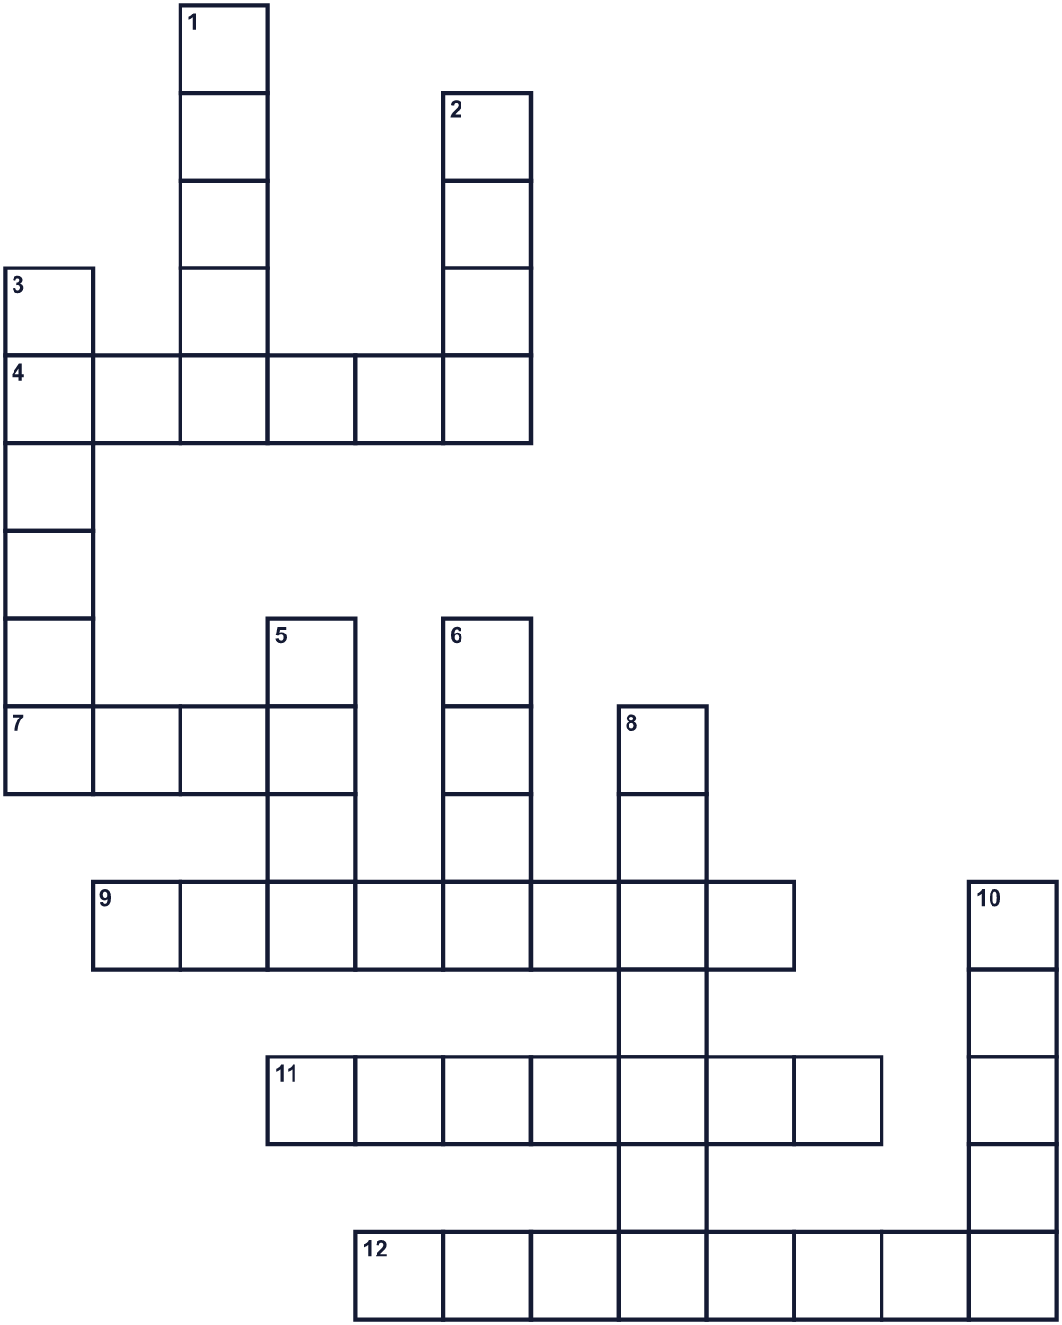
Across →
4. The season between summer and winter. (6)
7. A brown potato-like vegetable. It is offered on Jugoya. (4)
9. A small round ball made of rice flour. (8)
11. The time when farmers collect their crops. (7)
12. The daughter of a king. Kaguya is one. (8)
Down ↓
1. The dark time when you can see stars. (5)
2. It shines in the night sky and goes around the Earth. (4)
3. An animal with long ears. In Japan, people see one in the night sky. (6)
5. Short writing with beautiful words, often in lines. (4)
6. The moon is round and bright. It is a ____ moon. (4)
8. A paper light. Children in Vietnam carry one. (7)
10. A green plant that covers fields and parks. (5)

🎑 Tsukimi (Moon Viewing) Worksheet
Word Search
かくれた単語をさがそう（→ ↓ ↘ ↗）
Class ______ No. ____ Name ______________________________
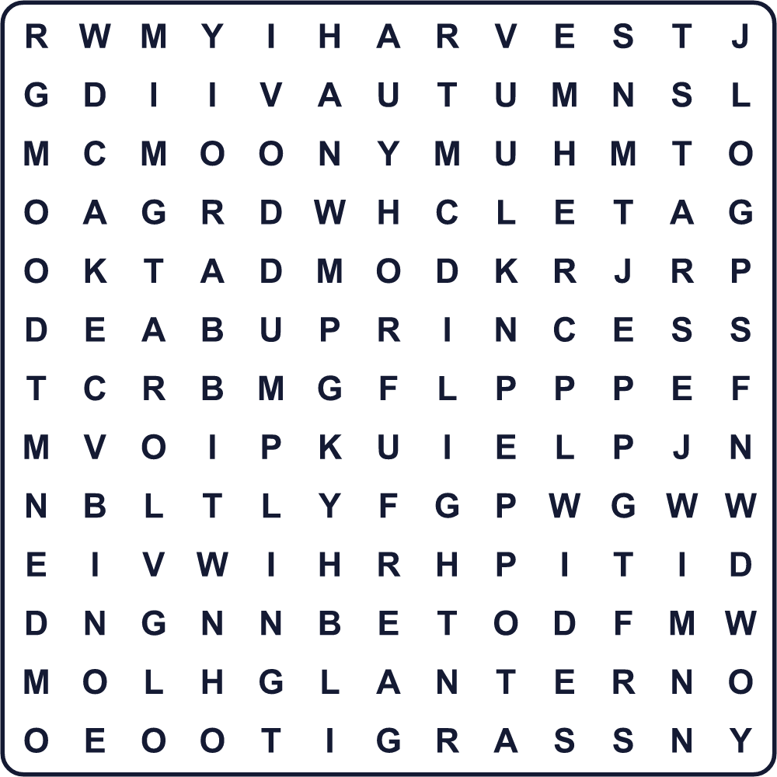
AUTUMN CAKE DUMPLING GRASS HARVEST LANTERN LIGHT MOON NIGHT PRINCESS RABBIT STAR TARO
Secret Code 暗号を解こう
◎=A ◆=E ♠=H ♪=K ☃=L ⚑=M ☺=N ♣=O ■=T
☃ ♣ ♣ ♪ ◎ ■ ■ ♠ ◆ ⚑ ♣ ♣ ☺
______________________________________________________________

🎑 Tsukimi (Moon Viewing) Worksheet
Maze & Sentences
Class ______ No. ____ Name ______________________________
Help the rabbit go back to the moon! うさぎを月まで帰してあげよう！
正しい道の文字を集めると、ひみつの言葉になるよ。 START 🐇 → GOAL 🌕
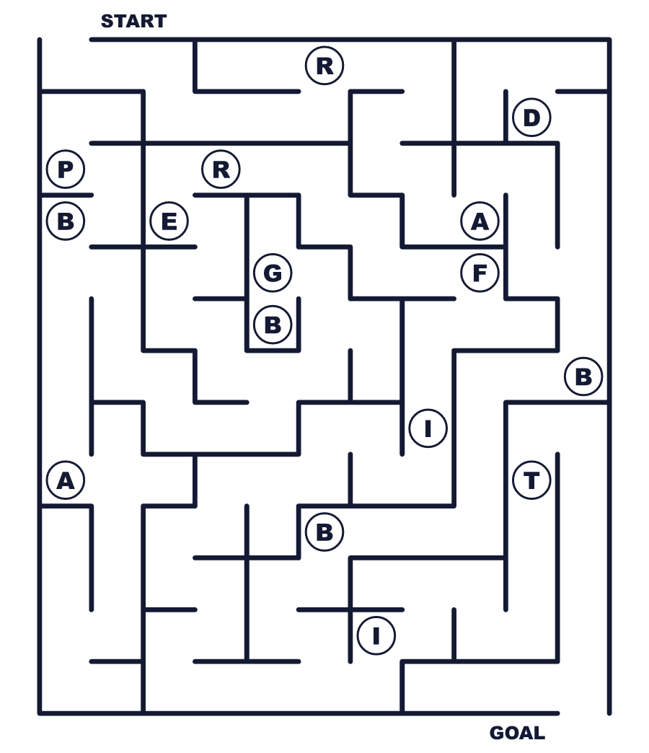
Secret word: ＿ ＿ ＿ ＿ ＿ ＿
Put the words in order. 並べかえよう。
1. in / We / the / look / autumn / moon / at . (私たちは秋に月を眺めます。)
______________________________________________________________
2. cakes / rabbit / moon / the / on / rice / makes / A . (月でうさぎが餅をついています。)
______________________________________________________________
3. put / dumplings / the / window / We / by . (私たちは窓辺に団子を置きます。)
______________________________________________________________
4. later / came / days / moon / full / two / The . (満月は2日後に来ました。)
______________________________________________________________
5. custom / This / China / long / ago / came / from . (この習わしはずっと昔に中国から来ました。)
______________________________________________________________

🎑 Tsukimi (Moon Viewing) Worksheet
Class Activity & Writing
Class ______ No. ____ Name ______________________________
Find Someone Who… クラスで聞いて回ろう！
Find someone who … | Name
… has made tsukimi dumplings 月見団子を作ったことがある
… can see a rabbit on the moon 月にうさぎが見える
… has eaten a mooncake 月餅を食べたことがある
… knows the story of Princess Kaguya かぐや姫の話を知っている
… has eaten tsukimi udon 月見うどんを食べたことがある
… knows the English word for 満月 「満月」の英語を知っている
… likes looking at the night sky 夜空を見るのが好き
… has seen the moon through a telescope 望遠鏡で月を見たことがある
Let's Write! 英語で書いてみよう。
When I look at the moon, I see ______.
月を見ると、私には＿＿が見えます。
______________________________________________________________
______________________________________________________________
If I could go to the moon, I would ______.
もし月に行けたら、私は＿＿します。
______________________________________________________________
______________________________________________________________
On Jugoya, I want to offer ______ to the moon because ______.
十五夜に、私は月に＿＿を供えたいです。なぜなら＿＿だからです。
______________________________________________________________
______________________________________________________________

🎑 Tsukimi (Moon Viewing) Worksheet
Trace & Color
なぞって書こう。絵に色をぬろう。
Class ______ No. ____ Name ______________________________
🌕 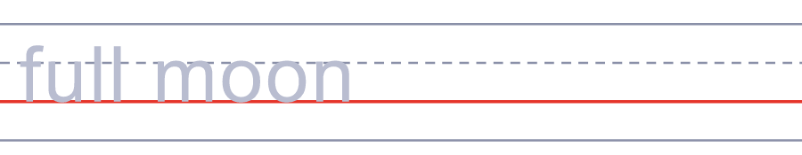

🐇 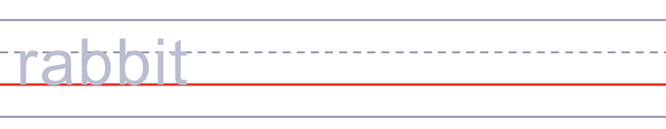
🍡 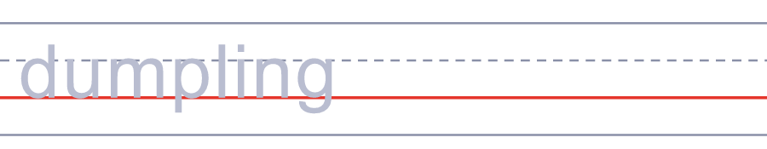
🌾 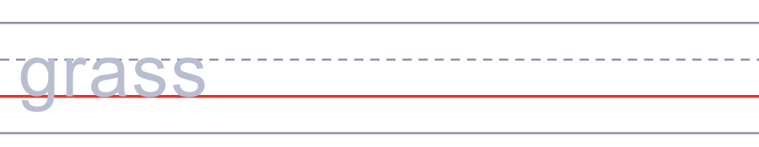
🌰 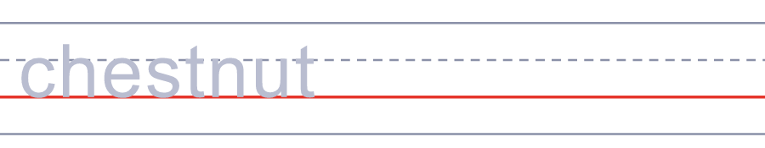
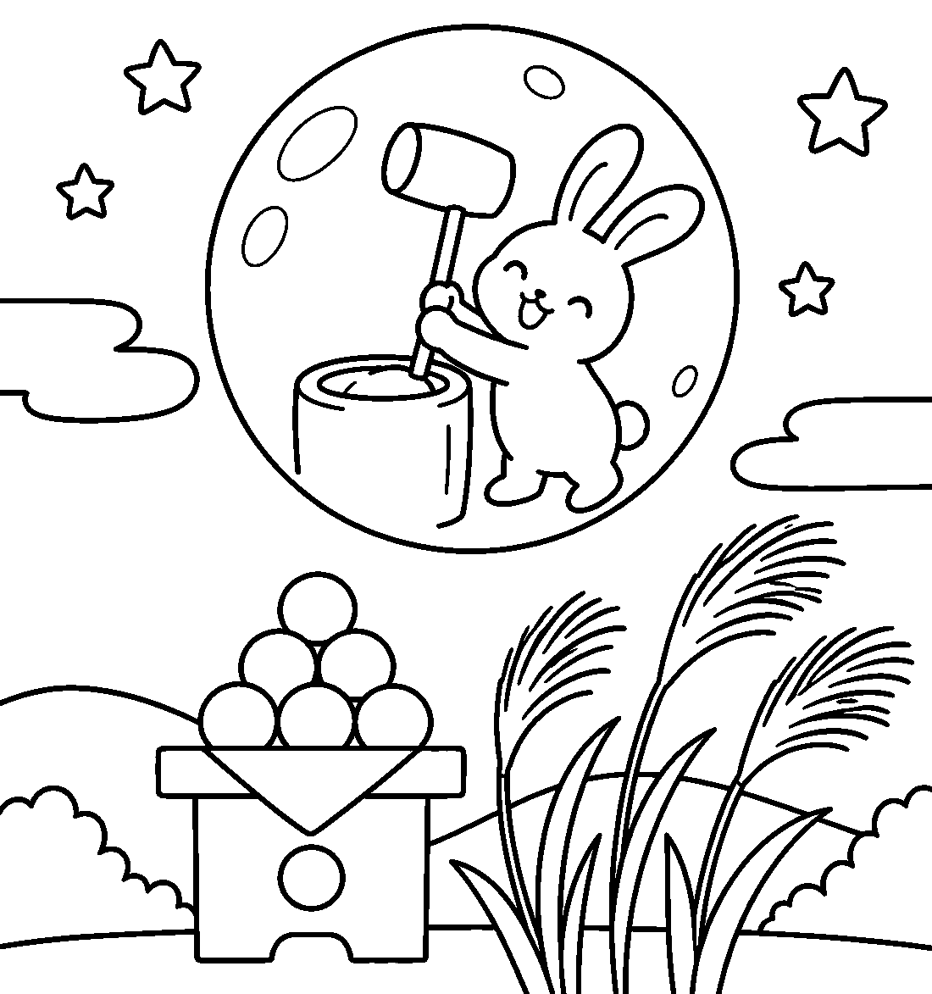

🎑 Tsukimi (Moon Viewing) Worksheet
Answer Key 解答
Reading Check: 1.B 2.C 3.A 4.D 5.B 6.C 7.C 8.A
True or False: 1.T 2.F 3.T 4.T 5.F 6.F
Match: 🌕=full moon 🐇=rabbit 🍡=dumpling 🌾=grass 🌰=chestnut 🏮=lantern ⭐=star 🥮=mooncake
Unscramble: 1.RABBIT 2.HARVEST 3.AUTUMN 4.LANTERN 5.PRINCESS 6.CUSTOM
Fill in the blanks: (1)dumplings (2)table (3)window (4)grass (5)moon (6)rabbit (7)cakes (8)outside (9)quiet (10)year
Sentence order: 1. We look at the moon in autumn. 2. A rabbit makes rice cakes on the moon. 3. We put dumplings by the window. 4. The full moon came two days later. 5. This custom came from China long ago.
Secret Code: LOOK AT THE MOON
Maze: RABBIT
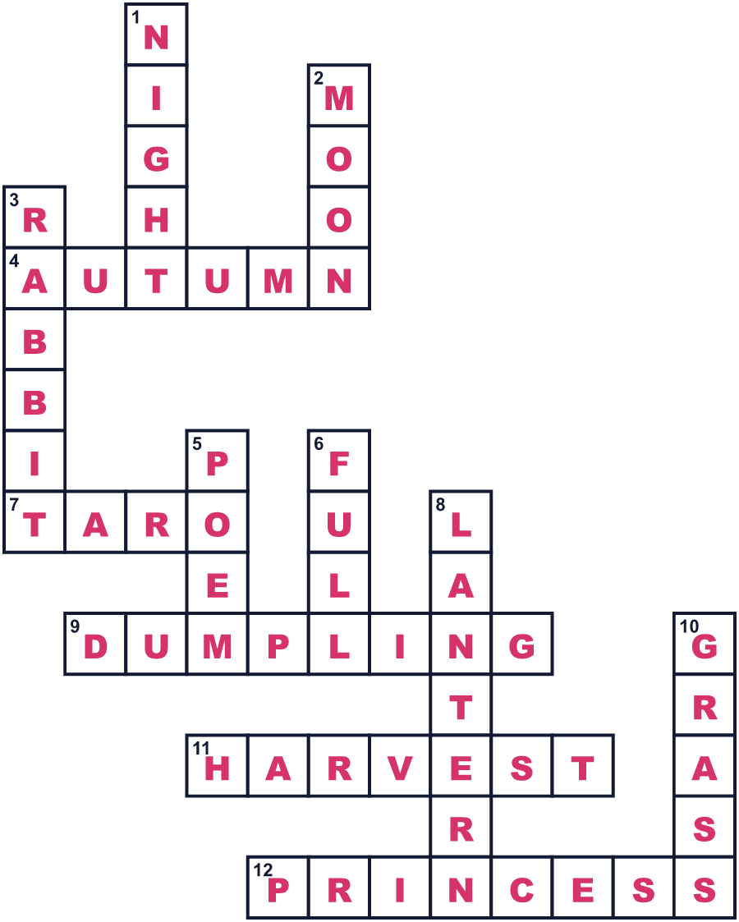
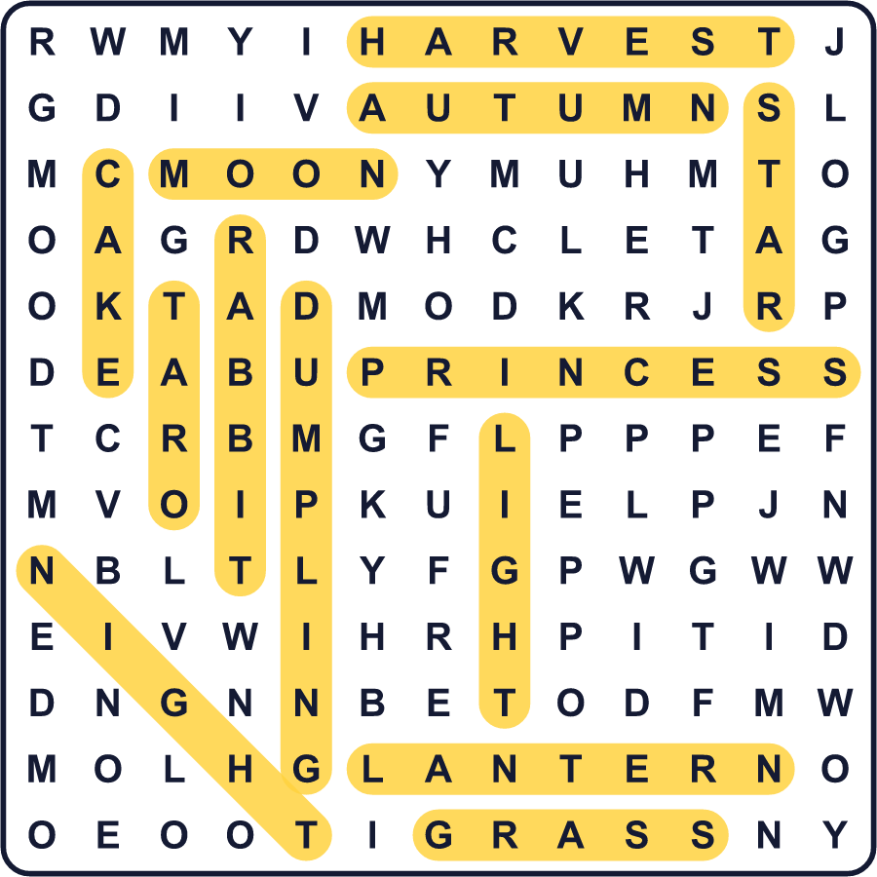
全訳
1 晴れた秋の夜に、月を見上げてみてください。うさぎが見えますか。日本では、月にうさぎが住んでいて、餅をついていると言います。毎年秋、家族は月にお供えをして、その光を楽しみます。この習わしは「月見」と呼ばれます。
2 月見はずっと昔に中国から伝わりました。日本で最も古い月の宴の記録は859年のものです。宮廷の貴族たちは、月の下で詩を作り、音楽を奏でました。舟に乗って、水に映る月を眺める人もいました。同じころの古い物語では、かぐや姫がまさにこの夜に月へ帰っていきます。
3 今、月見は昔の月の暦で8月15日の夜に行われます。たいてい9月か10月の初めです。家族は丸い団子と、すすきという背の高い草を窓辺に置きます。収穫の時期なので、里芋を供える人もいます。
4 ここでおもしろい事実を一つ。この夜の月は、いつも満月とはかぎりません。2026年、月見は9月25日でしたが、満月は2日後に来ました。これは、月が満ちるまでに14日より長くかかることが多く、その日数も毎月変わるために起こります。だから十五夜と満月は、1〜2日ずれることがよくあるのです。
5 アジアの多くの国が同じ月を楽しみます。中国の家族は月餅を食べ、韓国の人々はチュソクのために故郷へ帰ります。ベトナムでは、子どもたちが明るい灯籠を持って通りを歩きます。だから次に秋の月を見たら、うさぎにあいさつしてくださいね！

