🧣 Towel Day Worksheet
Never Travel Without a Towel
Read the story. 英文を読もう。
Class ______ No. ____ Name ______________________________

🔊 音声を聞こう（スマホで読みとってね）
1 On May 25, you may see people with towels on the train. They are not going to the beach. They are fans of a writer named Douglas Adams. This day is called Towel Day.
2 Douglas Adams was a British writer. His most famous story is The Hitchhiker's Guide to the Galaxy. It started as a radio show in 1978 and became a book in 1979. In the story, Earth is destroyed to make room for a road in space. One man escapes and travels across the galaxy. The story is very funny, and millions of people around the world love it.
3 In the book, a towel is the most useful thing for a space traveler. You can wrap it around you when it is cold. You can sleep on it, and you can wave it when you need help. Also, other people will think you are ready for anything. The book also says the answer to life and everything is 42. Adams later said it was just a joke.
4 Douglas Adams died suddenly on May 11, 2001. He was only 49 years old. Two weeks later, his fans carried towels to remember him. Some fans wear their towels around their necks all day. Today, people do it all over the world, and two astronauts even did it in space. So next May 25, take a towel with you, and don't panic!
Words 単語
towel（タオル） / writer（作家、書き手） / galaxy（銀河） / destroy（破壊する、取りこわす） / escape（逃げる） / useful（役に立つ） / wrap（巻く、包む） / astronaut（宇宙飛行士）

🧣 Towel Day Worksheet
Reading Check
Choose the best answer. 正しいものを選ぼう。
Class ______ No. ____ Name ______________________________
1. What is the main idea of the reading?
(A) Towel Day is a day to go to the beach with friends. (B) Towel Day is a day when fans remember Douglas Adams with towels. (C) Towel Day is a holiday made by the British government. (D) Towel Day is a day to clean your house with towels.
2. When did The Hitchhiker's Guide to the Galaxy start as a radio show?
(A) In 1979 (B) In 2001 (C) In 1978 (D) In 1942
3. Which is NOT a way to use a towel in the reading?
(A) Wrap it around you when it is cold (B) Sleep on it (C) Wave it when you need help (D) Use it as a map
4. Why did fans first carry towels on May 25, 2001?
(A) To remember Douglas Adams after he died (B) To celebrate the birthday of Douglas Adams (C) Because the weather was very hot (D) Because a new book came out that day
5. In the dialogue, why does Sophie say Ryo is "a real hitchhiker now"?
(A) Because he read the book in Japan (B) Because he likes the number 42 (C) Because he always carries a small towel (D) Because he is going swimming
True or False? T か F に○
1. Towel Day is on May 25. T / F
2. Douglas Adams was an American singer. T / F
3. In the book, a towel is very useful in space. T / F
4. Towel Day is a national holiday in Britain. T / F

🧣 Towel Day Worksheet
Word Work
単語のれんしゅう
Class ______ No. ____ Name ______________________________
① Match the pictures and the words. 絵と単語を線でむすぼう。
🚀 | ● | ● | star
🌍 | ● | ● | radio
⭐ | ● | ● | rocket
📻 | ● | ● | robot
📚 | ● | ● | books
🤖 | ● | ● | Earth
③ Fill in the blanks. 語群から選んで入れよう。
[ book / useful / towel / river / panic / umbrella / beach / space ]
Today is May 25. Max puts a blue (1) __________ in his bag. His sister laughs. "Are you going to the (2) __________ ?" she asks. "No," says Max. "It's Towel Day. In my favorite (3) __________ , people travel in (4) __________ . A towel is very (5) __________ there." He shows her the cover. It says, "Don't (6) __________ !"

🧣 Towel Day Worksheet
Crossword Puzzle
ヒントを読んでクロスワードを完成させよう。
Class ______ No. ____ Name ______________________________
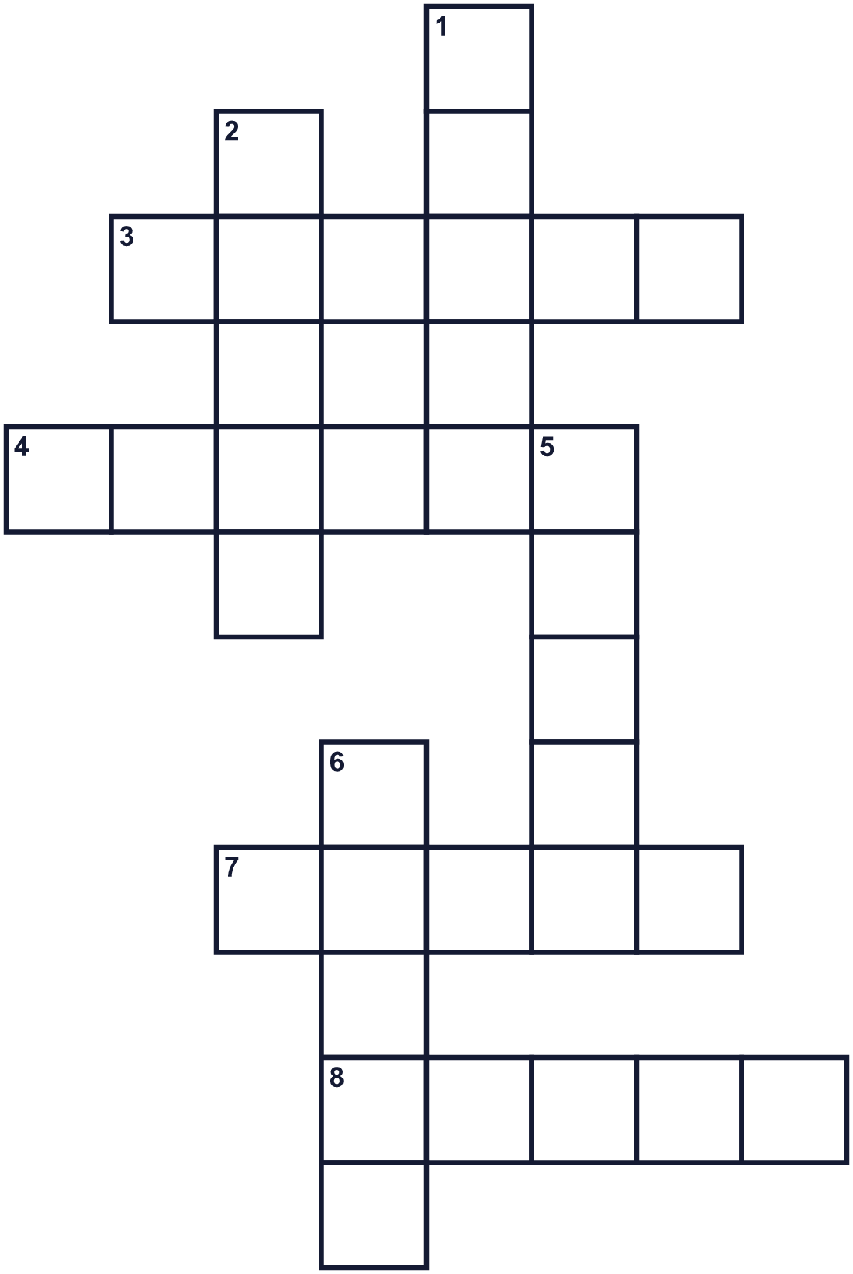
Across →
3. A very big group of stars, like the Milky Way. (6)
4. A person who makes stories and books. (6)
7. A machine that can move and work like a person. (5)
8. Our planet. In the story, it is destroyed. (5)
Down ↓
1. Rockets fly up into it. (5)
2. The book's cover says: Don't do this! (5)
5. The story first started on this, in 1978. (5)
6. You use it to dry your body after a bath. (5)

🧣 Towel Day Worksheet
Word Search
かくれた単語をさがそう（→ ↓ ↘ ↗）
Class ______ No. ____ Name ______________________________
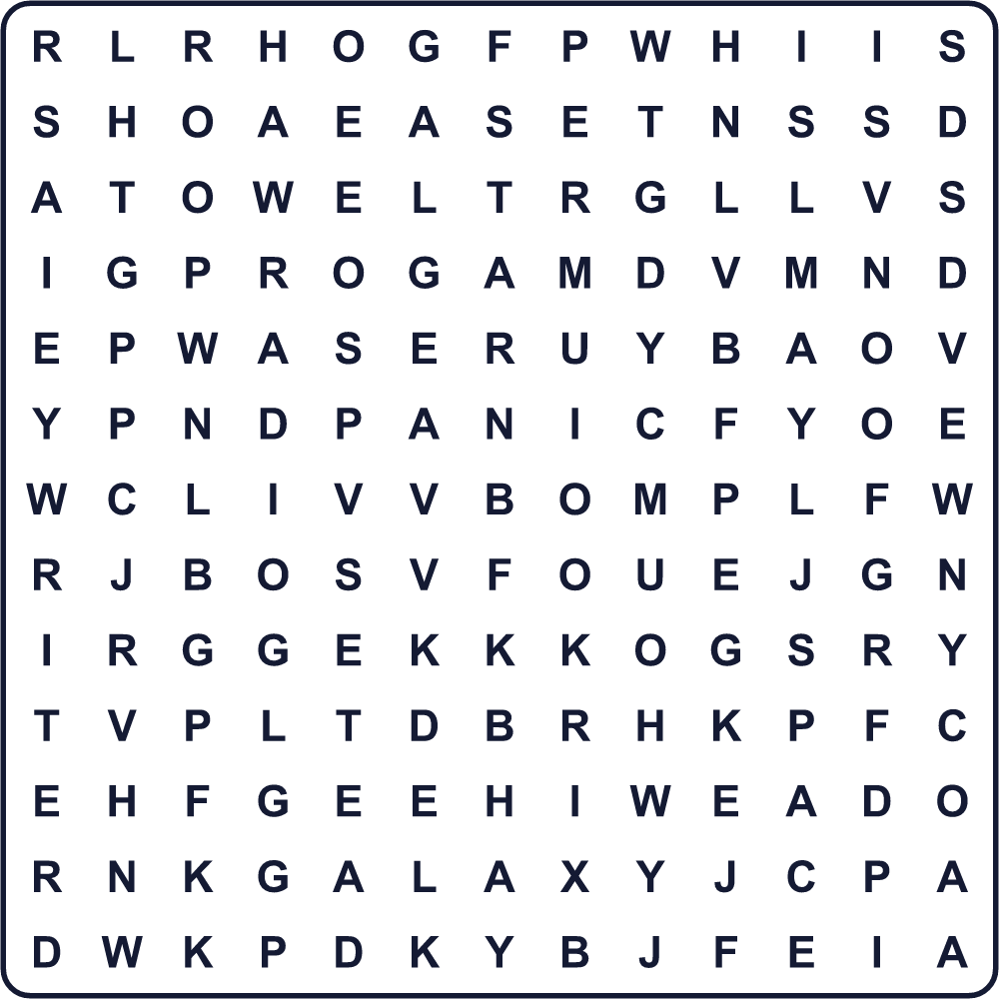
BOOK EARTH FANS GALAXY PANIC RADIO SPACE STAR TOWEL WRITER

🧣 Towel Day Worksheet
Maze & Sentences
Class ______ No. ____ Name ______________________________
Help the space traveler find his towel! 宇宙の旅人が自分のタオルを見つけるのを手伝おう！
正しい道の文字を集めると、ひみつの言葉になるよ。 START 🧑‍🚀 → GOAL 🧣
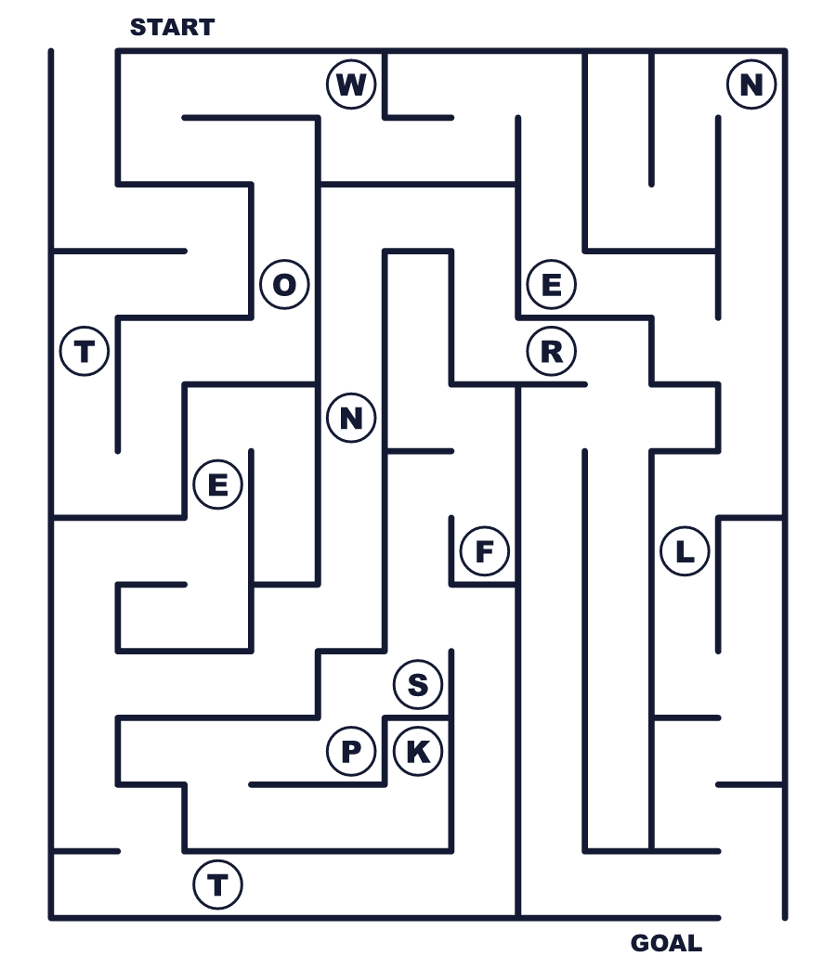
Secret word: ＿ ＿ ＿ ＿ ＿

🧣 Towel Day Worksheet
Class Activity & Writing
Class ______ No. ____ Name ______________________________
Let's Write! 英語で書いてみよう。
If I traveled in space, I would take ______ because ______.
宇宙を旅するなら、______を持っていきます。なぜなら______だからです。
______________________________________________________________
______________________________________________________________
My favorite writer is ______. I would remember this writer by ______.
好きな作家は______です。この作家を______でしのびたいです。
______________________________________________________________
______________________________________________________________

🧣 Towel Day Worksheet
Trace & Color
なぞって書こう。絵に色をぬろう。
Class ______ No. ____ Name ______________________________
🚀 

🌍 
⭐ 
📻 
📚 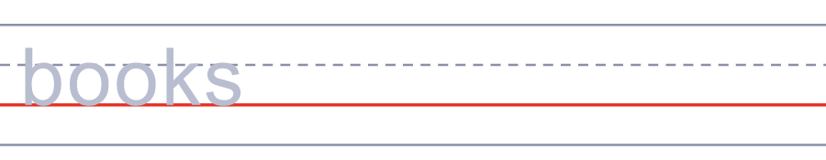

🧣 Towel Day Worksheet
Answer Key 解答
Reading Check: 1.B 2.C 3.D 4.A 5.C
True or False: 1.T 2.F 3.T 4.F
Match: 🚀=rocket 🌍=Earth ⭐=star 📻=radio 📚=books 🤖=robot
Fill in the blanks: (1)towel (2)beach (3)book (4)space (5)useful (6)panic
Maze: TOWEL
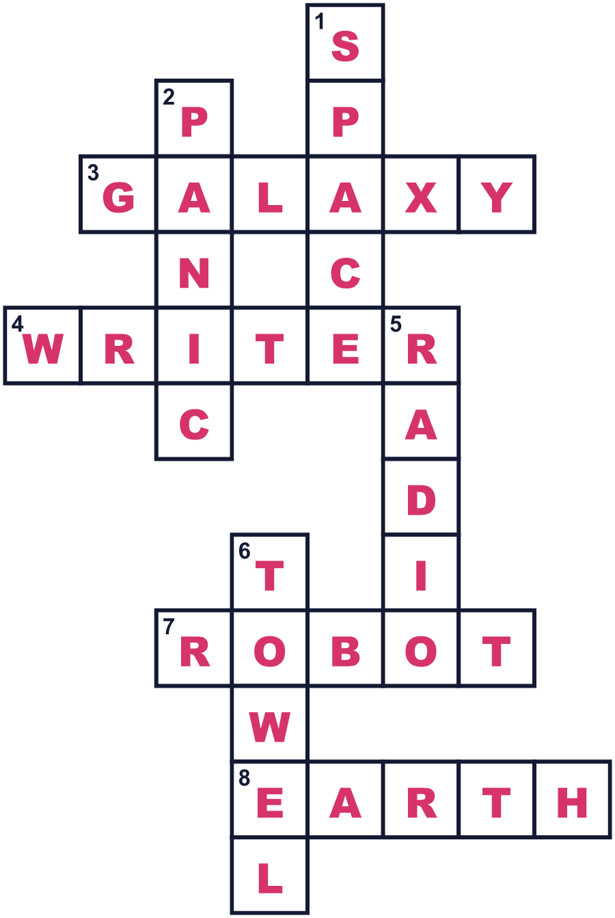
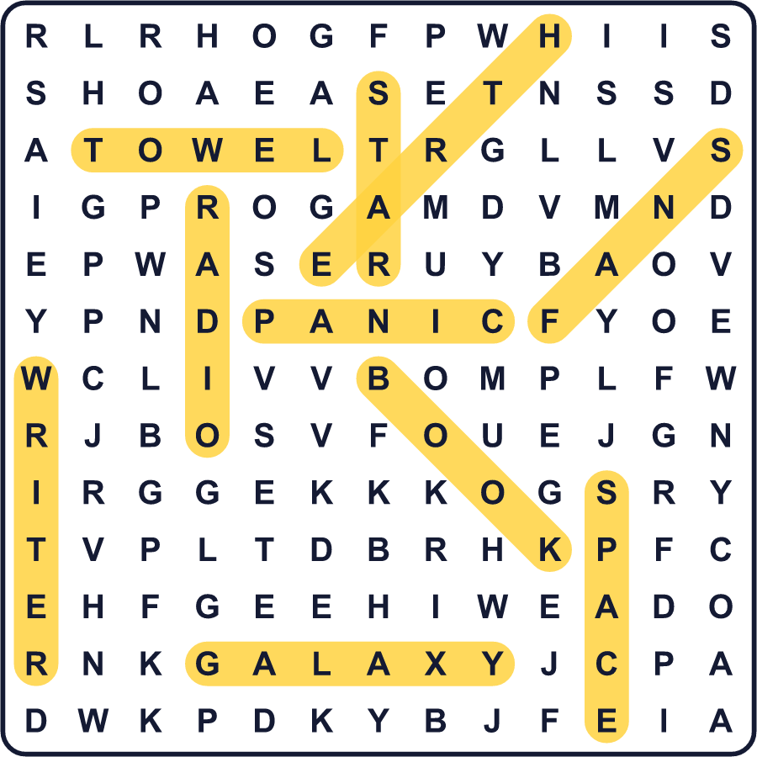
全訳
1 5月25日、電車でタオルを持った人を見かけるかもしれません。その人たちはビーチに行くわけではありません。ダグラス・アダムズという作家のファンなのです。この日はタオルデーと呼ばれています。
2 ダグラス・アダムズはイギリスの作家でした。いちばん有名な作品は『銀河ヒッチハイク・ガイド』です。1978年にラジオ番組として始まり、1979年に本になりました。物語では、宇宙の道路を作る場所を空けるために、地球が取りこわされます。一人の男が逃げ出し、銀河を旅します。物語はとてもおかしく、世界中の何百万人もの人に愛されています。
3 本の中では、タオルは宇宙の旅行者にとっていちばん役に立つ物です。寒いときは体に巻けます。その上で眠れますし、助けが必要なときは振ることもできます。それに、ほかの人はあなたが何にでも備えていると思ってくれます。本には、人生と万物の答えは42だとも書かれています。アダムズはのちに、あれはただのジョークだと言いました。
4 ダグラス・アダムズは2001年5月11日に突然亡くなりました。まだ49歳でした。2週間後、ファンは彼をしのんでタオルを持ち歩きました。1日じゅう首にタオルをかけて過ごすファンもいます。今では世界中の人が同じことをしていて、宇宙でそうした宇宙飛行士も2人います。だから次の5月25日には、タオルを持って出かけましょう。そして、あわてないで！

