🎋 Tori no Ichi (Rooster Fair) Worksheet
Raking in Good Luck
Read the story. 英文を読もう。
Class ______ No. ____ Name ______________________________

🔊 音声を聞こう（スマホで読みとってね）
1 In November, a big night market opens at some shrines in Tokyo. People call it Tori no Ichi, the Rooster Fair. It does not have one fixed date. It is held on the Days of the Rooster in an old calendar, and this day comes every 12 days. So November has two Rooster Days, and sometimes three.
2 The most famous fair is at Otori Shrine in Asakusa. It starts at midnight and goes on for 24 hours. About 150 shops sell kumade, or lucky bamboo rakes. A rake is a garden tool for collecting fallen leaves. People believe these rakes can collect good luck and money for the coming year.
3 The rakes are covered with lucky things, like smiling masks, gold coins, and bags of rice. Small ones cost about 1,000 yen, but the biggest ones cost hundreds of thousands of yen. When someone buys a rake, the seller and the buyer clap their hands together in a fast rhythm. This is called tejime, and it closes the deal with good wishes.
4 There is also an old saying about this fair. In years with three Rooster Days, people say there will be more fires. Nobody really knows why. But one of the worst fires in the city's history happened in such a year, in 1657. So even today, some rakes carry a small sticker that tells people to be careful with fire.
Words 単語
rake（熊手、（熊手で）かき集める） / fair（市、縁日、品評会） / rooster（おんどり） / fixed（決まった、固定の） / lucky（縁起のいい、幸運な） / clap（手をたたく） / deal（取り引き） / saying（ことわざ、言い伝え）

🎋 Tori no Ichi (Rooster Fair) Worksheet
Reading Check
Choose the best answer. 正しいものを選ぼう。
Class ______ No. ____ Name ______________________________
1. What is the main idea of the passage?
(A) The Rooster Fair is a market where people buy lucky rakes in November. (B) The Rooster Fair is a farm event for chickens. (C) The Rooster Fair is held every month in Tokyo. (D) The Rooster Fair started after a fire in 1657.
2. Why does the date of the fair change every year?
(A) Because the shrine chooses a new date by lottery. (B) Because it follows the weather. (C) Because the Day of the Rooster comes every 12 days. (D) Because shops open on weekends only.
3. How long does the fair at Otori Shrine in Asakusa last?
(A) 12 hours. (B) One week. (C) Three days. (D) 24 hours.
4. In paragraph 3, what does "closes the deal" mean?
(A) Shuts the shop for the night. (B) Finishes the buying and selling. (C) Makes the rake smaller. (D) Asks for more money.
5. In the dialogue, why is Chloe surprised?
(A) Because the rakes are very small. (B) Because the fair is in the morning. (C) Because people can ask for a lower price at a shrine. (D) Because Haruto bought a rake.
True or False? T か F に○
1. The Rooster Fair is held in November. T / F
2. The fair is always on the same date every year. T / F
3. People clap their hands after someone buys a rake. T / F
4. Everyone agrees that years with three Rooster Days have more fires. T / F

🎋 Tori no Ichi (Rooster Fair) Worksheet
Word Work
単語のれんしゅう
Class ______ No. ____ Name ______________________________
① Match the pictures and the words. 絵と単語を線でむすぼう。
🐓 | ● | ● | fire
⛩️ | ● | ● | night
👏 | ● | ● | clap
🪙 | ● | ● | shrine
🔥 | ● | ● | coin
🌙 | ● | ● | rooster
③ Fill in the blanks. 語群から選んで入れよう。
[ lights / price / luck / summer / snow / pizza / rake / claps / night / shrine / coins ]
It is a cold (1) __________ in November. Aya and her father walk to the (2) __________ . There are many (3) __________ and shops. They want to buy a small (4) __________ . It has a smiling mask and gold (5) __________ on it. Her father asks for a lower (6) __________ . Then everyone (7) __________ together. Aya says, "I hope it brings us good (8) __________ !"

🎋 Tori no Ichi (Rooster Fair) Worksheet
Crossword Puzzle
ヒントを読んでクロスワードを完成させよう。
Class ______ No. ____ Name ______________________________
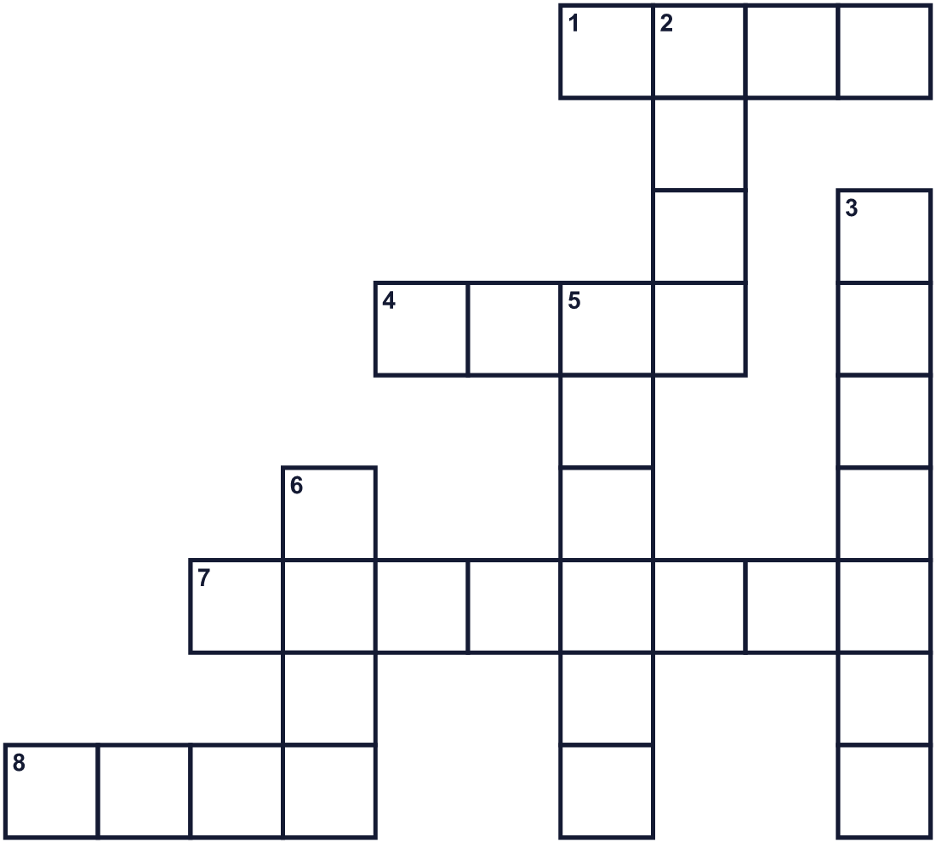
Across →
1. To hit your hands together. (4)
4. You wear this on your face. (4)
7. 12 o'clock at night. (8)
8. A garden tool for collecting leaves. (4)
Down ↓
2. Good things that happen by chance. (4)
3. A male chicken. It is one of the twelve animal signs. (7)
5. A holy place in Japan with a gate called torii. (6)
6. It is hot and burns wood. (4)

🎋 Tori no Ichi (Rooster Fair) Worksheet
Word Search
かくれた単語をさがそう（→ ↓ ↘ ↗）
Class ______ No. ____ Name ______________________________
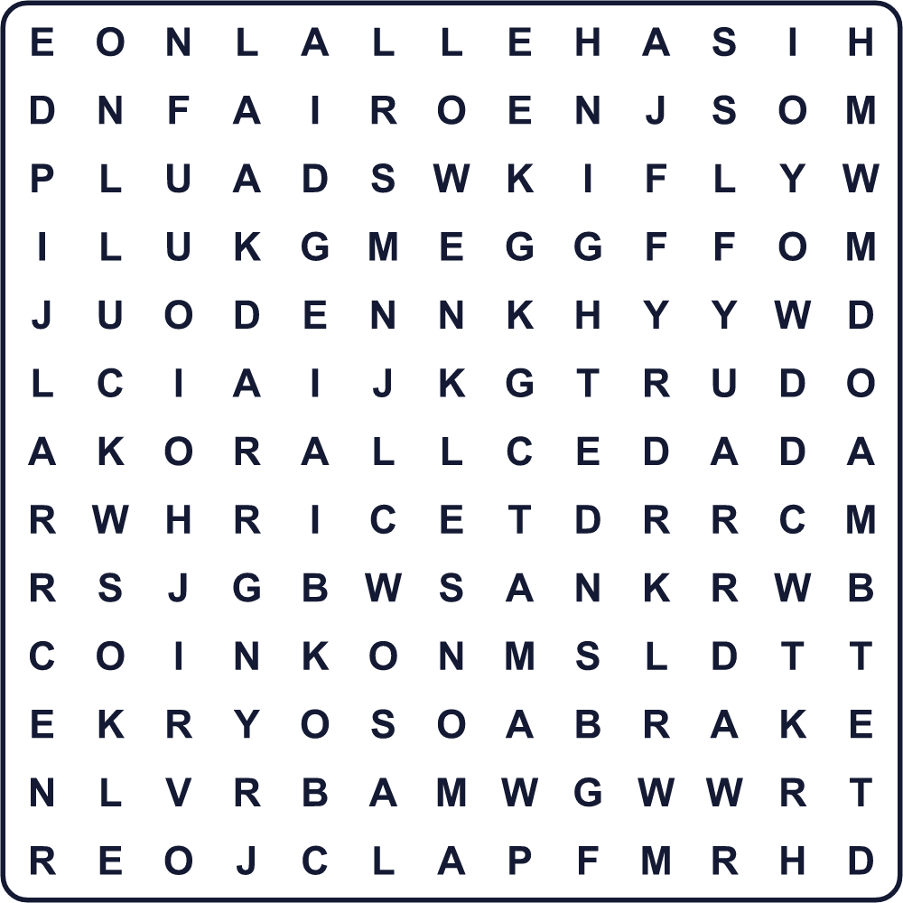
CLAP COIN FAIR LUCK MASK NIGHT RAKE RICE ROOSTER SHRINE

🎋 Tori no Ichi (Rooster Fair) Worksheet
Maze & Sentences
Class ______ No. ____ Name ______________________________
Help Aya find the lucky rake! アヤが縁起熊手を見つけられるように助けよう！
正しい道の文字を集めると、ひみつの言葉になるよ。 START 👧 → GOAL 🎋
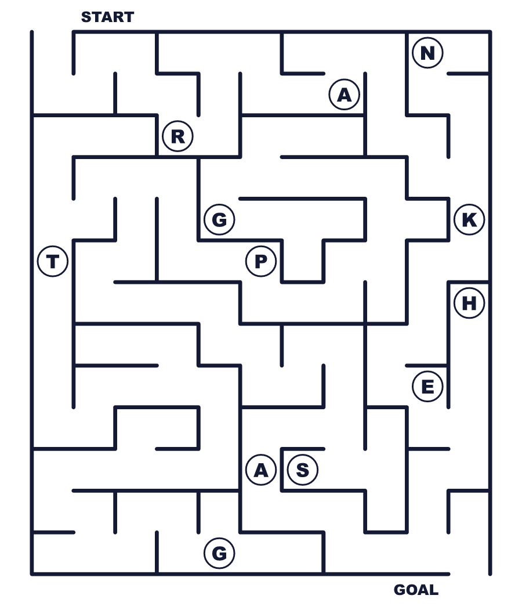
Secret word: ＿ ＿ ＿ ＿

🎋 Tori no Ichi (Rooster Fair) Worksheet
Class Activity & Writing
Class ______ No. ____ Name ______________________________
Let's Write! 英語で書いてみよう。
If I had a lucky rake, I would rake in ______ because ______.
縁起熊手があったら、______をかき集めたいです。なぜなら______だからです。
______________________________________________________________
______________________________________________________________
To explain Tori no Ichi to a friend, I would say, "______."
友だちに酉の市を説明するなら「______」と言います。
______________________________________________________________
______________________________________________________________

🎋 Tori no Ichi (Rooster Fair) Worksheet
Trace & Color
なぞって書こう。絵に色をぬろう。
Class ______ No. ____ Name ______________________________
🐓 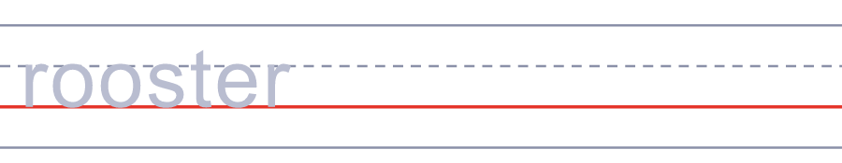

⛩️ 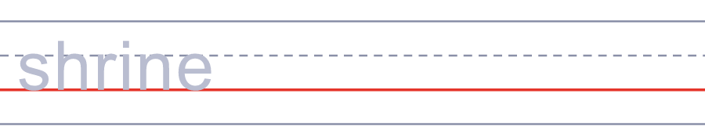
👏 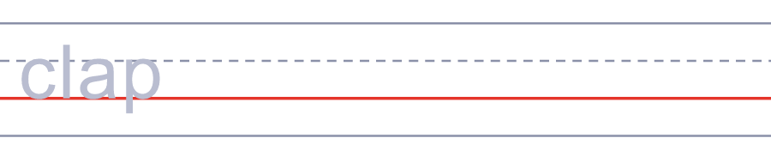
🪙 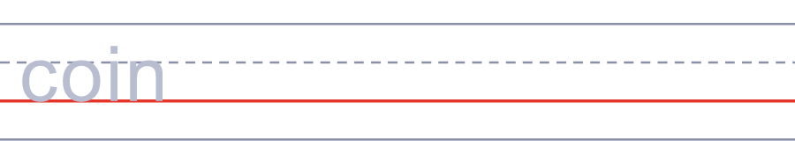
🔥 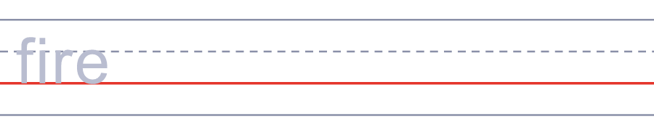

🎋 Tori no Ichi (Rooster Fair) Worksheet
Answer Key 解答
Reading Check: 1.A 2.C 3.D 4.B 5.C
True or False: 1.T 2.F 3.T 4.F
Match: 🐓=rooster ⛩️=shrine 👏=clap 🪙=coin 🔥=fire 🌙=night
Fill in the blanks: (1)night (2)shrine (3)lights (4)rake (5)coins (6)price (7)claps (8)luck
Maze: RAKE
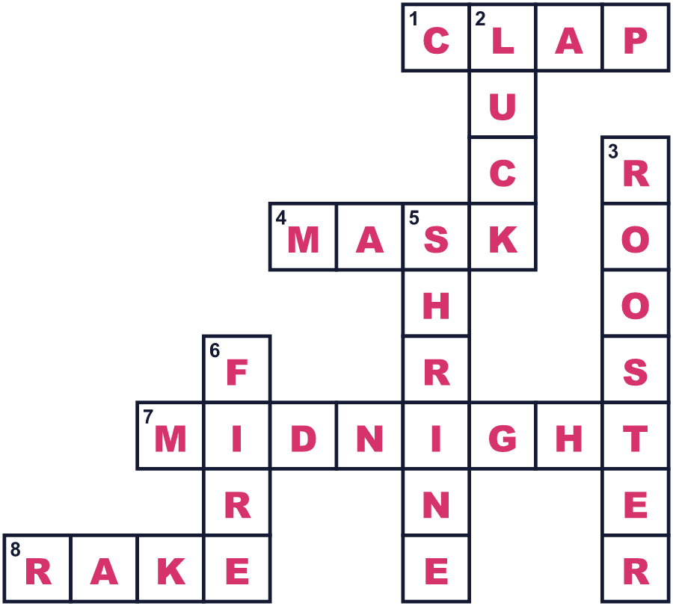
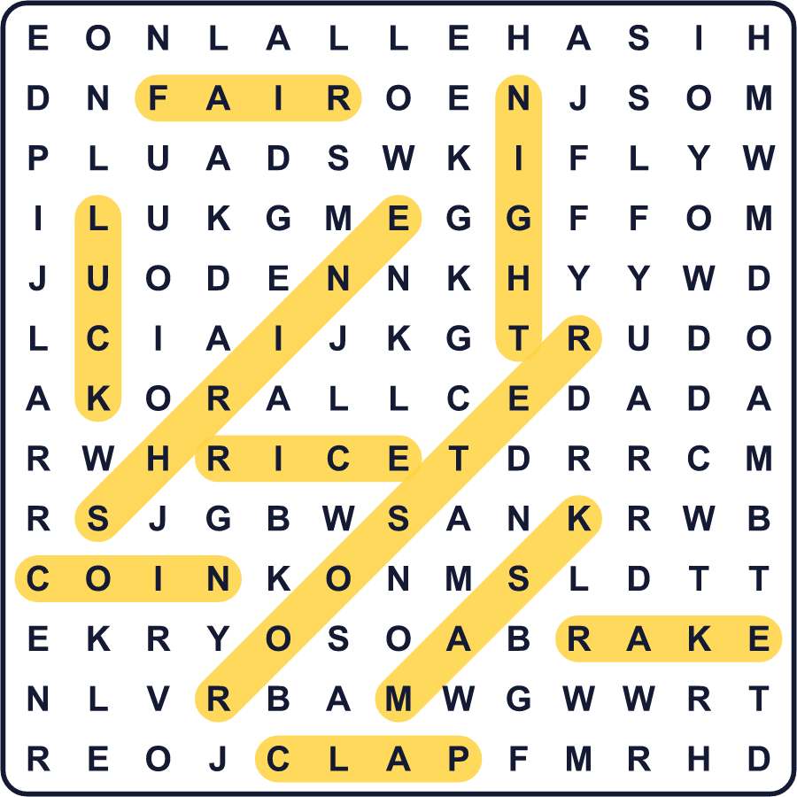
全訳
1 11月、東京のいくつかの神社で大きな夜の市が開かれます。人々はこれを「酉の市」と呼びます。決まった1つの日付はありません。昔の暦の「酉の日」に開かれ、この日は12日ごとにやって来ます。だから11月には酉の日が2回、ときには3回あるのです。
2 いちばん有名なのは、浅草の鷲神社の酉の市です。真夜中に始まり、24時間続きます。およそ150の店が、熊手、つまり縁起物の竹の熊手を売ります。熊手は、落ち葉を集めるための庭の道具です。人々は、この熊手が来る年の幸運とお金をかき集めてくれると信じています。
3 熊手は、笑顔のお面や金色の小判、米俵などの縁起物で飾られています。小さいものは1,000円ほどですが、いちばん大きいものは数十万円もします。熊手を買うと、店の人とお客がいっしょに速いリズムで手を打ちます。これを「手締め」と言い、よい願いを込めて取り引きをしめくくります。
4 この市には、古い言い伝えもあります。酉の日が3回ある年は、火事が多くなると言われます。本当の理由は誰にもわかりません。でも、この町の歴史で最悪の火事の1つが、1657年、まさにそんな年に起きました。だから今でも、「火の用心」と書いた小さなシールを貼った熊手があるのです。

