🍋 Toji (Winter Solstice in Japan) Worksheet
A Hot Bath on the Shortest Day
Read the story. 英文を読もう。
Class ______ No. ____ Name ______________________________

🔊 音声を聞こう（スマホで読みとってね）
1 Around December 22, Japan has the shortest day of the year. This day is called Toji, the winter solstice. In Tokyo in 2026, the sun rises at 6:47 in the morning and sets at 4:32 in the afternoon. That is less than ten hours of daylight. In June, Tokyo gets almost five more hours of sun.
2 On this night, many families take a yuzu bath. Yuzu is a small yellow citrus fruit with a strong, fresh smell. People put whole yuzu into the hot water and relax. Some say a yuzu bath keeps you from catching a cold. This custom is said to have started at public bathhouses in old Tokyo, about 200 years ago.
3 People also eat kabocha, a sweet Japanese pumpkin. An old saying tells us that kabocha on this day helps you live a long life. Today, some families also eat foods with the sound n in their names, like udon. But this custom is quite new. Old records from the 1800s talk about foods that start with to, like tofu.
4 Toji is not only about the cold. From this day, the days slowly get longer again. So people also see it as a day when good luck starts to come back. In China, many people eat dumplings on this day. In Iran, families stay up late with watermelon and poems on the longest night of the year.
Words 単語
solstice（至（夏至・冬至）） / daylight（日光、昼の明るさ） / sunset（日の入り） / citrus（かんきつ類） / custom（習慣、風習） / public bathhouse（銭湯、公衆浴場） / catch a cold（かぜをひく） / stay up late（夜ふかしする）

🍋 Toji (Winter Solstice in Japan) Worksheet
Reading Check
Choose the best answer. 正しいものを選ぼう。
Class ______ No. ____ Name ______________________________
1. What is the main idea of the passage?
(A) Toji is a summer festival in Japan. (B) On the shortest day, Japanese people enjoy yuzu baths and kabocha, and people in other countries have their own customs. (C) Toji is a national holiday with fireworks. (D) Yuzu baths started in Iran.
2. In Tokyo in 2026, when does the sun set on the winter solstice?
(A) At 6:47 in the morning. (B) At 4:25 in the morning. (C) At 7:00 in the evening. (D) At 4:32 in the afternoon.
3. Where is the yuzu bath custom said to have started?
(A) At public bathhouses in old Tokyo. (B) At schools in Kyoto. (C) At hot springs in Hokkaido. (D) At temples in China.
4. What does the passage say about eating foods with the sound n?
(A) It is the oldest custom of Toji. (B) It started in Iran. (C) It is quite a new custom. (D) Only children do it.
5. In the dialogue, what did Emily think the yuzu were at first?
(A) Oranges. (B) Lemons. (C) Pumpkins. (D) Apples.
True or False? T か F に○
1. The winter solstice is the shortest day of the year in Japan. T / F
2. On Toji, people put lemons in the bath. T / F
3. In Iran, families stay up late on the longest night. T / F
4. The earliest sunset in Tokyo is on the winter solstice. T / F

🍋 Toji (Winter Solstice in Japan) Worksheet
Word Work
単語のれんしゅう
Class ______ No. ____ Name ______________________________
① Match the pictures and the words. 絵と単語を線でむすぼう。
🍋 | ● | ● | night
🎃 | ● | ● | sunrise
🛁 | ● | ● | bath
🌅 | ● | ● | citrus
❄️ | ● | ● | snow
🌙 | ● | ● | pumpkin
③ Fill in the blanks. 語群から選んで入れよう。
[ solstice / smells / kabocha / beach / longer / cold / dark / water / ice / shorter / yuzu ]
Today is the winter (1) __________ . It gets (2) __________ very early. After school, Riko helps her mother cook (3) __________ . At night, her father puts three yellow (4) __________ into the bath. The bathroom (5) __________ so fresh! Riko stays in the hot (6) __________ for a long time. Her mother says, "Now you won't catch a (7) __________ ." From tomorrow, the days will get (8) __________ .

🍋 Toji (Winter Solstice in Japan) Worksheet
Crossword Puzzle
ヒントを読んでクロスワードを完成させよう。
Class ______ No. ____ Name ______________________________
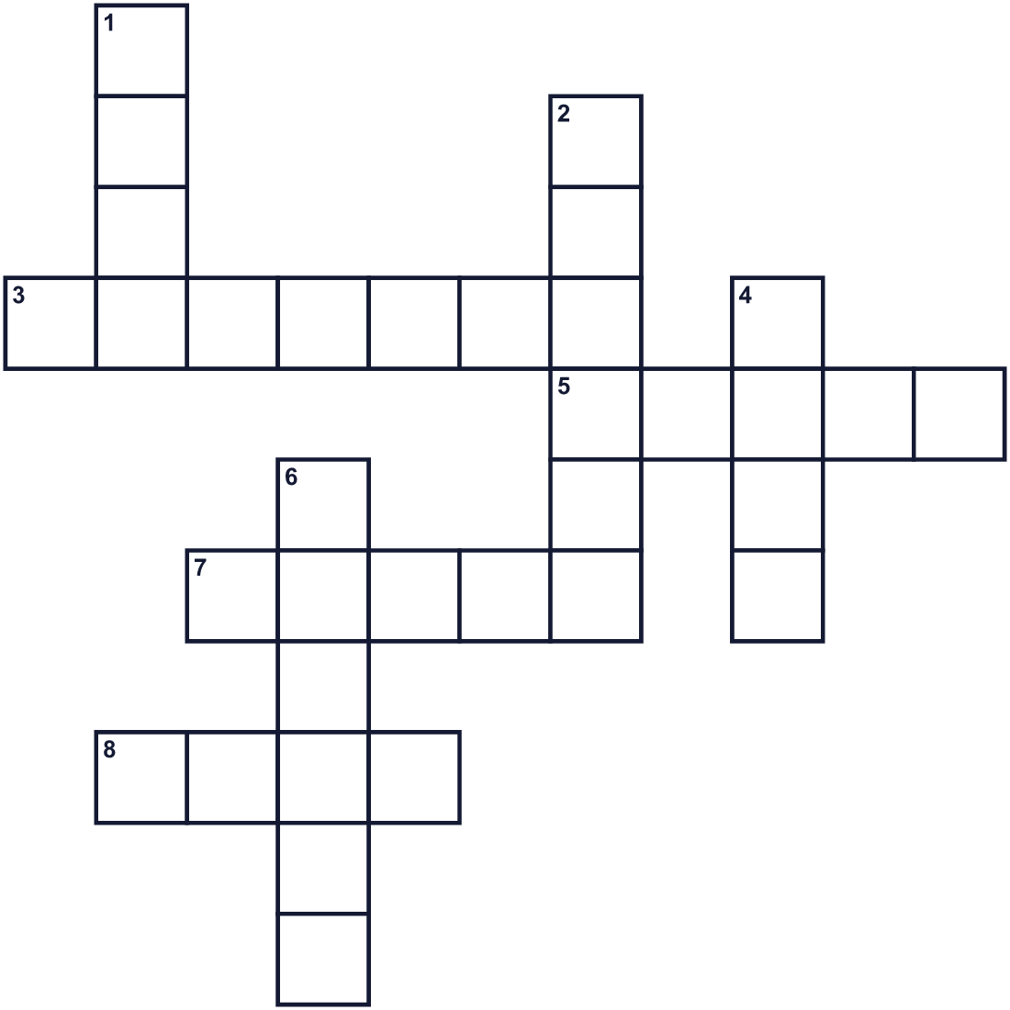
Across →
3. A big orange or green vegetable. Kabocha is one. (7)
5. The opposite of long. (5)
7. The dark time between evening and morning. (5)
8. You sit in hot water in this. (4)
Down ↓
1. A yellow citrus fruit. People put it in the bath on Toji. (4)
2. The time when the sun goes down. (6)
4. You may sneeze and cough when you have this. (4)
6. The cold season after autumn. (6)

🍋 Toji (Winter Solstice in Japan) Worksheet
Word Search
かくれた単語をさがそう（→ ↓ ↘ ↗）
Class ______ No. ____ Name ______________________________
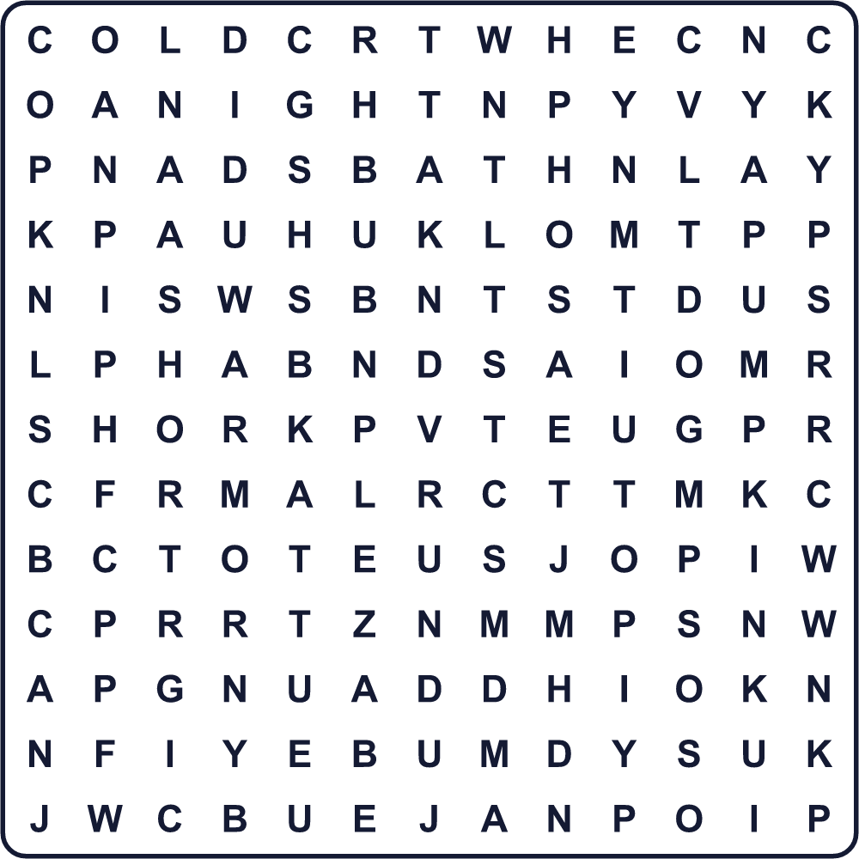
BATH BEANS COLD NIGHT PUMPKIN SHORT SUNSET WARM WINTER YUZU

🍋 Toji (Winter Solstice in Japan) Worksheet
Maze & Sentences
Class ______ No. ____ Name ______________________________
Help Riko carry the yuzu to the bath! リコがゆずをお風呂まで運べるように助けよう！
正しい道の文字を集めると、ひみつの言葉になるよ。 START 👧 → GOAL 🛁
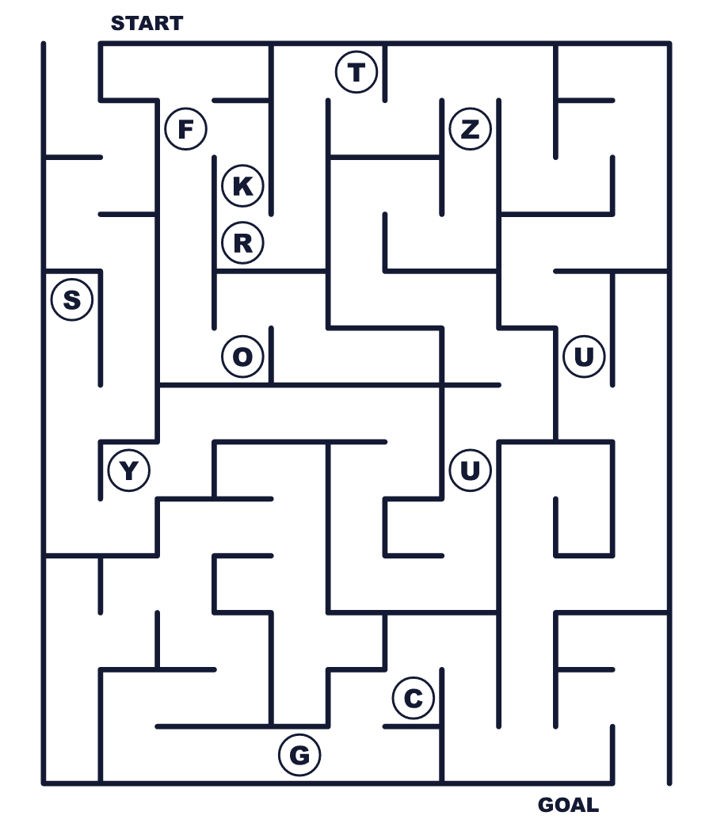
Secret word: ＿ ＿ ＿ ＿

🍋 Toji (Winter Solstice in Japan) Worksheet
Class Activity & Writing
Class ______ No. ____ Name ______________________________
Let's Write! 英語で書いてみよう。
On the shortest day of the year, I want to ______ because ______.
一年でいちばん昼が短い日に、______したいです。なぜなら______だからです。
______________________________________________________________
______________________________________________________________
To explain a yuzu bath to a friend, I would say, "______."
友だちにゆず湯を説明するなら「______」と言います。
______________________________________________________________
______________________________________________________________

🍋 Toji (Winter Solstice in Japan) Worksheet
Trace & Color
なぞって書こう。絵に色をぬろう。
Class ______ No. ____ Name ______________________________
🍋 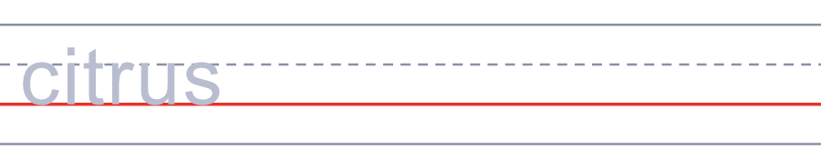

🎃 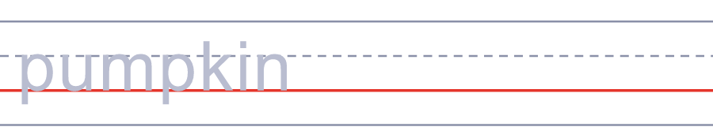
🛁 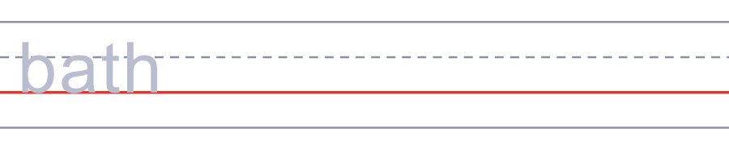
🌅 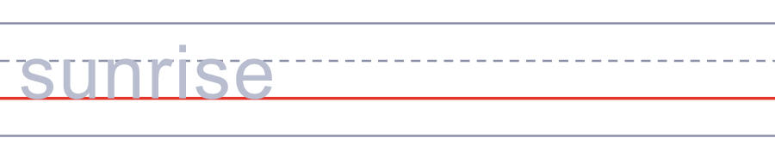
❄️ 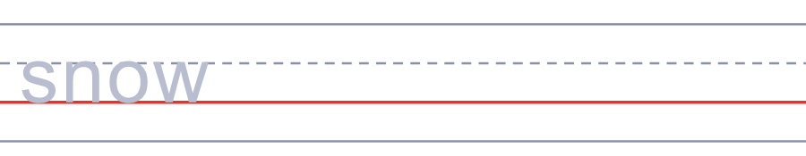

🍋 Toji (Winter Solstice in Japan) Worksheet
Answer Key 解答
Reading Check: 1.B 2.D 3.A 4.C 5.B
True or False: 1.T 2.F 3.T 4.F
Match: 🍋=citrus 🎃=pumpkin 🛁=bath 🌅=sunrise ❄️=snow 🌙=night
Fill in the blanks: (1)solstice (2)dark (3)kabocha (4)yuzu (5)smells (6)water (7)cold (8)longer
Maze: YUZU
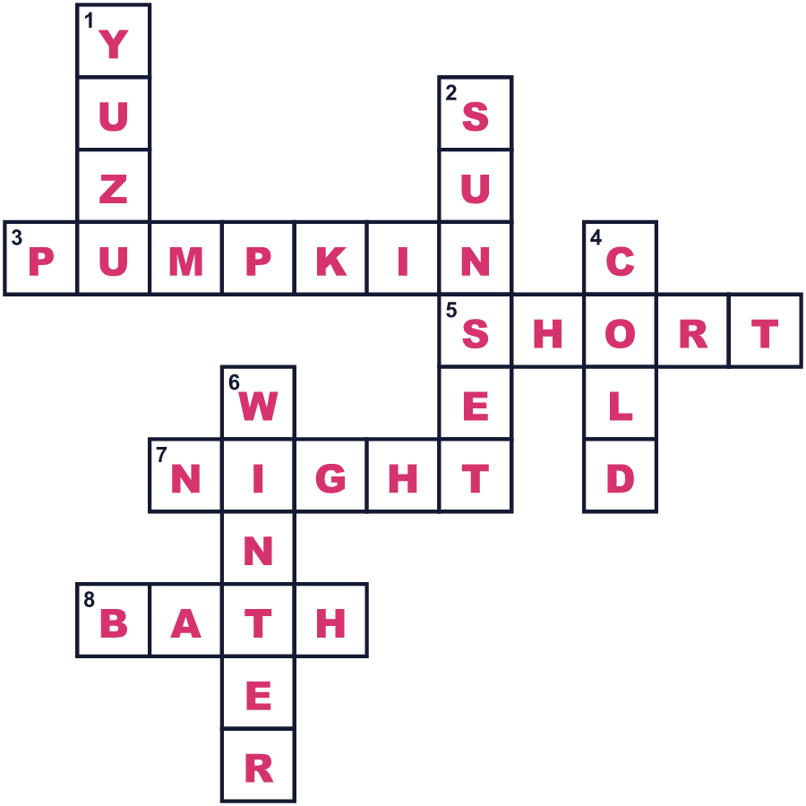
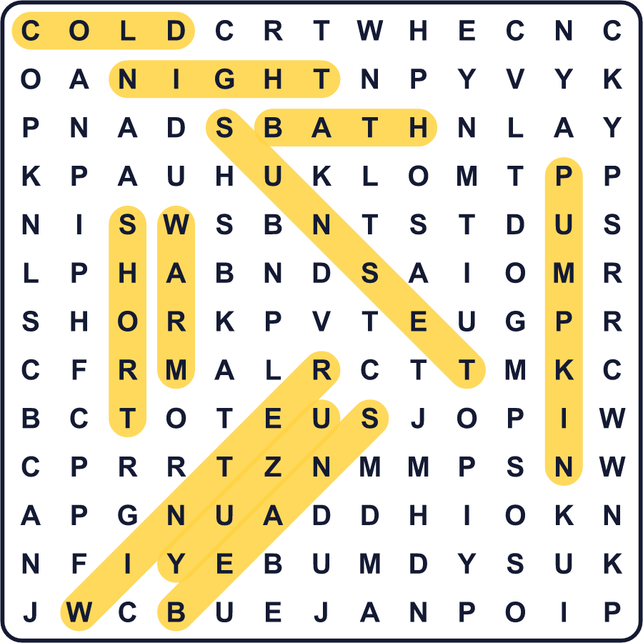
全訳
1 12月22日ごろ、日本は一年でいちばん昼の短い日をむかえます。この日を「冬至」と言います。2026年の東京では、日の出が朝6時47分、日の入りが午後4時32分です。昼の明るさは10時間もありません。6月の東京では、太陽が出ている時間がほぼ5時間も長いのです。
2 この夜、多くの家庭がゆず湯に入ります。ゆずは、強くさわやかな香りのする小さな黄色いかんきつ類です。丸ごとのゆずをお湯に入れて、ゆったりくつろぎます。ゆず湯に入るとかぜをひかない、と言う人もいます。この習慣は、約200年前の昔の東京の銭湯で始まったと言われます。
3 人々はかぼちゃ、つまり甘い日本のかぼちゃも食べます。この日にかぼちゃを食べると長生きできる、という古い言い伝えがあります。今では、うどんのように名前に「ん」の音がある食べ物を食べる家庭もあります。でも、この習慣はけっこう新しいものです。1800年代の古い記録に出てくるのは、豆腐のように「と」で始まる食べ物です。
4 冬至は寒さだけの日ではありません。この日から、昼は少しずつまた長くなっていきます。だから人々は、この日を幸運が戻りはじめる日とも考えます。中国では、この日に多くの人がぎょうざを食べます。イランでは、一年でいちばん長い夜に、家族がスイカと詩を楽しみながら夜ふかしをします。

