👑 Three Kings' Day Worksheet
Presents in Your Shoes
Read the story. 英文を読もう。
Class ______ No. ____ Name ______________________________

🔊 音声を聞こう（スマホで読みとってね）
1 In many homes in Spain, children go to bed early on the night of January 5. Before they sleep, they clean their shoes and leave them out. They are not waiting for Santa Claus. They are waiting for three kings.
2 The story comes from the Bible. Wise men from the East followed a bright star to find the baby Jesus. They brought three gifts: gold, frankincense, and myrrh. Frankincense and myrrh come from trees, and they smell sweet. But the Bible does not say there were three men, and it does not call them kings. People added these ideas much later, and they also gave the men names: Melchior, Caspar, and Balthasar.
3 Today, January 6 is a big day in Spain and Latin America. On the evening before, the kings ride through town in colorful parades and throw candy to the crowds. In the morning, children find presents by their shoes. Bad children may get black coal, but it is really sugar candy. In Puerto Rico, children leave a box of grass under the bed for the kings' camels and horses.
4 Families also share a ring of sweet bread called rosca de reyes. A tiny baby Jesus doll is hidden inside. In Mexico, the person who finds it gets a job. On February 2, that person must make tamales for everyone. So everyone at the table hopes to find the doll, and everyone hopes not to find it!
Words 単語
wise（かしこい、知恵のある） / follow（あとについて行く、たどる） / gift（贈り物） / frankincense（乳香（香りのよい樹脂）） / parade（パレード、行列） / crowd（人ごみ、群衆） / coal（石炭） / hidden（隠された）

👑 Three Kings' Day Worksheet
Reading Check
Choose the best answer. 正しいものを選ぼう。
Class ______ No. ____ Name ______________________________
1. What is the reading mainly about?
(A) How Santa Claus travels around the world (B) How people celebrate Three Kings' Day and where it comes from (C) How to bake sweet bread at home (D) Why children in Spain go to bed early every night
2. What do Spanish children do before they sleep on January 5?
(A) They write a letter to Santa. (B) They bake bread. (C) They watch a movie. (D) They clean their shoes.
3. What does the Bible NOT say about the wise men?
(A) That there were three of them (B) That they followed a star (C) That they brought gold (D) That they came to see the baby Jesus
4. In paragraph 3, what does "crowds" mean?
(A) Kings (B) Camels (C) Large groups of people (D) Small boxes
5. Why do people in Mexico hope to find the doll and also hope NOT to find it?
(A) Because the doll is very expensive (B) Because finding it is lucky, but the finder must make tamales (C) Because the doll is too small to see (D) Because the kings take the doll back
True or False? T か F に○
1. Three Kings' Day is on January 6. T / F
2. The Bible says there were exactly three kings. T / F
3. In Italy, an old woman called Befana brings gifts. T / F
4. In Mexico, the person who finds the doll makes tamales on Christmas Day. T / F

👑 Three Kings' Day Worksheet
Word Work
単語のれんしゅう
Class ______ No. ____ Name ______________________________
① Match the pictures and the words. 絵と単語を線でむすぼう。
👑 | ● | ● | star
⭐ | ● | ● | gift
🐫 | ● | ● | crown
🎁 | ● | ● | shoe
👞 | ● | ● | camel
🧹 | ● | ● | broom
③ Fill in the blanks. 語群から選んで入れよう。
[ summer / shoes / pumpkin / bread / laughs / February / doll / presents / January / door ]
On the night of (1) __________ 5, Sofia cleans her (2) __________ . She leaves them by the (3) __________ . In the morning, she runs to look. There are (4) __________ next to her shoes! Later, her family eats a sweet (5) __________ shaped like a ring. Her father finds a small (6) __________ inside. "Oh no," he (7) __________ . "Now I have to make tamales in (8) __________ !"

👑 Three Kings' Day Worksheet
Crossword Puzzle
ヒントを読んでクロスワードを完成させよう。
Class ______ No. ____ Name ______________________________
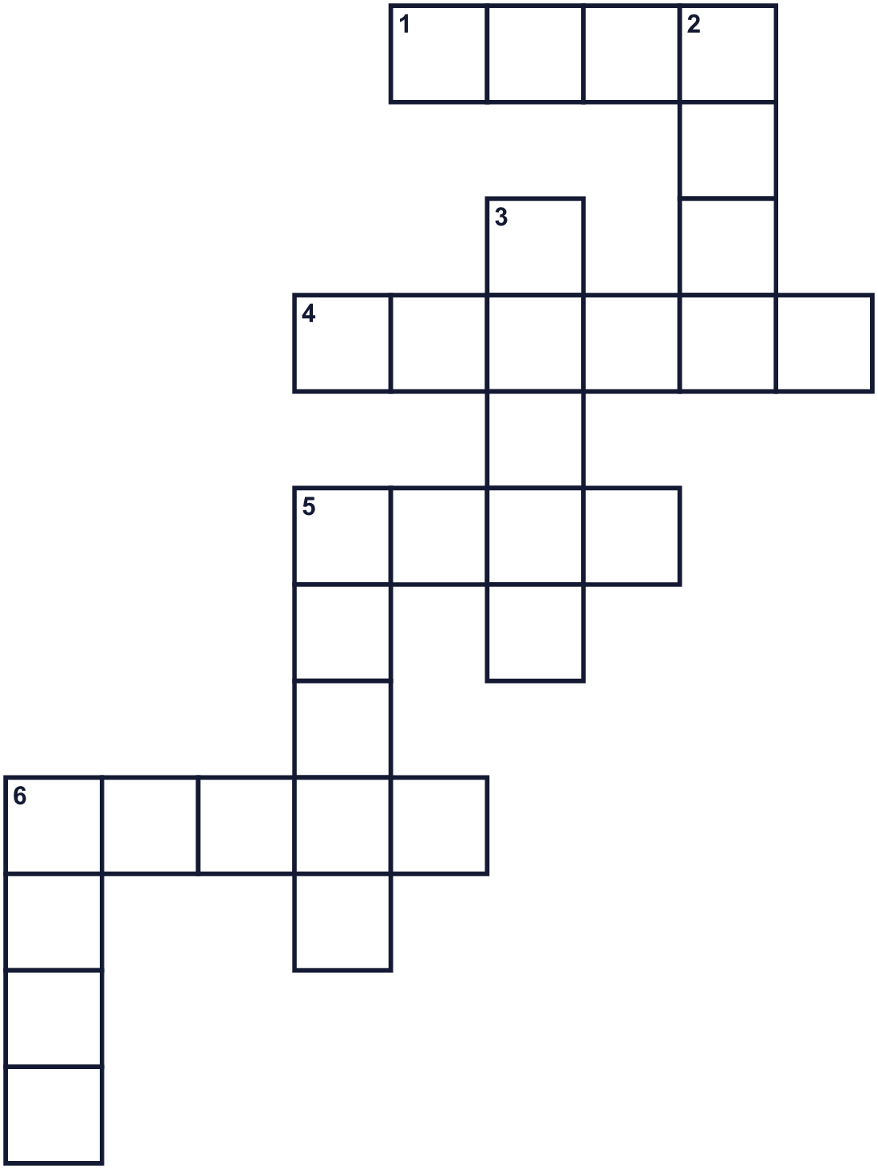
Across →
1. A man who rules a country. He wears a crown. (4)
4. People walk or ride down the street to celebrate, and others watch. (6)
5. A black rock that burns. Bad children may get some. (4)
6. You wear them on your feet. Spanish children clean them on January 5. (5)
Down ↓
2. A shiny yellow metal. It was one of the three gifts. (4)
3. A food made from flour. Rosca de reyes is a sweet one. (5)
5. A desert animal with a hump on its back. (5)
6. It shines in the night sky. The wise men followed one. (4)

👑 Three Kings' Day Worksheet
Word Search
かくれた単語をさがそう（→ ↓ ↘ ↗）
Class ______ No. ____ Name ______________________________
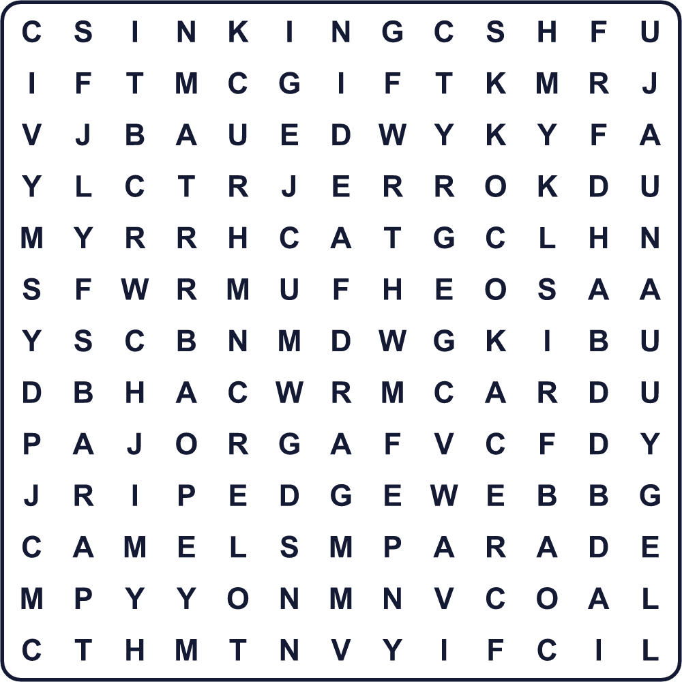
CAMEL COAL GIFT GOLD JANUARY KING MYRRH PARADE SHOES STAR

👑 Three Kings' Day Worksheet
Maze & Sentences
Class ______ No. ____ Name ______________________________
Help the camel follow the star! ラクダを星のところまで連れていこう！
正しい道の文字を集めると、ひみつの言葉になるよ。 START 🐫 → GOAL ⭐
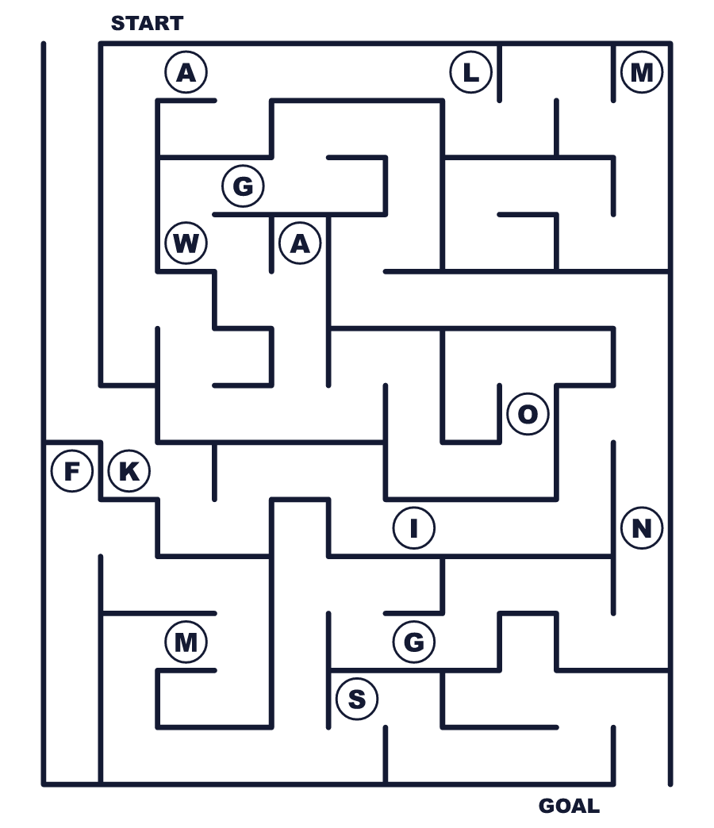
Secret word: ＿ ＿ ＿ ＿ ＿

👑 Three Kings' Day Worksheet
Class Activity & Writing
Class ______ No. ____ Name ______________________________
Let's Write! 英語で書いてみよう。
If the Three Kings came to my house, I would leave ______ for their camels because ______.
もし三賢王が家に来たら、ラクダのために＿＿＿を置いておきます。なぜなら＿＿＿だからです。
______________________________________________________________
______________________________________________________________
I would like to celebrate January 6 in ______ because ______.
1月6日を＿＿＿（国）で過ごしてみたいです。なぜなら＿＿＿だからです。
______________________________________________________________
______________________________________________________________

👑 Three Kings' Day Worksheet
Trace & Color
なぞって書こう。絵に色をぬろう。
Class ______ No. ____ Name ______________________________
👑 

⭐ 
🐫 
🎁 
👞 

👑 Three Kings' Day Worksheet
Answer Key 解答
Reading Check: 1.B 2.D 3.A 4.C 5.B
True or False: 1.T 2.F 3.T 4.F
Match: 👑=crown ⭐=star 🐫=camel 🎁=gift 👞=shoe 🧹=broom
Fill in the blanks: (1)January (2)shoes (3)door (4)presents (5)bread (6)doll (7)laughs (8)February
Maze: KINGS
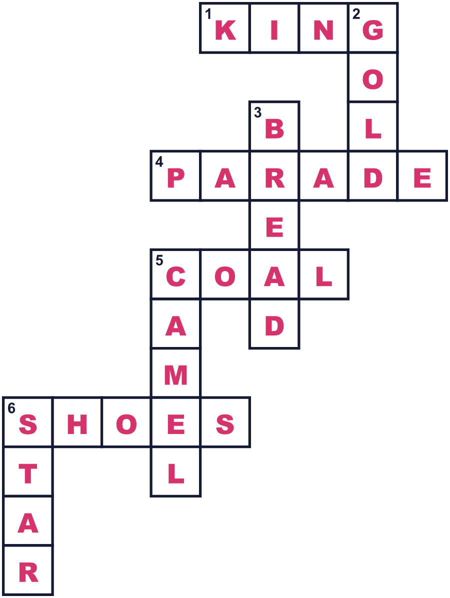
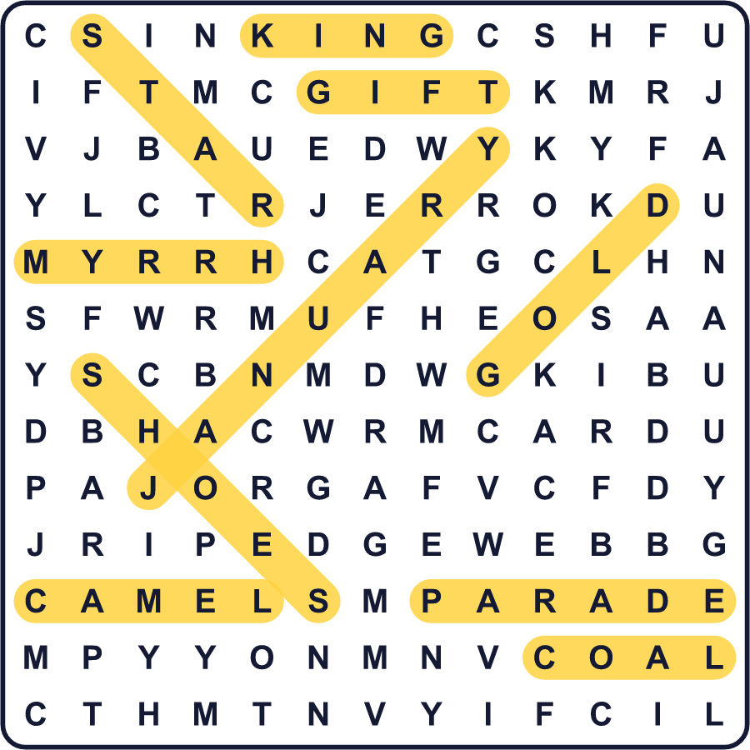
全訳
1 スペインの多くの家では、1月5日の夜、子どもたちが早く寝ます。寝る前に、くつをきれいにして外に出しておきます。待っているのはサンタクロースではありません。3人の王様を待っているのです。
2 この話は聖書から来ています。東の国の博士たちが、明るい星をたどって赤ちゃんのイエスをさがしに来ました。彼らは黄金、乳香、没薬という3つの贈り物を持ってきました。乳香と没薬は木からとれるもので、よい香りがします。でも聖書には、3人だったとも、王様だったとも書かれていません。そうした考えはずっと後に足されたもので、人々は名前もつけました。メルキオール、カスパール、バルタザールです。
3 今では1月6日は、スペインや中南米で大切な日です。前の日の夕方、王たちは色あざやかなパレードで町を進み、集まった人たちにあめを投げます。朝になると、子どもたちはくつのそばにプレゼントを見つけます。悪い子は黒い石炭をもらうかもしれませんが、それは本当は砂糖菓子です。プエルトリコでは、子どもたちが王様のラクダや馬のために、草を入れた箱をベッドの下に置きます。
4 家族は、ロスカ・デ・レジェスという輪の形の甘いパンも分け合います。中には、赤ちゃんのイエスの小さな人形が隠されています。メキシコでは、それを見つけた人に役目がまわってきます。2月2日に、その人はみんなのためにタマレスを作らなければならないのです。だからテーブルのみんなは、人形が当たってほしいと願い、同時に当たらないでほしいとも願うのです！

