🦃 Thanksgiving Worksheet
Two Sides of One Table
Read the story. 英文を読もう。
Class ______ No. ____ Name ______________________________

🔊 音声を聞こう（スマホで読みとってね）
1 In the fall of 1621, a small English village in North America held a harvest party. About 50 English settlers were there. Then about 90 Wampanoag men arrived with their leader, Ousamequin. They stayed for three days, and they brought five deer for the meal.
2 Both groups had a hard story behind them. The English came on a ship called the Mayflower in 1620. Their first winter was terrible, and about half of them died. A few years earlier, a terrible sickness had killed many Wampanoag people. So the two groups made an agreement to protect each other.
3 Today, many people call this meal the first Thanksgiving. But it became a national holiday much later. A writer named Sarah Josepha Hale sent letters to five presidents for 17 years. In 1863, President Abraham Lincoln finally agreed. Hale also wrote the famous children's poem Mary Had a Little Lamb.
4 Now Thanksgiving is on the fourth Thursday in November. Millions of families travel across the country to eat turkey, mashed potatoes, and pumpkin pie together. Many people watch a big parade in New York and football games on TV. In Canada, Thanksgiving comes earlier, on the second Monday in October.
5 Not everyone remembers the day in the same way. For many Native Americans, it is also a time to think about what their people lost. Since 1970, some of them have met in Plymouth on Thanksgiving Day for a National Day of Mourning. At the Thanksgiving table, there is more than one story to tell.
Words 単語
harvest（収穫） / settler（入植者、移住者） / Pilgrim（ピルグリム（メイフラワー号の入植者）、巡礼者） / Native American（アメリカ先住民） / agreement（約束、協定） / sickness（病気） / thankful（感謝している） / national holiday（国の祝日） / president（大統領） / parade（パレード、行列） / mourning（喪、追悼、深い悲しみ） / recipe（レシピ、作り方）

🦃 Thanksgiving Worksheet
Reading Check
Choose the best answer. 正しいものを選ぼう。
Class ______ No. ____ Name ______________________________
1. What is the main idea of the passage?
(A) Thanksgiving is only about eating turkey. (B) Thanksgiving started in Canada in 1957. (C) Thanksgiving has a long history, and people see it in different ways. (D) The Wampanoag came to America on the Mayflower.
2. How many Wampanoag men came to the harvest party?
(A) About 50 (B) About 90 (C) About 17 (D) About 102
3. Why did the two groups make an agreement?
(A) To protect each other (B) To build a ship (C) To sell deer (D) To start a parade
4. What did Sarah Josepha Hale do?
(A) She sailed on the Mayflower. (B) She cooked the first turkey. (C) She started the Macy's parade. (D) She wrote letters to presidents for 17 years.
5. In paragraph 5, the word mourning is closest in meaning to ___.
(A) the early part of the day (B) feeling sad about people who died or things that were lost (C) eating a big meal (D) watching football
6. Which is true according to the passage?
(A) Canadian Thanksgiving is in October. (B) Lincoln made Thanksgiving a holiday in 1621. (C) The first winter was easy for the English. (D) Everyone remembers Thanksgiving in the same way.
7. What can we guess about the harvest party in 1621?
(A) It was a national holiday with a parade. (B) Only English people were there. (C) It happened when both groups had been through hard times. (D) It took place in October 1863.
8. In the dialogue, what does Ryo compare Thanksgiving to?
(A) Christmas in America (B) Halloween in Canada (C) A birthday party (D) New Year's in Japan
True or False? T か F に○
1. American Thanksgiving is on the fourth Thursday in November. T / F
2. Canadian Thanksgiving is in December. T / F
3. About 90 Wampanoag men came to the harvest party in 1621. T / F
4. Thanksgiving became a national holiday in 1621. T / F
5. Sarah Josepha Hale wrote Mary Had a Little Lamb. T / F
6. All Native Americans celebrate Thanksgiving in the same way. T / F

🦃 Thanksgiving Worksheet
Word Work
単語のれんしゅう
Class ______ No. ____ Name ______________________________
① Match the pictures and the words. 絵と単語を線でむすぼう。
🦃 | ● | ● | ship
🥧 | ● | ● | potato
🌽 | ● | ● | balloon
🍂 | ● | ● | corn
⛵ | ● | ● | leaf
🏈 | ● | ● | football
🥔 | ● | ● | turkey
🎈 | ● | ● | pie
② Unscramble the words. 並べかえて単語にしよう。
1. U R K T E Y (七面鳥) → ____________________
2. V S A R T E H (収穫) → ____________________
3. I I G P L R M (ピルグリム) → ____________________
4. E F A T S (ごちそう、宴) → ____________________
5. F N U T K L A H (感謝している) → ____________________
6. E E T T S L R (入植者) → ____________________
③ Fill in the blanks. 語群から選んで入れよう。
[ summer / table / stories / snowman / card / Thursday / pumpkin / hug / football / hours / thankful / sushi / turkey ]
Leo lives in Boston. On (1) __________ , his whole family comes to his house. His uncle drives for six (2) __________ . In the kitchen, his mom cooks a big (3) __________ . His sister makes (4) __________ pie. Before dinner, everyone sits at the (5) __________ . Each person says one thing they are (6) __________ for. Leo is nervous, but he gives his grandma a (7) __________ . It says, Thank you for your (8) __________ . Grandma smiles and gives him a big (9) __________ . After dinner, they all watch (10) __________ on TV.

🦃 Thanksgiving Worksheet
Crossword Puzzle
ヒントを読んでクロスワードを完成させよう。
Class ______ No. ____ Name ______________________________
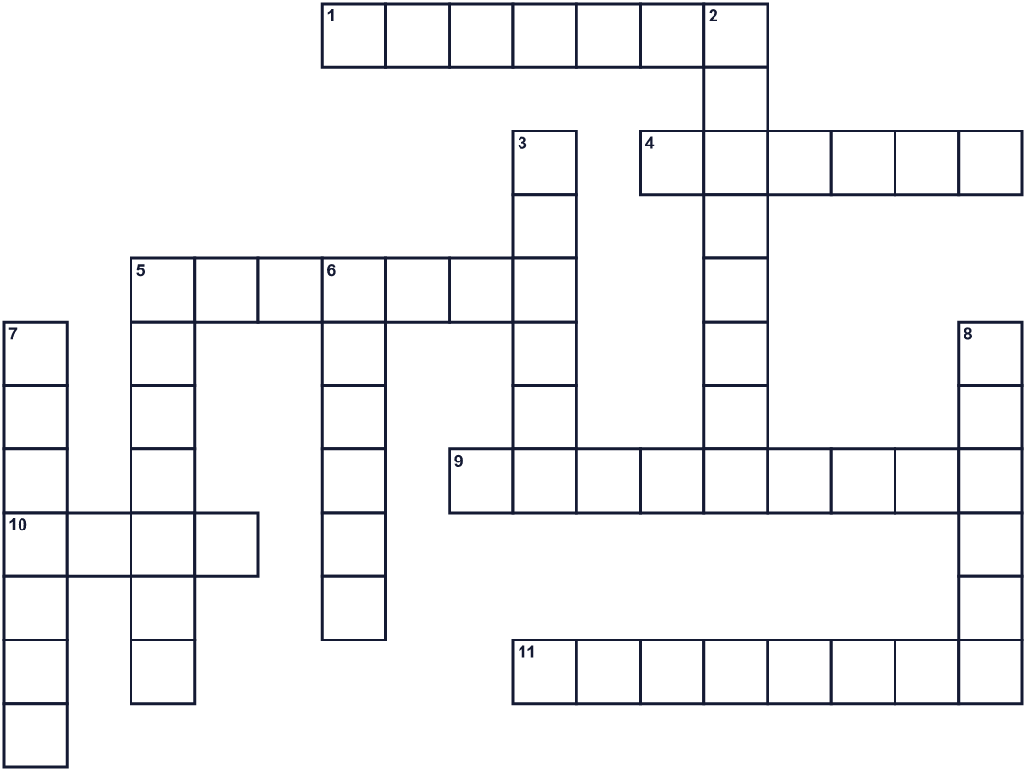
Across →
1. The time when farmers collect their crops. (7)
4. Parents, children, and grandparents together. (6)
5. An orange vegetable. People make pie with it. (7)
9. The ship that carried 102 people from England in 1620. (9)
10. A yellow crop. Squanto showed the settlers how to grow it. (4)
11. The day of the week for this holiday in the United States. (8)
Down ↓
2. Feeling glad and grateful for something. (8)
3. This country has the holiday in October. (6)
5. One of the English settlers who came to Plymouth. (7)
6. A long line of people and balloons moving down a street. (6)
7. The president who made the holiday national in 1863. (7)
8. A big bird. Americans eat it on this holiday. (6)

🦃 Thanksgiving Worksheet
Word Search
かくれた単語をさがそう（→ ↓ ↘ ↗）
Class ______ No. ____ Name ______________________________
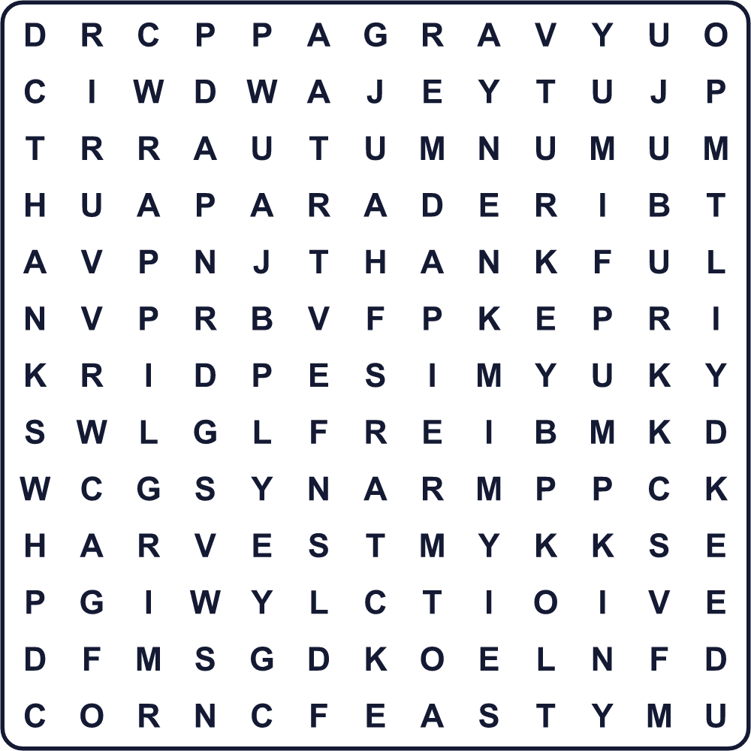
AUTUMN CORN CRANBERRY FAMILY FEAST GRAVY HARVEST PARADE PIE PILGRIM PUMPKIN THANKFUL THANKS TURKEY
Secret Code 暗号を解こう
▲=A ☀=G ✂=H ◎=I ✎=K ☺=N ☃=P ✉=S ●=T ✚=V ♪=Y
✂ ▲ ☃ ☃ ♪ ● ✂ ▲ ☺ ✎ ✉ ☀ ◎ ✚ ◎ ☺ ☀
______________________________________________________________

🦃 Thanksgiving Worksheet
Maze & Sentences
Class ______ No. ____ Name ______________________________
Help Leo bring the pie to the table! レオがパイをテーブルまで運ぶのを手伝おう！
正しい道の文字を集めると、ひみつの言葉になるよ。 START 🧒 → GOAL 🥧
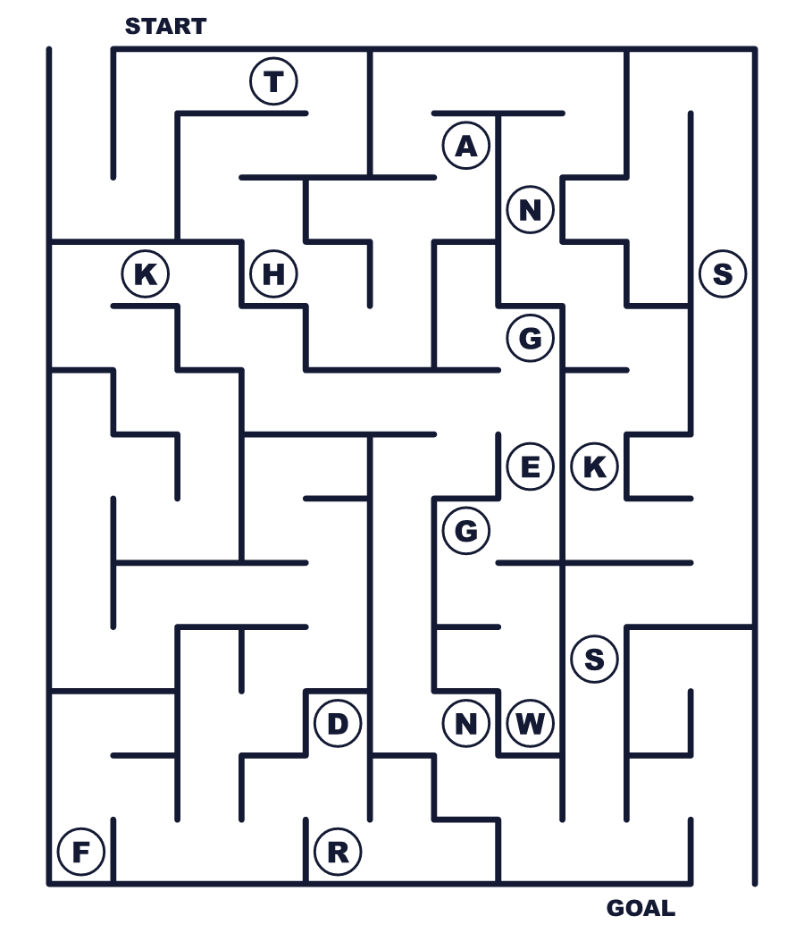
Secret word: ＿ ＿ ＿ ＿ ＿ ＿
Put the words in order. 並べかえよう。
1. turkey / Day / Thanksgiving / eat / Families / on . (家族は感謝祭の日に七面鳥を食べます。)
______________________________________________________________
2. good / am / I / for / my / thankful / friends . (私はよい友だちに感謝しています。)
______________________________________________________________
3. party / lasted / days / The / for / three . (そのお祝いは3日間続きました。)
______________________________________________________________
4. has / a / October / in / Monday / Thanksgiving / Canada / on . (カナダでは10月の月曜日に感謝祭があります。)
______________________________________________________________
5. people / home / travel / Many / for / the / holiday . (多くの人が祝日のために帰省します。)
______________________________________________________________

🦃 Thanksgiving Worksheet
Class Activity & Writing
Class ______ No. ____ Name ______________________________
Find Someone Who… クラスで聞いて回ろう！
Find someone who … | Name
… has eaten turkey 七面鳥を食べたことがある
… likes pumpkin pie パンプキンパイが好き
… can name a country in North America 北アメリカの国の名前を言える
… knows the song Mary Had a Little Lamb 『メリーさんのひつじ』の歌を知っている
… has traveled to see family for a holiday 祝日に家族に会いに出かけたことがある
… can say three things they are thankful for 感謝していることを3つ言える
… knows the date of Labor Thanksgiving Day 勤労感謝の日の日付を知っている
… has watched American football アメリカンフットボールを見たことがある
Let's Write! 英語で書いてみよう。
This year, I am thankful for ______ because ______.
今年、私は＿＿＿に感謝しています。なぜなら＿＿＿だから。
______________________________________________________________
______________________________________________________________
If I had a Thanksgiving dinner, I would invite ______ and cook ______.
もし感謝祭のディナーを開くなら、私は＿＿＿を招いて＿＿＿を料理します。
______________________________________________________________
______________________________________________________________
One thing I learned about the Wampanoag is ______.
ワンパノアグについて私が学んだことの1つは＿＿＿です。
______________________________________________________________
______________________________________________________________

🦃 Thanksgiving Worksheet
Trace & Color
なぞって書こう。絵に色をぬろう。
Class ______ No. ____ Name ______________________________
🦃 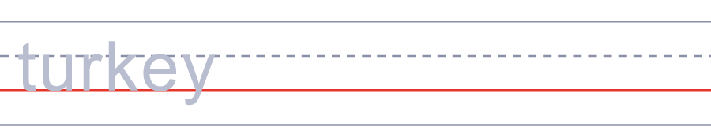

🥧 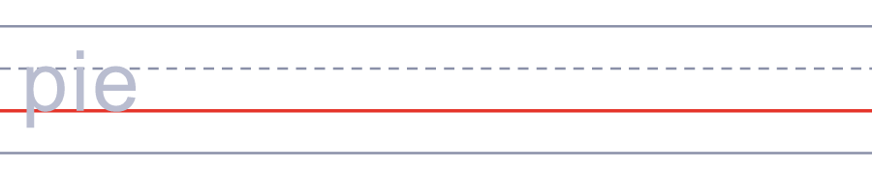
🌽 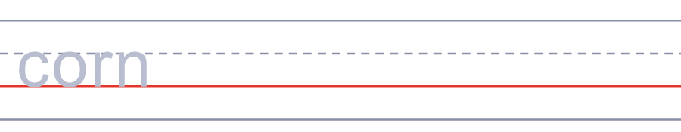
🍂 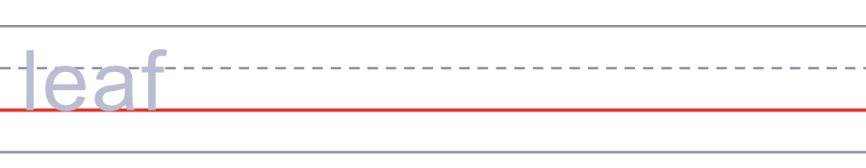
⛵ 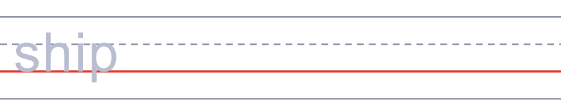
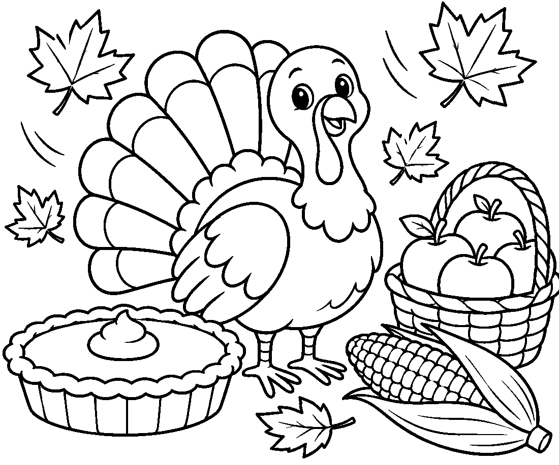

🦃 Thanksgiving Worksheet
Answer Key 解答
Reading Check: 1.C 2.B 3.A 4.D 5.B 6.A 7.C 8.D
True or False: 1.T 2.F 3.T 4.F 5.T 6.F
Match: 🦃=turkey 🥧=pie 🌽=corn 🍂=leaf ⛵=ship 🏈=football 🥔=potato 🎈=balloon
Unscramble: 1.TURKEY 2.HARVEST 3.PILGRIM 4.FEAST 5.THANKFUL 6.SETTLER
Fill in the blanks: (1)Thursday (2)hours (3)turkey (4)pumpkin (5)table (6)thankful (7)card (8)stories (9)hug (10)football
Sentence order: 1. Families eat turkey on Thanksgiving Day. 2. I am thankful for my good friends. 3. The party lasted for three days. 4. Canada has Thanksgiving on a Monday in October. 5. Many people travel home for the holiday.
Secret Code: HAPPY THANKSGIVING
Maze: THANKS
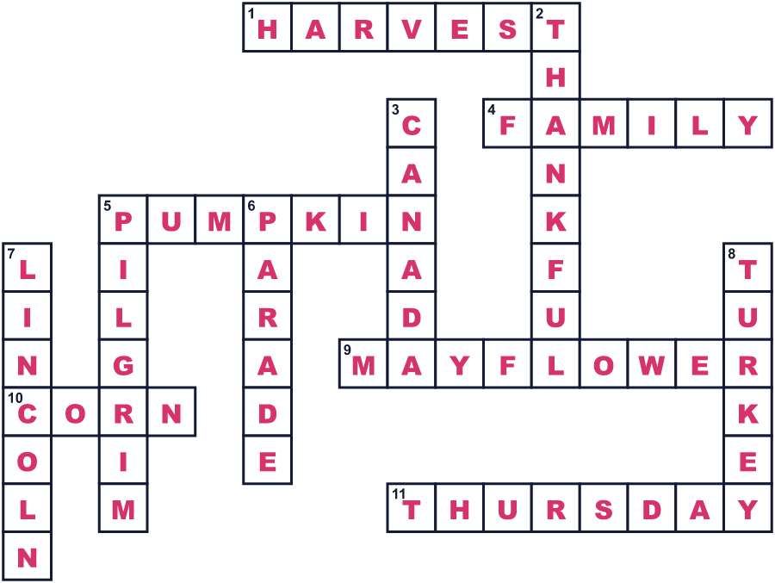
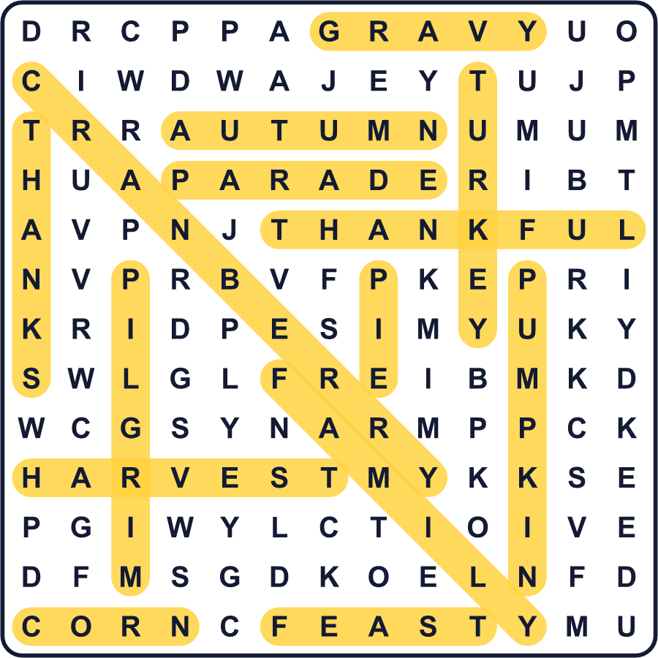
全訳
1 1621年の秋、北アメリカにあるイギリス人の小さな村で、収穫のお祝いが開かれました。そこには約50人のイギリス人入植者がいました。そこへ、指導者ウサメクィンとともに、約90人のワンパノアグの男たちがやってきました。彼らは3日間とどまり、食事のために5頭のシカを持ってきました。
2 どちらのグループにも、つらい事情がありました。イギリス人は1620年、メイフラワー号という船でやってきました。最初の冬はひどく、約半分が亡くなりました。その数年前には、おそろしい病気で多くのワンパノアグの人々が亡くなっていました。そこで、2つのグループはお互いを守る約束を結びました。
3 今では、多くの人がこの食事を「最初の感謝祭」と呼びます。でも、国の祝日になったのはずっとあとのことです。サラ・ジョセファ・ヘイルという作家が、17年間、5人の大統領に手紙を送りました。1863年、ついにエイブラハム・リンカーン大統領が賛成しました。ヘイルは、有名な子ども向けの詩『メリーさんのひつじ』も書きました。
4 今、感謝祭は11月の第4木曜日です。何百万もの家族が国じゅうを移動して、七面鳥やマッシュポテト、パンプキンパイをいっしょに食べます。多くの人が、ニューヨークの大きなパレードやフットボールの試合をテレビで見ます。カナダでは、感謝祭はもっと早く、10月の第2月曜日にやってきます。
5 この日の思い出し方は、人によって同じではありません。多くのアメリカ先住民にとって、この日は自分たちが失ったものを考える時でもあります。1970年から、その一部の人々は、感謝祭の日にプリマスに集まり「全米追悼の日」を開いています。感謝祭のテーブルには、語られるべき物語が1つだけではないのです。

