🎂 The Emperor's Birthday Worksheet
A Holiday That Moves
Read the story. 英文を読もう。
Class ______ No. ____ Name ______________________________
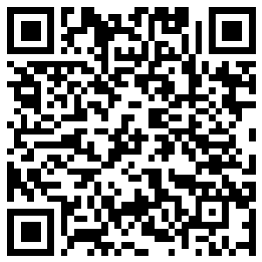
🔊 音声を聞こう（スマホで読みとってね）
1 February 23 is a national holiday in Japan called the Emperor's Birthday. The present Emperor was born on this day in 1960. But this holiday has a strange secret: its date can move.
2 The holiday has a very long history. In 775, an emperor told people to celebrate his birthday with a big party. He called the day Tenchosetsu. The name comes from an old Chinese saying about heaven and earth lasting for a long time. Japan used this name until 1948.
3 When a new emperor comes to the throne, the holiday moves to his birthday. From 1989 to 2018, it was on December 23. Then a new emperor came to the throne on May 1, 2019. February 23 had already passed, and December 23 was not his birthday. So in 2019, Japan had no Emperor's Birthday at all!
4 Some old birthdays are still holidays with new names. November 3 was the birthday of Emperor Meiji, and it is now Culture Day. April 29 was the birthday of Emperor Showa, and it is now Showa Day. So the calendar keeps a little piece of each past emperor.
5 On February 23, many people visit the Imperial Palace in Tokyo. In the morning, the Emperor and his family come out onto a balcony, and people wave small flags. The Emperor gives a short speech to thank them. In the afternoon, visitors can sign a special book to send their good wishes. Japanese people do not call him by his name. They say Tenno Heika, which means His Majesty the Emperor.
Words 単語
emperor（天皇、皇帝） / throne（王座、皇位） / palace（宮殿） / balcony（ベランダ、バルコニー） / wave（（手や旗を）振る） / speech（スピーチ、お言葉） / history（歴史） / saying（ことわざ、言いならわし） / official（公式の） / past（過去の、以前の） / celebrate（祝う） / majesty（陛下（敬称）、威厳）

🎂 The Emperor's Birthday Worksheet
Reading Check
Choose the best answer. 正しいものを選ぼう。
Class ______ No. ____ Name ______________________________
1. What is the main idea of the reading?
(A) The Emperor's Birthday is a long-loved holiday whose date can change. (B) The Emperor's Birthday is always on December 23. (C) The Emperor's Birthday is a new holiday from 2019. (D) The Emperor's Birthday is only for children.
2. When was the present Emperor born?
(A) On December 23, 1933 (B) On April 29, 1901 (C) On February 23, 1960 (D) On May 1, 2019
3. Where does the name Tenchosetsu come from?
(A) From an English song (B) From an old Chinese saying (C) From the name of a palace (D) From a Japanese mountain
4. Why did Japan have no Emperor's Birthday in 2019?
(A) Because the Emperor was sick (B) Because the government forgot it (C) Because people wanted to work (D) Because the new date had passed and the old date was not his birthday
5. In paragraph 3, 'came to the throne' means:
(A) sat on a chair (B) became emperor (C) left the palace (D) traveled abroad
6. Which is true according to the reading?
(A) Culture Day was once the birthday of Emperor Meiji. (B) Showa Day is on November 3. (C) Japanese people usually call the Emperor by his name. (D) The Emperor comes out onto the balcony at night.
7. What can we guess about the next Emperor's Birthday after a new emperor?
(A) It will stay on February 23 forever. (B) It will move to the new emperor's birthday. (C) It will be on January 1. (D) It will be cancelled forever.
8. In the dialogue, when is the King's real birthday in Sophie's story?
(A) In February (B) In June (C) In December (D) In November
True or False? T か F に○
1. The Emperor's Birthday is on February 23 now. T / F
2. The holiday has always been on February 23. T / F
3. In 2019, Japan had no Emperor's Birthday. T / F
4. December 23 is still a national holiday. T / F
5. Culture Day was once the birthday of Emperor Meiji. T / F
6. Japanese people usually call the Emperor by his first name. T / F

🎂 The Emperor's Birthday Worksheet
Word Work
単語のれんしゅう
Class ______ No. ____ Name ______________________________
① Match the pictures and the words. 絵と単語を線でむすぼう。
🎂 | ● | ● | Mount Fuji
👑 | ● | ● | wave
🏯 | ● | ● | crown
🎌 | ● | ● | birthday cake
👋 | ● | ● | flags
🎤 | ● | ● | microphone
🗻 | ● | ● | train
🚆 | ● | ● | castle
② Unscramble the words. 並べかえて単語にしよう。
1. R E M E P R O (天皇) → ____________________
2. A C A L E P (宮殿) → ____________________
3. T E O H N R (王座・皇位) → ____________________
4. A Y L O N C B (バルコニー) → ____________________
5. F I F L O A C I (公式の) → ____________________
6. S A T Y M J E (陛下) → ____________________
③ Fill in the blanks. 語群から選んで入れよう。
[ Palace / morning / beach / happy / people / balcony / grandmother / cake / swimsuit / speech / wave / flag / snowball ]
On February 23, Hana and her (1) __________ went to Tokyo by train. They walked to the Imperial (2) __________ . There were many (3) __________ in a long line. Everyone had a small paper (4) __________ . At ten in the (5) __________ , the Emperor and his family came out onto the (6) __________ . People began to (7) __________ their flags. The Emperor gave a short (8) __________ . Hana could not hear every word, but she felt (9) __________ . On the way home, they bought (10) __________ to celebrate.

🎂 The Emperor's Birthday Worksheet
Crossword Puzzle
ヒントを読んでクロスワードを完成させよう。
Class ______ No. ____ Name ______________________________
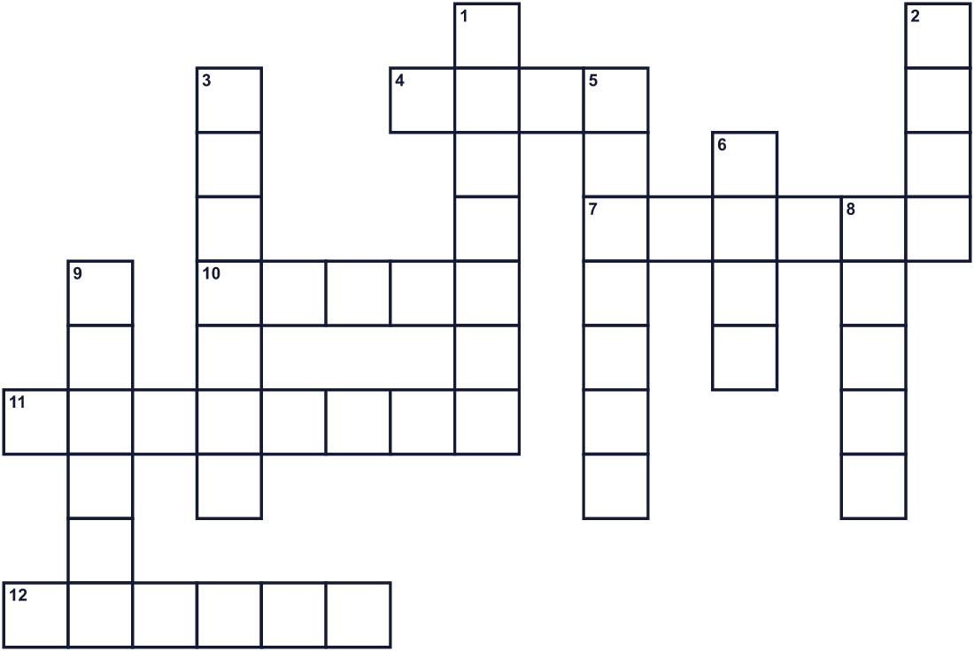
Across →
4. To move your hand from side to side to say hello. (4)
7. A very large and grand home for a king or queen. (6)
10. The capital city of Japan. (5)
11. The month of this holiday now. (8)
12. The special chair of a king. Also means the royal position. (6)
Down ↓
1. A small open area outside an upper window. (7)
2. A sweet food with candles for a birthday. (4)
3. Things that happened long ago. (7)
5. The title of Japan's head of the Imperial family. (7)
6. People wave a small paper one with a red circle. (4)
8. A gold thing a king wears on his head. (5)
9. A short talk to a crowd of people. (6)

🎂 The Emperor's Birthday Worksheet
Word Search
かくれた単語をさがそう（→ ↓ ↘ ↗）
Class ______ No. ____ Name ______________________________
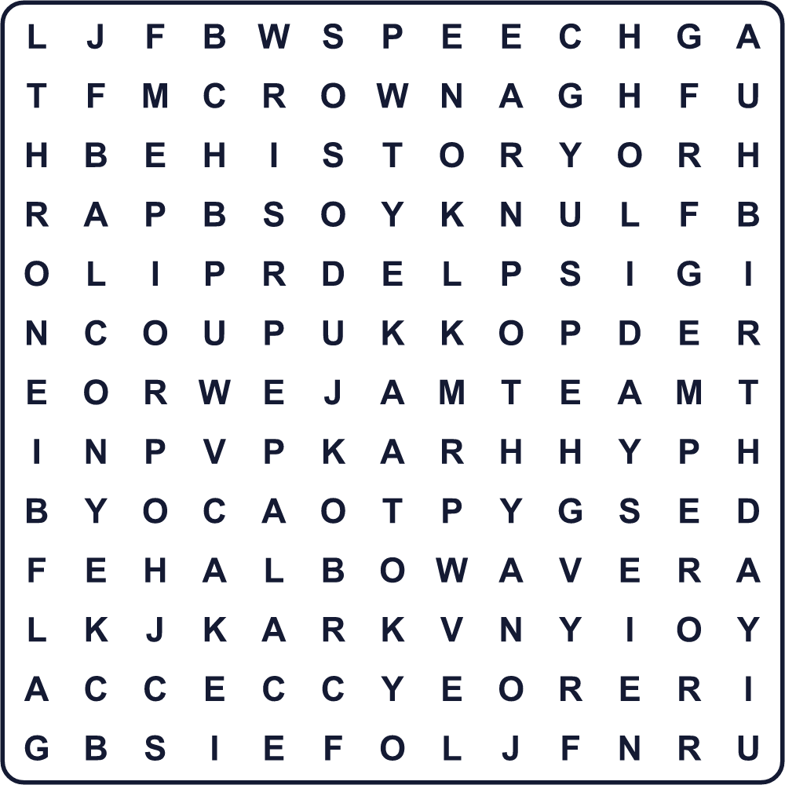
BALCONY BIRTHDAY CAKE CROWN EMPEROR FEBRUARY FLAG HISTORY HOLIDAY PALACE SPEECH THRONE TOKYO WAVE
Secret Code 暗号を解こう
◆=A ☀=B ☃=D ☎=H ★=I ✎=P ⚑=R ☘=T ✈=Y
☎ ◆ ✎ ✎ ✈ ☀ ★ ⚑ ☘ ☎ ☃ ◆ ✈
______________________________________________________________

🎂 The Emperor's Birthday Worksheet
Maze & Sentences
Class ______ No. ____ Name ______________________________
Help Hana get to the palace! ハナを皇居まで連れていこう！
正しい道の文字を集めると、ひみつの言葉になるよ。 START 🚉 → GOAL 🏯
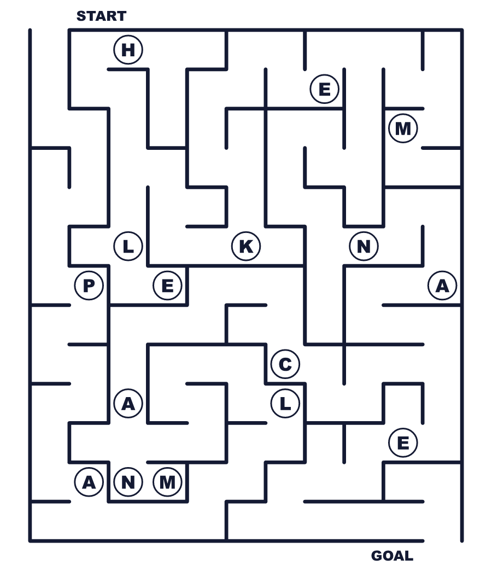
Secret word: ＿ ＿ ＿ ＿ ＿ ＿
Put the words in order. 並べかえよう。
1. The / born / was / 1960 / in / Emperor . (天皇陛下は1960年に生まれました。)
______________________________________________________________
2. emperor / The / date / changes / a / new / with . (日付は新しい天皇とともに変わります。)
______________________________________________________________
3. Many / Palace / people / the / visit / Imperial . (多くの人が皇居を訪れます。)
______________________________________________________________
4. in / flags / the / morning / People / wave / small . (人々は午前中に小さな旗を振ります。)
______________________________________________________________
5. Birthday / Japan / in / 2019 / had / no / Emperor's . (2019年、日本には天皇誕生日がありませんでした。)
______________________________________________________________

🎂 The Emperor's Birthday Worksheet
Class Activity & Writing
Class ______ No. ____ Name ______________________________
Find Someone Who… クラスで聞いて回ろう！
Find someone who … | Name
… has a birthday in February 2月生まれ
… has been to the Imperial Palace 皇居に行ったことがある
… knows the birthday of the present Emperor 今の天皇陛下の誕生日を知っている
… can name a holiday that was an old emperor's birthday 昔の天皇の誕生日だった祝日を言える
… has seen Mount Fuji 富士山を見たことがある
… knows a king or queen in another country ほかの国の国王や女王を知っている
… likes birthday cake バースデーケーキが好き
… can say 'His Majesty the Emperor' in English 「天皇陛下」を英語で言える
Let's Write! 英語で書いてみよう。
If I explain the Emperor's Birthday to a friend, I will say ______.
天皇誕生日を友だちに説明するなら、＿＿と言います。
______________________________________________________________
______________________________________________________________
My favorite way to celebrate a birthday is ______ because ______.
私の好きな誕生日の祝い方は＿＿です。なぜなら＿＿だからです。
______________________________________________________________
______________________________________________________________
If I had an official birthday, I would choose ______ because ______.
もし公式の誕生日があったら、＿＿にします。なぜなら＿＿だからです。
______________________________________________________________
______________________________________________________________

🎂 The Emperor's Birthday Worksheet
Trace & Color
なぞって書こう。絵に色をぬろう。
Class ______ No. ____ Name ______________________________
🎂 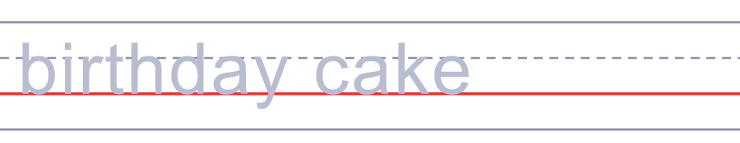

👑 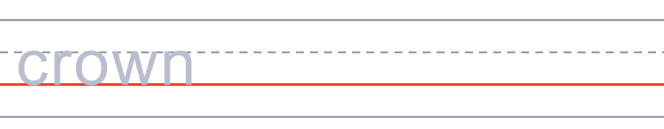
🏯 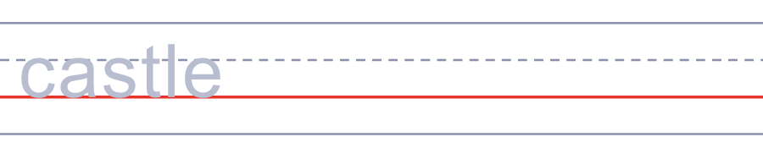
🎌 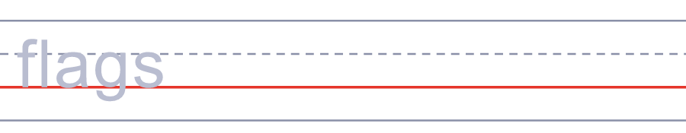
👋 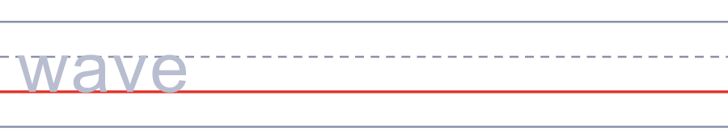
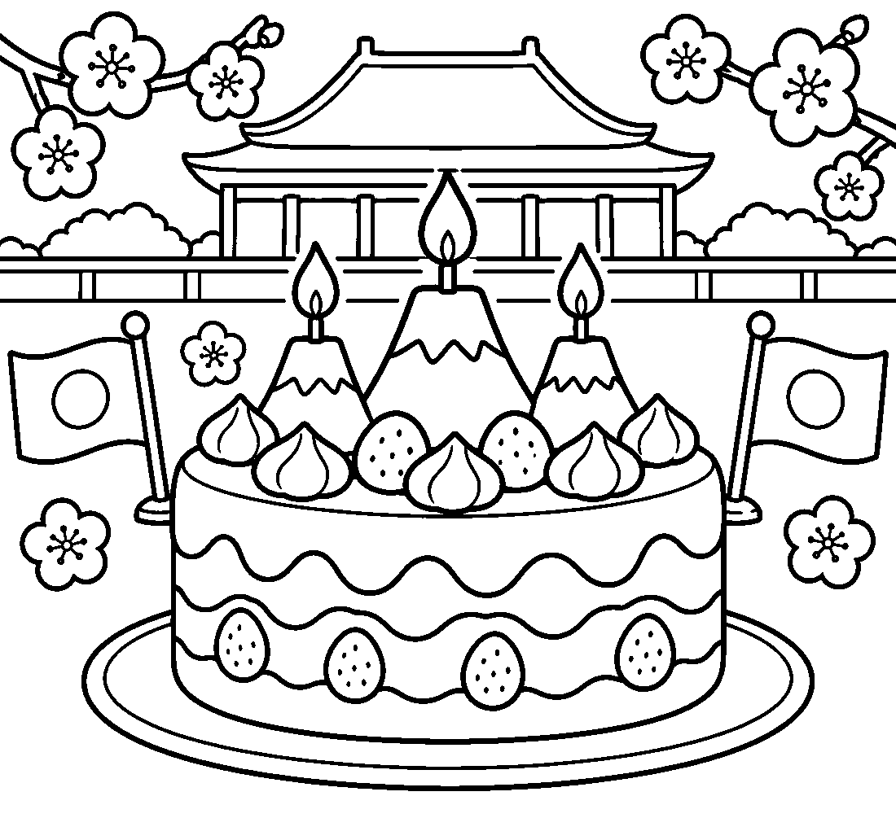

🎂 The Emperor's Birthday Worksheet
Answer Key 解答
Reading Check: 1.A 2.C 3.B 4.D 5.B 6.A 7.B 8.D
True or False: 1.T 2.F 3.T 4.F 5.T 6.F
Match: 🎂=birthday cake 👑=crown 🏯=castle 🎌=flags 👋=wave 🎤=microphone 🗻=Mount Fuji 🚆=train
Unscramble: 1.EMPEROR 2.PALACE 3.THRONE 4.BALCONY 5.OFFICIAL 6.MAJESTY
Fill in the blanks: (1)grandmother (2)Palace (3)people (4)flag (5)morning (6)balcony (7)wave (8)speech (9)happy (10)cake
Sentence order: 1. The Emperor was born in 1960. 2. The date changes with a new emperor. 3. Many people visit the Imperial Palace. 4. People wave small flags in the morning. 5. Japan had no Emperor's Birthday in 2019.
Secret Code: HAPPY BIRTHDAY
Maze: PALACE
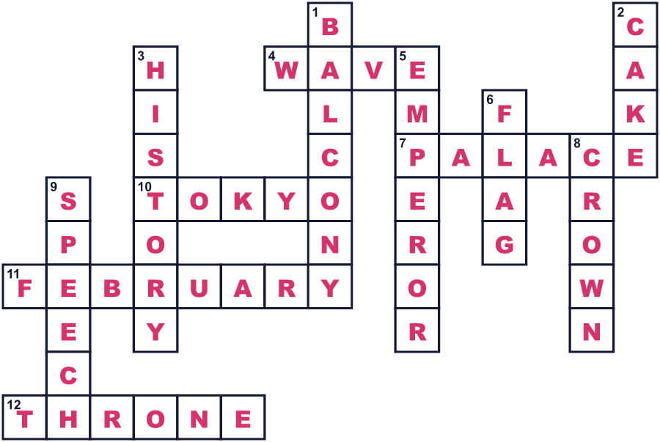
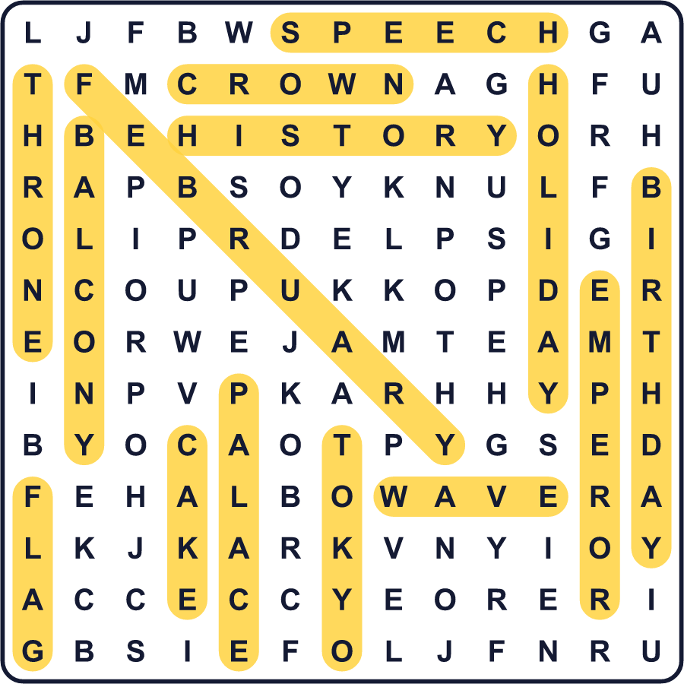
全訳
1 2月23日は、天皇誕生日と呼ばれる日本の国民の祝日です。今の天皇陛下は、1960年のこの日に生まれました。でも、この祝日には不思議な秘密があります。日付が動くのです。
2 この祝日にはとても長い歴史があります。775年、ある天皇が自分の誕生日を大きな宴で祝うよう人々に命じました。彼はその日を天長節と呼びました。その名前は、天と地が長く続くという中国の古い言葉から来ています。日本は1948年までこの名前を使いました。
3 新しい天皇が位につくと、祝日はその天皇の誕生日に移ります。1989年から2018年までは、12月23日でした。そして2019年5月1日に新しい天皇が即位しました。2月23日はもう過ぎていて、12月23日は新しい天皇の誕生日ではありませんでした。だから2019年、日本には天皇誕生日がまったくなかったのです！
4 昔の誕生日の中には、新しい名前で今も祝日になっているものがあります。11月3日は明治天皇の誕生日で、今は文化の日です。4月29日は昭和天皇の誕生日で、今は昭和の日です。だからカレンダーには、それぞれの昔の天皇のかけらが少しずつ残っているのです。
5 2月23日には、多くの人が東京の皇居を訪れます。午前中、天皇陛下とご家族がベランダに出てこられ、人々は小さな旗を振ります。天皇陛下は感謝の短いお言葉を述べられます。午後には、訪れた人が特別な帳面に記帳して、お祝いの気持ちを伝えることができます。日本の人は、天皇を名前で呼びません。「天皇陛下」と言います。His Majesty the Emperor という意味です。

