⛅ Weather Day in Japan Worksheet
The Day Japan Started Watching the Sky
Read the story. 英文を読もう。
Class ______ No. ____ Name ______________________________

🔊 音声を聞こう（スマホで読みとってね）
1 On June 1, 1875, a small weather office opened in Tokyo. It stood in Akasaka, near the center of the city. At first, only one man did all the work there. He was an expert from abroad, and he checked the weather three times a day. This office later became the Japan Meteorological Agency. So June 1 is Weather Day in Japan.
2 Nine years later, on June 1, 1884, Japan got its first weather forecast. It was only one short sentence for the whole country. It said the wind was not steady and the weather could change easily. But it would be rainy most of the time. People read it on paper at police boxes in Tokyo.
3 Forecasts grew quickly after that. Radio started to give the weather in 1925, and TV did in 1953. In 1959, a computer began to help with forecasts. Then on June 1, 1980, Tokyo heard a new kind of forecast. It gave the chance of rain as a number, like 30 percent. That day was Weather Day, too.
4 Tokyo even has a shrine for the weather. It is called Kisho Jinja, and its biggest festival is on June 1. Army weather experts built the first one in 1944. Today, many visitors come and pray for good weather. Next time you check the weather on your phone, think of that one man in 1875.
Words 単語
forecast（（天気）予報） / abroad（外国に、外国から） / sentence（文） / steady（一定の、安定した） / chance（見込み、可能性） / percent（パーセント） / shrine（神社） / pray（祈る）

⛅ Weather Day in Japan Worksheet
Reading Check
Choose the best answer. 正しいものを選ぼう。
Class ______ No. ____ Name ______________________________
1. What is the main idea of this story?
(A) How to read a weather map (B) Why June 1 is Weather Day in Japan (C) How to make an umbrella (D) Why it rains a lot in June
2. When did Japan get its first weather forecast?
(A) 1875 (B) 1925 (C) 1980 (D) 1884
3. What was new about the forecast on June 1, 1980?
(A) It gave the chance of rain as a number. (B) It was on TV for the first time. (C) It used a computer for the first time. (D) It was only one sentence.
4. In paragraph 2, "steady" is closest in meaning to:
(A) very strong (B) very cold (C) not changing (D) very quiet
5. In the dialogue, why does Sota have an umbrella?
(A) It is raining now. (B) The forecast says it may rain in the afternoon. (C) Olivia asked him to bring it. (D) He wants to visit a shrine.
True or False? T か F に○
1. A weather office opened in Tokyo on June 1, 1875. T / F
2. The first weather forecast in Japan was a long report. T / F
3. TV started to give the weather in 1953. T / F
4. Kisho Jinja has its biggest festival in December. T / F

⛅ Weather Day in Japan Worksheet
Word Work
単語のれんしゅう
Class ______ No. ____ Name ______________________________
① Match the pictures and the words. 絵と単語を線でむすぼう。
☔ | ● | ● | lightning
☀️ | ● | ● | cloud
☁️ | ● | ● | rainbow
⛄ | ● | ● | snowman
🌈 | ● | ● | sun
⚡ | ● | ● | umbrella
③ Fill in the blanks. 語群から選んで入れよう。
[ rain / morning / chance / percent / umbrella / forecast / clouds / pizza / summer ]
Every (1) __________ , Mika looks at the sky. Today there are big gray (2) __________ . "I think it will (3) __________ after lunch," she writes in her diary. Then she checks the (4) __________ on TV. It says the (5) __________ of rain is 70 (6) __________ . Mika smiles and puts an (7) __________ in her bag.

⛅ Weather Day in Japan Worksheet
Crossword Puzzle
ヒントを読んでクロスワードを完成させよう。
Class ______ No. ____ Name ______________________________
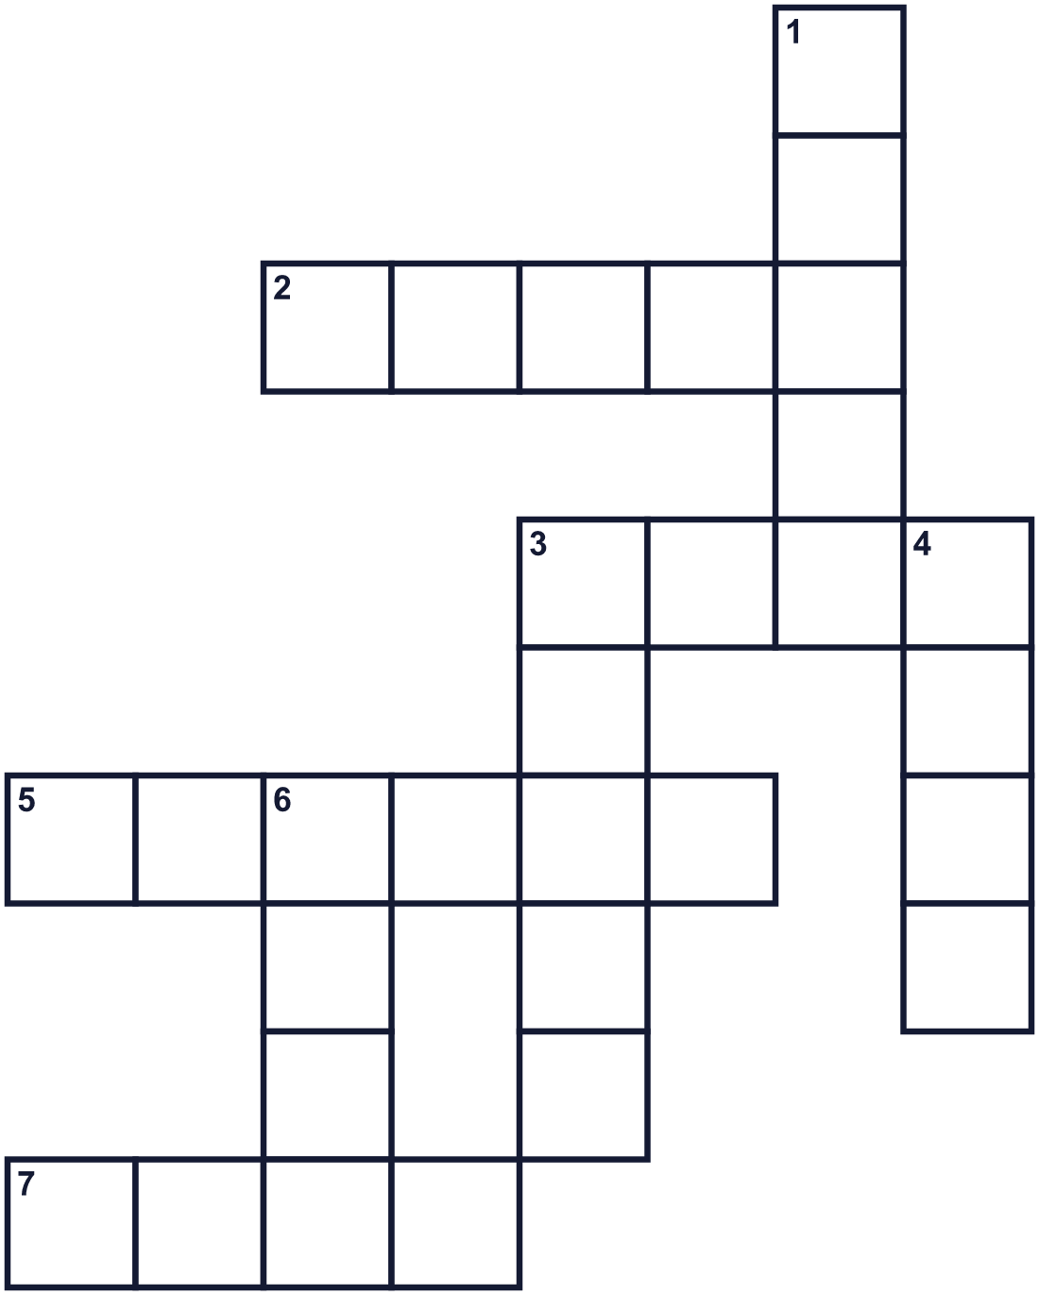
Across →
2. A white or gray thing in the sky. (5)
3. Cold white things that fall in winter. (4)
5. A place in Japan to pray. It often has a red gate. (6)
7. The sixth month of the year. (4)
Down ↓
1. You listen to news and music on it. (5)
3. The sky is blue and bright. It is ____. (5)
4. Moving air. It can blow your hat away. (4)
6. Water that falls from the clouds. (4)

⛅ Weather Day in Japan Worksheet
Word Search
かくれた単語をさがそう（→ ↓ ↘ ↗）
Class ______ No. ____ Name ______________________________
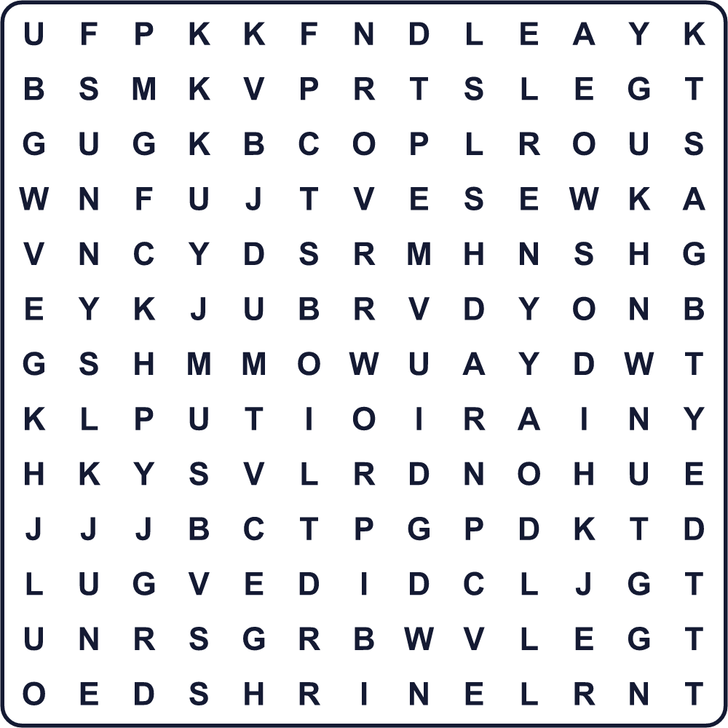
CLOUD JUNE RAIN SHRINE SKY SNOW STORM SUNNY UMBRELLA WIND

⛅ Weather Day in Japan Worksheet
Maze & Sentences
Class ______ No. ____ Name ______________________________
Help the weather girl get to the sunny park! 女の子を晴れた公園まで連れていこう！
正しい道の文字を集めると、ひみつの言葉になるよ。 START 👧 → GOAL ☀️
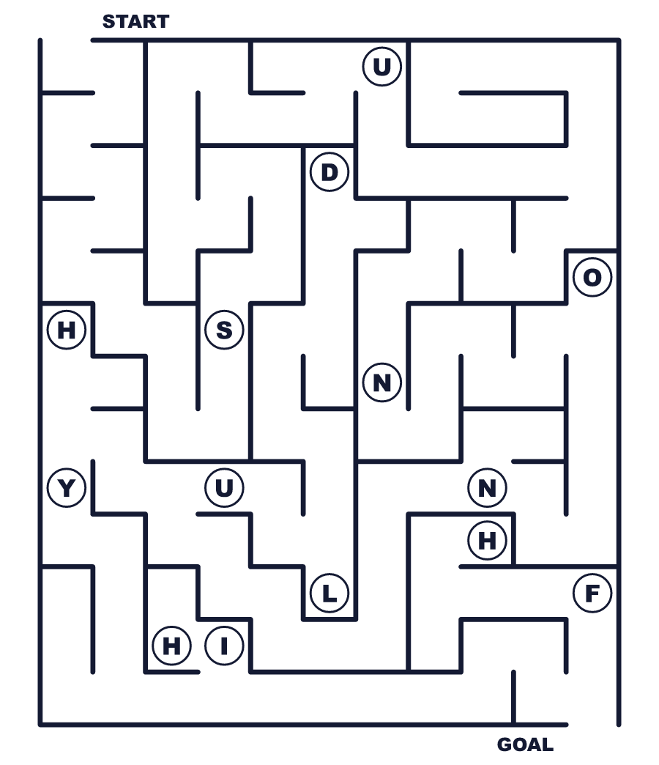
Secret word: ＿ ＿ ＿ ＿ ＿

⛅ Weather Day in Japan Worksheet
Class Activity & Writing
Class ______ No. ____ Name ______________________________
Let's Write! 英語で書いてみよう。
Tomorrow's weather will be ______ because ______.
明日の天気は______でしょう。なぜなら______だからです。
______________________________________________________________
______________________________________________________________
My favorite weather is ______. On days like that, I like to ______.
私の好きな天気は______です。そんな日は______するのが好きです。
______________________________________________________________
______________________________________________________________

⛅ Weather Day in Japan Worksheet
Trace & Color
なぞって書こう。絵に色をぬろう。
Class ______ No. ____ Name ______________________________
☔ 

☀️ 
☁️ 
⛄ 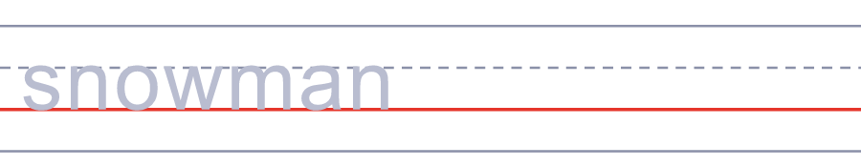
🌈 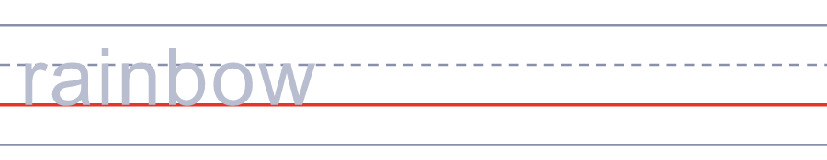

⛅ Weather Day in Japan Worksheet
Answer Key 解答
Reading Check: 1.B 2.D 3.A 4.C 5.B
True or False: 1.T 2.F 3.T 4.F
Match: ☔=umbrella ☀️=sun ☁️=cloud ⛄=snowman 🌈=rainbow ⚡=lightning
Fill in the blanks: (1)morning (2)clouds (3)rain (4)forecast (5)chance (6)percent (7)umbrella
Maze: SUNNY
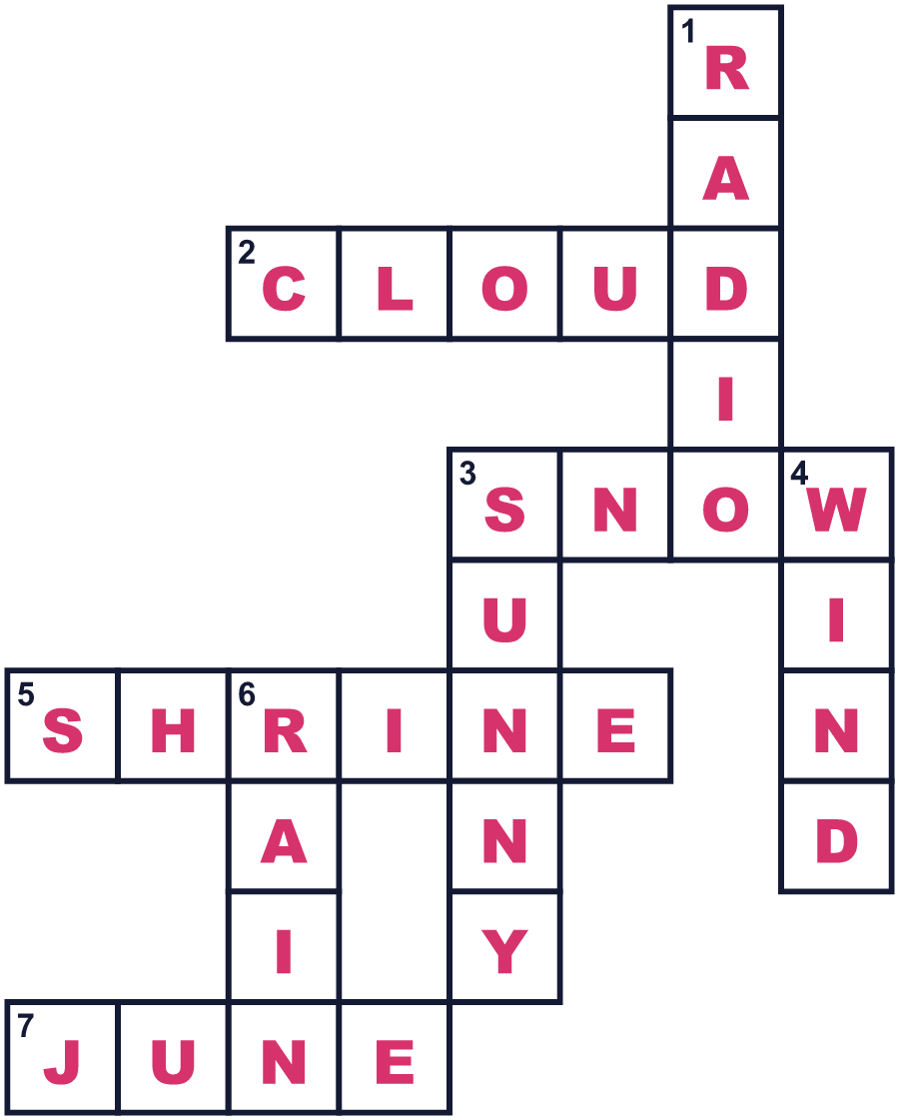
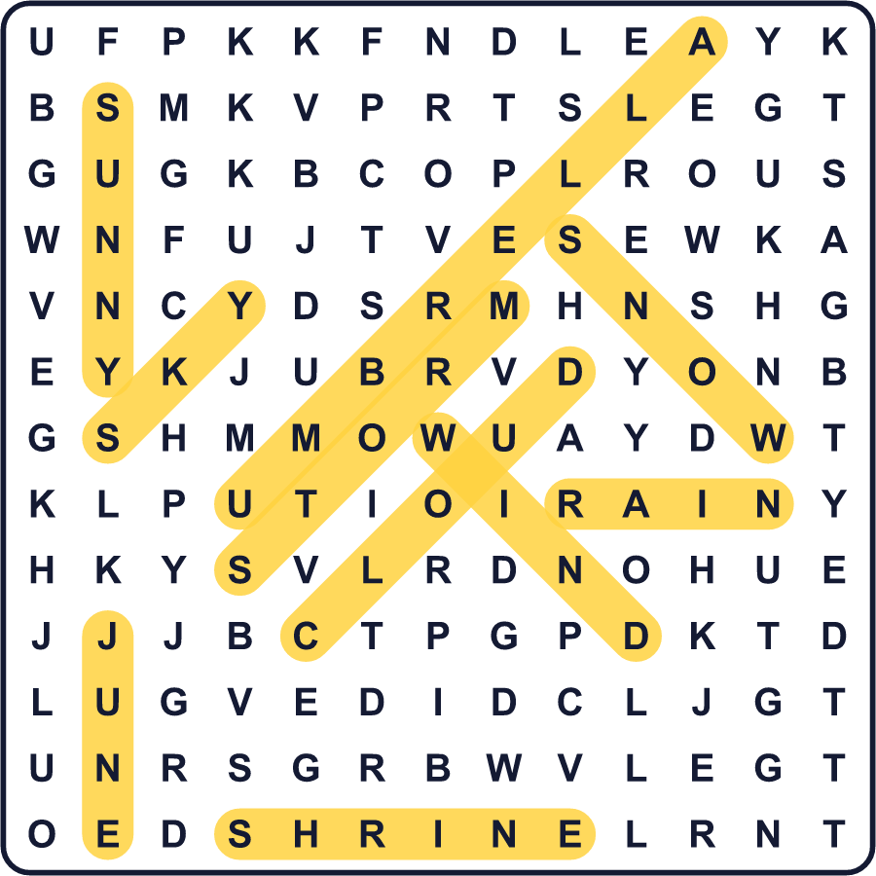
全訳
1 1875年6月1日、東京に小さな気象台ができました。場所は、町の中心に近い赤坂でした。はじめは、たった1人がそこで仕事のすべてをしていました。彼は外国から来た専門家で、1日に3回、天気を調べていました。この気象台が、のちに気象庁になりました。だから6月1日は、日本の気象記念日なのです。
2 9年後の1884年6月1日、日本で最初の天気予報が出ました。それは、国全体でたった1文の短いものでした。風の向きは定まらず、天気は変わりやすい、という内容でした。ただし、たいていは雨だろう、と。人々は、東京の交番にはり出された紙でそれを読みました。
3 その後、天気予報はどんどん進歩しました。1925年にはラジオ、1953年にはテレビが天気を伝え始めました。1959年には、コンピューターが予報を手伝うようになりました。そして1980年6月1日、東京で新しい種類の予報が流れました。雨の降る見込みを、30％のような数字で伝えたのです。その日も、気象記念日でした。
4 東京には、天気の神社まであります。気象神社という名前で、いちばん大きなお祭りは6月1日です。最初の神社は、1944年に陸軍の気象の専門家たちが建てました。今では多くの人が訪れて、よい天気をお願いします。今度スマホで天気を見るときは、1875年のあの1人のことを思い出してください。

