🎋 Tanabata (Star Festival) Worksheet
Wishes Under the Milky Way
Read the story. 英文を読もう。
Class ______ No. ____ Name ______________________________

🔊 音声を聞こう（スマホで読みとってね）
1 Every year on July 7, Japanese children write wishes on colorful paper strips. Then they hang the wishes on bamboo branches. This is Tanabata, the Star Festival.
2 The festival comes from an old Chinese love story. Orihime was a princess who made beautiful cloth. Hikoboshi took care of cows. After they got married, they played all day and stopped working. The king of the sky got angry and put them on two sides of the Milky Way. Now they can meet only once a year, on the night of July 7.
3 In the sky, Orihime is the star Vega, and Hikoboshi is the star Altair. But here is a surprising fact. The two stars are about 14.4 light-years apart. Even light needs more than 14 years to travel between them. Together with a third star, Deneb, they make a big shape called the Summer Triangle.
4 Long ago in China, women prayed to the stars on this night to become better at sewing. In Japan, children in the Edo period wished for better handwriting. Today, people write all kinds of wishes, like passing a test or winning a game.
5 July 7 is often rainy in Japan, so the stars may hide behind clouds. That is why some cities hold their festival in August. In Sendai, more than 2 million people come to see huge paper decorations from August 6 to 8. Rain or shine, it is a night to look up and make a wish.
Words 単語
wish（願い、願う） / strip（細長い切れ） / bamboo（竹、笹） / branch（枝） / princess（王女、お姫さま） / cloth（布） / the Milky Way（天の川） / light-year（光年） / apart（はなれて） / sewing（裁縫） / handwriting（手書きの文字、字） / decoration（飾り）

🎋 Tanabata (Star Festival) Worksheet
Reading Check
Choose the best answer. 正しいものを選ぼう。
Class ______ No. ____ Name ______________________________
1. What is the main idea of the passage?
(A) How to grow bamboo (B) The story and customs of Tanabata (C) Why it rains in July (D) How to become a princess
2. Why did the king of the sky get angry?
(A) Orihime and Hikoboshi stopped working. (B) The cows ran away. (C) It rained every day. (D) Hikoboshi lost the cloth.
3. Which star is Hikoboshi?
(A) Vega (B) The Sun (C) Altair (D) The Moon
4. How far apart are the two stars?
(A) About 7 light-years (B) About 1 light-year (C) About 100 light-years (D) About 14.4 light-years
5. In paragraph 4, what does "sewing" mean?
(A) cooking food (B) making clothes with a needle and thread (C) singing songs (D) planting rice
6. Which is true about Tanabata in Sendai?
(A) It is held in December. (B) It is held from August 6 to 8. (C) Only 200 people come. (D) It has no decorations.
7. Why do some cities hold Tanabata in August?
(A) Because bamboo grows only in August. (B) Because schools are closed in July. (C) Because July 7 is often rainy and the stars are hard to see. (D) Because the stars move in August.
8. In the dialogue, what does Lucas wish for?
(A) To win a game (B) To see the Milky Way (C) To pass a test (D) To speak Japanese better
True or False? T か F に○
1. Tanabata is on July 7. T / F
2. Orihime is the star Altair. T / F
3. The two stars are about 14.4 light-years apart. T / F
4. Tanabata is a national holiday in Japan today. T / F
5. The Sendai Tanabata Festival is held in August. T / F
6. Tanabata started in Brazil. T / F

🎋 Tanabata (Star Festival) Worksheet
Word Work
単語のれんしゅう
Class ______ No. ____ Name ______________________________
① Match the pictures and the words. 絵と単語を線でむすぼう。
⭐ | ● | ● | moon
🎋 | ● | ● | umbrella
🌙 | ● | ● | star
☔ | ● | ● | bamboo
🐄 | ● | ● | thread
🧵 | ● | ● | princess
👸 | ● | ● | noodles
🍜 | ● | ● | cow
② Unscramble the words. 並べかえて単語にしよう。
1. A S T R (星) → ____________________
2. H S W I (願い) → ____________________
3. M B O O B A (竹・笹) → ____________________
4. C L H T O (布) → ____________________
5. I P G M A E (カササギ) → ____________________
6. T H G I N (夜) → ____________________
③ Fill in the blanks. 語群から選んで入れよう。
[ winter / cloudy / faster / strip / August / wish / bamboo / practice / snow / stars / 7 / pumpkin / sky ]
It is July (1) __________ . Aya's class makes Tanabata decorations. Each student gets a paper (2) __________ . Aya thinks hard. Then she writes, "I want to swim (3) __________ ." She hangs it on the (4) __________ . In the evening, Aya and her mom look up at the (5) __________ . It is (6) __________ , and they cannot see the (7) __________ . Aya is a little sad. Mom says, "Don't worry. In (8) __________ , we can try again." Aya smiles and says, "I will also (9) __________ hard!" Her (10) __________ feels a little closer.

🎋 Tanabata (Star Festival) Worksheet
Crossword Puzzle
ヒントを読んでクロスワードを完成させよう。
Class ______ No. ____ Name ______________________________
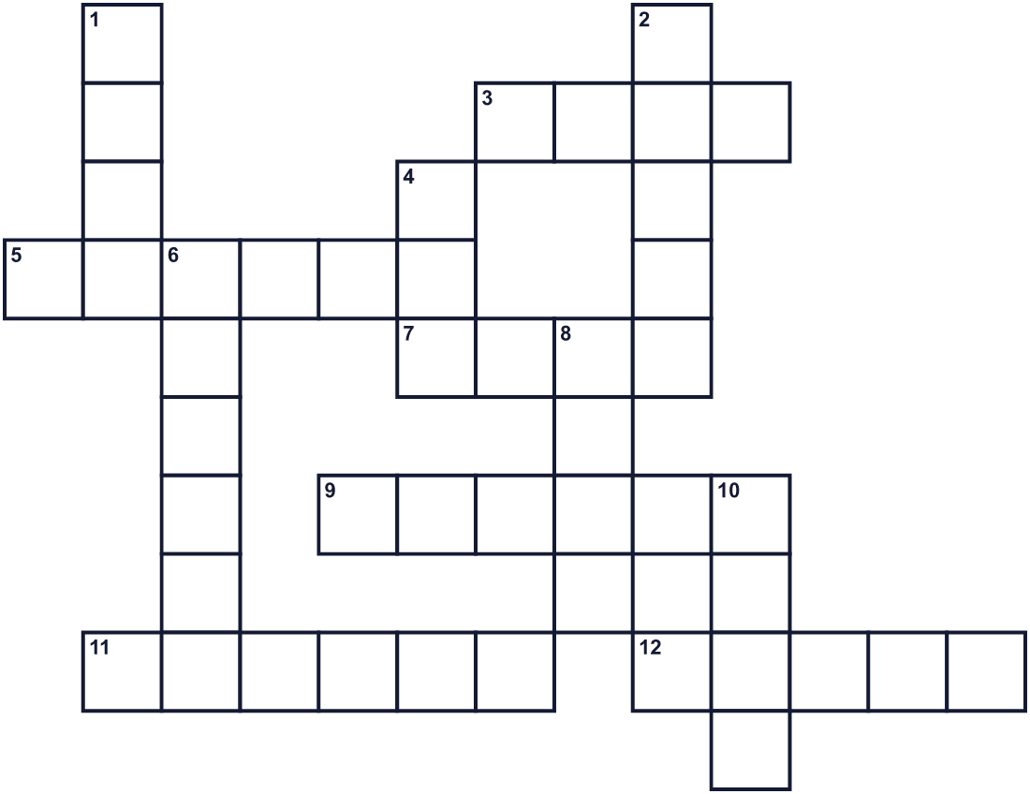
Across →
3. The seventh month of the year. (4)
5. A tall green plant. Pandas like to eat it. (6)
7. You write this on a paper strip. (4)
9. The bright star of Hikoboshi. (6)
11. A city in Tohoku with a famous festival in August. (6)
12. The dark time between evening and morning. (5)
Down ↓
1. The bright star of Orihime. (4)
2. Orihime made this. You can make a shirt from it. (5)
4. Hikoboshi took care of this farm animal. (3)
6. A black and white bird. In Chinese stories, it makes a bridge. (6)
8. A bright point in the night sky. (4)
10. Water that falls from clouds. It often comes in early July. (4)

🎋 Tanabata (Star Festival) Worksheet
Word Search
かくれた単語をさがそう（→ ↓ ↘ ↗）
Class ______ No. ____ Name ______________________________
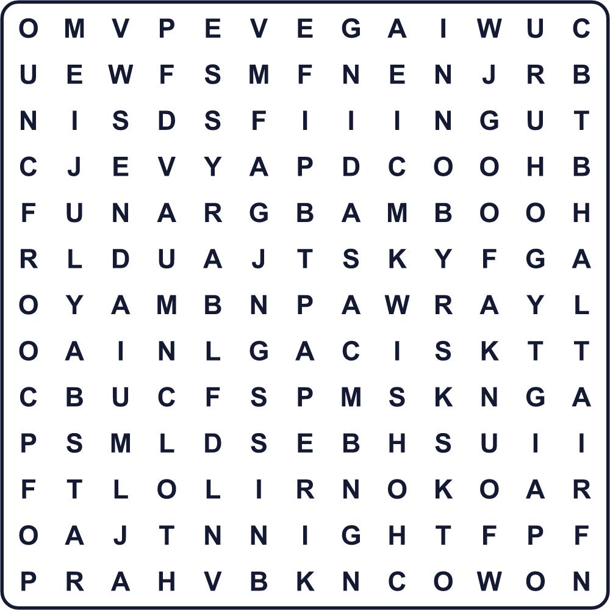
ALTAIR BAMBOO CLOTH COW JULY MAGPIE NIGHT PAPER RAIN SENDAI SKY STAR VEGA WISH
Secret Code 暗号を解こう
☀=A ✉=E ▲=H ♥=I ♦=K ☂=M ☺=S ☃=W
☂ ☀ ♦ ✉ ☀ ☃ ♥ ☺ ▲
______________________________________________________________

🎋 Tanabata (Star Festival) Worksheet
Maze & Sentences
Class ______ No. ____ Name ______________________________
Help Hikoboshi cross the Milky Way to meet Orihime! 彦星が天の川をわたって織姫に会えるように道を見つけよう！
正しい道の文字を集めると、ひみつの言葉になるよ。 START 🧑 → GOAL 👸
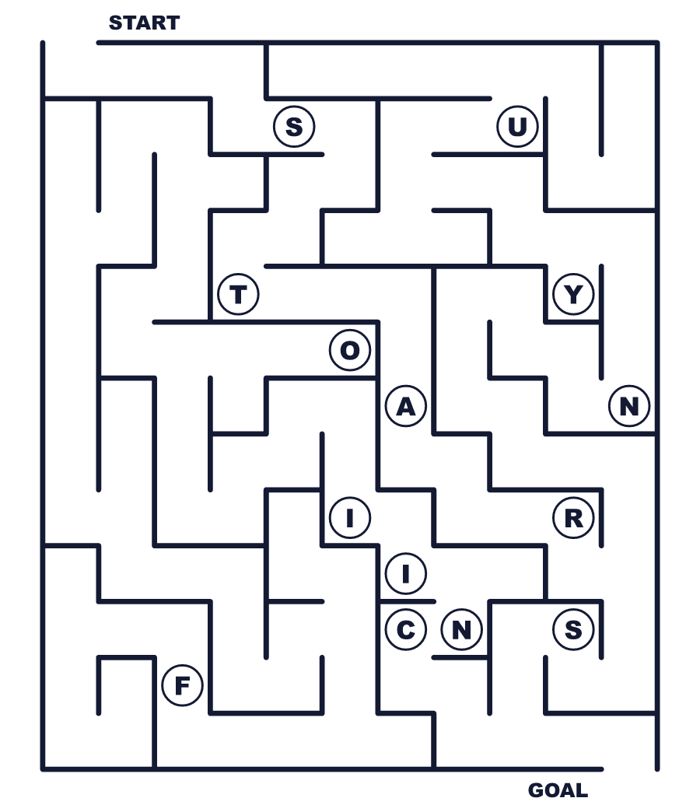
Secret word: ＿ ＿ ＿ ＿ ＿
Put the words in order. 並べかえよう。
1. on / I / wrote / strip / my / wish / paper / a . (私は短冊に願いごとを書きました。)
______________________________________________________________
2. year / stars / once / meet / a / Two . (2つの星は年に一度会います。)
______________________________________________________________
3. hang / We / the / on / wishes / bamboo . (私たちは願いごとを笹に飾ります。)
______________________________________________________________
4. is / July / often / It / on / 7 / rainy . (7月7日はよく雨が降ります。)
______________________________________________________________
5. festival / big / has / August / in / Sendai / a . (仙台では8月に大きなお祭りがあります。)
______________________________________________________________

🎋 Tanabata (Star Festival) Worksheet
Class Activity & Writing
Class ______ No. ____ Name ______________________________
Find Someone Who… クラスで聞いて回ろう！
Find someone who … | Name
… has written a wish on a tanzaku 短冊に願いごとを書いたことがある
… has seen the Milky Way 天の川を見たことがある
… knows the name of a star 星の名前を1つ知っている
… has been to a Tanabata festival 七夕まつりに行ったことがある
… likes somen noodles そうめんが好き
… can find the Summer Triangle 夏の大三角を見つけられる
… has a wish about sports スポーツについての願いがある
… knows the English word for tanabata 七夕の英語の言い方を知っている
Let's Write! 英語で書いてみよう。
My Tanabata wish is ______ because ______.
私の七夕の願いは＿＿です。なぜなら＿＿だからです。
______________________________________________________________
______________________________________________________________
If I could meet someone only once a year, I would ______.
もし誰かに年に一度しか会えないなら、私は＿＿します。
______________________________________________________________
______________________________________________________________
I want to get better at ______, so I will ______.
私は＿＿が上手になりたいので、＿＿します。
______________________________________________________________
______________________________________________________________

🎋 Tanabata (Star Festival) Worksheet
Trace & Color
なぞって書こう。絵に色をぬろう。
Class ______ No. ____ Name ______________________________
⭐ 

🎋 
🌙 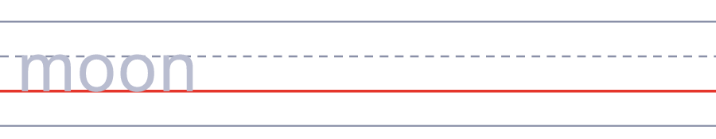
☔ 
🐄 
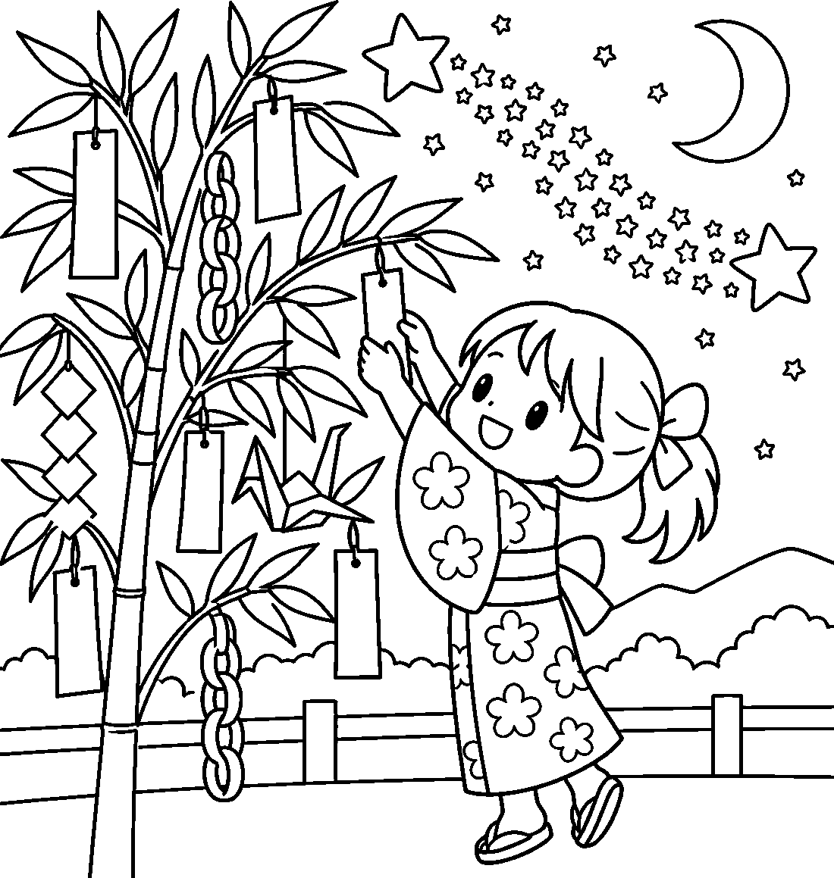

🎋 Tanabata (Star Festival) Worksheet
Answer Key 解答
Reading Check: 1.B 2.A 3.C 4.D 5.B 6.B 7.C 8.D
True or False: 1.T 2.F 3.T 4.F 5.T 6.F
Match: ⭐=star 🎋=bamboo 🌙=moon ☔=umbrella 🐄=cow 🧵=thread 👸=princess 🍜=noodles
Unscramble: 1.STAR 2.WISH 3.BAMBOO 4.CLOTH 5.MAGPIE 6.NIGHT
Fill in the blanks: (1)7 (2)strip (3)faster (4)bamboo (5)sky (6)cloudy (7)stars (8)August (9)practice (10)wish
Sentence order: 1. I wrote my wish on a paper strip. 2. Two stars meet once a year. 3. We hang the wishes on bamboo. 4. It is often rainy on July 7. 5. Sendai has a big festival in August.
Secret Code: MAKE A WISH
Maze: STARS
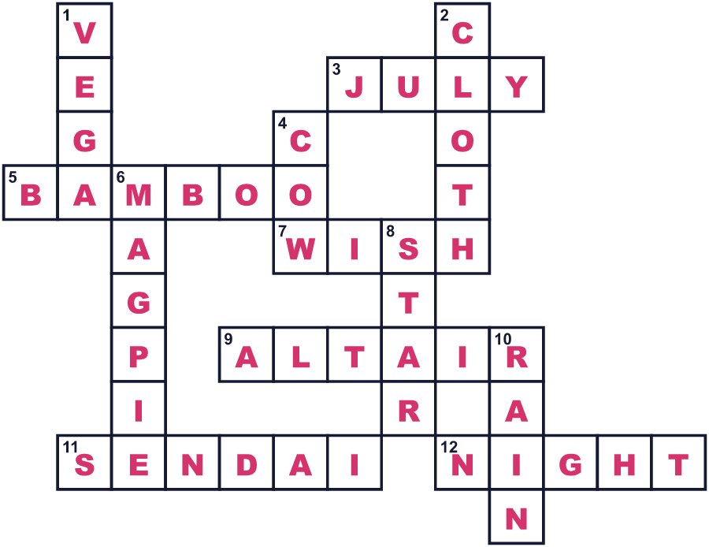
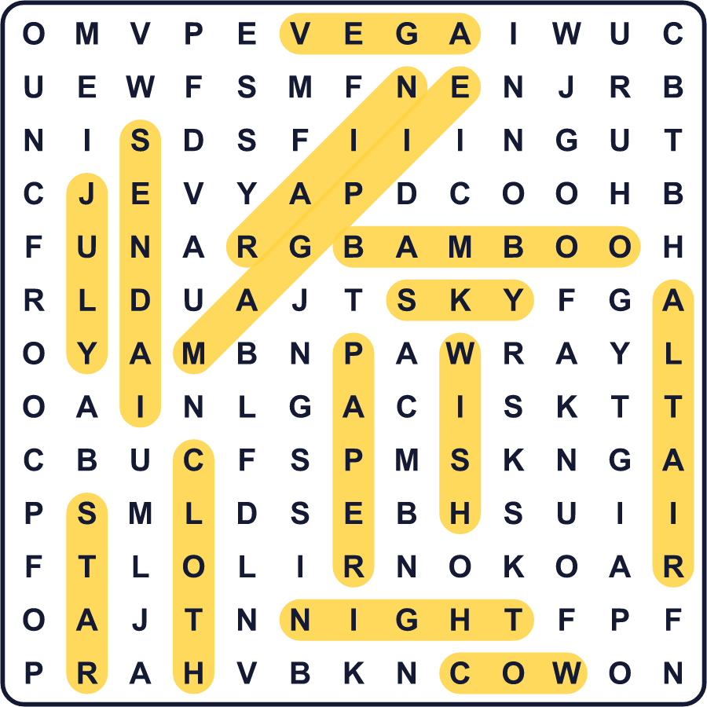
全訳
1 毎年7月7日、日本の子どもたちは色とりどりの細長い紙に願いごとを書きます。そして、その願いを笹の枝に飾ります。これが七夕、星祭りです。
2 このお祭りは、中国の古い恋の物語から来ています。織姫は、美しい布を織るお姫さまでした。彦星は牛の世話をしていました。結婚したあと、二人は一日中遊んで、働くのをやめてしまいました。空の王さまは怒って、二人を天の川の両側に引き離しました。今では、二人は年に一度、7月7日の夜にしか会えません。
3 空では、織姫はベガという星、彦星はアルタイルという星です。でも、驚くような事実があります。2つの星は約14.4光年はなれています。光でさえ、二人の間を進むのに14年以上かかるのです。3つめの星デネブといっしょに、「夏の大三角」という大きな形をつくります。
4 昔の中国では、女性たちがこの夜、裁縫が上手になるよう星に祈りました。日本では、江戸時代の子どもたちが字がうまくなるよう願いました。今では、テストに受かりますように、試合に勝てますようにと、人々はいろいろな願いを書きます。
5 日本の7月7日は雨が多いので、星は雲にかくれてしまうかもしれません。そのため、8月にお祭りをする町もあります。仙台では8月6日から8日に、200万人以上が巨大な紙の飾りを見に訪れます。雨でも晴れでも、空を見上げて願いごとをする夜です。

