🏴‍☠️ International Talk Like a Pirate Day Worksheet
A Holiday That Started with Arrr
Read the story. 英文を読もう。
Class ______ No. ____ Name ______________________________

🔊 音声を聞こう（スマホで読みとってね）
1 On June 6, 1995, two friends in Oregon were playing racquetball. Their names were John Baur and Mark Summers. During the game, Mark suddenly shouted, "Arrr!" He sounded just like a pirate in a movie. So the two men started to talk like pirates, and the game became much more fun.
2 They decided the world needed a new holiday called Talk Like a Pirate Day. But they did not want to use June 6. That day remembers the soldiers of D-Day in World War II. So Mark chose September 19, the birthday of his ex-wife. He did not even stop to think about it. He said it was easy to remember.
3 For seven years, the holiday was only a joke between friends. Every September 19, they called each other at work, shouted "Arrr!" and hung up. Then in 2002, John sent an email to Dave Barry, a famous humor writer. Barry wrote about the day in his newspaper column. Soon, radio stations from America to Australia wanted to talk to the two friends.
4 Today, people say "Ahoy, matey!" instead of "Hello, friend!" Some wear eye patches and draw treasure maps. But real pirates probably did not talk like this. Much of the famous pirate voice comes from a 1950 movie, Treasure Island. The actor made his accent from the west of England very strong, and the whole world copied him.
Words 単語
pirate（海賊） / shout（叫ぶ） / decide（決める） / remember（覚えている、記念する） / joke（冗談） / column（（新聞の）コラム） / accent（なまり、話し方のくせ） / copy（まねする）

🏴‍☠️ International Talk Like a Pirate Day Worksheet
Reading Check
Choose the best answer. 正しいものを選ぼう。
Class ______ No. ____ Name ______________________________
1. What is the reading mainly about?
(A) The life of a real pirate (B) How to play racquetball well (C) How Talk Like a Pirate Day started and grew (D) Why D-Day happened
2. Why did Mark choose September 19?
(A) It was his ex-wife's birthday, so it was easy to remember. (B) It was the day of a famous pirate battle. (C) It was the day Treasure Island came out. (D) It was Dave Barry's birthday.
3. How long was the holiday only a joke between friends?
(A) One year (B) Two years (C) Fifty years (D) Seven years
4. What does "copied" mean in the last sentence?
(A) laughed at (B) did the same thing as (C) forgot about (D) paid money to
5. In the dialogue, what does Riku want to do tomorrow?
(A) Wear an eye patch to school (B) Go to America (C) Play racquetball (D) Read Treasure Island
True or False? T か F に○
1. Talk Like a Pirate Day started in 1995. T / F
2. September 19 is the birthday of a famous pirate. T / F
3. Dave Barry wrote about the day in a newspaper. T / F
4. Talk Like a Pirate Day is a national holiday in the United States. T / F

🏴‍☠️ International Talk Like a Pirate Day Worksheet
Word Work
単語のれんしゅう
Class ______ No. ____ Name ______________________________
① Match the pictures and the words. 絵と単語を線でむすぼう。
🦜 | ● | ● | island
🚢 | ● | ● | parrot
🗺️ | ● | ● | map
🏝️ | ● | ● | gold
💰 | ● | ● | ship
⚓ | ● | ● | anchor
③ Fill in the blanks. 語群から選んで入れよう。
[ pirate / tree / Ahoy / captain / map / snowman / patch / piano / hat ]
On September 19, Mika comes to school as a (1) __________ . She wears a black (2) __________ and an eye (3) __________ . " (4) __________ , everyone!" she says. Her friend Taro laughs. "You look like a real (5) __________ !" At lunch, Mika draws a treasure (6) __________ with a big X. "The gold is under the (7) __________ !" she says. Everyone runs outside.

🏴‍☠️ International Talk Like a Pirate Day Worksheet
Crossword Puzzle
ヒントを読んでクロスワードを完成させよう。
Class ______ No. ____ Name ______________________________
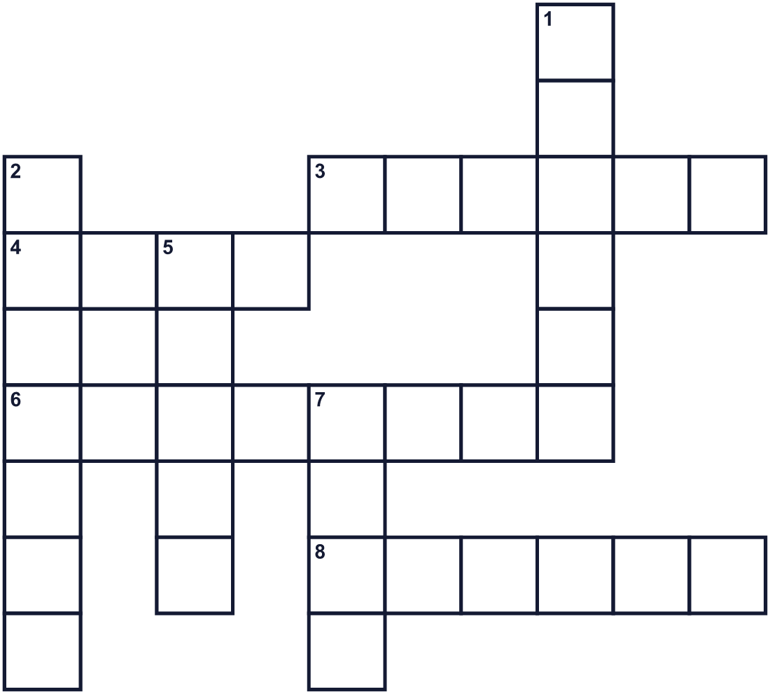
Across →
3. A colorful bird. It can copy words. (6)
4. A sailor says this for hello. (4)
6. Gold and jewels in a big box. (8)
8. Land with water all around it. (6)
Down ↓
1. A person who robs ships at sea. (6)
2. The leader of the people on a boat. (7)
5. A very big sea, like the Pacific. (5)
7. A big boat that sails on the sea. (4)

🏴‍☠️ International Talk Like a Pirate Day Worksheet
Word Search
かくれた単語をさがそう（→ ↓ ↘ ↗）
Class ______ No. ____ Name ______________________________
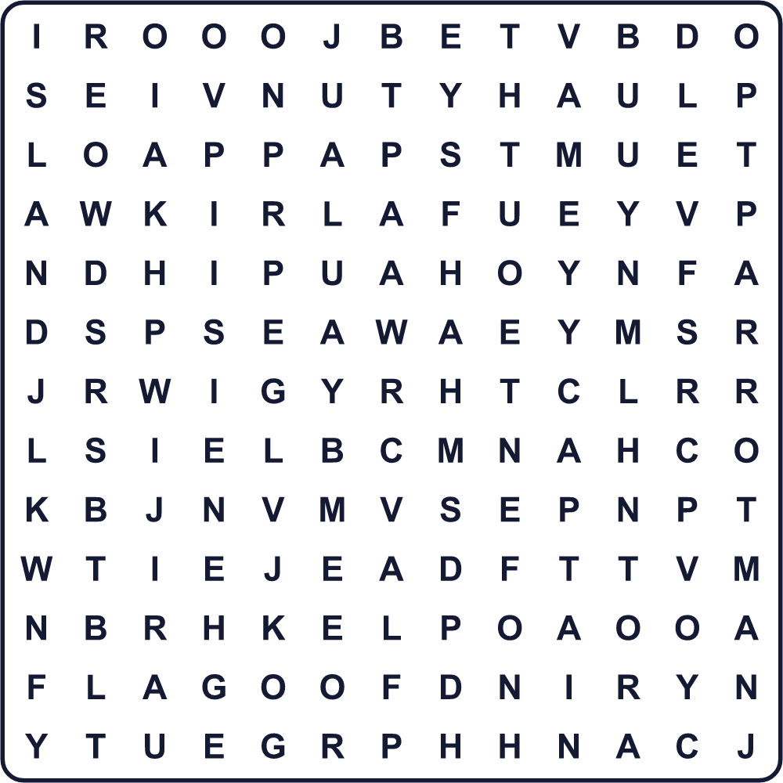
AHOY CAPTAIN FLAG GOLD ISLAND MAP PARROT PIRATE SEA SHIP

🏴‍☠️ International Talk Like a Pirate Day Worksheet
Maze & Sentences
Class ______ No. ____ Name ______________________________
Help the pirate find the treasure! 海賊を宝物のところまで連れていこう！
正しい道の文字を集めると、ひみつの言葉になるよ。 START 🏴‍☠️ → GOAL 💰
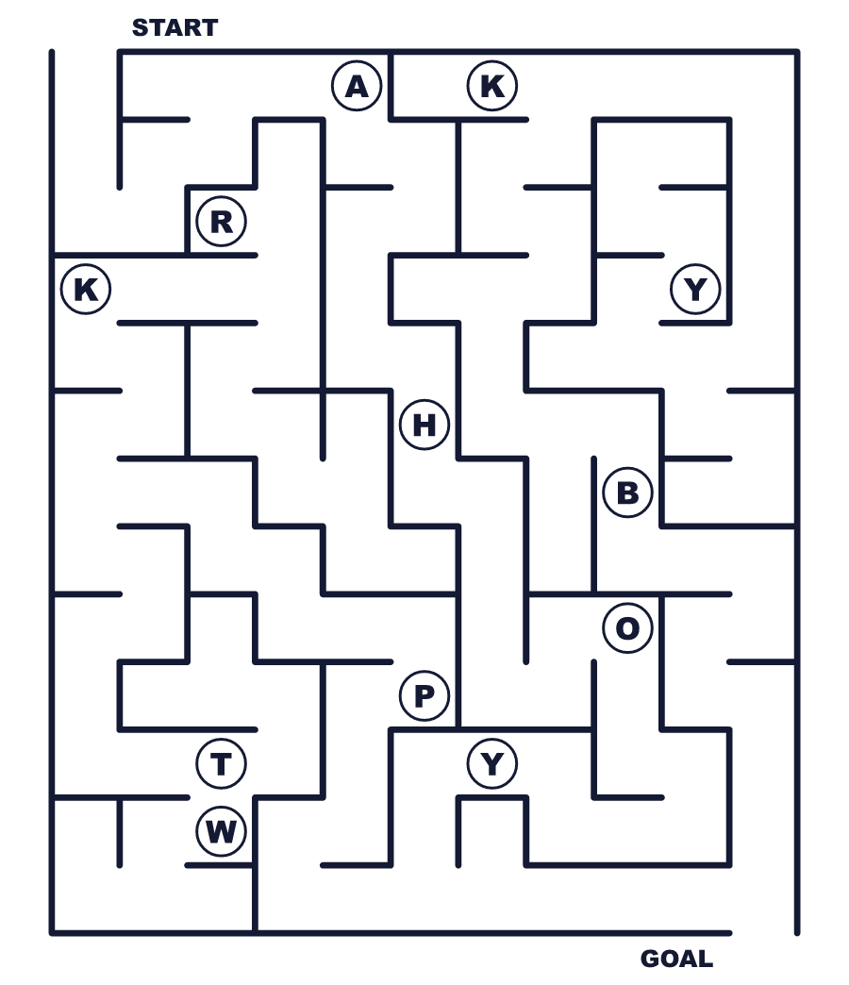
Secret word: ＿ ＿ ＿ ＿

🏴‍☠️ International Talk Like a Pirate Day Worksheet
Class Activity & Writing
Class ______ No. ____ Name ______________________________
Let's Write! 英語で書いてみよう。
If I were a pirate captain, my ship's name would be ______ because ______.
もし私が海賊の船長なら、船の名前は______にします。なぜなら______だからです。
______________________________________________________________
______________________________________________________________
My treasure is not gold. My treasure is ______.
私の宝物は金ではありません。私の宝物は______です。
______________________________________________________________
______________________________________________________________

🏴‍☠️ International Talk Like a Pirate Day Worksheet
Trace & Color
なぞって書こう。絵に色をぬろう。
Class ______ No. ____ Name ______________________________
🦜 

🚢 
🗺️ 
🏝️ 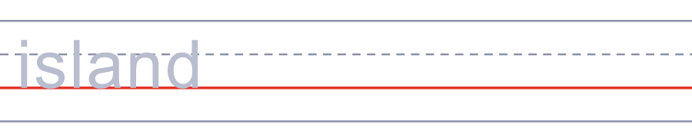
💰 

🏴‍☠️ International Talk Like a Pirate Day Worksheet
Answer Key 解答
Reading Check: 1.C 2.A 3.D 4.B 5.A
True or False: 1.T 2.F 3.T 4.F
Match: 🦜=parrot 🚢=ship 🗺️=map 🏝️=island 💰=gold ⚓=anchor
Fill in the blanks: (1)pirate (2)hat (3)patch (4)Ahoy (5)captain (6)map (7)tree
Maze: AHOY
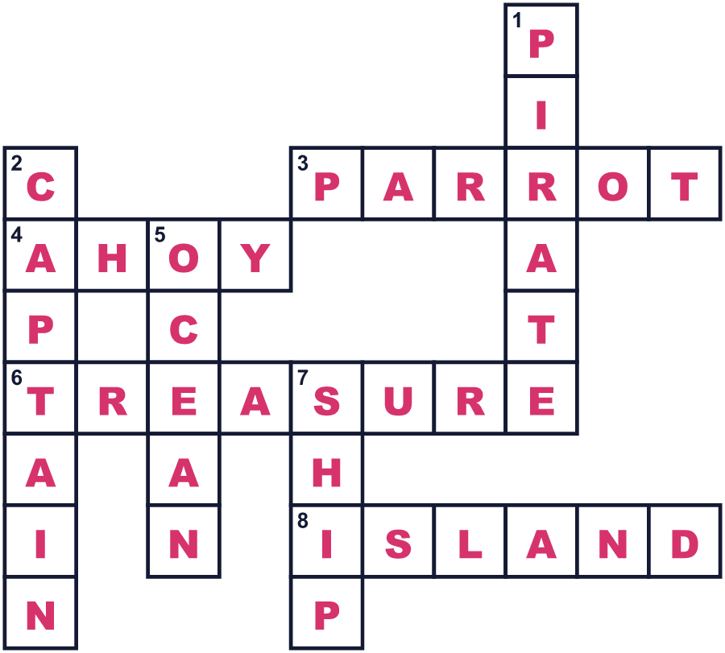
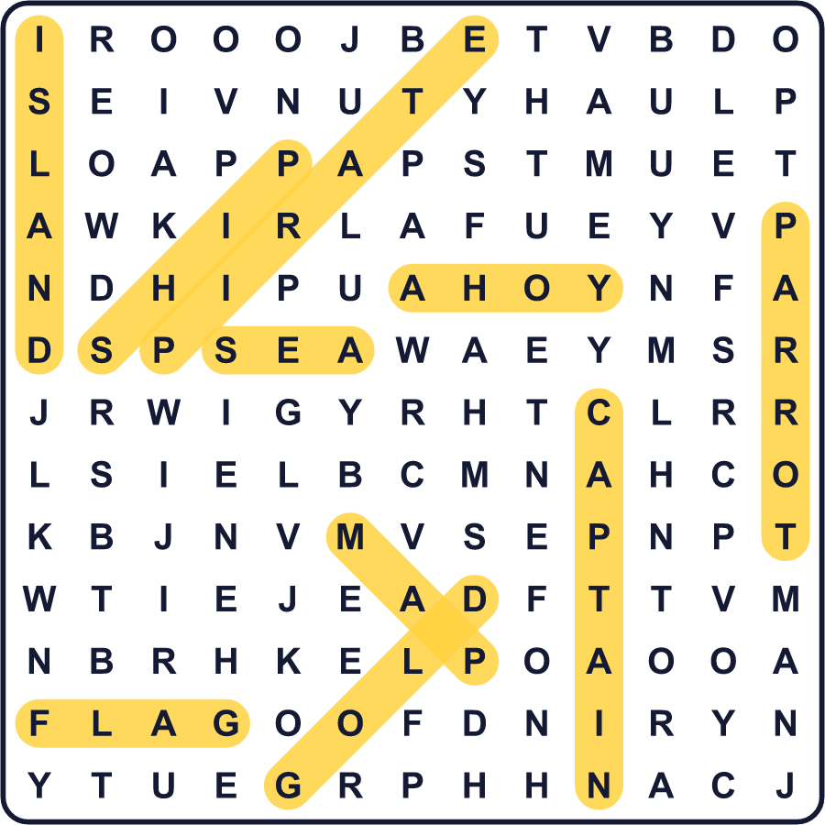
全訳
1 1995年6月6日、オレゴン州で2人の友人がラケットボールをしていました。2人の名前は、ジョン・ボーとマーク・サマーズでした。試合中、マークが突然「アーッ！」と叫びました。その声は、まるで映画の海賊のようでした。そこで2人は海賊のようにしゃべり始め、試合はずっと楽しくなりました。
2 2人は、世界には「海賊っぽくしゃべる日」という新しい記念日が必要だと決めました。でも、6月6日は使いたくありませんでした。その日は、第二次世界大戦のD-デイの兵士たちを記念する日だからです。そこでマークは、元奥さんの誕生日である9月19日を選びました。彼は少しも迷いませんでした。覚えやすいから、と彼は言いました。
3 7年間、この記念日は友だちの間だけの冗談でした。毎年9月19日、2人は職場からおたがいに電話をかけ、「アーッ！」と叫んで電話を切りました。そして2002年、ジョンは有名なユーモア作家のデイブ・バリーにメールを送りました。バリーは新聞のコラムでこの日のことを書きました。まもなく、アメリカからオーストラリアまで、ラジオ局が2人に話を聞きたがりました。
4 今では人々は「ハロー、フレンド！」のかわりに「アホイ、メイティ！」と言います。眼帯をつけたり、宝の地図を描いたりする人もいます。でも、本物の海賊はたぶんこんな話し方はしていませんでした。有名な海賊の声の多くは、1950年の映画『宝島』から来ています。俳優がイングランド西部のなまりをとても強くし、世界中がそれをまねしたのです。

