🌌 Star Wars Day Worksheet
May the Fourth Be with You
Read the story. 英文を読もう。
Class ______ No. ____ Name ______________________________
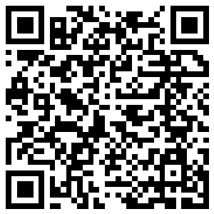
🔊 音声を聞こう（スマホで読みとってね）
1 Every year on May 4, Star Wars fans share a special greeting. They say, "May the Fourth be with you!" It is a joke. In the first Star Wars movie from 1977, the heroes say, "May the Force be with you." It means good luck.
2 Now say Force and Fourth out loud. They sound almost the same! The only difference is the last sound, s or th. So May 4 became Star Wars Day. It is not an official holiday, but fans around the world enjoy it.
3 Where did the joke start? A popular story says a British newspaper printed it on May 4, 1979. That was the day Margaret Thatcher's party won the election. But a writer checked the old newspapers carefully. The real ad came out on May 3, before anyone knew the results. It said, "Dear Maggie, May the Fourth Be With You."
4 The first big party for Star Wars Day was in Toronto, Canada, in 2011. Fans played a quiz game and wore costumes. Two years later, Disney started to celebrate the day at its theme parks. Today, fans watch the movies, wave toy lightsabers, and share jokes online.
5 Star Wars also has a strong link to Japan. George Lucas learned a lot from the samurai movies of Akira Kurosawa. The two robots, C-3PO and R2-D2, are based on two funny farmers in a 1958 film. And in Japan, May 4 is a national holiday called Greenery Day. So Japanese fans can stay home and watch all the movies!
Words 単語
greeting（あいさつ） / joke（冗談、ジョーク） / hero（ヒーロー、英雄） / force（力） / out loud（声に出して） / difference（ちがい） / official（公式の） / election（選挙） / costume（仮装、衣装） / celebrate（祝う） / be based on（～をもとにしている） / link（つながり）

🌌 Star Wars Day Worksheet
Reading Check
Choose the best answer. 正しいものを選ぼう。
Class ______ No. ____ Name ______________________________
1. What is the reading mainly about?
(A) How to make a toy lightsaber (B) Why May 4 is Star Wars Day (C) The life of Margaret Thatcher (D) How movies are made in Japan
2. When did the first Star Wars movie come out?
(A) In 1958 (B) In 1979 (C) In 2011 (D) In 1977
3. Where was the first big party for Star Wars Day?
(A) In London (B) In Tokyo (C) In Toronto (D) In Los Angeles
4. What was true about the real 1979 ad?
(A) It came out on May 3. (B) It had a photo of Luke. (C) It was in a Japanese paper. (D) It said congratulations.
5. In paragraph 2, the word "official" is closest in meaning to ...
(A) secret and hidden (B) decided by a government or company (C) very funny and silly (D) old and famous
6. Which sentence is true about the reading?
(A) Force and Fourth sound exactly the same. (B) Disney started the day in 2011. (C) C-3PO and R2-D2 are based on two farmers in a film. (D) May 4 is a school day in Japan.
7. Why can many Japanese fans watch all the movies on May 4?
(A) Because it is a holiday in Japan. (B) Because Disney gives free tickets. (C) Because schools show the movies. (D) Because it always rains in May.
8. In the dialogue, how does Emily help Sota say "fourth"?
(A) She shows him a movie. (B) She gives him a lightsaber. (C) She writes the word on the board. (D) She tells him to put his tongue between his teeth.
True or False? T か F に○
1. Star Wars Day is on May 4. T / F
2. Star Wars Day is an official holiday in the United States. T / F
3. The joke comes from the line May the Force be with you. T / F
4. The first big Star Wars Day party was in Tokyo. T / F
5. Some fans call May 5 Revenge of the Fifth. T / F
6. The first Star Wars movie came out in 1999. T / F

🌌 Star Wars Day Worksheet
Word Work
単語のれんしゅう
Class ______ No. ____ Name ______________________________
① Match the pictures and the words. 絵と単語を線でむすぼう。
🚀 | ● | ● | galaxy
🤖 | ● | ● | alien
⭐ | ● | ● | planet
🪐 | ● | ● | popcorn
🎬 | ● | ● | robot
🌌 | ● | ● | movie
👽 | ● | ● | star
🍿 | ● | ● | rocket
② Unscramble the words. 並べかえて単語にしよう。
1. O R F E C (力（フォース）) → ____________________
2. T O B O R (ロボット) → ____________________
3. Y A X G A L (銀河) → ____________________
4. N L E P T A (惑星) → ____________________
5. R E H O (ヒーロー) → ____________________
6. T F O U H R (4番目の、4日) → ____________________
③ Fill in the blanks. 語群から選んで入れよう。
[ mask / costume / Vader / movie / laughed / turkey / Force / snowman / fourth / pumpkin / lightsaber / battle / voice ]
On May the (1) __________ , Ben woke up early and put on his Jedi (2) __________ . He took his toy (3) __________ to school. His teacher smiled and said, "May the (4) __________ be with you!" At lunch, Ben and his friends talked about their favorite (5) __________ . After school, Ben's sister put on a black (6) __________ . "I am Darth (7) __________ !" she said in a deep (8) __________ . They had a lightsaber (9) __________ in the garden. Nobody won, but they both (10) __________ a lot.

🌌 Star Wars Day Worksheet
Crossword Puzzle
ヒントを読んでクロスワードを完成させよう。
Class ______ No. ____ Name ______________________________
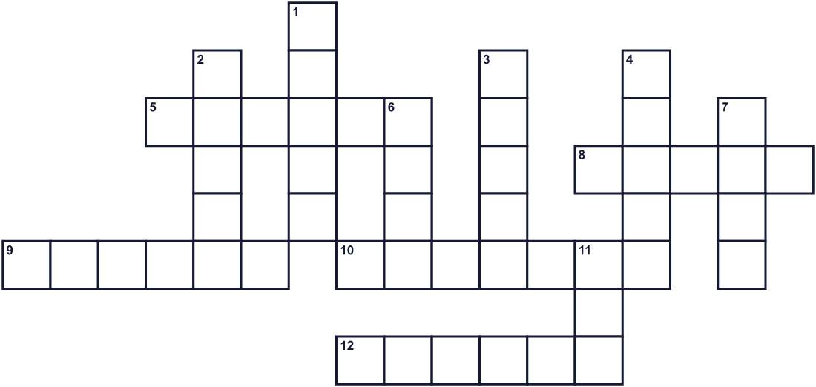
Across →
5. It comes after third. Number 4. (6)
8. Darth ___, a famous bad guy in a black mask. (5)
9. Earth is one. Mars is one, too. (6)
10. Special clothes you wear to look like someone else. (7)
12. A very big group of stars. (6)
Down ↓
1. A power in the movies. Jedi use it. (5)
2. You watch this at a theater. (5)
3. A machine that can move and sometimes talk. (5)
4. Where the planets and stars are. (5)
6. A brave person who saves other people. (4)
7. A hero who fights with a lightsaber. (4)
11. The fifth month of the year. (3)

🌌 Star Wars Day Worksheet
Word Search
かくれた単語をさがそう（→ ↓ ↘ ↗）
Class ______ No. ____ Name ______________________________
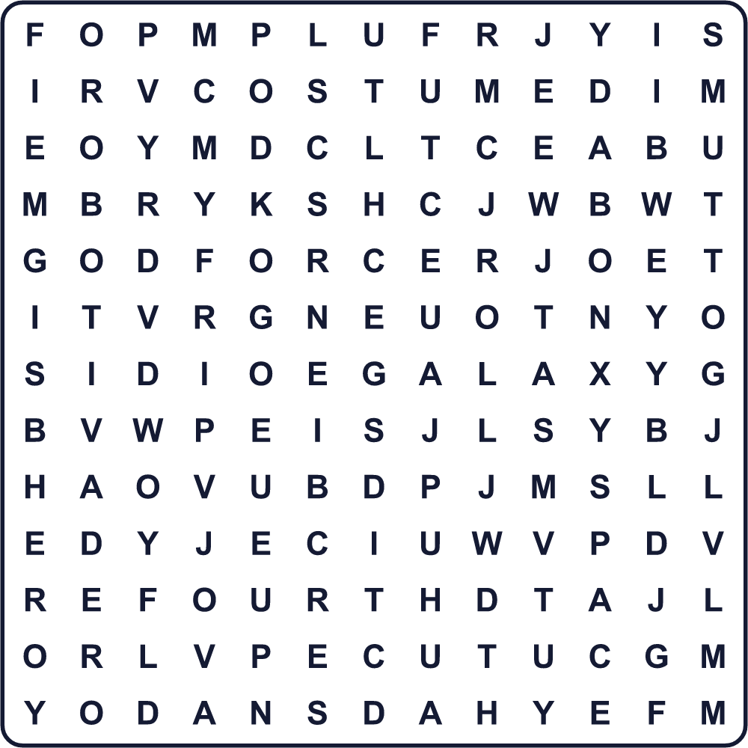
COSTUME DROID FORCE FOURTH GALAXY HERO JEDI MOVIE PLANET ROBOT SPACE VADER YODA
Secret Code 暗号を解こう
✈=A ♣=E ✎=F ☘=H ▲=M ■=O ☀=R ◆=T ⚓=U ✉=Y
▲ ✈ ✉ ◆ ☘ ♣ ✎ ■ ⚓ ☀ ◆ ☘
______________________________________________________________

🌌 Star Wars Day Worksheet
Maze & Sentences
Class ______ No. ____ Name ______________________________
Help the little robot get to the spaceship! 小さなロボットを宇宙船まで連れていこう！
正しい道の文字を集めると、ひみつの言葉になるよ。 START 🤖 → GOAL 🚀
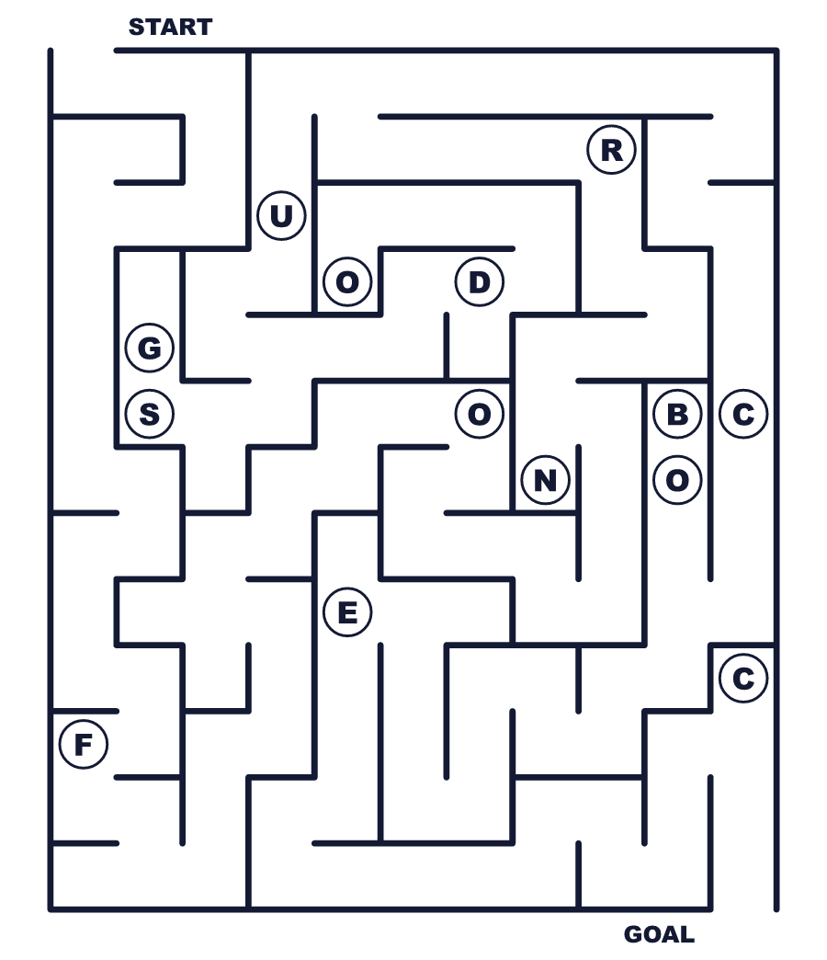
Secret word: ＿ ＿ ＿ ＿ ＿
Put the words in order. 並べかえよう。
1. Fourth / you / with / be / May / the . (5月4日があなたと共にありますように。)
______________________________________________________________
2. Day / 4 / Wars / May / Star / is / on . (スター・ウォーズの日は5月4日です。)
______________________________________________________________
3. movie / The / first / out / 1977 / came / in . (1作目は1977年に公開されました。)
______________________________________________________________
4. Fans / movies / wear / and / the / costumes / watch . (ファンは仮装をして映画を見ます。)
______________________________________________________________
5. Force / Fourth / same / sound / the / and / almost . (Force と Fourth はほとんど同じに聞こえます。)
______________________________________________________________

🌌 Star Wars Day Worksheet
Class Activity & Writing
Class ______ No. ____ Name ______________________________
Find Someone Who… クラスで聞いて回ろう！
Find someone who … | Name
… has seen a Star Wars movie スター・ウォーズの映画を見たことがある
… likes science fiction movies SF映画が好き
… can say fourth with a good th sound fourth をきれいな th の音で言える
… knows the name of a Star Wars character スター・ウォーズのキャラクターの名前を知っている
… has worn a costume 仮装をしたことがある
… knows a joke in English 英語のジョークを知っている
… has seen a movie by Akira Kurosawa 黒澤明の映画を見たことがある
… can name three planets 惑星の名前を3つ言える
Let's Write! 英語で書いてみよう。
If I had the Force, I would ______.
もし私にフォースがあったら、______します。
______________________________________________________________
______________________________________________________________
My favorite movie character is ______ because ______.
私の好きな映画のキャラクターは______です。なぜなら______だからです。
______________________________________________________________
______________________________________________________________
I want to make a new joke holiday on ______ because ______.
私は______にダジャレの記念日を作りたいです。なぜなら______だからです。
______________________________________________________________
______________________________________________________________

🌌 Star Wars Day Worksheet
Trace & Color
なぞって書こう。絵に色をぬろう。
Class ______ No. ____ Name ______________________________
🚀 

🤖 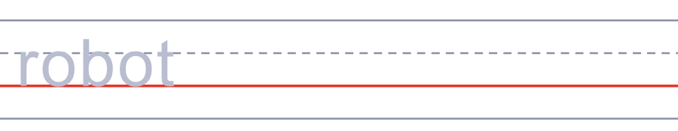
⭐ 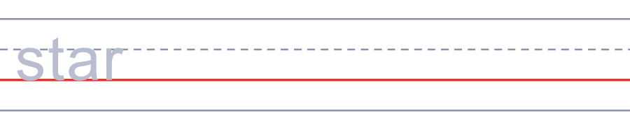
🪐 
🎬 
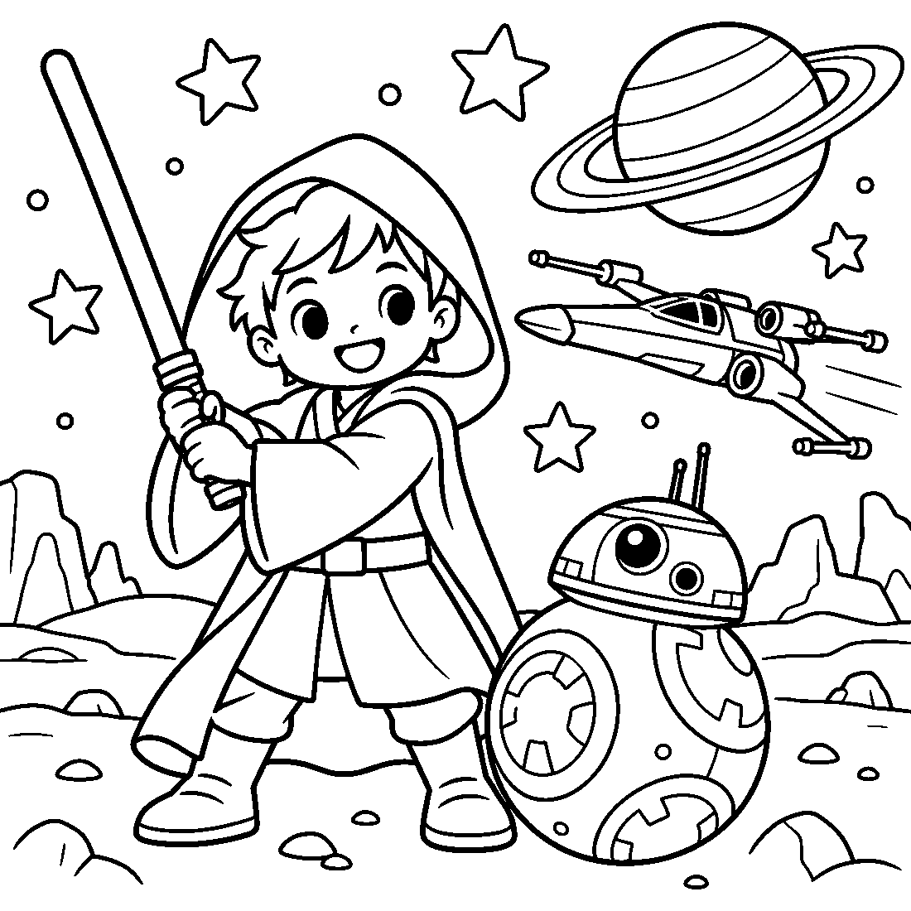

🌌 Star Wars Day Worksheet
Answer Key 解答
Reading Check: 1.B 2.D 3.C 4.A 5.B 6.C 7.A 8.D
True or False: 1.T 2.F 3.T 4.F 5.T 6.F
Match: 🚀=rocket 🤖=robot ⭐=star 🪐=planet 🎬=movie 🌌=galaxy 👽=alien 🍿=popcorn
Unscramble: 1.FORCE 2.ROBOT 3.GALAXY 4.PLANET 5.HERO 6.FOURTH
Fill in the blanks: (1)fourth (2)costume (3)lightsaber (4)Force (5)movie (6)mask (7)Vader (8)voice (9)battle (10)laughed
Sentence order: 1. May the Fourth be with you. 2. Star Wars Day is on May 4. 3. The first movie came out in 1977. 4. Fans wear costumes and watch the movies. 5. Force and Fourth sound almost the same.
Secret Code: MAY THE FOURTH
Maze: FORCE
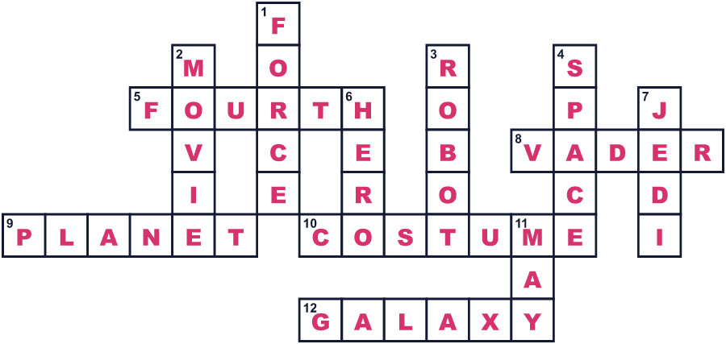
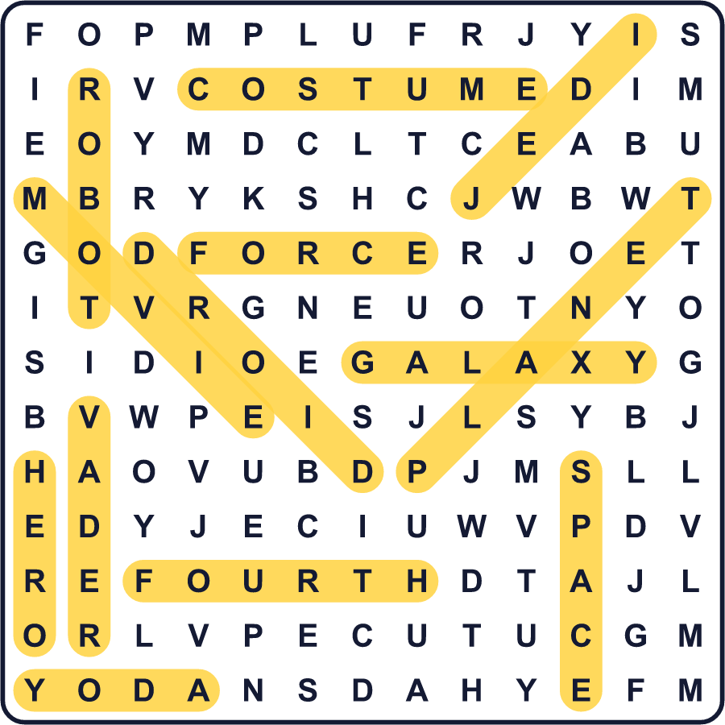
全訳
1 毎年5月4日、スター・ウォーズのファンは特別なあいさつを交わします。彼らは「May the Fourth be with you!」と言うのです。これはダジャレです。1977年のスター・ウォーズの1作目で、ヒーローたちは「フォースと共にあらんことを」と言います。それは「幸運を祈る」という意味です。
2 では、Force と Fourth を声に出して言ってみてください。ほとんど同じに聞こえますね！ちがうのは最後の音、s か th かだけです。こうして5月4日がスター・ウォーズの日になりました。公式の祝日ではありませんが、世界中のファンが楽しんでいます。
3 このダジャレはどこで始まったのでしょう？よく知られた話では、1979年5月4日にイギリスの新聞にのったと言われます。それは、マーガレット・サッチャーの党が選挙に勝った日でした。でも、ある書き手が古い新聞を注意深く調べました。本物の広告は5月3日、誰も結果を知る前に出ていたのです。そこには「親愛なるマギーへ May the Fourth Be With You」と書かれていました。
4 スター・ウォーズの日の最初の大きなパーティーは、2011年にカナダのトロントで開かれました。ファンはクイズ大会をしたり、仮装をしたりしました。2年後、ディズニーがテーマパークでこの日を祝い始めました。今ではファンは映画を見たり、おもちゃのライトセーバーをふったり、ネットでジョークを言い合ったりします。
5 スター・ウォーズは日本とも強いつながりがあります。ジョージ・ルーカスは、黒澤明の時代劇から多くを学びました。2体のロボット、C-3POとR2-D2は、1958年の映画に出てくる2人のこっけいな百姓がもとになっています。そして日本では、5月4日は「みどりの日」という国民の祝日です。だから日本のファンは、家で映画を全部見ることだってできるのです！

