☘️ St. Patrick's Day Worksheet
The Boy Who Came Back
Read the story. 英文を読もう。
Class ______ No. ____ Name ______________________________

🔊 音声を聞こう（スマホで読みとってね）
1 Every March, something strange happens in Chicago. The river in the middle of the city turns bright green! Workers put a special powder into the water. Thousands of people come to watch. It is all for one day, Saint Patrick's Day, on March 17.
2 Saint Patrick is the patron saint of Ireland, but he was not Irish. He was born in Britain more than 1,500 years ago. When he was about 16, raiders took him away to Ireland. He worked there as a slave and looked after animals for six years. Then he escaped and went home.
3 But later, Patrick chose to go back to Ireland. He taught people about Christianity there for many years. A famous story says he used a shamrock, a small plant with three leaves, to teach. People believe he died on March 17, so this became his day.
4 The first parades were not in Ireland. They were in America! In 1762, Irish soldiers marched through New York City. Later, many Irish people moved to the United States, and the parades grew bigger. Today, about two million people watch the New York parade.
5 Now the day is a big party around the world. People wear green clothes and put shamrocks on their coats. Famous buildings light up in green, and even Tokyo Tower has turned green. In Ireland, it is a national holiday, and many families go to church and watch parades. So, are you wearing anything green today?
Words 単語
patron saint（守護聖人） / raider（襲ってくる人、略奪者） / slave（奴隷） / escape（逃げる、脱出する） / look after（～の世話をする） / Christianity（キリスト教） / shamrock（シャムロック（三つ葉のクローバーの仲間）） / legend（伝説） / march（行進する） / light up（ライトアップする、明るく照らす） / national holiday（国の祝日） / bagpipes（バグパイプ）

☘️ St. Patrick's Day Worksheet
Reading Check
Choose the best answer. 正しいものを選ぼう。
Class ______ No. ____ Name ______________________________
1. What is the main idea of the passage?
(A) How to dye a river green (B) Why people in Japan like Irish music (C) Who Saint Patrick was and how his day became a world party (D) Why snakes left Ireland
2. Where was Saint Patrick born?
(A) In Britain (B) In Ireland (C) In New York (D) In Rome
3. How long did Patrick work as a slave?
(A) Sixteen years (B) Two years (C) Seventeen years (D) Six years
4. When did Irish soldiers march in New York?
(A) In 1601 (B) In 1762 (C) In 1962 (D) In 2007
5. In paragraph 3, what is a "shamrock"?
(A) A small plant with three leaves (B) A green river (C) A kind of soldier (D) A church in Ireland
6. Which sentence is true about the passage?
(A) Patrick never went back to Ireland. (B) The first parades were in Ireland. (C) Saint Patrick's Day is a national holiday in Ireland. (D) Only Irish people can join the party.
7. Why did the parades in America grow bigger?
(A) Because the river was green (B) Because many Irish people moved there (C) Because Patrick lived in New York (D) Because it was a holiday in America
8. In the dialogue, what does Sean's family usually eat on St. Patrick's Day?
(A) Corned beef (B) Sushi (C) Pancakes (D) Bacon and cabbage
True or False? T か F に○
1. Saint Patrick was born in Ireland. T / F
2. St. Patrick's Day is on March 17. T / F
3. A shamrock has three leaves. T / F
4. Saint Patrick drove real snakes out of Ireland. T / F
5. Chicago turns its river green for the day. T / F
6. Corned beef and cabbage was first made in Ireland. T / F

☘️ St. Patrick's Day Worksheet
Word Work
単語のれんしゅう
Class ______ No. ____ Name ______________________________
① Match the pictures and the words. 絵と単語を線でむすぼう。
☘️ | ● | ● | fiddle
🌈 | ● | ● | shamrock
🐍 | ● | ● | potato
🎻 | ● | ● | rainbow
🥔 | ● | ● | snake
🍀 | ● | ● | hat
🎩 | ● | ● | church
⛪ | ● | ● | clover
② Unscramble the words. 並べかえて単語にしよう。
1. R G E N E (緑) → ____________________
2. S A K E N (ヘビ) → ____________________
3. E P A A R D (パレード) → ____________________
4. H S I R I (アイルランドの) → ____________________
5. H R P A (ハープ) → ____________________
6. V R E R I (川) → ____________________
③ Fill in the blanks. 語群から選んで入れよう。
[ Dublin / green / favorite / snake / crowd / parade / bagpipes / church / cabbage / orange / winter / shamrock / school ]
Aoife lives in (1) __________ , the capital of Ireland. On March 17, she does not go to (2) __________ . It is a holiday! In the morning, her family goes to (3) __________ . Her grandmother puts a small (4) __________ on Aoife's coat. Then they walk to the city center to watch the (5) __________ . A band plays the (6) __________ , and a giant puppet waves at the (7) __________ . Aoife wears a (8) __________ hat. At home, they eat bacon and (9) __________ . "This is my (10) __________ day of spring," Aoife says.

☘️ St. Patrick's Day Worksheet
Crossword Puzzle
ヒントを読んでクロスワードを完成させよう。
Class ______ No. ____ Name ______________________________
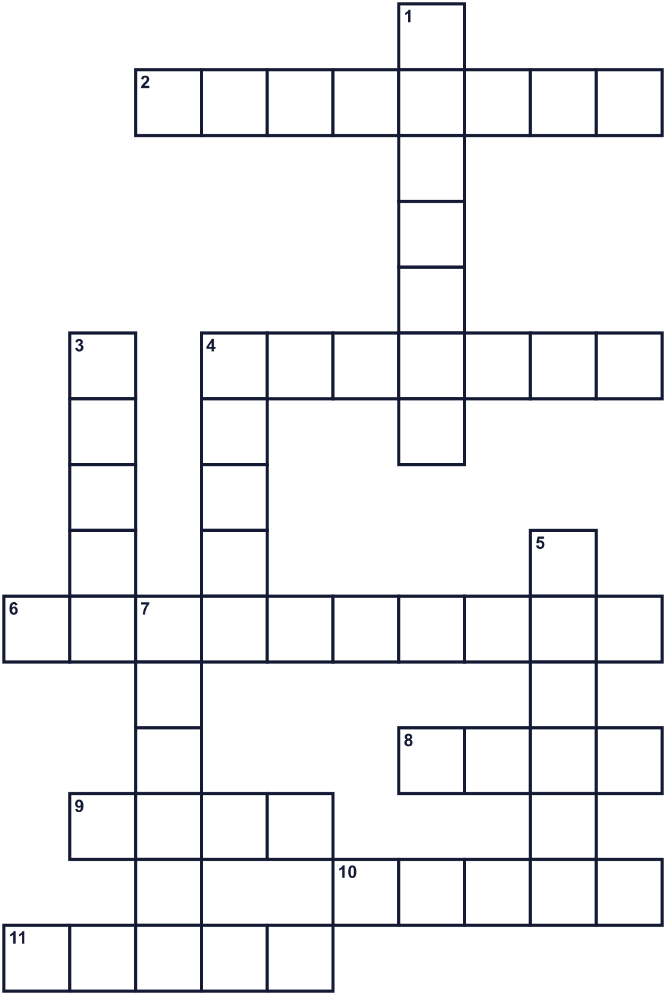
Across →
2. A small plant with three leaves. It is a symbol of Ireland. (8)
4. Seven colors in the sky after rain. (7)
6. A small fairy in Irish stories. He hides gold. (10)
8. A yellow metal. It is in a pot at the end of a rainbow. (4)
9. A big musical instrument with many strings. It is on Irish coins. (4)
10. A very holy person, like Patrick. (5)
11. The color of grass. People wear it on March 17. (5)
Down ↓
1. An island country. Its capital is Dublin. (7)
3. A long animal with no legs. There were none in Ireland. (5)
4. Chicago makes this water green. (5)
5. The capital city of Ireland. (6)
7. People walk and play music down the street in a long line. (6)

☘️ St. Patrick's Day Worksheet
Word Search
かくれた単語をさがそう（→ ↓ ↘ ↗）
Class ______ No. ____ Name ______________________________
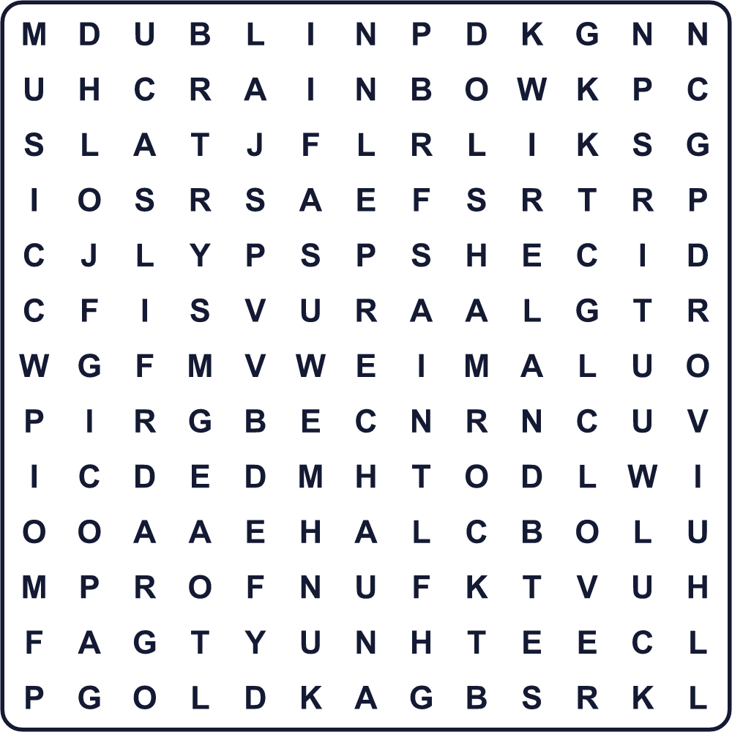
CLOVER DUBLIN GOLD GREEN HARP IRELAND LEPRECHAUN LUCK MUSIC PARADE RAINBOW SAINT SHAMROCK
Secret Code 暗号を解こう
✎=A ✉=E ♥=G ♪=H ☎=I ☀=M ■=N ⚓=O ✈=R ☘=S ♦=T ★=W
★ ✉ ✎ ✈ ☘ ⚓ ☀ ✉ ♦ ♪ ☎ ■ ♥ ♥ ✈ ✉ ✉ ■
______________________________________________________________

☘️ St. Patrick's Day Worksheet
Maze & Sentences
Class ______ No. ____ Name ______________________________
Help the leprechaun find his pot of gold! レプラコーンを金の壺のところまで連れていこう！
正しい道の文字を集めると、ひみつの言葉になるよ。 START 🧚 → GOAL 🌈
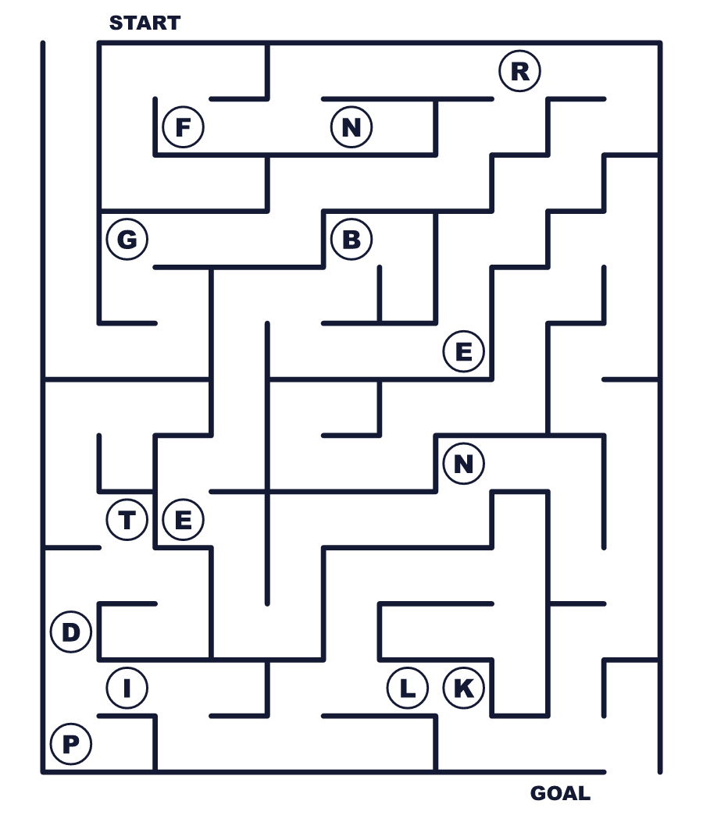
Secret word: ＿ ＿ ＿ ＿ ＿
Put the words in order. 並べかえよう。
1. born / Saint / Britain / in / Patrick / was . (聖パトリックはブリテン島で生まれました。)
______________________________________________________________
2. years / as / worked / a / He / for / six / slave . (彼は6年間、奴隷として働きました。)
______________________________________________________________
3. on / St. / green / Day / Patrick's / wear / People . (人々はセント・パトリックス・デーに緑を着ます。)
______________________________________________________________
4. plant / shamrock / three / with / leaves / a / is / A . (シャムロックは3枚の葉を持つ植物です。)
______________________________________________________________
5. bright / river / Chicago / The / in / turns / green . (シカゴの川があざやかな緑に変わります。)
______________________________________________________________

☘️ St. Patrick's Day Worksheet
Class Activity & Writing
Class ______ No. ____ Name ______________________________
Find Someone Who… クラスで聞いて回ろう！
Find someone who … | Name
… is wearing something green today 今日、緑のものを身につけている
… has found a four-leaf clover 四つ葉のクローバーを見つけたことがある
… knows the capital of Ireland アイルランドの首都を知っている
… likes potatoes ジャガイモが好き
… has seen a rainbow this year 今年、虹を見たことがある
… can play a musical instrument 楽器を演奏できる
… has been to a parade パレードに行ったことがある
… knows a story about a fairy 妖精の話を知っている
Let's Write! 英語で書いてみよう。
If I found a leprechaun's pot of gold, I would ______ because ______.
もしレプラコーンの金の壺を見つけたら、私は______します。なぜなら______だからです。
______________________________________________________________
______________________________________________________________
I want to light up ______ in green because ______.
私は______を緑にライトアップしたい。なぜなら______だからです。
______________________________________________________________
______________________________________________________________
The most surprising fact about Saint Patrick is that ______.
聖パトリックについていちばん驚いたことは、______ということです。
______________________________________________________________
______________________________________________________________

☘️ St. Patrick's Day Worksheet
Trace & Color
なぞって書こう。絵に色をぬろう。
Class ______ No. ____ Name ______________________________
☘️ 

🌈 
🐍 
🎻 
🥔 
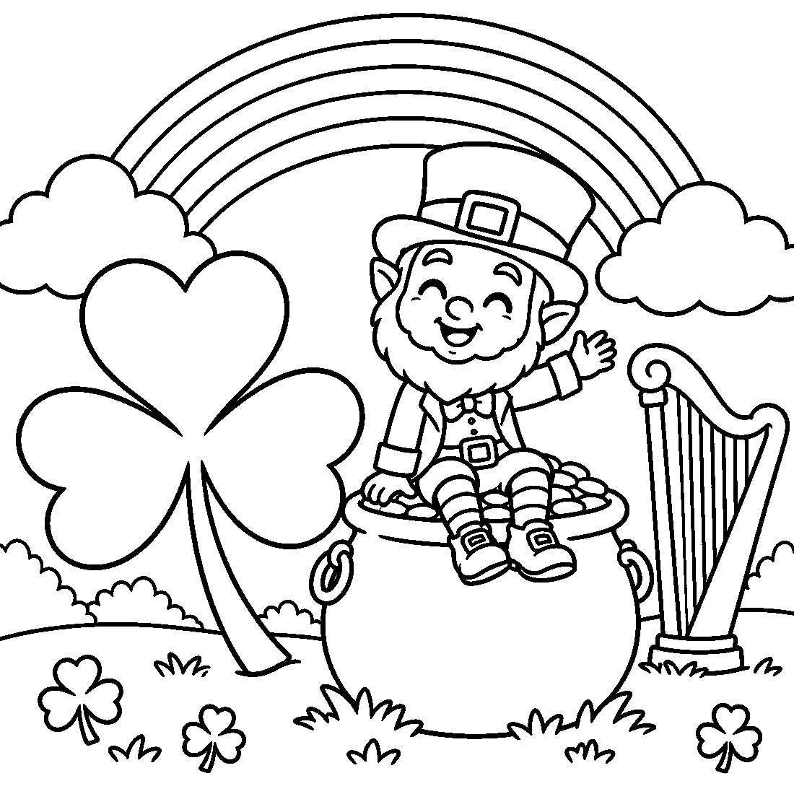

☘️ St. Patrick's Day Worksheet
Answer Key 解答
Reading Check: 1.C 2.A 3.D 4.B 5.A 6.C 7.B 8.D
True or False: 1.F 2.T 3.T 4.F 5.T 6.F
Match: ☘️=shamrock 🌈=rainbow 🐍=snake 🎻=fiddle 🥔=potato 🍀=clover 🎩=hat ⛪=church
Unscramble: 1.GREEN 2.SNAKE 3.PARADE 4.IRISH 5.HARP 6.RIVER
Fill in the blanks: (1)Dublin (2)school (3)church (4)shamrock (5)parade (6)bagpipes (7)crowd (8)green (9)cabbage (10)favorite
Sentence order: 1. Saint Patrick was born in Britain. 2. He worked as a slave for six years. 3. People wear green on St. Patrick's Day. 4. A shamrock is a plant with three leaves. 5. The river in Chicago turns bright green.
Secret Code: WEAR SOMETHING GREEN
Maze: GREEN
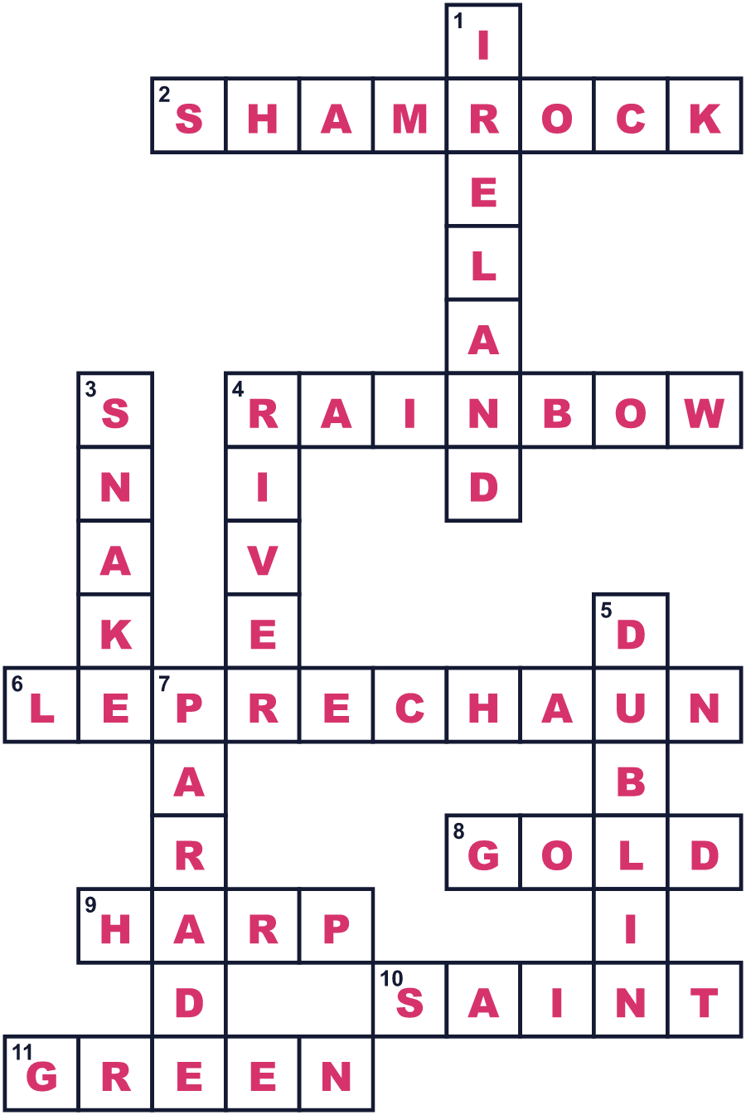
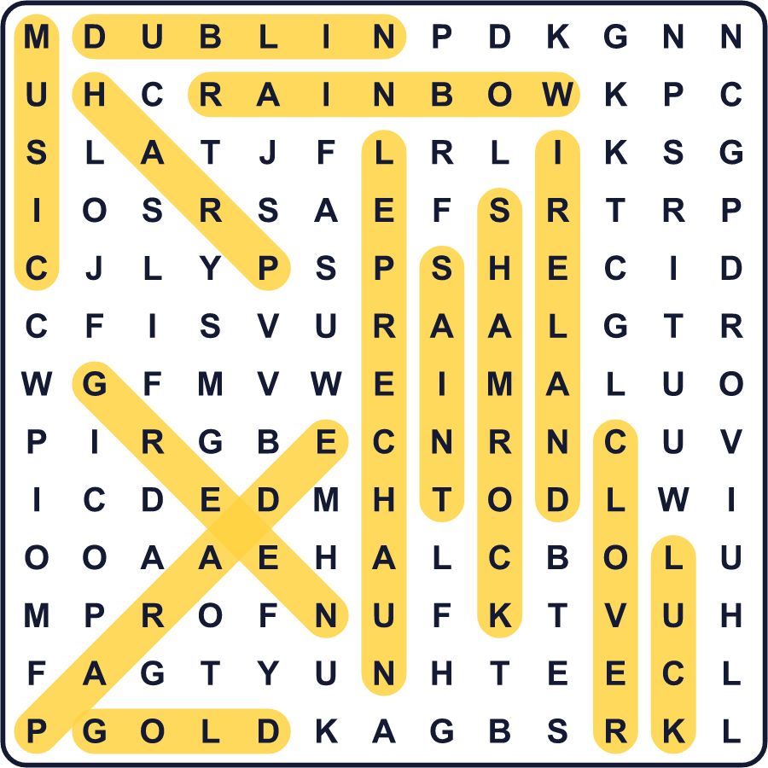
全訳
1 毎年3月、シカゴで不思議なことが起こります。町の真ん中を流れる川が、あざやかな緑色に変わるのです！作業員が特別な粉を水に入れます。何千人もの人が見に来ます。それはすべて、3月17日のセント・パトリックス・デーという1日のためです。
2 聖パトリックはアイルランドの守護聖人ですが、アイルランド人ではありませんでした。彼は1500年以上前にブリテン島で生まれました。16歳くらいのとき、襲ってきた人たちが彼をアイルランドへ連れ去りました。彼はそこで奴隷として働き、6年間動物の世話をしました。その後、彼は逃げて家に帰りました。
3 でも後に、パトリックはアイルランドへ戻ることを選びました。彼はそこで長い間、人々にキリスト教を教えました。有名な話では、彼は3枚の葉を持つ小さな植物、シャムロックを使って教えたといいます。彼は3月17日に亡くなったと信じられているので、この日が彼の日になりました。
4 最初のパレードはアイルランドではありませんでした。アメリカだったのです！1762年、アイルランド人の兵士たちがニューヨークの町を行進しました。その後、たくさんのアイルランドの人々がアメリカに移り住み、パレードは大きくなりました。今では、約200万人がニューヨークのパレードを見物します。
5 今、この日は世界中の大きなお祭りです。人々は緑の服を着て、コートにシャムロックをつけます。有名な建物が緑にライトアップされ、東京タワーまで緑になったことがあります。アイルランドでは国の祝日で、多くの家族が教会に行き、パレードを見ます。さて、あなたは今日、何か緑のものを身につけていますか？

