🕯️ St. Lucia's Day Worksheet
A Crown of Candles in the Dark
Read the story. 英文を読もう。
Class ______ No. ____ Name ______________________________

🔊 音声を聞こう（スマホで読みとってね）
1 It is early on a dark December morning in Sweden. The door opens, and a girl walks in slowly. She wears a long white dress and a red sash. On her head, there is a crown of candles. She sings a soft song and brings coffee and yellow buns. This is Lucia.
2 December 13 is St. Lucia's Day. Lucia was a young Christian woman in Sicily, Italy. She died around the year 304. Her name means light. One story says she wore candles on her head. Then she could use both hands to carry food to people in hiding.
3 But why do people remember her in the cold north? In the old calendar, December 13 was the longest night of the year. Sweden changed its calendar in 1753, but Lucia stayed on the same day. In 1927, a newspaper in Stockholm chose a Lucia for the city. After that, the custom spread to schools, offices, and churches all over the country.
4 Today, Lucia walks at the front of a line of children. Girls in white hold candles, and boys called star boys walk with them. Some children dress up as gingerbread men. Everyone eats lussekatter, saffron buns in the shape of the letter S. The name means Lucia's cats, and the raisins look like cat eyes. On the darkest days of winter, the candles bring a little light to everyone.
Words 単語
crown（冠） / candle（ろうそく） / sash（（肩や腰に巻く）帯） / saffron（サフラン） / bun（小さな丸いパン） / custom（習慣、風習） / spread（広まる） / in hiding（かくれて）

🕯️ St. Lucia's Day Worksheet
Reading Check
Choose the best answer. 正しいものを選ぼう。
Class ______ No. ____ Name ______________________________
1. What is the main idea of the text?
(A) Lucia was a queen of Sweden. (B) St. Lucia's Day is a summer festival in Italy. (C) St. Lucia's Day is a day for buying gifts. (D) St. Lucia's Day brings light to the dark Swedish winter.
2. Where did Lucia live?
(A) In Sicily, Italy (B) In Stockholm, Sweden (C) In Naples, Italy (D) In Finland
3. Why was December 13 special in the old calendar?
(A) It was the first day of the year. (B) It was the longest night of the year. (C) It was the day Sweden changed its calendar. (D) It was the hottest day of the year.
4. In paragraph 3, "spread" is closest in meaning to:
(A) stopped (B) became smaller (C) went to more places (D) was forgotten
5. In the dialogue, what will Haruto be in the Lucia line?
(A) Lucia (B) A teacher (C) A gingerbread man (D) A star boy
True or False? T か F に○
1. Lucia was born in Sweden. T / F
2. The name Lucia means light. T / F
3. Lussekatter are buns shaped like the letter S. T / F
4. St. Lucia's Day is on December 25. T / F

🕯️ St. Lucia's Day Worksheet
Word Work
単語のれんしゅう
Class ______ No. ____ Name ______________________________
① Match the pictures and the words. 絵と単語を線でむすぼう。
🕯️ | ● | ● | crown
👑 | ● | ● | coffee
⭐ | ● | ● | snow
☕ | ● | ● | cat
🐈 | ● | ● | candle
❄️ | ● | ● | star
③ Fill in the blanks. 語群から選んで入れよう。
[ beach / candles / family / coffee / sings / buns / noisy / dark / dress ]
On December 13, Anna gets up before her (1) __________ . It is still (2) __________ outside. She puts on a white (3) __________ and a crown of (4) __________ . Then she walks into her parents' room and (5) __________ a soft song. She brings them hot (6) __________ and yellow (7) __________ . Her father smiles and says, "Thank you, Lucia!"

🕯️ St. Lucia's Day Worksheet
Crossword Puzzle
ヒントを読んでクロスワードを完成させよう。
Class ______ No. ____ Name ______________________________
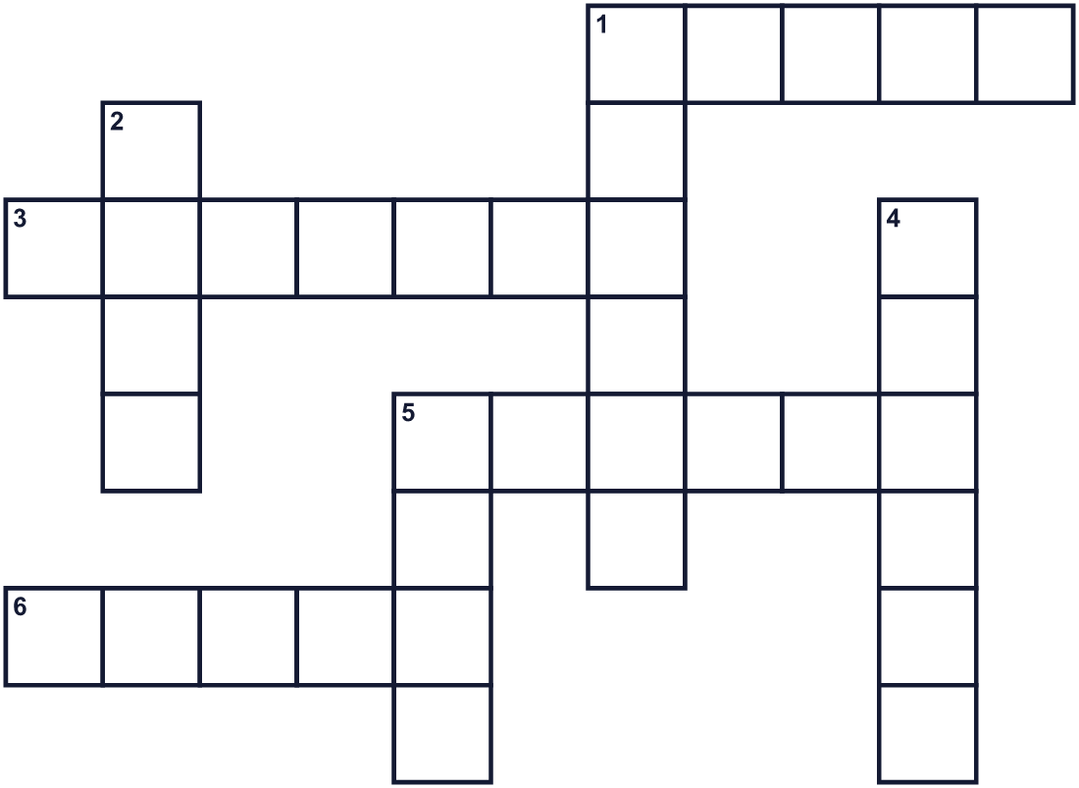
Across →
1. The color of snow. (5)
3. A yellow spice. It is very expensive. (7)
5. A country in the north of Europe. Stockholm is its capital. (6)
6. A king or queen wears this on the head. (5)
Down ↓
1. The coldest season of the year. (6)
2. The opposite of bright. (4)
4. It gives a small light. You light it with a match. (6)
5. You do this with a song. (4)

🕯️ St. Lucia's Day Worksheet
Word Search
かくれた単語をさがそう（→ ↓ ↘ ↗）
Class ______ No. ____ Name ______________________________
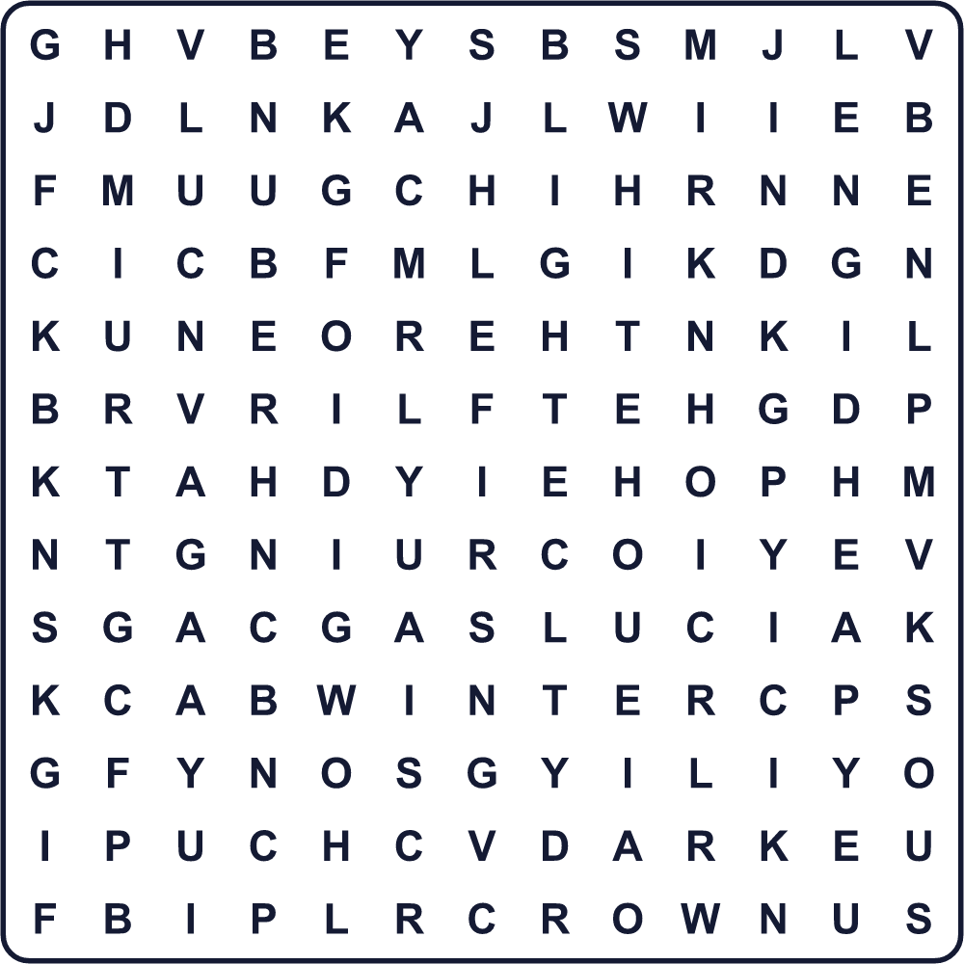
BUN CANDLE CROWN DARK LIGHT LUCIA SING STAR WHITE WINTER

🕯️ St. Lucia's Day Worksheet
Maze & Sentences
Class ______ No. ____ Name ______________________________
Help Lucia bring the buns to the family! ルシアがパンを家族に届けられるようにしよう！
正しい道の文字を集めると、ひみつの言葉になるよ。 START 👧 → GOAL 🏠
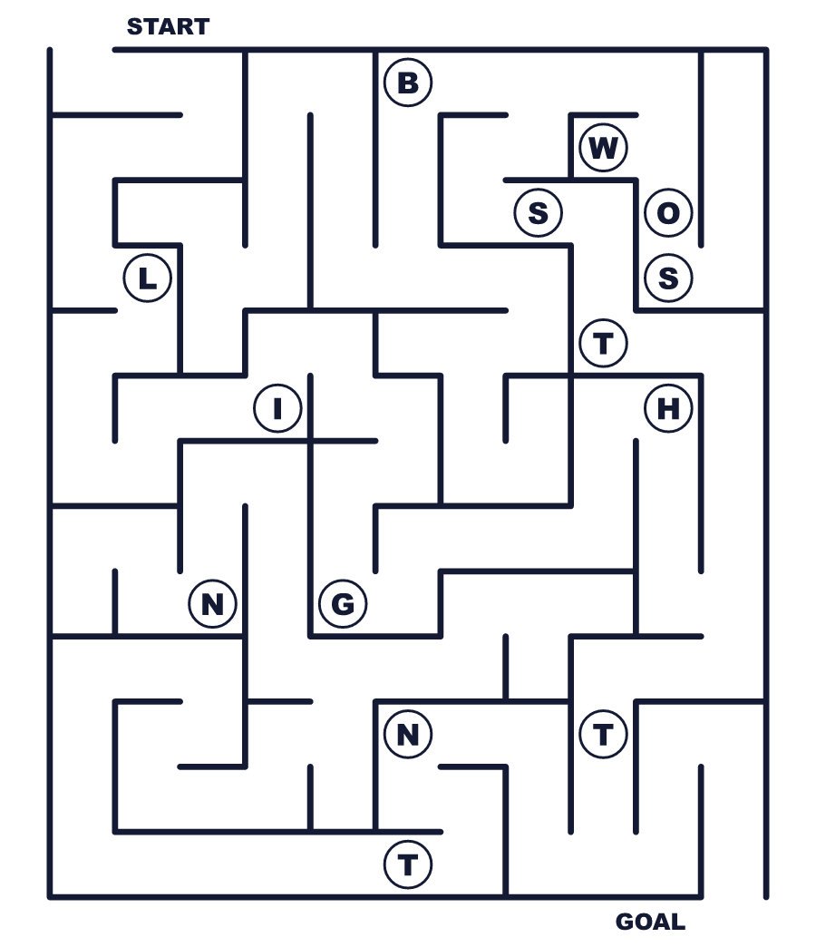
Secret word: ＿ ＿ ＿ ＿ ＿

🕯️ St. Lucia's Day Worksheet
Class Activity & Writing
Class ______ No. ____ Name ______________________________
Let's Write! 英語で書いてみよう。
On a dark winter morning, I like to ______.
暗い冬の朝、私は______するのが好きです。
______________________________________________________________
______________________________________________________________
If I joined a Lucia line, I would be ______ because ______.
ルシアの行列に入るなら、______になりたいです。なぜなら______だからです。
______________________________________________________________
______________________________________________________________

🕯️ St. Lucia's Day Worksheet
Trace & Color
なぞって書こう。絵に色をぬろう。
Class ______ No. ____ Name ______________________________
🕯️ 

👑 
⭐ 
☕ 
🐈 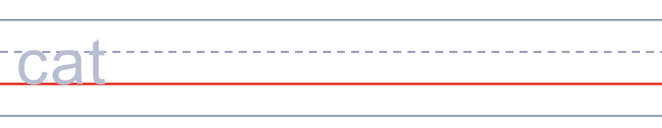

🕯️ St. Lucia's Day Worksheet
Answer Key 解答
Reading Check: 1.D 2.A 3.B 4.C 5.D
True or False: 1.F 2.T 3.T 4.F
Match: 🕯️=candle 👑=crown ⭐=star ☕=coffee 🐈=cat ❄️=snow
Fill in the blanks: (1)family (2)dark (3)dress (4)candles (5)sings (6)coffee (7)buns
Maze: LIGHT
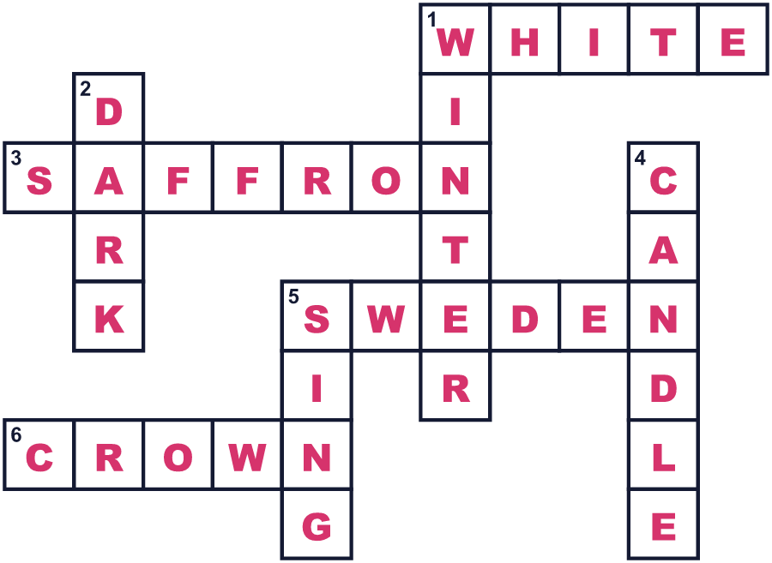
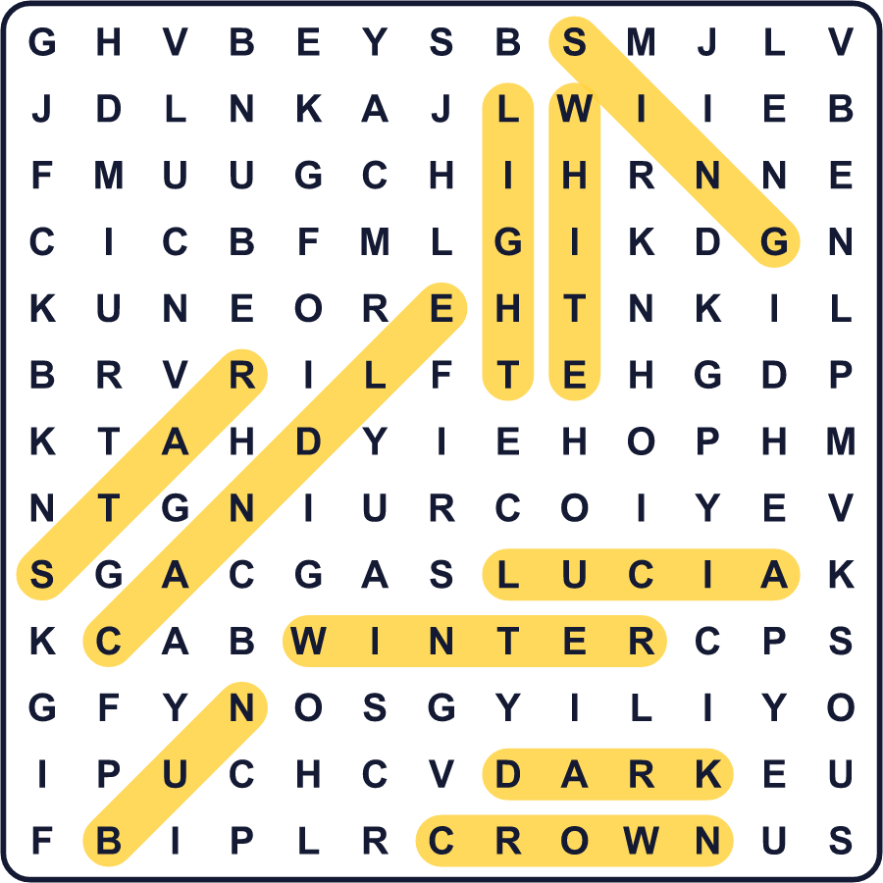
全訳
1 スウェーデンの、暗い12月の朝早くのことです。ドアが開き、ひとりの少女がゆっくりと入ってきます。長い白い服に、赤い帯をしめています。頭には、ろうそくの冠がのっています。やさしい歌を歌いながら、コーヒーと黄色いパンを運んできます。これがルシアです。
2 12月13日は聖ルチア祭です。ルチアは、イタリアのシチリア島に住んでいた若いキリスト教徒の女性でした。彼女は西暦304年ごろに亡くなりました。彼女の名前は「光」という意味です。ある言い伝えでは、彼女は頭にろうそくをのせていたそうです。そうすれば、両手を使って、かくれている人たちに食べ物を運べたからです。
3 でも、なぜ寒い北の国で彼女が祝われるのでしょう。昔の暦では、12月13日は1年でいちばん長い夜でした。スウェーデンは1753年に暦を変えましたが、ルシアの日は同じ日のまま残りました。1927年、ストックホルムの新聞社が町のルシアを選びました。そのあと、この習慣は国中の学校や職場、教会に広まりました。
4 今では、ルシアは子どもたちの行列の先頭を歩きます。白い服の少女たちはろうそくを持ち、スター・ボーイと呼ばれる男の子たちもいっしょに歩きます。ジンジャーブレッドマンの仮装をする子もいます。みんなが食べるのは、S字の形をしたサフランパン、ルッセカットです。名前は「ルシアのネコ」という意味で、レーズンがネコの目のように見えます。冬のいちばん暗い日々に、ろうそくがみんなに小さな光を届けるのです。

