🏃 Sports Day Worksheet
The Day the Torch Came to Tokyo
Read the story. 英文を読もう。
Class ______ No. ____ Name ______________________________

🔊 音声を聞こう（スマホで読みとってね）
1 On October 10, 1964, a young runner carried a torch into a huge stadium in Tokyo. His name was Yoshinori Sakai, and he was a college student. He was born in Hiroshima on August 6, 1945, the day of the atomic bomb. When he lit the Olympic flame, the crowd in the stadium cheered. It was the first Olympic Games in Asia.
2 Two years later, Japan made October 10 a national holiday to remember that day. It was called Taiiku no Hi, or Health and Sports Day. Taiiku means physical education, like the PE class at school. In 2000, the holiday moved to the second Monday of October. So now most people enjoy a three-day weekend.
3 In 2020, the holiday got a new name, Sports no Hi, or Sports Day. Many people felt that the word sports sounds more fun and free than PE. The law now says the day is for enjoying sports and respecting other people. That year, Tokyo planned to host the Olympics again, so the holiday moved to July 24. But the Games were delayed for one year, and that October had no holiday at all!
4 How do people spend the day? In October, many schools and towns hold an undokai, a sports festival. Children run relays, play tug of war, and throw small balls into a high basket. Families sit on picnic mats and share big boxes of lunch. Some cities also open their gyms and pools for free.
5 Sports Day is a good day to try something new. You do not need to be fast or strong. You can take a walk, ride a bike, or play catch with a friend. Just remember the simple rule in the law. Have fun, and be kind to others.
Words 単語
torch（たいまつ、トーチ） / stadium（競技場、スタジアム） / national holiday（国民の祝日） / physical education（体育） / ceremony（式、儀式） / respect（尊重する、大切にする） / relay（リレー） / tug of war（綱引き） / festival（祭り、祭典） / compete（競う） / host（（大会などを）主催する、開く） / delay（遅らせる、延期する）

🏃 Sports Day Worksheet
Reading Check
Choose the best answer. 正しいものを選ぼう。
Class ______ No. ____ Name ______________________________
1. What is the passage mainly about?
(A) How to win a relay race at school (B) The story and meaning of Sports Day in Japan (C) The life of a famous Olympic swimmer (D) Why Japan has no holidays in October
2. When was the opening ceremony of the Tokyo Olympics?
(A) August 6, 1945 (B) July 24, 2020 (C) October 10, 1964 (D) The second Monday of October, 2000
3. Why did the holiday move to July 24 in 2020?
(A) Because October was too cold (B) Because Tokyo planned to host the Olympics (C) Because schools had an undokai (D) Because the name changed to PE Day
4. Since when has the holiday been on the second Monday of October?
(A) Since 2000 (B) Since 1964 (C) Since 1966 (D) Since 2021
5. In paragraph 3, the word respecting is closest in meaning to ____.
(A) beating (B) forgetting (C) following (D) caring about
6. Which is true about the passage?
(A) Yoshinori Sakai was born in Tokyo. (B) The 1964 Games were the first Olympics in Asia. (C) Every city opens its pools for free. (D) Taiiku means a big lunch box.
7. Why did October 2020 have no holiday at all?
(A) Because the holiday that year was moved to July (B) Because the Olympics were held in October (C) Because people did not like sports (D) Because Monday was a school day
8. In the dialogue, what will Olivia bring to the undokai?
(A) A medal (B) A lunch box (C) Her running shoes (D) A red and white flag
True or False? T か F に○
1. Sports Day started with the 1964 Tokyo Olympics. T / F
2. Sports Day is always on October 10. T / F
3. The old name of the holiday was Health and Sports Day. T / F
4. In 2020, the holiday was on July 24. T / F
5. Yoshinori Sakai was born in Osaka. T / F
6. At an undokai, every winner gets a gold medal. T / F

🏃 Sports Day Worksheet
Word Work
単語のれんしゅう
Class ______ No. ____ Name ______________________________
① Match the pictures and the words. 絵と単語を線でむすぼう。
🏃 | ● | ● | flags
🥇 | ● | ● | fire
🔥 | ● | ● | lunch box
⚽ | ● | ● | medal
🏊 | ● | ● | bike
🚲 | ● | ● | soccer
🍱 | ● | ● | swim
🎌 | ● | ● | run
② Unscramble the words. 並べかえて単語にしよう。
1. H C O R T (トーチ、たいまつ) → ____________________
2. Y A L E R (リレー) → ____________________
3. D L A M E (メダル) → ____________________
4. M I D T U S A (競技場) → ____________________
5. C E R E P T S (尊重する) → ____________________
6. H O L D Y A I (祝日、休日) → ____________________
③ Fill in the blanks. 語群から選んで入れよう。
[ baton / red / quiet / watched / winter / swim / day / relay / fast / tug / undokai / Sunday / proud ]
On (1) __________ , Mika's school had its (2) __________ . Mika was on the (3) __________ team. Her family sat on a mat and (4) __________ from the side. First, everyone pulled the rope in the (5) __________ of war. Then it was time for the (6) __________ . Mika held the (7) __________ tightly and ran as (8) __________ as she could. Her team did not win, but she was (9) __________ of her friends. At lunch, they shared rice balls and laughed. It was a happy (10) __________ .

🏃 Sports Day Worksheet
Crossword Puzzle
ヒントを読んでクロスワードを完成させよう。
Class ______ No. ____ Name ______________________________
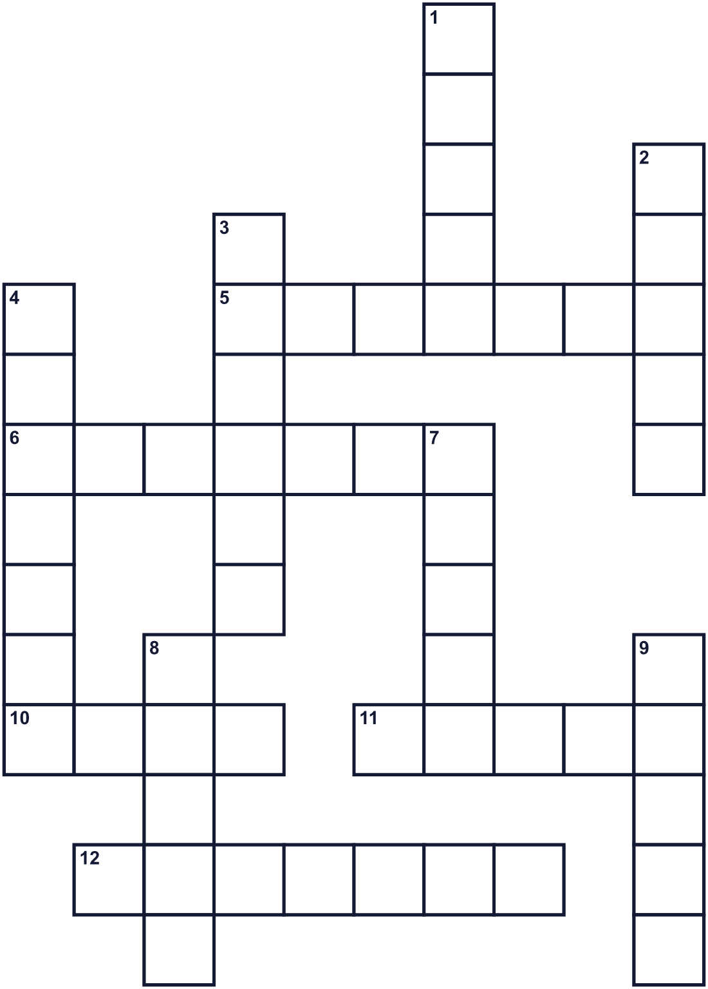
Across →
5. The tenth month of the year. (7)
6. A very big place for sports with many seats. (7)
10. A group of players. Red or white at an undokai. (4)
11. The fire that burns during the Olympic Games. (5)
12. A day with no school or work for most people. (7)
Down ↓
1. The capital city of Japan. It hosted the Games in 1964. (5)
2. A runner carries this fire stick into the stadium. (5)
3. The holiday is on this day of the week. (6)
4. To care about other people and treat them well. (7)
7. Winners at the Olympics get this round prize. (5)
8. The short stick that runners pass in a team race. (5)
9. A race for a team. Runners pass a stick. (5)

🏃 Sports Day Worksheet
Word Search
かくれた単語をさがそう（→ ↓ ↘ ↗）
Class ______ No. ____ Name ______________________________
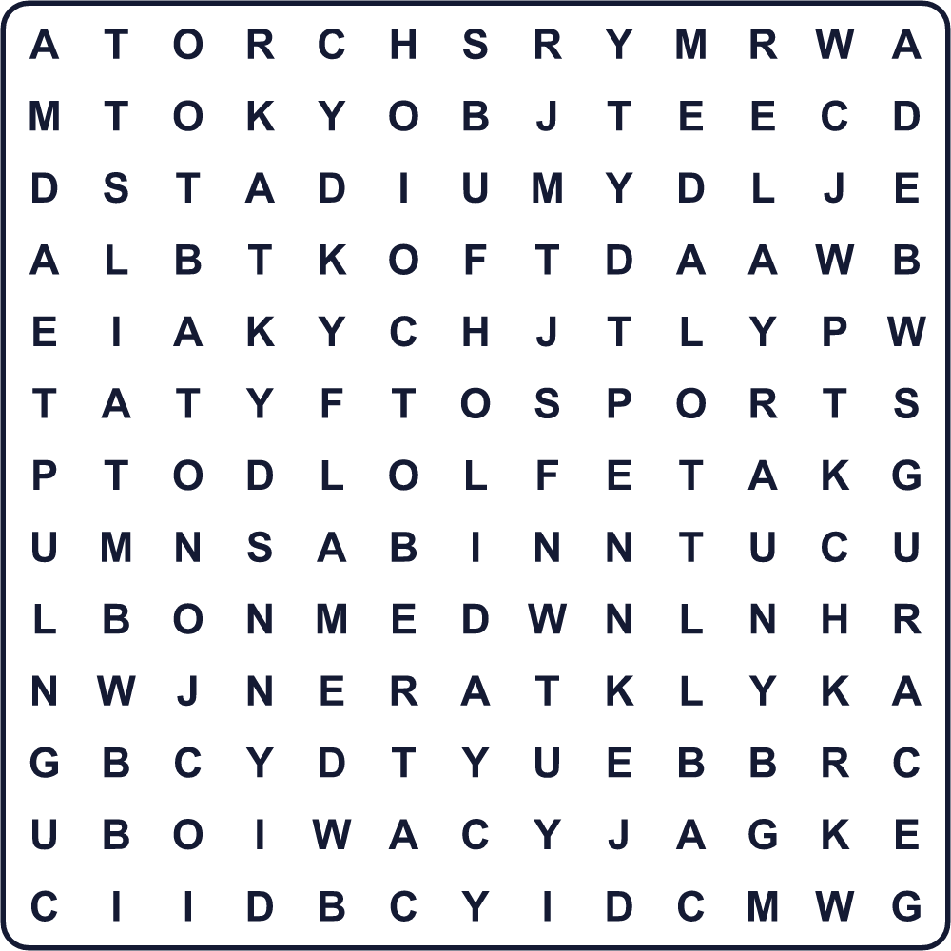
BATON FLAME HOLIDAY MEDAL MONDAY OCTOBER RACE RELAY SPORTS STADIUM TEAM TOKYO TORCH
Secret Code 暗号を解こう
♣=A ▲=D ✿=E ☎=F ⚓=H ☾=I ◆=L ■=N ★=P ✈=R ♥=U ✂=V ♦=Y
⚓ ♣ ✂ ✿ ☎ ♥ ■ ♣ ■ ▲ ★ ◆ ♣ ♦ ☎ ♣ ☾ ✈
______________________________________________________________

🏃 Sports Day Worksheet
Maze & Sentences
Class ______ No. ____ Name ______________________________
Help Haruto carry the torch to the stadium! 陽翔がトーチを競技場まで運べるように道を見つけよう！
正しい道の文字を集めると、ひみつの言葉になるよ。 START 🏃 → GOAL 🏟️
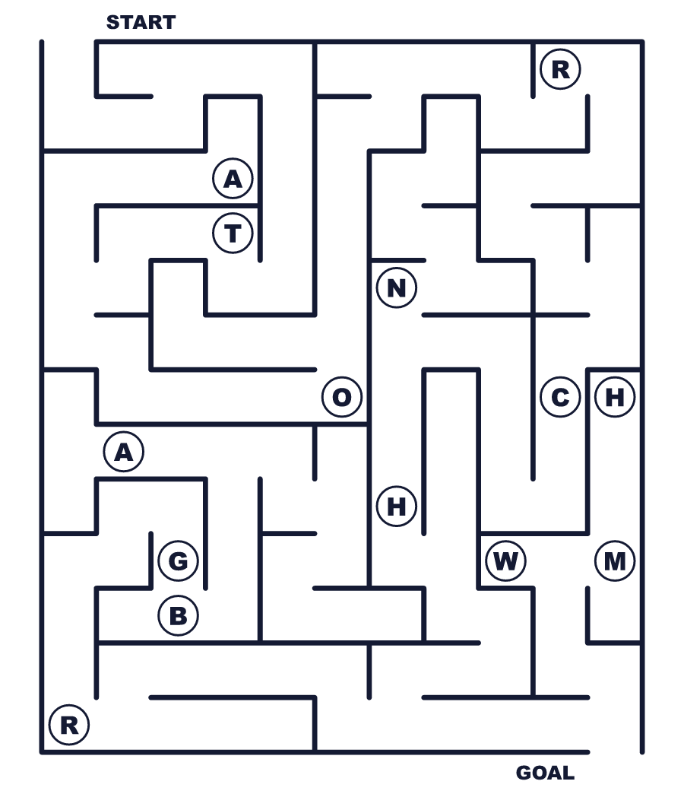
Secret word: ＿ ＿ ＿ ＿ ＿
Put the words in order. 並べかえよう。
1. Japan / Day / in / is / national / Sports / holiday / a . (スポーツの日は日本の祝日です。)
______________________________________________________________
2. It / Tokyo / the / Olympics / started / with . (それは東京オリンピックがきっかけで始まりました。)
______________________________________________________________
3. sports / schools / Many / have / October / a / in / festival . (10月には多くの学校で運動会があります。)
______________________________________________________________
4. relays / run / of / tug / war / We / and / play . (私たちはリレーを走り、綱引きをします。)
______________________________________________________________
5. sports / each / enjoy / respect / other / and / Let's . (スポーツを楽しんで、おたがいを大切にしよう。)
______________________________________________________________

🏃 Sports Day Worksheet
Class Activity & Writing
Class ______ No. ____ Name ______________________________
Find Someone Who… クラスで聞いて回ろう！
Find someone who … | Name
… has run in a relay リレーを走ったことがある
… likes tug of war 綱引きが好き
… can swim 50 meters 50メートル泳げる
… knows the year of the first Tokyo Olympics 最初の東京オリンピックの年を知っている
… has watched a game in a stadium 競技場で試合を見たことがある
… likes to ride a bike 自転車に乗るのが好き
… can name three Olympic sports in English オリンピックの競技を英語で3つ言える
… has been on the red team at an undokai 運動会で紅組だったことがある
Let's Write! 英語で書いてみよう。
On Sports Day, I want to try ______ because ______.
スポーツの日に、私は＿＿をやってみたいです。なぜなら＿＿だからです。
______________________________________________________________
______________________________________________________________
My best memory of an undokai is ______.
運動会のいちばんの思い出は＿＿です。
______________________________________________________________
______________________________________________________________
To respect other players, I will ______.
ほかの選手を尊重するために、私は＿＿します。
______________________________________________________________
______________________________________________________________

🏃 Sports Day Worksheet
Trace & Color
なぞって書こう。絵に色をぬろう。
Class ______ No. ____ Name ______________________________
🏃 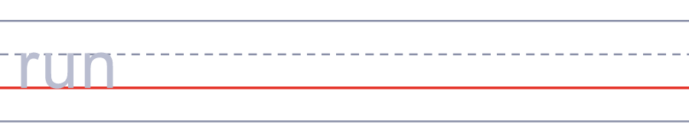

🥇 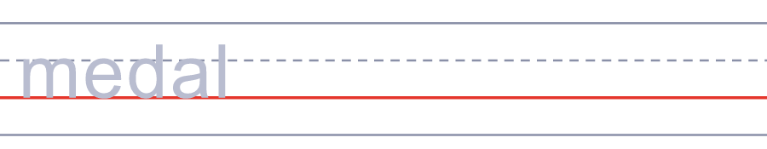
🔥 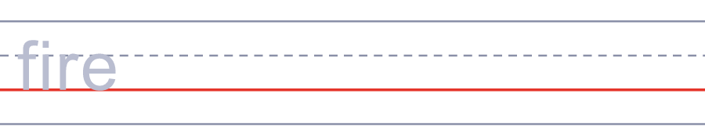
⚽ 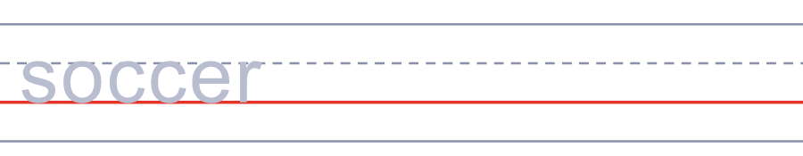
🏊 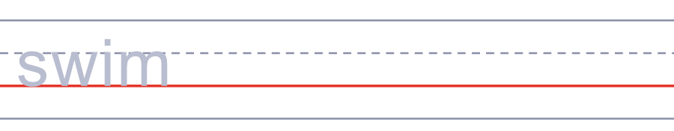
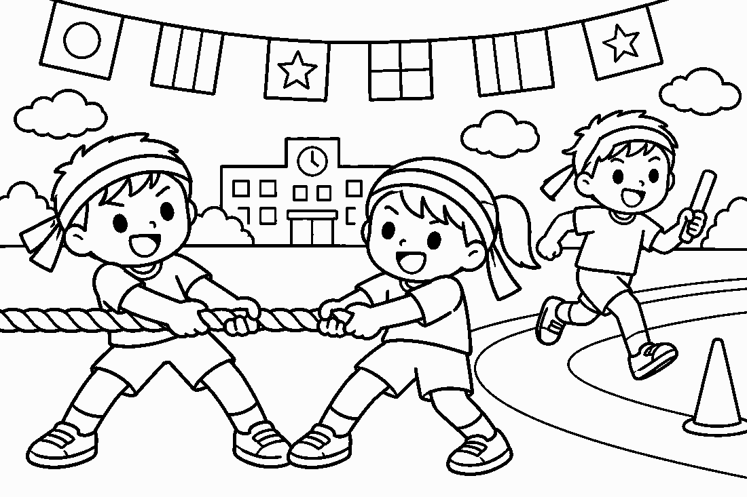

🏃 Sports Day Worksheet
Answer Key 解答
Reading Check: 1.B 2.C 3.B 4.A 5.D 6.B 7.A 8.C
True or False: 1.T 2.F 3.T 4.T 5.F 6.F
Match: 🏃=run 🥇=medal 🔥=fire ⚽=soccer 🏊=swim 🚲=bike 🍱=lunch box 🎌=flags
Unscramble: 1.TORCH 2.RELAY 3.MEDAL 4.STADIUM 5.RESPECT 6.HOLIDAY
Fill in the blanks: (1)Sunday (2)undokai (3)red (4)watched (5)tug (6)relay (7)baton (8)fast (9)proud (10)day
Sentence order: 1. Sports Day is a national holiday in Japan. 2. It started with the Tokyo Olympics. 3. Many schools have a sports festival in October. 4. We run relays and play tug of war. 5. Let's enjoy sports and respect each other.
Secret Code: HAVE FUN AND PLAY FAIR
Maze: TORCH
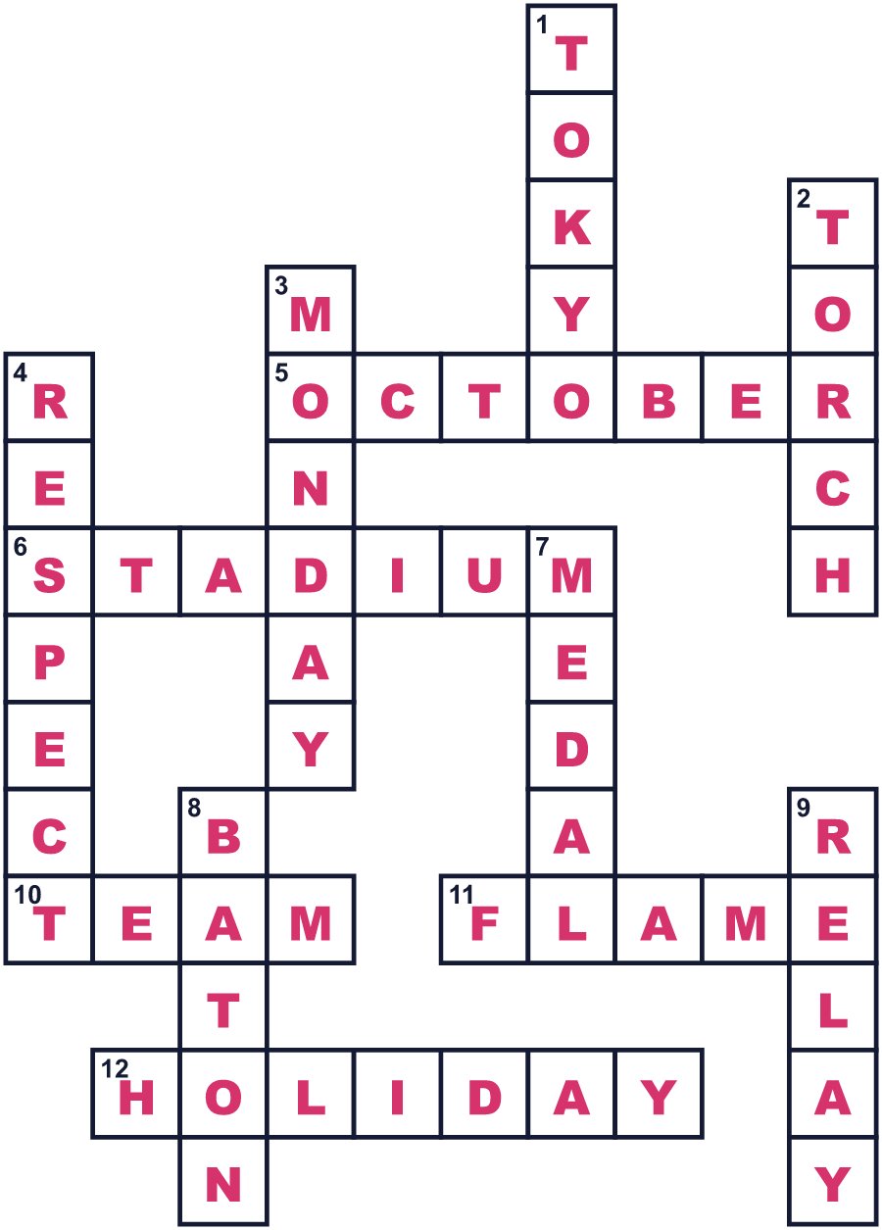
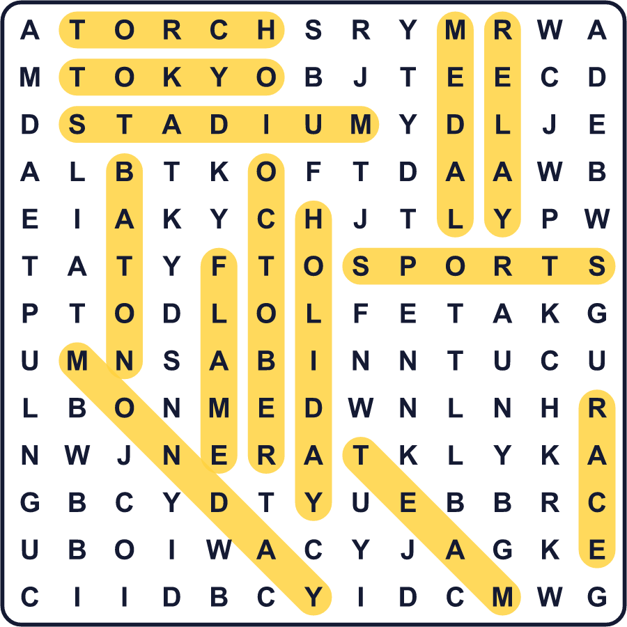
全訳
1 1964年10月10日、ひとりの若いランナーが、東京の大きな競技場にトーチを運び入れました。彼の名前は坂井義則さん。大学生でした。彼は1945年8月6日、原爆が落とされたその日に広島で生まれました。彼が聖火をともすと、競技場の観客から大きな歓声が上がりました。それはアジアで初めてのオリンピックでした。
2 2年後、日本はその日を記念して、10月10日を国民の祝日にしました。その名前は「体育の日」、英語では Health and Sports Day でした。「体育」は physical education、つまり学校の体育の授業と同じ言葉です。2000年、この祝日は10月の第2月曜日に移りました。そのおかげで、今ではたいていの人が3連休を楽しめます。
3 2020年、この祝日は「スポーツの日」という新しい名前になりました。「スポーツ」という言葉のほうが「体育」より楽しくて自由に聞こえる、と感じる人が多かったのです。今の法律では、この日はスポーツを楽しみ、ほかの人を大切にする日だとされています。その年、東京ではもう一度オリンピックが開かれる予定だったので、祝日は7月24日に移されました。ところが大会は1年延期になり、その年の10月には祝日が1日もありませんでした！
4 人々はこの日をどう過ごすのでしょう。10月には、多くの学校や町で運動会（スポーツのお祭り）が開かれます。子どもたちはリレーを走り、綱引きをし、高いかごに小さな玉を投げ入れます。家族はレジャーシートに座って、大きなお弁当をいっしょに食べます。体育館やプールを無料で開放する市もあります。
5 スポーツの日は、何か新しいことを試すのにいい日です。速くなくても、強くなくてもかまいません。散歩をしても、自転車に乗っても、友だちとキャッチボールをしてもいいのです。法律にあるシンプルなルールを覚えておきましょう。楽しむこと、そしてほかの人にやさしくすること。

