🎓 Graduation & Entrance Ceremonies Worksheet
Why April? The Secret of the Japanese School Year
Read the story. 英文を読もう。
Class ______ No. ____ Name ______________________________

🔊 音声を聞こう（スマホで読みとってね）
1 In Japan, spring is the season of new starts. Students graduate in March and start a new school year in early April. At the entrance ceremony, families take photos under the cherry blossoms. Many people think school starts in April because of the flowers. But the real reason is about money.
2 In the 1870s, Japanese universities started in September, like schools in Europe. Then, in 1886, the government changed its money year. The new year for money started in April. Farmers paid taxes after they sold their rice in the fall, so the government needed time. Schools used government money, so they started in April, too. Some people say the army was another reason. Young men had to sign up for the army in April. Schools did not want to lose their best students.
3 Slowly, more and more schools moved to April. Elementary schools followed by 1900. The big universities were the last to change, in 1921. Today, schools, companies, and city offices all start their year in April.
4 Most countries start school in September, but not all. South Korea starts in March, and India often starts in April, like Japan. In 2020, Japan talked about moving to September. But many people said it was too difficult to change so quickly. So for now, Japanese students still say goodbye in March and hello in April.
Words 単語
graduate（卒業する） / entrance ceremony（入学式） / government（政府） / tax（税金） / fiscal year（会計年度） / follow（あとに続く、従う） / diploma（卒業証書） / romantic（ロマンチックな、夢のある）

🎓 Graduation & Entrance Ceremonies Worksheet
Reading Check
Choose the best answer. 正しいものを選ぼう。
Class ______ No. ____ Name ______________________________
1. What is the passage mainly about?
(A) How to take good photos under cherry trees (B) Why the Japanese school year starts in April (C) Why French students wear uniforms (D) How rice is grown in Japan
2. When did Japanese universities start their year in the 1870s?
(A) in January (B) in March (C) in April (D) in September
3. Why did the government need time before April?
(A) Farmers paid taxes after selling rice in the fall. (B) Teachers were on vacation in winter. (C) Cherry trees bloomed in April. (D) The emperor's birthday was in March.
4. In paragraph 3, the big universities were the last to change. What does this mean?
(A) They never changed to April. (B) They changed before elementary schools. (C) They changed after all the other schools. (D) They changed back to September.
5. Why does Lucas say it's not very romantic?
(A) Because the cherry trees have no flowers. (B) Because the reason for April is about money. (C) Because he does not like photos. (D) Because school in France is better.
True or False? T か F に○
1. The Japanese school year starts in April. T / F
2. Japanese universities always started in April. T / F
3. Japan's money year started in April from 1886. T / F
4. Every country in the world starts school in September. T / F

🎓 Graduation & Entrance Ceremonies Worksheet
Word Work
単語のれんしゅう
Class ______ No. ____ Name ______________________________
① Match the pictures and the words. 絵と単語を線でむすぼう。
🎓 | ● | ● | backpack
🌸 | ● | ● | camera
🏫 | ● | ● | graduation
📜 | ● | ● | school
🎒 | ● | ● | diploma
📸 | ● | ● | cherry blossom
③ Fill in the blanks. 語群から選んで入れよう。
[ photo / year / July / April / gate / entrance / blossoms / September / snow / England ]
Emma is from (1) __________ . In her country, school starts in (2) __________ . But in Japan, it starts in (3) __________ . On the first day, there is an (4) __________ ceremony. The cherry (5) __________ are pink and pretty. Emma takes a (6) __________ with her new friends at the school (7) __________ . She is happy to start a new (8) __________ .

🎓 Graduation & Entrance Ceremonies Worksheet
Crossword Puzzle
ヒントを読んでクロスワードを完成させよう。
Class ______ No. ____ Name ______________________________
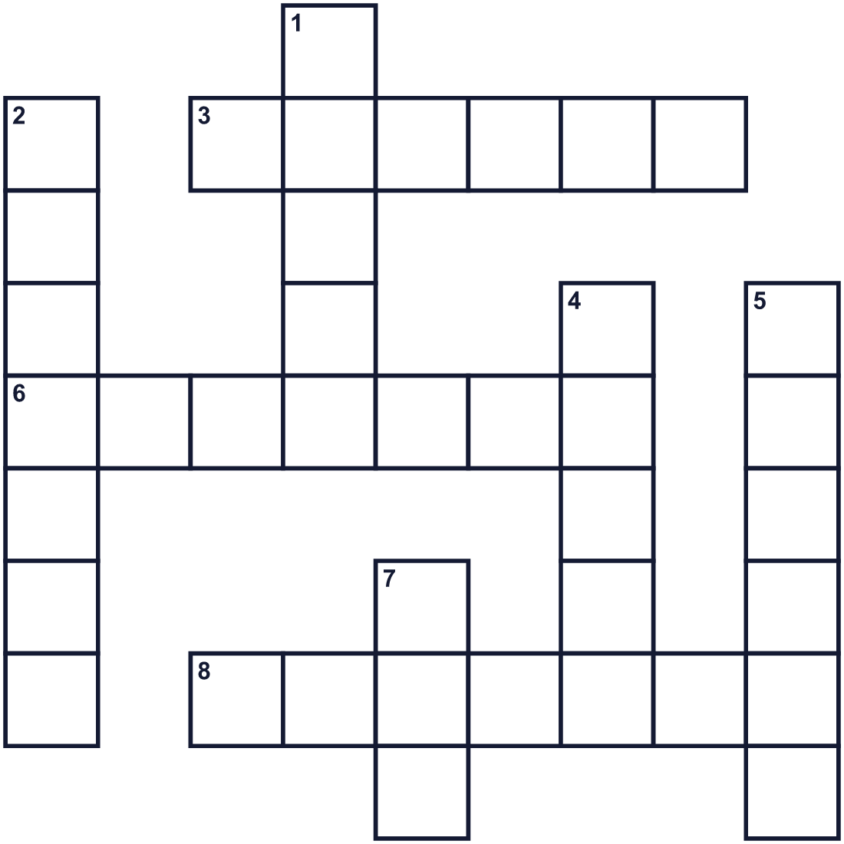
Across →
3. The season after winter. (6)
6. You get this paper when you finish school. (7)
8. A person who helps you learn at school. (7)
Down ↓
1. The fourth month of the year. (5)
2. A person who studies at a school. (7)
4. The third month of the year. (5)
5. A tree with pink flowers in spring. (6)
7. Money people must pay to the government. (3)

🎓 Graduation & Entrance Ceremonies Worksheet
Word Search
かくれた単語をさがそう（→ ↓ ↘ ↗）
Class ______ No. ____ Name ______________________________

APRIL CHERRY DIPLOMA GATE MARCH PHOTO SCHOOL SPRING STUDENT TEACHER

🎓 Graduation & Entrance Ceremonies Worksheet
Maze & Sentences
Class ______ No. ____ Name ______________________________
Help Yuki get to her new classroom! ユキが新しい教室に着けるように助けよう！
正しい道の文字を集めると、ひみつの言葉になるよ。 START 👧 → GOAL 🏫
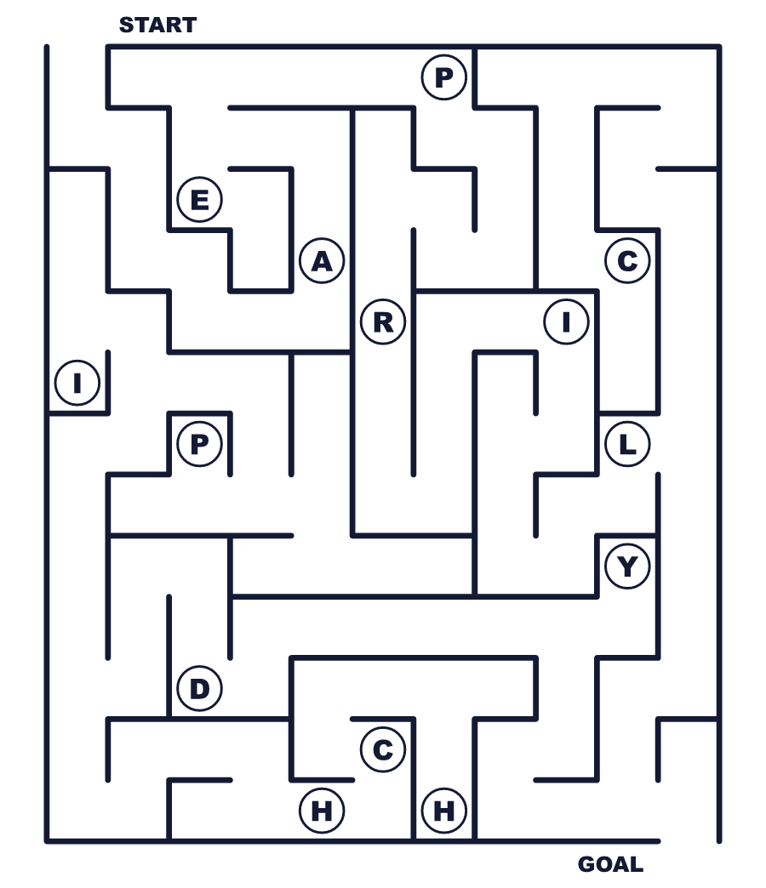
Secret word: ＿ ＿ ＿ ＿ ＿

🎓 Graduation & Entrance Ceremonies Worksheet
Class Activity & Writing
Class ______ No. ____ Name ______________________________
Let's Write! 英語で書いてみよう。
I think the school year should start in ______ because ______.
学年は______に始まるべきだと思います。なぜなら______だからです。
______________________________________________________________
______________________________________________________________
At my graduation, I want to say "thank you" to ______ because ______.
卒業式では______に「ありがとう」と言いたいです。なぜなら______だからです。
______________________________________________________________
______________________________________________________________

🎓 Graduation & Entrance Ceremonies Worksheet
Trace & Color
なぞって書こう。絵に色をぬろう。
Class ______ No. ____ Name ______________________________
🎓 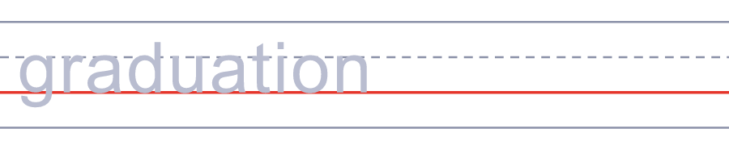

🌸 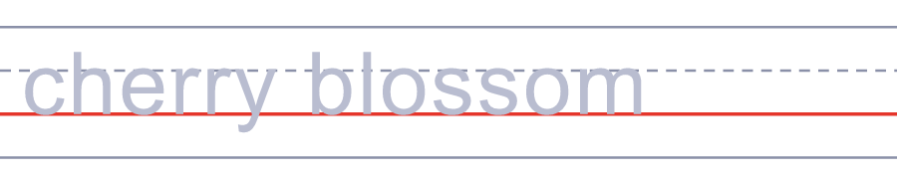
🏫 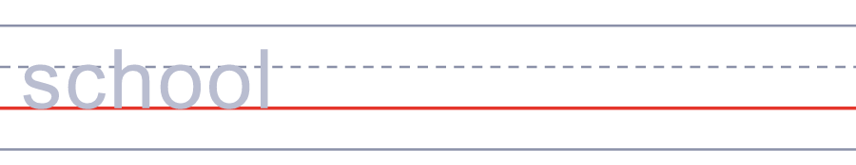
📜 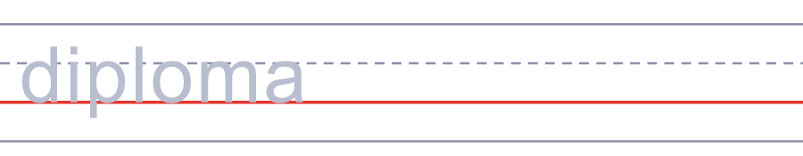
🎒 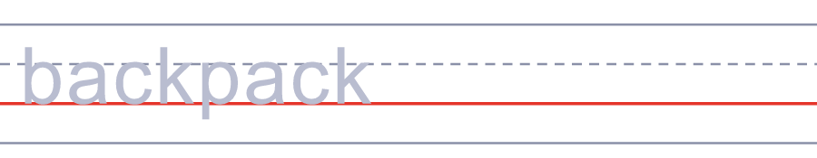

🎓 Graduation & Entrance Ceremonies Worksheet
Answer Key 解答
Reading Check: 1.B 2.D 3.A 4.C 5.B
True or False: 1.T 2.F 3.T 4.F
Match: 🎓=graduation 🌸=cherry blossom 🏫=school 📜=diploma 🎒=backpack 📸=camera
Fill in the blanks: (1)England (2)September (3)April (4)entrance (5)blossoms (6)photo (7)gate (8)year
Maze: APRIL
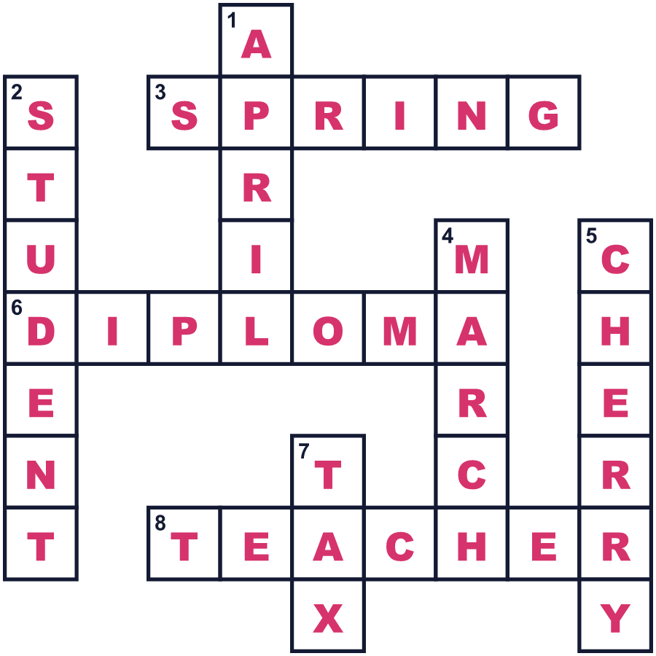
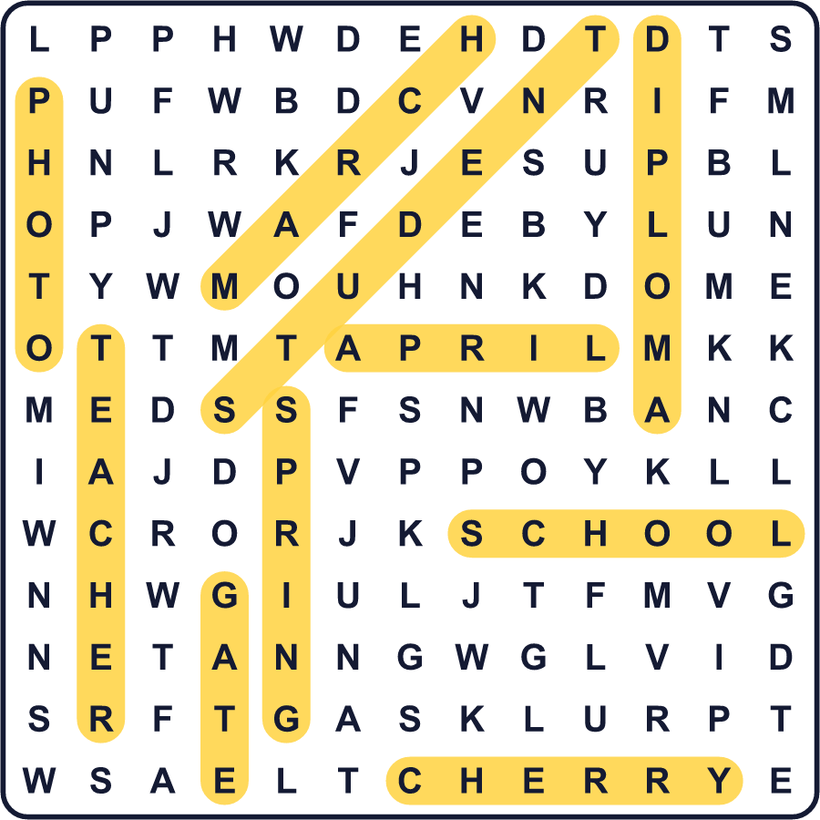
全訳
1 日本では、春は新しいスタートの季節です。生徒は3月に卒業し、4月のはじめに新しい学年を始めます。入学式では、家族が桜の下で写真を撮ります。学校が4月に始まるのは花のためだと思っている人がたくさんいます。でも、本当の理由はお金に関係しています。
2 1870年代、日本の大学はヨーロッパの学校と同じように9月に始まっていました。その後1886年、政府はお金の1年（会計年度）を変えました。新しい会計年度は4月に始まることになりました。農家は秋に米を売ってから税を納めたので、政府には時間が必要だったのです。学校は国のお金を使っていたので、学校も4月に始まるようにしました。軍隊がもう一つの理由だったと言う人もいます。若い男性は4月に軍隊への届け出をしなければなりませんでした。学校は優秀な生徒を失いたくなかったのです。
3 少しずつ、4月始まりの学校が増えていきました。小学校も1900年までに続きました。大きな大学は最後に、1921年に変わりました。今では学校も会社も市役所も、みんな4月に1年を始めます。
4 多くの国は9月に学校が始まりますが、すべてではありません。韓国は3月に始まり、インドは日本と同じように4月に始まることが多いです。2020年、日本は9月への移行について話し合いました。でも多くの人が、そんなに急に変えるのはむずかしすぎると言いました。だから今のところ、日本の生徒は今も3月にさよならを言い、4月にこんにちはを言うのです。

