💦 Songkran Worksheet
A Splash for the New Year
Read the story. 英文を読もう。
Class ______ No. ____ Name ______________________________
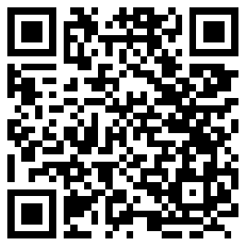
🔊 音声を聞こう（スマホで読みとってね）
1 In mid-April, Bangkok is at its hottest. The average high is almost 36 degrees. Then, for three days, the whole city turns into a giant water fight. People fill the streets with buckets, hoses, and colorful water guns. Even strangers laugh and splash each other. This is Songkran, the traditional Thai New Year.
2 The name Songkran comes from an old Indian word. It means moving or passing. At this time of year, the sun moves into a new star sign. For a long time, this was New Year's Day in Thailand. Today, Thailand uses January 1, but Songkran is still its biggest holiday. It runs from April 13 to 15.
3 But the water fights are only one part of the story. In the old days, people poured water very gently. Young people poured sweet-smelling water over the hands of their parents and grandparents. Then the elders gave them a blessing for the new year. Families also visit temples and wash Buddha statues with flower water.
4 There is also a strange old story behind the festival. A god lost a riddle contest to a clever boy, and he lost his head! The head was very dangerous. If it touched the ground, the world would catch fire. So his seven daughters take turns and carry it every year.
5 Thailand is not the only country with a water festival. Myanmar, Laos, and Cambodia also welcome the new year in mid-April. In Japan, people pour sweet tea over a small Buddha statue on April 8. In many places, water means a fresh start. So if you get wet in Bangkok, just smile. Someone is wishing you good luck for the new year!
Words 単語
splash（（水を）はねかける、ばしゃっとかける） / bucket（バケツ） / stranger（知らない人） / traditional（伝統的な） / gently（やさしく、そっと） / pour（注ぐ） / elder（年長者、お年寄り） / blessing（祝福、ありがたいお祈り） / temple（寺、寺院） / statue（像） / riddle（なぞなぞ） / take turns（交代でする）

💦 Songkran Worksheet
Reading Check
Choose the best answer. 正しいものを選ぼう。
Class ______ No. ____ Name ______________________________
1. What is the reading mainly about?
(A) The hot weather in Japan (B) How to make a water gun (C) Songkran, the Thai New Year festival (D) A famous temple in Bangkok
2. When is Songkran?
(A) From April 13 to 15 (B) On January 1 (C) On April 8 (D) From May 1 to 3
3. What does the word Songkran mean?
(A) Cold water (B) Moving or passing (C) Happy new year (D) A large bucket
4. In the old days, what did young people do?
(A) They had water fights with strangers. (B) They built water guns at home. (C) They carried the god's head. (D) They poured water over their elders' hands.
5. In paragraph 3, the word "gently" is closest in meaning to ...
(A) quickly and loudly (B) softly and carefully (C) angrily and strongly (D) late and slowly
6. Which sentence is true about the reading?
(A) Only Thailand has a water festival in April. (B) Thailand's official New Year is still in April. (C) Families visit temples during Songkran. (D) The god won the riddle contest.
7. Why are people not angry when strangers splash them?
(A) The water means good wishes for the new year. (B) The water is always very warm. (C) They cannot see the strangers. (D) The police tell them to smile.
8. In the dialogue, what did Ploy do in the morning?
(A) She bought a water gun at the market. (B) She poured flower water over her grandmother's hands. (C) She splashed water on the monks. (D) She drank sweet tea with Haruto.
True or False? T か F に○
1. Songkran is the traditional Thai New Year. T / F
2. Songkran is in December. T / F
3. Young people pour water over the hands of their elders. T / F
4. It is good manners to splash water on monks. T / F
5. Myanmar and Laos also have water festivals in April. T / F
6. Thailand still uses Songkran as its official New Year's Day. T / F

💦 Songkran Worksheet
Word Work
単語のれんしゅう
Class ______ No. ____ Name ______________________________
① Match the pictures and the words. 絵と単語を線でむすぼう。
💦 | ● | ● | bucket
🔫 | ● | ● | splash
🪣 | ● | ● | mango
🛕 | ● | ● | sun
☀️ | ● | ● | flower
🥭 | ● | ● | water gun
🌼 | ● | ● | grandmother
👵 | ● | ● | temple
② Unscramble the words. 並べかえて単語にしよう。
1. W R E T A (水) → ____________________
2. P A H L S S (水をかける) → ____________________
3. T P M E L E (お寺) → ____________________
4. B U C E T K (バケツ) → ____________________
5. N L S S G E B I (祝福) → ____________________
6. E E R D L (年長者) → ____________________
③ Fill in the blanks. 語群から選んで入れよう。
[ temple / coat / Songkran / wet / Year / gun / snow / stranger / hands / winter / water / hot / blessing ]
It was the first day of (1) __________ . The sun was very (2) __________ . Mali woke up early and went to the (3) __________ with her family. She poured flower (4) __________ over a Buddha statue. Then she poured water over her grandfather's (5) __________ . He smiled and gave her a (6) __________ . In the afternoon, Mali took her new water (7) __________ to the street. A (8) __________ splashed her from the back of a truck. Mali was (9) __________ from head to toe, but she laughed. "Happy New (10) __________ !" she shouted.

💦 Songkran Worksheet
Crossword Puzzle
ヒントを読んでクロスワードを完成させよう。
Class ______ No. ____ Name ______________________________
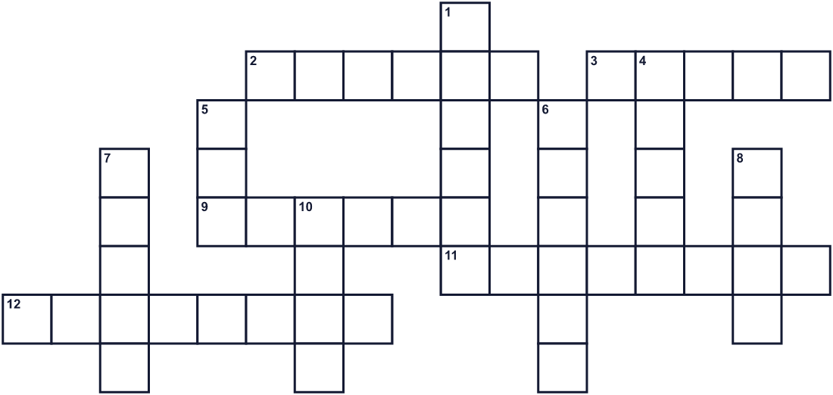
Across →
2. A figure of a person made of stone or metal. (6)
3. You drink it. People throw it during the festival. (5)
9. A building where Buddhists pray. (6)
11. A country in Southeast Asia. Its capital is Bangkok. (8)
12. A kind wish from an older person or a monk. (8)
Down ↓
1. You carry water in this. It has a handle. (6)
4. The fourth month of the year. (5)
5. The opposite of dry. (3)
6. To throw water on someone. (6)
7. An older person in your family or town. (5)
8. People build small towers with this at the temple. (4)
10. A Buddhist man who lives at a temple. Don't throw water at him. (4)

💦 Songkran Worksheet
Word Search
かくれた単語をさがそう（→ ↓ ↘ ↗）
Class ______ No. ____ Name ______________________________
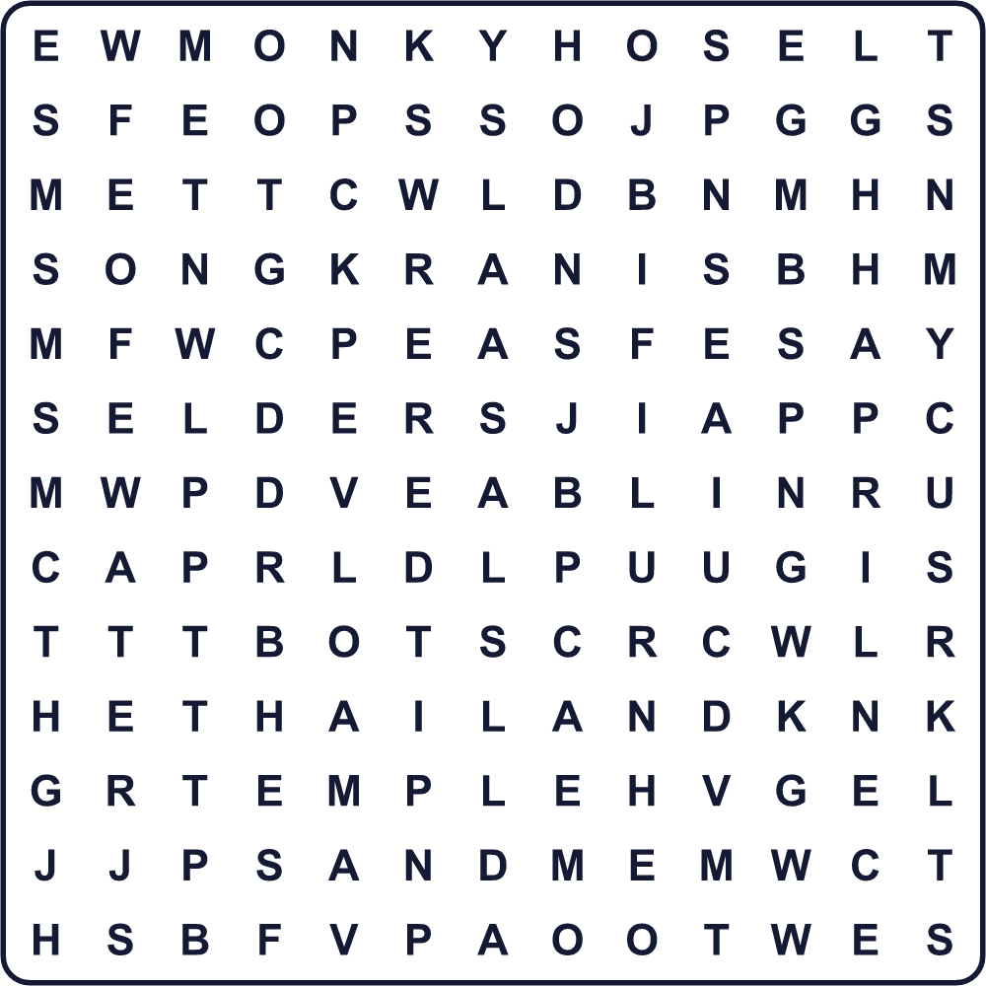
APRIL BLESSING BUCKET ELDER HOSE MONK SAND SONGKRAN SPLASH TEMPLE THAILAND WATER WET
Secret Code 暗号を解こう
⚑=A ✚=G ♣=H ●=K ✉=N ♪=O ◎=P ☎=R ♥=S ☃=Y
♣ ⚑ ◎ ◎ ☃ ♥ ♪ ✉ ✚ ● ☎ ⚑ ✉
______________________________________________________________

💦 Songkran Worksheet
Maze & Sentences
Class ______ No. ____ Name ______________________________
Help Ploy get to the temple! プロイをお寺まで連れていこう！
正しい道の文字を集めると、ひみつの言葉になるよ。 START 👧 → GOAL 🛕
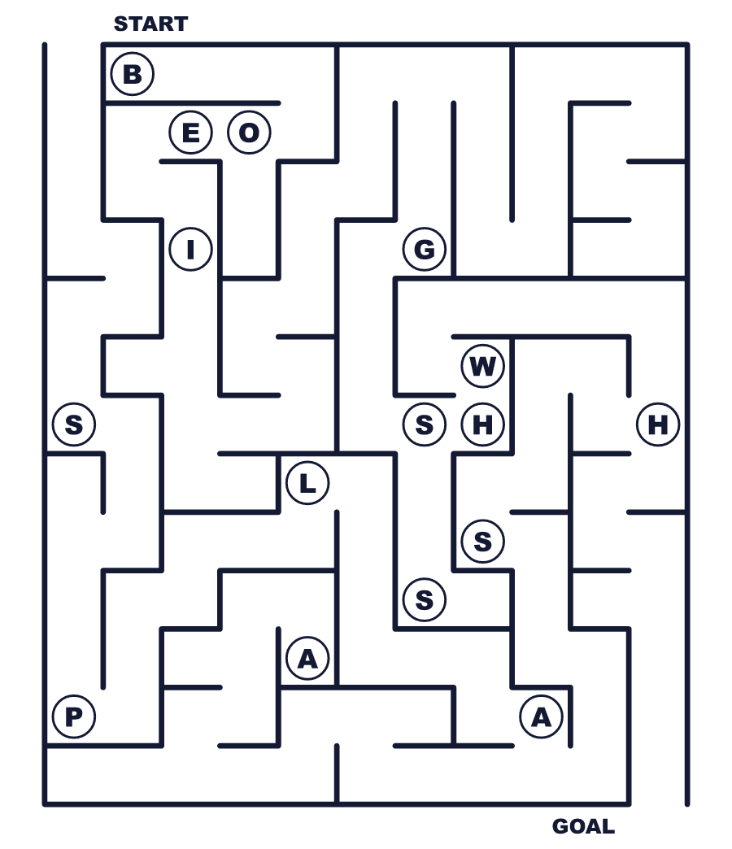
Secret word: ＿ ＿ ＿ ＿ ＿ ＿
Put the words in order. 並べかえよう。
1. Songkran / Year / Thai / New / is / the . (ソンクラーンはタイのお正月です。)
______________________________________________________________
2. street / splash / on / People / the / water . (人々は通りで水をかけ合います。)
______________________________________________________________
3. grandmother's / She / hands / her / poured / over / water . (彼女はおばあさんの手に水を注ぎました。)
______________________________________________________________
4. on / water / monks / do / not / Please / splash . (お坊さんに水をかけないでください。)
______________________________________________________________
5. festival / The / from / 13 / 15 / April / is / to . (祭りは4月13日から15日までです。)
______________________________________________________________

💦 Songkran Worksheet
Class Activity & Writing
Class ______ No. ____ Name ______________________________
Find Someone Who… クラスで聞いて回ろう！
Find someone who … | Name
… has been to Thailand タイに行ったことがある
… likes Thai food タイ料理が好き
… has played with a water gun 水鉄砲で遊んだことがある
… knows how to say hello in Thai タイ語で「こんにちは」を言える
… can name three countries in Southeast Asia 東南アジアの国を3つ言える
… has poured sweet tea on a Buddha statue 仏像に甘茶をかけたことがある
… likes hot weather 暑い天気が好き
… can say Happy New Year in two languages 2つの言語で「新年おめでとう」を言える
Let's Write! 英語で書いてみよう。
If I went to Songkran, I would ______ because ______.
もしソンクラーンに行ったら、______したい。なぜなら______だからです。
______________________________________________________________
______________________________________________________________
In my family, we show respect to our elders by ______.
私の家族では、______することで年長者に敬意を表します。
______________________________________________________________
______________________________________________________________
For me, a fresh start means ______.
私にとって、新しい出発とは______ということです。
______________________________________________________________
______________________________________________________________

💦 Songkran Worksheet
Trace & Color
なぞって書こう。絵に色をぬろう。
Class ______ No. ____ Name ______________________________
💦 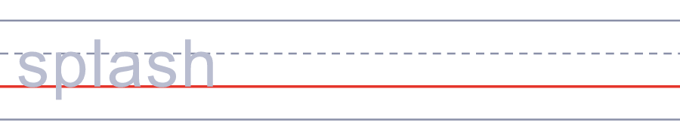

🔫 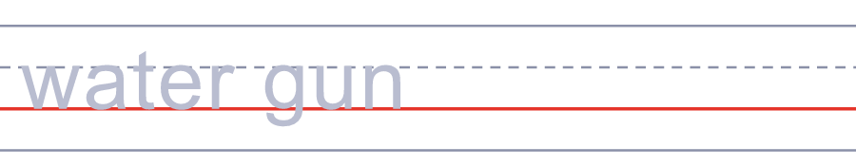
🪣 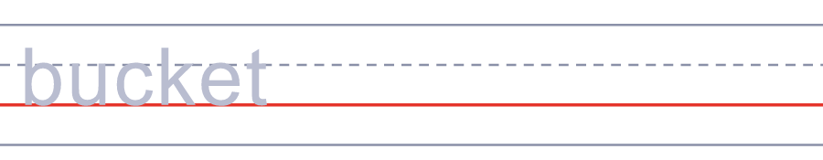
🛕 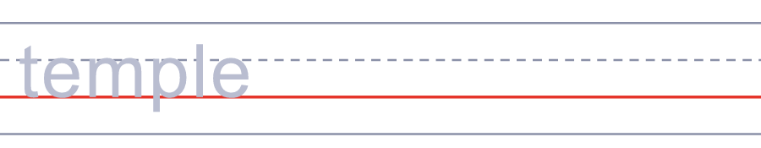
☀️ 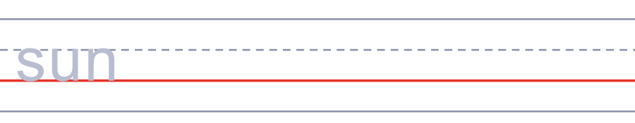
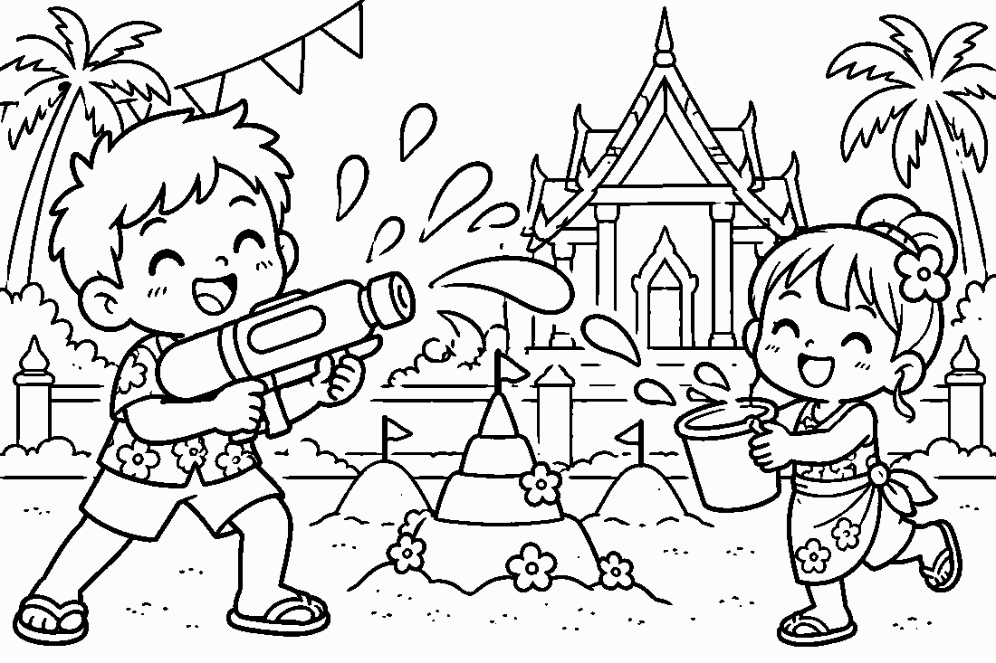

💦 Songkran Worksheet
Answer Key 解答
Reading Check: 1.C 2.A 3.B 4.D 5.B 6.C 7.A 8.B
True or False: 1.T 2.F 3.T 4.F 5.T 6.F
Match: 💦=splash 🔫=water gun 🪣=bucket 🛕=temple ☀️=sun 🥭=mango 🌼=flower 👵=grandmother
Unscramble: 1.WATER 2.SPLASH 3.TEMPLE 4.BUCKET 5.BLESSING 6.ELDER
Fill in the blanks: (1)Songkran (2)hot (3)temple (4)water (5)hands (6)blessing (7)gun (8)stranger (9)wet (10)Year
Sentence order: 1. Songkran is the Thai New Year. 2. People splash water on the street. 3. She poured water over her grandmother's hands. 4. Please do not splash water on monks. 5. The festival is from April 13 to 15.
Secret Code: HAPPY SONGKRAN
Maze: SPLASH
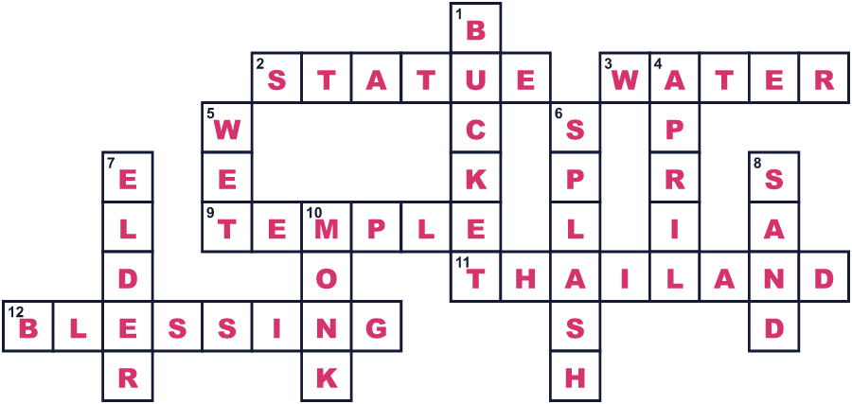
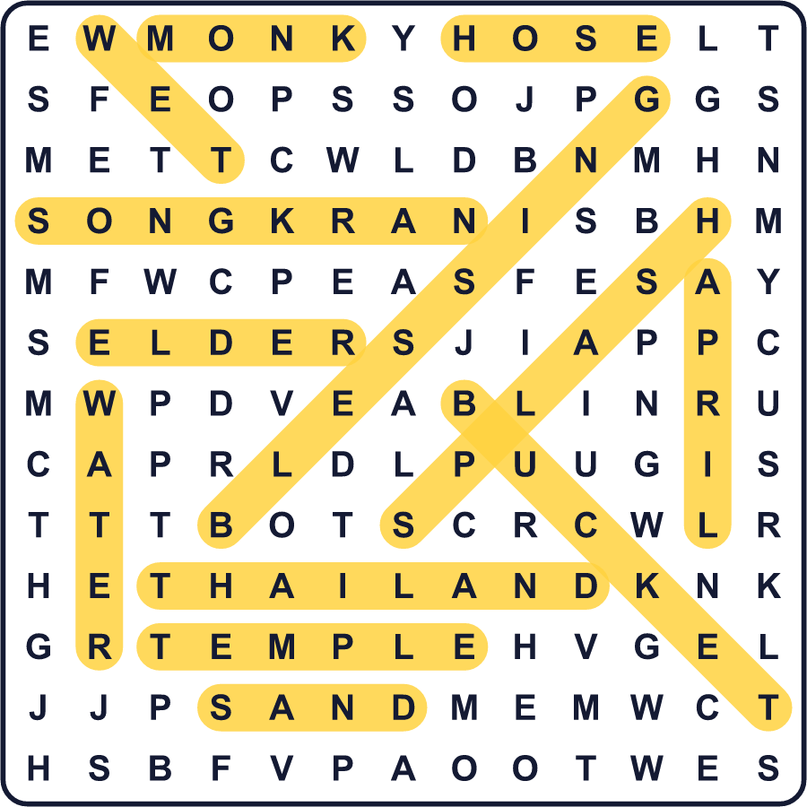
全訳
1 4月のなかば、バンコクは1年でいちばん暑くなります。平均の最高気温は36度近くです。そして3日間、町全体が巨大な水かけ合戦の場に変わります。人々はバケツやホース、色とりどりの水鉄砲を持って通りを埋めつくします。知らない人どうしでさえ、笑いながら水をかけ合います。これがタイの伝統的なお正月、ソンクラーンです。
2 ソンクラーンという名前は、古いインドの言葉から来ています。「移ること」「通り過ぎること」という意味です。1年のこの時期、太陽は新しい星座に移ります。長いあいだ、これがタイの元日でした。今のタイは1月1日を元日にしていますが、ソンクラーンは今でもいちばん大きな休みです。祭りは4月13日から15日まで続きます。
3 でも、水かけ合戦はこの話のほんの一部です。昔は、人々はとてもやさしく水を注いでいました。若い人たちは、両親や祖父母の手に、よい香りの水を注ぎました。すると年長者は、新しい年のための祝福を返してくれました。家族はお寺にも行き、花の香りの水で仏像を清めます。
4 この祭りには、ふしぎな昔話もあります。ある神さまがかしこい少年になぞなぞ勝負で負け、首を失ってしまったのです！その首はとても危険でした。もし地面にふれたら、世界が燃えてしまうのです。そこで神さまの7人の娘が、毎年交代でその首を運んでいます。
5 水かけ祭りがあるのはタイだけではありません。ミャンマー、ラオス、カンボジアも、4月なかばに新しい年を迎えます。日本では4月8日に、小さな仏像に甘茶をかけます。多くの場所で、水は新しい出発を意味するのです。だから、もしバンコクでぬれても、ただほほえんでください。誰かがあなたの新しい年の幸運を祈ってくれているのですから！

