🍁 Silver Week Worksheet
Rarer Than Gold
Read the story. 英文を読もう。
Class ______ No. ____ Name ______________________________

🔊 音声を聞こう（スマホで読みとってね）
1 In September 2026, many people in Japan had five days off in a row, from Saturday to Wednesday. Trains and airports were crowded. Some families went to hot springs, and others visited their grandparents. People call this long break Silver Week.
2 The name is a play on Golden Week, the famous spring holidays. In the 1950s, a movie company made the name Golden Week to sell more movie tickets. It also tried the name Silver Week for some holidays in autumn. But at that time, almost nobody used it. For more than 50 years, the name was almost forgotten.
3 So why did the name come back? There are two national holidays in September: Respect for the Aged Day and Autumn Equinox Day. A Japanese rule says that a day between two national holidays also becomes a holiday. In 2009, there was only one day between the two holidays. With the weekend, people got five days off for the first time. In 2008, a survey asked people to name this new holiday, and Silver Week came first.
4 This does not happen every year, because the dates of the holidays move a little. The date of Autumn Equinox Day is decided in February of the year before. After 2026, the next five-day Silver Week will probably come in 2032. So when it comes, people plan their trips months early. Silver is not as shiny as gold, but this silver is much harder to find.
Words 単語
in a row（続けて、連続で） / crowded（混雑した） / break（休み、休けい） / play on（〜をもじったもの、しゃれ） / equinox（春分・秋分） / national holiday（国民の祝日） / probably（たぶん、おそらく） / shiny（ぴかぴかの、輝く）

🍁 Silver Week Worksheet
Reading Check
Choose the best answer. 正しいものを選ぼう。
Class ______ No. ____ Name ______________________________
1. What is the reading mainly about?
(A) A famous movie from the 1950s (B) How to make silver jewelry (C) Silver Week, a long holiday in September (D) Golden Week in China
2. Who first made the name Golden Week?
(A) A movie company (B) The government (C) A train company (D) A TV station
3. Why can people get five days off in some years?
(A) Because schools add extra holidays (B) Because a day between two national holidays becomes a holiday (C) Because the emperor's birthday is in September (D) Because everyone takes a paid holiday
4. What does the last sentence mean?
(A) Silver is more expensive than gold. (B) People cannot find silver in Japan. (C) Golden Week is shorter than Silver Week. (D) A five-day Silver Week comes less often than Golden Week.
5. In the dialogue, why is Yui going to her grandparents' house?
(A) Because they live near the sea (B) Because it is a holiday for older people (C) Because her school is closed for a month (D) Because Tom told her to go
True or False? T か F に○
1. Silver Week has five days off every year. T / F
2. A movie company first made the name Golden Week. T / F
3. In 2026, Silver Week was from September 19 to 23. T / F
4. Silver Week is in May. T / F

🍁 Silver Week Worksheet
Word Work
単語のれんしゅう
Class ______ No. ____ Name ______________________________
① Match the pictures and the words. 絵と単語を線でむすぼう。
🥈 | ● | ● | leaf
🥇 | ● | ● | suitcase
🚄 | ● | ● | hot spring
🍁 | ● | ● | silver
♨️ | ● | ● | train
🧳 | ● | ● | gold
③ Fill in the blanks. 語群から選んで入れよう。
[ red / snowman / beach / July / days / home / away / Grandma / September / train ]
This (1) __________ , we had five (2) __________ off in a row. On Saturday, we took a (3) __________ to the mountains. The trees were turning (4) __________ . On Monday, it was Respect for the Aged Day, so we visited (5) __________ . She made rice balls for us. On Wednesday, we came (6) __________ . Dad said, "The next five-day holiday is six years (7) __________ !"

🍁 Silver Week Worksheet
Crossword Puzzle
ヒントを読んでクロスワードを完成させよう。
Class ______ No. ____ Name ______________________________
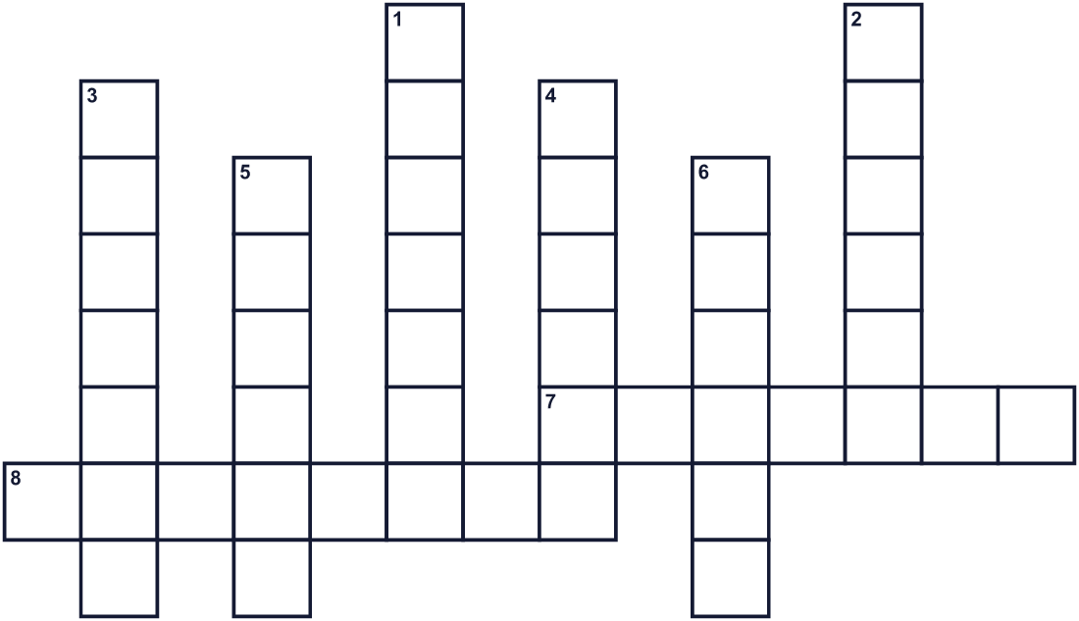
Across →
7. A day when day and night are almost the same length. (7)
8. It shows the days, weeks and months of the year. (8)
Down ↓
1. Saturday and Sunday. (7)
2. Made of gold, or the color of gold. (6)
3. A day with no school or work. (7)
4. A shiny gray metal. It comes second after gold. (6)
5. To go to another place for fun. (6)
6. The season after summer. Leaves turn red. (6)

🍁 Silver Week Worksheet
Word Search
かくれた単語をさがそう（→ ↓ ↘ ↗）
Class ______ No. ____ Name ______________________________
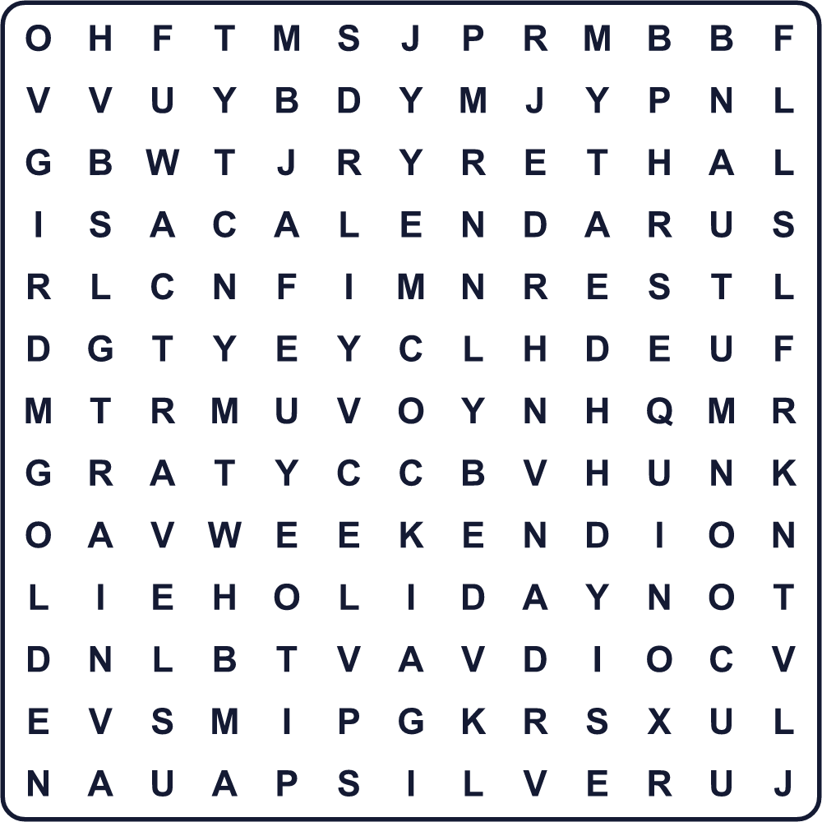
AUTUMN CALENDAR EQUINOX GOLDEN HOLIDAY REST SILVER TRAIN TRAVEL WEEKEND

🍁 Silver Week Worksheet
Maze & Sentences
Class ______ No. ____ Name ______________________________
Help Yui get to her grandparents' house! ユイをおじいちゃん・おばあちゃんの家まで連れていこう！
正しい道の文字を集めると、ひみつの言葉になるよ。 START 👧 → GOAL 🏡
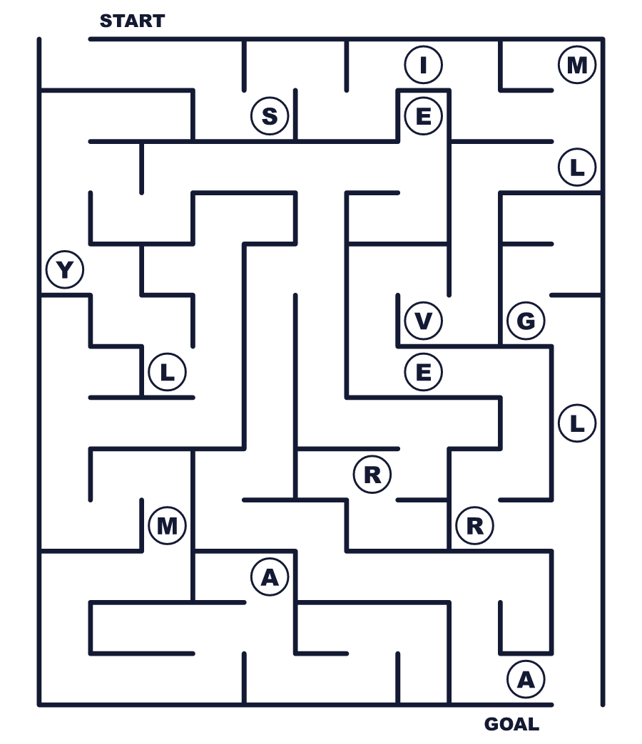
Secret word: ＿ ＿ ＿ ＿ ＿ ＿

🍁 Silver Week Worksheet
Class Activity & Writing
Class ______ No. ____ Name ______________________________
Let's Write! 英語で書いてみよう。
If I had five days off in a row, I would ______ because ______.
もし5連休があったら、私は＿＿します。なぜなら＿＿だからです。
______________________________________________________________
______________________________________________________________
If I could make a new national holiday, it would be ______ Day because ______.
新しい祝日を作れるなら、＿＿の日にします。なぜなら＿＿だからです。
______________________________________________________________
______________________________________________________________

🍁 Silver Week Worksheet
Trace & Color
なぞって書こう。絵に色をぬろう。
Class ______ No. ____ Name ______________________________
🥈 

🥇 
🚄 
🍁 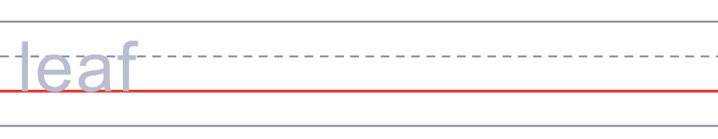
♨️ 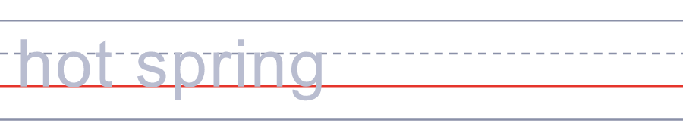

🍁 Silver Week Worksheet
Answer Key 解答
Reading Check: 1.C 2.A 3.B 4.D 5.B
True or False: 1.F 2.T 3.T 4.F
Match: 🥈=silver 🥇=gold 🚄=train 🍁=leaf ♨️=hot spring 🧳=suitcase
Fill in the blanks: (1)September (2)days (3)train (4)red (5)Grandma (6)home (7)away
Maze: SILVER
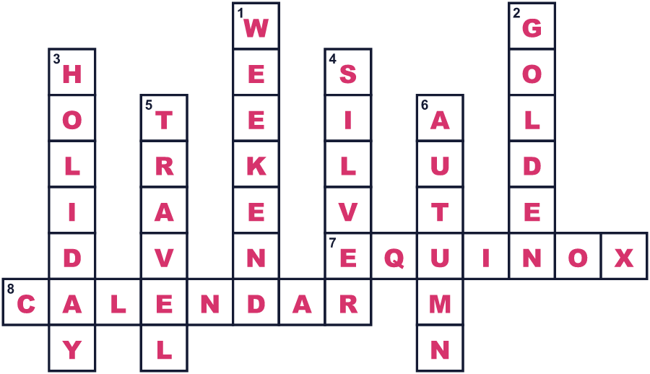
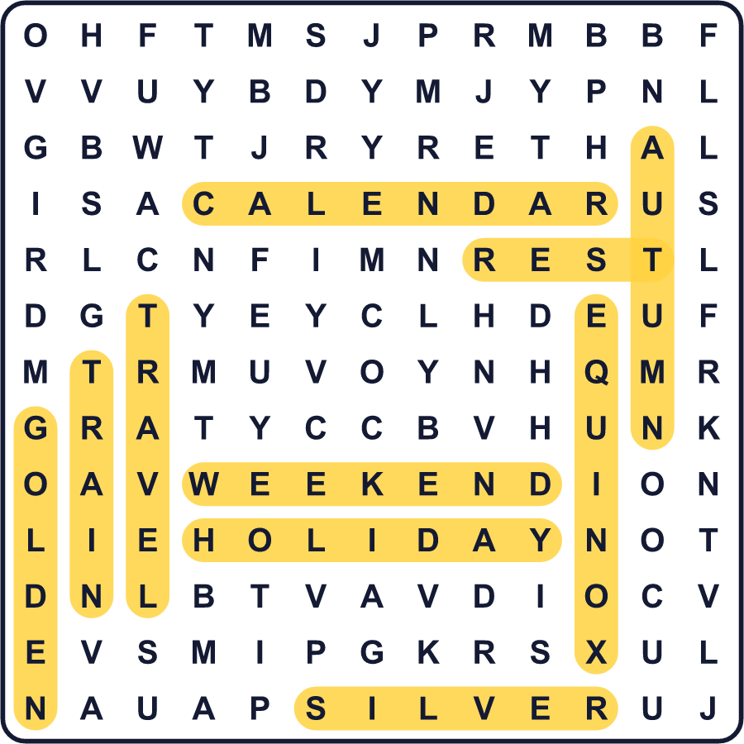
全訳
1 2026年9月、日本の多くの人が土曜日から水曜日まで5日続けて休みになりました。電車や空港は混み合いました。温泉に出かける家族もいれば、祖父母に会いに行く家族もいました。人々はこの長い休みをシルバーウィークと呼びます。
2 この名前は、有名な春の連休であるゴールデンウィークをもじったものです。1950年代、ある映画会社が映画のチケットをもっと売るためにゴールデンウィークという名前を作りました。その会社は、秋の休みにもシルバーウィークという名前を使ってみました。でも当時は、ほとんど誰もその名前を使いませんでした。50年以上のあいだ、この名前はほとんど忘れられていました。
3 では、なぜその名前は復活したのでしょう。9月には敬老の日と秋分の日という2つの祝日があります。日本のルールでは、2つの祝日にはさまれた日も休日になります。2009年、2つの祝日のあいだはたった1日でした。週末と合わせて、人々は初めて5日間の休みを手に入れました。2008年、この新しい連休の名前をたずねる調査があり、シルバーウィークが1位になりました。
4 祝日の日付が少しずつ動くので、これは毎年起きるわけではありません。秋分の日の日付は、前の年の2月に決まります。2026年の次の5連休のシルバーウィークは、たぶん2032年に来ます。だからそれが来るときは、人々は何か月も前から旅行の計画を立てます。銀は金ほど輝きませんが、この銀は金よりずっと見つけにくいのです。

