🕊️ End of the War Memorial Day Worksheet
One Minute at Noon
Read the story. 英文を読もう。
Class ______ No. ____ Name ______________________________
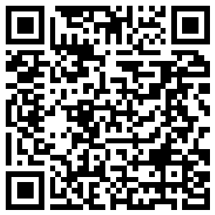
🔊 音声を聞こう（スマホで読みとってね）
1 At noon on August 15, a siren sounds at Koshien Stadium. The high school baseball game stops. Players, umpires and fans stand up and close their eyes. For one minute, the big stadium is silent. This day is called Shusen no Hi, the day the war ended for Japan.
2 On August 15, 1945, people all over Japan gathered around radios at noon. Most of them heard the emperor's voice for the first time. He said that Japan accepted the Allies' demands to end the war. His message was recorded the night before. But many people could not understand it, because the words were difficult and the sound was not clear.
3 About 3.1 million Japanese people died in the war. About 800,000 of them were ordinary people, not soldiers. Every year on this day, the government holds a ceremony in Tokyo to remember them. Families of the dead come from all over Japan. At noon, they bow their heads together. In 1982, the day got an official name: a day to remember the war dead and pray for peace.
4 Other countries remember the end of the war on different days. Britain and Australia remember it on August 15. South Korea celebrates its liberation on the same day. But the United States marks September 2, when Japan signed the surrender papers on a ship in Tokyo Bay. One war, but many different dates for its end.
Words 単語
silent（静かな、音のない） / emperor（天皇、皇帝） / accept（受け入れる） / record（録音する、記録する） / ordinary（ふつうの） / ceremony（式、式典） / liberation（解放） / surrender（降伏）

🕊️ End of the War Memorial Day Worksheet
Reading Check
Choose the best answer. 正しいものを選ぼう。
Class ______ No. ____ Name ______________________________
1. What is the main idea of the reading?
(A) August 15 is a day to remember the end of the war in Japan. (B) August 15 is a national holiday for sports. (C) Koshien Stadium was built in 1945. (D) All countries end the war on August 15.
2. When was the emperor's message recorded?
(A) On September 2 (B) At noon on August 15 (C) The night before the broadcast (D) In 1982
3. Why could many people not understand the message?
(A) Because it was in English (B) Because the words were difficult and the sound was not clear (C) Because the radio broke (D) Because it was too long
4. In paragraph 3, what does "ordinary people" mean?
(A) Soldiers (B) Famous people (C) Government leaders (D) Common people who were not soldiers
5. In the dialogue, what does Olivia say about Australia?
(A) It has no day for the end of the war. (B) It remembers the end of the war on September 3. (C) It calls its day VP Day, in August. (D) It watches baseball on August 15.
True or False? T か F に○
1. August 15 is a national holiday in Japan. T / F
2. The emperor's message was played on the radio at noon. T / F
3. The United States marks the end of the war on September 2. T / F
4. Every country in the world uses the same date for the end of the war. T / F

🕊️ End of the War Memorial Day Worksheet
Word Work
単語のれんしゅう
Class ______ No. ____ Name ______________________________
① Match the pictures and the words. 絵と単語を線でむすぼう。
📻 | ● | ● | dove
🕛 | ● | ● | pray
🕊️ | ● | ● | flowers
🚢 | ● | ● | noon
🙏 | ● | ● | radio
💐 | ● | ● | ship
③ Fill in the blanks. 語群から選んで入れよう。
[ caps / eyes / radio / peace / party / remember / candy / snow / noon / minute / hope ]
At (1) __________ , a siren sounded at the stadium. The players took off their (2) __________ . Everyone stood up. For one (3) __________ , nobody said a word. Grandpa closed his (4) __________ . "My mother heard the (5) __________ on this day in 1945," he said quietly. "Today we (6) __________ the people who died in the war." Then the game started again. I (7) __________ the world will always have (8) __________ .

🕊️ End of the War Memorial Day Worksheet
Crossword Puzzle
ヒントを読んでクロスワードを完成させよう。
Class ______ No. ____ Name ______________________________
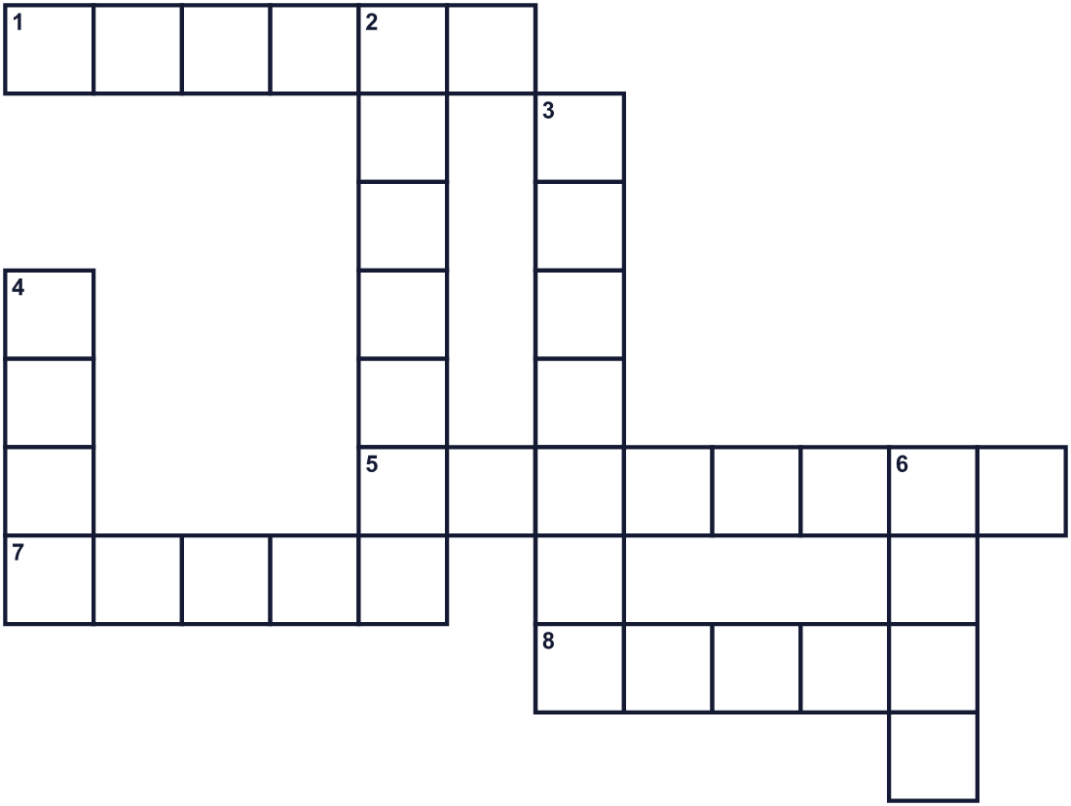
Across →
1. The eighth month of the year. (6)
5. A formal event, for example to remember people who died. (8)
7. A time when there is no war. (5)
8. People listened to the emperor on this in 1945. (5)
Down ↓
2. No sound at all. (7)
3. The head of the imperial family of Japan. (7)
4. A very big boat. The USS Missouri was one. (4)
6. Twelve o'clock in the daytime. (4)

🕊️ End of the War Memorial Day Worksheet
Word Search
かくれた単語をさがそう（→ ↓ ↘ ↗）
Class ______ No. ____ Name ______________________________
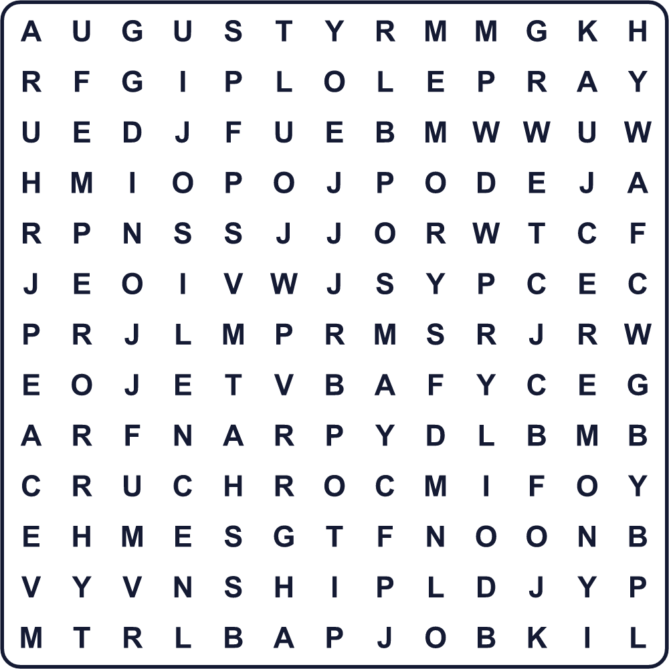
AUGUST CEREMONY EMPEROR MEMORY NOON PEACE PRAY RADIO SHIP SILENCE

🕊️ End of the War Memorial Day Worksheet
Maze & Sentences
Class ______ No. ____ Name ______________________________
Help the dove fly to the peaceful world! ハトを平和な世界まで飛ばそう！
正しい道の文字を集めると、ひみつの言葉になるよ。 START 🕊️ → GOAL 🌏
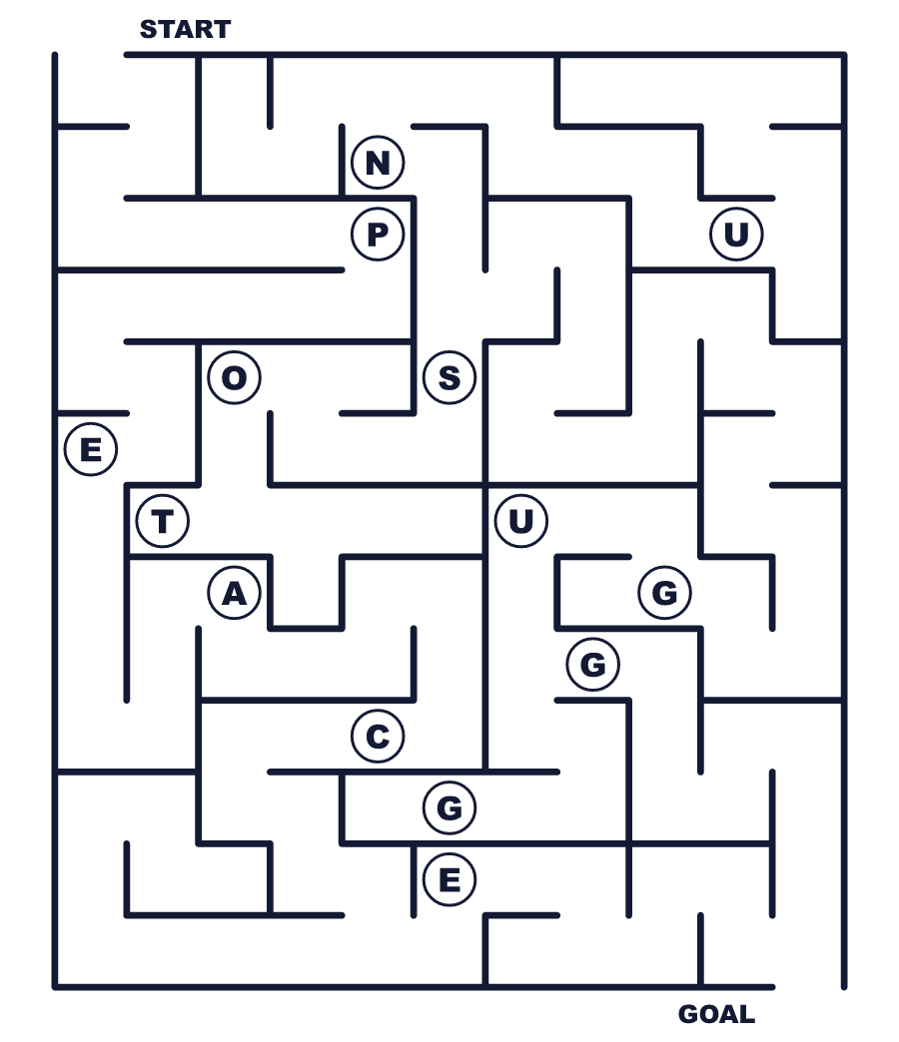
Secret word: ＿ ＿ ＿ ＿ ＿

🕊️ End of the War Memorial Day Worksheet
Class Activity & Writing
Class ______ No. ____ Name ______________________________
Let's Write! 英語で書いてみよう。
On August 15, I want to remember ______ because ______.
8月15日、私は＿＿のことを思い出したいです。なぜなら＿＿だからです。
______________________________________________________________
______________________________________________________________
To keep peace in the world, I think we should ______.
世界の平和を守るために、私たちは＿＿すべきだと思います。
______________________________________________________________
______________________________________________________________

🕊️ End of the War Memorial Day Worksheet
Trace & Color
なぞって書こう。絵に色をぬろう。
Class ______ No. ____ Name ______________________________
📻 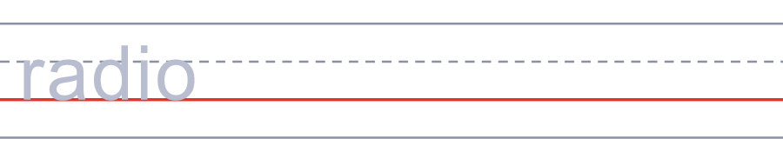

🕛 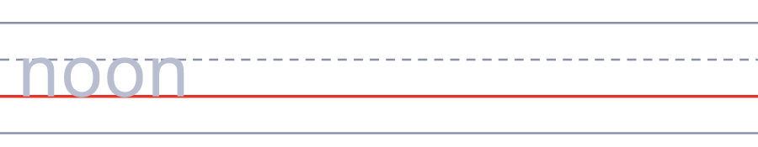
🕊️ 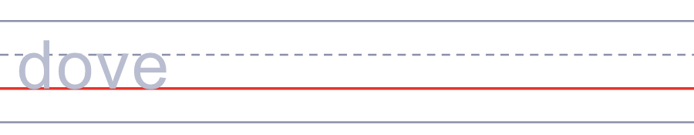
🚢 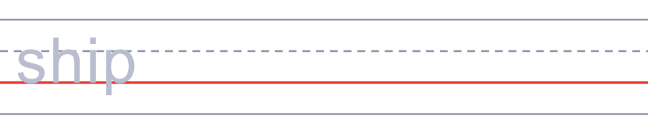
🙏 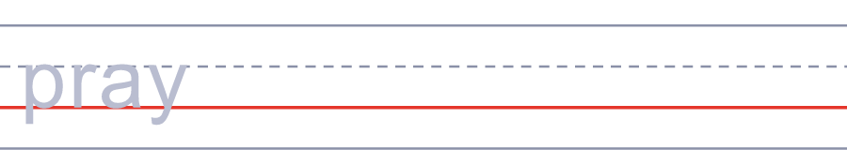

🕊️ End of the War Memorial Day Worksheet
Answer Key 解答
Reading Check: 1.A 2.C 3.B 4.D 5.C
True or False: 1.F 2.T 3.T 4.F
Match: 📻=radio 🕛=noon 🕊️=dove 🚢=ship 🙏=pray 💐=flowers
Fill in the blanks: (1)noon (2)caps (3)minute (4)eyes (5)radio (6)remember (7)hope (8)peace
Maze: PEACE
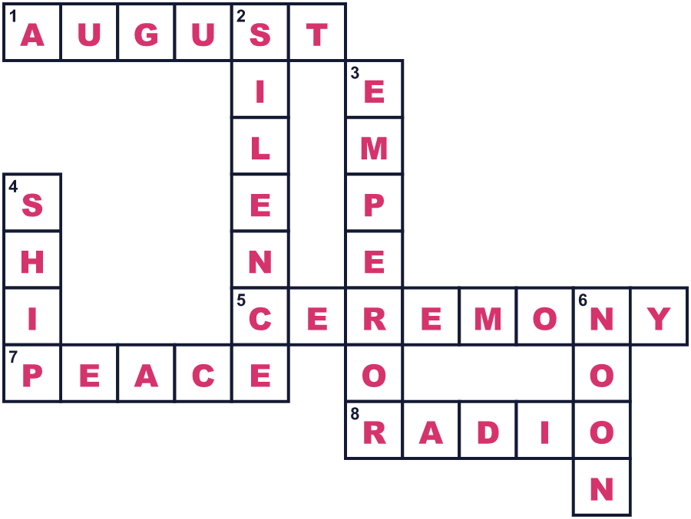
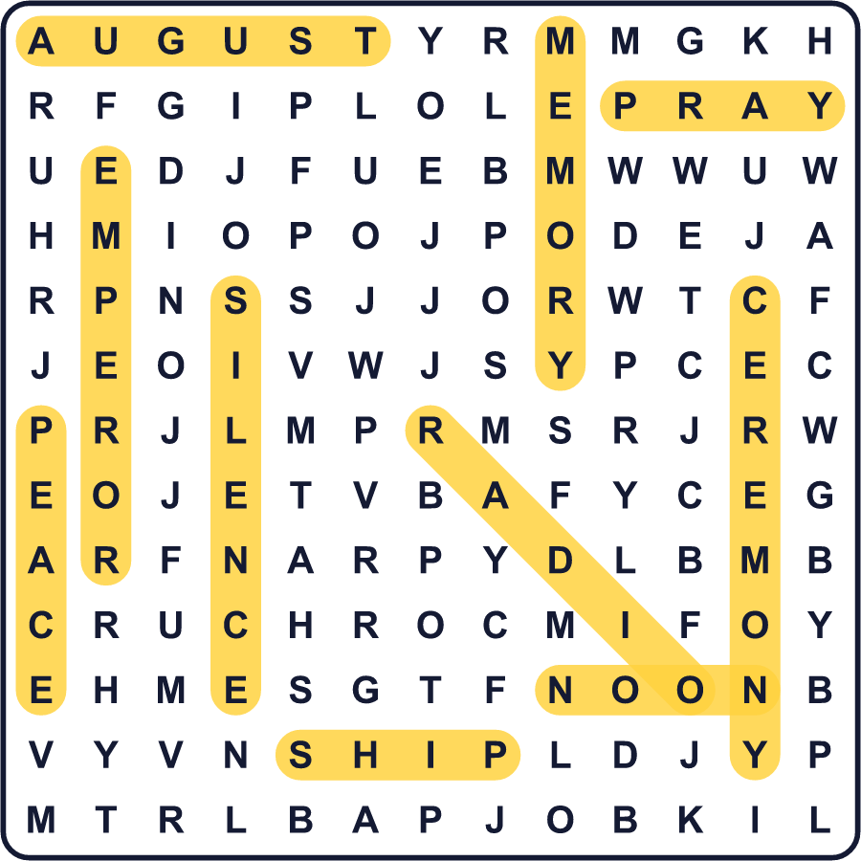
全訳
1 8月15日の正午、甲子園球場にサイレンが鳴ります。高校野球の試合が止まります。選手も審判もファンも立ち上がり、目を閉じます。1分間、大きな球場が静まりかえります。この日は「終戦の日」、日本にとって戦争が終わった日と呼ばれます。
2 1945年8月15日の正午、日本中の人々がラジオのまわりに集まりました。そのほとんどが、天皇の声を初めて聞きました。天皇は、戦争を終わらせるための連合国の要求を日本が受け入れたことを伝えました。そのメッセージは前の夜に録音されたものでした。でも、言葉がむずかしく音がはっきりしなかったので、多くの人は内容がわかりませんでした。
3 戦争では約310万人の日本人が亡くなりました。そのうち約80万人は、兵士ではないふつうの人々でした。毎年この日、政府は東京で亡くなった人々を追悼する式典を開きます。亡くなった人の家族が全国から集まります。正午、みんなでいっしょに頭を下げます。1982年、この日に「戦没者を追悼し平和を祈念する日」という正式な名前がつきました。
4 ほかの国々は、別の日に戦争の終わりを思い起こします。イギリスとオーストラリアは8月15日です。韓国は同じ日に解放を祝います。でもアメリカは、日本が東京湾の船の上で降伏文書に署名した9月2日を記念日にしています。一つの戦争なのに、その終わりの日付はいくつもあるのです。

