🌸 Vernal Equinox Day Worksheet
The Day the Sun Goes Straight West
Read the story. 英文を読もう。
Class ______ No. ____ Name ______________________________

🔊 音声を聞こう（スマホで読みとってね）
1 On one day in March, the sun rises exactly in the east and sets exactly in the west. This is the spring equinox. In Japan, it is a national holiday called Vernal Equinox Day. Schools and many offices are closed.
2 But the holiday has no fixed date. The law only says the day of the spring equinox. Each year, scientists at the National Astronomical Observatory of Japan figure out the exact moment. The date is then announced one year early, usually March 20 or 21. In 2026, the equinox came at 11:46 at night, only 14 minutes before midnight.
3 This day is also the middle of Higan, a special week in Japanese Buddhism. Higan means the other shore, a peaceful world beyond this life. Many families visit their family graves. They wash the stones, give flowers, and pray for the people they lost. Higan is found only in Japan, not in India or China.
4 People also eat botamochi, rice balls covered with sweet red bean paste. The name comes from the botan, a big spring flower. In fall, the same sweet is called ohagi. Some families make it at home, and others buy it at Japanese sweet shops.
5 Many people say day and night are the same length on this day. But in Tokyo, the day is about 15 minutes longer. After this, the days keep getting longer, and spring really begins. In Iran, this day is even the start of a new year.
Words 単語
equinox（春分・秋分（分点）） / vernal（春の） / national holiday（国民の祝日） / fixed（決まった、固定された） / scientist（科学者） / figure out（（考えて・計算して）求める、わかる） / announce（発表する） / moment（瞬間） / grave（墓） / shore（岸） / bean paste（（豆の）あん、ペースト） / length（長さ）

🌸 Vernal Equinox Day Worksheet
Reading Check
Choose the best answer. 正しいものを選ぼう。
Class ______ No. ____ Name ______________________________
1. What is the main idea of the passage?
(A) Vernal Equinox Day is a Japanese holiday about the sun, family, and spring. (B) Vernal Equinox Day is a festival only for scientists. (C) Vernal Equinox Day is always on March 21. (D) Vernal Equinox Day came to Japan from India.
2. Who figures out the exact moment of the equinox?
(A) Buddhist monks (B) School teachers (C) Scientists at the National Astronomical Observatory (D) The Prime Minister
3. What time was the equinox in 2026?
(A) 6:00 in the morning (B) At noon (C) 11:46 at night (D) Just after midnight
4. Why is the sweet called botamochi in spring?
(A) Because it is made in a big pot. (B) Because its name comes from a spring flower. (C) Because it is only eaten by children. (D) Because it is white like snow.
5. In paragraph 3, what does "the other shore" mean?
(A) A beach in another country (B) A peaceful world beyond this life (C) The east side of a river (D) A new school year
6. Which is true according to the passage?
(A) The law says the holiday is on March 20. (B) Higan is a custom in India and China. (C) The same sweet is called ohagi in fall. (D) In Tokyo, the night is longer than the day.
7. Why does the date of the holiday need to be announced one year early?
(A) Because people like long vacations. (B) Because the date is chosen by a lottery. (C) Because the holiday is very old. (D) Because it changes and people need to plan their year.
8. In the dialogue, why does Sakura say "it's an autumn equinox for you"?
(A) Because Australia is in the southern half of the world. (B) Because Noah likes fall more than spring. (C) Because Noah will visit a grave in autumn. (D) Because Australia has no spring.
True or False? T か F に○
1. Vernal Equinox Day is a national holiday in Japan. T / F
2. The date of Vernal Equinox Day is written in the law. T / F
3. On this day, the sun rises in the east and sets in the west. T / F
4. Higan is a Buddhist custom in India and China. T / F
5. Many families visit their family graves during Higan. T / F
6. Day and night are exactly the same length on this day. T / F

🌸 Vernal Equinox Day Worksheet
Word Work
単語のれんしゅう
Class ______ No. ____ Name ______________________________
① Match the pictures and the words. 絵と単語を線でむすぼう。
🌅 | ● | ● | telescope
🌸 | ● | ● | sprout
📅 | ● | ● | flower
🌙 | ● | ● | night
🔭 | ● | ● | calendar
🍵 | ● | ● | compass
🧭 | ● | ● | tea
🌱 | ● | ● | sunrise
② Unscramble the words. 並べかえて単語にしよう。
1. S R G N I P (春) → ____________________
2. O E U I X Q N (春分・秋分) → ____________________
3. A V R E G (墓) → ____________________
4. E S N U T S (日の入り) → ____________________
5. H Y O D I A L (祝日、休日) → ____________________
6. H S R E O (岸) → ____________________
③ Fill in the blanks. 語群から選んで入れよう。
[ Christmas / breakfast / grave / flowers / east / west / window / botamochi / north / longer / snowman / Spring / tea ]
Today is Vernal Equinox Day. Ren wakes up early and looks out the (1) __________ . The sun is rising in the (2) __________ . "It will set in the (3) __________ tonight," says his mother. After (4) __________ , the family goes to visit his grandfather's (5) __________ . They wash the stone and put (6) __________ in front of it. Then they go home and eat (7) __________ with green (8) __________ . Ren's sister says, "The days will be (9) __________ from now on." Ren smiles. (10) __________ is really here.

🌸 Vernal Equinox Day Worksheet
Crossword Puzzle
ヒントを読んでクロスワードを完成させよう。
Class ______ No. ____ Name ______________________________
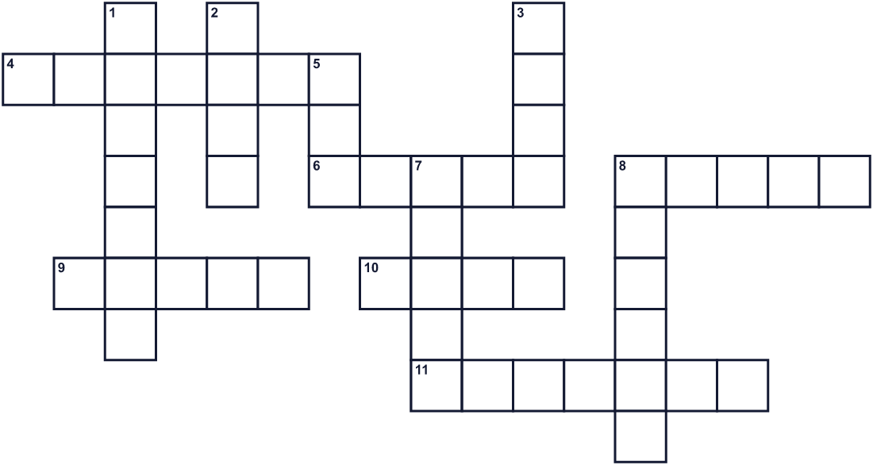
Across →
4. Families bring these to a family stone. They are colorful. (7)
6. The dark time after the sun goes down. (5)
8. The land at the side of the sea or a river. (5)
9. The third month of the year. (5)
10. The sun rises in this direction. (4)
11. The day when day and night are almost the same length. (7)
Down ↓
1. A day with no school or work. (7)
2. A small seed. Sweet red paste is made from it. (4)
3. The sun sets in this direction. (4)
5. The big star that gives us light in the day. (3)
7. A place where a person who died is buried. (5)
8. The season after winter. (6)

🌸 Vernal Equinox Day Worksheet
Word Search
かくれた単語をさがそう（→ ↓ ↘ ↗）
Class ______ No. ____ Name ______________________________
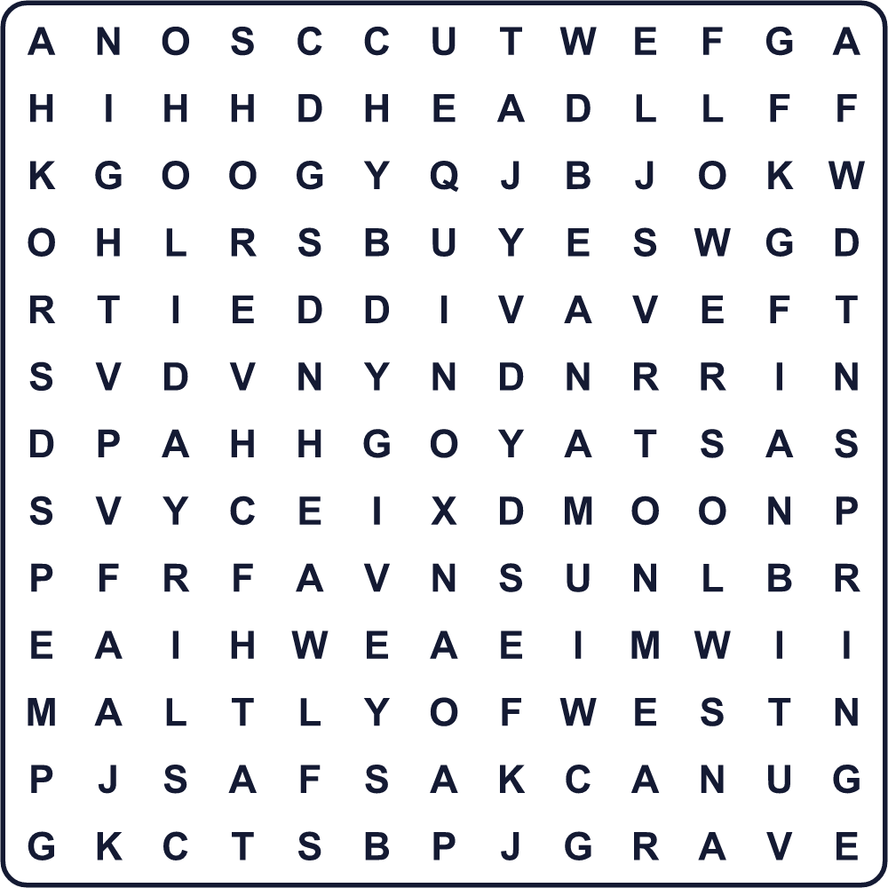
BEAN CALENDAR EAST EQUINOX FLOWERS GRAVE HOLIDAY MARCH MOON NIGHT SHORE SPRING SUN WEST
Secret Code 暗号を解こう
♪=E ▲=G ⚑=H ✈=I ☀=L ★=N ●=O ✿=P ◎=R ✂=S
⚑ ♪ ☀ ☀ ● ✂ ✿ ◎ ✈ ★ ▲
______________________________________________________________

🌸 Vernal Equinox Day Worksheet
Maze & Sentences
Class ______ No. ____ Name ______________________________
Help Yuto walk toward the rising sun! ユウトが朝日に向かって歩けるように助けよう！
正しい道の文字を集めると、ひみつの言葉になるよ。 START 🧒 → GOAL 🌅
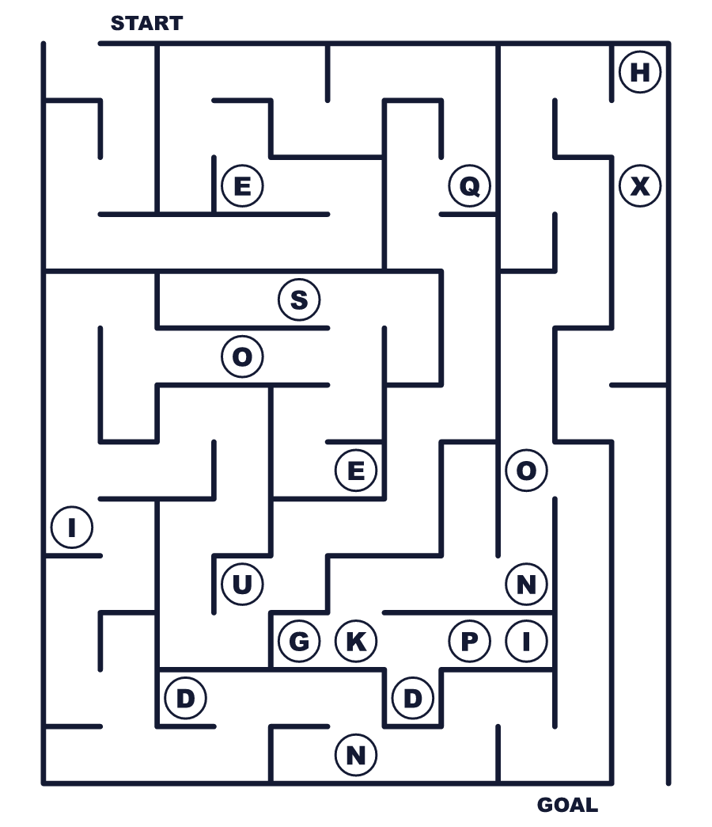
Secret word: ＿ ＿ ＿ ＿ ＿ ＿ ＿
Put the words in order. 並べかえよう。
1. rises / the / The / east / in / sun . (太陽は東からのぼります。)
______________________________________________________________
2. is / Equinox / national / holiday / Vernal / Day / a . (春分の日は国民の祝日です。)
______________________________________________________________
3. family / visit / spring / our / grave / in / We . (私たちは春にお墓参りをします。)
______________________________________________________________
4. little / year / every / changes / date / The / a . (日付は毎年少し変わります。)
______________________________________________________________
5. equinox / after / longer / the / days / The / get . (春分のあと、昼が長くなります。)
______________________________________________________________

🌸 Vernal Equinox Day Worksheet
Class Activity & Writing
Class ______ No. ____ Name ______________________________
Find Someone Who… クラスで聞いて回ろう！
Find someone who … | Name
… has visited a family grave お墓参りをしたことがある
… likes botamochi or ohagi ぼたもちかおはぎが好き
… knows the date of Vernal Equinox Day this year 今年の春分の日の日付を知っている
… can point to the east from this room この部屋から東を指せる
… has seen a sunrise 日の出を見たことがある
… likes spring better than fall 秋より春が好き
… knows what equinox means equinox の意味を知っている
… has been to a planetarium プラネタリウムに行ったことがある
Let's Write! 英語で書いてみよう。
On Vernal Equinox Day, I want to ______ because ______.
春分の日に、私は______したいです。なぜなら______だからです。
______________________________________________________________
______________________________________________________________
My favorite thing about spring is ______.
春でいちばん好きなものは______です。
______________________________________________________________
______________________________________________________________
To explain Vernal Equinox Day to a friend from abroad, I would say, "______."
海外の友だちに春分の日を説明するなら「______」と言います。
______________________________________________________________
______________________________________________________________

🌸 Vernal Equinox Day Worksheet
Trace & Color
なぞって書こう。絵に色をぬろう。
Class ______ No. ____ Name ______________________________
🌅 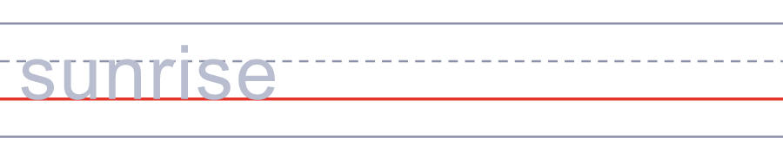

🌸 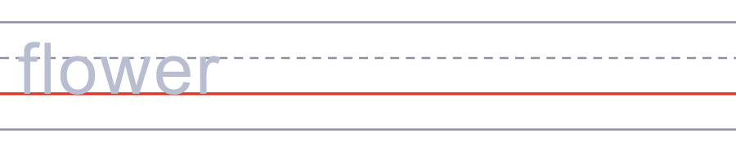
📅 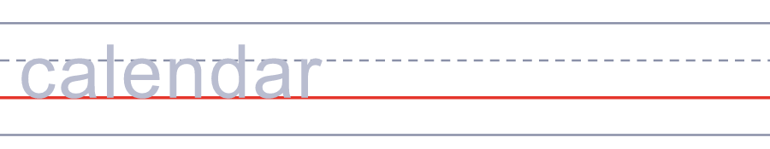
🌙 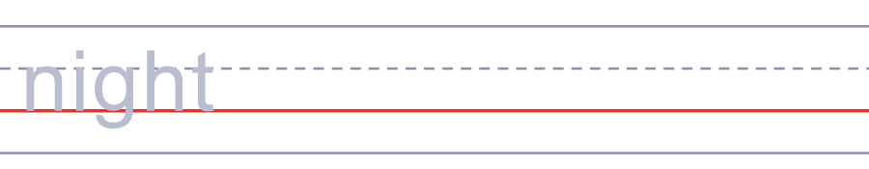
🔭 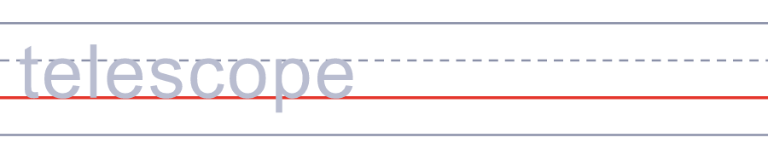
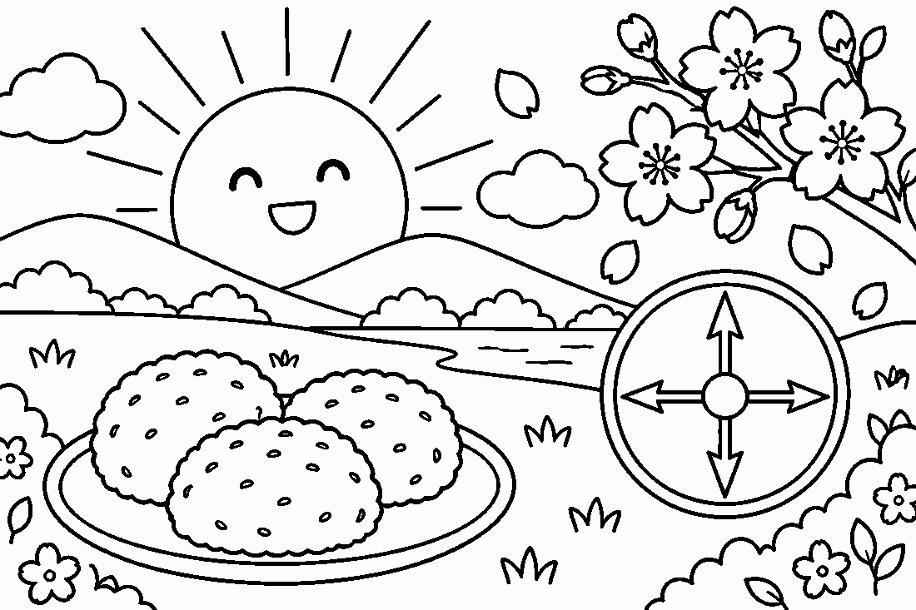

🌸 Vernal Equinox Day Worksheet
Answer Key 解答
Reading Check: 1.A 2.C 3.C 4.B 5.B 6.C 7.D 8.A
True or False: 1.T 2.F 3.T 4.F 5.T 6.F
Match: 🌅=sunrise 🌸=flower 📅=calendar 🌙=night 🔭=telescope 🍵=tea 🧭=compass 🌱=sprout
Unscramble: 1.SPRING 2.EQUINOX 3.GRAVE 4.SUNSET 5.HOLIDAY 6.SHORE
Fill in the blanks: (1)window (2)east (3)west (4)breakfast (5)grave (6)flowers (7)botamochi (8)tea (9)longer (10)Spring
Sentence order: 1. The sun rises in the east. 2. Vernal Equinox Day is a national holiday. 3. We visit our family grave in spring. 4. The date changes a little every year. 5. The days get longer after the equinox.
Secret Code: HELLO SPRING
Maze: EQUINOX
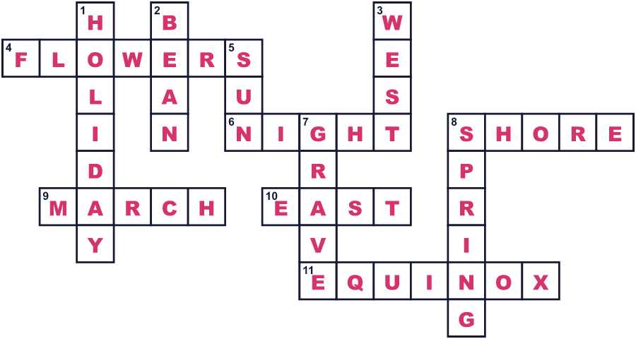
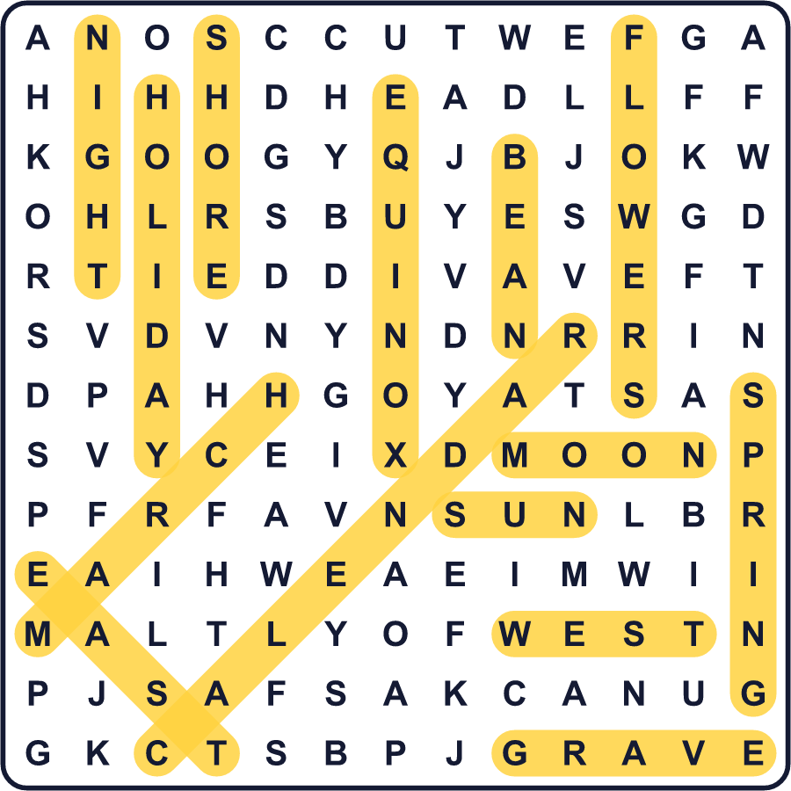
全訳
1 3月のある日、太陽はちょうど真東からのぼり、真西にしずみます。これが春分です。日本では、春分の日という国民の祝日です。学校や多くの会社は休みになります。
2 でも、この祝日には決まった日付がありません。法律には「春分の日」とあるだけです。毎年、国立天文台の科学者が正確な瞬間を計算します。日付は1年前に発表され、たいてい3月20日か21日です。2026年の春分は夜11時46分で、真夜中のわずか14分前でした。
3 この日は、日本の仏教の特別な1週間「お彼岸」のまん中の日でもあります。彼岸は「向こう岸」という意味で、この世の先にある安らかな世界のことです。多くの家族がお墓参りをします。墓石を洗い、花を供え、亡くなった人のために祈ります。お彼岸は日本にしかなく、インドや中国にはありません。
4 人々は、あんこで包んだもち米のお菓子、ぼたもちも食べます。その名前は、春の大きな花、牡丹から来ています。秋には、同じお菓子がおはぎと呼ばれます。家で作る家族もいれば、和菓子屋さんで買う家族もいます。
5 この日は昼と夜が同じ長さだと言う人が多くいます。でも東京では、昼のほうが15分ほど長いのです。このあと昼はどんどん長くなり、本当の春がやって来ます。イランでは、この日が新しい年の始まりでもあります。

