🍂 Autumnal Equinox Day Worksheet
The Day the Sun Sets Due West
Read the story. 英文を読もう。
Class ______ No. ____ Name ______________________________

🔊 音声を聞こう（スマホで読みとってね）
1 Twice a year, the sun rises exactly in the east and sets exactly in the west. One of these days comes in September. In Japan, it is a national holiday called Shubun no Hi, or Autumnal Equinox Day.
2 The date is different from year to year. It is usually September 22 or 23. For example, it was September 23 in 2026, but it will probably be September 22 in 2028. The law does not give a date. Instead, scientists at the National Astronomical Observatory of Japan study the movement of the sun and find the right day. The government announces the date each February for the next year.
3 The holiday is a day to respect our ancestors and remember people who have died. It is the middle day of Higan, a Buddhist week in spring and fall. Many families visit their family graves, clean them, and bring flowers. Some people also go to temples for special services. They also eat ohagi, sticky rice covered in sweet red bean paste.
4 Why this day? In Buddhism, a happy world called the Pure Land is far away in the west. On the equinox, the sun goes down right in the west, so people thought it was the best day to pray. This custom is found only in Japan.
5 Around this time, bright red flowers called higanbana bloom along rice fields. Their name means equinox flower. People also say that the summer heat ends at Higan. And by the way, day and night are not exactly equal on the equinox. In Tokyo, the day is still more than 10 minutes longer!
Words 単語
equinox（春分・秋分（昼夜平分時）） / autumnal（秋の） / exactly（ちょうど、正確に） / observatory（天文台） / announce（発表する） / ancestor（先祖） / remember（思い出す、しのぶ） / grave（墓） / paste（ペースト、練ったもの） / pray（祈る） / bloom（（花が）咲く） / poisonous（毒のある）

🍂 Autumnal Equinox Day Worksheet
Reading Check
Choose the best answer. 正しいものを選ぼう。
Class ______ No. ____ Name ______________________________
1. What is the main idea of the reading?
(A) Japan has a holiday on the autumn equinox to remember ancestors. (B) Scientists in Japan found a new star in September. (C) Red flowers are the most popular gift in Japan. (D) The summer in Japan is very long.
2. Who finds the right date for the holiday?
(A) Buddhist monks. (B) The Prime Minister. (C) Farmers in the rice fields. (D) Scientists at the observatory.
3. When does the government announce the date?
(A) On the day itself. (B) Each February, for the next year. (C) Every September, one week before. (D) Once every ten years.
4. Why did people think the equinox was a good day to pray?
(A) Because the moon is full on that day. (B) Because it is the hottest day of the year. (C) Because the sun goes down right in the west, where the Pure Land is. (D) Because the flowers are red.
5. In paragraph 5, what does "bloom" mean?
(A) To grow open as a flower. (B) To die in the cold. (C) To be sold in a shop. (D) To be eaten.
6. Which sentence matches the reading?
(A) The holiday is always on September 23. (B) Day and night are exactly the same length on the equinox. (C) Higan is a custom from India. (D) In Tokyo, the day is longer than the night on the equinox.
7. What can we guess about the date of the holiday?
(A) Nobody knows it until the morning. (B) It depends on the movement of the sun, not on a fixed number. (C) It was chosen by a famous emperor. (D) It is the same in every country's calendar as a holiday.
8. In the dialogue, why does Yui say Liam should not pick the red flowers?
(A) Because they belong to the temple. (B) Because they are poisonous. (C) Because Grandpa did not like red. (D) Because the shop is closed.
True or False? T か F に○
1. The law gives a fixed date for Autumnal Equinox Day. T / F
2. The holiday is usually on September 22 or 23. T / F
3. On the equinox, the sun sets exactly in the west. T / F
4. Higan started in India. T / F
5. Many families visit their family graves on this day. T / F
6. Day and night are exactly the same length on the equinox. T / F

🍂 Autumnal Equinox Day Worksheet
Word Work
単語のれんしゅう
Class ______ No. ____ Name ______________________________
① Match the pictures and the words. 絵と単語を線でむすぼう。
🌅 | ● | ● | rice plant
🍂 | ● | ● | night
🌺 | ● | ● | autumn leaf
🙏 | ● | ● | sunset
🌾 | ● | ● | red flower
🌰 | ● | ● | telescope
🔭 | ● | ● | chestnut
🌙 | ● | ● | pray
② Unscramble the words. 並べかえて単語にしよう。
1. O E N U X Q I (春分・秋分) → ____________________
2. N T U A M U (秋) → ____________________
3. A E R G V (墓) → ____________________
4. E S U T N S (日の入り) → ____________________
5. A V R S T E H (収穫) → ____________________
6. N O T E S A R C (先祖) → ____________________
③ Fill in the blanks. 語群から選んで入れよう。
[ smile / water / pizza / fields / incense / higanbana / grave / snow / ohagi / plate / summer / beach / flowers ]
On Autumnal Equinox Day, Hana went to the (1) __________ with her grandma. They cleaned the stone with (2) __________ and put (3) __________ in front of it. Grandma lit some (4) __________ . "Your grandpa liked (5) __________ ," she said, and she put two on a small (6) __________ . On the way home, they saw red (7) __________ along the rice (8) __________ . The air was cool. "The (9) __________ heat ends at Higan," Grandma said with a (10) __________ .

🍂 Autumnal Equinox Day Worksheet
Crossword Puzzle
ヒントを読んでクロスワードを完成させよう。
Class ______ No. ____ Name ______________________________
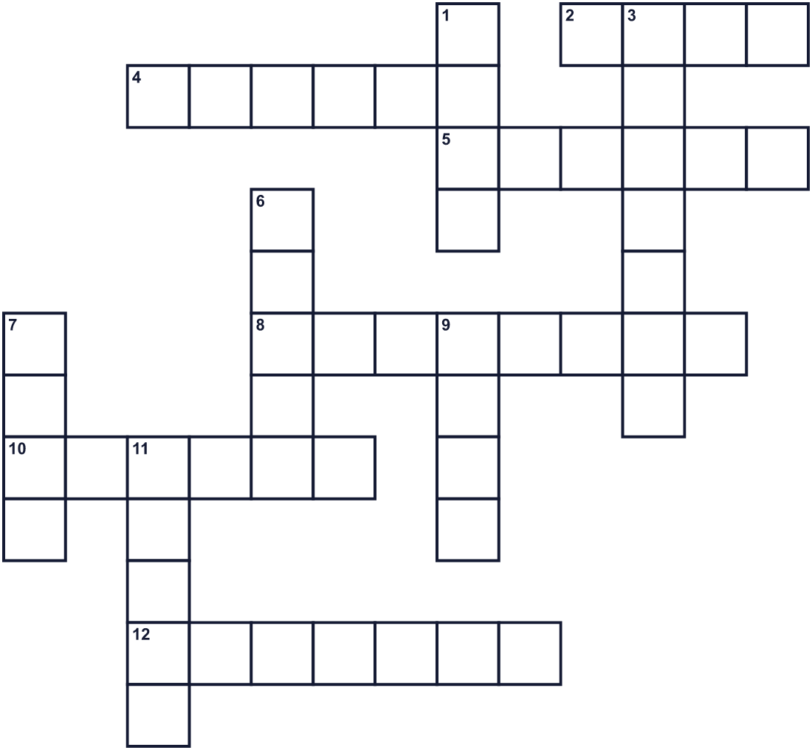
Across →
2. A small seed. Sweet paste is made from red ones. (4)
4. A rose or a lily is one. (6)
5. The season after summer. Americans often call it fall. (6)
8. A family member from long, long ago. (8)
10. The time in the evening when the sun goes down. (6)
12. The time when farmers cut and collect rice. (7)
Down ↓
1. To talk to God or Buddha with your heart. (4)
3. A day in March or September when day and night are almost equal. (7)
6. A place where a dead person rests. (5)
7. The direction where the sun goes down. (4)
9. The direction where the sun comes up. (4)
11. The dark time between evening and morning. (5)

🍂 Autumnal Equinox Day Worksheet
Word Search
かくれた単語をさがそう（→ ↓ ↘ ↗）
Class ______ No. ____ Name ______________________________
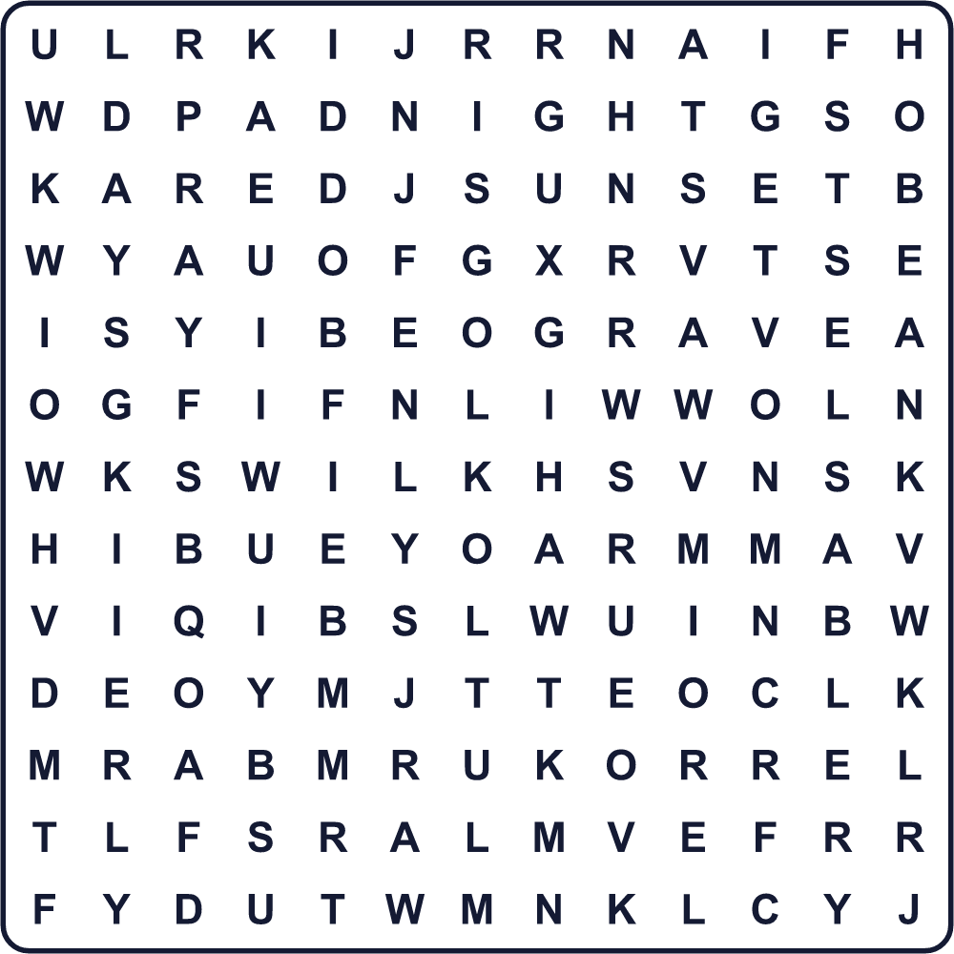
AUTUMN BEAN DAY EAST EQUINOX FLOWER GRAVE MOON NIGHT PRAY RICE SUNSET WEST
Secret Code 暗号を解こう
☃=A ♦=C ♣=E ☾=H ★=K ☂=N ✈=O ♥=R ☘=S ◆=T ●=U ✎=Y
◆ ☾ ☃ ☂ ★ ✎ ✈ ● ☃ ☂ ♦ ♣ ☘ ◆ ✈ ♥ ☘
______________________________________________________________

🍂 Autumnal Equinox Day Worksheet
Maze & Sentences
Class ______ No. ____ Name ______________________________
Follow the sunset to the west! 夕日を追いかけて西へ進もう！
正しい道の文字を集めると、ひみつの言葉になるよ。 START 🧒 → GOAL 🌅
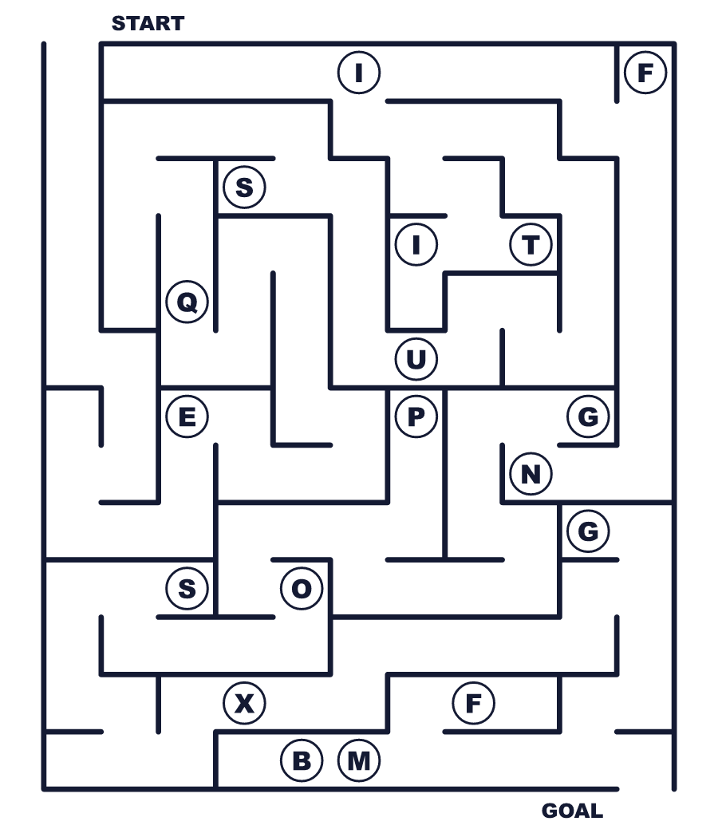
Secret word: ＿ ＿ ＿ ＿ ＿ ＿ ＿
Put the words in order. 並べかえよう。
1. sets / The / sun / in / the / west / exactly . (太陽はちょうど真西に沈みます。)
______________________________________________________________
2. day / this / our / grave / We / on / family / visit . (私たちはこの日にお墓参りをします。)
______________________________________________________________
3. covered / is / paste / Ohagi / sweet / in / bean . (おはぎは甘いあんこで包まれています。)
______________________________________________________________
4. the / fields / rice / Red / bloom / along / flowers . (赤い花が田んぼに沿って咲きます。)
______________________________________________________________
5. The / around / ends / heat / this / summer / time . (夏の暑さはこのころに終わります。)
______________________________________________________________

🍂 Autumnal Equinox Day Worksheet
Class Activity & Writing
Class ______ No. ____ Name ______________________________
Find Someone Who… クラスで聞いて回ろう！
Find someone who … | Name
… has visited a family grave this year 今年お墓参りに行った
… likes ohagi おはぎが好き
… has seen red spider lilies 彼岸花を見たことがある
… knows the English word for 秋分 「秋分」の英語を知っている
… can point to the west from this room この部屋から西の方角を指させる
… has watched a sunset this month 今月、夕日を見た
… knows the name of a grandparent's grandparent 祖父母のそのまた祖父母の名前を知っている
… likes autumn better than spring 春より秋が好き
Let's Write! 英語で書いてみよう。
On Autumnal Equinox Day, I want to thank ______ because ______.
秋分の日に、私は＿＿に感謝したいです。なぜなら＿＿だからです。
______________________________________________________________
______________________________________________________________
My favorite thing about autumn is ______.
秋のいちばん好きなところは＿＿です。
______________________________________________________________
______________________________________________________________
If I could talk to one of my ancestors, I would ask ______.
もし先祖の一人と話せたら、＿＿と聞きたいです。
______________________________________________________________
______________________________________________________________

🍂 Autumnal Equinox Day Worksheet
Trace & Color
なぞって書こう。絵に色をぬろう。
Class ______ No. ____ Name ______________________________
🌅 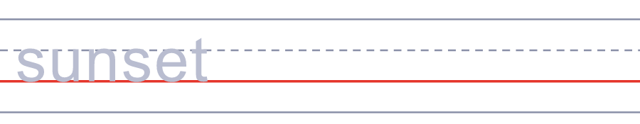

🍂 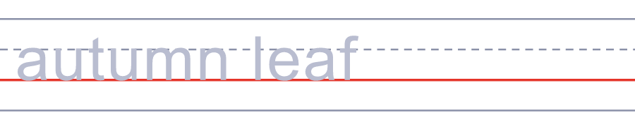
🌺 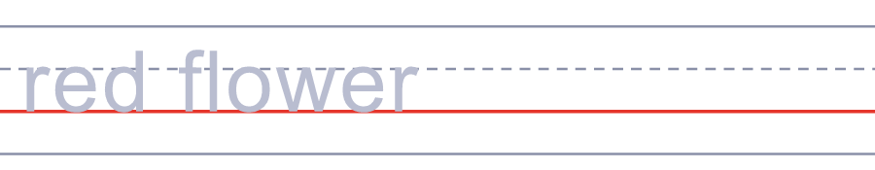
🙏 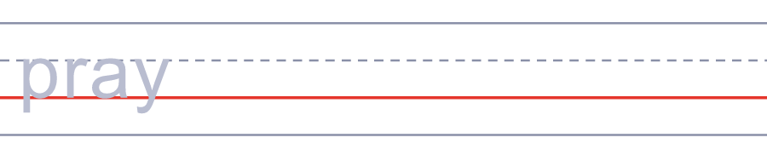
🌾 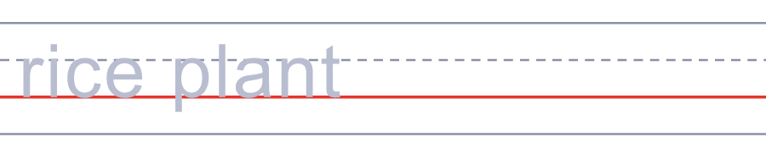
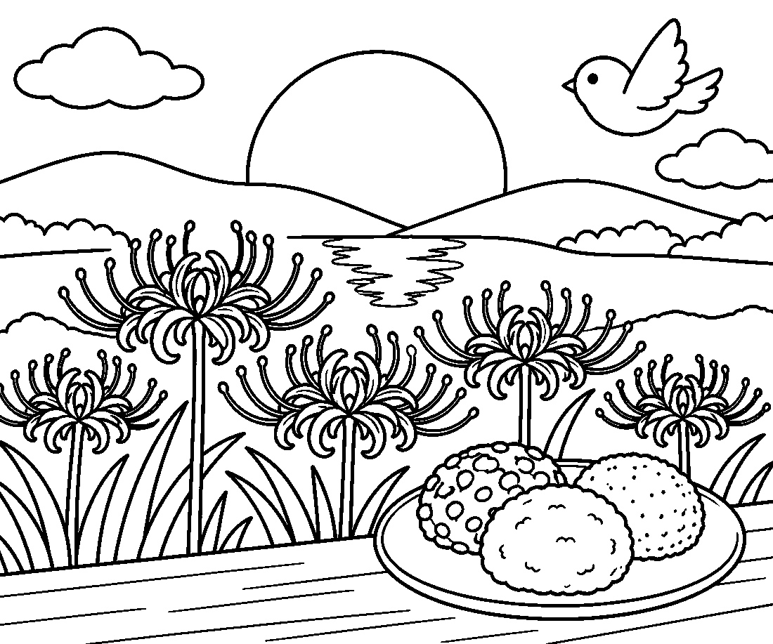

🍂 Autumnal Equinox Day Worksheet
Answer Key 解答
Reading Check: 1.A 2.D 3.B 4.C 5.A 6.D 7.B 8.B
True or False: 1.F 2.T 3.T 4.F 5.T 6.F
Match: 🌅=sunset 🍂=autumn leaf 🌺=red flower 🙏=pray 🌾=rice plant 🌰=chestnut 🔭=telescope 🌙=night
Unscramble: 1.EQUINOX 2.AUTUMN 3.GRAVE 4.SUNSET 5.HARVEST 6.ANCESTOR
Fill in the blanks: (1)grave (2)water (3)flowers (4)incense (5)ohagi (6)plate (7)higanbana (8)fields (9)summer (10)smile
Sentence order: 1. The sun sets exactly in the west. 2. We visit our family grave on this day. 3. Ohagi is covered in sweet bean paste. 4. Red flowers bloom along the rice fields. 5. The summer heat ends around this time.
Secret Code: THANK YOU ANCESTORS
Maze: EQUINOX
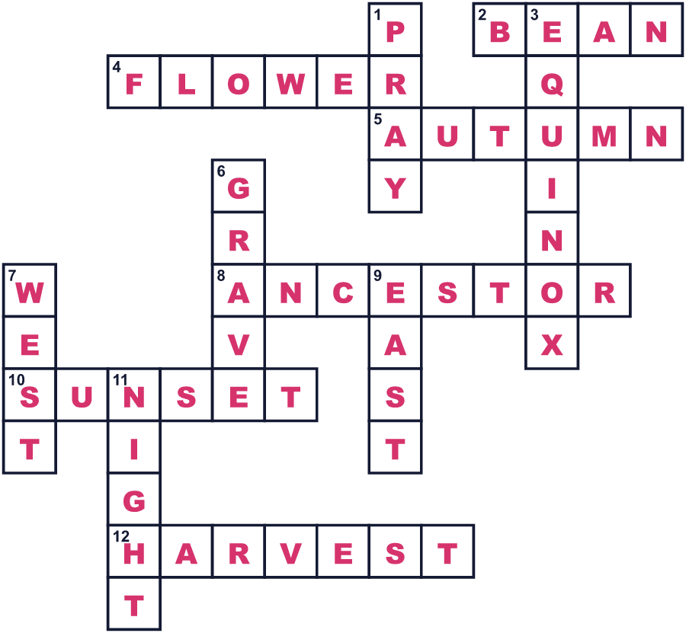
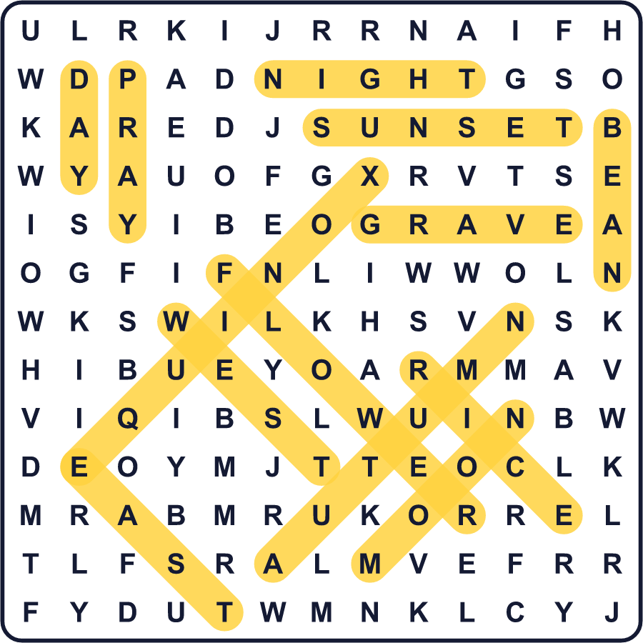
全訳
1 1年に2回、太陽はちょうど真東から昇り、真西に沈みます。そのうちの1日は9月にやってきます。日本ではそれが「秋分の日」という国民の祝日です。
2 日付は年によって違います。たいてい9月22日か23日です。たとえば2026年は9月23日でしたが、2028年はおそらく9月22日になります。法律には日付が書かれていません。代わりに、国立天文台の科学者たちが太陽の動きを調べて、正しい日を見つけます。政府は毎年2月に、翌年の日付を発表します。
3 この祝日は、祖先を敬い、亡くなった人々をしのぶ日です。春と秋にある仏教の1週間、お彼岸のまん中の日です。多くの家族がお墓参りに行き、お墓を掃除して花を供えます。お寺の特別な法要に行く人もいます。また、もち米を甘いあんこで包んだ「おはぎ」を食べます。
4 なぜこの日なのでしょう。仏教では、極楽浄土と呼ばれる幸せな世界が、はるか西にあるとされます。秋分の日には太陽がちょうど西に沈むので、人々は祈るのにいちばんよい日だと考えました。この習わしは日本にしかありません。
5 このころ、彼岸花と呼ばれるまっ赤な花が田んぼのあぜに咲きます。その名前は「お彼岸の花」という意味です。人々はまた、夏の暑さはお彼岸で終わると言います。ところで、秋分の日の昼と夜は、ぴったり同じではありません。東京では、昼のほうがまだ10分以上長いのです！

