🎌 Showa Day Worksheet
One Date, Four Names
Read the story. 英文を読もう。
Class ______ No. ____ Name ______________________________

🔊 音声を聞こう（スマホで読みとってね）
1 Some holidays keep the same name for hundreds of years. But in Japan, one spring holiday has had four names in less than 100 years. Its date is April 29, and today it is called Showa Day.
2 April 29 was the birthday of Emperor Showa. He was born in 1901 and became emperor in 1926. His time on the throne is called the Showa era. It lasted for 62 years, longer than any other era name in Japan. In those years, Japan went through a terrible war and then rebuilt itself.
3 From 1927, April 29 was a holiday for the emperor's birthday. When he died in 1989, the Emperor's Birthday moved to the new emperor's birthday. But people did not want to lose a holiday in Golden Week, a long series of spring holidays. So April 29 became Greenery Day, because the emperor loved plants and studied nature.
4 Later, some lawmakers wanted a day to remember the Showa era. Their plan failed twice, but it passed on the third try in 2005. Since 2007, April 29 has been Showa Day, and Greenery Day has moved to May 4.
5 The law gives this day a clear purpose. It is a day to look back on a time of war and recovery. It is also a day to think about the future of Japan. Many families travel on this day. Others ask their grandparents about life long ago, when TVs were black and white.
Words 単語
era（時代、元号の期間） / emperor（天皇、皇帝） / throne（王座、皇位） / last（続く） / terrible（ひどい、恐ろしい） / rebuild（再建する、立て直す） / greenery（緑の草木） / lawmaker（議員、立法者） / fail（失敗する） / look back on（～をふり返る） / future（未来、将来） / grandparents（祖父母）

🎌 Showa Day Worksheet
Reading Check
Choose the best answer. 正しいものを選ぼう。
Class ______ No. ____ Name ______________________________
1. What is the main idea of the passage?
(A) April 29 has changed its name many times, and today it is Showa Day. (B) Showa Day is a festival for gardeners. (C) Showa Day started in 1901. (D) Showa Day is a day to celebrate a new emperor.
2. How long did the Showa era last?
(A) 26 years (B) 48 years (C) 62 years (D) 100 years
3. What was April 29 called after 1989?
(A) Culture Day (B) Children's Day (C) Showa Day (D) Greenery Day
4. Why was April 29 named Greenery Day?
(A) Because many trees are cut on that day. (B) Because the emperor loved plants and studied nature. (C) Because green is the color of Golden Week. (D) Because the new emperor was born in a forest.
5. In paragraph 2, what does "rebuilt itself" mean?
(A) Made itself strong again after damage (B) Built a new emperor (C) Moved to a new place (D) Became very small
6. Which is true according to the passage?
(A) Greenery Day does not exist anymore. (B) The plan for Showa Day passed on the first try. (C) Greenery Day is now on May 4. (D) Showa Day is in winter.
7. Why did people probably want to keep April 29 as a holiday in 1989?
(A) Because they wanted to work more. (B) Because a long spring holiday is important to many people. (C) Because the new emperor was born on April 29. (D) Because it was the first day of school.
8. In the dialogue, what will Takumi do on Showa Day?
(A) Go to a birthday party (B) Plant trees in the park (C) Study for a test (D) Visit his grandparents
True or False? T か F に○
1. Showa Day is on April 29. T / F
2. April 29 was the birthday of Emperor Showa. T / F
3. Showa Day started in 1948. T / F
4. Greenery Day is now on May 4. T / F
5. The Showa era lasted for 100 years. T / F
6. Showa Day is the last holiday of Golden Week. T / F

🎌 Showa Day Worksheet
Word Work
単語のれんしゅう
Class ______ No. ____ Name ______________________________
① Match the pictures and the words. 絵と単語を線でむすぼう。
📅 | ● | ● | train
🎂 | ● | ● | microscope
🌳 | ● | ● | tree
🔬 | ● | ● | grandmother
📺 | ● | ● | birthday
🚄 | ● | ● | calendar
📷 | ● | ● | camera
👵 | ● | ● | television
② Unscramble the words. 並べかえて単語にしよう。
1. R R O E P M E (天皇) → ____________________
2. H Y S T R O I (歴史) → ____________________
3. U T F R U E (未来) → ____________________
4. P S T N A L (植物（複数）) → ____________________
5. I L R A P (4月) → ____________________
6. V A E T L R (旅行する) → ____________________
③ Fill in the blanks. 語群から選んで入れよう。
[ Olympics / stories / names / school / snowman / plants / album / TV / garden / Halloween / grandmother / surprised / smartphone ]
April 29 is Showa Day. Kaito does not have (1) __________ today. He visits his (2) __________ in the countryside. She shows him an old photo (3) __________ . In one photo, she is a young girl in front of a black and white (4) __________ . "We watched the Tokyo (5) __________ on this TV in 1964," she says. Kaito is (6) __________ . Then they walk in the (7) __________ together. Grandma knows the (8) __________ of many (9) __________ . Kaito says, "I want to hear more (10) __________ about the Showa era!"

🎌 Showa Day Worksheet
Crossword Puzzle
ヒントを読んでクロスワードを完成させよう。
Class ______ No. ____ Name ______________________________
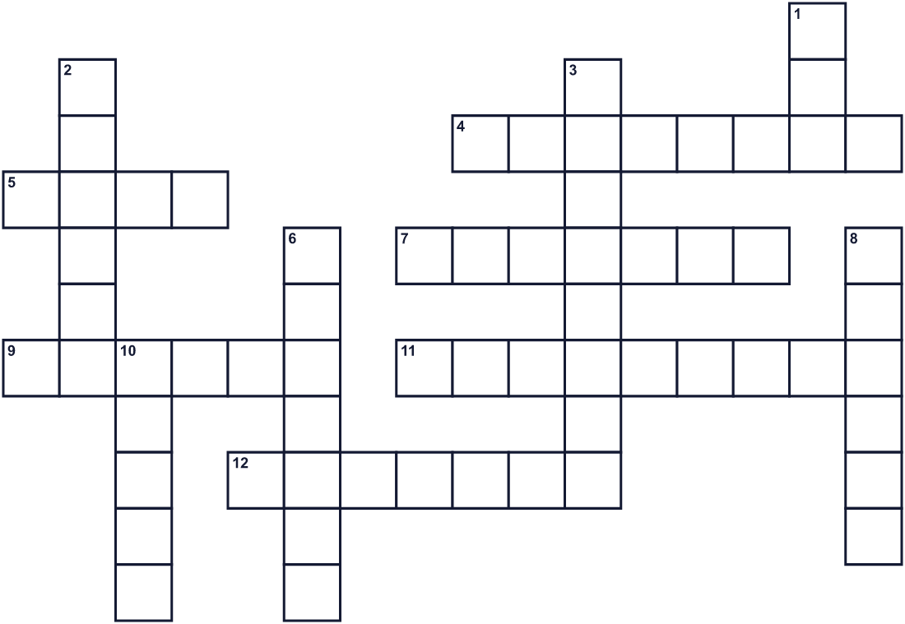
Across →
4. The day you were born. (8)
5. A big green place with trees where families walk. (4)
7. The head of the Imperial family of Japan. (7)
9. Trees, flowers, and grass are all these. (6)
11. A person who studies nature in a lab. (9)
12. A day with no school or work. (7)
Down ↓
1. A long period of time with a name, like Heisei or Reiwa. (3)
2. To go on a trip. Many people do this in Golden Week. (6)
3. Green plants and trees. A May holiday has this word in its name. (8)
6. The study of the past. (7)
8. The time that will come after now. (6)
10. The fourth month of the year. (5)

🎌 Showa Day Worksheet
Word Search
かくれた単語をさがそう（→ ↓ ↘ ↗）
Class ______ No. ____ Name ______________________________
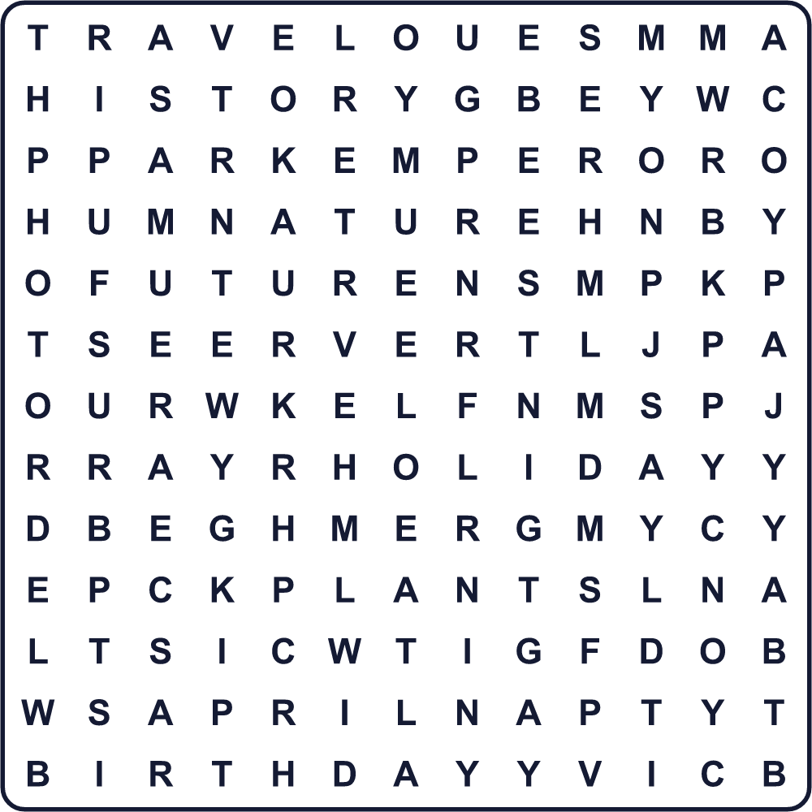
APRIL BIRTHDAY EMPEROR ERA FUTURE GREENERY HISTORY HOLIDAY NATURE PARK PHOTO PLANTS SHOWA TRAVEL
Secret Code 暗号を解こう
✎=A ☃=B ▲=C ✂=D ♣=E ☎=H ☺=K ✈=L ☘=N ♦=O
✈ ♦ ♦ ☺ ☃ ✎ ▲ ☺ ✎ ☘ ✂ ✈ ♦ ♦ ☺ ✎ ☎ ♣ ✎ ✂
______________________________________________________________

🎌 Showa Day Worksheet
Maze & Sentences
Class ______ No. ____ Name ______________________________
Help Riku find his grandpa's old photo album! リクがおじいちゃんの古いアルバムを見つけられるように助けよう！
正しい道の文字を集めると、ひみつの言葉になるよ。 START 👦 → GOAL 📷
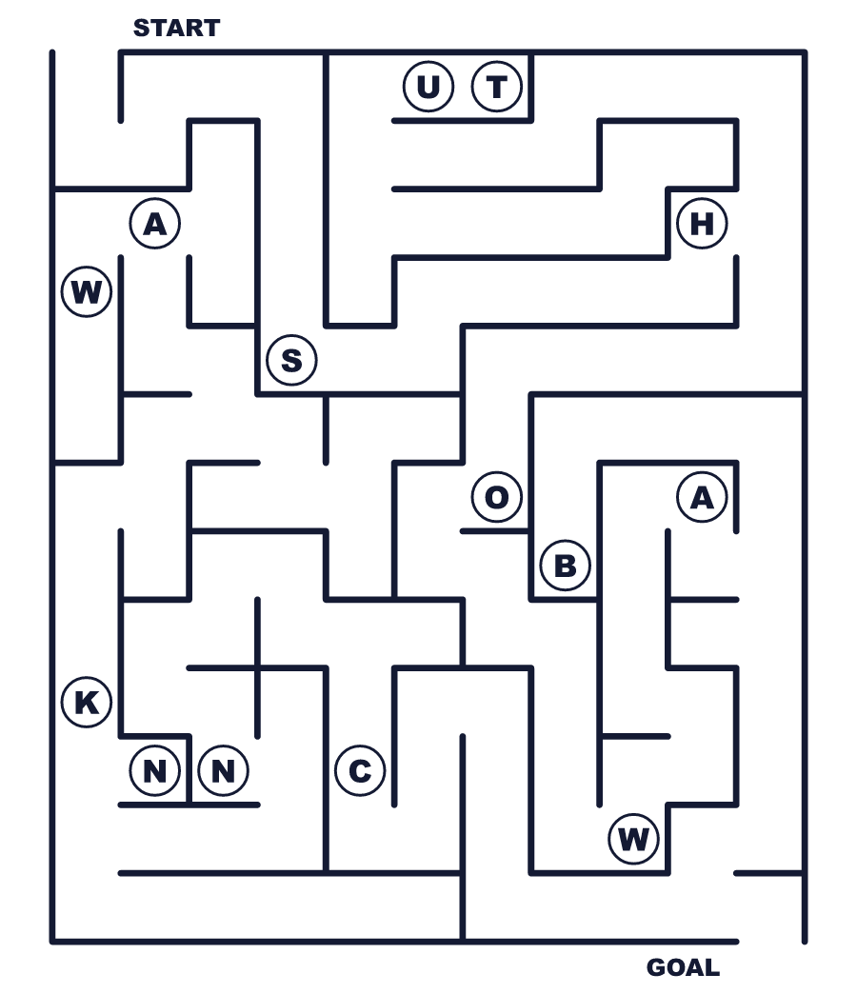
Secret word: ＿ ＿ ＿ ＿ ＿
Put the words in order. 並べかえよう。
1. April / Day / Japan / is / Showa / in / 29 . (4月29日は日本の昭和の日です。)
______________________________________________________________
2. and / The / nature / plants / loved / emperor . (天皇は植物と自然を愛しました。)
______________________________________________________________
3. to / 4 / moved / Greenery / May / Day . (みどりの日は5月4日に移りました。)
______________________________________________________________
4. look / the / era / We / back / Showa / on . (私たちは昭和の時代をふり返ります。)
______________________________________________________________
5. Golden / families / travel / during / Week / Many . (多くの家族がゴールデンウィークに旅行します。)
______________________________________________________________

🎌 Showa Day Worksheet
Class Activity & Writing
Class ______ No. ____ Name ______________________________
Find Someone Who… クラスで聞いて回ろう！
Find someone who … | Name
… has visited a grandparent during Golden Week ゴールデンウィークに祖父母を訪ねたことがある
… knows someone born in the Showa era 昭和生まれの人を知っている
… has seen a black and white photo 白黒写真を見たことがある
… can name all four holidays in Golden Week ゴールデンウィークの4つの祝日を全部言える
… likes studying history 歴史の勉強が好き
… has looked at something under a microscope 顕微鏡で何かを見たことがある
… knows what era name we use now 今の元号を知っている
… likes going to big parks 大きな公園に行くのが好き
Let's Write! 英語で書いてみよう。
If I could ask a person from the Showa era one question, I would ask, "______?"
昭和の時代の人に一つ質問できるなら「______？」と聞きます。
______________________________________________________________
______________________________________________________________
In the future, I hope Japan will be ______ because ______.
将来、日本が______になってほしいです。なぜなら______だからです。
______________________________________________________________
______________________________________________________________
To explain Showa Day to a friend from abroad, I would say, "______."
海外の友だちに昭和の日を説明するなら「______」と言います。
______________________________________________________________
______________________________________________________________

🎌 Showa Day Worksheet
Trace & Color
なぞって書こう。絵に色をぬろう。
Class ______ No. ____ Name ______________________________
📅 

🎂 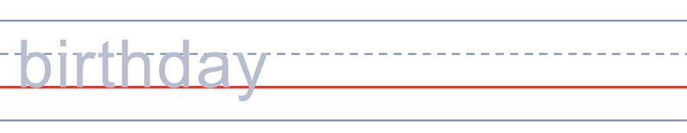
🌳 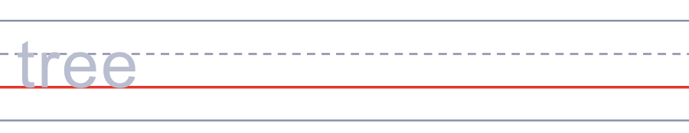
🔬 
📺 


🎌 Showa Day Worksheet
Answer Key 解答
Reading Check: 1.A 2.C 3.D 4.B 5.A 6.C 7.B 8.D
True or False: 1.T 2.T 3.F 4.T 5.F 6.F
Match: 📅=calendar 🎂=birthday 🌳=tree 🔬=microscope 📺=television 🚄=train 📷=camera 👵=grandmother
Unscramble: 1.EMPEROR 2.HISTORY 3.FUTURE 4.PLANTS 5.APRIL 6.TRAVEL
Fill in the blanks: (1)school (2)grandmother (3)album (4)TV (5)Olympics (6)surprised (7)garden (8)names (9)plants (10)stories
Sentence order: 1. April 29 is Showa Day in Japan. 2. The emperor loved plants and nature. 3. Greenery Day moved to May 4. 4. We look back on the Showa era. 5. Many families travel during Golden Week.
Secret Code: LOOK BACK AND LOOK AHEAD
Maze: SHOWA
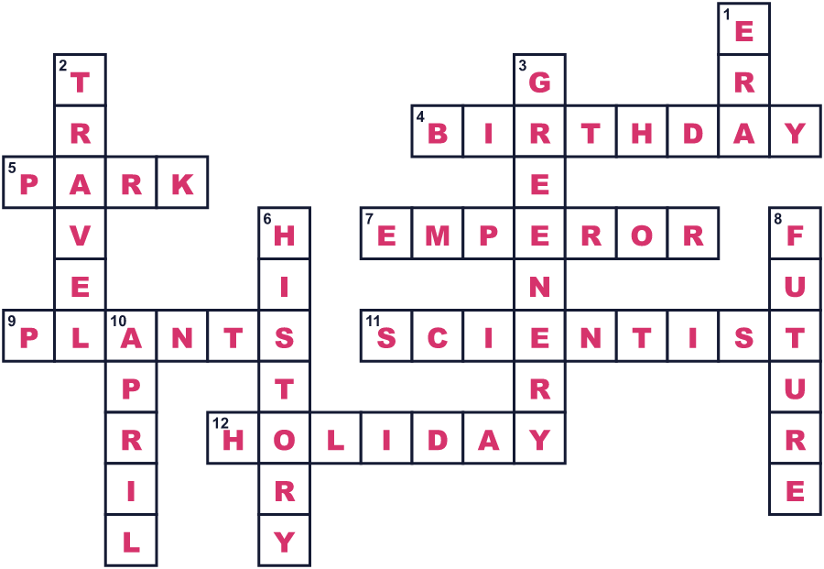
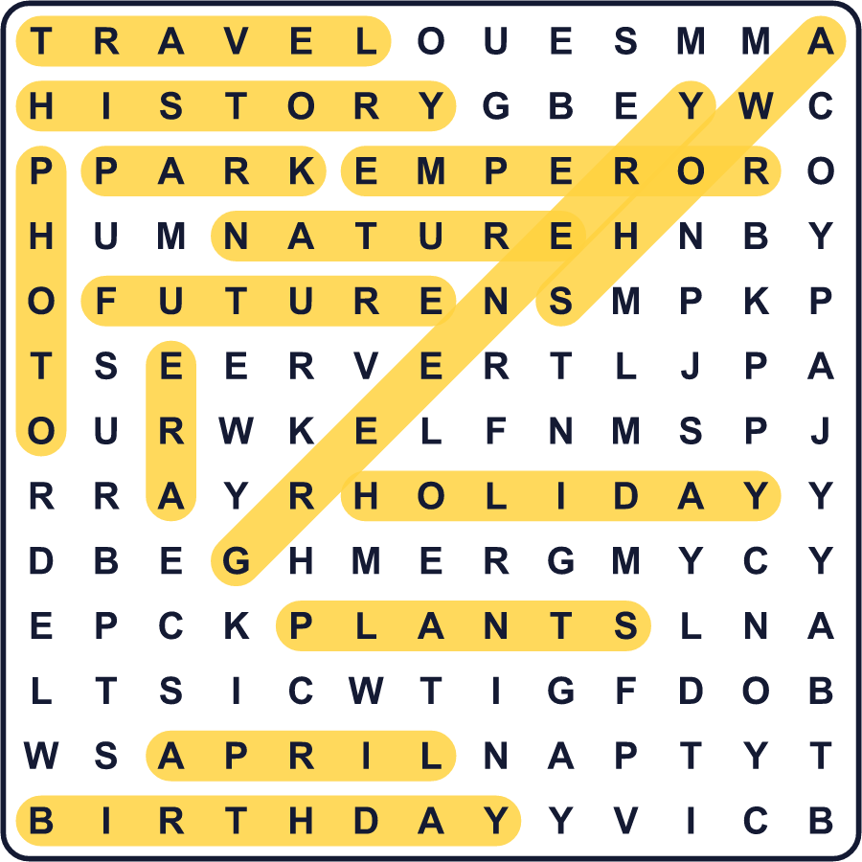
全訳
1 何百年も同じ名前のままの祝日もあります。でも日本には、100年たらずのあいだに4つの名前を持った春の祝日があります。その日付は4月29日で、今は「昭和の日」と呼ばれています。
2 4月29日は昭和天皇の誕生日でした。昭和天皇は1901年に生まれ、1926年に天皇になりました。その在位の時代を、昭和と言います。昭和は62年続き、日本のどの元号よりも長くなりました。その間に日本はひどい戦争を経験し、そのあと国を立て直しました。
3 1927年から、4月29日は天皇の誕生日の祝日でした。1989年に亡くなると、天皇誕生日は新しい天皇の誕生日に移りました。でも人々は、春の長い連休であるゴールデンウィークの祝日を失いたくありませんでした。そこで4月29日は、植物を愛し自然を研究した天皇にちなんで「みどりの日」になりました。
4 その後、昭和の時代を思い出す日がほしいと考える議員たちが出てきました。その案は2回失敗しましたが、2005年、3回目の挑戦で成立しました。2007年から4月29日は昭和の日になり、みどりの日は5月4日に移りました。
5 法律は、この日にはっきりした目的をあたえています。それは、戦争と復興の時代をふり返る日です。そして、日本の未来について考える日でもあります。この日は多くの家族が旅行に出かけます。テレビが白黒だった昔の暮らしについて、祖父母に話を聞く人もいます。

