👘 Shichi-Go-San Worksheet
Seven, Five, Three: A Thank-You for Growing Up
Read the story. 英文を読もう。
Class ______ No. ____ Name ______________________________

🔊 音声を聞こう（スマホで読みとってね）
1 Every November, you can see small children in beautiful kimono at shrines all over Japan. Some hold their parents' hands. Others carry long paper bags with candy inside. This is Shichi-Go-San, which means seven, five, three. It is a festival for children aged three, five, and seven.
2 Long ago, these were three different events. At three, children's heads were no longer shaved, and they started to grow their hair. At five, boys wore a hakama, a kind of wide pants, for the first time. At seven, girls tied a real obi, a wide belt, instead of simple strings. Children often got sick in those days, so each of these steps was a big thank-you to the gods.
3 The name Shichi-Go-San became popular in Tokyo in the late 1800s. After World War II, families all over Japan started to celebrate it. Today, many families take photos at a studio and eat a special meal together. November 15 is not a national holiday, so most families visit a shrine on a weekend.
4 The candy in the bag is called chitose-ame, or thousand-year candy. It is long and thin, and it comes in red and white. Parents hope their children will have long and healthy lives. The bag shows a crane and a turtle because both are symbols of long life in Japan.
5 Many countries have their own ways to celebrate growing children. In Korea, babies choose an object at their first birthday party. In Mexico, girls have a big party when they turn fifteen. The ages and customs are different, but the message is the same. We are so glad you are here.
Words 単語
shrine（神社） / kimono（着物） / aged（～歳の） / ceremony（儀式） / odd number（奇数） / lucky（縁起がよい、幸運な） / candy（飴、お菓子） / crane（鶴） / turtle（亀） / symbol（象徴、しるし） / healthy（健康な） / grow up（成長する、大人になる）

👘 Shichi-Go-San Worksheet
Reading Check
Choose the best answer. 正しいものを選ぼう。
Class ______ No. ____ Name ______________________________
1. What is the passage mainly about?
(A) How to make chitose-ame at home (B) A Japanese festival that celebrates growing children (C) The history of kimono in Japan (D) Birthday parties in Mexico
2. What did boys do at age five long ago?
(A) They shaved their heads. (B) They tied an obi. (C) They chose an object. (D) They wore a hakama for the first time.
3. When did the name Shichi-Go-San become popular in Tokyo?
(A) In the late 1800s (B) After World War II (C) In the year 1615 (D) Last year
4. Why do most families visit a shrine on a weekend?
(A) Because shrines are closed on weekdays (B) Because the candy is cheaper (C) Because November 15 is not a national holiday (D) Because children are three, five, or seven
5. In paragraph 4, the word symbols is closest in meaning to ____.
(A) signs (B) toys (C) foods (D) colors
6. Which is true about the passage?
(A) Shichi-Go-San was always one event. (B) Chitose-ame is red and white. (C) Girls tie an obi at age three. (D) Shichi-Go-San started after World War II.
7. Why was each step a big thank-you to the gods long ago?
(A) Because children got presents (B) Because it was a holiday (C) Because kimono were cheap (D) Because many children got sick and did not grow up safely
8. In the dialogue, what does Yui say about the name chitose-ame?
(A) It is a wish for a long life. (B) The candy is a thousand years old. (C) It comes from Brazil. (D) It is only for girls.
True or False? T か F に○
1. Shichi-Go-San is for children aged three, five, and seven. T / F
2. Shichi-Go-San is a national holiday in Japan. T / F
3. Chitose-ame means thousand-year candy. T / F
4. Long ago, boys tied an obi at age seven. T / F
5. The crane and the turtle are symbols of long life. T / F
6. All families must visit a shrine on November 15. T / F

👘 Shichi-Go-San Worksheet
Word Work
単語のれんしゅう
Class ______ No. ____ Name ______________________________
① Match the pictures and the words. 絵と単語を線でむすぼう。
👘 | ● | ● | girl
⛩️ | ● | ● | candy
🍬 | ● | ● | turtle
🐢 | ● | ● | kimono
📸 | ● | ● | boy
👧 | ● | ● | camera
👦 | ● | ● | shrine
🌕 | ● | ● | moon
② Unscramble the words. 並べかえて単語にしよう。
1. N I O K O M (着物) → ____________________
2. E H I S R N (神社) → ____________________
3. A C E N R (鶴) → ____________________
4. L U E T R T (亀) → ____________________
5. C Y N A D (飴) → ____________________
6. A Y E H H T L (健康な) → ____________________
③ Fill in the blanks. 語群から選んで入れよう。
[ kimono / years / crane / angry / photo / summer / hands / happy / shrine / pizza / grown / candy / obi ]
Hana is seven (1) __________ old. Today she is wearing a pink (2) __________ for the first time. Her mother ties a wide (3) __________ around her waist. The family walks to the (4) __________ near their house. Hana claps her (5) __________ and says thank you to the gods. After that, her grandfather gives her a long bag of (6) __________ . There is a (7) __________ and a turtle on it. They take a family (8) __________ under a big tree. Hana smiles. She feels very (9) __________ up and very (10) __________ .

👘 Shichi-Go-San Worksheet
Crossword Puzzle
ヒントを読んでクロスワードを完成させよう。
Class ______ No. ____ Name ______________________________
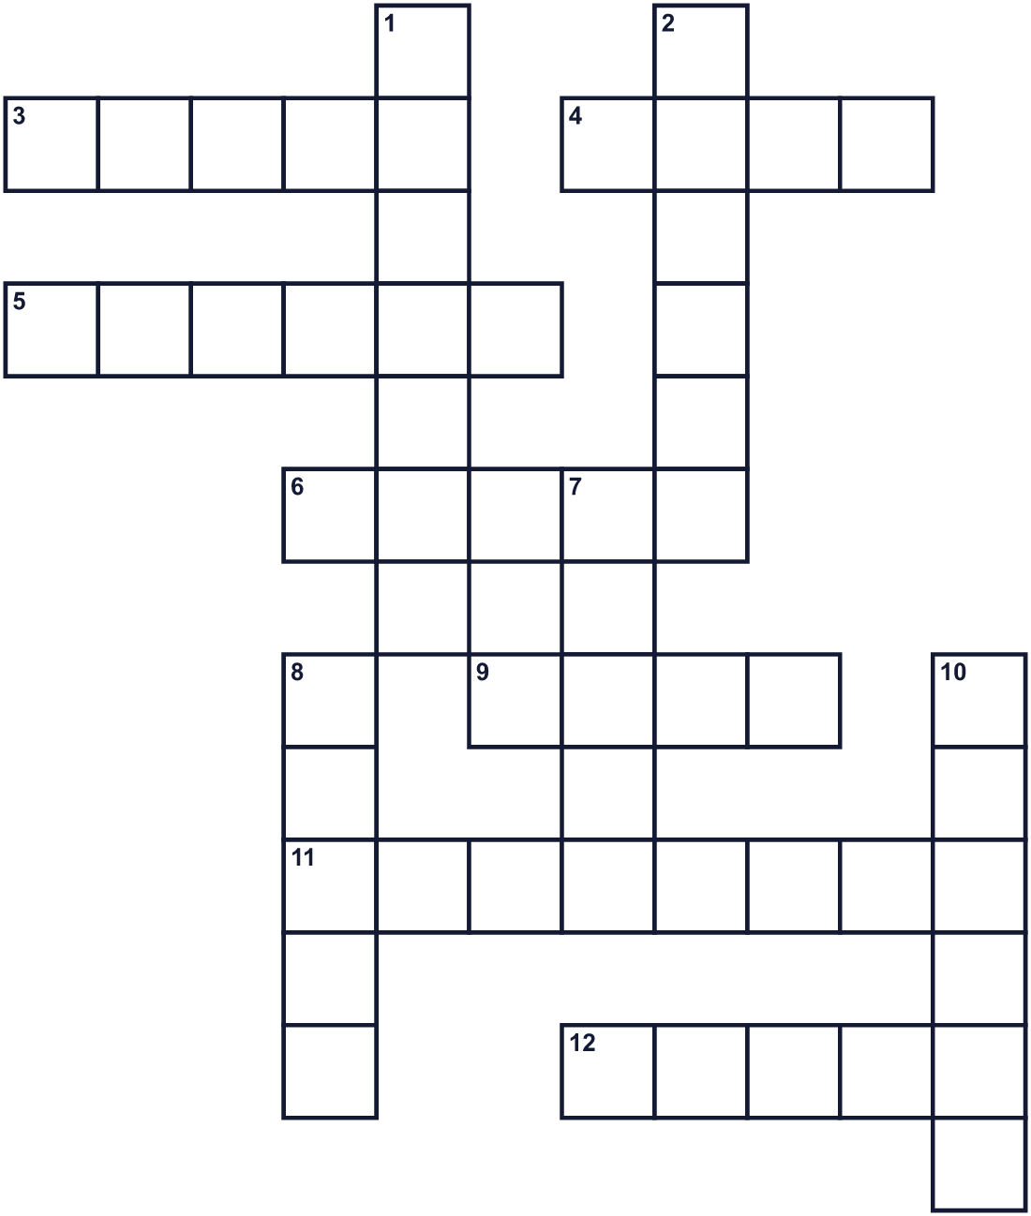
Across →
3. A bird with a long neck. It means long life. (5)
4. The number of fingers on one hand. (4)
5. A slow animal with a hard shell. (6)
6. A picture you take with a camera. (5)
9. To talk to God or the gods. (4)
11. The eleventh month of the year. (8)
12. The number after six. (5)
Down ↓
1. Strong and not sick. (7)
2. Traditional Japanese clothes with long sleeves. (6)
7. The number after two. (5)
8. A sweet food. Chitose-ame is one. (5)
10. A Shinto place where people pray. (6)

👘 Shichi-Go-San Worksheet
Word Search
かくれた単語をさがそう（→ ↓ ↘ ↗）
Class ______ No. ____ Name ______________________________
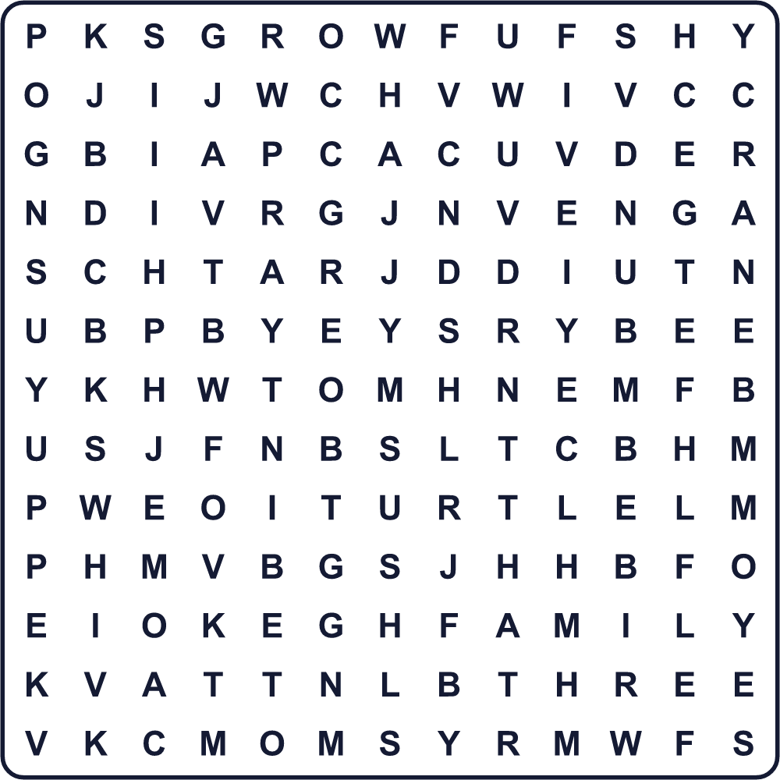
CANDY CRANE FAMILY FIVE GROW KIMONO OBI PHOTO PRAY SEVEN SHRINE THREE TURTLE
Secret Code 暗号を解こう
♪=A ✿=F ▲=G ♠=H ☺=I ☎=K ☘=N ✎=O ⚑=P ★=R ●=T ✈=U ♥=W ☂=Y
● ♠ ♪ ☘ ☎ ☂ ✎ ✈ ✿ ✎ ★ ▲ ★ ✎ ♥ ☺ ☘ ▲ ✈ ⚑
______________________________________________________________

👘 Shichi-Go-San Worksheet
Maze & Sentences
Class ______ No. ____ Name ______________________________
Help Hana get to the shrine! ハナを神社まで連れていこう！
正しい道の文字を集めると、ひみつの言葉になるよ。 START 👧 → GOAL ⛩️
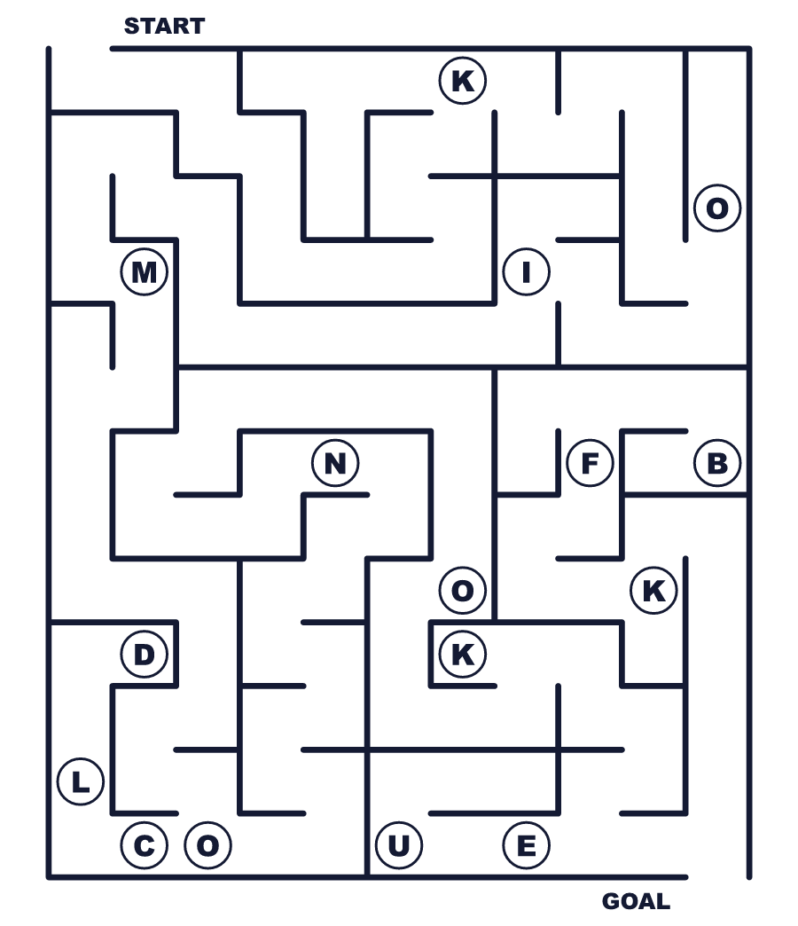
Secret word: ＿ ＿ ＿ ＿ ＿ ＿
Put the words in order. 並べかえよう。
1. Shichi-Go-San / a / for / children / is / festival . (七五三は子どものためのお祝いです。)
______________________________________________________________
2. Families / a / November / shrine / visit / in . (家族は11月に神社にお参りします。)
______________________________________________________________
3. day / Children / kimono / beautiful / on / wear / this . (この日、子どもたちは美しい着物を着ます。)
______________________________________________________________
4. long / a / wish / life / is / for / Chitose-ame . (千歳飴には長生きの願いがこめられています。)
______________________________________________________________
5. up / you / are / glad / are / We / growing . (あなたが大きくなってくれてうれしい。)
______________________________________________________________

👘 Shichi-Go-San Worksheet
Class Activity & Writing
Class ______ No. ____ Name ______________________________
Find Someone Who… クラスで聞いて回ろう！
Find someone who … | Name
… has a Shichi-Go-San photo 七五三の写真を持っている
… has eaten chitose-ame 千歳飴を食べたことがある
… has worn a kimono 着物を着たことがある
… knows what kazoedoshi means 数え年の意味を知っている
… has a younger brother or sister 弟か妹がいる
… can draw a crane 鶴の絵がかける
… likes taking photos 写真を撮るのが好き
… can fold a paper crane 折り鶴を折れる
Let's Write! 英語で書いてみよう。
When I was little, I ______.
小さいころ、私は＿＿でした（＿＿しました）。
______________________________________________________________
______________________________________________________________
I want to thank my family for ______.
私は家族に＿＿のことで感謝したいです。
______________________________________________________________
______________________________________________________________
If I explain Shichi-Go-San to a friend from abroad, I will say ______.
海外の友だちに七五三を説明するなら、＿＿と言います。
______________________________________________________________
______________________________________________________________

👘 Shichi-Go-San Worksheet
Trace & Color
なぞって書こう。絵に色をぬろう。
Class ______ No. ____ Name ______________________________
👘 

⛩️ 
🍬 
🐢 
📸 
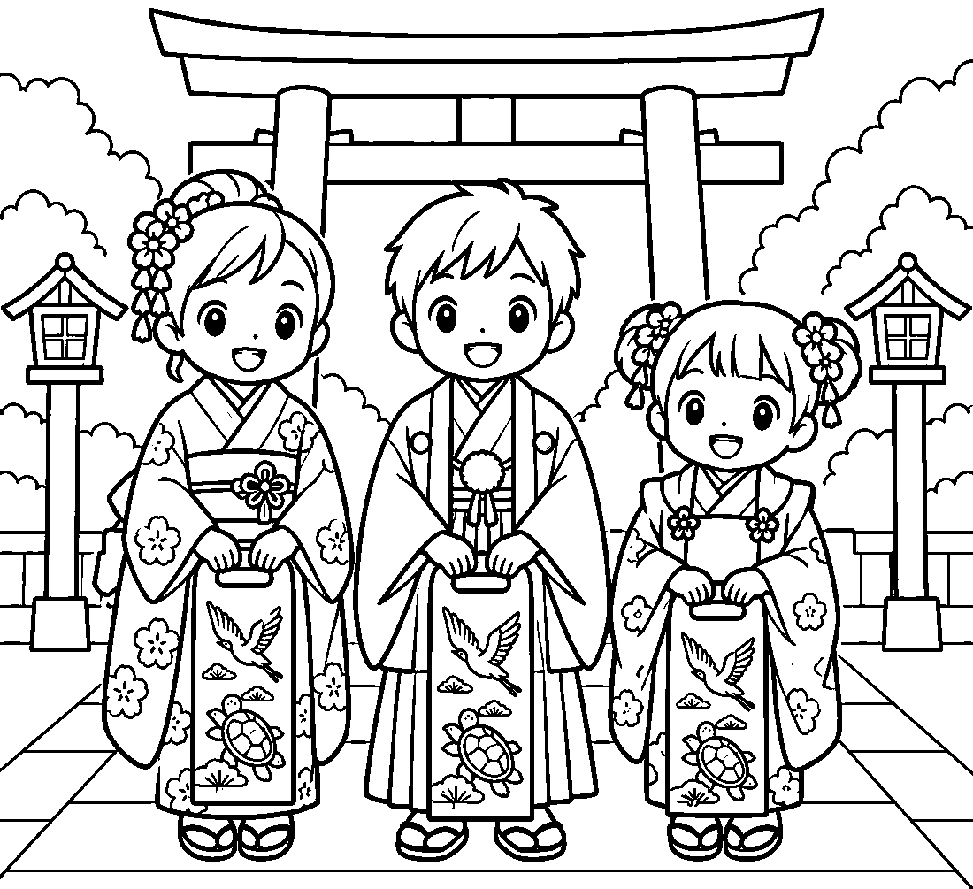

👘 Shichi-Go-San Worksheet
Answer Key 解答
Reading Check: 1.B 2.D 3.A 4.C 5.A 6.B 7.D 8.A
True or False: 1.T 2.F 3.T 4.F 5.T 6.F
Match: 👘=kimono ⛩️=shrine 🍬=candy 🐢=turtle 📸=camera 👧=girl 👦=boy 🌕=moon
Unscramble: 1.KIMONO 2.SHRINE 3.CRANE 4.TURTLE 5.CANDY 6.HEALTHY
Fill in the blanks: (1)years (2)kimono (3)obi (4)shrine (5)hands (6)candy (7)crane (8)photo (9)grown (10)happy
Sentence order: 1. Shichi-Go-San is a festival for children. 2. Families visit a shrine in November. 3. Children wear beautiful kimono on this day. 4. Chitose-ame is a wish for long life. 5. We are glad you are growing up.
Secret Code: THANK YOU FOR GROWING UP
Maze: KIMONO
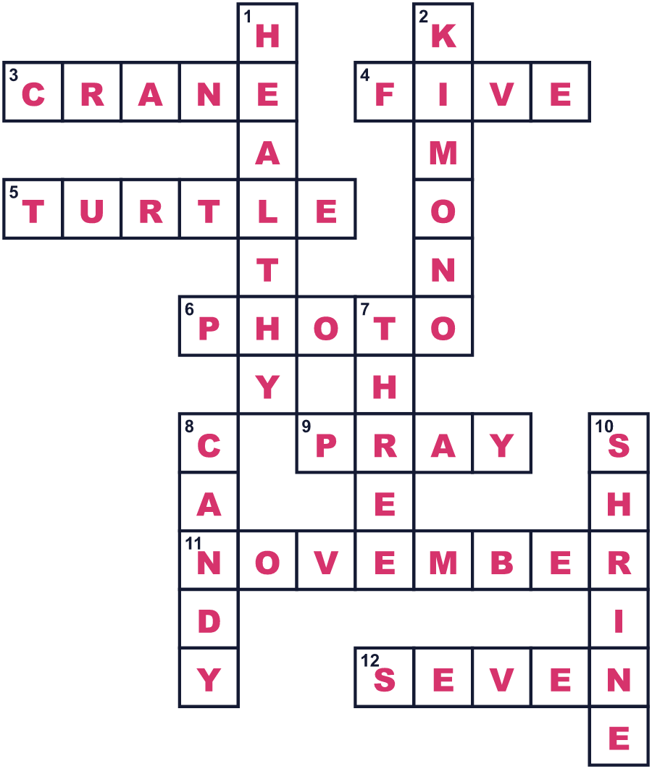
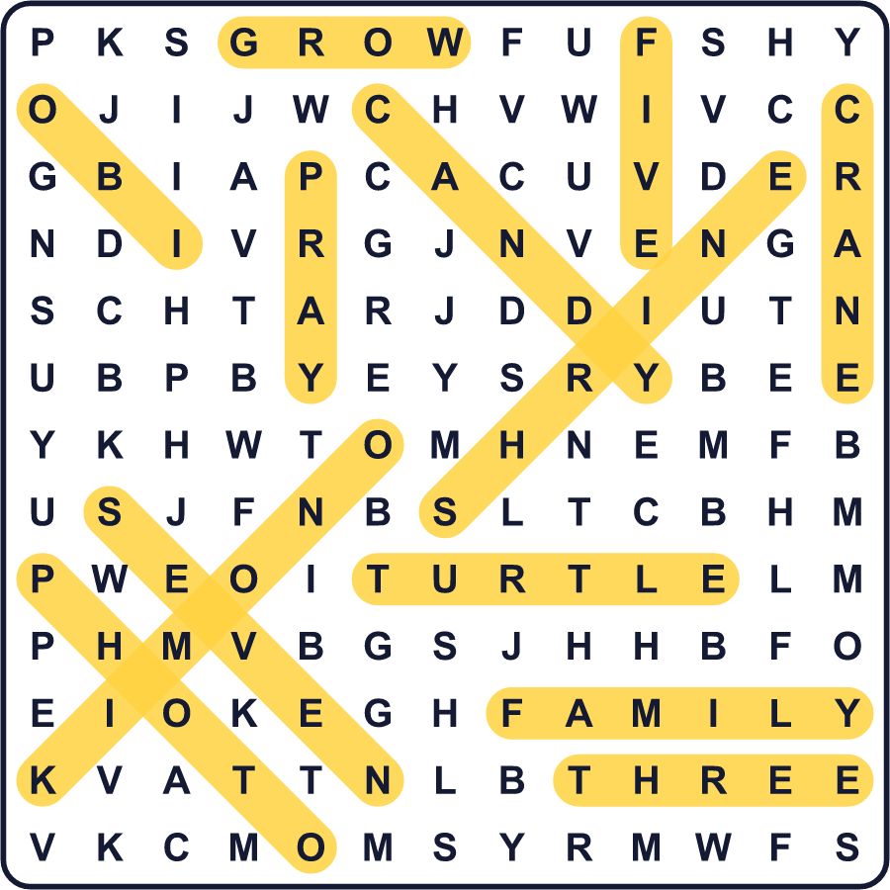
全訳
1 毎年11月になると、日本中の神社で美しい着物を着た小さな子どもたちを見かけます。親と手をつないでいる子もいれば、中に飴が入った細長い紙袋を持っている子もいます。これが七五三、「7・5・3」という意味の行事です。3歳・5歳・7歳の子どものためのお祝いです。
2 昔、これらは3つの別々の行事でした。3歳になると、子どもは頭をそられることがなくなり、髪を伸ばし始めました。5歳になると、男の子は初めて袴という幅の広いズボンのようなものをはきました。7歳になると、女の子は簡単なひもではなく、本物の帯という幅の広い帯を結びました。当時は子どもがよく病気になったので、一つ一つの節目は神さまへの大きな「ありがとう」でした。
3 七五三という名前は、1800年代の終わりに東京で広まりました。第二次世界大戦の後、日本中の家族が七五三を祝うようになりました。今では、写真館で写真を撮り、家族でごちそうを食べる家族が多くいます。11月15日は祝日ではないので、たいていの家族は週末に神社へお参りします。
4 袋の中の飴は千歳飴、つまり「千年の飴」と呼ばれます。細長くて、赤と白の色をしています。親は子どもが長く健康に生きることを願っています。袋に鶴と亀が描かれているのは、どちらも日本では長寿の象徴だからです。
5 多くの国に、子どもの成長を祝う独自のやり方があります。韓国では、赤ちゃんが1歳の誕生日パーティーで物を一つ選びます。メキシコでは、女の子が15歳になると盛大なパーティーをします。年齢も習慣も違いますが、伝えたいことは同じです。あなたがここにいてくれて、本当にうれしい。

