👹 Setsubun Worksheet
Demons Out, Luck In!
Read the story. 英文を読もう。
Class ______ No. ____ Name ______________________________

🔊 音声を聞こう（スマホで読みとってね）
1 On a cold night in early February, Japanese families open the front door and throw beans into the dark. They shout, 'Oni wa soto! Fuku wa uchi!' It means 'Demons out! Luck in!' This is Setsubun. Then they quickly close the door, so the demons cannot come back in.
2 Setsubun means the line between two seasons. Long ago, there were four Setsubun days each year, one before each season. Today, people only celebrate the day before the first day of spring. It is usually February 3, but not always. In 2021 and 2025, it was on February 2.
3 The custom began at the palace more than 1,000 years ago. People held a ceremony to chase away demons that brought sickness. A man in a scary mask with four eyes chased the demons. He also carried a spear and a big shield. But later, people began to see this man as a demon himself!
4 Today, people throw roasted soybeans. After that, each person eats one bean for each year of their age. Some people eat one more for good luck. So a grandmother who is 80 has a lot of beans to eat! In snowy places like Hokkaido, many families throw peanuts, because they are easy to find in the snow.
5 Many people also eat ehomaki, a thick sushi roll. They face the lucky direction of the year and eat the whole roll without talking. People say this custom came from Osaka. In 1989, a convenience store in Hiroshima gave it the name ehomaki, and by the 2000s the whole country was eating it.
Words 単語
demon（鬼、悪魔） / throw（投げる、まく） / roasted（炒った、焼いた） / soybean（大豆） / chase away（追い払う） / luck（運、幸運） / season（季節） / direction（方角、方向） / mask（お面、仮面） / custom（習慣、風習） / ceremony（儀式、式） / sickness（病気）

👹 Setsubun Worksheet
Reading Check
Choose the best answer. 正しいものを選ぼう。
Class ______ No. ____ Name ______________________________
1. What is the main idea of the reading?
(A) Setsubun is a summer festival in Osaka. (B) Setsubun is a day to chase away bad luck before spring. (C) Setsubun is a day to give gifts to teachers. (D) Setsubun is a holiday when schools close.
2. How many Setsubun days were there each year long ago?
(A) One (B) Two (C) Three (D) Four
3. What did the man in the four-eyed mask do at first?
(A) He chased the demons. (B) He sold beans. (C) He made sushi. (D) He brought sickness.
4. How many beans should a 13-year-old eat?
(A) 3 beans (B) 8 beans (C) 13 or 14 beans (D) 80 beans
5. In paragraph 3, 'chase away' means:
(A) to make something go away (B) to invite someone to a party (C) to cook something quickly (D) to buy something cheaply
6. Which is true according to the reading?
(A) Setsubun is always on February 3. (B) Families in Hokkaido never throw anything. (C) People eat ehomaki without talking. (D) Ehomaki came from Hokkaido.
7. Why do you think families in snowy places throw peanuts?
(A) Because peanuts are bigger and easy to pick up from the snow (B) Because demons love peanuts (C) Because soybeans do not grow in Japan (D) Because peanuts are the lucky direction
8. In the dialogue, how many beans will Mia eat?
(A) 8 (B) 13 (C) 80 (D) 16
True or False? T か F に○
1. Setsubun is the day before the first day of spring. T / F
2. Setsubun is always on February 3. T / F
3. People say 'Demons out! Luck in!' T / F
4. People eat ehomaki while talking a lot. T / F
5. Some families throw peanuts instead of soybeans. T / F
6. Setsubun is a national holiday in Japan. T / F

👹 Setsubun Worksheet
Word Work
単語のれんしゅう
Class ______ No. ____ Name ______________________________
① Match the pictures and the words. 絵と単語を線でむすぼう。
👹 | ● | ● | fish
🫘 | ● | ● | peanuts
🍣 | ● | ● | compass
🥜 | ● | ● | beans
🧭 | ● | ● | demon
🐟 | ● | ● | spring flower
🌸 | ● | ● | door
🚪 | ● | ● | sushi
② Unscramble the words. 並べかえて単語にしよう。
1. E M O D N (鬼) → ____________________
2. S E S O N A (季節) → ____________________
3. R A E O S T D (炒った) → ____________________
4. T O U C S M (習慣) → ____________________
5. N E I T D I C O R (方角) → ____________________
6. Y A E B O S N (大豆) → ____________________
③ Fill in the blanks. 語群から選んで入れよう。
[ beans / mask / candy cane / swimsuit / quietly / lucky / door / sister / summer / year / direction / dinner / outside ]
It was February 3. After (1) __________ , Dad put on a red demon (2) __________ . "Grrr!" he said. Riku and his little (3) __________ were ready. They opened the (4) __________ and threw (5) __________ at Dad. "Oni wa soto! Fuku wa uchi!" Dad ran (6) __________ , and they quickly closed the door. Then they each ate beans, one for each (7) __________ of their age. Riku ate nine. Mom made ehomaki. Everyone faced the lucky (8) __________ and ate (9) __________ . Riku wanted to talk, but he did not. It was a (10) __________ night.

👹 Setsubun Worksheet
Crossword Puzzle
ヒントを読んでクロスワードを完成させよう。
Class ______ No. ____ Name ______________________________
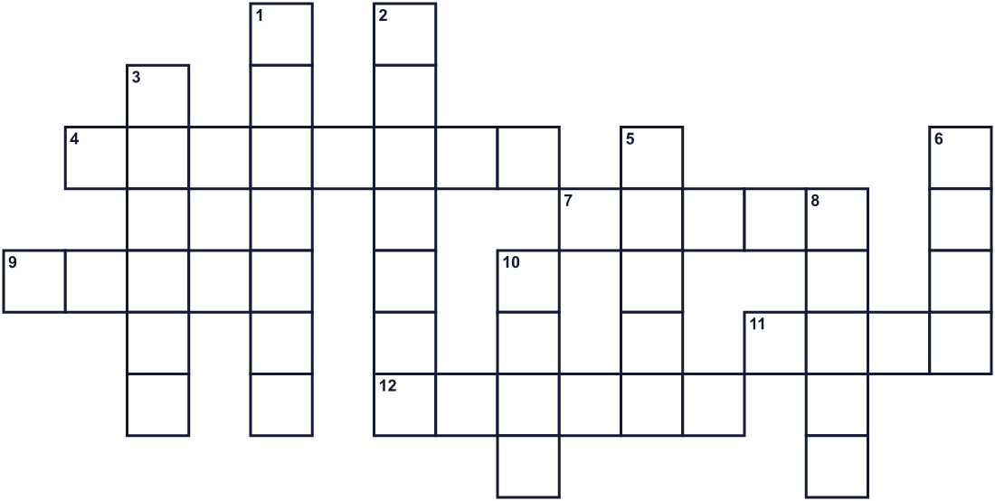
Across →
4. The month of this event. (8)
7. People throw these small seeds at oni. (5)
9. Japanese food with rice and fish. Ehomaki is a big roll of it. (5)
11. Good things that happen by chance. (4)
12. The season after winter. (6)
Down ↓
1. A small fish. Its head is put on a holly branch. (7)
2. Nuts in a shell. People in Hokkaido throw them. (7)
3. Spring, summer, fall, or winter. (6)
5. A scary monster with horns. In Japan, it is oni. (5)
6. You wear this over your face. Dad wears a scary one. (4)
8. The opposite of north. (5)
10. A hard pointed thing on the head of a cow or an oni. (4)

👹 Setsubun Worksheet
Word Search
かくれた単語をさがそう（→ ↓ ↘ ↗）
Class ______ No. ____ Name ______________________________
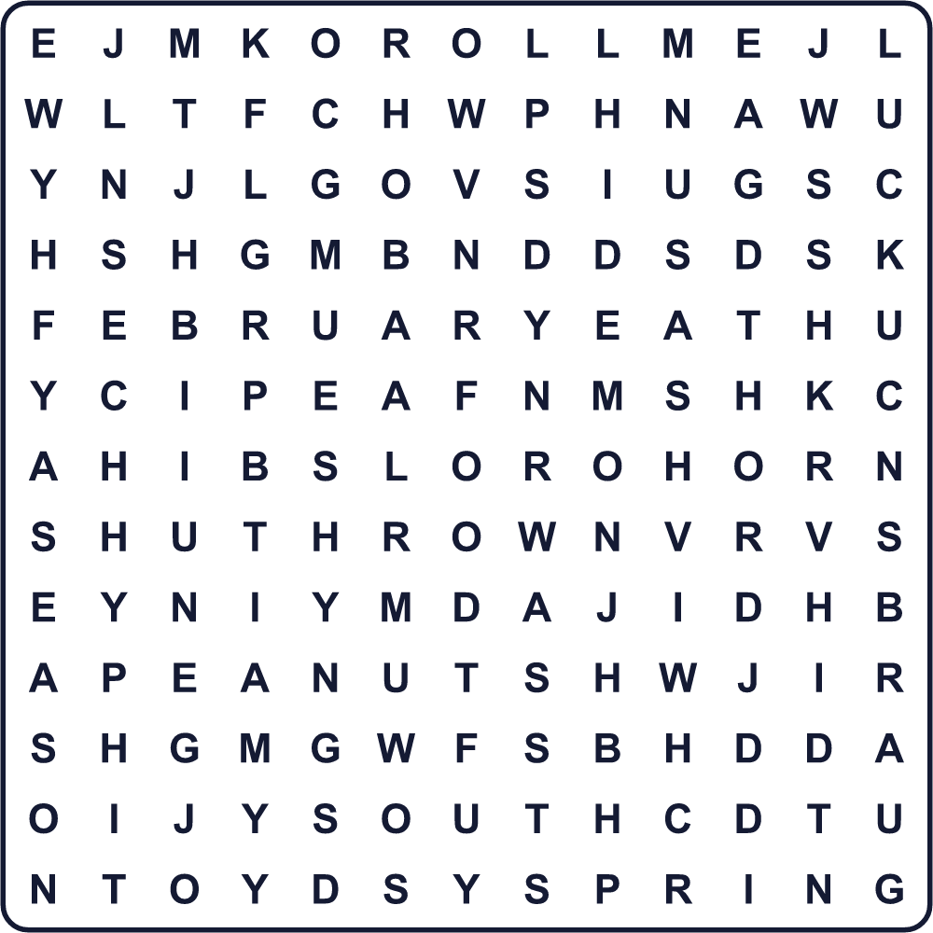
BEANS DEMON FEBRUARY HORN LUCK MASK PEANUTS ROLL SARDINE SEASON SOUTH SPRING SUSHI THROW
Secret Code 暗号を解こう
☂=C ♠=D ☎=E ⚓=I ■=K ◆=L ☃=M ♦=N ♪=O ✎=S ✈=T ☺=U
♠ ☎ ☃ ♪ ♦ ✎ ♪ ☺ ✈ ◆ ☺ ☂ ■ ⚓ ♦
______________________________________________________________

👹 Setsubun Worksheet
Maze & Sentences
Class ______ No. ____ Name ______________________________
Help the beans hit the demon! 豆を鬼まで届けよう！
正しい道の文字を集めると、ひみつの言葉になるよ。 START 🫘 → GOAL 👹
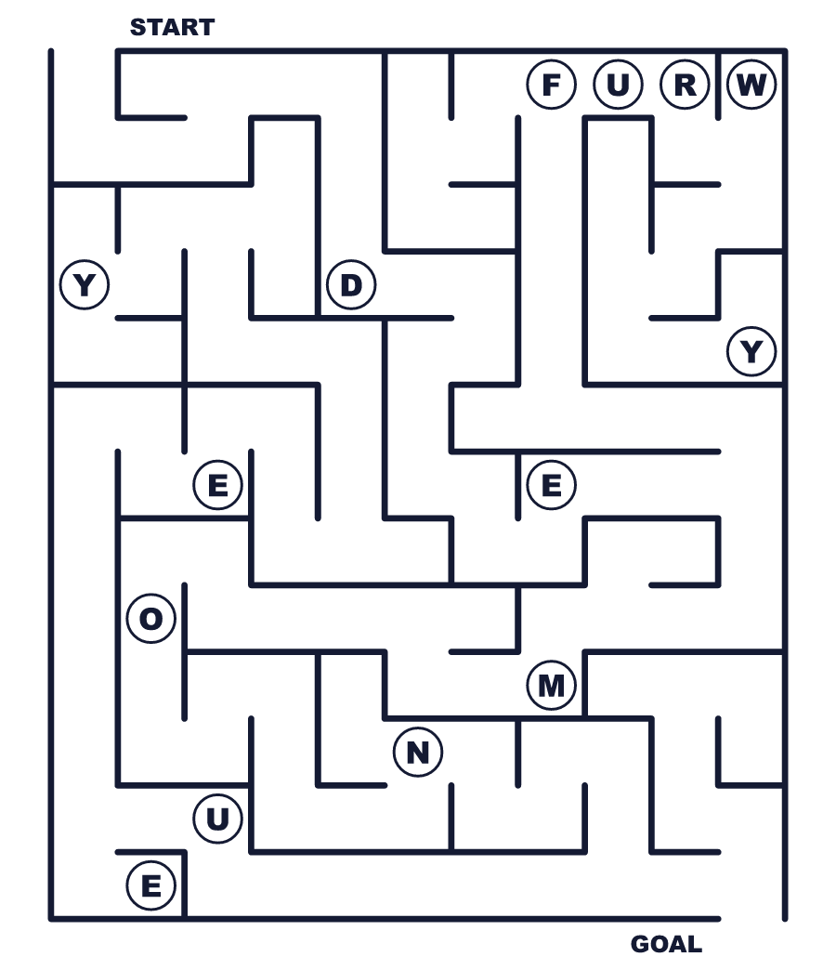
Secret word: ＿ ＿ ＿ ＿ ＿
Put the words in order. 並べかえよう。
1. the / beans / out / throw / We / door . (私たちはドアの外へ豆を投げます。)
______________________________________________________________
2. the / spring / is / before / Setsubun / day . (節分は春の前の日です。)
______________________________________________________________
3. for / each / bean / one / Eat / year . (1歳につき1粒の豆を食べなさい。)
______________________________________________________________
4. My / a / dad / mask / wears / demon / scary . (父はこわい鬼のお面をかぶります。)
______________________________________________________________
5. talking / ehomaki / eat / without / We . (私たちはしゃべらずに恵方巻を食べます。)
______________________________________________________________

👹 Setsubun Worksheet
Class Activity & Writing
Class ______ No. ____ Name ______________________________
Find Someone Who… クラスで聞いて回ろう！
Find someone who … | Name
… has thrown beans at a demon 鬼に豆を投げたことがある
… has worn a demon mask 鬼のお面をかぶったことがある
… likes ehomaki 恵方巻が好き
… knows this year's lucky direction 今年の恵方を知っている
… has thrown peanuts on Setsubun 節分に落花生をまいたことがある
… can eat ehomaki without talking しゃべらずに恵方巻を食べられる
… knows the date of Setsubun this year 今年の節分の日付を知っている
… can say 'Oni wa soto' in English 「鬼は外」を英語で言える
Let's Write! 英語で書いてみよう。
This year, I want to chase away ______ because ______.
今年は＿＿を追い払いたいです。なぜなら＿＿だからです。
______________________________________________________________
______________________________________________________________
I want to invite ______ into my home because ______.
＿＿を家に招き入れたいです。なぜなら＿＿だからです。
______________________________________________________________
______________________________________________________________
If I explain Setsubun to a friend, I will say ______.
節分を友だちに説明するなら、＿＿と言います。
______________________________________________________________
______________________________________________________________

👹 Setsubun Worksheet
Trace & Color
なぞって書こう。絵に色をぬろう。
Class ______ No. ____ Name ______________________________
👹 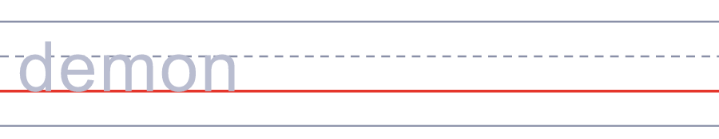

🫘 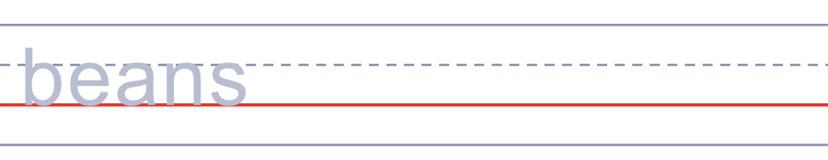
🍣 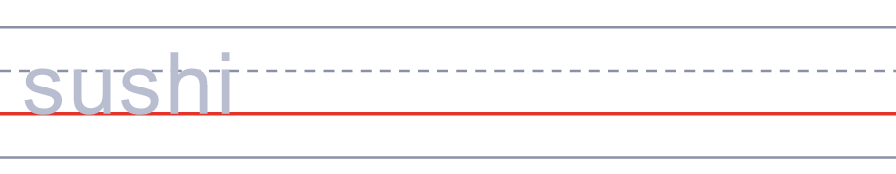
🥜 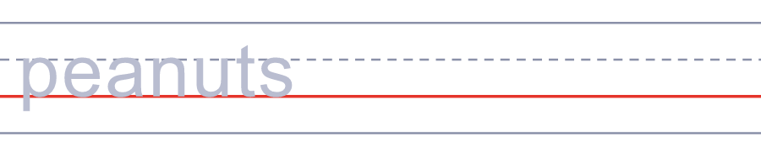
🧭 
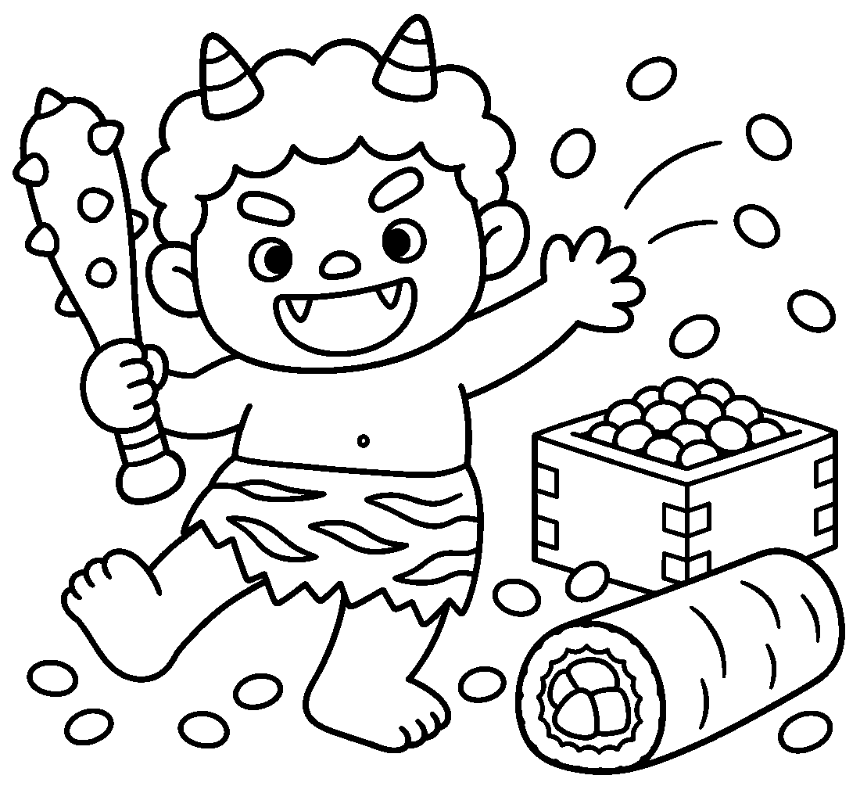

👹 Setsubun Worksheet
Answer Key 解答
Reading Check: 1.B 2.D 3.A 4.C 5.A 6.C 7.A 8.D
True or False: 1.T 2.F 3.T 4.F 5.T 6.F
Match: 👹=demon 🫘=beans 🍣=sushi 🥜=peanuts 🧭=compass 🐟=fish 🌸=spring flower 🚪=door
Unscramble: 1.DEMON 2.SEASON 3.ROASTED 4.CUSTOM 5.DIRECTION 6.SOYBEAN
Fill in the blanks: (1)dinner (2)mask (3)sister (4)door (5)beans (6)outside (7)year (8)direction (9)quietly (10)lucky
Sentence order: 1. We throw beans out the door. 2. Setsubun is the day before spring. 3. Eat one bean for each year. 4. My dad wears a scary demon mask. 5. We eat ehomaki without talking.
Secret Code: DEMONS OUT LUCK IN
Maze: DEMON
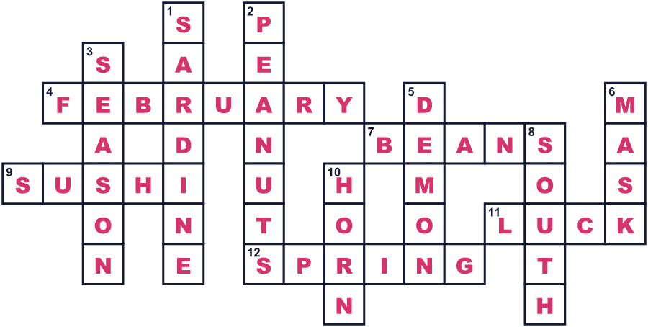
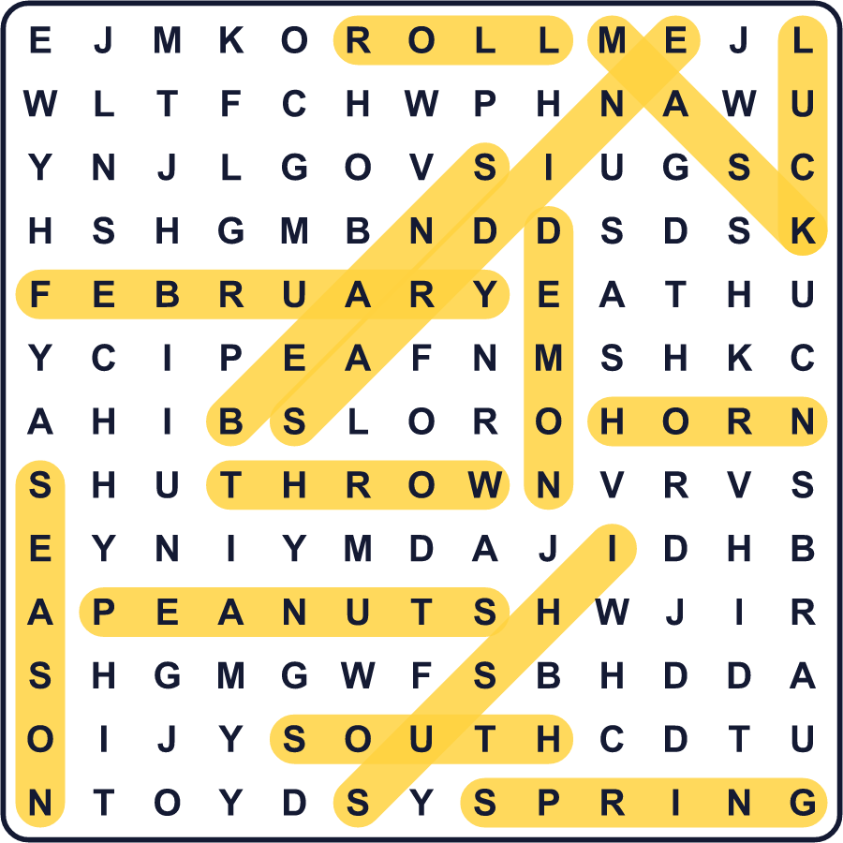
全訳
1 2月はじめの寒い夜、日本の家族は玄関の戸を開けて、暗やみに豆を投げます。「鬼は外！福は内！」とさけびます。それは「鬼は外へ！幸運は中へ！」という意味です。これが節分です。それから鬼がもどってこられないように、すぐに戸を閉めます。
2 節分は、2つの季節の間の線という意味です。昔は、それぞれの季節の前に1回ずつ、1年に4回の節分がありました。今では、春の始まりの日の前の日だけを祝います。たいてい2月3日ですが、いつもではありません。2021年と2025年は2月2日でした。
3 この習慣は、1000年以上前に宮中で始まりました。人々は、病気を運ぶ鬼を追い払うための儀式を行いました。4つの目があるこわい仮面をつけた男が、鬼を追いかけました。彼はほこと大きな盾も持っていました。でも後に、人々はこの男そのものを鬼だと思うようになりました！
4 今日、人々は炒った大豆をまきます。そのあと、一人ひとりが自分の年の数だけ豆を食べます。幸運のためにもう1つ食べる人もいます。だから80歳のおばあちゃんは、たくさんの豆を食べなければなりません！北海道のような雪の多い場所では、多くの家族が落花生をまきます。雪の中でも見つけやすいからです。
5 多くの人は、太い巻きずしの恵方巻も食べます。その年の縁起のよい方角を向いて、しゃべらずに1本まるごと食べます。この習慣は大阪から来たと言われています。1989年、広島のコンビニがそれに恵方巻という名前をつけ、2000年代には国じゅうで食べられるようになりました。

