👘 Coming of Age Day Worksheet
A Day for New Adults
Read the story. 英文を読もう。
Class ______ No. ____ Name ______________________________

🔊 音声を聞こう（スマホで読みとってね）
1 On the second Monday of January, young people in bright kimono fill the streets of Japan. It is Coming of Age Day, or Seijin no Hi. On this national holiday, towns hold ceremonies for young people who are becoming adults.
2 The idea started in 1946, just one year after the war. Japan was poor, and many young people felt lost. In a small town called Warabi, near Tokyo, a local youth group held a festival to give them hope. Life was still hard, and men wore plain wartime clothes while women wore work pants. The idea spread across the country, and in 1948 Japan made it a national holiday.
3 At first, the holiday was always on January 15. Some people say this date was chosen because of genpuku, an old ceremony for boys. In 2000, the holiday moved to the second Monday of January. Now people can enjoy a three-day weekend.
4 Many women wear furisode, a kimono with very long sleeves. Many men wear suits, and some wear hakama, a traditional kimono skirt. After the ceremony, old classmates meet again, take photos, and talk for hours. For many people, it feels like a big class reunion.
5 In 2022, the legal adult age in Japan changed from 20 to 18. But many towns still invite 20-year-olds, because most 18-year-olds are busy with exams. Some towns now call the event a gathering for twenty-year-olds. And one rule did not change at all. In Japan, you still have to wait until 20 for your first glass of sake.
Words 単語
adult（大人） / ceremony（式、儀式） / come of age（大人になる、成年に達する） / national holiday（国民の祝日） / sleeve（袖） / traditional（伝統的な） / invite（招待する） / legal（法律上の、合法の） / classmate（同級生） / hope（希望） / spread（広まる） / celebrate（祝う）

👘 Coming of Age Day Worksheet
Reading Check
Choose the best answer. 正しいものを選ぼう。
Class ______ No. ____ Name ______________________________
1. What is the main idea of the reading?
(A) Coming of Age Day is a holiday to celebrate young people becoming adults. (B) Coming of Age Day is a festival for children under 10. (C) Coming of Age Day started in Brazil. (D) Coming of Age Day is only for people who drink sake.
2. When did the idea of the ceremony start?
(A) In 1876 (B) In 2000 (C) In 2022 (D) In 1946
3. Why did the youth group in Warabi hold a festival?
(A) To sell kimono (B) To give young people hope (C) To start a new school (D) To celebrate the New Year
4. What happened to the holiday in 2000?
(A) It moved to the second Monday of January. (B) It moved to May. (C) It stopped being a holiday. (D) It became a two-week holiday.
5. In paragraph 2, 'felt lost' means:
(A) could not find the station (B) felt hungry (C) did not know what to do or hope for (D) were very happy
6. Which is true according to the reading?
(A) Men must wear furisode. (B) Many towns still invite 20-year-olds. (C) The holiday is always on January 15 now. (D) Old classmates never meet after the ceremony.
7. What can we guess about a 19-year-old in Japan today?
(A) They are not adults by law. (B) They can drink sake. (C) They are adults by law, but they cannot drink sake. (D) They cannot go to any ceremony.
8. In the dialogue, how old is Aoi's sister?
(A) 15 (B) 18 (C) 19 (D) 20
True or False? T か F に○
1. Coming of Age Day is in January. T / F
2. The first ceremony idea started in Osaka in 1990. T / F
3. Furisode is a kimono with long sleeves. T / F
4. In Japan, people can drink sake at 18. T / F
5. The holiday was on January 15 before 2000. T / F
6. Every town holds the ceremony for 18-year-olds. T / F

👘 Coming of Age Day Worksheet
Word Work
単語のれんしゅう
Class ______ No. ____ Name ______________________________
① Match the pictures and the words. 絵と単語を線でむすぼう。
👘 | ● | ● | kimono
📸 | ● | ● | camera
💐 | ● | ● | microphone
🎤 | ● | ● | flowers
👔 | ● | ● | school
🎂 | ● | ● | calendar
📅 | ● | ● | tie
🏫 | ● | ● | birthday cake
② Unscramble the words. 並べかえて単語にしよう。
1. D A T U L (大人) → ____________________
2. S V E L E E (袖) → ____________________
3. I I T V E N (招待する) → ____________________
4. L L G E A (法律上の) → ____________________
5. H E O P (希望) → ____________________
6. M N Y R E E C O (式) → ____________________
③ Fill in the blanks. 語群から選んで入れよう。
[ ceremony / homework / adult / summer / Day / photos / sleeves / party / classmates / beautiful / swimsuit / kimono / morning ]
Today is Coming of Age (1) __________ . Mika got up at four in the (2) __________ . She went to a beauty salon and put on a red (3) __________ with very long (4) __________ . Her grandmother cried and said, "You look (5) __________ !" At the (6) __________ , the mayor gave a short speech. After that, Mika saw her old (7) __________ from junior high school. They took a lot of (8) __________ together. In the evening, her family had a small (9) __________ . Now Mika feels like an (10) __________ .

👘 Coming of Age Day Worksheet
Crossword Puzzle
ヒントを読んでクロスワードを完成させよう。
Class ______ No. ____ Name ______________________________
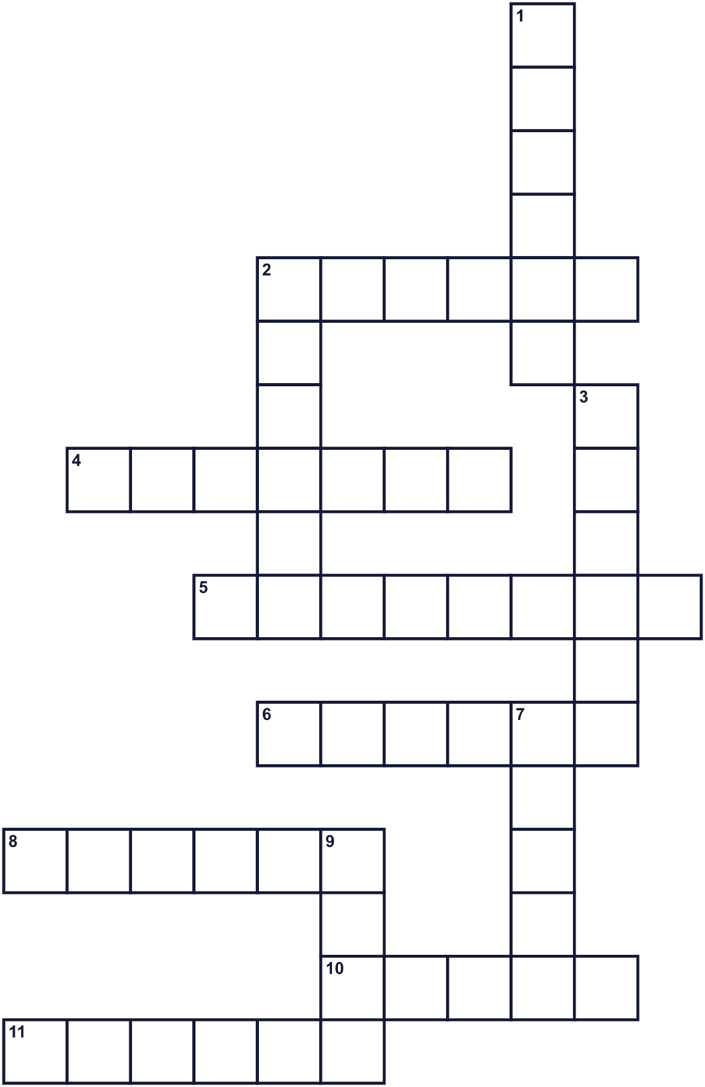
Across →
2. A person you like and trust. (6)
4. The month of this holiday. (7)
5. A formal event, like a wedding or a graduation. (8)
6. The holiday is on the second one of this day of the week. (6)
8. A talk in front of many people. (6)
10. A picture you take with a camera. (5)
11. The part of a shirt that covers your arm. (6)
Down ↓
1. Traditional Japanese clothing with wide sleeves. (6)
2. The time that will come after now. (6)
3. Many towns still invite people of this age. (6)
7. A grown-up person, not a child. (5)
9. A good feeling about the future. (4)

👘 Coming of Age Day Worksheet
Word Search
かくれた単語をさがそう（→ ↓ ↘ ↗）
Class ______ No. ____ Name ______________________________
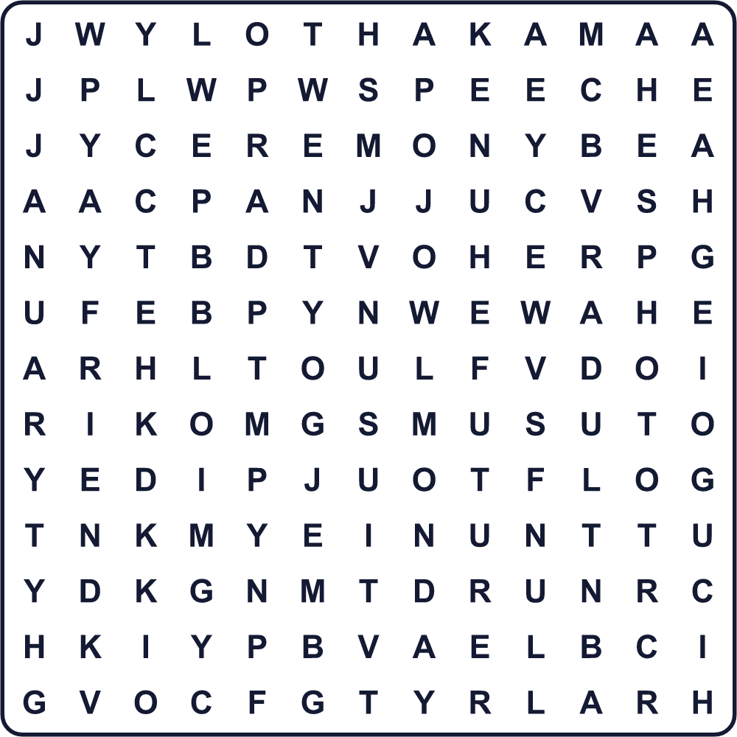
ADULT CEREMONY FRIEND FUTURE HAKAMA HOPE JANUARY KIMONO MONDAY PHOTO SLEEVE SPEECH SUIT TWENTY
Secret Code 暗号を解こう
✂=A ♦=C ☘=G ⚑=I ✿=L ♣=N ⚓=O ▲=R ✈=S ☂=T ✉=U
♦ ⚓ ♣ ☘ ▲ ✂ ☂ ✉ ✿ ✂ ☂ ⚑ ⚓ ♣ ✈
______________________________________________________________

👘 Coming of Age Day Worksheet
Maze & Sentences
Class ______ No. ____ Name ______________________________
Help Mika get to the ceremony on time! ミカを式の会場まで時間どおりに連れていこう！
正しい道の文字を集めると、ひみつの言葉になるよ。 START 👘 → GOAL 🏛️
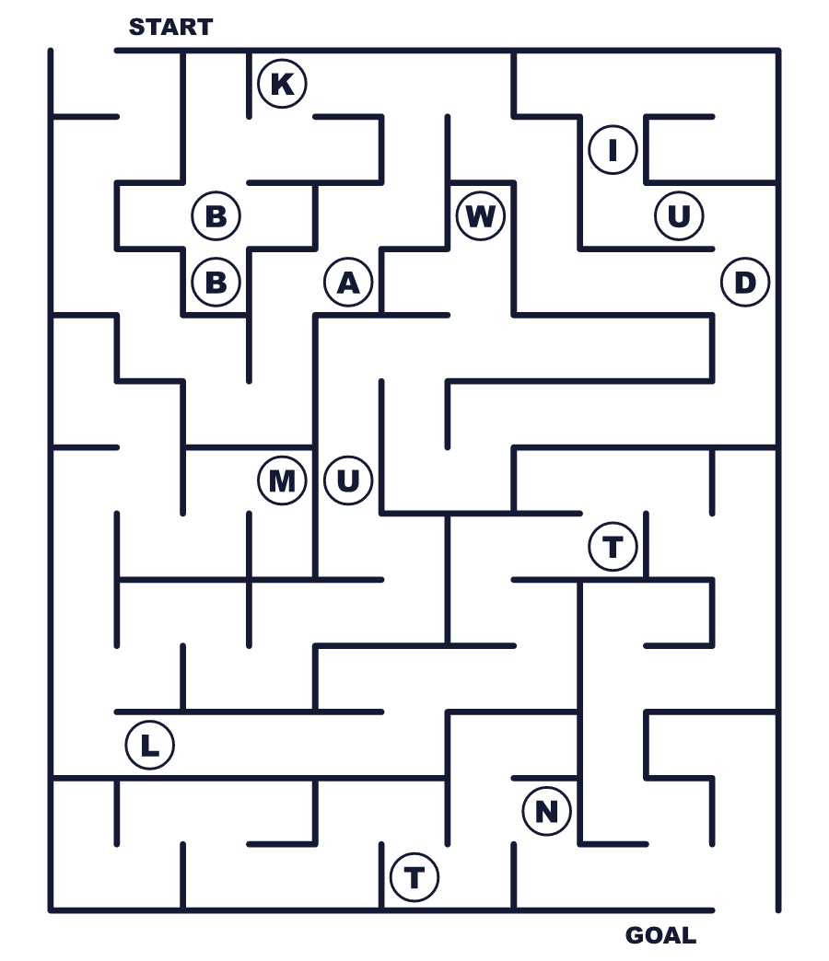
Secret word: ＿ ＿ ＿ ＿ ＿
Put the words in order. 並べかえよう。
1. January / Day / Age / in / Coming / is / of . (成人の日は1月にあります。)
______________________________________________________________
2. Many / with / long / women / kimono / sleeves / wear . (多くの女性が長い袖の着物を着ます。)
______________________________________________________________
3. The / age / now / 18 / is / legal / adult . (今、法律上の大人の年齢は18歳です。)
______________________________________________________________
4. my / ceremony / old / I / after / met / classmates / the . (式のあと、昔の同級生に会いました。)
______________________________________________________________
5. in / started / small / idea / The / town / a . (そのアイデアは小さな町で始まりました。)
______________________________________________________________

👘 Coming of Age Day Worksheet
Class Activity & Writing
Class ______ No. ____ Name ______________________________
Find Someone Who… クラスで聞いて回ろう！
Find someone who … | Name
… has worn a kimono 着物を着たことがある
… knows the date of Coming of Age Day this year 今年の成人の日の日付を知っている
… has an older brother or sister who went to the ceremony 式に行った兄や姉がいる
… can explain furisode in English 振袖を英語で説明できる
… knows the legal adult age in Japan 日本の法律上の大人の年齢を知っている
… likes taking photos with friends 友だちと写真を撮るのが好き
… has a dream for the future 将来の夢がある
… can name a coming-of-age custom in another country ほかの国の成人のお祝いを一つ言える
Let's Write! 英語で書いてみよう。
When I become an adult, I want to ______.
大人になったら、私は＿＿したいです。
______________________________________________________________
______________________________________________________________
I think an adult is a person who ______.
大人とは＿＿な人だと思います。
______________________________________________________________
______________________________________________________________
At my ceremony, I want to wear ______ because ______.
自分の式では＿＿を着たいです。なぜなら＿＿だからです。
______________________________________________________________
______________________________________________________________

👘 Coming of Age Day Worksheet
Trace & Color
なぞって書こう。絵に色をぬろう。
Class ______ No. ____ Name ______________________________
👘 

📸 
💐 
🎤 
👔 
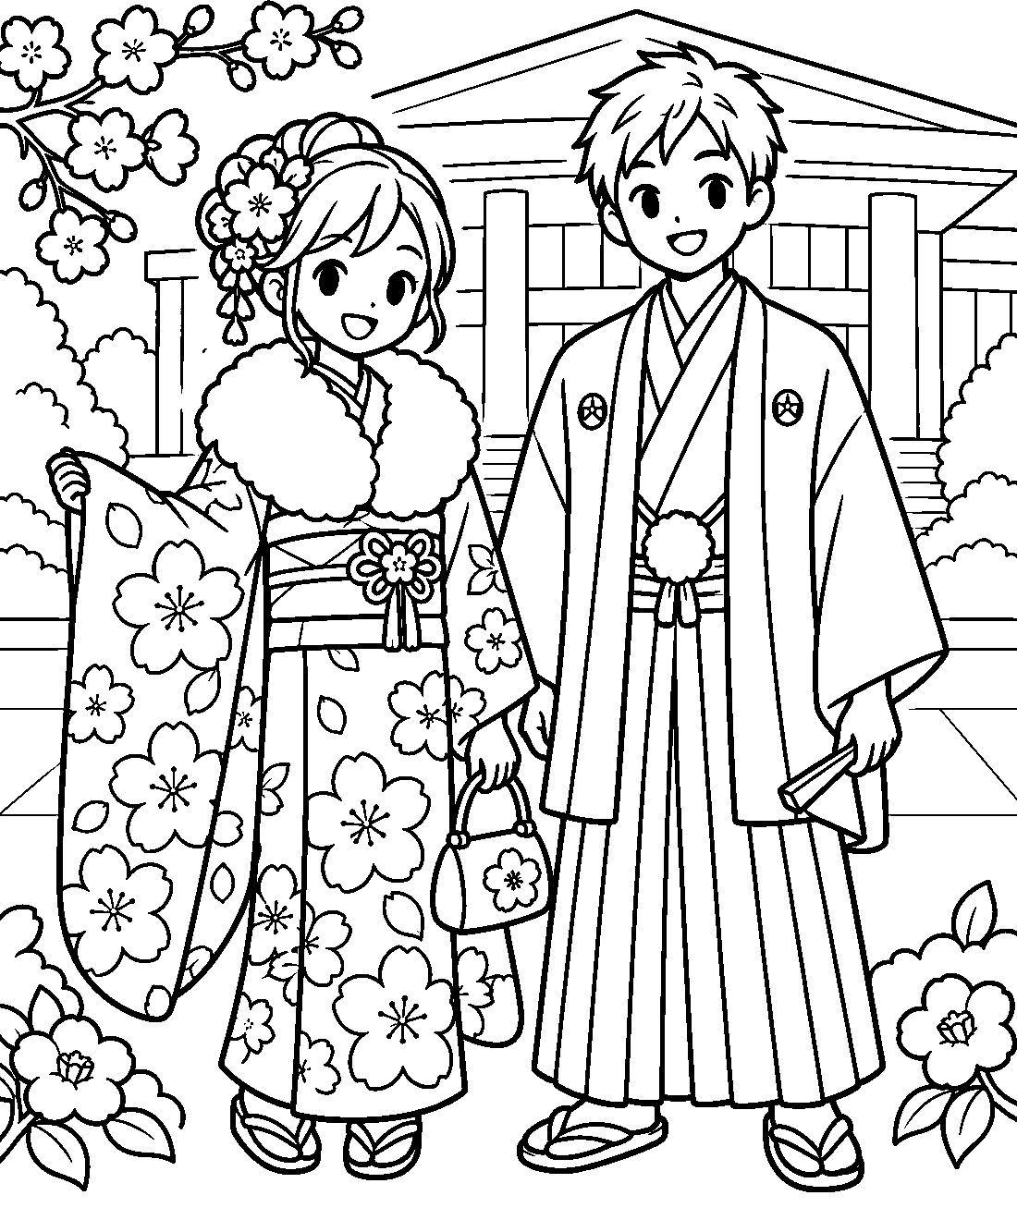

👘 Coming of Age Day Worksheet
Answer Key 解答
Reading Check: 1.A 2.D 3.B 4.A 5.C 6.B 7.C 8.D
True or False: 1.T 2.F 3.T 4.F 5.T 6.F
Match: 👘=kimono 📸=camera 💐=flowers 🎤=microphone 👔=tie 🎂=birthday cake 📅=calendar 🏫=school
Unscramble: 1.ADULT 2.SLEEVE 3.INVITE 4.LEGAL 5.HOPE 6.CEREMONY
Fill in the blanks: (1)Day (2)morning (3)kimono (4)sleeves (5)beautiful (6)ceremony (7)classmates (8)photos (9)party (10)adult
Sentence order: 1. Coming of Age Day is in January. 2. Many women wear kimono with long sleeves. 3. The legal adult age is 18 now. 4. I met my old classmates after the ceremony. 5. The idea started in a small town.
Secret Code: CONGRATULATIONS
Maze: ADULT
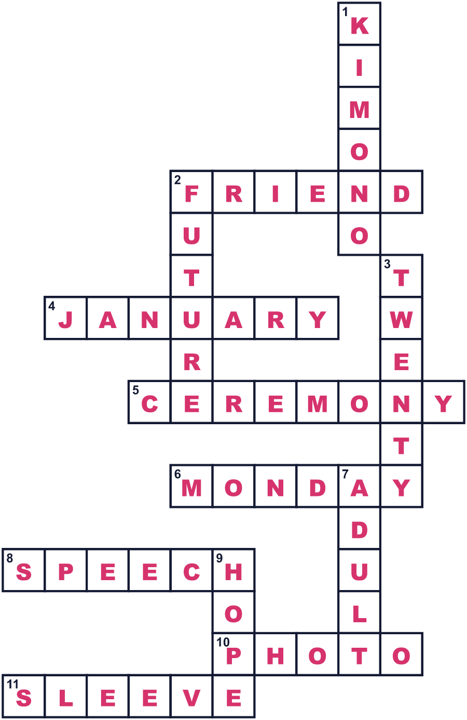
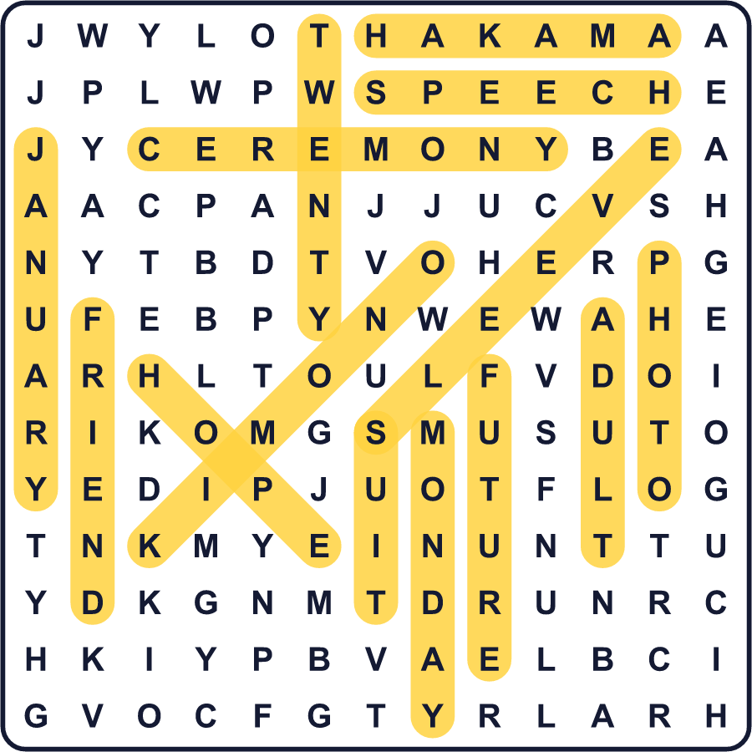
全訳
1 1月の第2月曜日、色あざやかな着物を着た若者たちが日本の街を埋めます。成人の日です。この国民の祝日に、町は大人になる若者のための式を開きます。
2 このアイデアは、戦争が終わってたった1年後の1946年に始まりました。日本は貧しく、多くの若者が希望をなくしていました。東京の近くの蕨という小さな町で、地元の青年団が若者に希望を与えるためのお祭りを開きました。暮らしはまだ苦しく、男性は戦時中の質素な服、女性は作業用のズボン姿でした。その考えは全国に広まり、1948年に日本はそれを国民の祝日にしました。
3 はじめ、この祝日はいつも1月15日でした。この日が選ばれたのは、男の子の昔の儀式、元服のためだと言う人もいます。2000年、この祝日は1月の第2月曜日に移りました。今では3連休を楽しめます。
4 多くの女性は、袖がとても長い着物、振袖を着ます。多くの男性はスーツを着て、はかまという伝統的な着物のスカートをはく人もいます。式のあと、昔の同級生が再会し、写真を撮って、何時間もおしゃべりします。多くの人にとって、それは大きな同窓会のように感じられます。
5 2022年、日本の法律上の大人の年齢は20歳から18歳に変わりました。でも多くの町は今も20歳を招きます。18歳の多くは試験で忙しいからです。今ではこの行事を「二十歳のつどい」と呼ぶ町もあります。そして、まったく変わらなかったルールが一つあります。日本では、はじめてのお酒の一杯は、今も20歳まで待たなければなりません。

