🌺 Remembrance Day / Veterans Day Worksheet
The Eleventh Hour
Read the story. 英文を読もう。
Class ______ No. ____ Name ______________________________

🔊 音声を聞こう（スマホで読みとってね）
1 At eleven o'clock in the morning on November 11, 1918, the guns stopped. After more than four years, the fighting of the First World War came to an end. Millions of soldiers died in the war. Today, many countries remember that moment every year.
2 In Britain, Canada, and Australia, the day is called Remembrance Day. At eleven in the morning, people stop what they are doing. They stand still and stay silent for two minutes. This idea began in Cape Town, South Africa, in 1918. The mayor of the city lost his son in the war. So he asked people to stop and remember for two minutes every day.
3 Many people also wear a small red poppy. During the war, poppies grew in the fields where soldiers fought in Belgium and France. In 1915, a Canadian doctor named John McCrae wrote a famous poem about them. He wrote it the day after a friend died. Today, people give money and get a paper poppy, and the money helps soldiers and their families. In 2014, 888,246 ceramic poppies filled the ground around the Tower of London. There was one for each soldier from Britain and its empire who died in the war.
4 In the United States, November 11 is Veterans Day. A veteran is a person who has served in the army, navy, or air force. Veterans Day thanks all of them, not only the people who died. Different countries use different names, but they share one message: lest we forget.
Words 単語
remember（思い出す、しのぶ） / silent（静かな、だまっている） / mayor（市長） / poppy（ポピー、ヒナゲシ） / poem（詩） / ceramic（陶器の） / veteran（元兵士、退役軍人） / serve（（軍などで）務める）

🌺 Remembrance Day / Veterans Day Worksheet
Reading Check
Choose the best answer. 正しいものを選ぼう。
Class ______ No. ____ Name ______________________________
1. What is the reading mainly about?
(A) How to grow poppies in a garden (B) How some countries remember the end of the First World War (C) The history of the Tower of London (D) Why soldiers wear red clothes
2. Where did the idea of two minutes of silence begin?
(A) In London (B) In Belgium (C) In New York (D) In Cape Town
3. Why did the mayor ask people to stop for two minutes?
(A) Because his son died in the war (B) Because the trains were too loud (C) Because he wanted a longer lunch (D) Because the king told him to
4. In paragraph 4, a "veteran" is:
(A) a very old doctor (B) a person who writes poems (C) a person who has served in the army, navy, or air force (D) a person who sells poppies
5. In the dialogue, what will Haruto do after the silence?
(A) Go back to Japan (B) Get a poppy (C) Write a poem (D) Take a train to Belgium
True or False? T か F に○
1. The First World War fighting stopped at eleven o'clock. T / F
2. People stay silent for ten minutes on Remembrance Day. T / F
3. John McCrae wrote a poem about poppies. T / F
4. In the US, Veterans Day honors only soldiers who died. T / F

🌺 Remembrance Day / Veterans Day Worksheet
Word Work
単語のれんしゅう
Class ______ No. ____ Name ______________________________
① Match the pictures and the words. 絵と単語を線でむすぼう。
🌺 | ● | ● | poppy
🕚 | ● | ● | dove
🎺 | ● | ● | eleven o'clock
🕊️ | ● | ● | trumpet
🪖 | ● | ● | helmet
💐 | ● | ● | flowers
③ Fill in the blanks. 語群から選んで入れよう。
[ poppy / poem / birthday / thankful / word / soldier / noisy / minutes ]
On November 11, Emma goes to school with a red (1) __________ on her coat. Her great-grandfather was a (2) __________ long ago. At eleven o'clock, the whole class stands up. Nobody says a (3) __________ for two (4) __________ . Emma thinks about her great-grandfather. After that, the teacher reads a short (5) __________ . Emma feels sad, but also (6) __________ .

🌺 Remembrance Day / Veterans Day Worksheet
Crossword Puzzle
ヒントを読んでクロスワードを完成させよう。
Class ______ No. ____ Name ______________________________
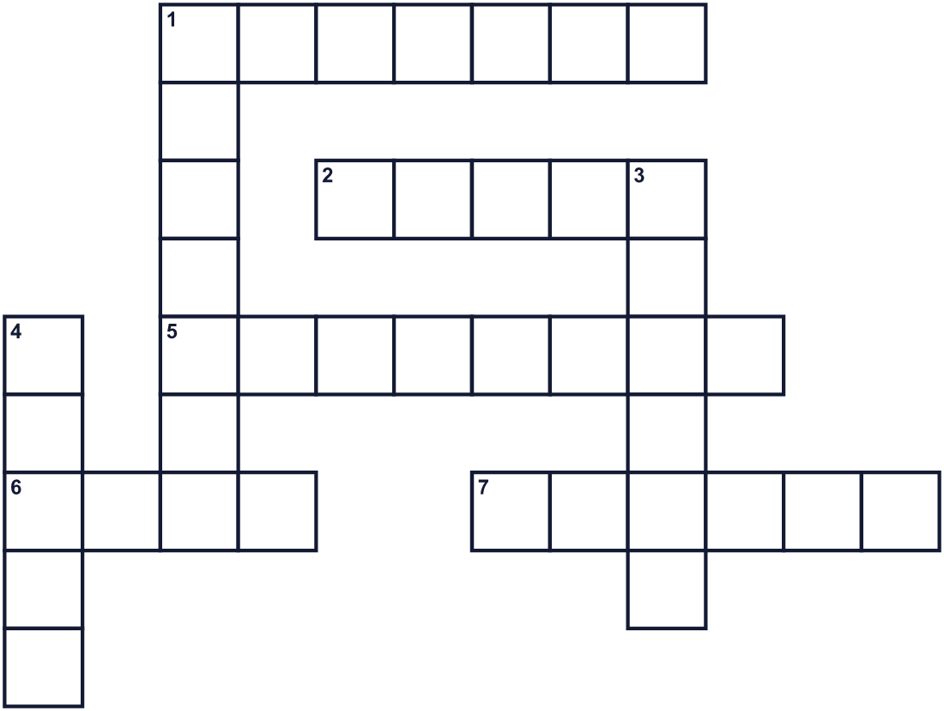
Across →
1. A person who fights in an army. (7)
2. A time with no war. (5)
5. The eleventh month of the year. (8)
6. A short piece of writing with lines, like a song without music. (4)
7. A ring of flowers. People put it in front of a memorial. (6)
Down ↓
1. No sound at all. (7)
3. The number after ten. (6)
4. A small red flower. People wear it in November. (5)

🌺 Remembrance Day / Veterans Day Worksheet
Word Search
かくれた単語をさがそう（→ ↓ ↘ ↗）
Class ______ No. ____ Name ______________________________
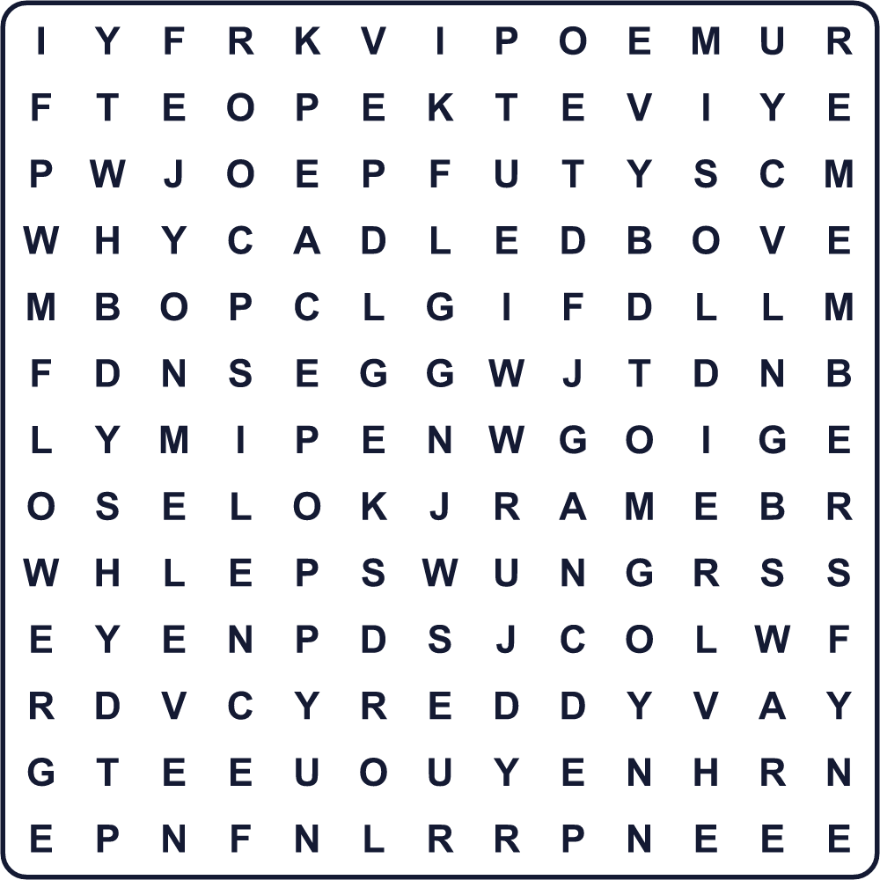
ELEVEN FLOWER PEACE POEM POPPY RED REMEMBER SILENCE SOLDIER WAR

🌺 Remembrance Day / Veterans Day Worksheet
Maze & Sentences
Class ______ No. ____ Name ______________________________
Help the girl bring a poppy to the memorial! 女の子がポピーを記念碑に届けられるようにしよう！
正しい道の文字を集めると、ひみつの言葉になるよ。 START 👧 → GOAL 🌺
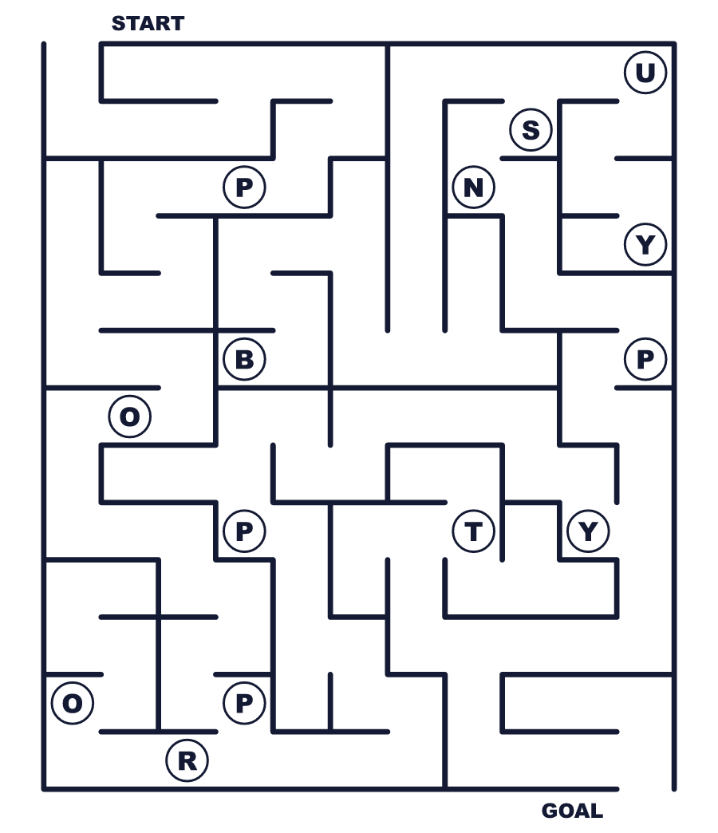
Secret word: ＿ ＿ ＿ ＿ ＿

🌺 Remembrance Day / Veterans Day Worksheet
Class Activity & Writing
Class ______ No. ____ Name ______________________________
Let's Write! 英語で書いてみよう。
I want to remember ______ because ______.
私は______のことを覚えていたい。なぜなら______だからです。
______________________________________________________________
______________________________________________________________
For me, peace means ______.
私にとって平和とは______です。
______________________________________________________________
______________________________________________________________

🌺 Remembrance Day / Veterans Day Worksheet
Trace & Color
なぞって書こう。絵に色をぬろう。
Class ______ No. ____ Name ______________________________
🌺 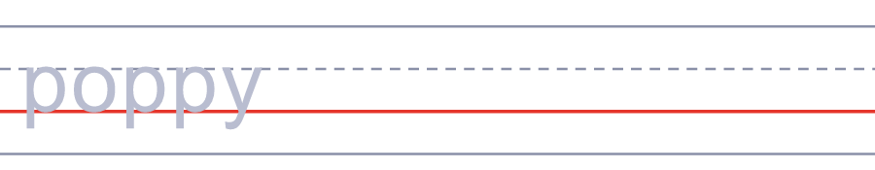

🕚 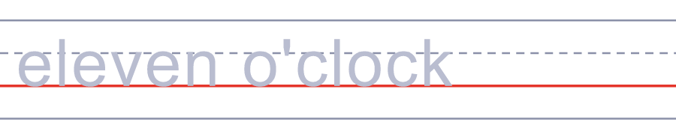
🎺 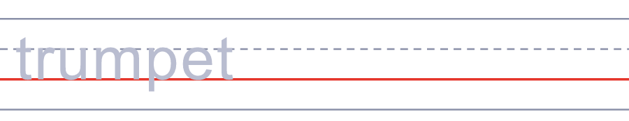
🕊️ 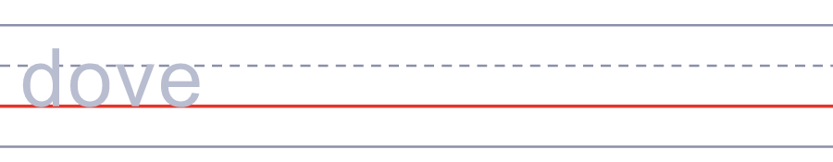
🪖 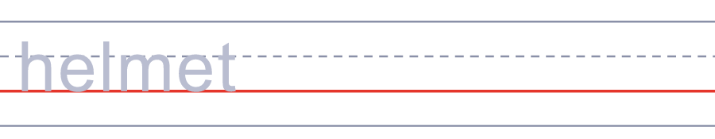

🌺 Remembrance Day / Veterans Day Worksheet
Answer Key 解答
Reading Check: 1.B 2.D 3.A 4.C 5.B
True or False: 1.T 2.F 3.T 4.F
Match: 🌺=poppy 🕚=eleven o'clock 🎺=trumpet 🕊️=dove 🪖=helmet 💐=flowers
Fill in the blanks: (1)poppy (2)soldier (3)word (4)minutes (5)poem (6)thankful
Maze: POPPY
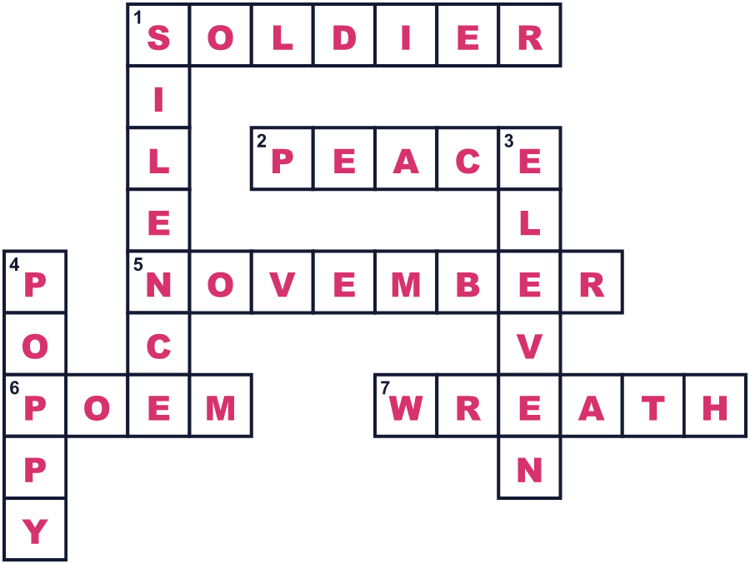
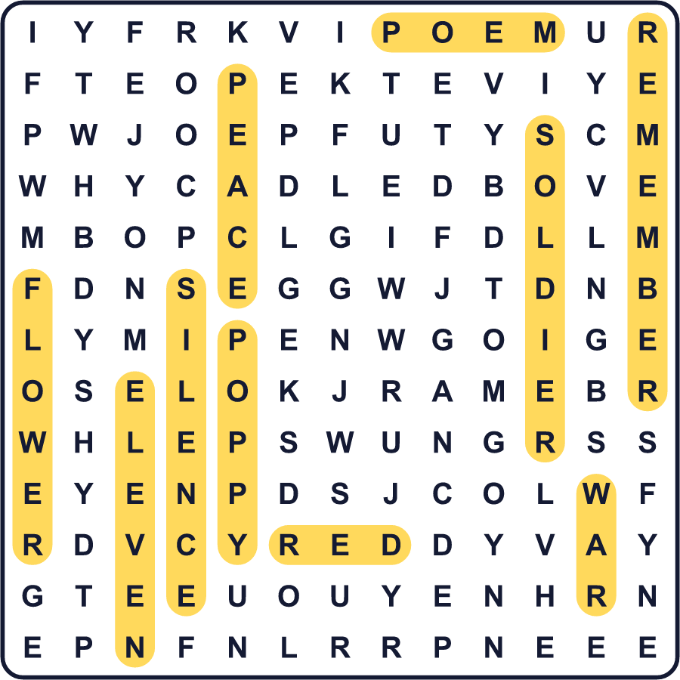
全訳
1 1918年11月11日午前11時、銃声が止まりました。4年以上続いた第一次世界大戦の戦いが、終わったのです。この戦争で、何百万人もの兵士が亡くなりました。今、多くの国が毎年その瞬間を思い出します。
2 イギリス、カナダ、オーストラリアでは、この日はリメンブランス・デーと呼ばれます。午前11時、人々はしていることを止めます。じっと立ち、2分間だまっています。この考えは、1918年に南アフリカのケープタウンで始まりました。その市の市長は、戦争で息子を亡くしました。そこで彼は、毎日2分間、立ち止まって思い出すよう人々に呼びかけたのです。
3 多くの人は、小さな赤いポピーも身につけます。戦争中、兵士たちが戦ったベルギーやフランスの畑には、ポピーが咲いていました。1915年、ジョン・マクレーというカナダの医師が、その花について有名な詩を書きました。彼は、友人が亡くなった次の日にその詩を書きました。今、人々はお金を寄付して紙のポピーを受け取り、そのお金は兵士とその家族の助けになります。2014年には、88万8,246本の陶器のポピーがロンドン塔のまわりを埋めつくしました。戦争で亡くなったイギリスとその帝国の兵士1人につき1本です。
4 アメリカでは、11月11日はベテランズ・デーです。ベテランとは、陸軍・海軍・空軍で務めたことのある人のことです。ベテランズ・デーは、亡くなった人だけでなく、その全員に感謝する日です。国によって名前はちがいますが、伝えたいことは同じです。「忘れることのないように」。

