🌙 Ramadan & Eid al-Fitr Worksheet
A Month of Fasting, a Day of Joy
Read the story. 英文を読もう。
Class ______ No. ____ Name ______________________________
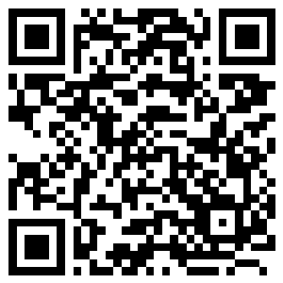
🔊 音声を聞こう（スマホで読みとってね）
1 It is three o'clock in the morning in Cairo, Egypt. A man walks down a dark street and beats a small drum. He is waking people up for an early breakfast. It is the month of Ramadan.
2 Ramadan is the ninth month of the Islamic calendar. Muslims believe that the first words of the Quran, their holy book, came to the Prophet Muhammad in this month. So for about 30 days, many Muslims fast from dawn to sunset. They do not eat or drink anything during the day, not even water.
3 Before the sun comes up, families eat a meal called suhoor. After the sun goes down, they break the fast with a meal called iftar. Many people eat a few dates and drink some water first, just like the Prophet did. Then they share a big dinner with family and friends. During Ramadan, people also pray more and give food and money to people in need.
4 Not everyone has to fast. Children, sick people, and travelers do not need to. The Islamic calendar follows the moon, so Ramadan comes about 11 days earlier every year. Some years it is in cold winter, and some years it is in hot summer.
5 At the end of the month, people look for a thin new moon in the evening sky. When they see it, Ramadan is over. The next day is Eid al-Fitr, the festival of breaking the fast. People wear new clothes, pray together in the morning, and visit their relatives. Children often get money or gifts, and everyone says, Eid Mubarak!
Words 単語
fast（断食する） / holy（神聖な、聖なる） / Muslim（イスラム教徒、ムスリム） / dawn（夜明け） / sunset（日没、夕日） / pray（祈る） / calendar（暦、カレンダー） / relative（親せき） / in need（困っている、生活に苦しい） / festival（祭り） / moon（月） / share（分け合う、いっしょに食べる）

🌙 Ramadan & Eid al-Fitr Worksheet
Reading Check
Choose the best answer. 正しいものを選ぼう。
Class ______ No. ____ Name ______________________________
1. What is the main idea of the reading?
(A) How to play a drum in Cairo (B) What Muslims do during Ramadan and how they celebrate Eid (C) Why the moon changes its shape (D) How to cook dates
2. Why is the man beating a drum at three in the morning?
(A) He is playing in a concert. (B) He is celebrating Eid. (C) He is waking people up for an early meal. (D) He wants people to go to school.
3. What do many people eat first at iftar?
(A) dates (B) rice cakes (C) cookies (D) bread
4. Why does Ramadan come about 11 days earlier every year?
(A) Because people want a longer holiday. (B) Because winter is getting shorter. (C) Because the Prophet changed the date. (D) Because the Islamic calendar follows the moon.
5. In paragraph 2, what does fast mean?
(A) run quickly (B) not eat or drink (C) pray at night (D) sleep early
6. Which sentence is true about the reading?
(A) Children must fast every day. (B) Ramadan is always in summer. (C) People can drink water during the day. (D) People pray together on the morning of Eid.
7. Why do people look at the evening sky at the end of Ramadan?
(A) To check the weather for the festival (B) To find out when Eid starts (C) To count the stars (D) To see fireworks
8. In the dialogue, why is Amir not eating lunch?
(A) He is fasting for Ramadan. (B) He forgot his lunch. (C) He is sick today. (D) He does not like Japanese food.
True or False? T か F に○
1. Ramadan is a month in the Islamic calendar. T / F
2. During Ramadan, people do not eat at night. T / F
3. Children and sick people do not have to fast. T / F
4. Ramadan is in the same season every year. T / F
5. Eid al-Fitr comes after Ramadan ends. T / F
6. During the day in Ramadan, people can drink water. T / F

🌙 Ramadan & Eid al-Fitr Worksheet
Word Work
単語のれんしゅう
Class ______ No. ____ Name ______________________________
① Match the pictures and the words. 絵と単語を線でむすぼう。
🌙 | ● | ● | mosque
🕌 | ● | ● | book
🌅 | ● | ● | gift
🥁 | ● | ● | drum
📖 | ● | ● | sunrise
🎁 | ● | ● | rice
💧 | ● | ● | water
🍚 | ● | ● | moon
② Unscramble the words. 並べかえて単語にしよう。
1. O M N O (月) → ____________________
2. N E S T S U (日没) → ____________________
3. M U S O E Q (モスク) → ____________________
4. R Y P A (祈る) → ____________________
5. L A Y M F I (家族) → ____________________
6. S H E A R (分け合う) → ____________________
③ Fill in the blanks. 語群から選んで入れよう。
[ snow / money / village / pray / grandparents / Jakarta / station / Tokyo / angry / train / ketupat / happy / moon ]
Budi works in (1) __________ , a big city in Indonesia. Every year, he goes back to his (2) __________ for Eid. The (3) __________ is full of people with big bags. Budi's mother is waiting at the (4) __________ . That night, the whole family looks at the (5) __________ . The next morning, they (6) __________ together. Then Budi says sorry to his (7) __________ for his mistakes. They eat (8) __________ , a rice cake in a leaf box. His little sister gets some (9) __________ . Everyone is (10) __________ .

🌙 Ramadan & Eid al-Fitr Worksheet
Crossword Puzzle
ヒントを読んでクロスワードを完成させよう。
Class ______ No. ____ Name ______________________________
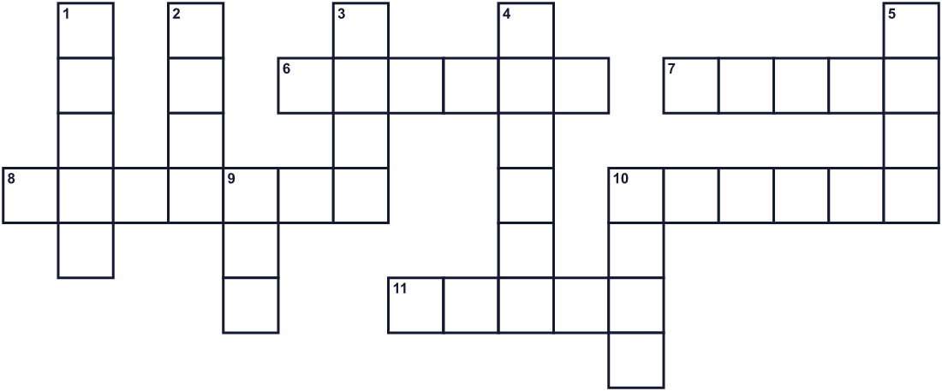
Across →
6. A building where Muslims go to pray. (6)
7. The meal after sunset in Ramadan. (5)
8. A light with a glass cover. People hang them on streets in Egypt. (7)
10. Your parents, brothers, and sisters. (6)
11. Sweet brown fruit. People often eat them first at iftar. (5)
Down ↓
1. The holy book of Islam. (5)
2. A present. Children get them on Eid. (4)
3. It shines in the night sky. It changes shape every night. (4)
4. The time when the sun goes down. (6)
5. To talk to God. (4)
9. The festival after Ramadan. (3)
10. To eat and drink nothing for some time. (4)

🌙 Ramadan & Eid al-Fitr Worksheet
Word Search
かくれた単語をさがそう（→ ↓ ↘ ↗）
Class ______ No. ____ Name ______________________________
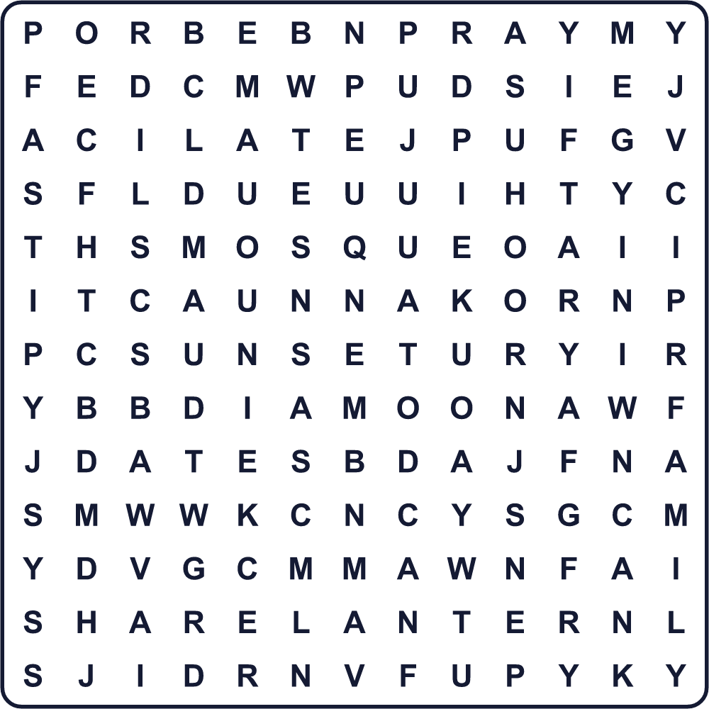
DATES DAWN EID FAMILY FAST IFTAR LANTERN MOON MOSQUE PRAY SHARE SUHOOR SUNSET
Secret Code 暗号を解こう
✿=A ◆=B ✉=D ♠=E ☘=I ☎=K ♦=M ☺=R ✚=U
♠ ☘ ✉ ♦ ✚ ◆ ✿ ☺ ✿ ☎
______________________________________________________________

🌙 Ramadan & Eid al-Fitr Worksheet
Maze & Sentences
Class ______ No. ____ Name ______________________________
Help Amir get home for iftar! アミールがイフタールの時間に家に帰れるように手伝おう！
正しい道の文字を集めると、ひみつの言葉になるよ。 START 👦 → GOAL 🌙
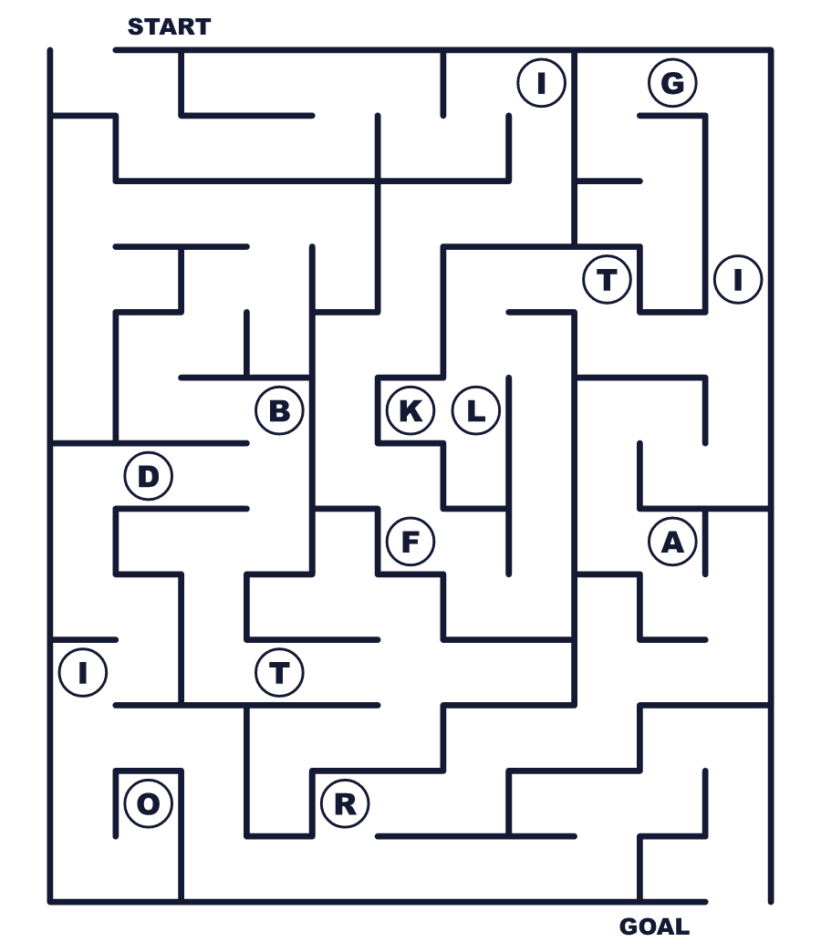
Secret word: ＿ ＿ ＿ ＿ ＿
Put the words in order. 並べかえよう。
1. ninth / the / month / of / is / calendar / the / Ramadan / Islamic . (ラマダンはイスラム暦の9番目の月です。)
______________________________________________________________
2. to / Muslims / from / dawn / sunset / fast . (ムスリムは夜明けから日没まで断食します。)
______________________________________________________________
3. fast / with / They / dates / break / the . (彼らはナツメヤシの実で断食を終えます。)
______________________________________________________________
4. Children / money / on / get / often / Eid . (子どもたちはイードにお金をもらうことが多いです。)
______________________________________________________________
5. earlier / Ramadan / comes / every / year . (ラマダンは毎年早く来ます。)
______________________________________________________________

🌙 Ramadan & Eid al-Fitr Worksheet
Class Activity & Writing
Class ______ No. ____ Name ______________________________
Find Someone Who… クラスで聞いて回ろう！
Find someone who … | Name
… knows the name of the Islamic holy book イスラム教の聖典の名前を知っている
… has eaten dates ナツメヤシの実を食べたことがある
… has visited a mosque モスクを訪れたことがある
… can say hello in another language 外国語であいさつができる
… has seen a crescent moon this month 今月、三日月を見た
… likes sweets very much 甘いものが大好き
… has a friend from another country 外国出身の友だちがいる
… knows a country where many Muslims live ムスリムが多く住む国を知っている
Let's Write! 英語で書いてみよう。
During Ramadan, Muslims ______. I think ______.
ラマダン中、ムスリムは＿＿します。私は＿＿と思います。
______________________________________________________________
______________________________________________________________
If my friend is fasting, I will ______ because ______.
友だちが断食していたら、私は＿＿します。なぜなら＿＿だからです。
______________________________________________________________
______________________________________________________________
Eid and Japanese New Year are similar because ______.
イードと日本のお正月は＿＿という点で似ています。
______________________________________________________________
______________________________________________________________

🌙 Ramadan & Eid al-Fitr Worksheet
Trace & Color
なぞって書こう。絵に色をぬろう。
Class ______ No. ____ Name ______________________________
🌙 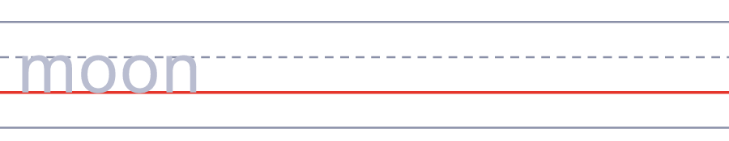

🕌 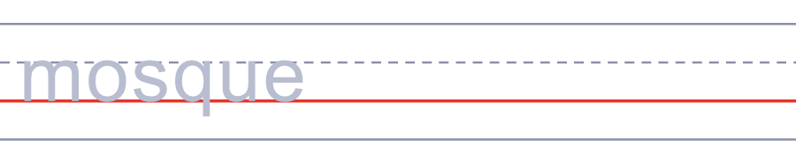
🌅 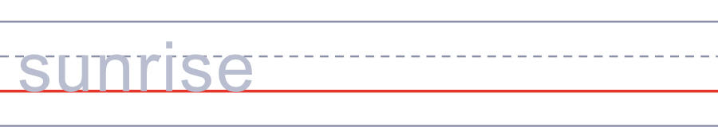
🥁 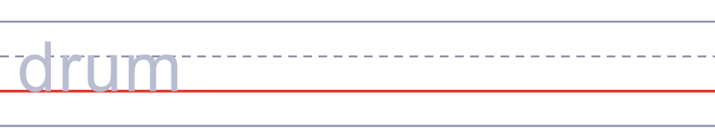
📖 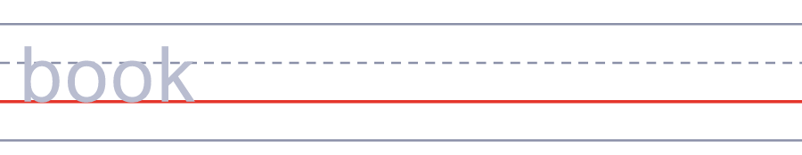
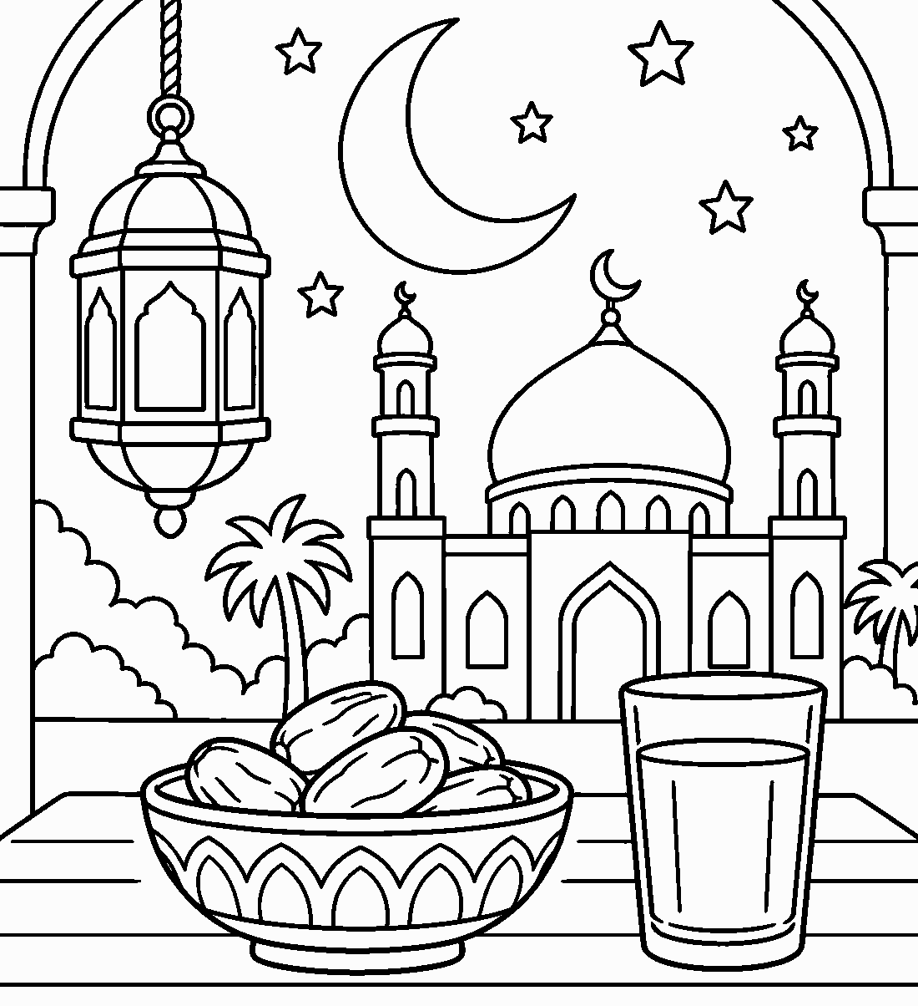

🌙 Ramadan & Eid al-Fitr Worksheet
Answer Key 解答
Reading Check: 1.B 2.C 3.A 4.D 5.B 6.D 7.B 8.A
True or False: 1.T 2.F 3.T 4.F 5.T 6.F
Match: 🌙=moon 🕌=mosque 🌅=sunrise 🥁=drum 📖=book 🎁=gift 💧=water 🍚=rice
Unscramble: 1.MOON 2.SUNSET 3.MOSQUE 4.PRAY 5.FAMILY 6.SHARE
Fill in the blanks: (1)Jakarta (2)village (3)train (4)station (5)moon (6)pray (7)grandparents (8)ketupat (9)money (10)happy
Sentence order: 1. Ramadan is the ninth month of the Islamic calendar. 2. Muslims fast from dawn to sunset. 3. They break the fast with dates. 4. Children often get money on Eid. 5. Ramadan comes earlier every year.
Secret Code: EID MUBARAK
Maze: IFTAR
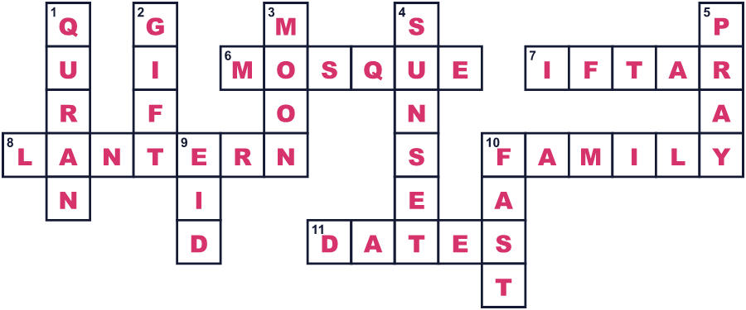
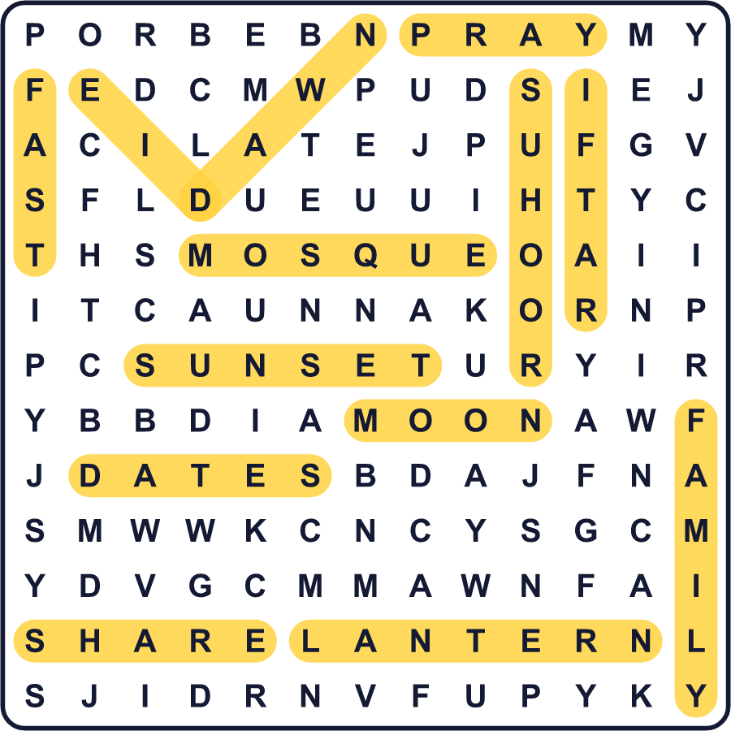
全訳
1 エジプトのカイロ、朝の3時です。一人の男性が暗い通りを歩きながら、小さな太鼓をたたいています。早い朝食のために、人々を起こしているのです。今はラマダンの月です。
2 ラマダンは、イスラム暦の9番目の月です。ムスリムは、自分たちの聖典コーランの最初の言葉が、この月に預言者ムハンマドに下されたと信じています。そのため約30日間、多くのムスリムは夜明けから日没まで断食をします。昼の間は何も食べず、何も飲みません。水さえも飲まないのです。
3 日が昇る前に、家族はスフールという食事をとります。日が沈んだあと、イフタールという食事で断食を終えます。多くの人は、預言者がしたように、まずナツメヤシの実を少し食べて水を飲みます。それから家族や友だちと、たっぷりの夕食を囲みます。ラマダン中、人々はいつもより多く祈り、困っている人に食べ物やお金をわけます。
4 全員が断食しなければならないわけではありません。子ども、病気の人、旅行中の人はしなくてよいのです。イスラム暦は月に合わせているので、ラマダンは毎年約11日ずつ早く来ます。寒い冬の年もあれば、暑い夏の年もあります。
5 月の終わりに、人々は夕方の空に細い新しい月を探します。それが見えたら、ラマダンは終わりです。次の日は、断食明けの祭りイード・アル＝フィトルです。人々は新しい服を着て、朝にいっしょに礼拝し、親せきを訪ねます。子どもたちはお金やプレゼントをもらうことが多く、みんなが「イード・ムバラク！」と言い合います。

