🏳️‍🌈 Pride Month Worksheet
From One Night in New York to a Rainbow for the World
Read the story. 英文を読もう。
Class ______ No. ____ Name ______________________________
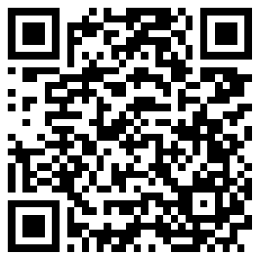
🔊 音声を聞こう（スマホで読みとってね）
1 Early in the morning on June 28, 1969, police came into a small bar in New York City. It was called the Stonewall Inn. At that time, police often went into bars for gay people and arrested some customers. But this night was different. People did not go home. They stayed on the street and fought back, and the protests went on for several nights.
2 One year later, on June 28, 1970, people marched in New York to remember that night. Thousands of people walked 51 blocks to Central Park. People marched in Chicago and Los Angeles, too. These were some of the first Pride marches. The word pride was important. It means feeling good about who you are, not feeling shame.
3 In 1978, an artist named Gilbert Baker made a new flag for a parade in San Francisco. It had eight colors, and each color had a meaning. For example, red meant life, and yellow meant sunlight. But pink cloth was hard to find, so the pink stripe went away. Later, turquoise was dropped too, and the flag had six colors. Today, this rainbow flag is a symbol of LGBTQ people around the world.
4 Now many cities hold Pride events in June. But not every city does it in June. The big parade in Sydney, Australia, is in February or March. That is summer there. In Taipei, it is in October. Tokyo moved its big event to June in 2025.
5 Many people who are not LGBTQ join Pride, too. They are called allies, and they march to show their support. Some people call Pride a party, and others call it a protest. In a way, it is both. It started with one hard night in 1969, and now it fills streets with rainbow colors.
Words 単語
pride（誇り、自分をよいと思う気持ち） / shame（恥、恥ずかしさ） / police（警察） / arrest（逮捕する） / protest（抗議、抗議運動） / march（行進する、デモ行進する） / remember（記念する、思い起こす、覚えている） / stripe（しま、すじ） / symbol（象徴、シンボル） / meaning（意味） / ally（支える人、味方、アライ） / support（支え、支持）

🏳️‍🌈 Pride Month Worksheet
Reading Check
Choose the best answer. 正しいものを選ぼう。
Class ______ No. ____ Name ______________________________
1. What is the story mainly about?
(A) How New York police worked in the 1960s (B) Why Gilbert Baker moved to San Francisco (C) How Pride began and how people celebrate it today (D) Why Sydney has summer in February
2. When did the police come into the Stonewall Inn?
(A) Early in the morning on June 28, 1969 (B) Late at night on June 28, 1970 (C) In the summer of 1978 (D) In February in Sydney
3. How many colors did the first rainbow flag have?
(A) Five (B) Six (C) Seven (D) Eight
4. Why did the pink stripe go away?
(A) People did not like the color pink. (B) Pink cloth was hard to find. (C) The flag was too long. (D) Pink meant shame.
5. In paragraph 2, what does pride mean?
(A) Being afraid of the police (B) Walking a long way (C) Feeling good about who you are (D) Making a new flag
6. Which is true according to the story?
(A) Every city holds Pride in June. (B) The first march went to Times Square. (C) Only LGBTQ people can join Pride. (D) Tokyo moved its big event to June in 2025.
7. What does the writer mean by In a way, it is both?
(A) Pride is held in both June and October in every city. (B) Pride is fun like a party, and it also has a message like a protest. (C) Pride has two flags, an old one and a new one. (D) Both Chicago and Los Angeles started Pride first.
8. In the dialogue, why can Ryo count only six colors?
(A) Pink and turquoise were dropped from the flag. (B) The flag was far away from him. (C) Olivia's flag was a new design. (D) He did not know the word turquoise.
True or False? T か F に○
1. The Stonewall Inn was in New York City. T / F
2. The first rainbow flag had six colors. T / F
3. Gilbert Baker made the rainbow flag. T / F
4. Every city holds its Pride parade in June. T / F
5. An ally is a person who shows support. T / F
6. The first Pride march was in 1990. T / F

🏳️‍🌈 Pride Month Worksheet
Word Work
単語のれんしゅう
Class ______ No. ____ Name ______________________________
① Match the pictures and the words. 絵と単語を線でむすぼう。
🌈 | ● | ● | tree
🚩 | ● | ● | sun
❤️ | ● | ● | rainbow
🥁 | ● | ● | drum
☀️ | ● | ● | megaphone
🌳 | ● | ● | flag
💃 | ● | ● | heart
📣 | ● | ● | dancer
② Unscramble the words. 並べかえて単語にしよう。
1. R W O I A N B (にじ) → ____________________
2. A R P D A E (パレード) → ____________________
3. E R P T O T S (抗議) → ____________________
4. O S T P P U R (支え、応援) → ____________________
5. R P S E I T (しま) → ____________________
6. D P E I R (誇り) → ____________________
③ Fill in the blanks. 語群から選んで入れよう。
[ color / pumpkin / happy / June / angry / support / stripes / remember / winter / rainbow / march / signs / protest ]
In (1) __________ , Aya visited her aunt in New York. One Sunday, they went to the Pride (2) __________ together. The street was full of (3) __________ flags. Her aunt said that each (4) __________ on the flag has a meaning. People sang, danced, and carried (5) __________ . A woman gave Aya a small flag with six (6) __________ . Her aunt told her that the first march in 1970 was a (7) __________ . Today, many people march to (8) __________ their friends and family. That night, Aya wrote in her diary that she wanted to (9) __________ this day. Everyone looked so (10) __________ .

🏳️‍🌈 Pride Month Worksheet
Crossword Puzzle
ヒントを読んでクロスワードを完成させよう。
Class ______ No. ____ Name ______________________________
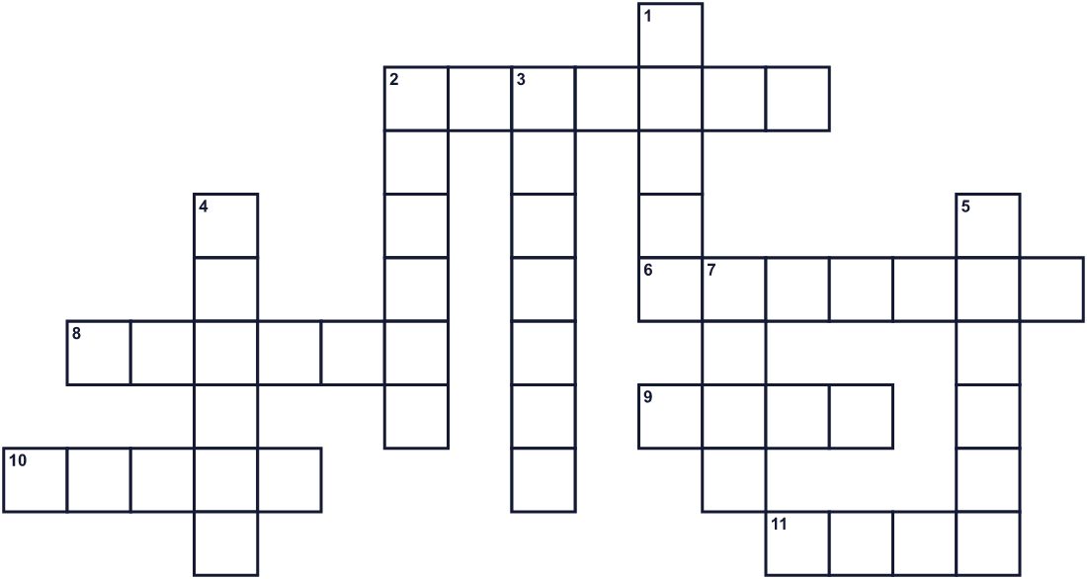
Across →
2. Help and kind words for someone. (7)
6. You can see it in the sky after rain. It has many colors. (7)
8. A long line of one color on a flag. (6)
9. A piece of cloth with colors. People wave it. (4)
10. A good feeling about who you are. (5)
11. The sixth month of the year. (4)
Down ↓
1. Red, blue and green are examples of this. (5)
2. A big city in Australia. Its parade is in February or March. (6)
3. People do this to say that something is unfair. (7)
4. People walk, dance and play music down the street in this. (6)
5. They came into the Stonewall Inn in 1969. (6)
7. A person who stands with a group and helps them. (4)

🏳️‍🌈 Pride Month Worksheet
Word Search
かくれた単語をさがそう（→ ↓ ↘ ↗）
Class ______ No. ____ Name ______________________________
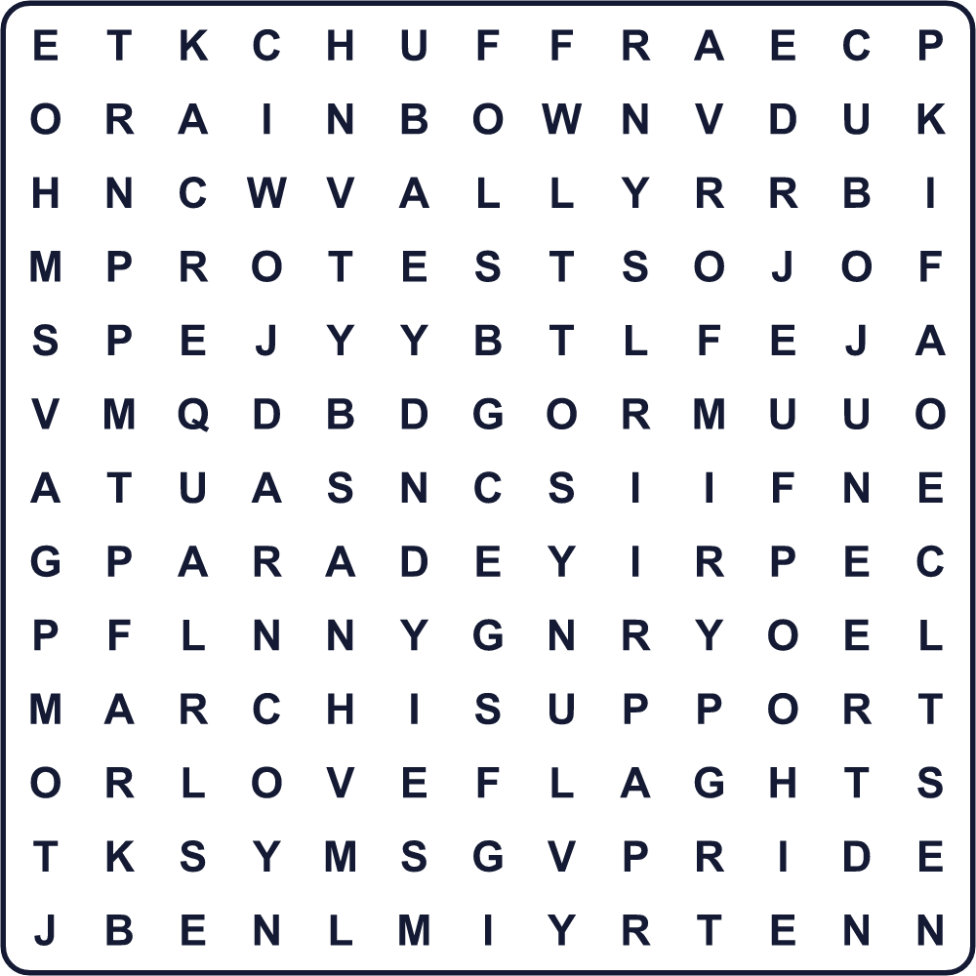
ALLY COLOR EQUAL FLAG JUNE LOVE MARCH PARADE PRIDE PROTEST RAINBOW STRIPE SUPPORT
Secret Code 暗号を解こう
◆=E ☎=I ☾=L ☺=O ♠=S ★=V
☾ ☺ ★ ◆ ☎ ♠ ☾ ☺ ★ ◆
______________________________________________________________

🏳️‍🌈 Pride Month Worksheet
Maze & Sentences
Class ______ No. ____ Name ______________________________
Help Leo get to the parade! レオをパレードまで連れていこう！
正しい道の文字を集めると、ひみつの言葉になるよ。 START 🧒 → GOAL 🌈
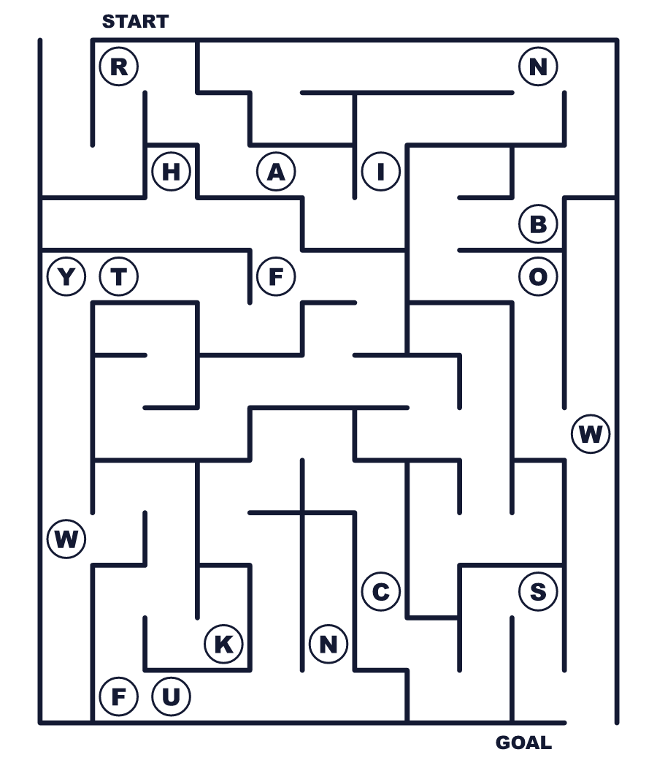
Secret word: ＿ ＿ ＿ ＿ ＿ ＿ ＿
Put the words in order. 並べかえよう。
1. York / The / New / march / in / was / first . (最初の行進はニューヨークでした。)
______________________________________________________________
2. rainbow / The / eight / first / had / flag / colors . (最初のレインボーフラッグは8色でした。)
______________________________________________________________
3. Many / cities / parades / Pride / hold / June / in . (多くの都市が6月にプライドパレードを開きます。)
______________________________________________________________
4. Allies / show / their / march / support / to . (アライは支える気持ちを示すために行進します。)
______________________________________________________________
5. good / about / feeling / yourself / Pride / means . (プライドとは、自分をよいと思う気持ちのことです。)
______________________________________________________________

🏳️‍🌈 Pride Month Worksheet
Class Activity & Writing
Class ______ No. ____ Name ______________________________
Find Someone Who… クラスで聞いて回ろう！
Find someone who … | Name
… knows the seven colors of a rainbow in English にじの7色を英語で言える
… has watched a parade パレードを見たことがある
… likes the color purple 紫色が好き
… can name a city in Brazil ブラジルの都市の名前を1つ言える
… has made a flag or a poster 旗やポスターを作ったことがある
… knows what the word ally means ally という言葉の意味を知っている
… has been to a summer festival 夏祭りに行ったことがある
… can say thank you in three languages 3つの言語で「ありがとう」が言える
Let's Write! 英語で書いてみよう。
If I made a flag for my class, it would have ______ colors because ______.
もしクラスの旗を作るなら、＿＿色にします。なぜなら＿＿だからです。
______________________________________________________________
______________________________________________________________
Pride Month is in June because ______.
プライド月間が6月なのは、＿＿だからです。
______________________________________________________________
______________________________________________________________
One way to make our school a kind place for everyone is ______.
学校をだれにとってもやさしい場所にする方法の1つは、＿＿です。
______________________________________________________________
______________________________________________________________

🏳️‍🌈 Pride Month Worksheet
Trace & Color
なぞって書こう。絵に色をぬろう。
Class ______ No. ____ Name ______________________________
🌈 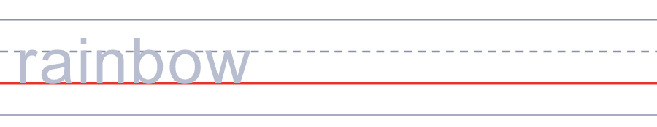

🚩 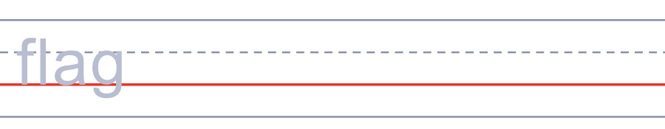
❤️ 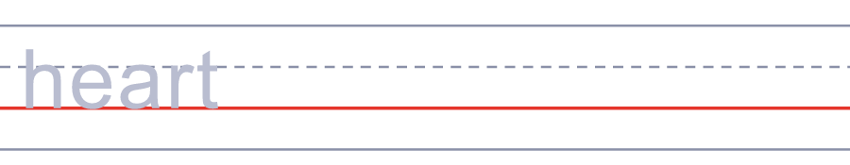
🥁 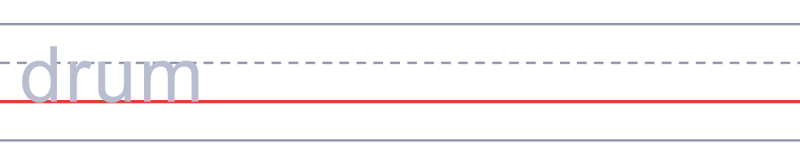
☀️ 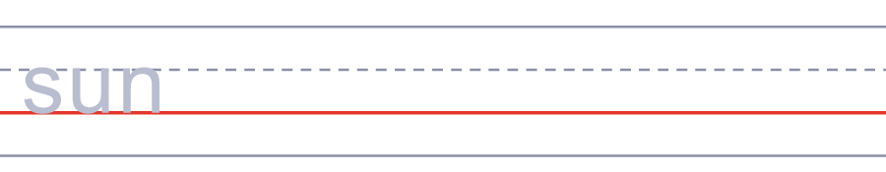
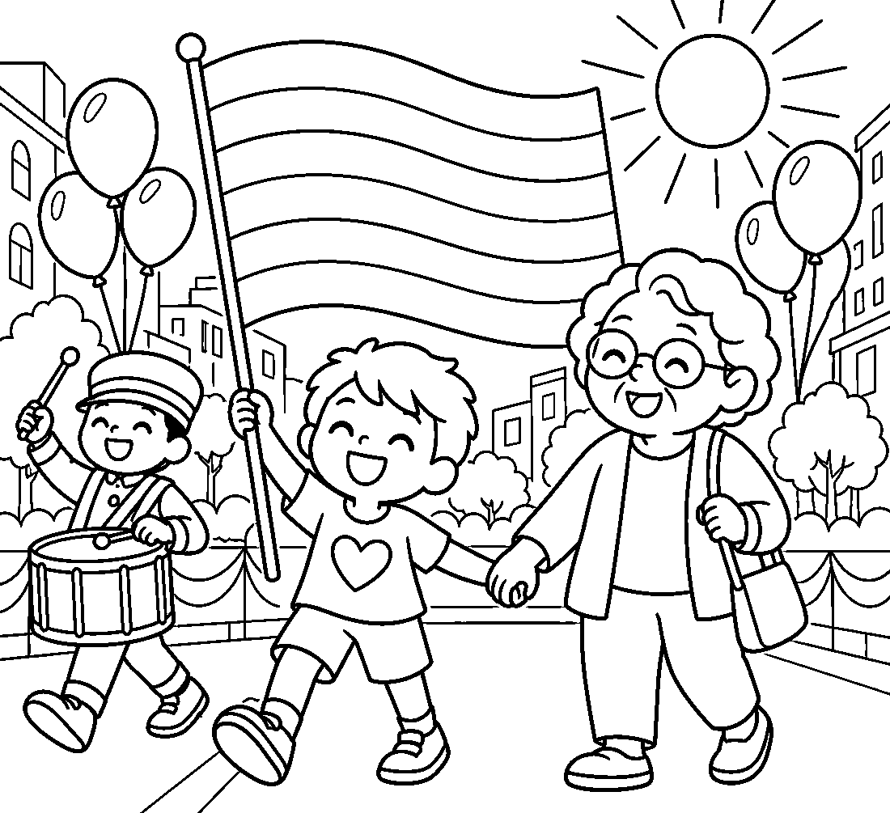

🏳️‍🌈 Pride Month Worksheet
Answer Key 解答
Reading Check: 1.C 2.A 3.D 4.B 5.C 6.D 7.B 8.A
True or False: 1.T 2.F 3.T 4.F 5.T 6.F
Match: 🌈=rainbow 🚩=flag ❤️=heart 🥁=drum ☀️=sun 🌳=tree 💃=dancer 📣=megaphone
Unscramble: 1.RAINBOW 2.PARADE 3.PROTEST 4.SUPPORT 5.STRIPE 6.PRIDE
Fill in the blanks: (1)June (2)march (3)rainbow (4)color (5)signs (6)stripes (7)protest (8)support (9)remember (10)happy
Sentence order: 1. The first march was in New York. 2. The first rainbow flag had eight colors. 3. Many cities hold Pride parades in June. 4. Allies march to show their support. 5. Pride means feeling good about yourself.
Secret Code: LOVE IS LOVE
Maze: RAINBOW
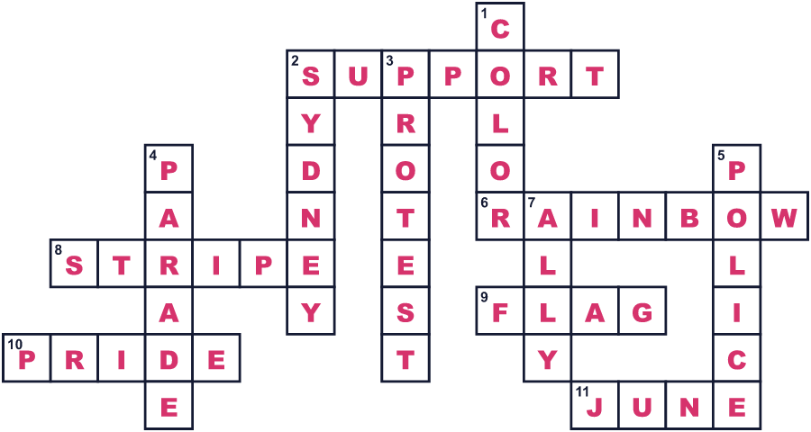
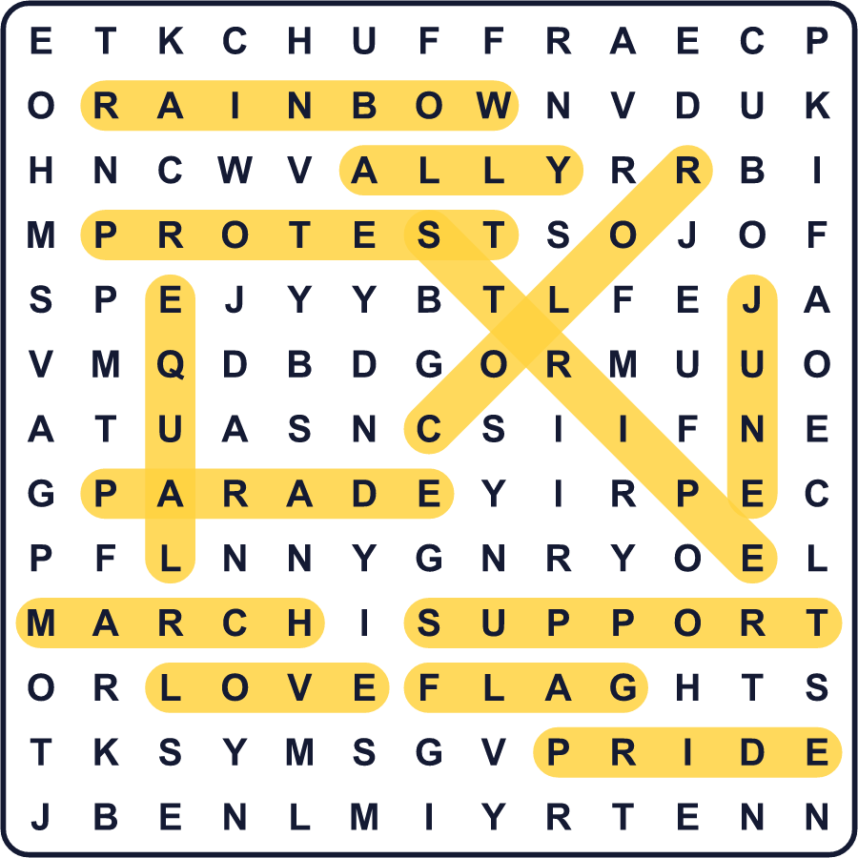
全訳
1 1969年6月28日の未明、ニューヨーク市の小さなバーに警察が入ってきました。その店はストーンウォール・インといいました。当時、警察は同性愛者のためのバーによく入り、客の一部を逮捕していました。でも、この夜は違いました。人々は家に帰りませんでした。通りに残って立ち向かい、抗議は何日も夜ごとに続きました。
2 1年後の1970年6月28日、人々はあの夜を記念してニューヨークで行進しました。何千人もの人が、セントラルパークまで51ブロックを歩きました。シカゴやロサンゼルスでも人々が行進しました。これらは、最初のプライド行進の一部でした。プライドという言葉は大切でした。それは、自分が自分であることをよいと思う気持ち、恥ずかしく思わない気持ちを意味します。
3 1978年、ギルバート・ベイカーという芸術家が、サンフランシスコのパレードのために新しい旗を作りました。旗には8つの色があり、それぞれの色に意味がありました。たとえば、赤は生命、黄色は太陽の光を意味しました。でもピンクの布は手に入りにくかったので、ピンクのしまはなくなりました。その後ターコイズも外され、旗は6色になりました。今では、このレインボーフラッグは世界中のLGBTQの人々のシンボルです。
4 今では多くの都市が6月にプライドの行事を開きます。でも、すべての都市が6月に開くわけではありません。オーストラリアのシドニーの大パレードは、2月か3月です。それは現地では夏です。台北では10月です。東京は2025年に大きな行事を6月に移しました。
5 LGBTQではない多くの人も、プライドに参加します。その人たちはアライと呼ばれ、支える気持ちを示すために行進します。プライドをお祭りと呼ぶ人もいれば、抗議と呼ぶ人もいます。ある意味では、その両方なのです。それは1969年のつらい一夜から始まり、今では通りをにじ色で埋めつくしています。

