🇺🇸 Presidents' Day Worksheet
The Holiday That Misses the Birthday
Read the story. 英文を読もう。
Class ______ No. ____ Name ______________________________
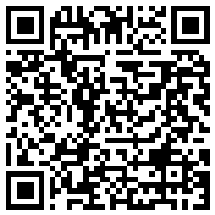
🔊 音声を聞こう（スマホで読みとってね）
1 In February, many stores in the United States have big sales. Their signs say "Presidents' Day Sale!" Many families shop for new beds and sofas. But the official name of this holiday is not Presidents' Day. It is Washington's Birthday.
2 George Washington was the first president of the United States. Before that, he led the army in the war for independence. He was born in Virginia in 1732. He was chosen as president with every vote, two times. The capital city, Washington, D.C., has his name. In 1879, his birthday became a holiday, and it was the first national holiday for a president.
3 Washington's birthday is February 22. But since 1971, the holiday has been on the third Monday of February. The government wanted more three-day weekends. So now the holiday always comes between February 15 and 21. It is never on his real birthday! Abraham Lincoln was also born in February, so many people remember him on this day too. Some states call it Presidents' Day, and other states use different names.
4 There is a famous story about young George. He cut down his father's cherry tree and said, "I can't tell a lie." But a writer named Mason Weems probably made up this story. Also, Washington did not have wooden teeth. His false teeth were made of ivory, gold, and even human teeth. Still, some Americans eat cherry pie on this day!
Words 単語
president（大統領） / official（公式の、正式な） / capital（首都） / vote（票、投票（する）） / weekend（週末） / lie（うそ、うそをつく） / make up（（話を）作り上げる、でっちあげる） / false teeth（入れ歯）

🇺🇸 Presidents' Day Worksheet
Reading Check
Choose the best answer. 正しいものを選ぼう。
Class ______ No. ____ Name ______________________________
1. What is the reading mainly about?
(A) How to find good sales in February (B) The life of Abraham Lincoln (C) How to make cherry pie (D) A holiday for Washington and some stories about him
2. Since when has the holiday been on the third Monday of February?
(A) Since 1732 (B) Since 1971 (C) Since 1879 (D) Since 1789
3. Why is the holiday never on February 22?
(A) Because the third Monday is always between February 15 and 21 (B) Because February 22 is Lincoln's birthday (C) Because stores are closed on February 22 (D) Because Washington did not like his birthday
4. In paragraph 4, what does "made up" mean?
(A) Cleaned (B) Bought (C) Invented, not true (D) Forgot
5. What does Mio say about Japan in the dialogue?
(A) Japan has Monday holidays too. (B) Japan has a holiday for presidents. (C) Japan has big sales in February. (D) Japan has no holidays in February.
True or False? T か F に○
1. Presidents' Day is on the third Monday of February. T / F
2. The holiday is always on Washington's real birthday. T / F
3. George Washington was the first president of the United States. T / F
4. Washington had wooden teeth. T / F

🇺🇸 Presidents' Day Worksheet
Word Work
単語のれんしゅう
Class ______ No. ____ Name ______________________________
① Match the pictures and the words. 絵と単語を線でむすぼう。
🍒 | ● | ● | axe
🥧 | ● | ● | tooth
🪓 | ● | ● | dollar
🦷 | ● | ● | ballot box
💵 | ● | ● | cherry
🗳️ | ● | ● | pie
③ Fill in the blanks. 語群から選んで入れよう。
[ together / pumpkin / summer / laughs / tree / real / school / pie / story ]
On Presidents' Day, Emma does not go to (1) __________ . She and her dad bake a cherry (2) __________ . "Why cherry?" Emma asks. Her dad tells her an old (3) __________ about George Washington and a cherry (4) __________ . "Is it true?" she asks. "Maybe not," he (5) __________ . "But the pie is (6) __________ !" They eat it (7) __________ after dinner.

🇺🇸 Presidents' Day Worksheet
Crossword Puzzle
ヒントを読んでクロスワードを完成させよう。
Class ______ No. ____ Name ______________________________
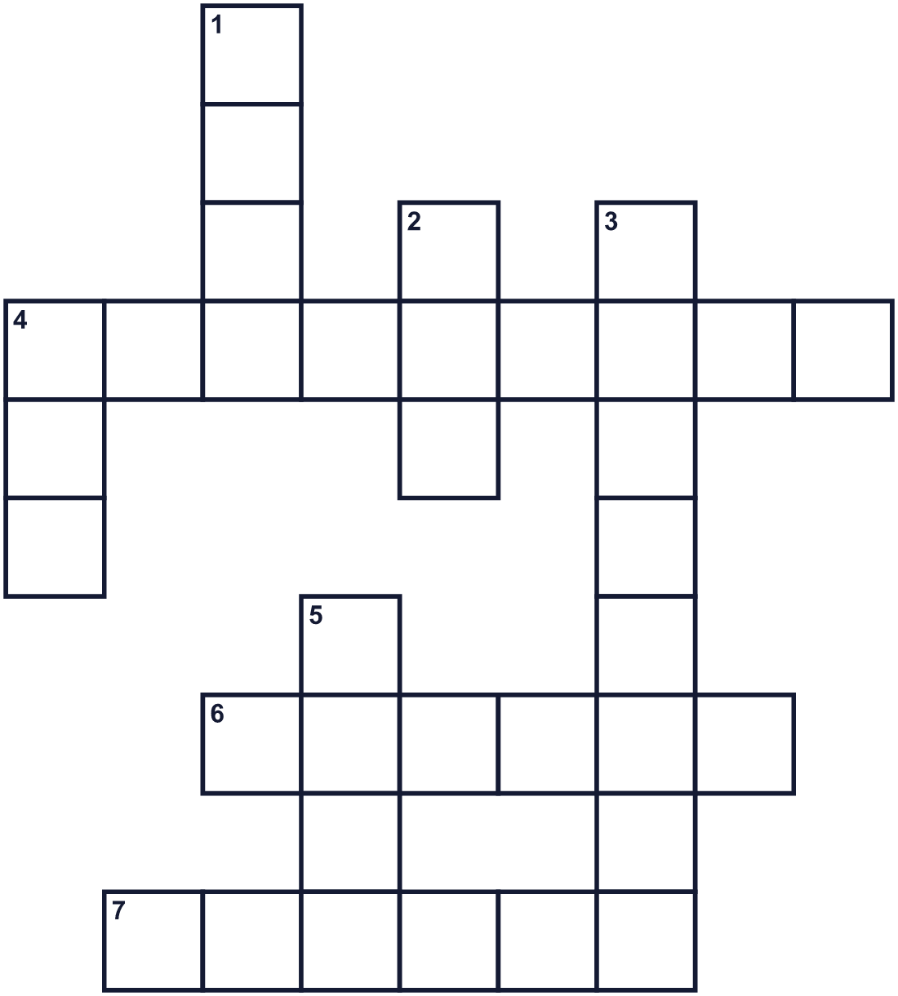
Across →
4. The leader of the United States. (9)
6. The first workday of the week. (6)
7. A small red fruit. It grows on a tree. (6)
Down ↓
1. A time when stores sell things for less money. (4)
2. Something you say that is not true. (3)
3. The second month of the year. (8)
4. A baked sweet food with fruit inside. (3)
5. You do this to choose a leader. (4)

🇺🇸 Presidents' Day Worksheet
Word Search
かくれた単語をさがそう（→ ↓ ↘ ↗）
Class ______ No. ____ Name ______________________________
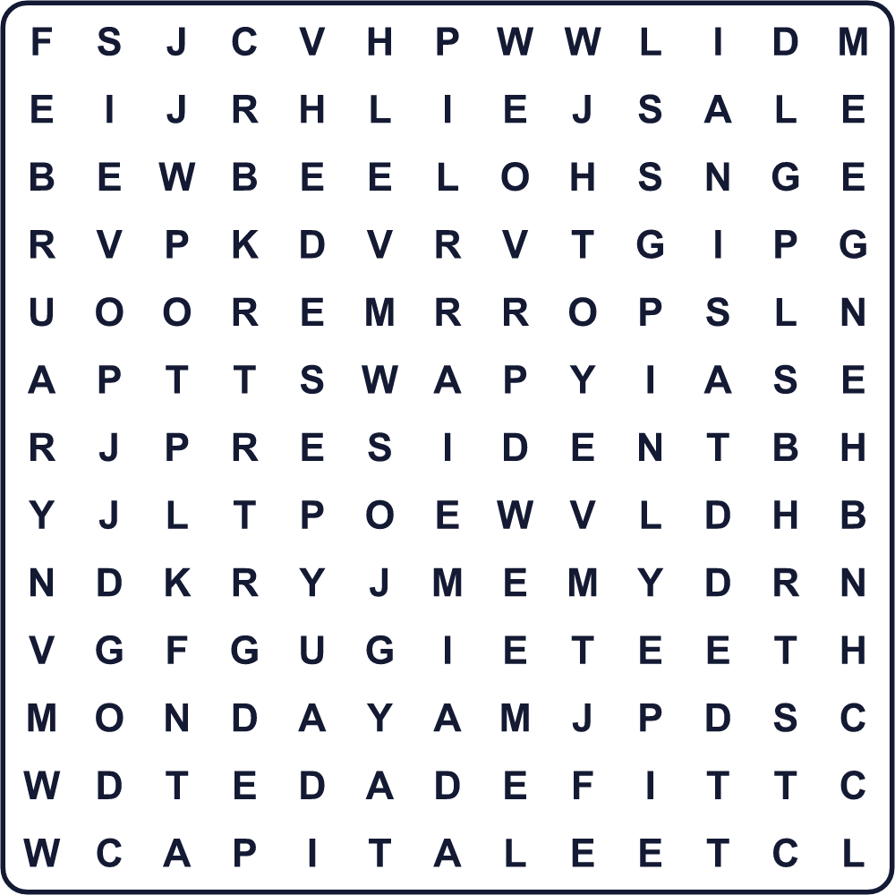
CAPITAL CHERRY FEBRUARY LIE MONDAY PIE PRESIDENT SALE TEETH VOTE

🇺🇸 Presidents' Day Worksheet
Maze & Sentences
Class ______ No. ____ Name ______________________________
Help George get to the cherry pie! ジョージをチェリーパイのところまで連れていこう！
正しい道の文字を集めると、ひみつの言葉になるよ。 START 🎩 → GOAL 🥧
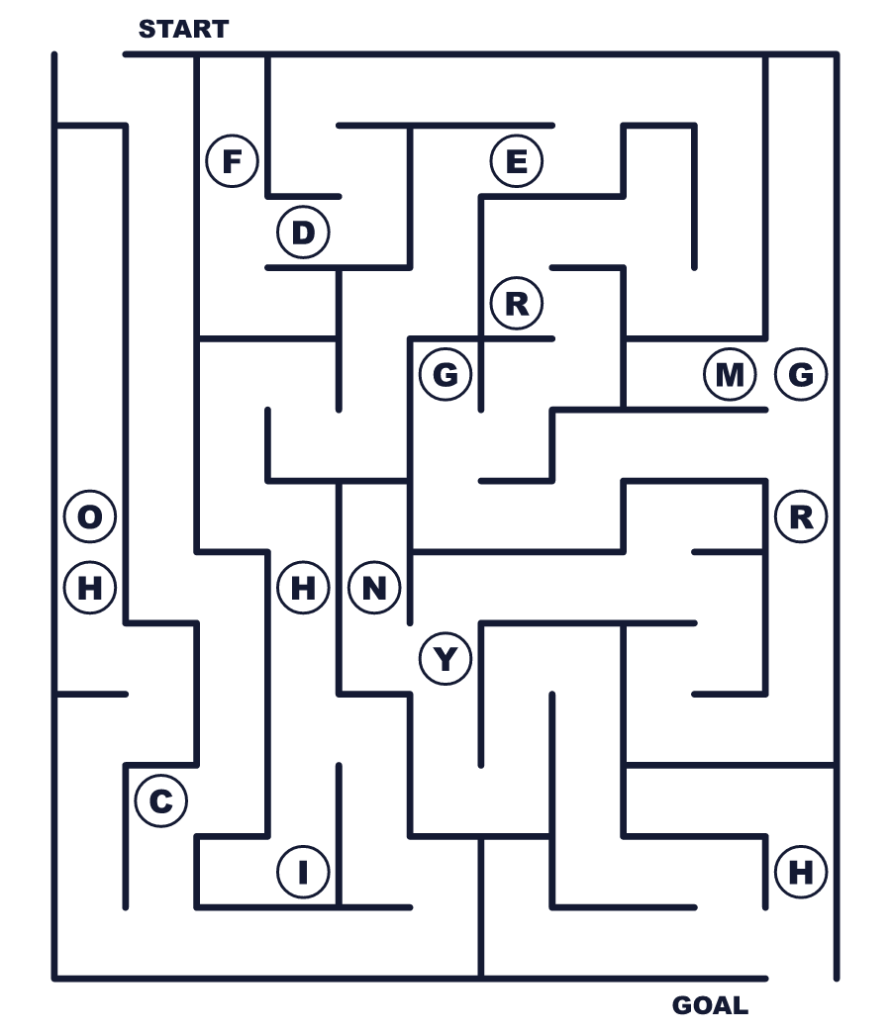
Secret word: ＿ ＿ ＿ ＿ ＿ ＿

🇺🇸 Presidents' Day Worksheet
Class Activity & Writing
Class ______ No. ____ Name ______________________________
Let's Write! 英語で書いてみよう。
If I were president for one day, I would ______ because ______.
もし1日だけ大統領になれたら、＿＿＿をします。なぜなら＿＿＿だからです。
______________________________________________________________
______________________________________________________________
On a three-day weekend, I like to ______.
3連休には、＿＿＿をするのが好きです。
______________________________________________________________
______________________________________________________________

🇺🇸 Presidents' Day Worksheet
Trace & Color
なぞって書こう。絵に色をぬろう。
Class ______ No. ____ Name ______________________________
🍒 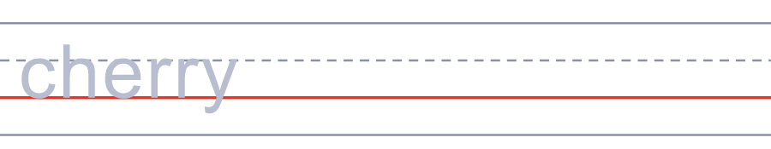

🥧 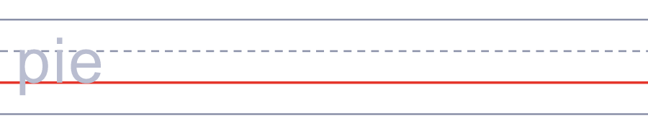
🪓 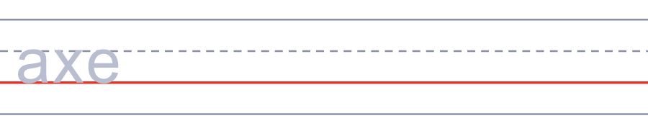
🦷 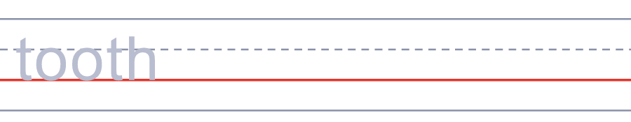
💵 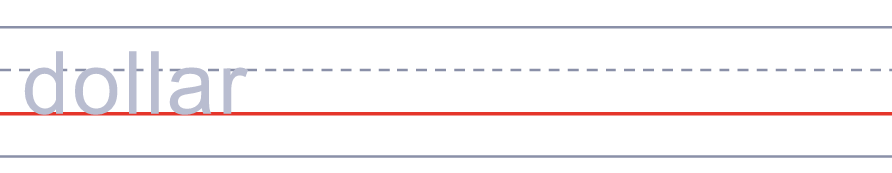

🇺🇸 Presidents' Day Worksheet
Answer Key 解答
Reading Check: 1.D 2.B 3.A 4.C 5.A
True or False: 1.T 2.F 3.T 4.F
Match: 🍒=cherry 🥧=pie 🪓=axe 🦷=tooth 💵=dollar 🗳️=ballot box
Fill in the blanks: (1)school (2)pie (3)story (4)tree (5)laughs (6)real (7)together
Maze: CHERRY
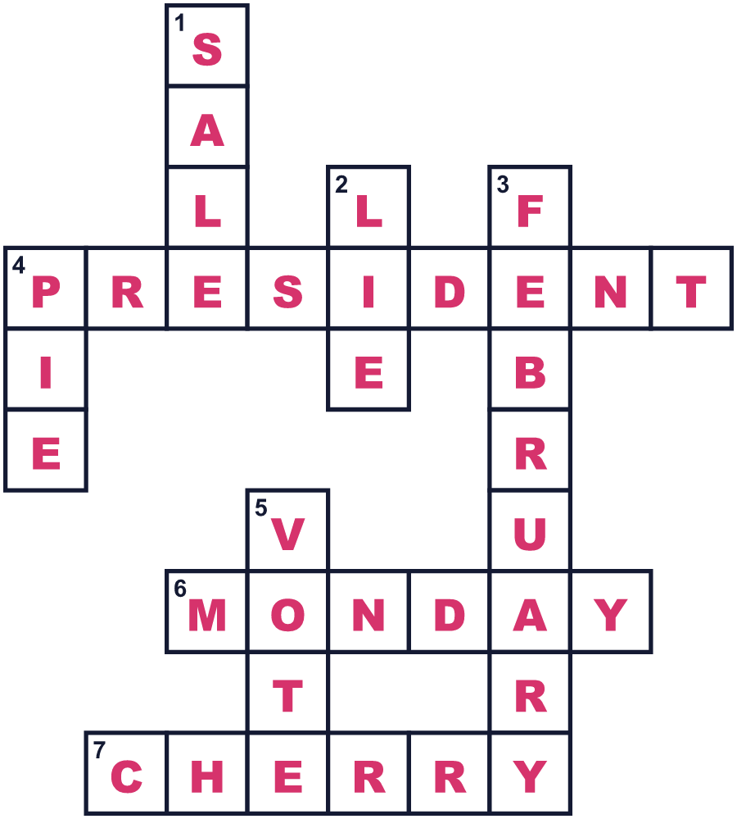
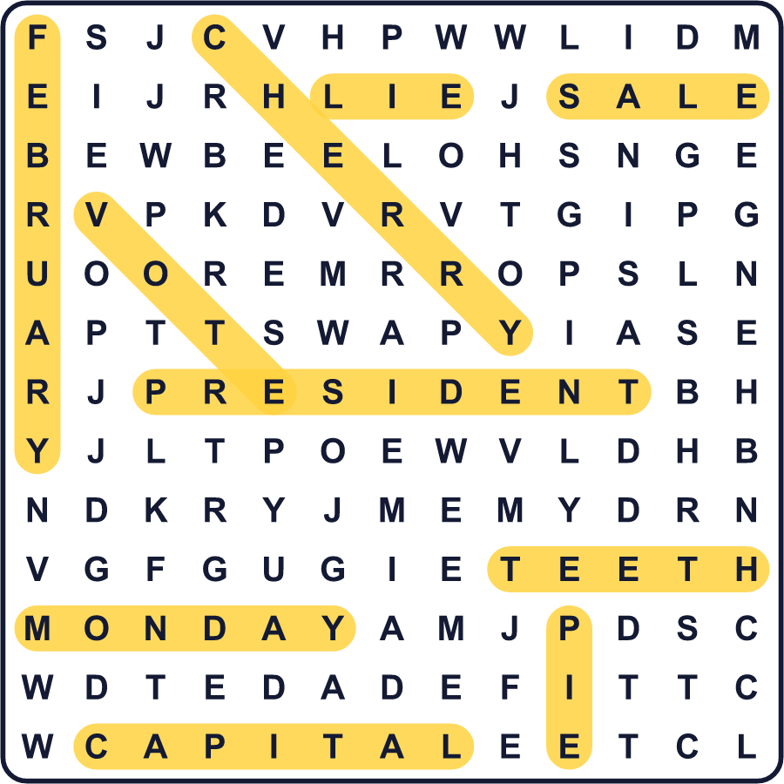
全訳
1 2月になると、アメリカの多くのお店が大きなセールをします。看板には「プレジデント・デー・セール！」と書かれています。多くの家族が新しいベッドやソファを買いに出かけます。でも、この祝日の正式な名前はプレジデント・デーではありません。「ワシントンの誕生日」なのです。
2 ジョージ・ワシントンはアメリカの初代大統領でした。その前には、独立戦争で軍を率いていました。彼は1732年にバージニアで生まれました。彼は2回とも、すべての票を得て大統領に選ばれました。首都ワシントンD.C.には、彼の名前がついています。1879年に彼の誕生日は祝日になり、それは大統領のための初めての国の祝日でした。
3 ワシントンの誕生日は2月22日です。でも1971年から、祝日は2月の第3月曜日になっています。政府は3連休を増やしたかったのです。そのため今では、祝日はいつも2月15日から21日の間に来ます。本当の誕生日には決して来ないのです！エイブラハム・リンカーンも2月生まれなので、この日に彼のこともしのぶ人がたくさんいます。プレジデント・デーと呼ぶ州もあれば、ちがう名前を使う州もあります。
4 子どものころのジョージについて、有名な話があります。父親のサクランボの木を切ってしまい、「うそはつけません」と言ったというのです。でもこの話は、メイソン・ウィームズという作家がおそらく作ったものです。また、ワシントンの歯は木でできてはいませんでした。入れ歯は、牙、金、そして人間の歯からもできていたのです。それでも、この日にチェリーパイを食べるアメリカ人もいます！

