🍫 Pocky & Pretz Day Worksheet
Four Little Sticks on One Day
Read the story. 英文を読もう。
Class ______ No. ____ Name ______________________________

🔊 音声を聞こう（スマホで読みとってね）
1 On November 11, many people in Japan eat thin chocolate sticks called Pocky. Why this day? Just look at the date, 11/11. The four ones look like four little sticks in a row. So the snack company Ezaki Glico named it Pocky & Pretz Day.
2 Pretz came first. It is a long, thin, salty biscuit stick, and it went on sale in 1963. Three years later, in 1966, the company covered Pretz with chocolate. But they left one end plain, so people could hold it with clean fingers. The name comes from pokkin, the sound a stick makes when it breaks.
3 The first Pocky & Pretz Day was on November 11, 1999. In the Japanese calendar, that year was Heisei 11. So the date had six ones in a row! Today, Pocky is sold in many countries. In parts of Europe, it has a different name, Mikado, after a game with thin sticks. In 2020, Guinness World Records called it the top-selling chocolate-covered biscuit in the world.
4 Japan is not alone. In South Korea, November 11 is Pepero Day, and friends give each other chocolate sticks. In China, the same date is Singles' Day, a huge day for online shopping. One simple shape, the number one, gives three countries three different ways to have fun. Next November 11, try counting the sticks in your box before you eat them.
Words 単語
stick（棒、棒状のもの） / snack（おやつ、軽食） / in a row（一列に並んで、連続で） / plain（何もかかっていない、無地の） / cover（おおう、かける） / go on sale（発売される） / share（分け合う） / shape（形）

🍫 Pocky & Pretz Day Worksheet
Reading Check
Choose the best answer. 正しいものを選ぼう。
Class ______ No. ____ Name ______________________________
1. What is the main idea of the passage?
(A) Pocky is the oldest snack in Japan. (B) The shape of 11/11 led to a snack day in Japan and other days in Asia. (C) Pocky Day is a national holiday in Japan. (D) People in Europe started Pocky Day.
2. When did Pocky go on sale?
(A) In 1963. (B) In 1999. (C) In 1966. (D) In 2020.
3. Why did the company leave one end of Pocky plain?
(A) So people could hold it with clean fingers. (B) Because chocolate was too expensive. (C) So it would look like the number one. (D) Because the stick broke there.
4. Why did the date November 11, 1999 have six ones in a row?
(A) Because it was the 11th Pocky Day. (B) Because Pocky was 11 years old. (C) Because the store opened at 11:11. (D) Because the year was Heisei 11 in the Japanese calendar.
5. In the dialogue, what does Olivia want to do at the end?
(A) Buy Pocky in Canada. (B) Eat the Pocky together with Sora. (C) Start a new snack day. (D) Give the box to her teacher.
True or False? T か F に○
1. Pocky & Pretz Day is on November 11. T / F
2. Pocky went on sale before Pretz. T / F
3. The name Pocky comes from the sound of a stick breaking. T / F
4. In China, November 11 is called Pepero Day. T / F

🍫 Pocky & Pretz Day Worksheet
Word Work
単語のれんしゅう
Class ______ No. ____ Name ______________________________
① Match the pictures and the words. 絵と単語を線でむすぼう。
🍫 | ● | ● | calendar
🥨 | ● | ● | gift
1️⃣ | ● | ● | one
📅 | ● | ● | autumn
🎁 | ● | ● | chocolate
🍂 | ● | ● | pretzel
③ Fill in the blanks. 語群から選んで入れよう。
[ box / friends / end / rice / share / 11 / rain / summer / sticks / date ]
Today is November (1) __________ . Ken looks at the (2) __________ on the board. "It looks like four (3) __________ !" he says. After school, he buys a (4) __________ of Pocky. He gives some to his (5) __________ . They all eat together in the park. The chocolate is sweet, and the (6) __________ of each stick is plain. Ken says, "Let's (7) __________ again next year!"

🍫 Pocky & Pretz Day Worksheet
Crossword Puzzle
ヒントを読んでクロスワードを完成させよう。
Class ______ No. ____ Name ______________________________
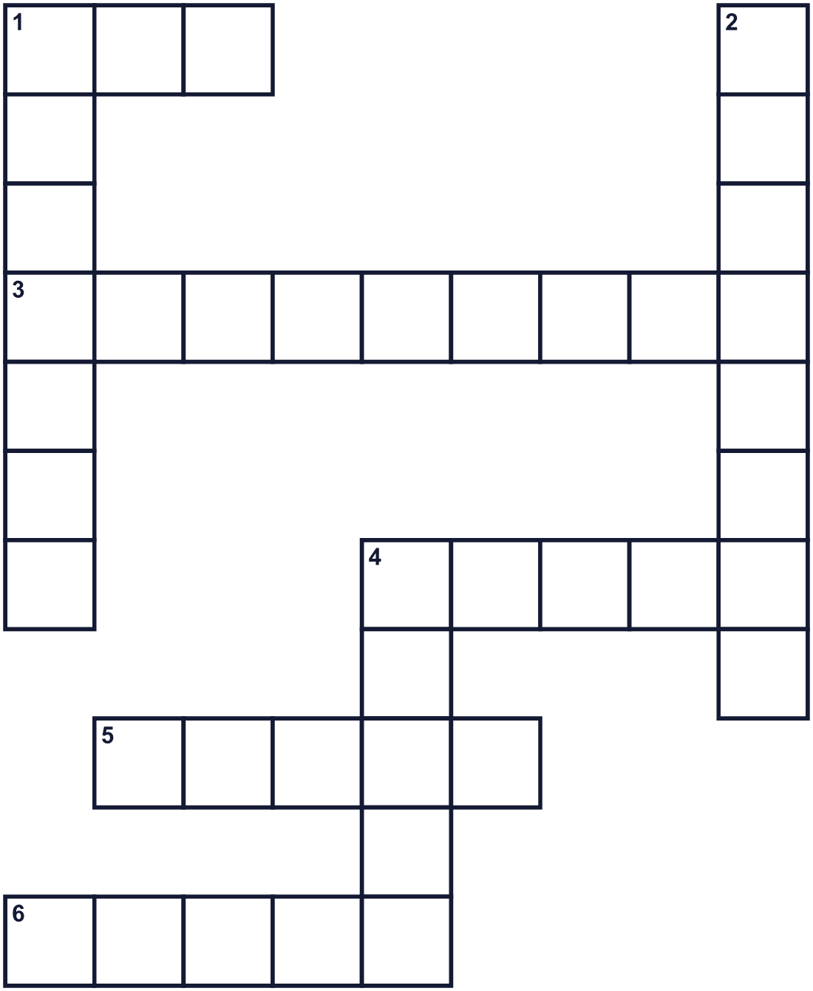
Across →
1. Snacks often come in this paper container. (3)
3. Sweet and brown. It covers most of a Pocky. (9)
4. To give part of your food to others. (5)
5. With nothing on it. (5)
6. Food you eat between meals. (5)
Down ↓
1. A small, dry, baked food. Pretz is one. (7)
2. The eleventh month of the year. (8)
4. A long, thin piece. Pocky looks like this. (5)

🍫 Pocky & Pretz Day Worksheet
Word Search
かくれた単語をさがそう（→ ↓ ↘ ↗）
Class ______ No. ____ Name ______________________________
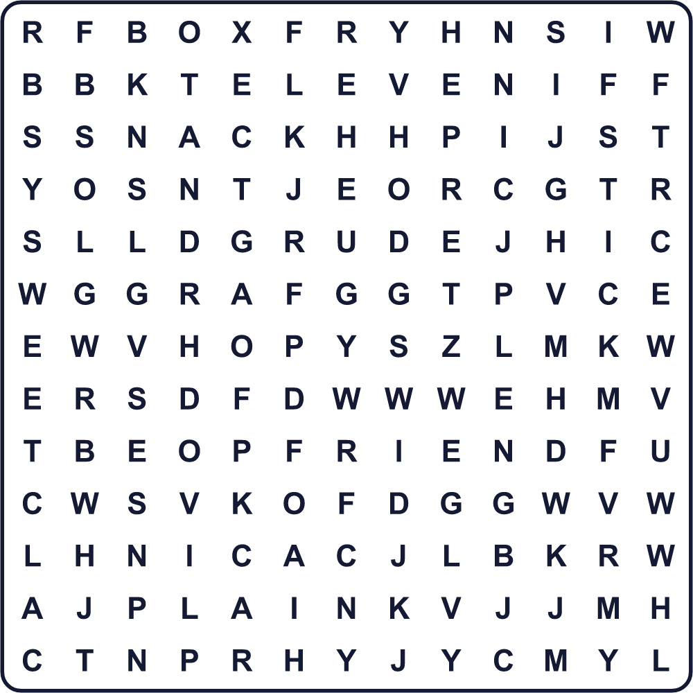
BOX ELEVEN FRIEND PLAIN POCKY PRETZ SHARE SNACK STICK SWEET

🍫 Pocky & Pretz Day Worksheet
Maze & Sentences
Class ______ No. ____ Name ______________________________
Help Ken bring the snack to his friend! ケンがお菓子を友だちに届けられるように助けよう！
正しい道の文字を集めると、ひみつの言葉になるよ。 START 🧒 → GOAL 🍫
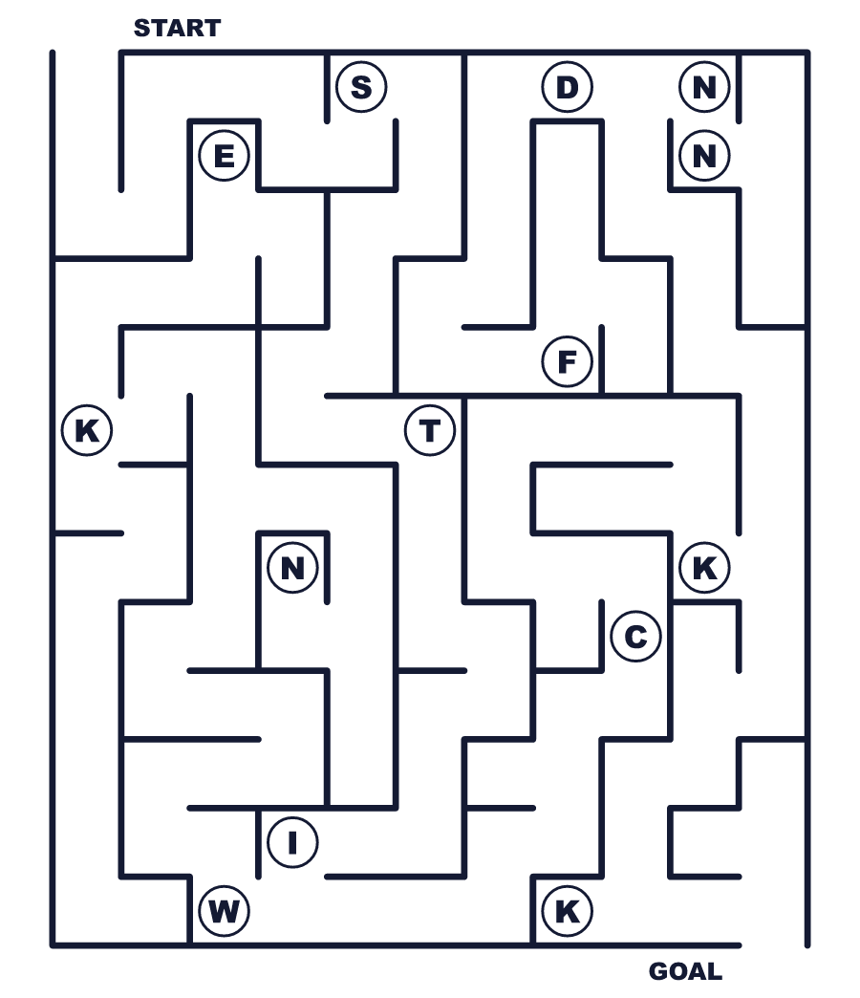
Secret word: ＿ ＿ ＿ ＿ ＿

🍫 Pocky & Pretz Day Worksheet
Class Activity & Writing
Class ______ No. ____ Name ______________________________
Let's Write! 英語で書いてみよう。
If I made a snack day, it would be on ______ because ______.
お菓子の記念日を作るなら、______にします。なぜなら______だからです。
______________________________________________________________
______________________________________________________________
To explain Pocky Day to a friend, I would say, "______."
友だちにポッキーの日を説明するなら「______」と言います。
______________________________________________________________
______________________________________________________________

🍫 Pocky & Pretz Day Worksheet
Trace & Color
なぞって書こう。絵に色をぬろう。
Class ______ No. ____ Name ______________________________
🍫 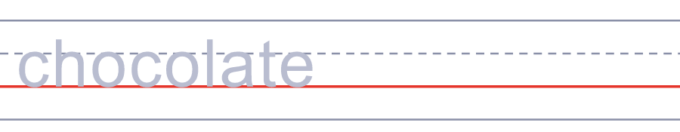

🥨 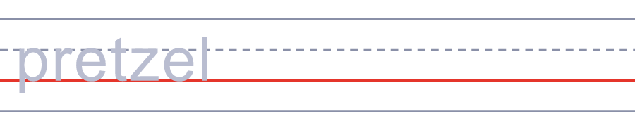
1️⃣ 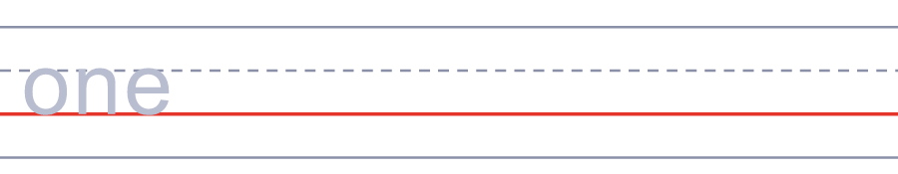
📅 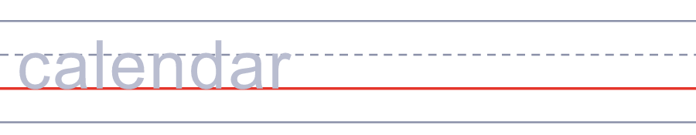
🎁 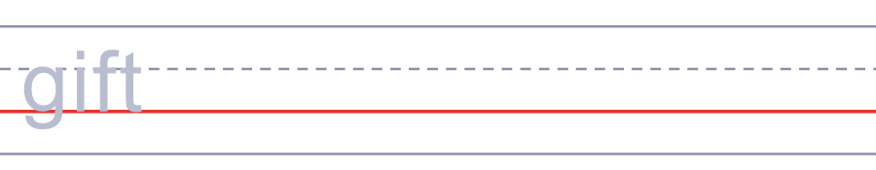

🍫 Pocky & Pretz Day Worksheet
Answer Key 解答
Reading Check: 1.B 2.C 3.A 4.D 5.B
True or False: 1.T 2.F 3.T 4.F
Match: 🍫=chocolate 🥨=pretzel 1️⃣=one 📅=calendar 🎁=gift 🍂=autumn
Fill in the blanks: (1)11 (2)date (3)sticks (4)box (5)friends (6)end (7)share
Maze: STICK
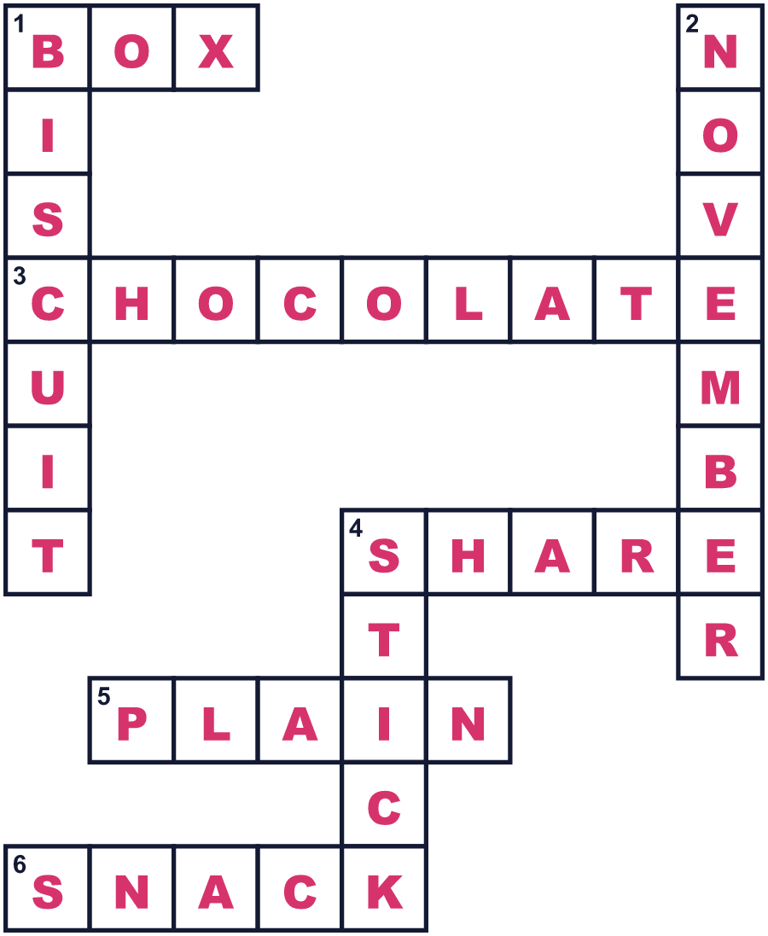
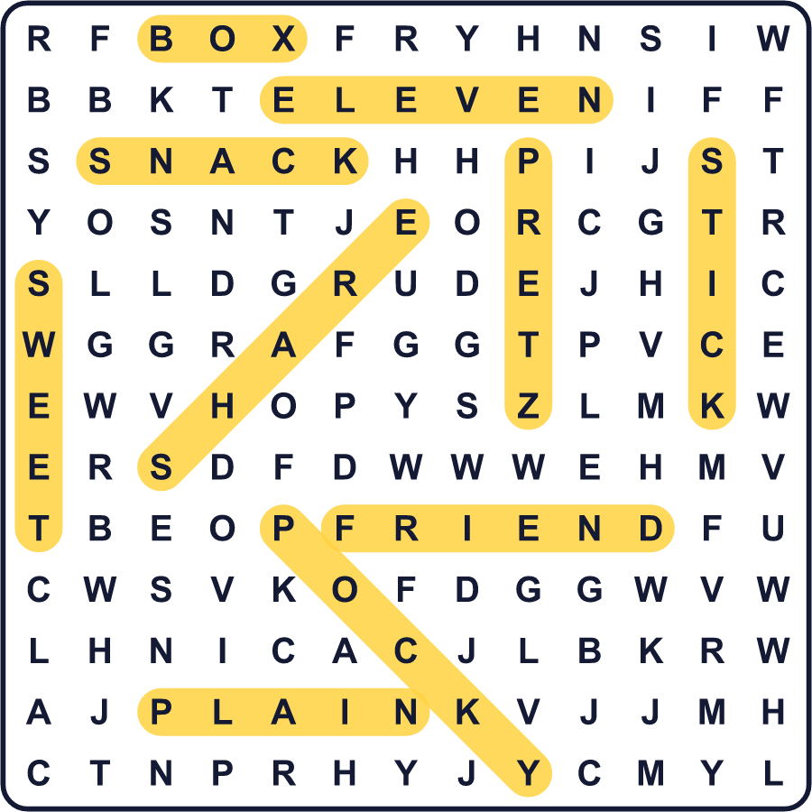
全訳
1 11月11日、日本では多くの人がポッキーという細いチョコのお菓子を食べます。なぜこの日なのでしょう。日付の「11/11」を見てください。4つの「1」が、小さな棒が4本並んでいるように見えます。そこでお菓子の会社の江崎グリコが、この日を「ポッキー＆プリッツの日」と名づけました。
2 先に生まれたのはプリッツです。長くて細い、塩味のビスケットの棒で、1963年に発売されました。3年後の1966年、会社はプリッツにチョコレートをかけました。でも片方の端はチョコなしで残しました。指をよごさずに持てるようにです。名前は、棒が折れるときの音「ポッキン」から来ています。
3 第1回のポッキー＆プリッツの日は、1999年11月11日でした。日本の暦では、その年は平成11年でした。つまり日付に「1」が6つも並んだのです！今では、ポッキーはたくさんの国で売られています。ヨーロッパの一部では、細い棒を使うゲームにちなんで「ミカド」という別の名前です。2020年、ギネス世界記録はポッキーを世界で一番売れているチョコがけビスケットと認めました。
4 こうした日は日本だけではありません。韓国では11月11日は「ペペロデー」で、友だち同士でチョコの棒菓子を贈り合います。中国では同じ日が「独身の日」で、ネットで買い物をする巨大な日になっています。数字の「1」というひとつの単純な形が、3つの国に3通りの楽しみ方をくれるのです。次の11月11日には、食べる前に箱の中の棒を数えてみてください。

