🥧 Pi Day Worksheet
A Day for Pie, Circles, and a Very Long Number
Read the story. 英文を読もう。
Class ______ No. ____ Name ______________________________

🔊 音声を聞こう（スマホで読みとってね）
1 In 1988, a scientist named Larry Shaw had a funny idea. He worked at a science museum in San Francisco. On March 14, he and other people at the museum walked around a big circle there. Then they all ate fruit pies. That was the start of Pi Day.
2 So what is pi? Pi is a number. It tells us how many times the line across a circle fits into the line around it. The answer is always about 3.14. But pi never ends. After 3.14 come 159, 265, and many more digits. In America, people write the month first, so March 14 looks like 3.14.
3 Why do people eat pie on this day? In English, pi and pie sound the same. Also, most pies are round like a circle. Some schools have pie parties, and some students throw cream pies at their teachers. Some people wait until 1:59 to cut their pie.
4 March 14 is special for another reason, too. It is the birthday of Albert Einstein, the famous scientist. In Princeton, the town where he lived, people hold an Einstein look-alike contest. Since 2020, the day has also been the International Day of Mathematics.
5 Some people try to remember as many digits of pi as they can. In 2006, a man in Japan said 100,000 digits from memory. It took him about 16 hours, and he ate rice balls during his breaks. You don't need 100,000 digits to have fun on Pi Day. Just remember 3.14, and have a slice of pie!
Words 単語
circle（円） / number（数） / digit（（0〜9の）数字、けた） / round（丸い） / museum（博物館、美術館、科学館） / throw（投げる） / remember（覚えている、覚える） / memory（記憶） / contest（コンテスト、競技会） / look-alike（そっくりさん） / slice（（薄く切った）ひと切れ） / mathematics（数学）

🥧 Pi Day Worksheet
Reading Check
Choose the best answer. 正しいものを選ぼう。
Class ______ No. ____ Name ______________________________
1. What is the story mainly about?
(A) How to bake an apple pie (B) Why March 14 is a fun day for math (C) The life of Albert Einstein (D) A science museum in Japan
2. Who started Pi Day?
(A) Albert Einstein (B) A teacher in Princeton (C) A man in Japan (D) Larry Shaw
3. Why do people in America think March 14 looks like pi?
(A) Because they write the month first (B) Because it is in spring (C) Because pies are cheap then (D) Because Einstein liked math
4. How long did it take the man in Japan to say 100,000 digits?
(A) About 6 hours (B) About 10 hours (C) About 16 hours (D) About 3 days
5. In the story, what does "from memory" mean?
(A) By reading a book (B) Without looking at anything (C) By using a computer (D) With a friend's help
6. Which sentence is true?
(A) Pi ends after 100,000 digits. (B) Pi and pie sound different in English. (C) March 14 is Einstein's birthday. (D) Pi Day started in Japan.
7. Why do some people cut their pie at 1:59?
(A) Because 159 comes after 3.14 in pi (B) Because lunch ends at 1:59 (C) Because the pie is hot until then (D) Because schools close at 1:59
8. In the dialogue, what can the winner of the pi contest do?
(A) Eat the whole pie (B) Go home early (C) Meet Einstein (D) Throw a pie at Mr. Brown
True or False? T か F に○
1. Pi Day is on March 14. T / F
2. Pi Day started in Japan. T / F
3. Pi and pie sound the same in English. T / F
4. Pi ends after 3.14. T / F
5. March 14 is Albert Einstein's birthday. T / F
6. Japanese schools teach that pi is 3. T / F

🥧 Pi Day Worksheet
Word Work
単語のれんしゅう
Class ______ No. ____ Name ______________________________
① Match the pictures and the words. 絵と単語を線でむすぼう。
🥧 | ● | ● | ruler
⭕ | ● | ● | brain
🍎 | ● | ● | clock
🍕 | ● | ● | circle
🧠 | ● | ● | trophy
🏆 | ● | ● | pizza
🕐 | ● | ● | pie
📏 | ● | ● | apple
② Unscramble the words. 並べかえて単語にしよう。
1. E L I C C R (円) → ____________________
2. I G T I D (数字・けた) → ____________________
3. U R D O N (丸い) → ____________________
4. M R M E O Y (記憶) → ____________________
5. E S C L I (ひと切れ) → ____________________
6. C E T N O S T (コンテスト) → ____________________
③ Fill in the blanks. 語群から選んで入れよう。
[ digits / oven / March / summer / slice / circle / buys / pie / wins / letter / sleeps / best / quickly ]
It is (1) __________ 14. Mia wants to make a (2) __________ for her math class. She (3) __________ apples at the store. At home, she puts the pie in the (4) __________ . On top, she cuts the shape of the Greek (5) __________ pi. At school, her teacher draws a big (6) __________ on the board. "Who can say the most (7) __________ ?" he asks. Mia says, "3.14159!" She (8) __________ the contest. Everyone eats a (9) __________ of her pie. It is the (10) __________ Pi Day ever.

🥧 Pi Day Worksheet
Crossword Puzzle
ヒントを読んでクロスワードを完成させよう。
Class ______ No. ____ Name ______________________________
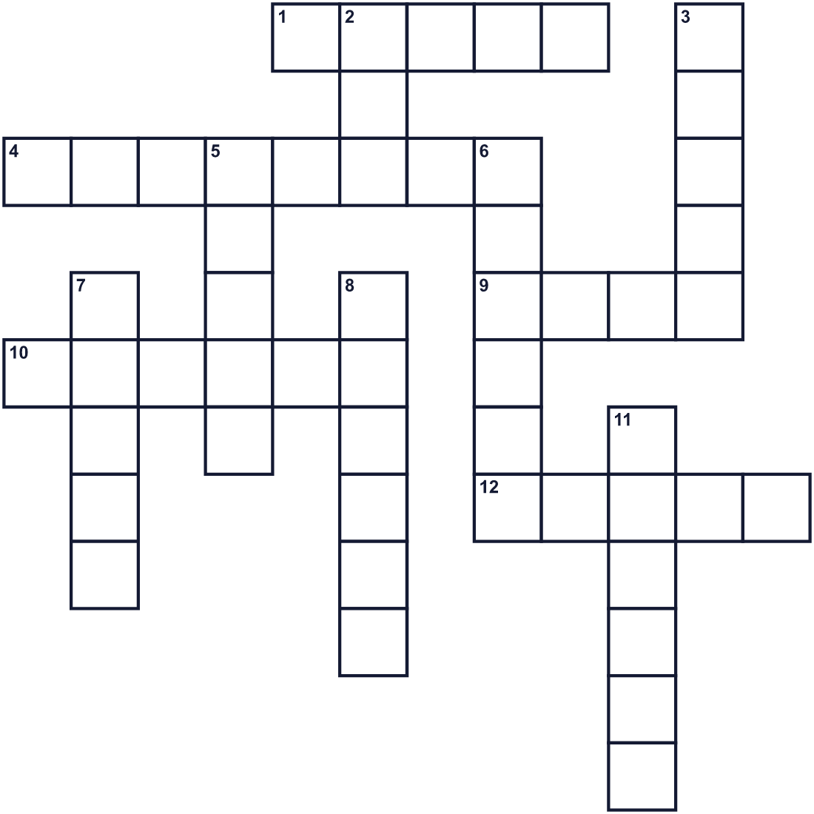
Across →
1. A red or green fruit. It is often in American pies. (5)
4. A famous scientist. He was born on March 14, 1879. (8)
9. A school subject with numbers. (4)
10. A round shape with no corners. (6)
12. Shaped like a ball or a coin. (5)
Down ↓
2. A round food. It sounds like the name of the number 3.14. (3)
3. The third month of the year. (5)
5. One piece of a cake or a pizza. (5)
6. One, two, three, and 3.14 are all examples. (6)
7. One number from 0 to 9. (5)
8. Your brain uses this to keep words and numbers. (6)
11. A building where you can see art or science. (6)

🥧 Pi Day Worksheet
Word Search
かくれた単語をさがそう（→ ↓ ↘ ↗）
Class ______ No. ____ Name ______________________________
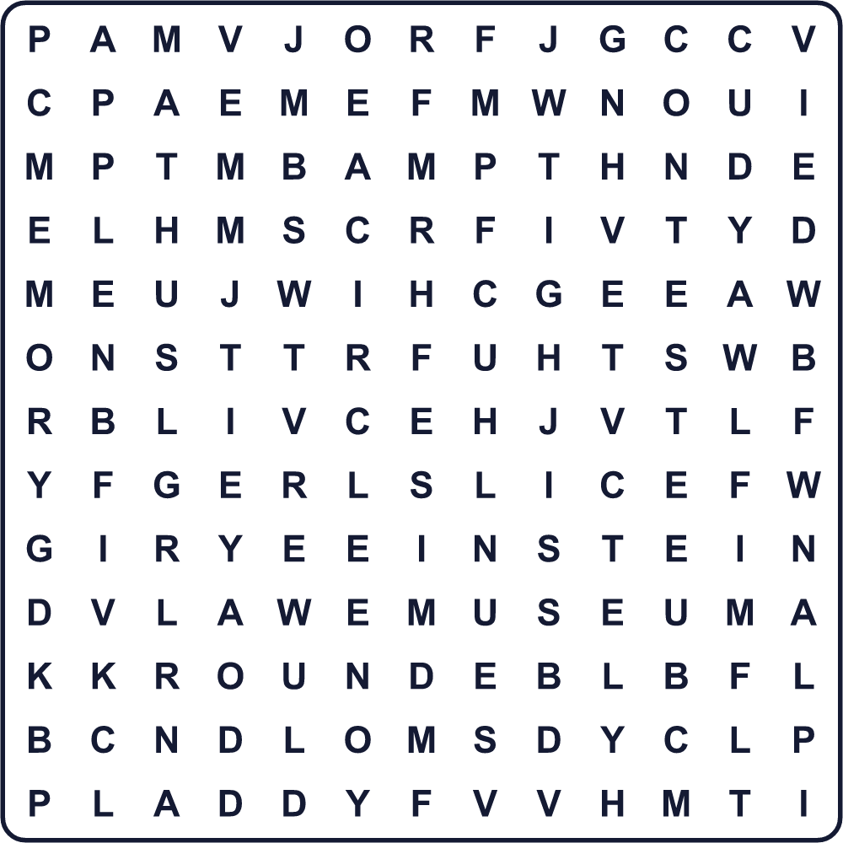
APPLE CIRCLE CONTEST DIGIT EINSTEIN MARCH MATH MEMORY MUSEUM NUMBER PIE ROUND SLICE
Secret Code 暗号を解こう
☎=A ✚=D ♦=H ☂=I ◆=P ✉=Y
♦ ☎ ◆ ◆ ✉ ◆ ☂ ✚ ☎ ✉
______________________________________________________________

🥧 Pi Day Worksheet
Maze & Sentences
Class ______ No. ____ Name ______________________________
Help Mia carry her pie to the math class! ミアがパイを数学の教室まで運ぶのを手伝おう！
正しい道の文字を集めると、ひみつの言葉になるよ。 START 👧 → GOAL 🥧
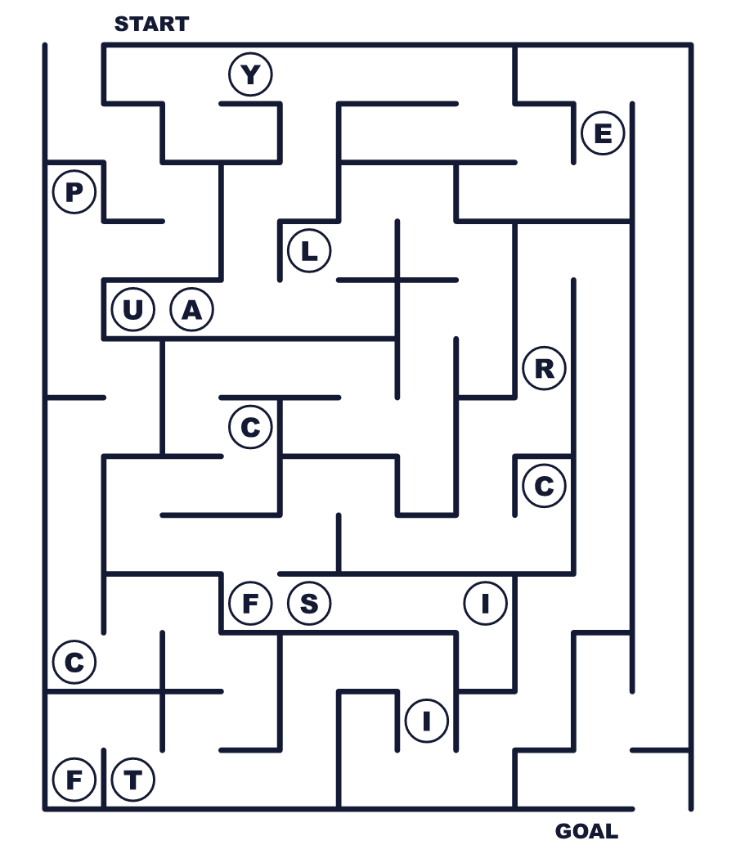
Secret word: ＿ ＿ ＿ ＿ ＿ ＿
Put the words in order. 並べかえよう。
1. Day / Pi / is / 14 / March / on . (円周率の日は3月14日です。)
______________________________________________________________
2. Most / pies / round / are / circle / like / a . (ほとんどのパイは円のように丸いです。)
______________________________________________________________
3. the / sound / same / pie / and / Pi . (pi と pie は同じ発音です。)
______________________________________________________________
4. said / memory / the / digits / He / from . (彼は何も見ずにその数字を言いました。)
______________________________________________________________
5. throw / students / teachers / at / their / Some / pies . (先生にパイを投げる生徒もいます。)
______________________________________________________________

🥧 Pi Day Worksheet
Class Activity & Writing
Class ______ No. ____ Name ______________________________
Find Someone Who… クラスで聞いて回ろう！
Find someone who … | Name
… can say pi to five digits 円周率を5けた言える
… likes apple pie アップルパイが好き
… knows who Albert Einstein was アルベルト・アインシュタインが誰か知っている
… has baked a pie or a cake パイかケーキを焼いたことがある
… has a birthday in March 3月生まれ
… likes math 数学が好き
… has visited a science museum 科学館に行ったことがある
… can draw a circle without a tool 道具なしで円がかける
Let's Write! 英語で書いてみよう。
On Pi Day, I want to eat ______ pie because ______.
円周率の日に、私は＿＿パイが食べたいです。なぜなら＿＿だからです。
______________________________________________________________
______________________________________________________________
If I could make a new math holiday, it would be on ______ because ______.
新しい数学の記念日を作れるなら、＿＿にします。なぜなら＿＿だからです。
______________________________________________________________
______________________________________________________________
One thing I like about math is ______.
数学で好きなことの1つは＿＿です。
______________________________________________________________
______________________________________________________________

🥧 Pi Day Worksheet
Trace & Color
なぞって書こう。絵に色をぬろう。
Class ______ No. ____ Name ______________________________
🥧 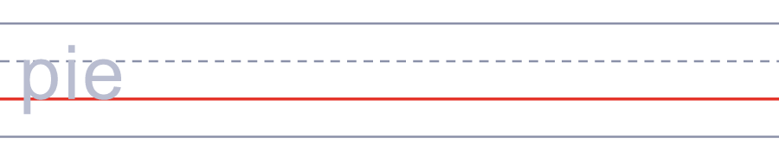

⭕ 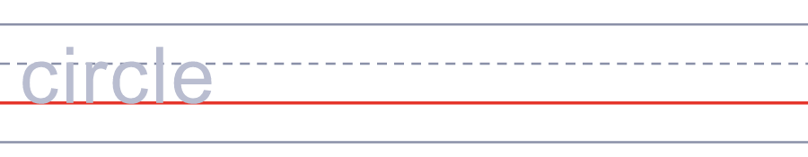
🍎 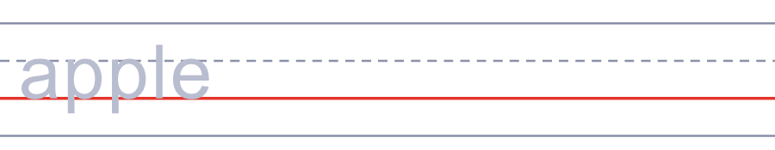
🍕 
🧠 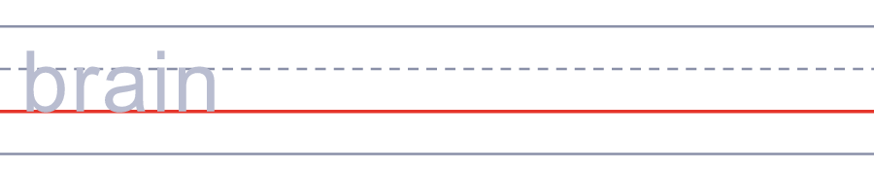
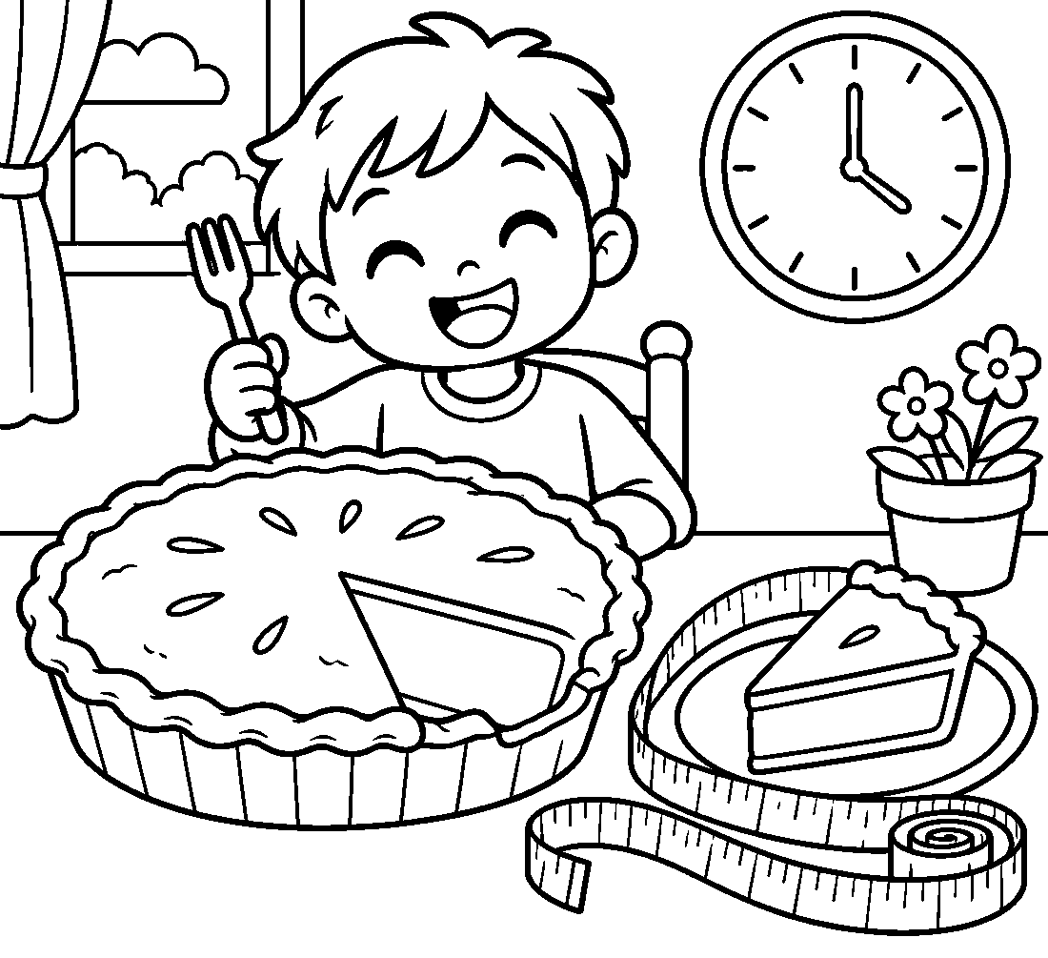

🥧 Pi Day Worksheet
Answer Key 解答
Reading Check: 1.B 2.D 3.A 4.C 5.B 6.C 7.A 8.D
True or False: 1.T 2.F 3.T 4.F 5.T 6.F
Match: 🥧=pie ⭕=circle 🍎=apple 🍕=pizza 🧠=brain 🏆=trophy 🕐=clock 📏=ruler
Unscramble: 1.CIRCLE 2.DIGIT 3.ROUND 4.MEMORY 5.SLICE 6.CONTEST
Fill in the blanks: (1)March (2)pie (3)buys (4)oven (5)letter (6)circle (7)digits (8)wins (9)slice (10)best
Sentence order: 1. Pi Day is on March 14. 2. Most pies are round like a circle. 3. Pi and pie sound the same. 4. He said the digits from memory. 5. Some students throw pies at their teachers.
Secret Code: HAPPY PI DAY
Maze: CIRCLE
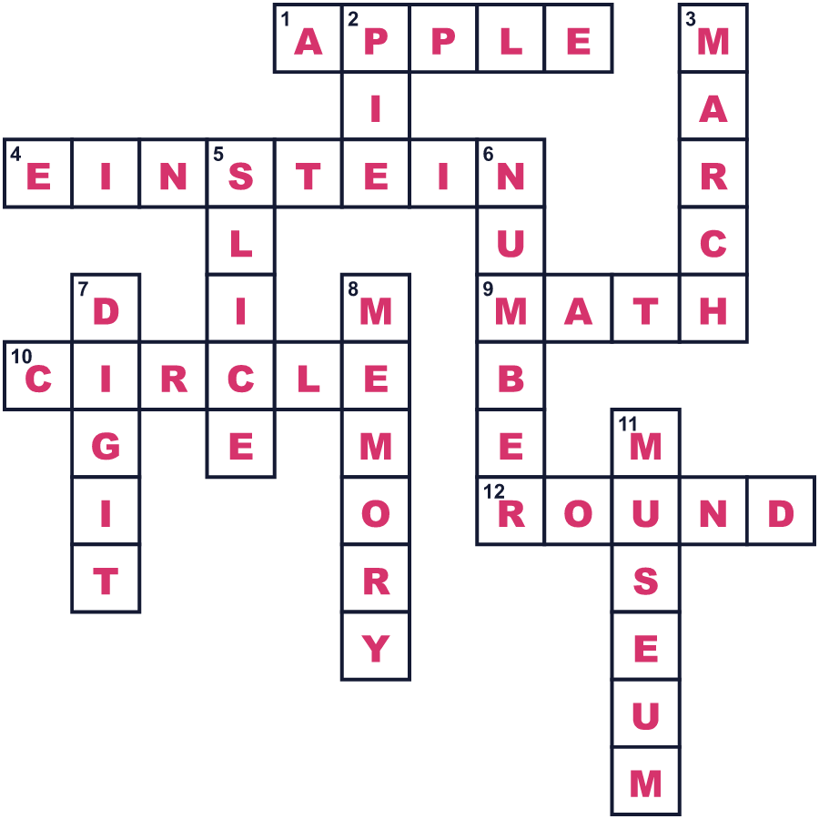
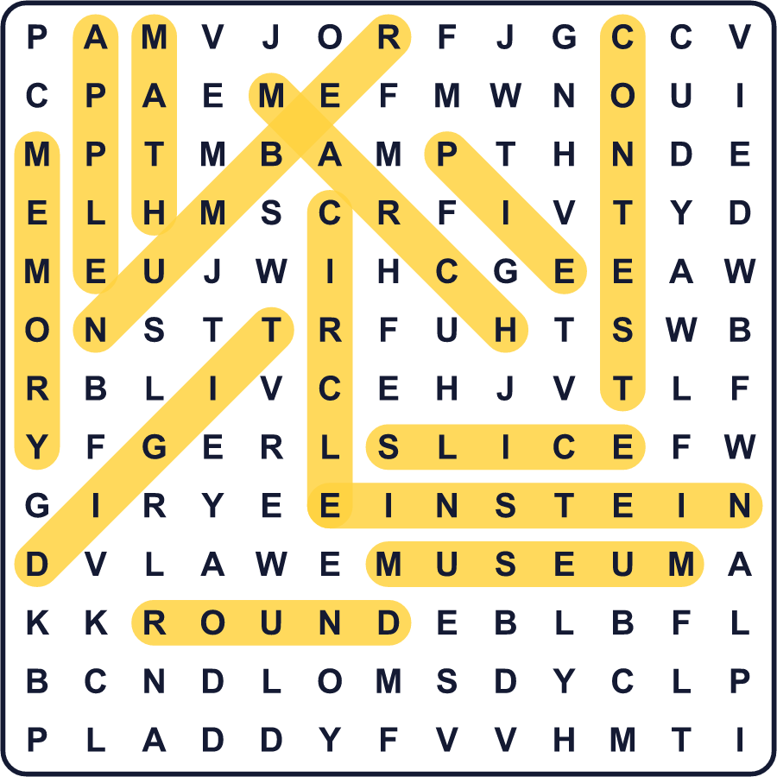
全訳
1 1988年、ラリー・ショーという科学者が、おもしろいことを思いつきました。彼はサンフランシスコの科学館で働いていました。3月14日、彼と館内の人たちは、そこにある大きな円のまわりを歩きました。それから、みんなでフルーツパイを食べました。それが円周率の日の始まりでした。
2 では、円周率とは何でしょうか。円周率は数です。円をまっすぐ横切る線が、円のまわりの線に何回分入るかを教えてくれます。答えはいつも約3.14です。でも円周率は終わりません。3.14のあとに159、265と、たくさんの数字が続きます。アメリカでは月を先に書くので、3月14日が3.14のように見えるのです。
3 なぜこの日にパイを食べるのでしょうか。英語では、pi と pie は同じ発音です。それに、ほとんどのパイは円のように丸い形です。パイ・パーティーを開く学校もあれば、先生にクリームパイを投げる生徒もいます。1時59分まで待ってパイを切る人もいます。
4 3月14日は、別の理由でも特別です。有名な科学者アルベルト・アインシュタインの誕生日なのです。彼が住んでいた町プリンストンでは、アインシュタインのそっくりさんコンテストが開かれます。2020年からは、この日は国際数学の日にもなっています。
5 円周率をできるだけ多く覚えようとする人もいます。2006年、日本の男性が10万けたを暗唱しました。それにはおよそ16時間かかり、彼は休けいのあいだにおにぎりを食べました。円周率の日を楽しむのに、10万けたはいりません。3.14だけ覚えて、パイをひと切れ食べればいいのです！

