🍷 Passover Worksheet
Why Is This Night Different?
Read the story. 英文を読もう。
Class ______ No. ____ Name ______________________________

🔊 音声を聞こう（スマホで読みとってね）
1 At a big family dinner, the youngest child stands up. She asks, "Why is this night different from all other nights?" Everyone smiles, because this question starts a very old story. This is the Seder, the special dinner of Passover.
2 Passover is a Jewish holiday in spring. It remembers the story of Exodus in the Bible. Long ago, the Israelites were slaves in Egypt. Then they became free and left Egypt in a hurry. They had no time to let their bread rise. So during Passover, many Jewish people eat flat bread called matzah.
3 For about a week, they do not eat bread, cake, or pasta. So before the holiday, families clean their homes very carefully. They look for every small piece of bread and cake. Some families even search the house by candlelight at night. At the Seder table, there is a special plate with six foods. Bitter herbs remind people of the hard life of slaves. A sweet mix of apples and nuts looks like the mud for bricks.
4 Children love one part of the night. An adult hides a piece of matzah called the afikoman. The child who finds it often gets a small prize. At the end, everyone says, "Next year in Jerusalem!" Jewish families have told this story at the table for many centuries. Each year, the children ask the same questions, and a new generation learns the answers.
Words 単語
slave（奴隷） / free（自由な） / in a hurry（急いで） / rise（（パンが）ふくらむ、上がる） / bitter（苦い） / remind（思い出させる） / hide（かくす） / generation（世代）

🍷 Passover Worksheet
Reading Check
Choose the best answer. 正しいものを選ぼう。
Class ______ No. ____ Name ______________________________
1. What is the main idea of the reading?
(A) Passover is a holiday when people eat a lot of bread and cake. (B) Passover is a new holiday that started in New York. (C) At Passover, families remember a story of freedom and pass it to their children. (D) Passover is a game in which children hide in the house.
2. Why do people eat flat bread during Passover?
(A) Because the Israelites had no time to let their bread rise. (B) Because flat bread is cheaper than other bread. (C) Because children like flat bread the best. (D) Because bread was not known in Egypt.
3. What do bitter herbs remind people of?
(A) The sweet taste of spring (B) The mud for bricks (C) The prize for children (D) The hard life of slaves
4. In paragraph 4, what does "hides" mean?
(A) eats (B) puts something where others cannot see it (C) breaks into small pieces (D) gives as a present
5. In the dialogue, why does Daiki decide to bring flowers?
(A) Because Rachel's family does not eat bread during Passover. (B) Because Rachel asked him to bring flowers. (C) Because flowers are on the Seder plate. (D) Because he wants to win the prize.
True or False? T か F に○
1. Passover remembers a story in the Bible. T / F
2. People eat a lot of cake during Passover. T / F
3. The youngest child asks questions at the Seder. T / F
4. Passover is on the same day every year. T / F

🍷 Passover Worksheet
Word Work
単語のれんしゅう
Class ______ No. ____ Name ______________________________
① Match the pictures and the words. 絵と単語を線でむすぼう。
🫓 | ● | ● | candle
🍷 | ● | ● | egg
🥚 | ● | ● | apple
🕯️ | ● | ● | flat bread
🚪 | ● | ● | wine
🍎 | ● | ● | door
③ Fill in the blanks. 語群から選んで入れよう。
[ questions / snow / oldest / bread / prize / hides / pizza / finds / youngest / story ]
Noah is six years old. This year, he is the (1) __________ at the table, so he asks the four (2) __________ . His grandma tells the old (3) __________ . Everyone eats flat (4) __________ called matzah. Later, Noah's uncle (5) __________ a piece of matzah. Noah looks under the sofa and (6) __________ it! He gets a small (7) __________ . "Next year in Jerusalem!" everyone says.

🍷 Passover Worksheet
Crossword Puzzle
ヒントを読んでクロスワードを完成させよう。
Class ______ No. ____ Name ______________________________
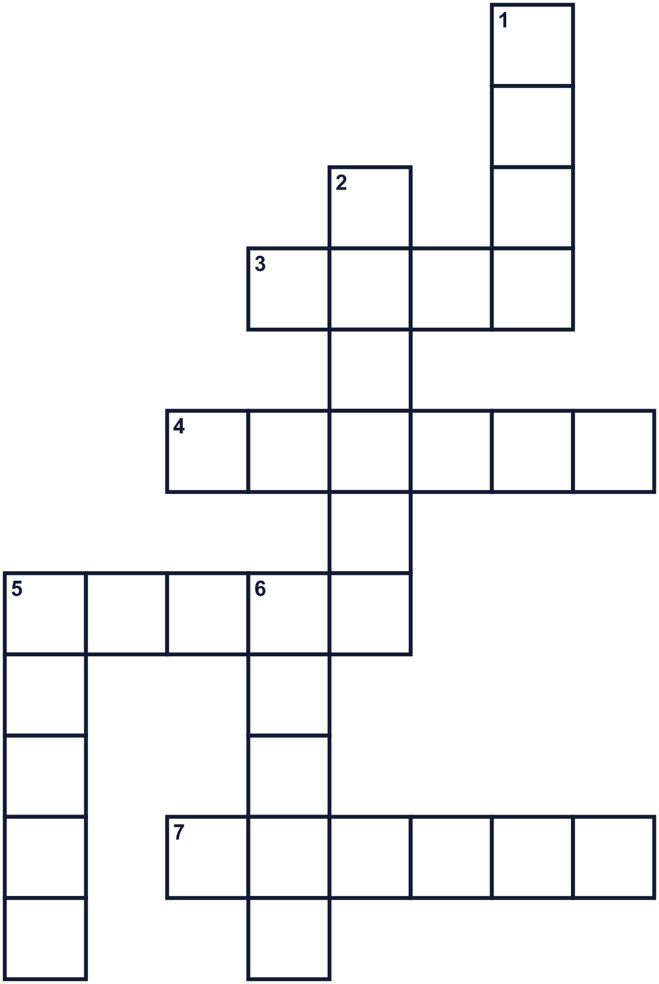
Across →
3. A drink made from grapes. Adults drink four cups. (4)
4. Flat bread for this spring holiday. (6)
5. The special family dinner on the first night. (5)
7. The season after winter. (6)
Down ↓
1. Not a slave. You can choose your life. (4)
2. The taste of strong coffee or some herbs. (6)
5. Families tell this at the table every year. (5)
6. The country the Israelites left. It has pyramids. (5)

🍷 Passover Worksheet
Word Search
かくれた単語をさがそう（→ ↓ ↘ ↗）
Class ______ No. ____ Name ______________________________
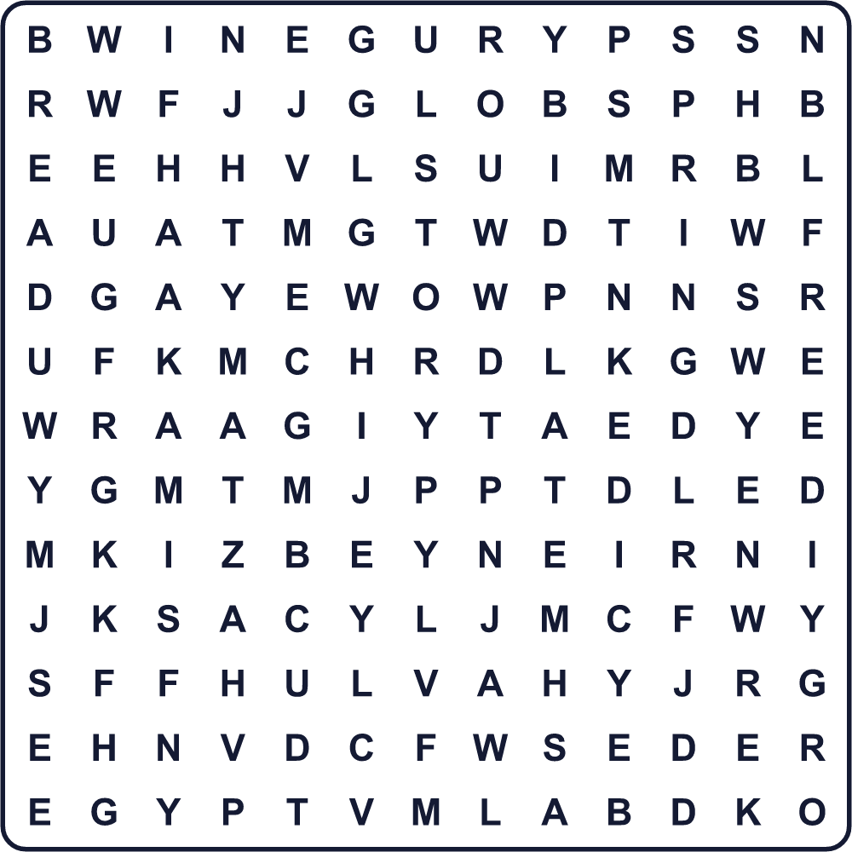
BREAD EGYPT FAMILY FREE MATZAH PLATE SEDER SPRING STORY WINE

🍷 Passover Worksheet
Maze & Sentences
Class ______ No. ____ Name ______________________________
Help Noah find the afikoman! ノアをアフィコマンのところまで連れていこう！
正しい道の文字を集めると、ひみつの言葉になるよ。 START 👦 → GOAL 🫓
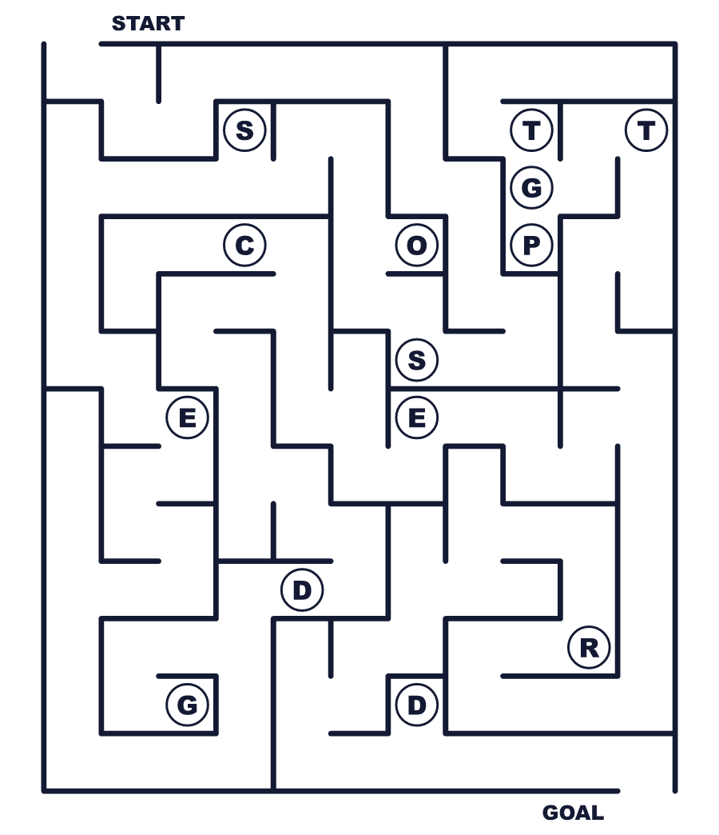
Secret word: ＿ ＿ ＿ ＿ ＿

🍷 Passover Worksheet
Class Activity & Writing
Class ______ No. ____ Name ______________________________
Let's Write! 英語で書いてみよう。
One question I would ask at a special family dinner is ______.
家族の特別な夕食で私がしたい質問は______です。
______________________________________________________________
______________________________________________________________
Freedom is important to me because ______.
自由が私にとって大切なのは______だからです。
______________________________________________________________
______________________________________________________________

🍷 Passover Worksheet
Trace & Color
なぞって書こう。絵に色をぬろう。
Class ______ No. ____ Name ______________________________
🫓 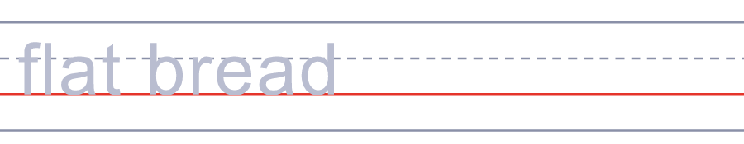

🍷 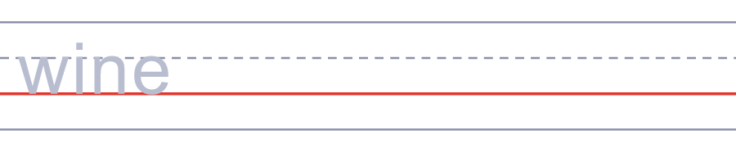
🥚 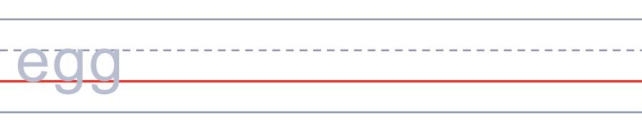
🕯️ 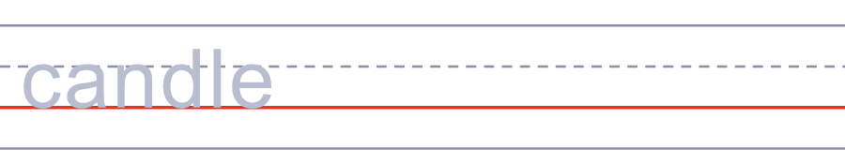
🚪 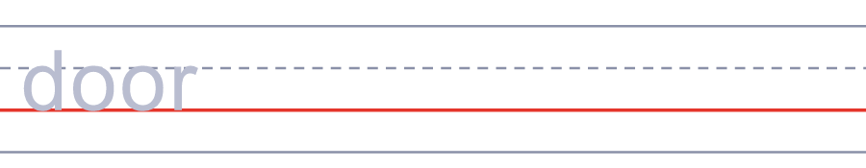

🍷 Passover Worksheet
Answer Key 解答
Reading Check: 1.C 2.A 3.D 4.B 5.A
True or False: 1.T 2.F 3.T 4.F
Match: 🫓=flat bread 🍷=wine 🥚=egg 🕯️=candle 🚪=door 🍎=apple
Fill in the blanks: (1)youngest (2)questions (3)story (4)bread (5)hides (6)finds (7)prize
Maze: SEDER
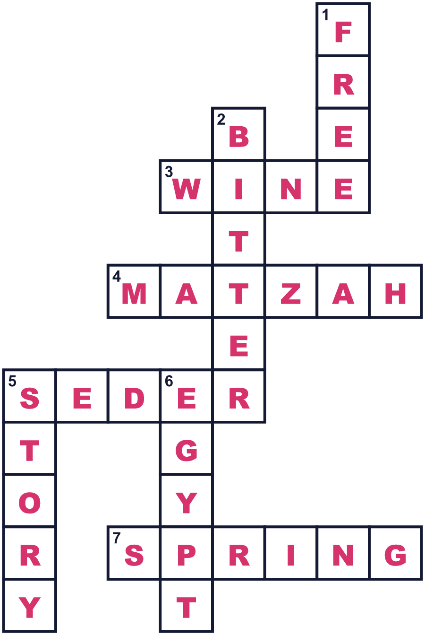
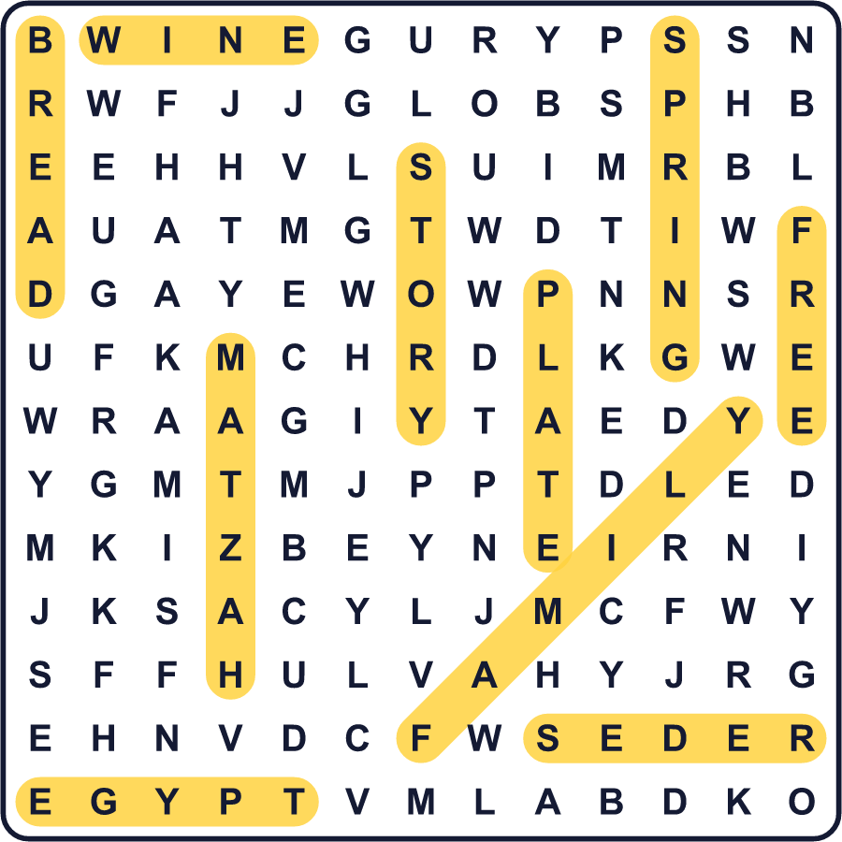
全訳
1 家族の大きな夕食の席で、いちばん年下の子が立ち上がります。そして「なぜ今夜は、ほかの夜とちがうの？」とたずねます。みんながほほえみます。この質問が、とても古い物語の始まりだからです。これがセーデル、過越祭の特別な夕食です。
2 過越祭は春のユダヤ教の祭りです。聖書の『出エジプト記』の物語を記念します。昔、イスラエルの民はエジプトで奴隷でした。やがて自由になり、急いでエジプトを出ました。パンをふくらませる時間もありませんでした。そのため過越祭の間、多くのユダヤ教徒はマッツァーという平たいパンを食べます。
3 約1週間、パンもケーキもパスタも食べません。そのため祭りの前、家族はとてもていねいに家を掃除します。パンやケーキの小さなかけらを、1つ残らず探します。夜にろうそくの明かりで家じゅうを探す家族もいます。セーデルの食卓には、6つの食べ物をのせた特別な皿があります。苦い野菜は、奴隷のつらい暮らしを思い出させます。リンゴとナッツの甘いペーストは、れんが作りの泥に似ています。
4 子どもたちには、大好きな場面があります。大人がアフィコマンというマッツァーのかけらをかくします。見つけた子は、たいてい小さなごほうびをもらえます。最後に、みんなで「来年はエルサレムで！」と言います。ユダヤの家族は、何百年にもわたって食卓でこの物語を語り継いできました。毎年子どもたちが同じ質問をし、新しい世代が答えを学んでいくのです。

