🧹 Year-End Cleaning & Customs Worksheet
Sweeping Out the Old Year
Read the story. 英文を読もう。
Class ______ No. ____ Name ______________________________

🔊 音声を聞こう（スマホで読みとってね）
1 At the end of December, homes, schools, and offices across Japan get a big cleaning. This is called oosouji, which means big cleaning. People wash windows, wipe floors, and throw away things they do not need. The goal is to start the new year in a clean place. Students clean their classrooms, too, before the winter break begins.
2 This custom is very old. Long ago, houses had open fires, so the ceilings turned black with soot. Before New Year, people swept the soot away to welcome the New Year god. This was called susuharai, or soot sweeping. It was done on December 13, the day to start getting ready for New Year.
3 In the Edo period, shops in old Tokyo had a funny custom. After the cleaning, workers threw people up into the air to celebrate. Then everyone ate a hot soup with whale meat. Some people found old pictures and news sheets inside paper sliding doors, and they stopped cleaning to read them!
4 The end of the year is busy in other ways, too. Government offices finish work around December 28 and open again in January. People also write New Year cards, called nengajo. If you mail them by about December 25, they arrive on the morning of January 1. After all this work, people say goodbye with a special phrase, Yoi otoshi o, or have a good New Year.
Words 単語
cleaning（掃除） / wipe（ふく） / throw away（捨てる） / soot（煤（すす）） / sweep（はく、はらう） / ceiling（天井） / celebrate（祝う） / mail（郵便で送る、投函する）

🧹 Year-End Cleaning & Customs Worksheet
Reading Check
Choose the best answer. 正しいものを選ぼう。
Class ______ No. ____ Name ______________________________
1. What is the main idea of the passage?
(A) Japanese people clean only in spring. (B) Year-end cleaning in Japan started as a way to get ready for the New Year god. (C) Whale soup is the most popular food in Japan. (D) Japanese offices are open on January 1.
2. Why did ceilings in old houses turn black?
(A) Because people painted them. (B) Because of soot from open fires. (C) Because of rain. (D) Because of old news sheets.
3. When was susuharai done in the past?
(A) On December 31. (B) On January 1. (C) On December 25. (D) On December 13.
4. In paragraph 3, what does "threw people up into the air" show?
(A) The workers were very happy after the cleaning. (B) The workers were angry with each other. (C) The shop was too small. (D) The cleaning was dangerous.
5. In the dialogue, when do people in England usually do a big cleaning?
(A) In winter. (B) In summer. (C) In spring. (D) In autumn.
True or False? T か F に○
1. Oosouji is a big cleaning at the end of the year. T / F
2. In the past, susuharai was done on December 31. T / F
3. In the Edo period, people ate whale soup after the cleaning. T / F
4. Government offices in Japan are open on January 2. T / F

🧹 Year-End Cleaning & Customs Worksheet
Word Work
単語のれんしゅう
Class ______ No. ____ Name ______________________________
① Match the pictures and the words. 絵と単語を線でむすぼう。
🧹 | ● | ● | window
🪣 | ● | ● | bucket
🪟 | ● | ● | broom
📮 | ● | ● | trash
🗑️ | ● | ● | mailbox
🐋 | ● | ● | whale
③ Fill in the blanks. 語群から選んで入れよう。
[ come / kitchen / photo / papers / windows / clean / summer / pizza / house / beach ]
It is December 28. Kaito and his family clean the whole (1) __________ . His father washes the (2) __________ . His mother cleans the (3) __________ . Kaito throws away old (4) __________ from his desk. He finds a funny (5) __________ from first grade and laughs. In the evening, everything is (6) __________ . His grandmother says, "Now the New Year god can (7) __________ !"

🧹 Year-End Cleaning & Customs Worksheet
Crossword Puzzle
ヒントを読んでクロスワードを完成させよう。
Class ______ No. ____ Name ______________________________
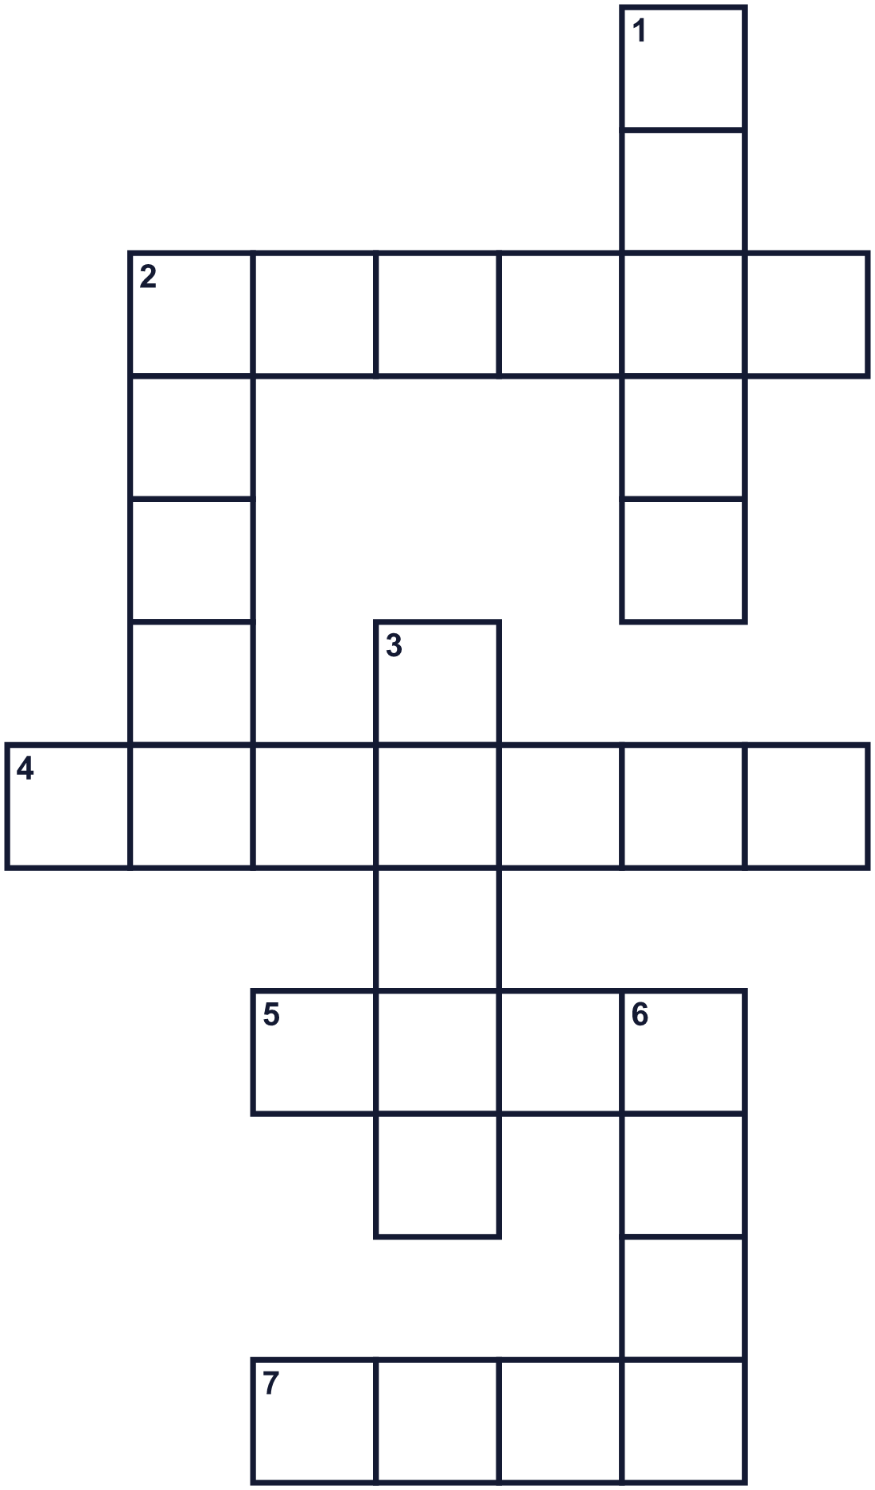
Across →
2. You can see outside through this glass. (6)
4. The top of a room, above your head. (7)
5. A small piece of paper you send to say hello. (4)
7. Black powder from fires. (4)
Down ↓
1. A tool with a long handle for sweeping the floor. (5)
2. A very big sea animal. (5)
3. Not dirty. (5)
6. Small dry dirt on shelves and floors. (4)

🧹 Year-End Cleaning & Customs Worksheet
Word Search
かくれた単語をさがそう（→ ↓ ↘ ↗）
Class ______ No. ____ Name ______________________________
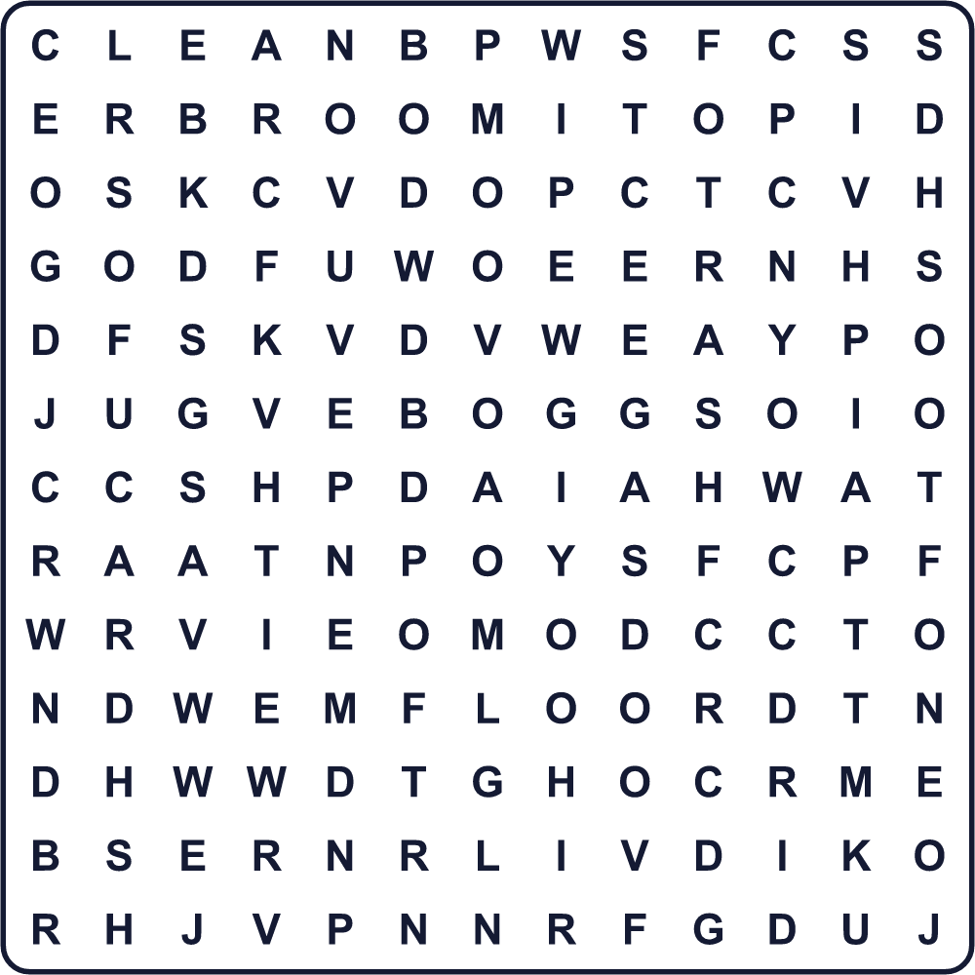
BROOM CARD CLEAN DUST FLOOR SOOT SWEEP TRASH WINDOW WIPE

🧹 Year-End Cleaning & Customs Worksheet
Maze & Sentences
Class ______ No. ____ Name ______________________________
Help Kaito take the trash to the trash can! カイトがごみをごみ箱まで運べるように助けよう！
正しい道の文字を集めると、ひみつの言葉になるよ。 START 👦 → GOAL 🗑️
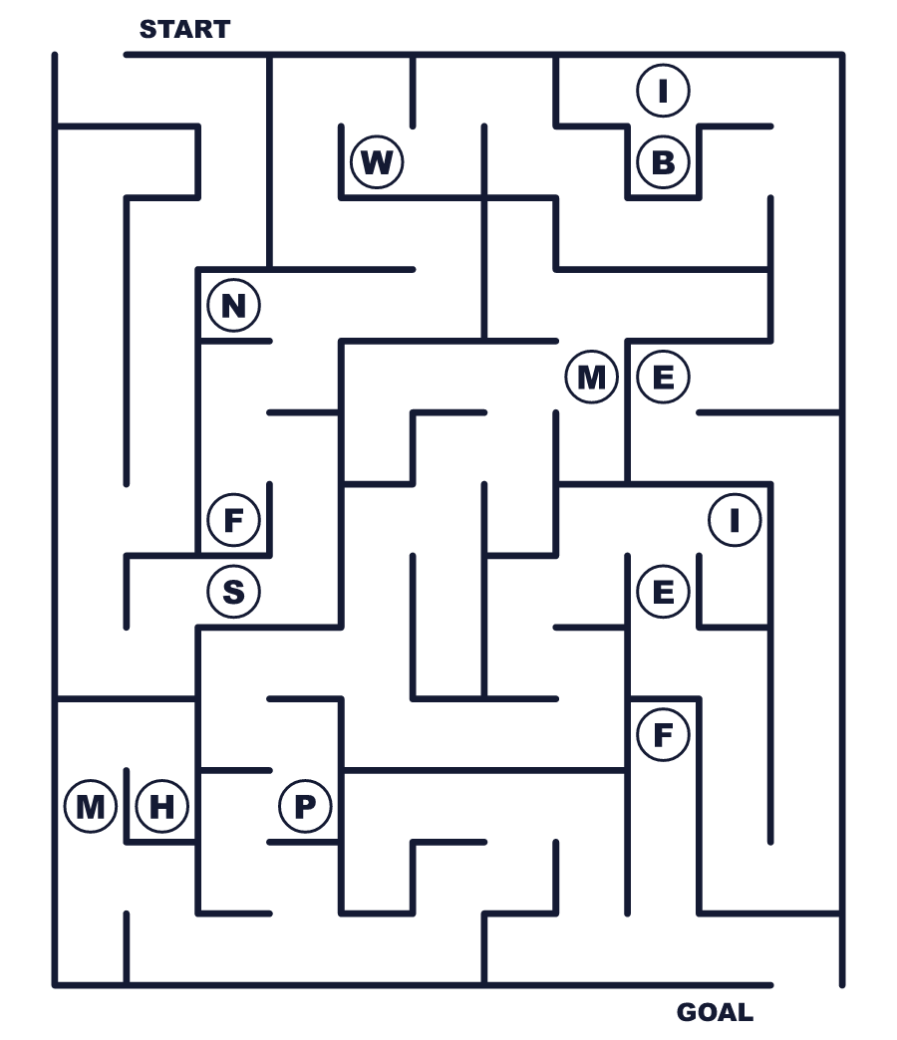
Secret word: ＿ ＿ ＿ ＿ ＿

🧹 Year-End Cleaning & Customs Worksheet
Class Activity & Writing
Class ______ No. ____ Name ______________________________
Let's Write! 英語で書いてみよう。
Before New Year, I want to clean ______ because ______.
新年の前に______を掃除したいです。なぜなら______だからです。
______________________________________________________________
______________________________________________________________
In my New Year card, I will write, "______."
年賀状に「______」と書きます。
______________________________________________________________
______________________________________________________________

🧹 Year-End Cleaning & Customs Worksheet
Trace & Color
なぞって書こう。絵に色をぬろう。
Class ______ No. ____ Name ______________________________
🧹 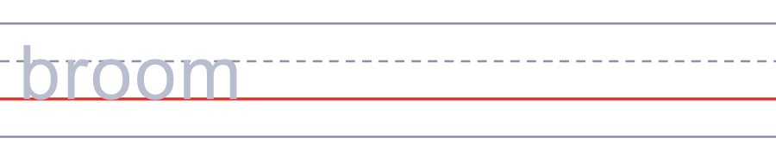

🪣 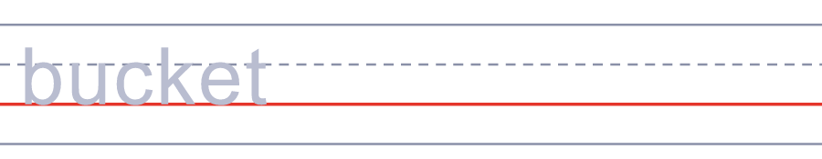
🪟 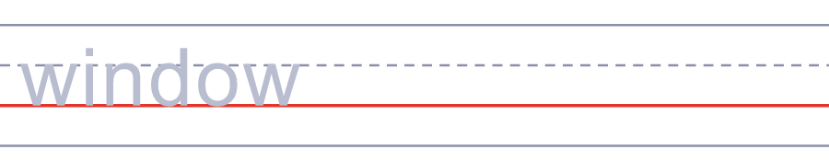
📮 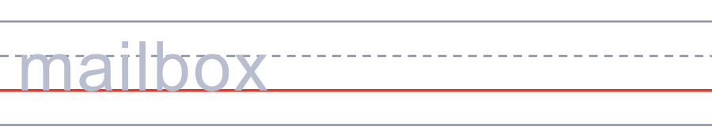
🗑️ 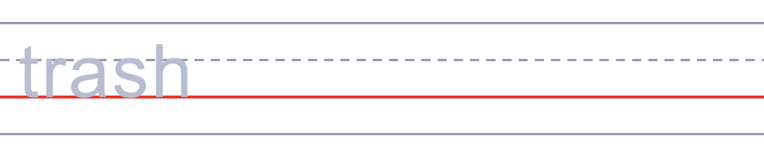

🧹 Year-End Cleaning & Customs Worksheet
Answer Key 解答
Reading Check: 1.B 2.B 3.D 4.A 5.C
True or False: 1.T 2.F 3.T 4.F
Match: 🧹=broom 🪣=bucket 🪟=window 📮=mailbox 🗑️=trash 🐋=whale
Fill in the blanks: (1)house (2)windows (3)kitchen (4)papers (5)photo (6)clean (7)come
Maze: SWEEP
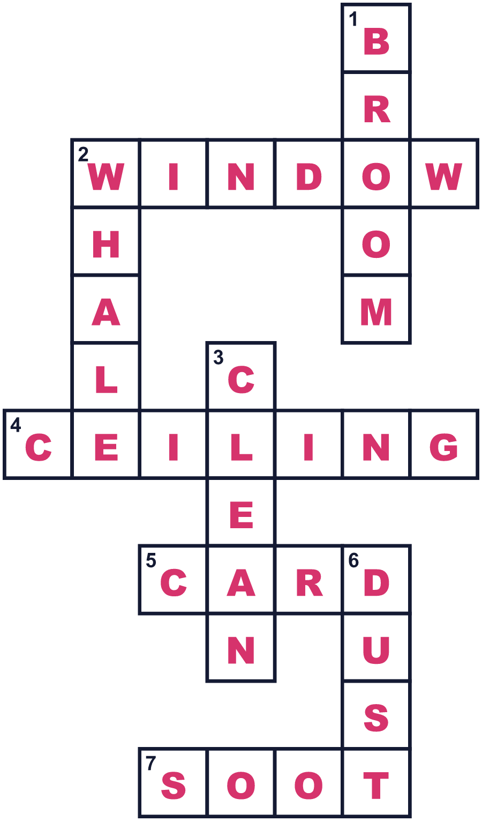
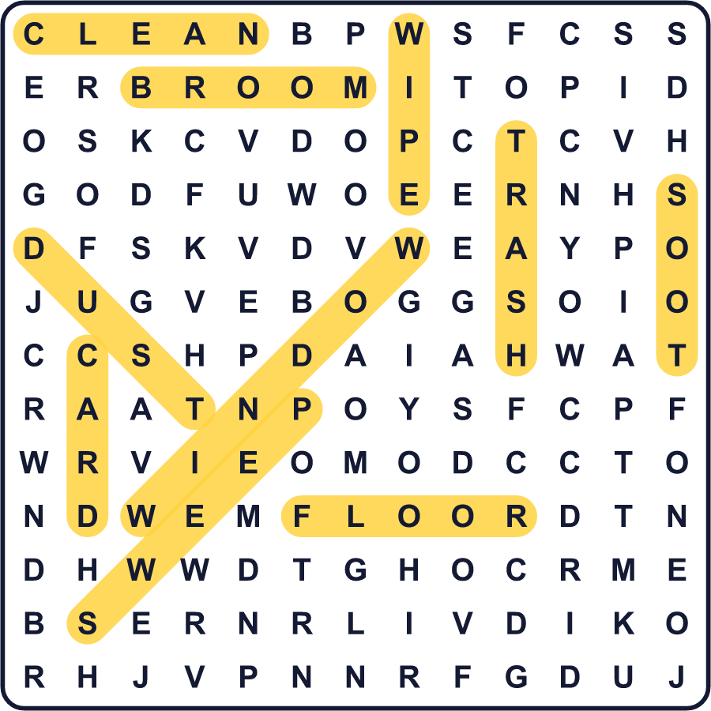
全訳
1 12月の終わり、日本中の家や学校、会社が大掃除をします。これを「大掃除」と言います。大きな掃除という意味です。人々は窓を洗い、床をふき、いらないものを捨てます。目的は、きれいな場所で新しい年を始めることです。冬休みが始まる前には、生徒たちも教室を掃除します。
2 この習慣はとても古いものです。昔の家には火をたく場所があったので、天井が煤で黒くなりました。新年の前に、人々は年神さまを迎えるために煤をはらいました。これを「煤払い」と言いました。お正月の準備を始める日、12月13日に行われていました。
3 江戸時代、江戸の町の店にはゆかいな習慣がありました。掃除が終わると、店の人たちは人を空中に放り上げてお祝いしたのです。それから、みんなで鯨の肉が入った温かい汁を食べました。ふすまの中から昔の絵や瓦版を見つけて、掃除の手を止めて読みふける人もいました！
4 年末は、ほかのことでも忙しい時期です。役所は12月28日ごろに仕事を終え、1月にまた開きます。人々は「年賀状」と呼ばれる新年のカードも書きます。12月25日ごろまでに出せば、1月1日の朝に届きます。こうした仕事を全部終えると、人々は「よいお年を」という特別な言葉で別れのあいさつをします。

