🔔 Omisoka (New Year's Eve in Japan) Worksheet
The Quietest Party of the Year
Read the story. 英文を読もう。
Class ______ No. ____ Name ______________________________

🔊 音声を聞こう（スマホで読みとってね）
1 In many countries, New Year's Eve is loud, with parties, music, and fireworks. In Japan, it is often quiet. Families stay home, eat together, and wait for the new year. This day is called Omisoka. Misoka once meant the 30th day, the last day of a month in the old calendar.
2 On this night, many people eat toshikoshi soba, or year-crossing noodles. Why soba? Some say the long noodles mean a long life. Others say soba breaks easily, so it cuts away the bad luck of the year. Nobody knows which story is true.
3 After dinner, many families watch Kohaku, a big singing show on TV. A red team of women and a white team of men sing against each other. The first Kohaku was not on New Year's Eve. It was on January 3, 1951. Since 1953, it has been on December 31 every year.
4 Near midnight, Buddhist temples begin to ring their big bells. Most temples ring them 108 times. Many people believe 108 is the number of human desires that cause trouble. With each deep sound, they try to let go of one. Radio programs in the 1920s helped this custom spread across Japan.
5 When the last bell rings, people say Akemashite omedeto, or Happy New Year. Some walk to a shrine in the cold night air. Others go straight to bed, warm and full. It is a quiet party, but it is full of hope.
Words 単語
New Year's Eve（大みそか） / calendar（暦、カレンダー） / noodles（麺） / luck（運） / temple（寺） / ring（（鐘を）鳴らす、鳴る） / desire（欲望、願い） / midnight（真夜中、午前0時） / custom（習慣、風習） / spread（広まる、広げる） / let go of（手放す） / hope（希望）

🔔 Omisoka (New Year's Eve in Japan) Worksheet
Reading Check
Choose the best answer. 正しいものを選ぼう。
Class ______ No. ____ Name ______________________________
1. What is the passage mainly about?
(A) How to make soba at home (B) How Japanese people spend New Year's Eve (C) The history of fireworks (D) Parties in other countries
2. What does misoka mean?
(A) The last week (B) The new moon (C) The 30th day (D) A big party
3. When was the first Kohaku show?
(A) On December 31, 1953 (B) On January 3, 1951 (C) In the 1920s (D) On December 31, 1945
4. How many times do most temples ring their bells?
(A) 108 times (B) 12 times (C) 33 times (D) 1,000 times
5. In paragraph 4, the word spread is closest in meaning to ____.
(A) stop (B) become smaller (C) go to many places (D) get louder
6. Which is true about the passage?
(A) Everyone knows why people eat soba. (B) Kohaku is a cooking show. (C) In Japan, New Year's Eve is often quiet. (D) Temples ring bells in the morning.
7. Why does the writer call it the quietest party of the year?
(A) Because people spend it calmly at home but still celebrate (B) Because nobody eats anything (C) Because TV is not allowed (D) Because it is in summer
8. In the dialogue, what does Mei tell Tom to bring?
(A) A bowl of soba (B) A warm coat (C) A TV (D) A bell
True or False? T か F に○
1. Omisoka is on December 31. T / F
2. Omisoka is a national holiday in Japan. T / F
3. Misoka originally means the 30th day. T / F
4. The first Kohaku show was on New Year's Eve. T / F
5. Most temples ring their bells 108 times. T / F
6. In Spain, people eat soba at midnight. T / F

🔔 Omisoka (New Year's Eve in Japan) Worksheet
Word Work
単語のれんしゅう
Class ______ No. ____ Name ______________________________
① Match the pictures and the words. 絵と単語を線でむすぼう。
🍜 | ● | ● | grapes
🔔 | ● | ● | orange
🎤 | ● | ● | fireworks
📺 | ● | ● | TV
🍇 | ● | ● | noodles
🎆 | ● | ● | bell
🕛 | ● | ● | midnight
🍊 | ● | ● | singer
② Unscramble the words. 並べかえて単語にしよう。
1. E L E M T P (寺) → ____________________
2. N O O E S D L (麺) → ____________________
3. M H G N D I T I (真夜中) → ____________________
4. B E R E C M E D (12月) → ____________________
5. U T C M S O (習慣) → ____________________
6. K C L U (運) → ____________________
③ Fill in the blanks. 語群から選んで入れよう。
[ cold / summer / excited / soba / show / midnight / 31 / Year / life / house / bell / swim / pizza ]
It was December (1) __________ . Kenta helped his mother clean the (2) __________ . In the evening, the family ate hot (3) __________ together. Grandpa said, Long noodles mean a long (4) __________ . After dinner, they watched a singing (5) __________ on TV. Near (6) __________ , they walked to the temple in the (7) __________ air. Kenta rang the big (8) __________ one time. It made a deep sound. Then everyone said, Happy New (9) __________ ! Kenta felt (10) __________ about the new year.

🔔 Omisoka (New Year's Eve in Japan) Worksheet
Crossword Puzzle
ヒントを読んでクロスワードを完成させよう。
Class ______ No. ____ Name ______________________________
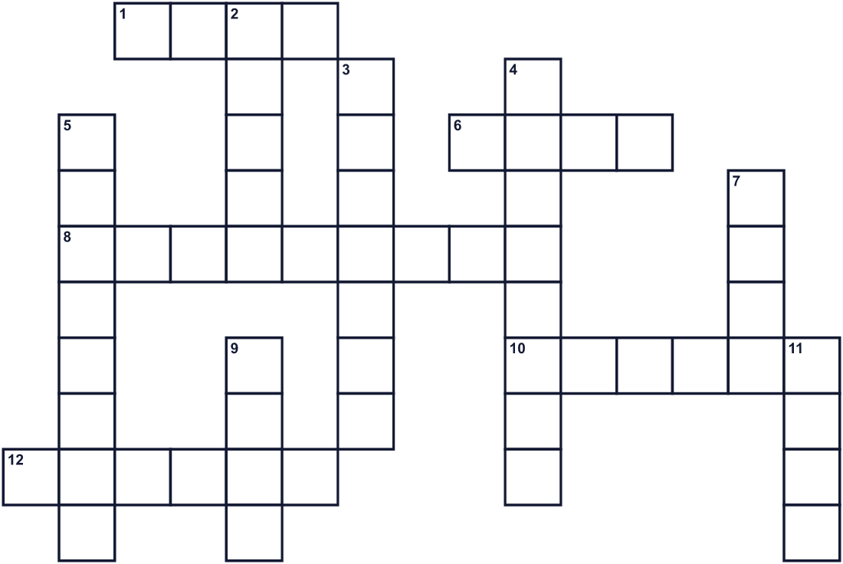
Across →
1. Good fortune. People hope for good ___. (4)
6. To hope for something. People make one for the new year. (4)
8. Ten, nine, eight... to zero! (9)
10. In Spain, people eat twelve of these small fruits. (6)
12. A Buddhist place with a big bell. (6)
Down ↓
2. To make your room nice and not dirty. (5)
3. Long, thin food like ramen or udon. (7)
4. Twelve o'clock at night. (8)
5. The last month of the year. (8)
7. A good feeling about the future. (4)
9. Temples ring this big metal thing 108 times. (4)
11. Thin Japanese buckwheat noodles eaten on this night. (4)

🔔 Omisoka (New Year's Eve in Japan) Worksheet
Word Search
かくれた単語をさがそう（→ ↓ ↘ ↗）
Class ______ No. ____ Name ______________________________
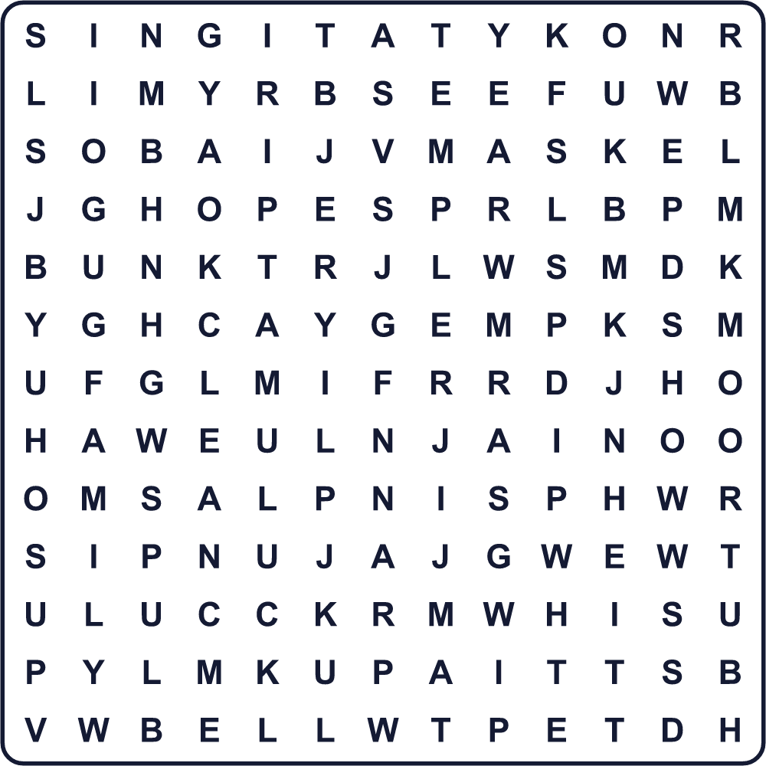
BELL CLEAN FAMILY GRAPES HOPE LUCK NIGHT SHOW SING SOBA TEMPLE WISH YEAR
Secret Code 暗号を解こう
●=A ◆=E ☾=H ♥=N ⚑=P ■=R ✎=V ✂=W ♣=Y
☾ ● ✎ ◆ ● ☾ ● ⚑ ⚑ ♣ ♥ ◆ ✂ ♣ ◆ ● ■
______________________________________________________________

🔔 Omisoka (New Year's Eve in Japan) Worksheet
Maze & Sentences
Class ______ No. ____ Name ______________________________
Help Kenta get to the temple bell! ケンタを除夜の鐘まで連れていこう！
正しい道の文字を集めると、ひみつの言葉になるよ。 START 👦 → GOAL 🔔
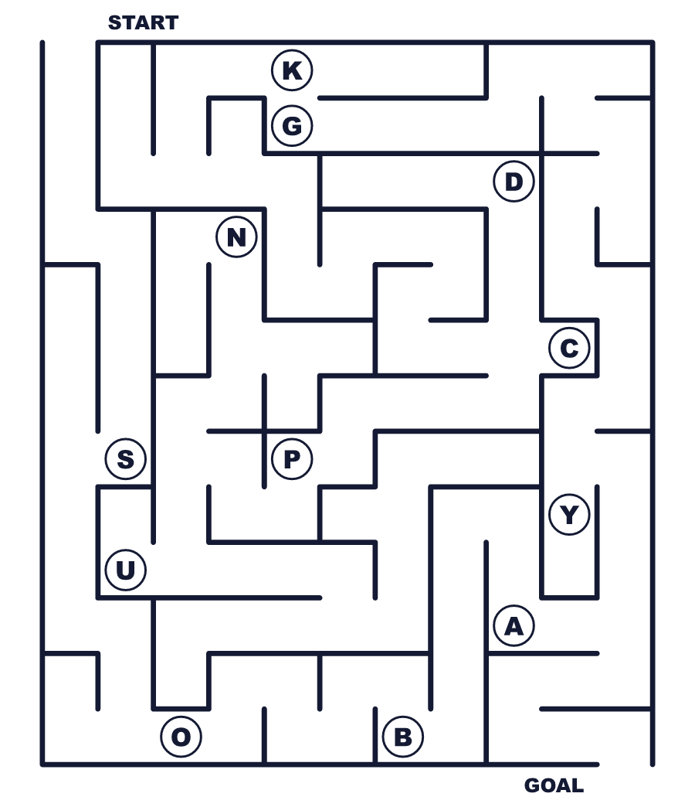
Secret word: ＿ ＿ ＿ ＿
Put the words in order. 並べかえよう。
1. day / is / the / Omisoka / last / year / the / of . (大晦日は一年の最後の日です。)
______________________________________________________________
2. a / life / for / eat / We / soba / long . (長生きのためにそばを食べます。)
______________________________________________________________
3. families / TV / show / music / watch / on / Many / a . (多くの家族がテレビで音楽番組を見ます。)
______________________________________________________________
4. The / 108 / rings / temple / bell / times . (お寺の鐘が108回鳴ります。)
______________________________________________________________
5. Happy / at / say / We / midnight / New / Year . (真夜中にあけましておめでとうと言います。)
______________________________________________________________

🔔 Omisoka (New Year's Eve in Japan) Worksheet
Class Activity & Writing
Class ______ No. ____ Name ______________________________
Find Someone Who… クラスで聞いて回ろう！
Find someone who … | Name
… has eaten toshikoshi soba 年越しそばを食べたことがある
… has rung a temple bell お寺の鐘をついたことがある
… has stayed up until midnight on New Year's Eve 大みそかに真夜中まで起きていたことがある
… likes watching music shows 音楽番組を見るのが好き
… knows what misoka means 「みそか」の意味を知っている
… can say Happy New Year in two languages 2つの言葉で「あけましておめでとう」が言える
… helps clean the house at the end of the year 年末に家の掃除を手伝う
… has seen fireworks on New Year's Eve 大みそかに花火を見たことがある
Let's Write! 英語で書いてみよう。
On New Year's Eve, my family usually ______.
大みそか、私の家族はたいてい＿＿します。
______________________________________________________________
______________________________________________________________
This year, I want to let go of ______ because ______.
今年、私は＿＿を手放したいです。なぜなら＿＿だからです。
______________________________________________________________
______________________________________________________________
My wish for next year is ______.
来年の私の願いは＿＿です。
______________________________________________________________
______________________________________________________________

🔔 Omisoka (New Year's Eve in Japan) Worksheet
Trace & Color
なぞって書こう。絵に色をぬろう。
Class ______ No. ____ Name ______________________________
🍜 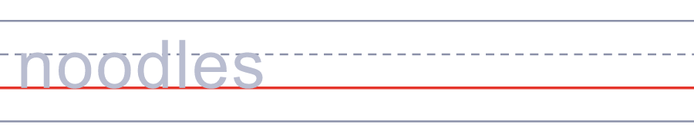

🔔 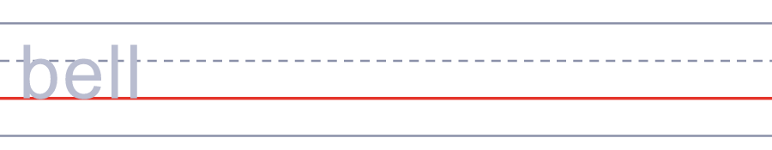
🎤 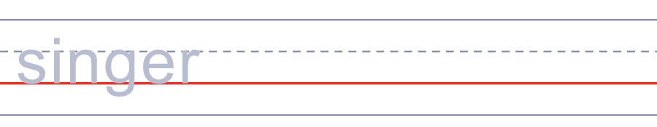
📺 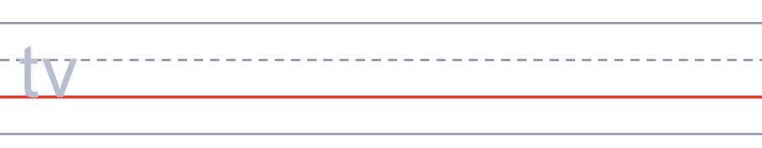
🍇 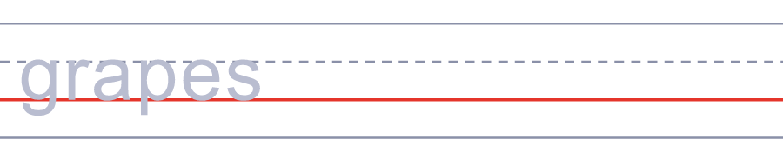
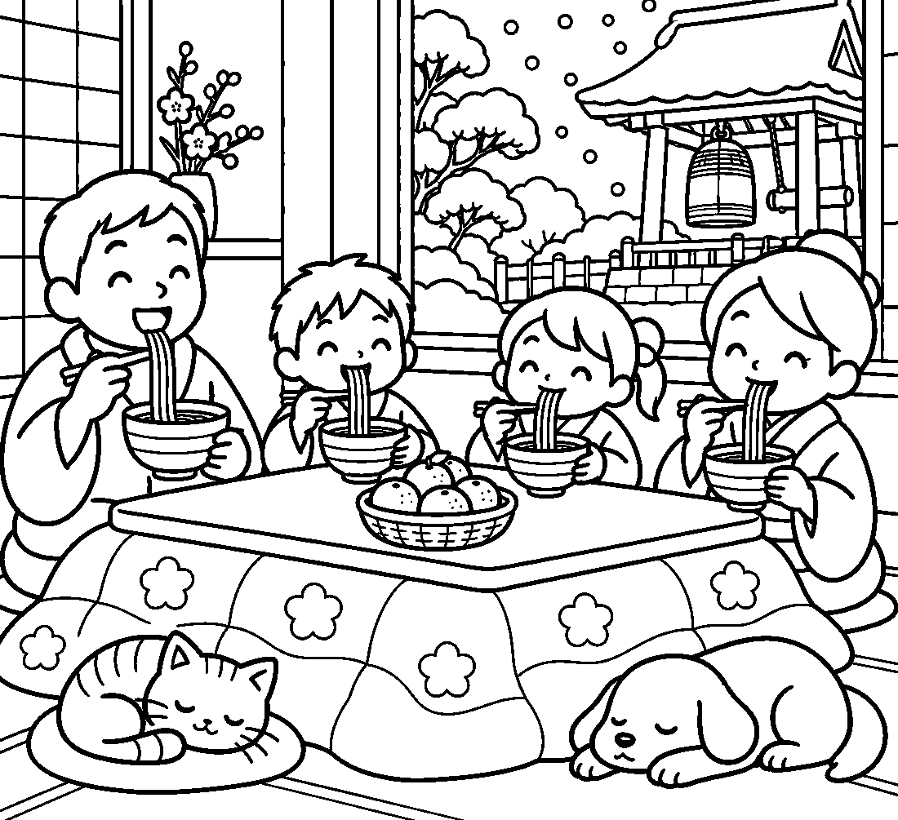

🔔 Omisoka (New Year's Eve in Japan) Worksheet
Answer Key 解答
Reading Check: 1.B 2.C 3.B 4.A 5.C 6.C 7.A 8.B
True or False: 1.T 2.F 3.T 4.F 5.T 6.F
Match: 🍜=noodles 🔔=bell 🎤=singer 📺=TV 🍇=grapes 🎆=fireworks 🕛=midnight 🍊=orange
Unscramble: 1.TEMPLE 2.NOODLES 3.MIDNIGHT 4.DECEMBER 5.CUSTOM 6.LUCK
Fill in the blanks: (1)31 (2)house (3)soba (4)life (5)show (6)midnight (7)cold (8)bell (9)Year (10)excited
Sentence order: 1. Omisoka is the last day of the year. 2. We eat soba for a long life. 3. Many families watch a music show on TV. 4. The temple bell rings 108 times. 5. We say Happy New Year at midnight.
Secret Code: HAVE A HAPPY NEW YEAR
Maze: SOBA
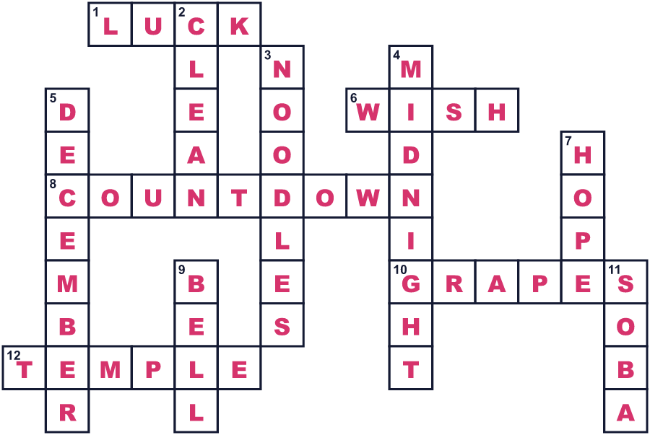
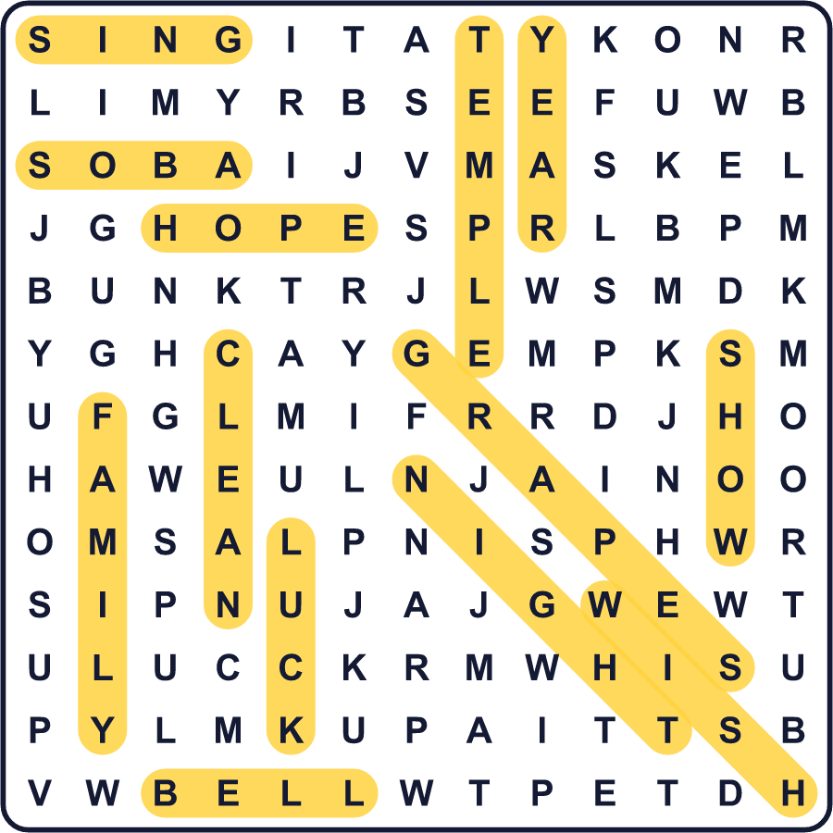
全訳
1 多くの国で、大みそかはパーティーや音楽、花火でにぎやかです。日本では、静かなことが多いのです。家族は家で過ごし、いっしょに食事をし、新しい年を待ちます。この日は大晦日と呼ばれます。「みそか」はもともと30日目、つまり昔の暦で月の最後の日のことでした。
2 この夜、多くの人が年越しそば、つまり「年を越すそば」を食べます。なぜそばなのでしょう。長い麺は長生きを意味する、と言う人がいます。そばは切れやすいので、一年の悪運を断ち切る、と言う人もいます。どの話が本当なのか、だれにもわかりません。
3 夕食のあと、多くの家族が紅白というテレビの大きな歌番組を見ます。女性の紅組と男性の白組が、歌で対決するのです。最初の紅白は大みそかではありませんでした。1951年1月3日だったのです。1953年からは、毎年12月31日に放送されています。
4 真夜中が近づくと、仏教のお寺が大きな鐘をつき始めます。たいていのお寺は108回つきます。多くの人は、108は悩みのもとになる人間の欲の数だと考えています。低く深い音が鳴るたびに、その一つを手放そうとするのです。1920年代のラジオ番組が、この習慣を日本中に広めるのを助けました。
5 最後の鐘が鳴ると、人々は「あけましておめでとう」と言います。冷たい夜の空気の中、神社へ歩いて行く人もいます。温かく、おなかいっぱいで、そのまま眠る人もいます。静かなパーティーですが、希望でいっぱいなのです。

