🥨 Oktoberfest Worksheet
A Royal Wedding That Never Ended
Read the story. 英文を読もう。
Class ______ No. ____ Name ______________________________

🔊 音声を聞こう（スマホで読みとってね）
1 In October 1810, a prince in Munich got married. His name was Ludwig, and his bride was Princess Therese. The prince later became King Ludwig I. The city held a big party for them. About 50,000 people came to watch a horse race in a large field outside the city.
2 The people loved the party, so they held it again the next year. Soon, the wedding party became a festival every year. They named the field Theresienwiese, or Therese's Meadow. Today, people in Munich just call the festival the Wiesn. It means the meadow.
3 Here is a surprise. Most of Oktoberfest happens in September! In 1872, the start moved to September because the weather is warmer then. Now the festival begins on a Saturday in mid-September and ends on the first Sunday of October. So the name says October, but the calendar says September.
4 Many visitors wear traditional Bavarian clothes. Women and girls wear a dress called a dirndl with an apron. Men and boys wear leather shorts called lederhosen. On the first Sunday, about 8,000 people in these clothes walk in a long parade with bands and horses. They walk about 7 kilometers through the city.
5 Oktoberfest is also a giant fair with roller coasters, a Ferris wheel, and a spinning ride from 1910. Families eat big pretzels, roast chicken, and sweet nuts. Many children buy a gingerbread heart with a message on it. On two Tuesdays, rides and snacks are cheaper for families. In 2026, a record 7.4 million people visited, all to celebrate a wedding from more than 200 years ago.
Words 単語
prince（王子） / bride（花嫁） / horse race（競馬） / meadow（野原、牧草地） / festival（祭り） / traditional（伝統的な） / apron（エプロン） / leather（革） / parade（パレード、行列） / fair（（移動）遊園地、催し） / gingerbread（ジンジャーブレッド、スパイス入りクッキー） / record（記録）

🥨 Oktoberfest Worksheet
Reading Check
Choose the best answer. 正しいものを選ぼう。
Class ______ No. ____ Name ______________________________
1. What is the main idea of the story?
(A) A wedding party in Munich became a huge yearly festival. (B) Horse racing is the most popular sport in Germany. (C) People in Munich do not like cold weather. (D) Lederhosen are the oldest clothes in Europe.
2. Who got married in 1810?
(A) A famous horse rider (B) Prince Ludwig and Princess Therese (C) The mayor of Munich (D) A Japanese student and Lena
3. Why did the start of the festival move to September?
(A) Because the prince was born in September (B) Because school starts in October (C) Because the weather is warmer in September (D) Because the horses were too tired
4. How many people walk in the parade on the first Sunday?
(A) About 800 (B) About 50,000 (C) About 7.4 million (D) About 8,000
5. In paragraph 2, what is a "meadow"?
(A) A large tent for music (B) A big open field with grass (C) A royal palace in a city (D) A long street for parades
6. Which sentence is true about the story?
(A) The festival ends on the first Sunday of October. (B) The festival was held only once in 1810. (C) Only men wear traditional clothes. (D) There are no rides at Oktoberfest.
7. Why is the story called "A Royal Wedding That Never Ended"?
(A) Because the prince and princess never left the party (B) Because the wedding took more than 200 days (C) Because people still celebrate the wedding every year (D) Because the bride never said yes
8. In the dialogue, what will Takumi buy for his mom?
(A) A dirndl (B) A pair of lederhosen (C) A big pretzel (D) A gingerbread heart
True or False? T か F に○
1. Oktoberfest started with a royal wedding. T / F
2. Most of Oktoberfest happens in November. T / F
3. People in Munich call the festival the Wiesn. T / F
4. A dirndl is a kind of leather shorts. T / F
5. There are rides like roller coasters at the festival. T / F
6. The first festival was a car race. T / F

🥨 Oktoberfest Worksheet
Word Work
単語のれんしゅう
Class ______ No. ____ Name ______________________________
① Match the pictures and the words. 絵と単語を線でむすぼう。
🥨 | ● | ● | wedding
🎡 | ● | ● | trumpet
👗 | ● | ● | roller coaster
🎺 | ● | ● | pretzel
🐴 | ● | ● | Ferris wheel
💒 | ● | ● | dress
🍗 | ● | ● | horse
🎢 | ● | ● | chicken
② Unscramble the words. 並べかえて単語にしよう。
1. I P C R E N (王子) → ____________________
2. R A A D E P (パレード) → ____________________
3. A N P O R (エプロン) → ____________________
4. E A O M D W (野原) → ____________________
5. Z R E E P L T (プレッツェル) → ____________________
6. G D N I W D E (結婚式) → ____________________
③ Fill in the blanks. 語群から選んで入れよう。
[ parade / gingerbread / horses / Munich / dirndl / apron / band / shorts / Ferris / kimono / ocean / meadow / snow ]
Anna is 10 and lives in (1) __________ . Today she wears her new (2) __________ with a blue (3) __________ . Her little brother wears leather (4) __________ . First, the family watches the (5) __________ . Many (6) __________ pull wagons with flowers, and a (7) __________ plays loud music. Then Anna rides the big (8) __________ wheel. From the top, she can see the whole (9) __________ . Before they go home, Dad buys her a (10) __________ heart. It says, "I love you!"

🥨 Oktoberfest Worksheet
Crossword Puzzle
ヒントを読んでクロスワードを完成させよう。
Class ______ No. ____ Name ______________________________
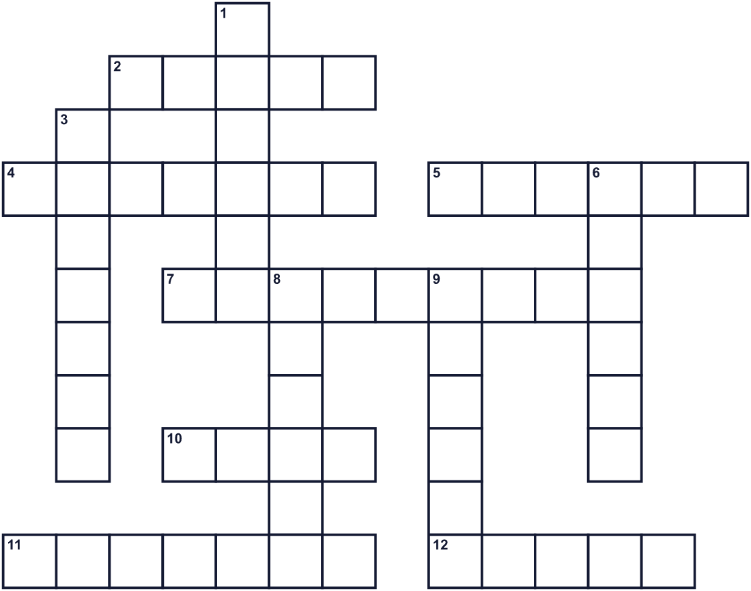
Across →
2. A gingerbread cookie often has this shape. (5)
4. The country where Munich is. (7)
5. A big field with grass. Wiesn means this. (6)
7. The festival starts in this month, not October. (9)
10. A group of musicians with trumpets and drums. (4)
11. Bread in the shape of a knot. (7)
12. In 1810, people watched this animal race. (5)
Down ↓
1. Many people walk in a line with bands and horses. (6)
3. A party when two people get married. (7)
6. A traditional dress with an apron. (6)
8. The son of a king. (6)
9. The German city of this festival. (6)

🥨 Oktoberfest Worksheet
Word Search
かくれた単語をさがそう（→ ↓ ↘ ↗）
Class ______ No. ____ Name ______________________________
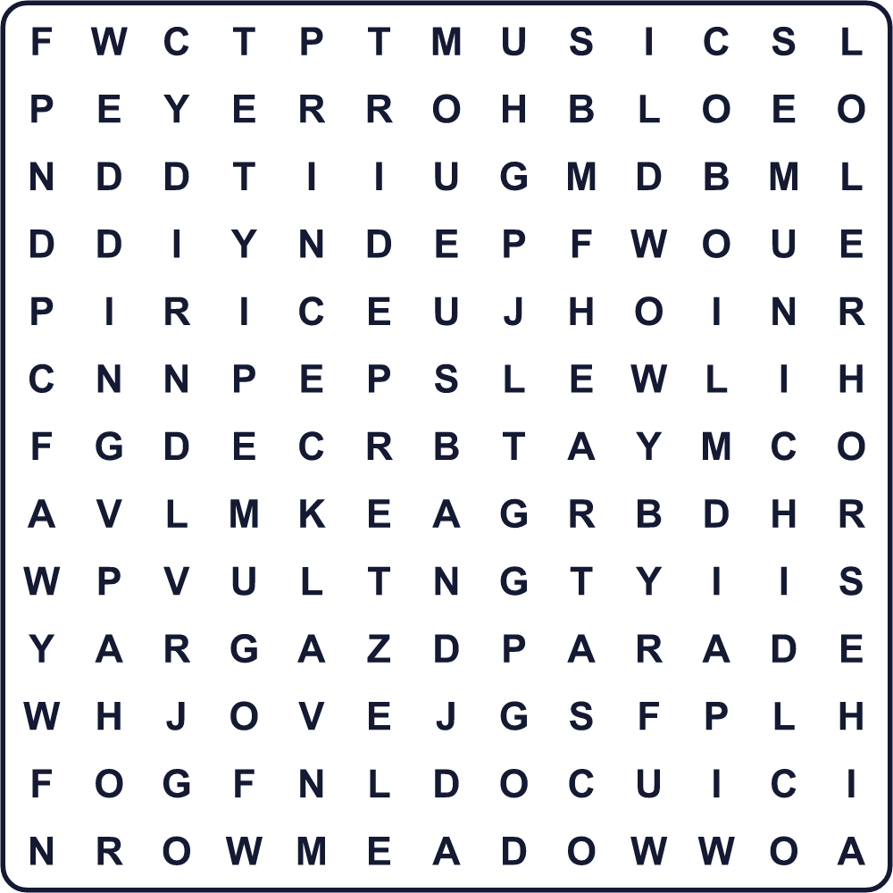
APRON BAND DIRNDL FAIR HEART HORSE MEADOW MUNICH MUSIC PARADE PRETZEL PRINCE RIDE WEDDING
Secret Code 暗号を解こう
✉=C ♪=E ✈=F ⚑=H ■=I ☎=M ☺=N ▲=O ◆=R ☃=S ♦=U ●=V
☃ ♪ ◆ ● ♦ ☃ ✈ ◆ ▲ ☎ ☎ ♦ ☺ ■ ✉ ⚑
______________________________________________________________

🥨 Oktoberfest Worksheet
Maze & Sentences
Class ______ No. ____ Name ______________________________
Help Anna get to the Ferris wheel! アンナを観覧車まで連れていこう！
正しい道の文字を集めると、ひみつの言葉になるよ。 START 👧 → GOAL 🎡
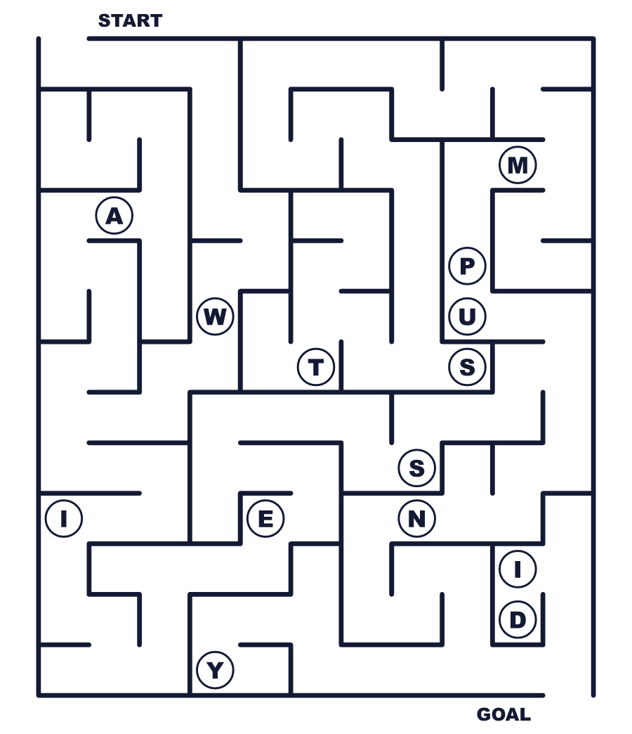
Secret word: ＿ ＿ ＿ ＿ ＿
Put the words in order. 並べかえよう。
1. prince / married / got / in / 1810 / A . (1810年に王子が結婚しました。)
______________________________________________________________
2. in / happens / September / Most / of / Oktoberfest . (オクトーバーフェストのほとんどは9月に行われます。)
______________________________________________________________
3. traditional / Bavarian / people / clothes / Many / wear . (多くの人がバイエルンの伝統的な服を着ます。)
______________________________________________________________
4. ride / a / Ferris / big / Children / wheel . (子どもたちは大きな観覧車に乗ります。)
______________________________________________________________
5. bought / for / She / gingerbread / mom / a / her / heart . (彼女はお母さんにハートのクッキーを買いました。)
______________________________________________________________

🥨 Oktoberfest Worksheet
Class Activity & Writing
Class ______ No. ____ Name ______________________________
Find Someone Who… クラスで聞いて回ろう！
Find someone who … | Name
… has been to Germany ドイツに行ったことがある
… likes pretzels プレッツェルが好き
… has ridden a Ferris wheel 観覧車に乗ったことがある
… can play a trumpet トランペットを吹ける
… knows a German word ドイツ語の単語を1つ知っている
… has worn a yukata or kimono at a festival 祭りで浴衣か着物を着たことがある
… has seen a parade with horses 馬のいるパレードを見たことがある
… likes roller coasters ジェットコースターが好き
Let's Write! 英語で書いてみよう。
If I went to the Wiesn, I would wear ______ and ride ______.
もしヴィーズンに行ったら、＿＿を着て＿＿に乗りたい。
______________________________________________________________
______________________________________________________________
I would write "______" on a gingerbread heart for ______.
＿＿のために、ハートのクッキーに「＿＿」と書きたい。
______________________________________________________________
______________________________________________________________
A festival in my town started because ______. Now people ______.
私の町の祭りは＿＿がきっかけで始まった。今では人々は＿＿する。
______________________________________________________________
______________________________________________________________

🥨 Oktoberfest Worksheet
Trace & Color
なぞって書こう。絵に色をぬろう。
Class ______ No. ____ Name ______________________________
🥨 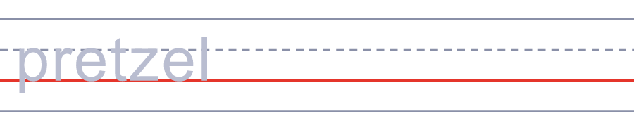

🎡 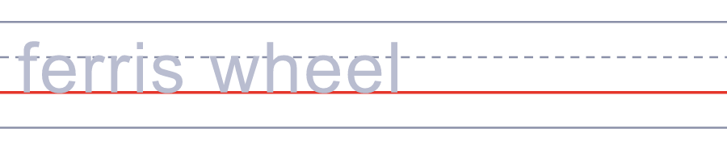
👗 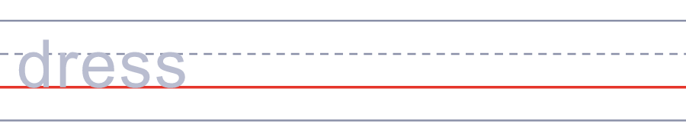
🎺 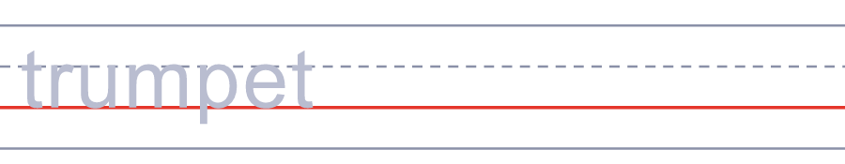
🐴 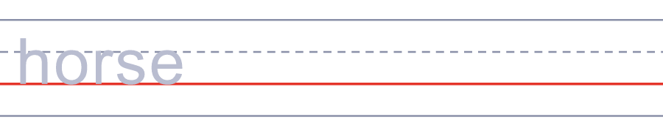
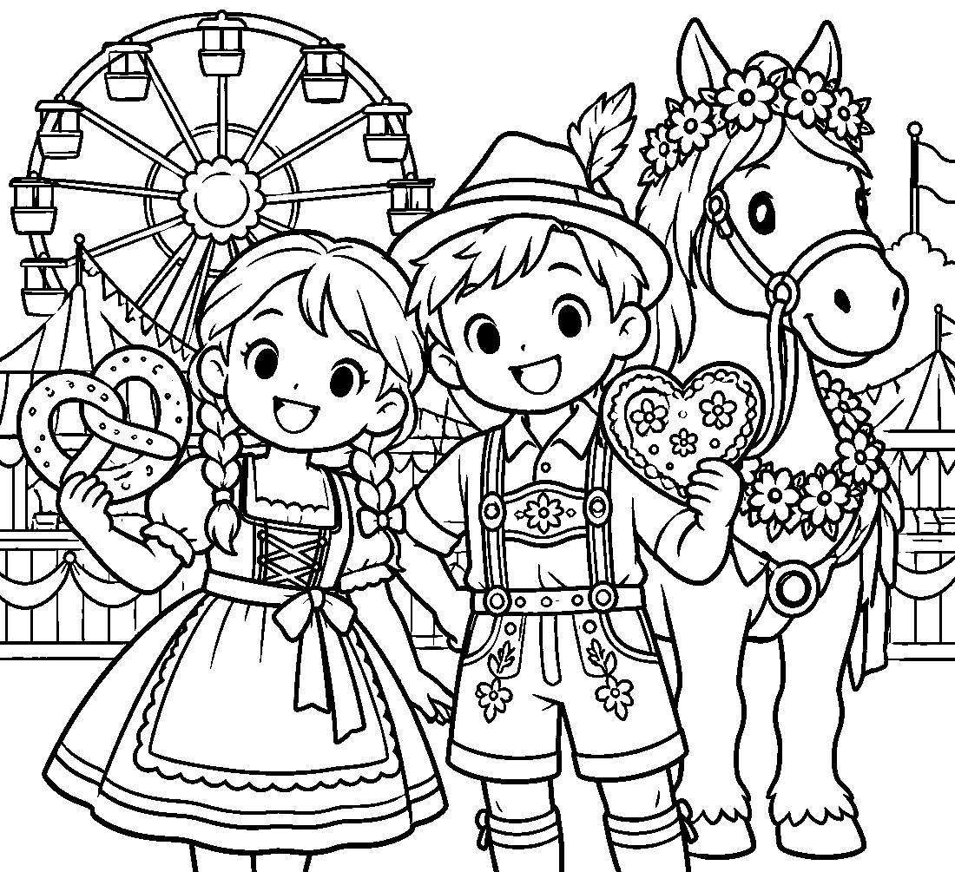

🥨 Oktoberfest Worksheet
Answer Key 解答
Reading Check: 1.A 2.B 3.C 4.D 5.B 6.A 7.C 8.D
True or False: 1.T 2.F 3.T 4.F 5.T 6.F
Match: 🥨=pretzel 🎡=Ferris wheel 👗=dress 🎺=trumpet 🐴=horse 💒=wedding 🍗=chicken 🎢=roller coaster
Unscramble: 1.PRINCE 2.PARADE 3.APRON 4.MEADOW 5.PRETZEL 6.WEDDING
Fill in the blanks: (1)Munich (2)dirndl (3)apron (4)shorts (5)parade (6)horses (7)band (8)Ferris (9)meadow (10)gingerbread
Sentence order: 1. A prince got married in 1810. 2. Most of Oktoberfest happens in September. 3. Many people wear traditional Bavarian clothes. 4. Children ride a big Ferris wheel. 5. She bought a gingerbread heart for her mom.
Secret Code: SERVUS FROM MUNICH
Maze: WIESN
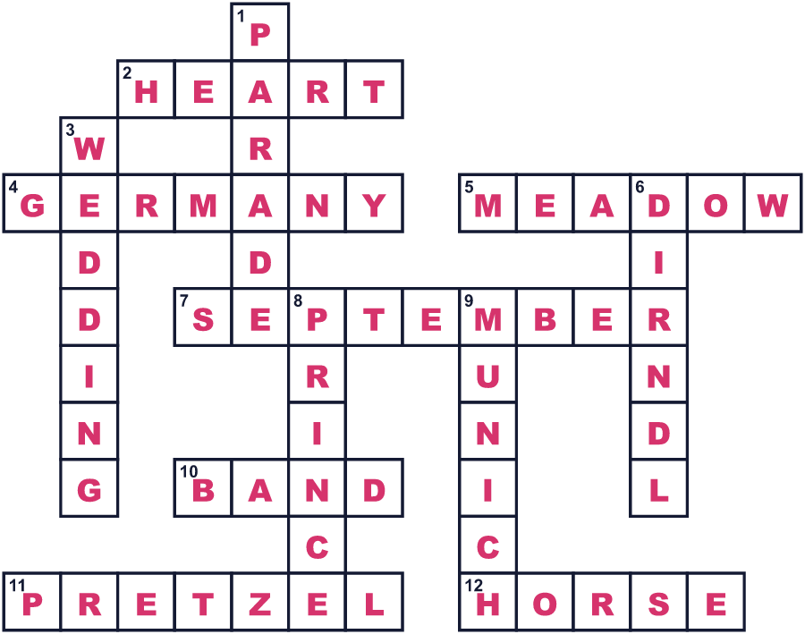
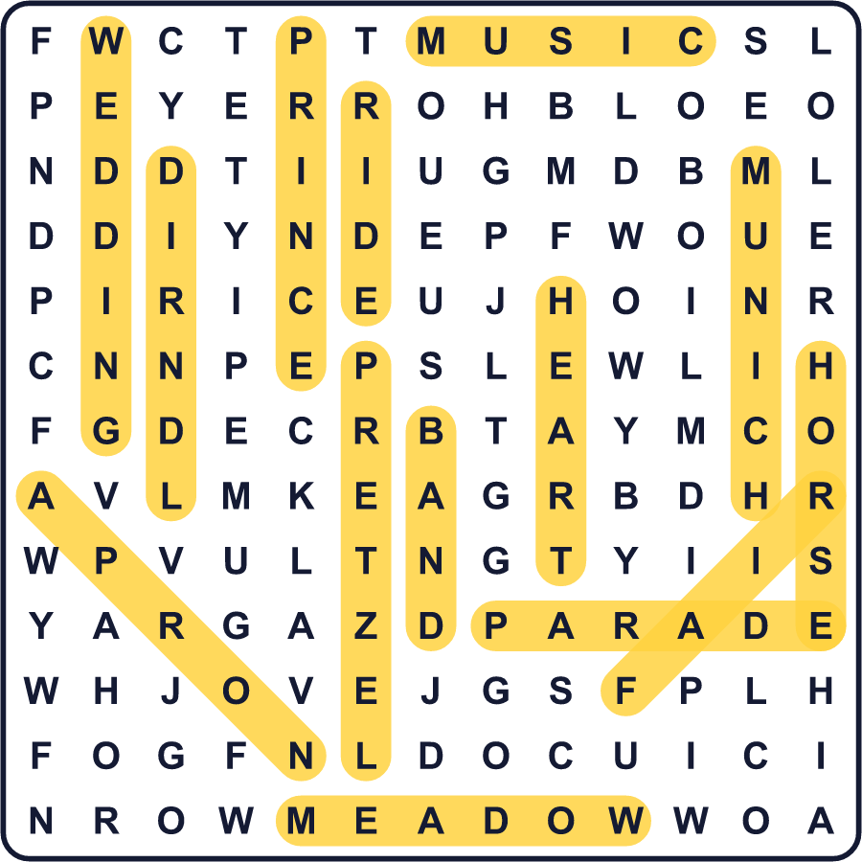
全訳
1 1810年10月、ミュンヘンの王子が結婚しました。名前はルートヴィヒ、花嫁はテレーゼ王女でした。この王子はのちに国王ルートヴィヒ1世になります。町は2人のために大きなお祝いを開きました。約5万人が、町の外の広い野原で開かれた競馬を見に来ました。
2 人々はこのお祝いが大好きになり、次の年もまた開きました。まもなく、結婚祝いは毎年のお祭りになりました。その野原はテレージエンヴィーゼ、つまり「テレーゼの野原」と名づけられました。今では、ミュンヘンの人たちはこのお祭りを単に「ヴィーズン」と呼びます。「野原」という意味です。
3 ここで驚きの事実です。オクトーバーフェストのほとんどは9月に行われるのです！1872年、9月のほうが暖かいので、始まりが9月に移りました。今では、お祭りは9月なかばの土曜日に始まり、10月の第1日曜日に終わります。つまり、名前は10月なのに、カレンダーは9月なのです。
4 多くの来場者が、バイエルンの伝統的な服を着ます。女性や女の子は、ディアンドルという服にエプロンをつけます。男性や男の子は、レーダーホーゼンという革の半ズボンをはきます。最初の日曜日には、こうした服を着た約8,000人が、楽隊や馬といっしょに長いパレードを歩きます。彼らは町の中を約7km歩きます。
5 オクトーバーフェストは、ジェットコースターや観覧車、1910年からある回転する乗り物がそろう巨大な移動遊園地でもあります。家族連れは大きなプレッツェルやローストチキン、甘いナッツを食べます。多くの子どもが、メッセージの書かれたハート形のクッキーを買います。火曜日のうち2日は、家族向けに乗り物や軽食が安くなります。2026年には過去最多の740万人が訪れました。200年以上前の結婚式を祝うためにです。

