🏮 Obon Worksheet
A Summer Visit from Home: Obon in Japan
Read the story. 英文を読もう。
Class ______ No. ____ Name ______________________________

🔊 音声を聞こう（スマホで読みとってね）
1 In the middle of August, many Japanese homes have strange little animals on the family altar. One is a cucumber with four legs made of sticks. Next to it stands an eggplant with legs, too. They are a horse and a cow for the spirits of the family's dead.
2 This is Obon, a Buddhist summer festival for ancestors. People believe the spirits of their family come home for a few days. The fast cucumber horse brings them home quickly. The slow eggplant cow takes them back slowly, so they can stay longer.
3 In most places, Obon lasts from August 13 to 16. On the first evening, families light a small fire at the gate to welcome the spirits. They clean the family grave and offer food, flowers, and incense. On the last evening, they light another fire to send the spirits back.
4 Obon is also a time for dancing. At night, people in light summer kimono dance in a big circle around a tall wooden stage. A drummer plays on top of the stage. In Kyoto, on the night of August 16, five giant fires burn on the mountains to say goodbye to the spirits.
5 Obon is not a national holiday, but many companies close for a few days. Many people go back to their hometowns, so trains and roads are packed. In parts of Tokyo, families hold Obon in July, and Okinawa still follows the old moon calendar. But the idea is the same everywhere. For a few summer days, the people we miss come home.
Words 単語
ancestor（先祖） / spirit（霊、魂） / altar（祭壇、仏壇） / Buddhist（仏教の／仏教徒） / grave（墓） / incense（線香、お香） / offer（供える、差し出す） / welcome（迎える、歓迎する） / gate（門、門口） / packed（ぎゅうぎゅうの、満員の） / hometown（ふるさと） / calendar（暦、カレンダー）

🏮 Obon Worksheet
Reading Check
Choose the best answer. 正しいものを選ぼう。
Class ______ No. ____ Name ______________________________
1. What is the main idea of the reading?
(A) Obon is a summer festival when families welcome back the spirits of their dead. (B) Obon is a national holiday for eating cucumbers and eggplants. (C) Obon is a dance contest held only in Kyoto. (D) Obon is a festival to welcome the new year.
2. What does the cucumber horse do?
(A) It takes the spirits back slowly. (B) It carries food to the grave. (C) It brings the spirits home quickly. (D) It dances around the stage.
3. In most places, how long does Obon last?
(A) One day, on August 15. (B) One month, all of August. (C) From July 1 to July 31. (D) From August 13 to 16.
4. What do families do on the first evening of Obon?
(A) They light a small fire to welcome the spirits. (B) They watch five fires on the mountains. (C) They send the spirits back. (D) They go to work early.
5. In paragraph 5, what does "packed" mean?
(A) Closed. (B) Very full of people. (C) Very quiet. (D) Free of charge.
6. Which sentence matches the reading?
(A) Obon is a national holiday in Japan. (B) Everyone in Japan holds Obon in July. (C) Okinawa uses the old moon calendar for Obon. (D) The Kyoto fires are on August 13.
7. Why is the eggplant cow slow on purpose?
(A) Because cows are easy to make. (B) Because the family wants the spirits to stay longer. (C) Because eggplants are cheap in August. (D) Because the spirits do not like horses.
8. In the dialogue, what does Kenta tell Sophie to do at the Bon dance?
(A) Wear a white kimono. (B) Learn the steps at home first. (C) Play the drum on the stage. (D) Follow the person in front of her.
True or False? T か F に○
1. In most places, Obon is from August 13 to 16. T / F
2. Obon is a national holiday in Japan. T / F
3. The eggplant cow is slow. T / F
4. Families light a fire to welcome the spirits. T / F
5. Everyone in Japan holds Obon in July. T / F
6. Obon is a festival to celebrate the new year. T / F

🏮 Obon Worksheet
Word Work
単語のれんしゅう
Class ______ No. ____ Name ______________________________
① Match the pictures and the words. 絵と単語を線でむすぼう。
🥒 | ● | ● | horse
🍆 | ● | ● | eggplant
🐎 | ● | ● | lantern
🐄 | ● | ● | drum
🏮 | ● | ● | fire
🔥 | ● | ● | cucumber
🥁 | ● | ● | flowers
💐 | ● | ● | cow
② Unscramble the words. 並べかえて単語にしよう。
1. I P T S R I (霊) → ____________________
2. E V R A G (墓) → ____________________
3. A E L T R N N (提灯) → ____________________
4. O C A R T E S N (先祖) → ____________________
5. I C N E S N E (線香) → ____________________
6. E U M S R M (夏) → ____________________
③ Fill in the blanks. 語群から選んで入れよう。
[ spirit / airplane / dance / August / Christmas / goodbye / grave / fire / circle / snow / quickly / flowers / horse ]
Every (1) __________ , Yuto visits his grandma in the countryside. This year, he helped her make a (2) __________ from a cucumber. "It brings Grandpa home (3) __________ ," she said. In the evening, they lit a small (4) __________ at the gate. The next day, the family cleaned Grandpa's (5) __________ and put (6) __________ on it. At night, Yuto went to the Bon (7) __________ . He moved in a big (8) __________ with his cousins. On the last day, Grandma said (9) __________ to Grandpa's (10) __________ with a smile.

🏮 Obon Worksheet
Crossword Puzzle
ヒントを読んでクロスワードを完成させよう。
Class ______ No. ____ Name ______________________________
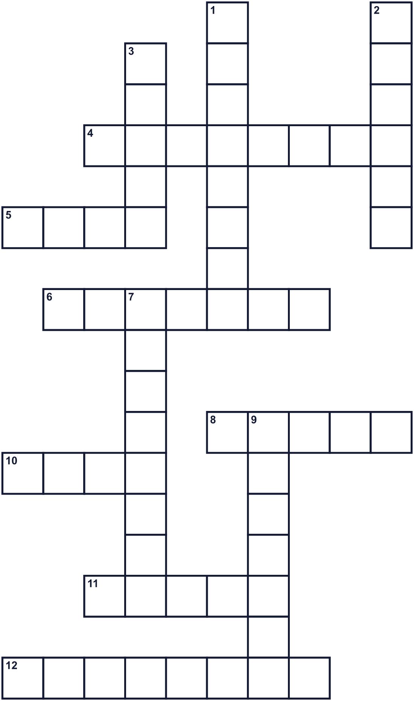
Across →
4. A family member who lived long, long ago. (8)
5. It is hot and bright. It burns wood. (4)
6. Sticks that make a nice smell when they burn. (7)
8. A special table or shelf for prayers and offerings. (5)
10. A music instrument you hit with sticks. (4)
11. The place where a dead person rests. (5)
12. A purple vegetable. At Obon it becomes a cow. (8)
Down ↓
1. The town where you were born and grew up. (8)
2. The soul of a person who has died. (6)
3. People move to music in a big circle at night. (5)
7. A long green vegetable. At Obon it becomes a horse. (8)
9. A paper light that you can carry. (7)

🏮 Obon Worksheet
Word Search
かくれた単語をさがそう（→ ↓ ↘ ↗）
Class ______ No. ____ Name ______________________________
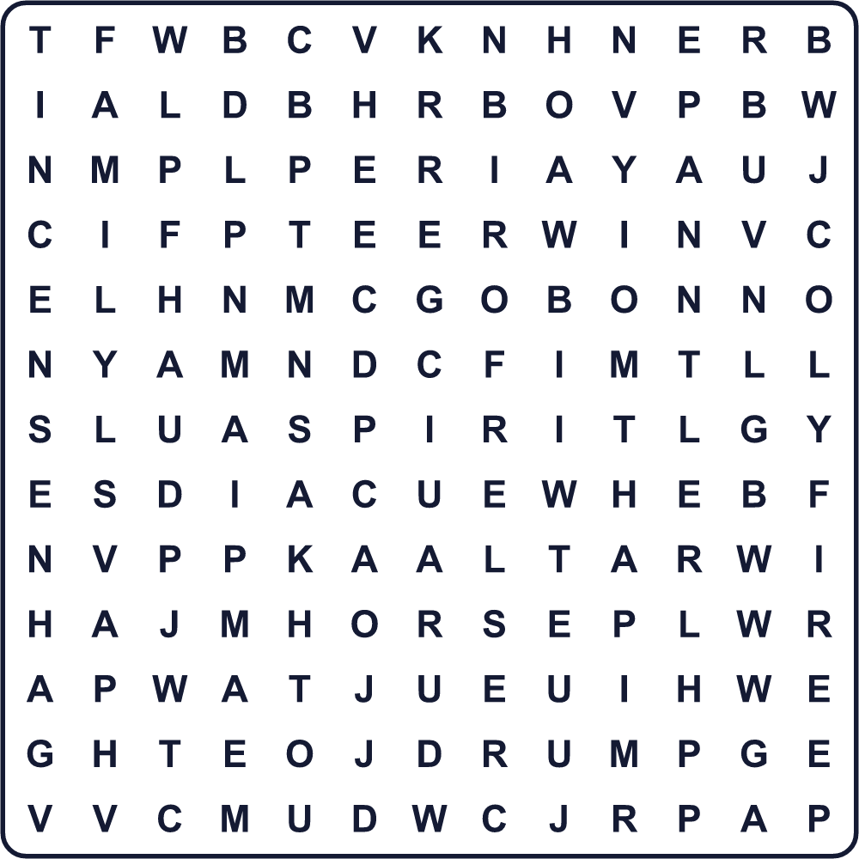
ALTAR COW DANCE DRUM FAMILY FIRE GRAVE HORSE INCENSE LANTERN OBON SPIRIT SUMMER
Secret Code 暗号を解こう
✉=C ☃=E ☂=H ☎=L ✿=M ■=O ▲=W
▲ ☃ ☎ ✉ ■ ✿ ☃ ☂ ■ ✿ ☃
______________________________________________________________

🏮 Obon Worksheet
Maze & Sentences
Class ______ No. ____ Name ______________________________
Help the cucumber horse bring Grandpa home! きゅうりの馬でおじいちゃんを家まで連れてこよう！
正しい道の文字を集めると、ひみつの言葉になるよ。 START 🐎 → GOAL 🏠
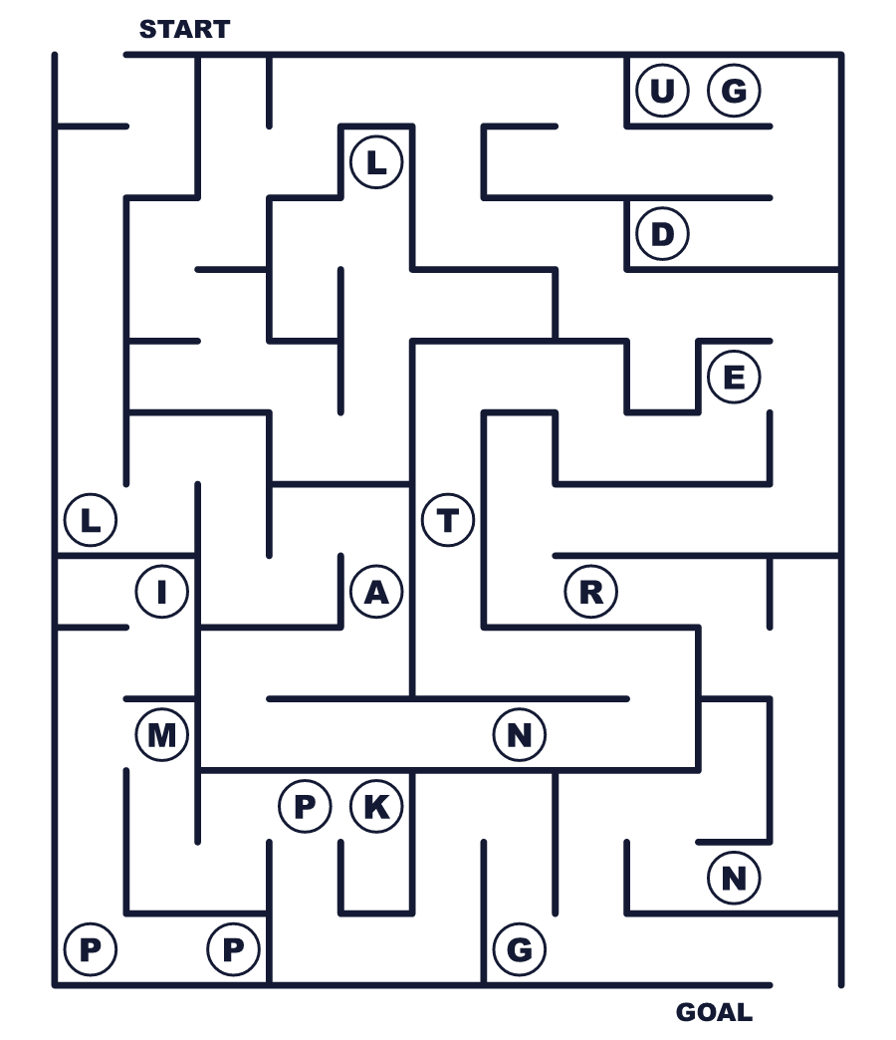
Secret word: ＿ ＿ ＿ ＿ ＿ ＿ ＿
Put the words in order. 並べかえよう。
1. festival / for / ancestors / is / Obon / our / a . (お盆は先祖のための行事です。)
______________________________________________________________
2. home / August / The / in / come / spirits . (霊は8月に帰ってきます。)
______________________________________________________________
3. We / fire / light / a / the / at / gate . (私たちは門口で火をたきます。)
______________________________________________________________
4. cucumber / runs / The / very / horse / fast . (きゅうりの馬はとても速く走ります。)
______________________________________________________________
5. People / night / big / dance / circle / a / in / at . (人々は夜、大きな輪になって踊ります。)
______________________________________________________________

🏮 Obon Worksheet
Class Activity & Writing
Class ______ No. ____ Name ______________________________
Find Someone Who… クラスで聞いて回ろう！
Find someone who … | Name
… has made a cucumber horse きゅうりの馬を作ったことがある
… has danced at a Bon dance 盆踊りを踊ったことがある
… goes to a grandparent's house for Obon お盆に祖父母の家へ行く
… has seen a floating lantern 灯籠流しを見たことがある
… knows the English word for 先祖 「先祖」の英語を知っている
… likes wearing a yukata 浴衣を着るのが好き
… can play the taiko drum 太鼓をたたける
… knows a festival like Obon in another country 外国のお盆に似た行事を知っている
Let's Write! 英語で書いてみよう。
During Obon, my family usually ______. I like it because ______.
お盆に、私の家族はたいてい＿＿します。私はそれが好きです。なぜなら＿＿だからです。
______________________________________________________________
______________________________________________________________
If I could meet one ancestor, I would like to meet ______ and ask, "______?"
もし先祖の一人に会えるなら、＿＿に会って「＿＿？」と聞きたいです。
______________________________________________________________
______________________________________________________________
Obon is like ______ in ______ because ______.
お盆は＿＿（国）の＿＿に似ています。なぜなら＿＿だからです。
______________________________________________________________
______________________________________________________________

🏮 Obon Worksheet
Trace & Color
なぞって書こう。絵に色をぬろう。
Class ______ No. ____ Name ______________________________
🥒 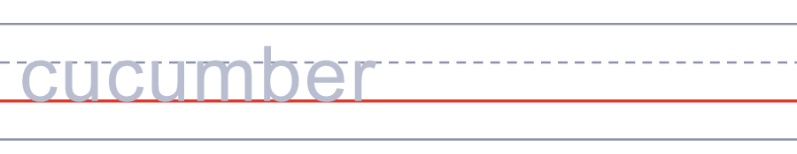

🍆 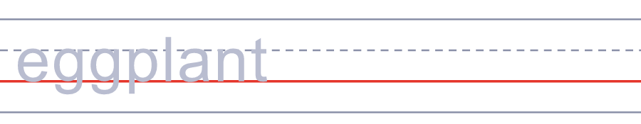
🐎 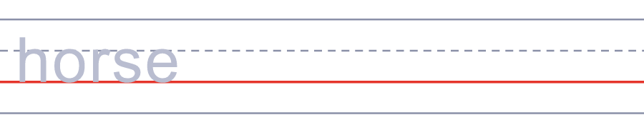
🐄 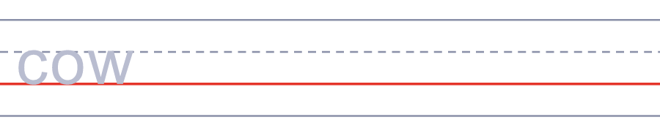
🏮 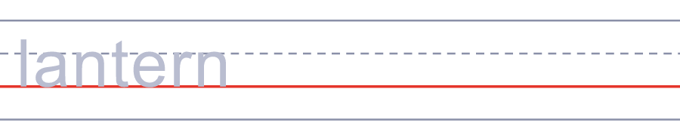
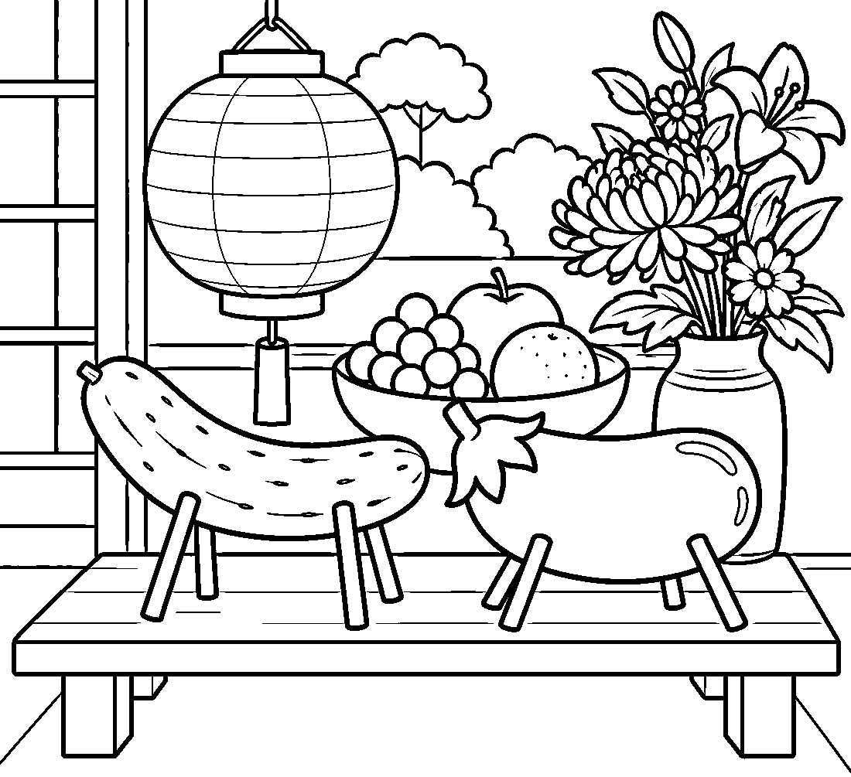

🏮 Obon Worksheet
Answer Key 解答
Reading Check: 1.A 2.C 3.D 4.A 5.B 6.C 7.B 8.D
True or False: 1.T 2.F 3.T 4.T 5.F 6.F
Match: 🥒=cucumber 🍆=eggplant 🐎=horse 🐄=cow 🏮=lantern 🔥=fire 🥁=drum 💐=flowers
Unscramble: 1.SPIRIT 2.GRAVE 3.LANTERN 4.ANCESTOR 5.INCENSE 6.SUMMER
Fill in the blanks: (1)August (2)horse (3)quickly (4)fire (5)grave (6)flowers (7)dance (8)circle (9)goodbye (10)spirit
Sentence order: 1. Obon is a festival for our ancestors. 2. The spirits come home in August. 3. We light a fire at the gate. 4. The cucumber horse runs very fast. 5. People dance in a big circle at night.
Secret Code: WELCOME HOME
Maze: LANTERN
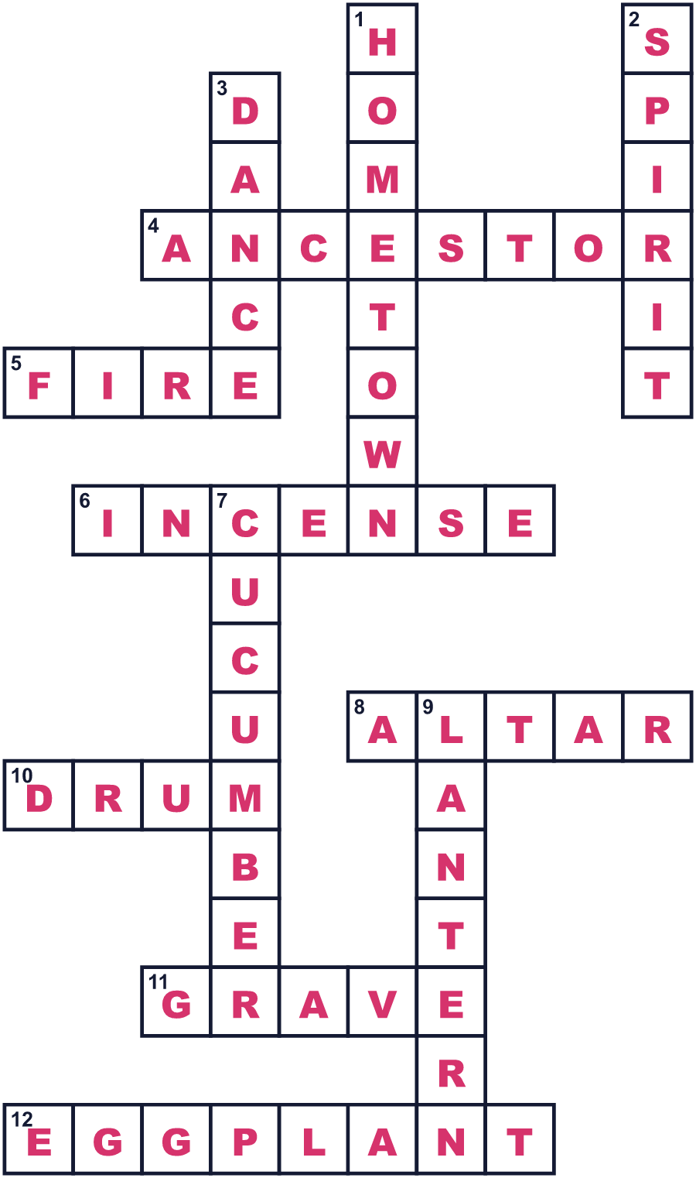
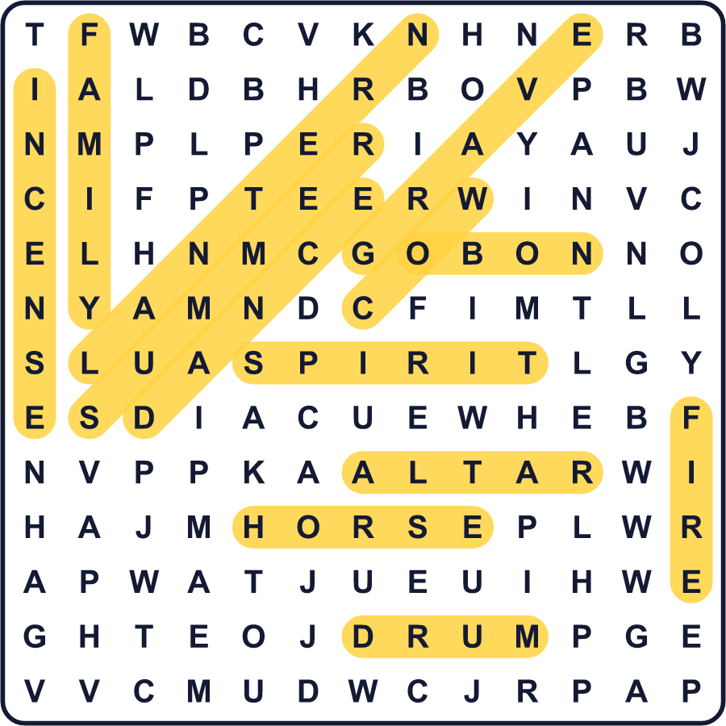
全訳
1 8月のなかば、日本の多くの家では、仏壇に不思議な小さな動物が置かれます。一つは、棒で作った4本の足がついたきゅうりです。その横には、やはり足のついたなすが立っています。それらは、その家の亡くなった人たちの霊のための馬と牛なのです。
2 これがお盆、ご先祖さまのための夏の仏教行事です。人々は、家族の霊が数日間家に帰ってくると信じています。足の速いきゅうりの馬が、霊を急いで家に連れてきます。足の遅いなすの牛は、霊をゆっくり送り返すので、霊は長くいられます。
3 多くの地域で、お盆は8月13日から16日まで続きます。最初の夕方、家族は門口で小さな火をたいて霊を迎えます。お墓を掃除し、食べ物や花、線香を供えます。最後の夕方には、もう一度火をたいて霊を送り返します。
4 お盆は踊りの季節でもあります。夜、浴衣を着た人たちが、高い木の台のまわりで大きな輪になって踊ります。台の上では太鼓が鳴ります。京都では8月16日の夜、霊にさよならを言うために、山の上で5つの大きな火が燃えます。
5 お盆は国の祝日ではありませんが、多くの会社が数日間休みになります。多くの人がふるさとへ帰るので、電車も道路もぎゅうぎゅうになります。東京の一部では7月にお盆をする家があり、沖縄は今も昔の月の暦に従っています。でも、考え方はどこでも同じです。夏の数日間、会いたい人たちが帰ってくるのです。

