🌱 Nowruz Worksheet
A New Year That Starts with the Sun
Read the story. 英文を読もう。
Class ______ No. ____ Name ______________________________

🔊 音声を聞こう（スマホで読みとってね）
1 In Iran, the new year does not start at midnight. It starts at the exact moment of spring, when day and night are the same length. This moment can come in the morning, in the afternoon, or even late at night. Families sit around a special table and watch the clock together. When the moment comes, they hug and say, "Happy Nowruz!"
2 Nowruz means "new day" in Persian. People have celebrated it for more than 3,000 years. Today, people celebrate it in Iran, Afghanistan, and many countries in Central Asia. In 2010, the United Nations made March 21 the International Day of Nowruz.
3 Before the new year, people clean their homes from top to bottom. On the last Tuesday night of the year, they make small fires in the street and jump over them. They ask the fire to take away their illness and bad luck.
4 The special table is called haft-sin, or "seven S's." It has seven things with names that start with the letter S in Persian. There are green sprouts, apples, garlic, vinegar, and a sweet wheat pudding. Many families also add a mirror, candles, painted eggs, and a goldfish in a bowl.
5 The holiday lasts for almost two weeks. Children visit relatives, and older people give them new money. On the 13th day, families go outside for a big picnic. At the end of the day, they throw their green sprouts into a river. The old year floats away, and spring is finally here.
Words 単語
moment（瞬間） / exact（正確な、ぴったりの） / length（長さ） / Persian（ペルシャの／ペルシャ語） / celebrate（祝う） / clean（掃除する、きれいにする） / jump over（～を飛びこえる） / illness（病気） / sprout（芽） / relative（親せき） / picnic（ピクニック） / float（浮かぶ、ただよう）

🌱 Nowruz Worksheet
Reading Check
Choose the best answer. 正しいものを選ぼう。
Class ______ No. ____ Name ______________________________
1. What is the main idea of the story?
(A) Nowruz is a winter festival in Japan. (B) Nowruz is a spring New Year with many old customs. (C) Nowruz is a day to eat only fish. (D) Nowruz started in 2010.
2. When does the new year start in Iran?
(A) At midnight on January 1 (B) At the exact moment of spring (C) At sunrise on March 1 (D) On the 13th day of spring
3. How long have people celebrated Nowruz?
(A) For about 100 years (B) For about 300 years (C) For more than 3,000 years (D) Since 2010
4. What do people do on the last Tuesday night of the year?
(A) They go on a picnic. (B) They throw sprouts into a river. (C) They paint eggs. (D) They jump over small fires.
5. In the story, what does "sprouts" mean?
(A) Young green plants (B) Small fish (C) Sweet cakes (D) Old coins
6. Which sentence is true?
(A) The new year always starts at the same time. (B) Haft-sin has seven things that start with S in Persian. (C) Children give money to older people. (D) Families stay home on the 13th day.
7. Why do people throw the sprouts into a river?
(A) Because they do not like green food (B) Because the river needs plants (C) To say goodbye to the old year and welcome spring (D) To feed the goldfish
8. In the dialogue, why does Yuna say "Just like otoshidama"?
(A) Because Arash's grandma gives everyone new money (B) Because there is garlic on the table (C) Because Nowruz starts at midnight (D) Because Arash lives in Japan
True or False? T か F に○
1. Nowruz means "new day." T / F
2. Nowruz starts in winter. T / F
3. Haft-sin has seven things that start with S in Persian. T / F
4. People jump over water on the last Tuesday night. T / F
5. On the 13th day, families go on a picnic. T / F
6. Nowruz is always on March 21 in Iran. T / F

🌱 Nowruz Worksheet
Word Work
単語のれんしゅう
Class ______ No. ____ Name ______________________________
① Match the pictures and the words. 絵と単語を線でむすぼう。
🔥 | ● | ● | garlic
🐟 | ● | ● | candle
🍎 | ● | ● | fire
🧄 | ● | ● | fish
🥚 | ● | ● | apple
🕯️ | ● | ● | picnic
🌱 | ● | ● | egg
🧺 | ● | ● | sprout
② Unscramble the words. 並べかえて単語にしよう。
1. G N I P S R (春) → ____________________
2. R O R M R I (鏡) → ____________________
3. P N I C C I (ピクニック) → ____________________
4. I G L A C R (ニンニク) → ____________________
5. L D C E A N (ろうそく) → ____________________
6. E N M M O T (瞬間) → ____________________
③ Fill in the blanks. 語群から選んで入れよう。
[ water / sprouts / seeds / candy / money / snow / river / clock / school / table / hugs / picnic / cleans ]
Before Nowruz, Sara puts wheat (1) __________ on a plate. Every day, she gives them a little (2) __________ . Soon, small green (3) __________ come up. Her mother (4) __________ the whole house. On the big day, the family sits at the (5) __________ and watches the (6) __________ . When spring comes, everyone (7) __________ . Grandpa gives Sara some new (8) __________ . On the 13th day, they go on a (9) __________ . Sara throws the sprouts into the (10) __________ and makes a wish.

🌱 Nowruz Worksheet
Crossword Puzzle
ヒントを読んでクロスワードを完成させよう。
Class ______ No. ____ Name ______________________________
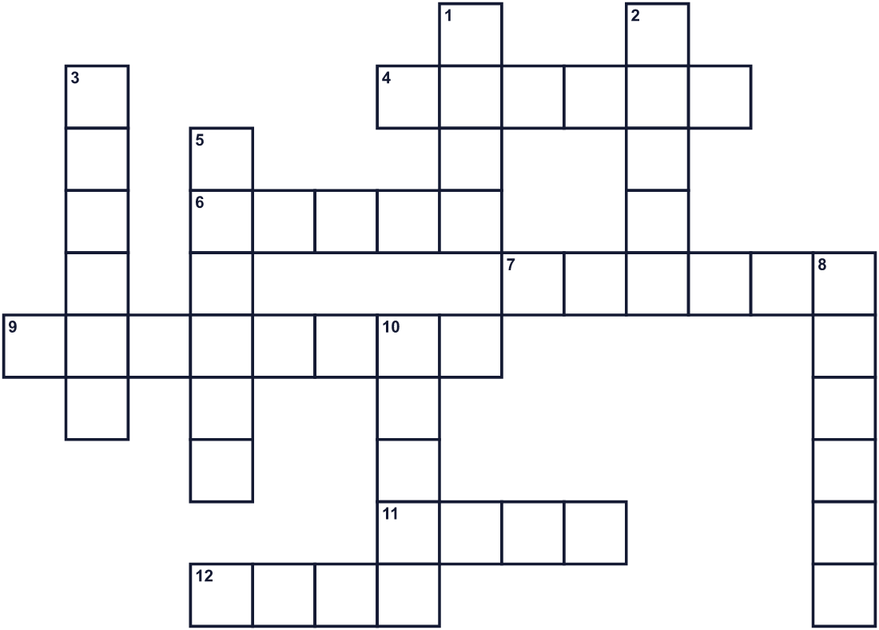
Across →
4. A meal you eat outside in a park. (6)
6. A red fruit. It is one of the seven S things. (5)
7. The season after winter. (6)
9. A small orange pet that lives in water. (8)
11. Birds lay these. People paint them for the table. (4)
12. A country in West Asia. Its capital is Tehran. (4)
Down ↓
1. It is hot and red. People jump over it before the new year. (4)
2. Water that moves through the land to the sea. (5)
3. You can see your face in it. (6)
5. It gives a small light when you burn it. (6)
8. A white vegetable with a strong smell. (6)
10. The number after six. (5)

🌱 Nowruz Worksheet
Word Search
かくれた単語をさがそう（→ ↓ ↘ ↗）
Class ______ No. ____ Name ______________________________
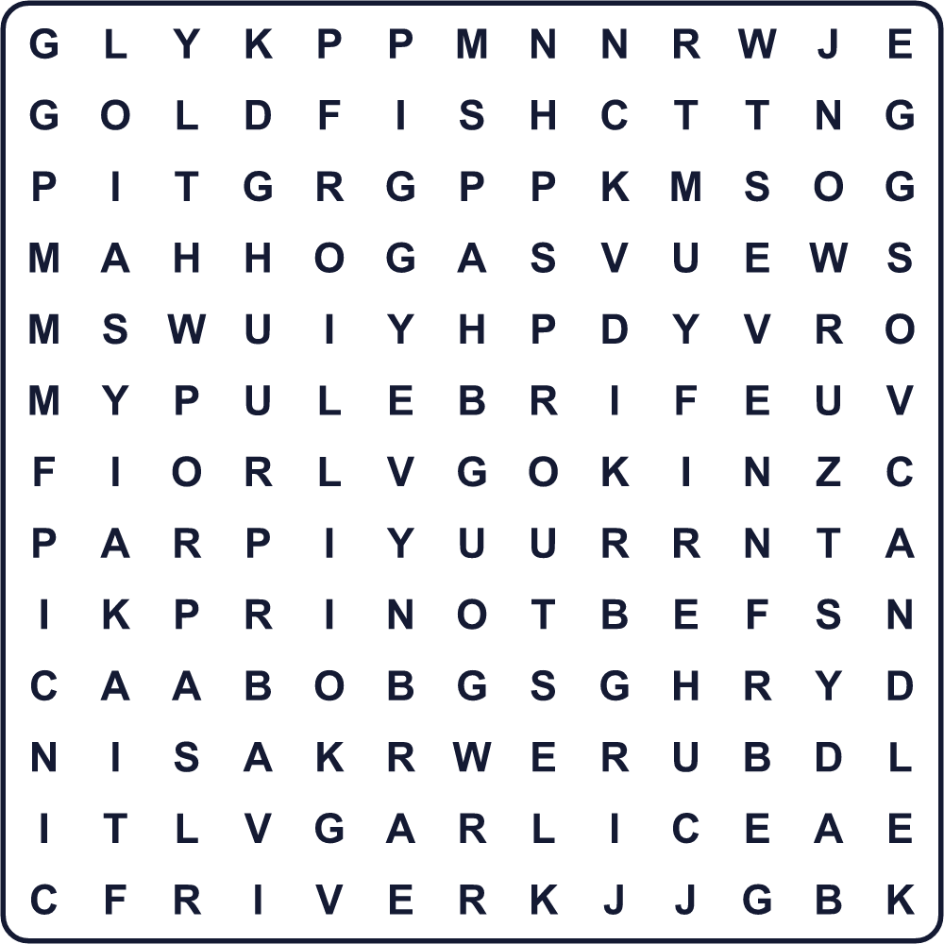
APPLE CANDLE EGGS FIRE GARLIC GOLDFISH MIRROR NOWRUZ PICNIC RIVER SEVEN SPRING SPROUTS
Secret Code 暗号を解こう
✈=A ♪=H ✿=N ♦=O ◆=P ☀=R ☺=U ♣=W ★=Y ⚓=Z
♪ ✈ ◆ ◆ ★ ✿ ♦ ♣ ☀ ☺ ⚓
______________________________________________________________

🌱 Nowruz Worksheet
Maze & Sentences
Class ______ No. ____ Name ______________________________
Help Sara carry her green plate to the river! サラが緑の芽のお皿を川まで運ぶのを手伝おう！
正しい道の文字を集めると、ひみつの言葉になるよ。 START 👧 → GOAL 🌊
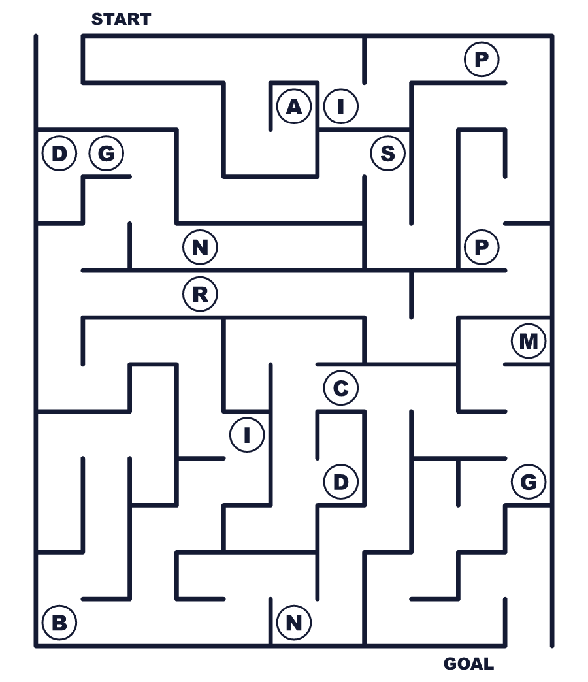
Secret word: ＿ ＿ ＿ ＿ ＿ ＿
Put the words in order. 並べかえよう。
1. new / day / Nowruz / means / in / Persian . (ノウルーズはペルシャ語で「新しい日」という意味です。)
______________________________________________________________
2. The / new / spring / with / year / starts . (新しい年は春とともに始まります。)
______________________________________________________________
3. People / small / over / night / jump / fires / at . (人々は夜に小さな火を飛びこえます。)
______________________________________________________________
4. clock / the / Families / watch / at / the / table . (家族はテーブルで時計を見つめます。)
______________________________________________________________
5. They / sprouts / throw / a / into / green / river . (彼らは緑の芽を川に流します。)
______________________________________________________________

🌱 Nowruz Worksheet
Class Activity & Writing
Class ______ No. ____ Name ______________________________
Find Someone Who… クラスで聞いて回ろう！
Find someone who … | Name
… has cleaned the whole house for New Year お正月のために家じゅうを掃除したことがある
… has a goldfish at home 家で金魚を飼っている
… likes garlic ニンニクが好き
… has grown plants from seeds 種から植物を育てたことがある
… knows the name of a country in Central Asia 中央アジアの国の名前を知っている
… can name the four seasons in English 四季を英語で言える
… has been on a picnic this year 今年ピクニックに行った
… likes spring the best 春がいちばん好き
Let's Write! 英語で書いてみよう。
My favorite thing about New Year is ______ because ______.
お正月でいちばん好きなことは＿＿です。なぜなら＿＿だからです。
______________________________________________________________
______________________________________________________________
If I made a haft-sin table, I would put ______ on it because ______.
もしハフト・スィーンを作るなら、＿＿を置きます。なぜなら＿＿だからです。
______________________________________________________________
______________________________________________________________
One thing I want to leave behind with the old year is ______.
古い年に置いていきたいものの1つは＿＿です。
______________________________________________________________
______________________________________________________________

🌱 Nowruz Worksheet
Trace & Color
なぞって書こう。絵に色をぬろう。
Class ______ No. ____ Name ______________________________
🔥 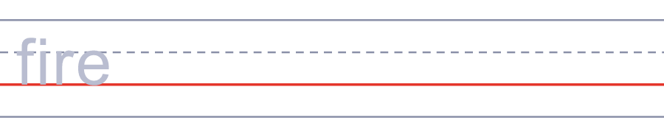

🐟 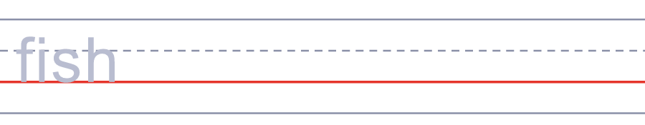
🍎 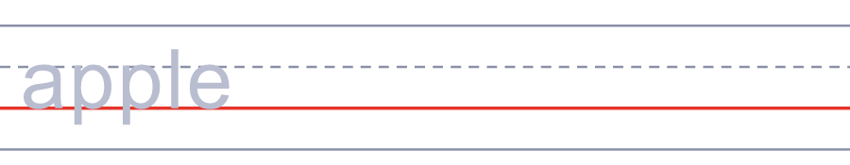
🧄 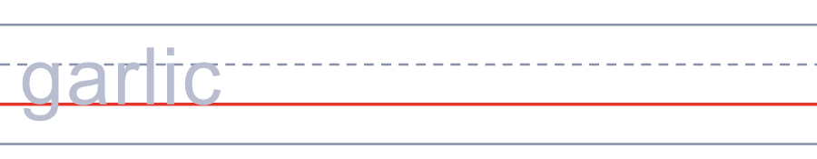
🥚 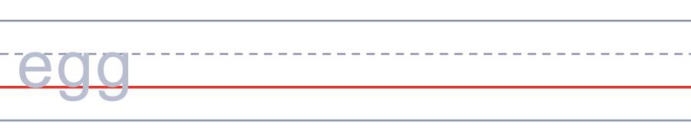
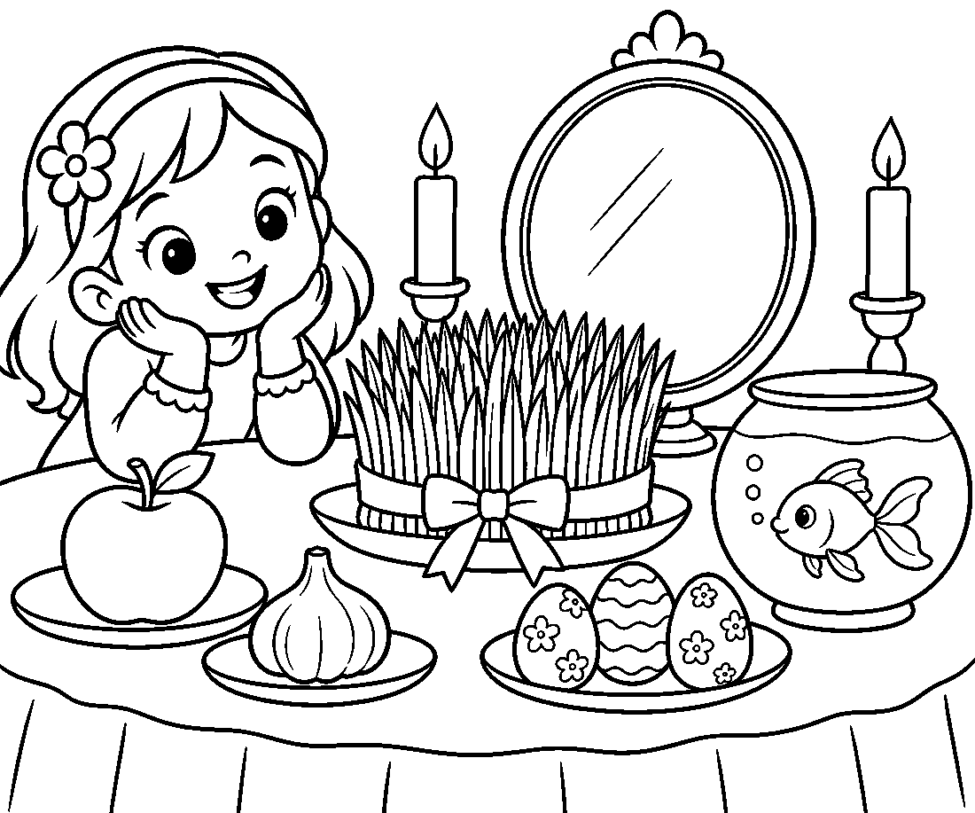

🌱 Nowruz Worksheet
Answer Key 解答
Reading Check: 1.B 2.B 3.C 4.D 5.A 6.B 7.C 8.A
True or False: 1.T 2.F 3.T 4.F 5.T 6.F
Match: 🔥=fire 🐟=fish 🍎=apple 🧄=garlic 🥚=egg 🕯️=candle 🌱=sprout 🧺=picnic
Unscramble: 1.SPRING 2.MIRROR 3.PICNIC 4.GARLIC 5.CANDLE 6.MOMENT
Fill in the blanks: (1)seeds (2)water (3)sprouts (4)cleans (5)table (6)clock (7)hugs (8)money (9)picnic (10)river
Sentence order: 1. Nowruz means new day in Persian. 2. The new year starts with spring. 3. People jump over small fires at night. 4. Families watch the clock at the table. 5. They throw green sprouts into a river.
Secret Code: HAPPY NOWRUZ
Maze: SPRING
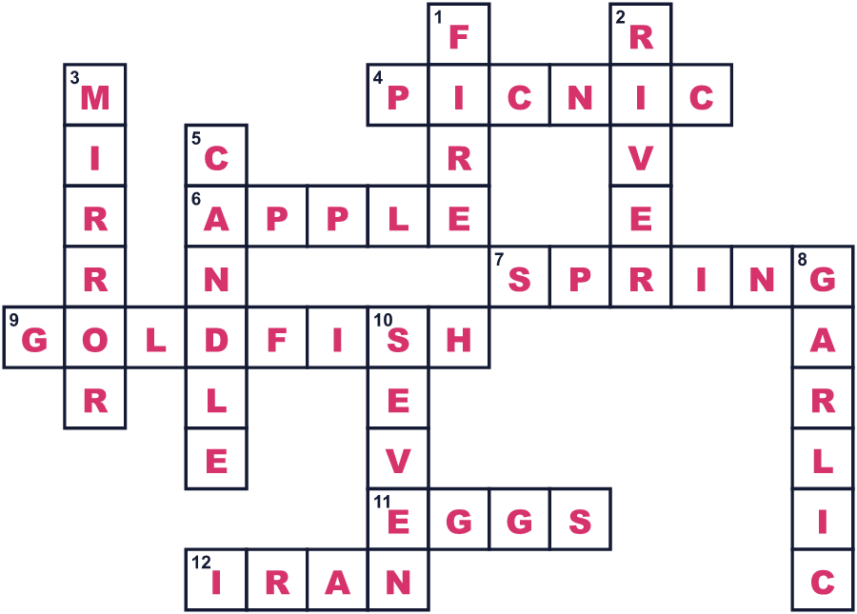
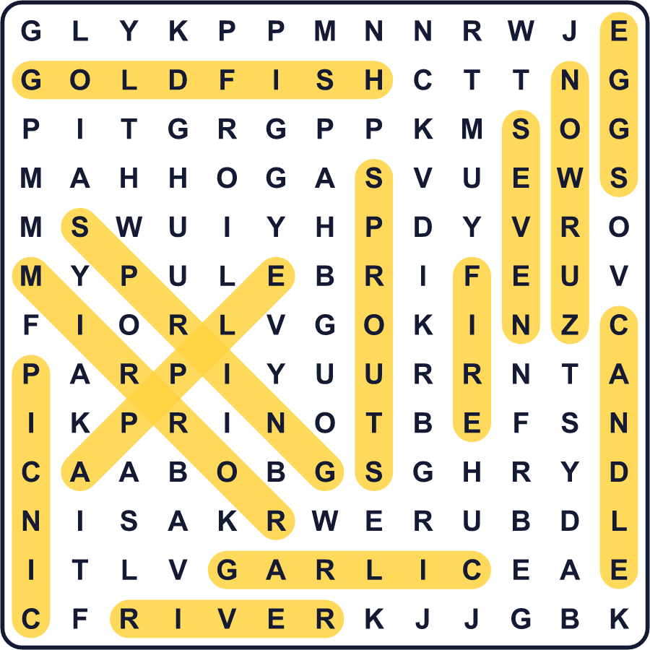
全訳
1 イランでは、新しい年は真夜中に始まりません。昼と夜が同じ長さになる、春のその瞬間に始まるのです。その瞬間は、朝のこともあれば、午後のことも、夜遅くのこともあります。家族は特別なテーブルを囲み、いっしょに時計を見つめます。その瞬間が来ると、みんなで抱き合い「ノウルーズおめでとう！」と言います。
2 ノウルーズはペルシャ語で「新しい日」という意味です。人々は3000年以上もこの日を祝ってきました。今日、イラン、アフガニスタン、そして中央アジアの多くの国の人々がこの日を祝っています。2010年、国連は3月21日を国際ノウルーズデーにしました。
3 新年の前に、人々は家を上から下まですっかりきれいにします。1年最後の火曜日の夜には、通りで小さな火をたいて、その上を飛びこえます。火に、病気や不運を持っていってくれるよう願うのです。
4 その特別なテーブルは、ハフト・スィーン、つまり「7つのS」と呼ばれます。ペルシャ語でSの文字から始まる名前の品が7つ置かれます。緑の芽、リンゴ、ニンニク、酢、そして甘い小麦のプディングなどがあります。多くの家族は、鏡、ろうそく、色をぬった卵、そして鉢に入れた金魚も添えます。
5 お祝いは2週間近く続きます。子どもたちは親せきを訪ね、年長者から新しいお金をもらいます。13日目には、家族で外へ出て大きなピクニックをします。その日の終わりに、彼らは緑の芽を川に流します。古い年は流れ去り、ついに春がやってきたのです。

